Compiler Design and Construction

Introduction
Programs written in any programming language needs to be translated to a machine readable form before it can be executed by the computer. This translation is done by a special program called compiler.
In other words, compiler is a program that can read a program in one language or the source language and translate it into an equivalent program in another language or the target language.
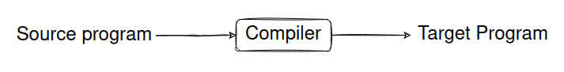
If the target program is an executable machine-language program, it can then be called by users to process output & provide results
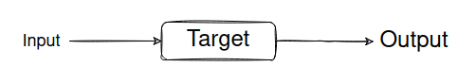

Interpreter: It is another popular language processor that directly executes the operations specified in source program as inputs supplied by users. No target program is produced.
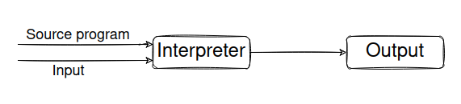
- It is slower at mapping inputs and outputs.
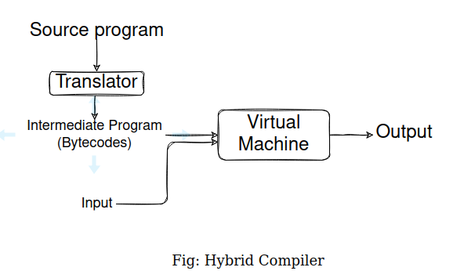
- It gives better error diagnostics.

Hybrid Compilers: It uses both compiler and interpreter. For e.g.: In Java, source program is first translated into byte codes, which is then interpreted by a virtual program.

Advantages: Bytecodes compiled on one machine can be interpreted on another machine or even a network.

Just-In-Time Compilers: It converts bytecodes to machine language immediately before the program is run.
Advantage: It improves faster input-to-output processing.

Preprocessor:
A source program maybe divided into modules, each stored in separate files. These separate files are collected by separate preprocessor. It also converts macros into language statements.
Compiler takes this modified source program and converts it into assembly language.
An assembler processes the assembly language & produces relocatable machine code.
Often large programs are compiled in modules, resulting in multiple relocatable machine codes. A linker links these codes with relevant object files and library files.
Loader puts all the executable object files into memory for execution.
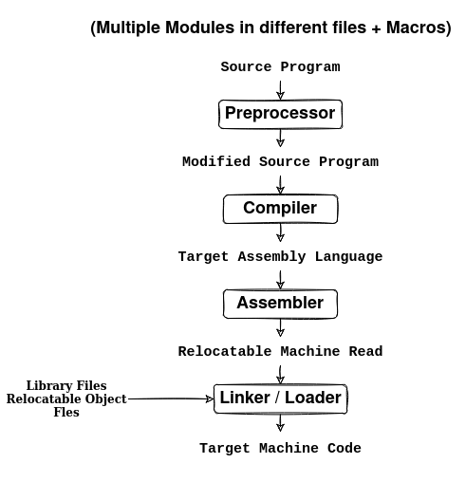
1.2 Structure of a Compiler
Inside compiler, there are two main processes:
      - Analysis (Front-end)
      - Synthesis (Back-end)

Analysis: It refers to the breaking down of the source program into constituent pieces which are compared against a grammatical structure.
- It checks if the program is ill formed or semantically unsound
- It then provides sufficient information to user for code correction.
- It stores data of the source program in system table. System table is passed to the synthesis part along with the immediate representation.

Synthesis: It uses the immediate representation of the source program to construct target program. It consists of different phases which may exist independently or in a group. All these phases make use of the system table.

Optimization Phase: Some compilers even introduce an optimization phase between front and back end. It performs transformations on the intermediate representation so that back end can produce better target problem.

