CS544 Final exam Review

The Final exam will consist of those questions. Total Score: ?

1. True/False question – 5-10 questions? – 5-10 points
2. Short Answer questions – 5 questions? – ? points
3. Programming question – 1 question – ? points
   1. Client: Validation, PRG, Controller, RESTTemplate(CRUD), JSP, Spring Form(Input, Select), JSTL(c:forEach, c:url)
   2. Server: RestController, Service, Repository(JpaRepository/CrudRepository), JPQL/SQL
   3. AOP: something like homework, but not the same
4. SCI – No

Location: V47A, V47B

Time: July 13, 10am ~ 12:30pm, 2.5 hours (Arrive 15 minutes earlier) Find your name tag to sit.

Cheat sheet: A4 – I page one side

# Don’t write down your StudentID&Name in the exam paper.

Exam Policy:

There is no tolerance policy for exams. You will be asked to leave the exam room immediately without a warning.

Once you do the following things which mean you’ll get NC.

1. You are caught cheating or trying to cheat.
2. Answers should be written with a Pen or Pencil, but if you use pencil please bring eraser and sharpener. You’re not allowed to borrow from other students or proctors during exam.
3. All mobile phones should be turned off and leave in the front desk before exam starts.
4. Restroom policy:
   1. No phones – show me your pockets
   2. Only 5 minutes
   3. Not allowed to go to restroom after someone submit paper
5. You’re not allowed to go out room for water.
6. You’re not allowed to ask/get extra papers from other students or proctors. All your notes must be written on the exam paper provided.
7. Please write down your answer clearly. If I cannot read your answer, you’ll not get credit.
8. If you’re not clear about the question, you MUST ask me during exam. You cannot claim the question isn’t clear while go through exam answers.

# Review Points:

Lesson 10 – AOP

* Understand AOP
* JDK dynamic proxy vs CGLib
* AOP Terminology: Advice, JoinPoint, Target, Pointcut, Aspect, Weaving
* 5 Types of Advice
* JoinPoint vs ProceedingJoinPoint
* PointCut Expression Language(execution)
* Sequence
* Code: Aspect

Lesson 11 – Spring MVC & Spring Data

Spring MVC:

* Front Controller
* @RequestMapping, @GetMapping, @PostMapping, @RequestParam, @PathVariable
* ViewResolver – what is used for?
* @ModelAttribute
* PRG(FlashAttribute)
* @SessionAttributes

Spring Data:

* What is Spring Data?
* Coding: JPARepository/CRUDRepository, JPQL/SQL
  + If you use methods are not built in, you have to implement by yourself.

Lesson 12

Spring Security

* For authentication/authorization(not method level): no coding in the exam, but you have to understand if I provide you a piece of code.
* Need to know how to code with Method Level Authrization

Spring Validation

* @NotEmpty, @Size, @Valid
* Coding question: PRG, BindingResult,
* spring form display errors(<form:errors path=””/>)

Lesson 13 Spring Boot & REST

Spring Boot

* What is spring boot?
* What are the features? Autoconfiguration, Opininated

Spring REST

Server Projects packages:

Controller – restcontroller 1. @RestController [2.@Controller](mailto:2.@Controller), @ResponseBody

Service – DI JpaRepository/CrudRepository

Repository – implements JpaRepository/CrudRepository

Client Project packages:

Controller – regular controller @Controller

Service – DI RestTemplate

WEB-INF/views – JSPs( Spring Form Tag, JSTL)

Server side Controller

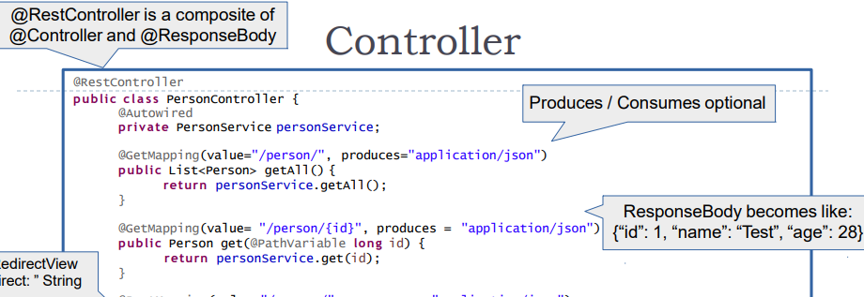

Client side Service

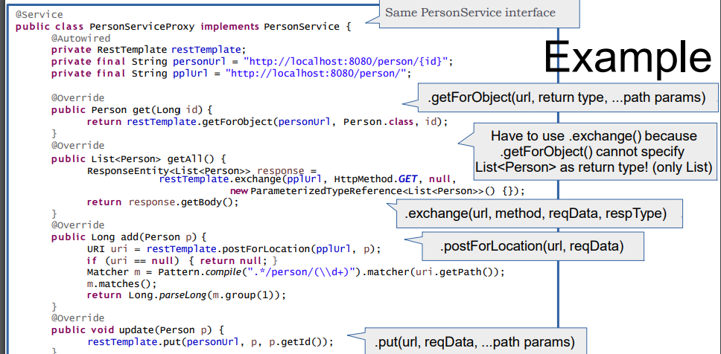

Lesson 14: Messaging

* What is Messaging?
* PTP / Publisher&Subscriber
* RabmitMQ: Exchange(Direct, Fanout, Topic), Queue