**“Click” on Session Button:**

SESSION GET

Attributes from @SessionAttributes:

No @SessionAttribute named Leonardo

No @SessionAttribute named Splinter

No @SessionAttribute named Donatello

Attributes from HttpSession:

Donatello : null

Splinter : null

Leonardo : null

**“Click” on “Submit Session Form” Button**

**DISPLAY**

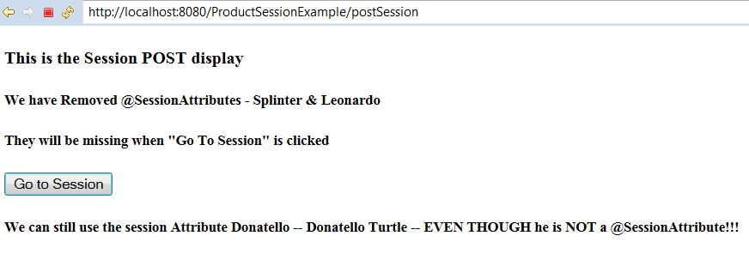

**Console**

**SHOWS ATTRIBUTES SET in Controller during GET**

SESSION POST

Attributes from @SessionAttributes: [declared in Session Controller]

Leonardo name : Leonardo Turtle

Splinter name : Splinter

Donatello name : null

Attributes from HttpSession: [set in Session Controller]

Donatello : Donatello Turtle

Splinter : Splinter

Leonardo : Leonardo Turtle

**“Click” on “go to Session” Button**

**SHOWS ATTRIBUTES CLEARED in Controller during POST**

SESSION GET

Attributes from @SessionAttributes:

No @SessionAttribute named Leonardo

No @SessionAttribute named Splinter

No @SessionAttribute named Donatello

Attributes from HttpSession:

Donatello : Donatello Turtle

Splinter : null

Leonardo : null

**NOTE: RUN THIS RIGHT AFTER SESSION**

**“Click” on “Delegate Session Controller” Button**

**DISPLAY**

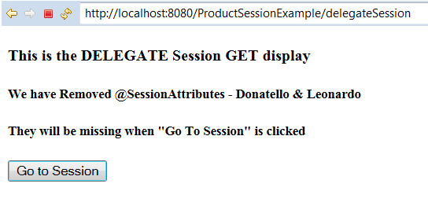

SHOWS ALL 3 as HTTPSession ATTRIBUTES shows ONLY Leonardo and Donatello as @SessionAttributes as declared in the Delegate Controler

**DELEGATE SESSION GET**

Attributes from @SessionAttributes [declared in DelegateSessionController] :

Leonardo name : Leonardo Turtle

Splinter name : null

Donatello name : Donatello Turtle

Attributes from HttpSession: [set in Session Controller]

Donatello : Donatello Turtle

Splinter : Splinter

Leonardo : Leonardo Turtle

**“Click” on “Submit Session Form” Button**

Shows Dontatello,Leonardo removed from Delegate controller

Splinter still in session because he was NOT a @SessionAttributes in Delegate

SESSION POST

Attributes from @SessionAttributes:

No @SessionAttribute named Leonardo

No @SessionAttribute named Splinter

No @SessionAttribute named Donatello

Attributes from HttpSession:

Donatello : null

Splinter : Splinter

Leonardo : null