

**Green University of Bangladesh**

**Department of Computer Science and Engineering (CSE)**

**Faculty of Sciences and Engineering**

**Semester: (Spring, Year: 2021), B.Sc. in CSE (Day/Eve)**

**Course Title: Database System Lab**

**Course Code: CSE210 Section: 201 - EC**

**Lab Project Name: Library Management System.**

**Student Details**

|  |  |  |
| --- | --- | --- |
| **Name** | | **ID** |
| **1.** | Mohammad Shah Alam | 201015075 |
| **2.** | Omar Faruk Shanto | 201015074 |
| **3.** | Badhan Saha | 201015060 |

**Submission Date : September 14, 2021**

**Course Teacher’s Name : Umme Habiba**

**[For Teachers use only: Don’t Write Anything inside this box]**

|  |
| --- |
| **Lab Project Status**  **Marks: ………………………………… Signature: .....................**  **Comments: .............................................. Date: ..............................** |

Table of Contents

Chapter 1 - Introduction 3

Introduction 3

Project Aims and Objectives 3

System Requirements 3

Chapter 2 - Structure of the project 4

Proposed System: 4

Module Description: 4

Chapter 3 - Design/Development/Implementation of the Project 5

Database Schema: 5

Table Design 6

Chapter 4 - Application of the Database 8

Conclusion 10

Introduction 10

Practical Implications 10

Scope of Future Work 10

References 11

# Chapter 1

# Introduction

## Introduction

The database is a collection of information and is systematically stored in tables in the form of rows and columns. The table in the database has unique name that identifies its contents. The database in turn is further described in detail giving all the fields used with the data types, constraints available, primary key and foreign key. Database design is used to manage large of information. In this database we describe the entire 4 table available in the software, which are used to store all the records.

## Project Aims and Objectives

The main objective of the Library Management system is discipline of the planning, organizing and managing the library tasks. Our project aims at making the task of library easy. Library Management is entering the records of new book and retrieving the details of book available in the library. We can issue book to the library member and maintain their records and can also checks how many book are issued and stock available in the library. In the project we can maintain the late fine of library member who return the issued book after the due date. In this project we can also maintain lost book information.

## System Requirements

* Processor: Intel core processor or better performance
* Operating System: Windows 7, Linux
* Memory: 1 GB RAM or more.
* Hard Disk: Minimum 3 GB for Database usage for future.
* Database: MySQL

# Chapter 2

# Structure of the project

## Proposed System:

In the proposed system, we assume that each member will be having an identity card which can be used for the library book issue, fine payment etc. whenever library member wish to take a book, the book issued by the library authority will be check both the book details as well as the student details and store it in library database. In case of retrieval of book much of human intervention can be eliminated.

## Module Description:

**User Module:**

       In this module student can check availability of the book...

       The following are the sub module in the user module.

**Book return:** Here student will return the books to the library.

**Administrator Module**:

 This is the main module in the proposed project. The administrator can read and write information about any member. The administrator can also update, create and delete the record of membership as per requirement and implementation plans.

The following are the sub module in the administrator module.

**Register student:** Allow the administrator to register new student and update the student records.

**Book details:** Allow administrator to entered book details.

**Book issue:** Here administrator issues the books to the student from library.

**Lost book issue:** Allow administrator to insert lost book information.

# Chapter 3

# Design/Development/Implementation of the Project

## Database Schema:

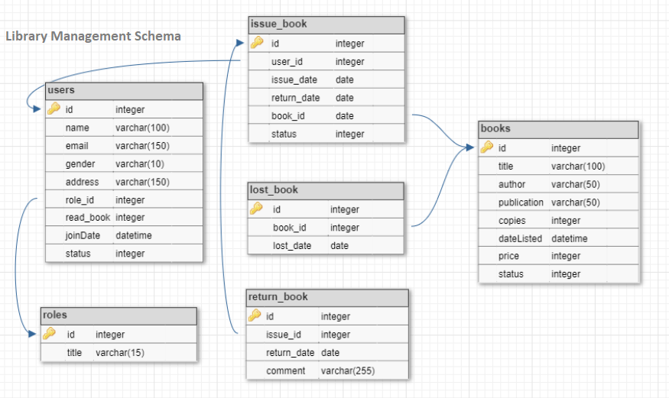

Figure 3.1: Schema

## 

## Table Design

**All tables form Database:**

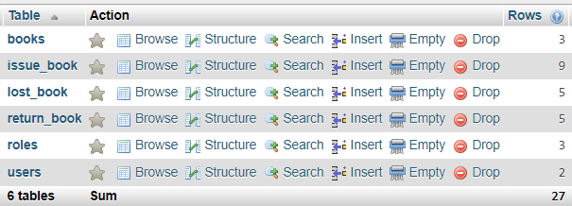

**Users Table Structure:**

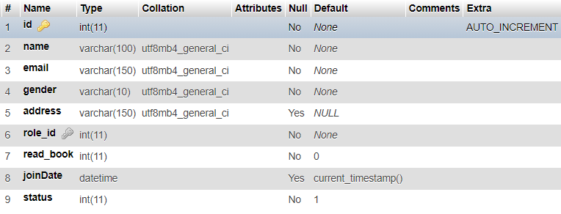

**Roles Table Structure:**

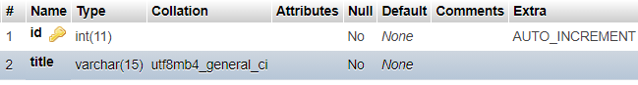

**Books Table Structure:**

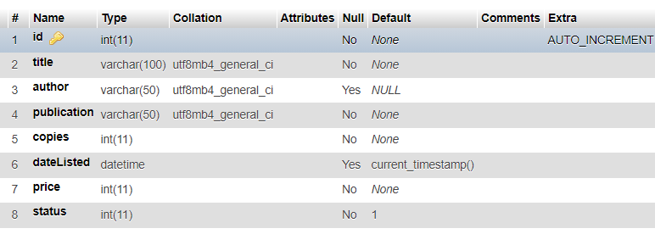

**Issue Book Table Structure:**

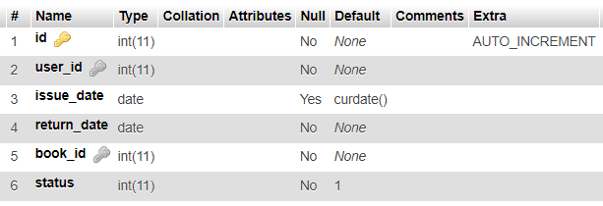

**Return Book Table Structure:**

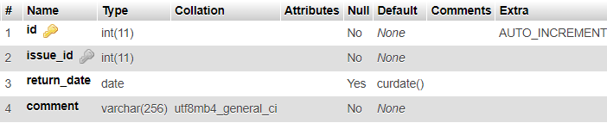

**Lost Book Table Structure:**

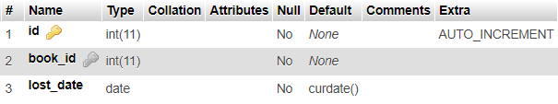

# 

# Chapter 4

# Application of the Database

**Application Scope:** Finding the book reader users.

**SQL query:**

select * from users where read_book != 0;

**Output:**

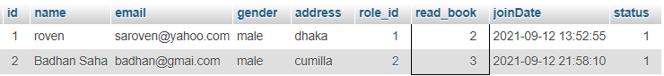

**Application scope**: Finding the total books in the library.

**SQL query:**

select sum(copies) total_books from books;

**Output:**



**Application Scope:** Find lost book id, title and lost date

**SQL query:**

select lost_book.book_id, books.title, lost_book.lost_date

from lost_book

join books on lost_book.book_id = books.id

**Output:**

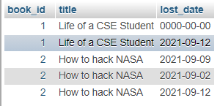

**Application Scope:** Finding the issue book id, book title and issue date

**SQL query:**

select issue_book.id issue_id, books.title, books.author, issue_book.issue_date

from issue_book

join books on issue_book.book_id = books.id

where issue_book.status = 1

**Output:**

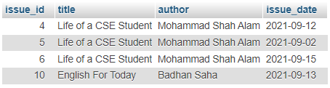

**Application Scope:** Finding the specific user reader book issue and return information

**SQL query:**

select users.name, books.title book_read, issue_book.issue_date, return_book.return_date

from users

join issue_book on users.id = issue_book.user_id

join books on issue_book.book_id = books.id

join return_book on issue_book.id = return_book.issue_id

where users.name = 'roven';

**Output:**

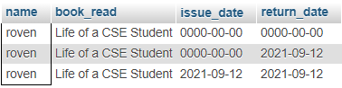

# 

# Conclusion

## Introduction

This database provides an online version of library management system database which will benefit the students as well as the staff of the library.

## Practical Implications

It makes entire process digital where student can issue books, staff can generate reports and do book transactions. It also has a facility for student login where student can login and can see status of books issued as well request for book or give some suggestions.

## Scope of Future Work

There is a future scope of this facility that many more features such as online lectures video tutorials can be added by teachers as well as online assignments submission facility, a feature Of group chat where students can discuss various issues of engineering can be added to this project thus making it more interactive more user friendly and project which fulfills each users need in the best way possible.

# 

# References

<https://www.w3schools.com/MySQL/default.asp>