Curriculum Vitae (CV) Md. Nahid Sarowar

Md. Nahid Sarowar  House#12/15, Road#1, Kollyanpur  Dhaka-1207, Bangladesh  Mobile: +8801737414499  E-mail: nahid782world@gmail.com  Social Contact :   | 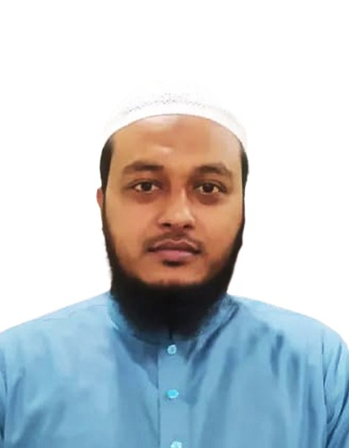
Objective/ Future Plan
To continue playing a leading role in maintaining engineering excellence in challenging technologies of Computer Engineering within a fast networking & programming organization/Company which offers good advancement potential, provides professional enhancement & maintains a sound corporate multinational culture. I want to build up my career with IT professionals and Software Development.

Skills
Hardware & Troubleshooting  IT Support  LAN Setup  CCNA  MS PowerPoint  MS Excel  Advance Excel  Power Pivot  Pivot Table  Power BI  Power Query  Router Config  Software  Language Skills:  Bengali | Software Development  HTML  HTML5  CSS  CSS3  Bootstrap  JavaScript  jQuery  AngularJS  WordPress  GitLab  Bootstrap3,4  Version Ctrl
English
Work Experience:
Employer Name : Nourish Poultry & Hatchery LTD.
Designation : Officer
Responsibilities : Software Development (Front-end), ERP Management, Data Processing.
Joining Date : 2nd March 2019
End Date : Till now.

Employer Name : Delta HealthCare Jatrabari LTD.
Designation : IT Officer
Responsibilities : IT Support, LAN Support, Hospital Software Management, CCTV Support, Attendance Module.
Joining Date : 2nd May 2013
End Date : 28th February 2019.

Employer Name : SOCIOCONSULT LTD.
Designation : Jr IT Officer
Responsibilities : IT Support, Data Processing
Joining Date : 10th February 2012
End Date : 15th April 2013.

Personal Information:
Name : Md. Nahid Sarowar
Father’s Name : Md. Abdul Jalil
Mother’s Name : Ms. Nasima Parvin
Date of Birth : 20th November 1990
Present Address : House#5/A, Road#2, Kolyanpur
Height : 5`6``
Marital Status : Married
Religion : Islam (Sunni)
Blood Group : AB (+)
Nationality : Bangladeshi
Permanent Address
Village : Sherkole
Post : Sherkole
Upozila : Singra
District : Natore
Division : Rajshahi
Bangladesh.

Academic Credentials
Secondary School Certificate (S.S.C)
Institute : Sherkole S.A High School
Board : Rajshahi
Passes year : 2006
Session : 2004-2005
Major : Science
Grade : GPA (A) 4.63
Diploma in engineering (4 year course)
Institute : Rajshahi Polytechnic Institute
Board : Bangladesh technical education board (BTEB)
Passes year : 2010
Session : 2006-2007
Major : Computer
Grade : GPA (B) 2.96 above (4.00)
Graduation
University : World University of Bangladesh
Subject : Computer Science & Engineering
Passes year : 2015
Session : 2011-2012
Grade : GPA 3.28 above (4.00)
References

Asst.Prof. Dr. Abdus Sattar Sarkar  MBBS, MCPS (Medicine), FCPS (Medicine)  Mob: 01711042196 | Prof. Dr. Md. Abdus Sadir  MBBS, DD(Thailand)  Dermatology Speacialist  Mitford Hospital, Dhaka  Mob: +8801711-820540 | Kazi Hasan Robin  Head of Department  Computer Science & Engineering  World University of Bangladesh.  Mob:+8801819-210452

Signature

________________
Md.Nahid Sarowar

