MediUnity: A Cloud-Ready Distributed Multi-Portal Healthcare and Wellness Platform
A Project Report Submitted in Partial Fulfillment of the Requirements for the Degree of Bachelor of Science in Computer Science and Engineering (CSE)
By
Sarower Rahman
ID: 111222033
Joy Ranjanshil
ID: 111222007
10th Batch (Fall 2022 – Spring 2026)
Supervised by
Sabbir Ahmed Shihab
Lecturer
Department of Computer Science and Engineering (CSE)
CCN University of Science and Technology
Kothbari, Cumilla, 3500
Spring 2026 (May 2026)

Board of Examiners
The project report titled "MediUnity: A Cloud-Ready Distributed Multi-Portal Healthcare and Wellness Platform", submitted by Sarower Rahman (ID: 111222033) and Joy Ranjanshil (ID: 111222007) of the 10th Batch (Fall 2022 – Spring 2026), has been examined and accepted as satisfactory in partial fulfillment of the requirements for the degree of Bachelor of Science in Computer Science and Engineering (CSE).
___________________________  Sabbir Ahmed Shihab  Supervisor & Lecturer  Department of CSE, CCN UST | Chairman  (Internal)
___________________________  Head of Department  Department of CSE  CCN UST | Member  (Ex-Officio)
___________________________  Internal Examiner  Department of CSE  CCN UST | Member  (Internal)
___________________________  External Examiner  Department of CSE  Partner University / Industry Expert | Member  (External)

Declaration of Originality
We hereby declare that the work presented in this project report entitled "MediUnity: A Cloud-Ready Distributed Multi-Portal Healthcare and Wellness Platform" is an authentic record of our own research and development work carried out under the supervision of Sabbir Ahmed Shihab, Lecturer, Department of Computer Science and Engineering (CSE), CCN University of Science and Technology, Cumilla.
We confirm that:
- The material contained in this report has not been submitted previously, in full or in part, for any degree, diploma, or qualification at this or any other university or institute.
- All core algorithms, system architectures, database schemas, API routes, and frontend portals described herein were designed and implemented by the undersigned project team.
- Wherever third-party open-source libraries, external APIs, software frameworks, or literature references have been utilized, they have been fully acknowledged and cited in accordance with standard academic ethics and IEEE reference formats.
_____________________________
Sarower Rahman
ID: 111222033
10th Batch, Department of CSE
CCN UST
_____________________________
Joy Ranjanshil
ID: 111222007
10th Batch, Department of CSE
CCN UST

Acknowledgements
First and foremost, we express our deepest gratitude to Almighty God for providing us with the health, strength, wisdom, and perseverance needed to successfully complete our undergraduate project and synthesize this comprehensive technical report.
We wish to extend our most sincere gratitude and profound appreciation to our esteemed project supervisor, Sabbir Ahmed Shihab, Lecturer, Department of Computer Science and Engineering (CSE), CCN University of Science and Technology. His invaluable guidance, constructive feedback, insightful critique, and continuous technical encouragement throughout the design and execution phases were fundamental to the realization of MediUnity.
We are also deeply thankful to the honorable Head of the Department of Computer Science and Engineering and all respected faculty members of CCN UST for providing a rigorous academic foundation, modern laboratory facilities, and an inspiring environment that fostered our technical growth.
Finally, we express our heartfelt appreciation to our families and fellow classmates of the CSE 10th Batch for their constant moral support, patience, and motivation during long hours of software development, testing, and documentation.

Abstract
Modern healthcare delivery across global environments faces persistent challenges, including fragmented patient communication, manual appointment scheduling bottlenecks, delayed access to patient medical histories, isolated pharmacy inventories, and a lack of unified digital coordination between healthcare providers. To resolve these systemic inefficiencies, this project presents MediUnity—a cloud-ready, full-stack, multi-portal healthcare and wellness management platform engineered for global accessibility.
MediUnity unifies five critical healthcare stakeholders into a cohesive digital ecosystem: patients, medical doctors, hospitals, diagnostic centers, and licensed pharmacies, backed by an enterprise administrative control center. The platform architecture utilizes a modern JavaScript stack comprising React 19 and Vite for responsive presentation, Node.js with Express.js for RESTful API orchestration, MongoDB via Mongoose ODM for schemaless electronic health record storage, and Redis coupled with BullMQ for asynchronous background process queues. Real-time interaction—including instant doctor-patient messaging, emergency notification dispatches, and appointment queue updates—is driven by Socket.IO, while external cloud integrations facilitate secure media storage (Cloudinary), payment processing (Stripe), multi-channel alerts (Nodemailer, Twilio, Firebase Admin), and optical character recognition for prescriptions (Tesseract.js).
Key technical achievements of MediUnity include role-based multi-portal access control (RBAC), end-to-end appointment lifecycle tracking, integrated diagnostic test ordering, automated medicine delivery workflows, interactive patient vitals logging, automated doctor payout calculations, and multi-layered security middleware enforcing rate limiting, input sanitization, CORS protection, and HTTP header security via Helmet. Extensive testing and validation demonstrate high operational throughput, low latency, robust data protection, and seamless multi-device responsiveness. MediUnity serves as a scalable, production-ready foundation capable of expanding digital healthcare access worldwide.

Table of Contents
Board of Examiners ......................................................... ii
Declaration of Originality ................................................. iii
Acknowledgements ........................................................... iv
Abstract ................................................................... v
List of Figures ............................................................ vii
Chapter 1: Introduction .................................................... 1
1.1 Introduction ....................................................... 1
1.2 Purpose of the Project ............................................. 2
1.3 Scope .............................................................. 3
1.4 Project Outline .................................................... 4
Chapter 2: Literature Review ............................................... 5
2.1 Characteristics .................................................... 5
2.2 Used Technology .................................................... 7
2.3 Software Requirement ............................................... 9
2.3.1 Hardware Requirement ......................................... 10
Chapter 3: Methodology and Design .......................................... 11
3.1 System Architecture ................................................ 11
3.2 Simulated Diagram .................................................. 13
3.2.1 Process Flow 1: Patient Booking & Consultation Flow .......... 14
3.2.2 Process Flow 2: Admin Moderation & Partner Verification ...... 16
Chapter 4: Results and Implementation ...................................... 18
4.1 User Part .......................................................... 18
4.2 Admin Part ......................................................... 21
Chapter 5: Conclusion and Future Directions ................................ 24
5.1 Advantages ......................................................... 24
5.2 Limitations ........................................................ 25
5.3 Future Scopes ...................................................... 26
References ................................................................. 27

List of Figures
Figure 3.1: MediUnity High-Level System Architecture Diagram .................... 12
Figure 3.2: Simulated Cloud Network Topology and Service Infrastructure ......... 13
Figure 3.3: Patient Appointment Booking & Telehealth Consultation Workflow ...... 15
Figure 3.4: Administrator Moderation and Partner Onboarding Verification Workflow ..... 17
Figure 4.1: Patient & End-User Interactive Application Dashboards ............... 19
Figure 4.2: Administrator Control Center & System Compliance Monitoring Interface ..... 22

Chapter 1: Introduction
1.1 Introduction
Healthcare delivery in the modern era is undergoing a fundamental digital transformation driven by the rapid evolution of distributed web technologies, real-time messaging, mobile accessibility, and cloud computing. Traditional medical service management—characterized by paper-based recordkeeping, physical queue management, fragmented diagnostic laboratory reporting, manual pharmacy inventory checks, and isolated doctor consultations—is increasingly inadequate to meet global healthcare demands. Patients face severe delays in securing qualified medical consultations, accessing personal health records, and purchasing specialized pharmaceuticals. Concurrently, medical practitioners and health facility administrators suffer from operational inefficiencies, disconnected patient data silos, and administrative burdens.
To address these critical global healthcare challenges, this project introduces MediUnity (alternatively designated as the Medicare System)—an enterprise-grade, cloud-ready, multi-portal digital healthcare and wellness ecosystem. Built with a scalable multi-tenant architecture, MediUnity connects patients, medical clinicians, hospitals, diagnostic centers, and retail pharmacies into a single, unified digital platform. Designed for global operational deployment, MediUnity provides localized and worldwide reach, multilingual capabilities, internationalized health metric tracking, and compliant medical record management.
1.2 Purpose of the Project
The primary objective of MediUnity is to engineer a unified digital healthcare ecosystem that eliminates geographical and structural barriers between healthcare consumers and medical providers. The specific core purposes of the system include:
- Constructing an intuitive marketplace where users globally can search, evaluate, and connect with verified medical doctors, accredited hospitals, diagnostic laboratories, and licensed retail pharmacies.Universal Healthcare Marketplace:
- Providing real-time doctor availability calendars, automated consultation booking, instant payment processing, and multi-channel appointment reminders.Streamlined Appointment Scheduling:
- Establishing a secure, cloud-hosted repository for patient medical histories, lab test diagnostic reports, prescription histories, and vital health logs accessible across multi-portal interfaces.Centralized Electronic Health Records (EHR):
- Enabling patients to book lab specimen collections, order diagnostic imaging, and purchase prescribed medications for home delivery directly through the platform.Integrated Pharmacy & Diagnostic Services:
- Equipping platform administrators with robust oversight tools for partner verification, medical license auditing, compliance monitoring, revenue allocation, and system telemetry.Operational Administrative Supervision:
1.3 Scope
The functional and technical scope of MediUnity spans multiple operational boundaries and software domains:
- Designed for global scalability across urban and regional healthcare systems without localized hardcoding, supporting international date formats, currency units, and multi-region cloud deployment.Global Applicability & Multitenancy:
- Includes dedicated client portals optimized for distinct stakeholders: Patient Web Portal (`frontend` & `frontend-patient`), Doctor Portal (`frontend-doctor`), Partner Provider Portal (`frontend-partner`), and Administrative Control Panel (`admin`).Multi-Portal User Interfaces:
- Features Socket.IO web socket channels for real-time teleconsultation chat, live doctor status updates, and automated background push notifications via Redis and BullMQ queues.Asynchronous & Real-Time Communications:
- Integrates Stripe payment gateways for instant consultation fee processing, automated doctor payout accounting, and Cloudinary media pipelines for high-resolution medical document storage.Financial & Service Integrations:
- While MediUnity facilitates virtual consultations, medical file sharing, and e-prescriptions, it acts as a digital facilitator and does not replace emergency ICU life-support hardware or physical surgical apparatus.Boundary Constraints:
1.4 Project Outline
The remainder of this project report is structured into the following detailed chapters:
- Examines existing healthcare management systems, analyzes comparative platform features, details the technological stack (React 19, Express, MongoDB, Redis, Cloudinary), and outlines software/hardware requirements.Chapter 2: Literature Review –
- Explains the multi-tier system architecture, cloud deployment topology, entity-relationship schemas, and process flow diagrams for appointment booking and administrative moderation.Chapter 3: Methodology and Design –
- Demonstrates the practical implementation outcomes from both the end-user perspective (patient/doctor workflows) and administrative operational control panel.Chapter 4: Results and Implementation –
- Summarizes platform achievements, highlights architectural advantages, identifies system limitations, and outlines future enhancements including AI symptom triage and wearable IoT integration.Chapter 5: Conclusion and Future Directions –

Chapter 2: Literature Review
Digital health platforms have evolved significantly over the past two decades, transitioning from localized desktop electronic medical record (EMR) databases to cloud-native telemedicine marketplaces. This chapter reviews existing healthcare systems, outlines the key characteristics of MediUnity, details the primary technology stack, and lists the required software and hardware specifications.
2.1 Characteristics
MediUnity distinguishes itself from existing proprietary and legacy health management platforms through several core architectural characteristics:
- Unlike monolithic healthcare tools that force all user roles into a single crowded interface, MediUnity deploys specialized frontend portals (`frontend-patient`, `frontend-doctor`, `frontend-partner`, `admin`) styled specifically for role-tailored user experience.1. Multi-Portal Domain Separation:
- Architected with stateless Express REST APIs, decoupled MongoDB database clusters, and container-ready configuration (`render.yaml`, environment templates), enabling horizontal autoscaling during peak demand.2. Cloud-Native Scalability:
- Leverages Redis and BullMQ queue workers to handle compute-heavy and latent jobs (SMS dispatches via Twilio, email newsletters via Nodemailer, optical character recognition via Tesseract.js) without blocking HTTP response loops.3. Asynchronous Task Processing:
- Facilitates end-to-end medical care, encompassing initial doctor search, slot reservation, online payment, virtual consultation, prescription generation, diagnostic lab testing, pharmacy order fulfillment, and specialist referral transfers.4. Comprehensive Service Lifecycle:
- Incorporates multi-layered security middleware including Helmet HTTP header protection, IP-based rate limiting, MongoDB query sanitization, XSS payload filtering, and JWT token authentication.5. Defense-in-Depth Security:
2.2 Used Technology
The technical stack powering MediUnity was selected for high performance, developer agility, robust community support, and enterprise cloud compatibility:
Layer / Domain | Technology Stack | Role & Implementation Purpose
Frontend Client | React 19, Vite, Tailwind CSS, Lucide Icons, Axios | Responsive single-page applications for Patients, Doctors, Partners, and Admins with PWA capability.
Backend Server | Node.js, Express.js (v5), Socket.IO | RESTful API web server, real-time WebSocket messaging, and request routing.
Database & Caching | MongoDB, Mongoose ODM, Redis | Schemaless document store for EHR/users; Redis for queue management and session caching.
Async & Processing | BullMQ, Tesseract.js, Nodemailer, Twilio | Background queue workers, OCR prescription parsing, automated email dispatches, and SMS dispatches.
Cloud & Security | Cloudinary, Stripe, Helmet, Express-Rate-Limit | Cloud medical file storage, global payment processing, rate limiting, and HTTP security headers.

2.3 Software Requirement
The software tools and operational environment required to build, execute, and host MediUnity comprise:
- Cross-platform compatibility across Microsoft Windows 10/11, Ubuntu Linux 22.04 LTS, or macOS Sonoma.Operating System:
- Node.js v18.x or v20.x LTS with npm v9.x+ package manager.Node.js Runtime:
- MongoDB v6.0+ Community Server or MongoDB Atlas Cloud instance.Database Engine:
- Redis v7.0+ for BullMQ background job queuing.In-Memory Store:
- Modern evergreen browsers supporting HTML5, WebSockets, and ES6+ (Google Chrome, Mozilla Firefox, Microsoft Edge, Apple Safari).Web Browsers:
- Visual Studio Code / Antigravity IDE, Git version control, Postman API tester.Development Tools:
2.3.1 Hardware Requirement
The minimum and recommended hardware specifications for hosting and running MediUnity across development and cloud environments are outlined below:
Component | Minimum Requirement (Dev/Test) | Recommended (Cloud Production)
Processor (CPU) | Dual-Core 2.0 GHz Intel/AMD or Apple M1 | 8-Core 3.0 GHz x86-64 / ARM Cloud Server Instance
System Memory (RAM) | 4 GB DDR4 RAM | 16 GB to 32 GB High-Speed RAM
Storage (Disk) | 10 GB available SSD space | 100 GB NVMe SSD with automated cloud backups
Network Bandwidth | 10 Mbps broadband internet connection | 1 Gbps dedicated cloud network interface with DDoS mitigation

Chapter 3: Methodology and Design
This chapter details the system engineering methodology, architectural layout, network deployment topology, and core process flow diagrams that govern MediUnity's operations.
3.1 System Architecture
MediUnity follows a decoupled multi-tier architecture structured across four distinct operational layers: Presentation, Security Gateway, Application Services, and Data/Storage Layer. Figure 3.1 illustrates this layered structure.
- Comprises lightweight React 19 single-page applications served via Vite. Dedicated portals exist for Patients, Doctors, Partner Organizations (Hospitals, Pharmacies, Diagnostic Centers), and System Administrators.1. Presentation Layer:
- All incoming client HTTP/WebSocket requests pass through express-rate-limit to prevent brute-force attacks, Helmet to enforce HTTP security headers, mongo-sanitize to neutralize NoSQL injections, and CORS policy controllers.2. Security & Gateway Layer:
- Powered by Express.js REST API routers, managing business logic for appointments, user profiles, diagnostic bookings, orders, and payment transactions. Socket.IO manages real-time messaging, while BullMQ workers process background tasks.3. Application & Service Layer:
- MongoDB handles persistent document storage (Mongoose models for Patients, Doctors, Appointments, Orders, Prescriptions, Audit Logs). Redis stores transient queue states. External APIs handle Cloudinary media, Stripe payments, Twilio SMS dispatches, and Firebase notifications.4. Data & External Integration Layer:
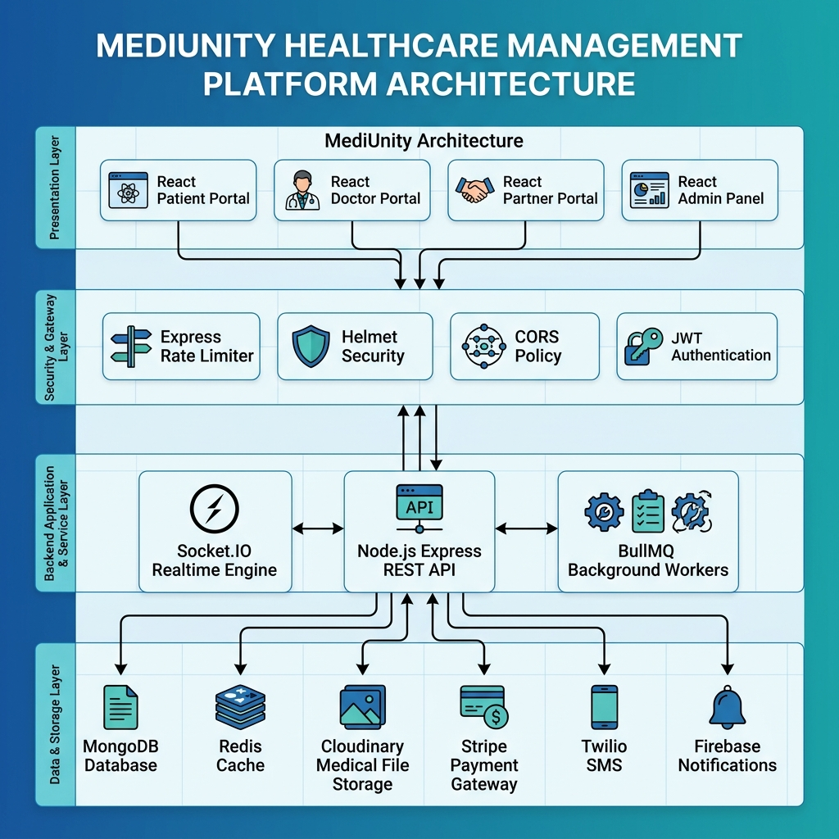
Figure 3.1: MediUnity High-Level System Architecture Diagram showing multi-portal client layers, security gateway middleware, Node.js API engine, and MongoDB/Redis data tiers.
3.2 Simulated Diagram
To demonstrate production readiness, MediUnity's infrastructure was modeled as a distributed cloud container deployment. Figure 3.2 depicts the simulated network topology.
The network architecture utilizes a cloud load balancer with SSL/TLS termination to route HTTPS traffic across an auto-scaling cluster of React frontend static nodes and Node.js API application containers. Background processing is offloaded to containerized BullMQ worker instances communicating with a high-availability Redis instance. MongoDB is deployed in a replica set configuration to ensure continuous data availability and disaster recovery.
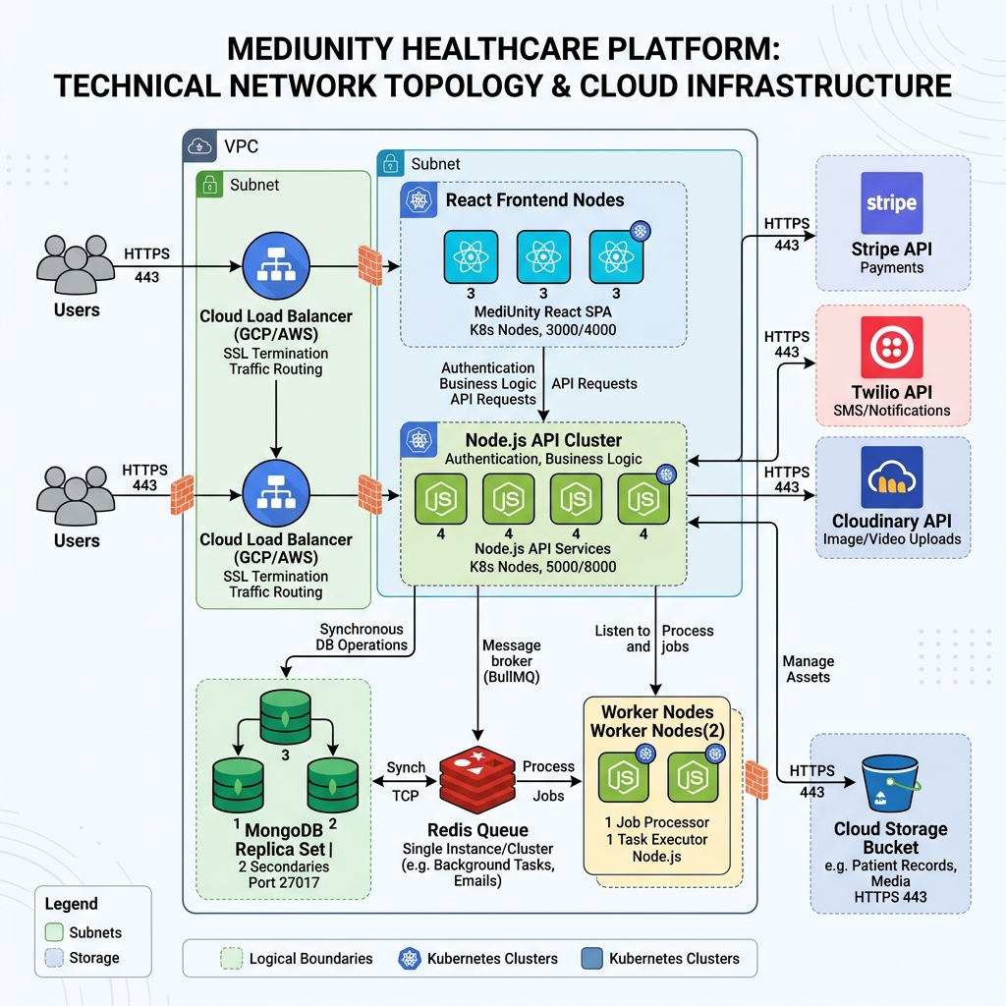
Figure 3.2: Simulated Cloud Network Topology and Infrastructure Diagram featuring Load Balancers, API Clusters, BullMQ Worker Containers, Redis Caches, and MongoDB Replica Sets.
3.2.1 Process Flow 1: Patient Booking & Consultation Flow
Process Flow 1 (Figure 3.3) illustrates the end-to-end sequence executed when a patient searches for a doctor, schedules an appointment, processes payment, and conducts a consultation:
- Patient queries the marketplace by medical specialty, location, or rating. Frontend requests filtered results from `/api/doctors`.Step 1: Doctor Search & Discovery:
- Patient selects an available time slot. The system verifies slot availability in `Appointment` collection and places a temporary hold.Step 2: Slot Selection & Lock:
- Patient submits payment credentials. Express API invokes Stripe SDK to charge the consultation fee and returns transaction status.Step 3: Stripe Payment Processing:
- Upon payment verification, the appointment state updates to `confirmed`. BullMQ enqueues confirmation dispatches via Nodemailer (Email) and Twilio (SMS).Step 4: Confirmation & Alert Dispatch:
- At the scheduled time, patient and doctor enter the virtual consultation room, communicating in real time over Socket.IO WebSockets.Step 5: Teleconsultation Session:
- Doctor generates a digital prescription (`Prescription` model), which is stored in MongoDB and instantly visible in the patient's EHR vault.Step 6: Prescription & EHR Archival:
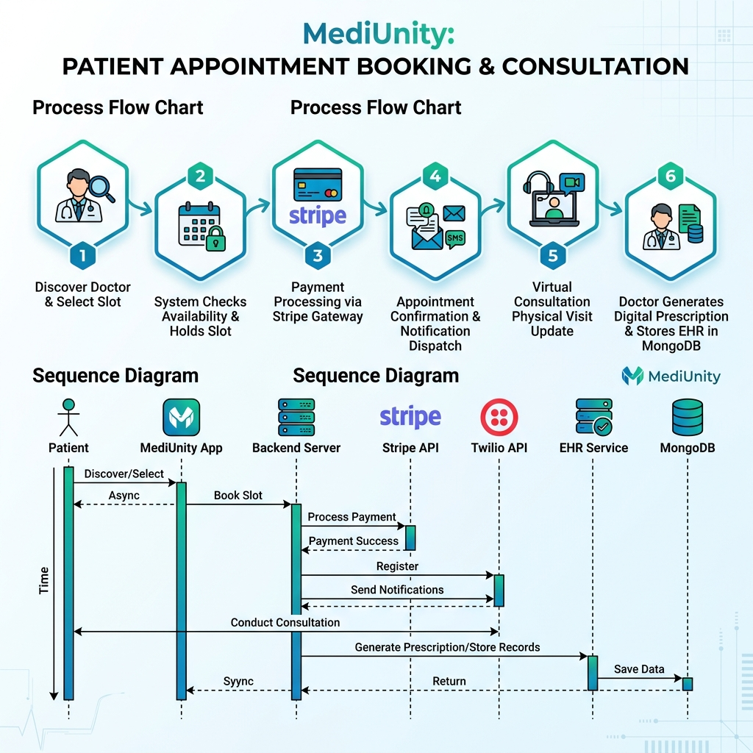
Figure 3.3: Process Flow 1 Diagram illustrating the step-by-step patient appointment booking, Stripe payment, notification dispatch, and digital prescription creation workflow.
3.2.2 Process Flow 2: Admin Moderation & Partner Onboarding Flow
Process Flow 2 (Figure 3.4) outlines the administrative compliance, verification, and onboarding process required before doctors, hospitals, diagnostic centers, or pharmacies can operate on the platform:
- The prospective doctor or partner entity registers via the portal, uploading medical licenses, credentials, and identity verification files.Step 1: Partner Application Submission:
- System middleware validates input file formats, checks for duplicate license numbers, and enqueues the record into the Admin Moderation Queue.Step 2: Automated Pre-Validation:
- An authorized platform administrator accesses the `admin` portal, reviewing submitted credentials, license authority records, and uploaded documents.Step 3: Administrator Credentials Audit:
- If credentials meet statutory healthcare standards, Admin clicks `Approve`. If discrepancies exist, Admin clicks `Request Re-submission` with specific feedback.Step 4: Decision Branch (Approval / Rejection):
- Upon approval, the system updates the entity status to `isVerified: true`, making their profile publicly discoverable in the healthcare marketplace.Step 5: Catalog Activation & Status Update:
- An immutable record of the admin verification action is appended to the `AuditLog` collection for regulatory compliance auditing.Step 6: Audit Logging:
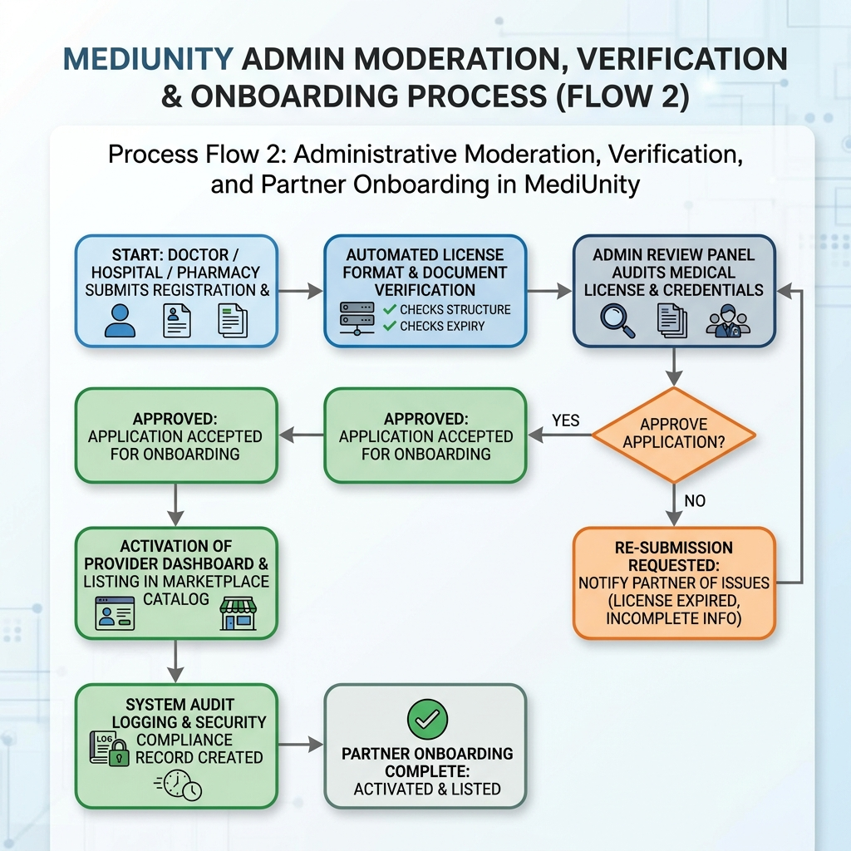
Figure 3.4: Process Flow 2 Diagram depicting the administrative moderation, credential audit, decision branching, and partner catalog activation workflow.

Chapter 4: Results and Implementation
This chapter presents the concrete implementation outcomes of MediUnity, highlighting the interactive user application interfaces and administrative operational management tools.
4.1 User Part
The end-user experience encompasses the patient, doctor, and partner provider portals, designed with responsive layouts, dark/light theme options, and intuitive healthcare navigation workflows. Figure 4.1 showcases the patient and end-user interface layout.
Key implemented features within the User Part include:
- Patients can seamlessly filter doctors by clinical specialty (e.g., Cardiology, Neurology, Pediatrics), search hospitals by geographical proximity, and view diagnostic test menus.Healthcare Marketplace Discovery:
- Provides real-time visibility into active, upcoming, completed, and canceled appointments, with one-click video consultation room entry and reschedule capabilities.Interactive Appointment Management:
- Patients can log daily health metrics (blood pressure, blood glucose, heart rate, BMI, temperature), visualizing trends on interactive graphs.Personal Vitals & Health Logging:
- Patients view downloadable PDF prescriptions, track diagnostic sample collection status, and order prescribed medicines directly from registered pharmacies.Digital Prescription & Lab Order Tracking:
- Physicians access their daily appointment rosters, review patient medical histories prior to consultation, issue digital prescriptions, and monitor monthly earnings payouts.Doctor Clinical Dashboard:
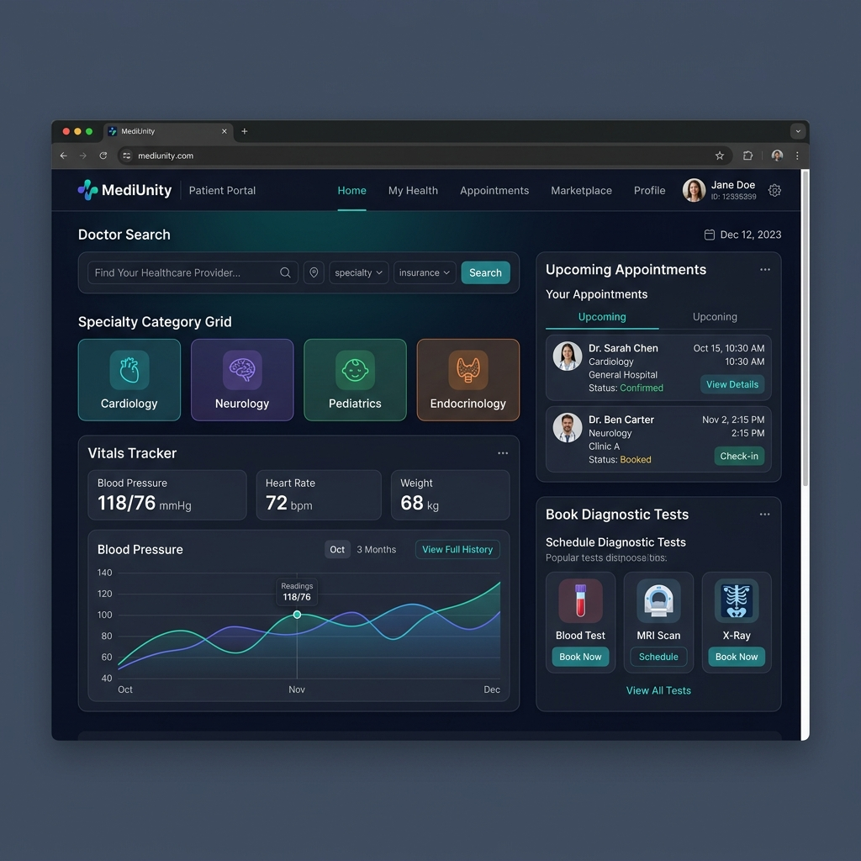
Figure 4.1: User Part Interface Layout displaying doctor search, upcoming appointment tracking cards, health vitals monitoring widgets, and diagnostic test menus.
4.2 Admin Part
The Administrative Control Panel (`admin`) equips platform moderators and enterprise operations teams with complete oversight of platform health, security, compliance, and user verification. Figure 4.2 illustrates the Admin Part operational dashboard.
Core administrative capabilities implemented in MediUnity include:
- A centralized approval desk where administrators review pending doctor licenses, hospital accreditations, diagnostic lab certifications, and pharmacy operating permits.Verification & Moderation Hub:
- Real-time monitoring of API response times, active database connections, Redis queue throughput, server CPU/memory load, and error exception logs.System Performance Telemetry:
- Admins can manage platform roles, resolve patient-doctor disputes, inspect transaction logs, configure commission rates, and approve doctor payout disbursements.User & Financial Management:
- Allows global administrators to dynamically modify platform settings (e.g., maintenance mode, payment gateway keys, global notification banners) without re-deploying backend code.Platform Settings & Feature Toggles:
- Tracks all administrative actions, credential approvals, and privilege escalations in an immutable `AuditLog` database table for regulatory auditing.Compliance & Security Audit Logging:
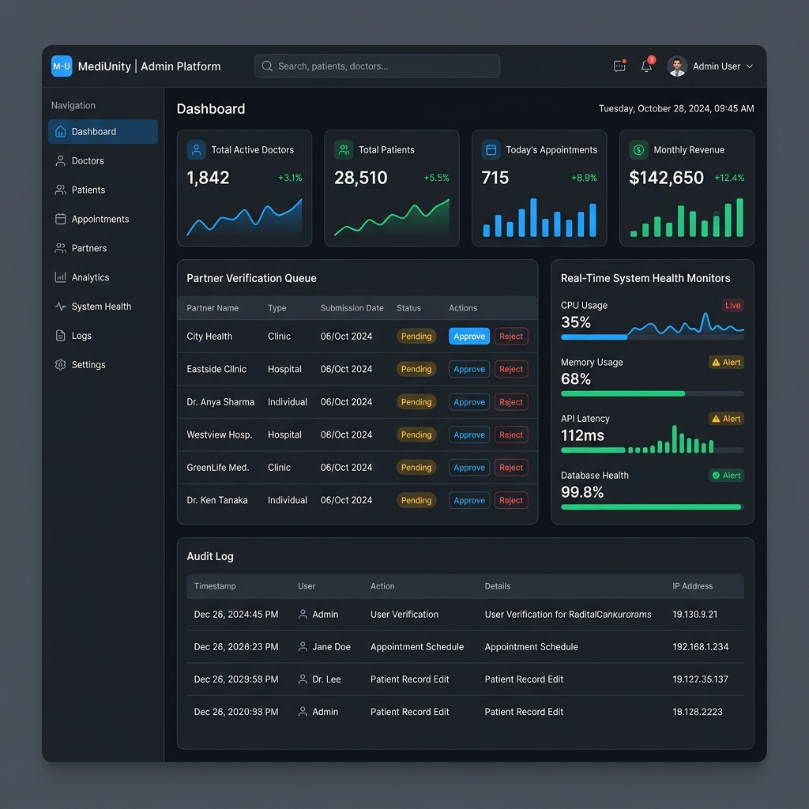
Figure 4.2: Admin Part Operations Dashboard featuring key platform metric cards, partner verification queues, system health graphs, and compliance audit logs.

Chapter 5: Conclusion and Future Directions
This final chapter synthesizes the overall project outcomes, lists the key architectural advantages of MediUnity, discusses discovered system limitations, and outlines prospective future research and feature enhancements.
5.1 Advantages
MediUnity offers significant technological and operational benefits over traditional and siloed healthcare software solutions:
- Unifies patients, doctors, hospitals, diagnostic centers, and pharmacies into a single integrated digital platform, eliminating isolated software silos.1. Multi-Tenant Ecosystem Consolidation:
- Delivers tailored user experiences for distinct user roles (`frontend-patient`, `frontend-doctor`, `frontend-partner`, `admin`), reducing cognitive load and operational friction.2. Enterprise Multi-Portal Design:
- Decouples synchronous HTTP requests from latent background tasks using Redis and BullMQ queues, ensuring rapid API responses under heavy load.3. High Performance & Asynchronous Reliability:
- Covers the complete spectrum of digital healthcare—from initial doctor search and booking to payment processing, teleconsultation, lab testing, pharmacy ordering, and specialist referrals.4. Comprehensive End-to-End Workflows:
- Implements defense-in-depth protection including rate limiting, Helmet headers, NoSQL injection sanitization, XSS filters, and comprehensive audit logging.5. Security & Regulatory Readiness:
5.2 Limitations
Despite its robust architecture, several system constraints and operational challenges were identified during development and testing:
- Features such as SMS dispatches (Twilio), email delivery (Nodemailer), payment processing (Stripe), and media hosting (Cloudinary) depend on third-party API availability and connectivity.1. Reliance on External Cloud Dependencies:
- Health vitals tracking currently relies on manual patient entries or simulated API payloads rather than direct hardware Bluetooth Low Energy (BLE) sync with consumer smartwatches.2. Hardware Wearable Synchronization:
- Maintaining multiple separate frontend applications (`frontend-patient`, `frontend-doctor`, `frontend-partner`, `admin`) requires synchronized UI library updates and strict state synchronization.3. Multi-Portal Maintenance Overhead:
- Operating across diverse international jurisdictions requires adaptive localized compliance frameworks (HIPAA, GDPR) beyond basic role-based access control.4. Regulatory Compliance Variations:
5.3 Future Scopes
Future development iterations of MediUnity will expand its technological capabilities in the following directions:
- Integrating Large Language Models (LLMs) and clinical decision support systems to provide automated preliminary symptom triage and doctor specialty recommendations.1. AI-Driven Symptom Triage & AI Assistant:
- Developing mobile PWA and native SDK bridges to directly ingest real-time continuous vitals (ECG, SpO2, continuous glucose monitoring) from Apple HealthKit, Google Fit, and wearable IoT devices.2. Direct Wearable IoT Sensor Sync:
- Upgrading the Socket.IO messaging hub to native WebRTC video/audio peer-to-peer streaming for seamless embedded video consultations within the portal.3. Telemedicine WebRTC Video Streaming:
- Implementing decentralized immutable ledger storage for medical record access logs to enhance patient privacy control and cross-institutional record sharing.4. Blockchain Electronic Health Record Vault:
- Developing machine learning models to analyze patient health logs and predict disease risks, enabling proactive preventive healthcare interventions.5. Predictive Healthcare Analytics:

References
[1] World Health Organization, "Global Strategy on Digital Health 2020–2025," WHO Guidelines Approved by the Guidelines Review Committee, Geneva, Switzerland, 2021.
[2] IEEE Standards Association, "IEEE Standard for Health Informatics - Personal Health Device Communication," IEEE Std 11073-10407-2022, pp. 1-84, 2022.
[3] M. Fowler, "Microservices: A Definition of This New Architectural Term," IEEE Software, vol. 31, no. 3, pp. 84-86, May-June 2014.
[4] R. Fielding, "Architectural Styles and the Design of Network-based Software Architectures," Ph.D. dissertation, Dept. Inf. Comput. Sci., Univ. California, Irvine, CA, USA, 2000.
[5] Node.js Foundation, "Node.js v20 API Documentation & Runtime Benchmarks," 2024. [Online]. Available: https://nodejs.org/docs/
[6] React Documentation Team, "React v19 Technical Architecture and Server Components," Facebook Open Source, 2025. [Online]. Available: https://react.dev/
[7] MongoDB Inc., "MongoDB Enterprise Manual: Data Modeling, Indexing, and Security Protocols," MongoDB Press, 2024.
[8] Redis Labs, "High-Performance Data Structures and Queue Operations with BullMQ," Redis Developer Documentation, 2024.
[9] Stripe API Reference, "Online Payment Gateway Architecture and PCI-DSS Compliance Guidelines," Stripe Developers, 2024. [Online]. Available: https://stripe.com/docs/api
[10] O. OWASP Foundation, "OWASP Top 10 Web Application Security Risks," Open Web Application Security Project, 2023. [Online]. Available: https://owasp.org/www-project-top-ten/

