
ROBOTICS CLUB
INSTITUTE OF ENGINEERING
PASHCHIMANCHAL CAMPUS
LAMACHAUR, POKHARA

A Project Report
On
“AN AUTONOMOUS BOAT”

Submitted by:
Sarpharaj Dewan
Dixit Pangenee
Nishi Yadav
Atit Chhetri

Submitted to:
Robotics Club- Institute of Engineering
Pashchimanchal Campus, Lamachaur-16, Pokhara

Copyright ©
This document, including all designs, concepts, and descriptions related to this autonomous boat “Hydra” for the competition Defying the Waves by the Robotics Club - Institute of Engineering, Paschimanchal Campus, is the intellectual property of Team Hydra.
No part of this work may be reproduced, distributed, or transmitted in any form or by any means, including photocopying, recording, or other electronic or mechanical methods, without the prior written permission of the owner, except for brief quotations for review purposes or academic use.
For inquiries or permissions, contact: sarphaaraj09@gmail.com

CONTENTS
CONTENTS........................................................................................... I
ACKNOWLEDGEMENTS................................................................. II
ABSTRACT......................................................................................... III
LIST OF FIGURES………………………………………..………... IV
1. INTRODUCTION……………………………………..…………... 1
1.1 Background…………………………………………….……….… 1
1.2 Objectives………………………………………………...…….…. 2
1.3 Scopes…………………………………………………………....... 2
  - Limitations……………………...………………………....…..….. 2
2. LITERATURE REVIEW……………...………………………...... 3
3. RELATED THEORY…………………………………….………... 5
  - Arduino Nano………..………………………………..…………... 5
3.2 Geared Motor…………………………………………...……...…. 5
3.3 L2938N Motor Driver………...………………………...………… 6
3.4 Ultrasonic Sensor…….………………………………….…..……. 7
3.5 Propulsion System…………………………..………………..…… 7
4. METHODOLOGY…………………………………………...…….. 9
4.1 Materials used……………………………………………………... 9
4.2 Design: Catamaran Boat and its benefits……………………….. 10
4.3 System Block Diagram……………………………………...……. 10
4.4 Activity Diagram (Flowchart)……………………………..…….. 11
4.5 Interfacing Between Obstacles and Hardware…………………. 12
4.6 Coding…………………………………………………………….. 13
5. OUTPUT AND ANALYSIS……………………………………….. 25
6. CONCLUSION AND FUTURE ENHANCEMENT………...…... 26

I

ACKNOWLEDGEMENTS
We would like to express our profound gratitude and deep regards to our mentor Mr. Bijay Acharya, for his exemplary guidance, monitoring, and constant encouragement throughout the course of this project. The guidance given by him from time to time shall carry us a long way in the journey of life on which we are about to embark.
We also take this opportunity to express a deep sense of gratitude to the Robotics Club-IOE, Paschimanchal Campus for providing such courses and a great atmosphere that helped us to get familiar with real problems and their solutions. Lastly, we thank the almighty, parents, our friends and all helping hands for their constant encouragement without which this project would not be possible.

II

ABSTRACT

This is a project of a double-hulled autonomous boat specifically designed for racing, capable of following a predefined path and avoiding obstacles using ultrasonic sensors. The boat's streamlined double-hull design ensures superior stability and hydrodynamic efficiency, allowing it to maintain high speeds during competitive scenarios.
An Arduino-based control system is used, and it processes real-time data from ultrasonic sensors, enabling precise navigation and obstacle avoidance. The system employs efficient algorithms to track the path while responding dynamically to environmental obstacles.
Powered by a lightweight propulsion system, the boat achieves optimal performance, balancing speed and maneuverability. This design highlights the potential of cost-effective, sensor-driven autonomous solutions for racing applications, offering a blend of speed, adaptability, and simplicity.

III

LIST OF FIGURES
Figure 1: Arduino Nano............................................................................ 5
Figure 2: Gear Motor…………………………………………...………. 6
Figure 3: L2938N Motor Driver……………………………………...… 6
Figure 4: Ultrasonic Sensor and its working mechanism………...…….. 7
Figure 5: Propeller………………………………………………...……. 8
Figure 6: System Block Diagram…………..……………………..…… 10
Figure 7: Flowchart………………….………………………………… 11
Figure 8 Interfacing/ Circuit………………...……………………...…. 12
Figure 9: Final Prototype of the Hydra and the Hydra in motion.......… 25

IV

- INTRODUCTION

1.1 Background
As developments in autonomous systems become commonplace, new opportunities arrive within the maritime domain, covering live surveillance, research activities, freight transportation, and competitive racing. Autonomous boats would perform the function using a combination of sensors and control systems, where they move without human intervention through ever-changing environments. Such systems are designed to further the safety, efficiency, and capability of operation, making them increasingly valuable for real-world applications.

Obstacle avoidance is a salient component of autonomous navigation. Ultrasonic modules, when attached to the boat for autonomous navigation, help detect obstacles and avoid them in real time, making movement safer during unpredictable circumstances. Ultrasonic modules are now most popular in autonomous systems due to the simplicity and inexpensiveness of such modules and the reliability of detecting any object within short and medium ranges. Together with microcontroller systems such as Arduino, these sensors make navigation highly cost-effective with challenging problems.

The double-hull, or catamaran style, proved to be a popular high-performance boat design. It is superior in stability with least resistance, great in acceleration, thereby making it suitable for highly accurate and agile applications, like racing. Combined with efficient means of propulsion, such as a two-fan configuration, this design balances power and speed in competitive modes.

This project takes advantage of these principles to create a racing boat that can autonomously traverse through challenging environments. Integration of ultrasonic sensors, an Arduino control box, and a motor driver allows for obstacle avoidance in real time and reliable boat performance, thereby allowing the operation of racing at high speed with altered variables.

1

1.2 Objectives
- Design and Construction:
To design a double-hulled, autonomous, catamaran-styled boat with stability and efficiency.
- Obstacle Avoidance:
Apply ultrasonic sensors for detecting and skirting obstacles in real-time.
- Control System:
Arduino will be applied for reading the sensors, thereby deciding on dynamic propulsion.
- Propulsion System:
Apply the two-fan system for highest speed and precision maneuvers.
- Motor Control:
Application of the motor driver to efficiently actuate speed and direction control.
- Testing and Optimization:
Racing tests of the boat and performance optimization.

1.3 Scope
The key aspects of this project focus on the design and building of a double-hulled autonomous boat for racing, as described below.
- Design and Structure:
Design a light, stable, double-hull for maximum performance.
- Obstacle Avoidance:
Autonomously detect and avoid obstacles in real time using ultrasonic sensors.
- Control System:
An Arduino microcontroller is used for sensor data processing and decision-making.
- Propulsion Mechanism:
A two-fan propulsion system driven by a motor driver for speed and control.
- Testing:
Test the boat under dynamic conditions for obstacle avoidance while optimizing stability.

  - Limitations:
- Navigation is restricted to obstacle avoidance without GPS.
- Performance is highly dependent on the range and accuracy of the ultrasonic sensors.

2

- LITERATURE REVIEW

The concept of autonomous boats, otherwise known as unmanned surface vehicles, has its origin in early attempts to automate navigation and control in a maritime environment. The history of such developments can be traced to the mid-20th century when advances in radar and sonar laid the base for automated systems. Early prototypes of remotely controlled vessels were mainly used in military operations, such as the detection of mines and espionage activities. However, with the developments of sensor technology, microcontrollers, and computing power, areas where autonomous boats were envisioned expanded to include environmental monitoring, research, and competitive racing.
The double hull (catamaran) configuration-a concept from traditional sea-going vessels-finds re-innovation in modern unmanned technologies. Centuries ago, traditional catamarans preferred because of their stability and speeds when at sea over troubled waters. This design is very useful in autonomous boats as it provides a stable platform for mounting sensors and electronics while offering reduced hydrodynamic drag. In the past few years, studies have proved that the catamaran structure is particularly good for applications that require speed and stability, such as racing.
Obstacle avoidance, one of the prime components of autonomous navigation, has undergone many changes with time. The ultrasonic sensor, a product of 20th-century achievements in acoustics, became one of the decisive technologies in autonomous systems. These sensors work by simply emitting sound waves and receiving the time it takes for that echo to return back-performing distance measurements with perfect accuracy. Ultrasonic sensors have been widely applied to autonomous boats because of their simplicity and cost-effectiveness in water object detection. It has also been determined through research that ultrasonic sensors perform very well under conditions that may defeat optical systems, such as low visibility or when water reflections interfere with cameras.
The advent of microcontrollers, like Arduino, brought a revolution to the field of automation and robotics. Arduino, introduced in the early 2000s, democratized access to programmable control systems through an open-source platform that is easy to use and supported by a wide range of sensors and actuators. In the case of autonomous boats, Arduino acts as the brain by processing the data from sensors and executing control algorithms that make real-time adjustments to the movements of the boat. By enabling the prototyping and development of autonomous systems inexpensively, Arduino has created an entryway into this technology for everything from academic projects to amateur enthusiasts.

3

Of course, autonomous boats themselves have significantly evolved as well. Moving past conventional single-motor designs are multi-motor systems. The two-fan propulsion mechanism, developed for applications that require high-speed racing and maneuverability in dynamic conditions, allows users to effectively manage both velocity and turn radius. The integration of motor drivers has further enhanced the precision of these systems. Motor drivers, especially H-bridge drivers, amplify low-power signals from microcontrollers for efficient and responsive control of high-power motors.
Though the technologies supporting autonomous boats have come a long way, challenges still persist. For instance, ultrasonic sensors have limited range and can easily be interfered with by environmental noise. In addition, reliance on one kind of sensor may reduce adaptability in complicated situations. The history of multi-sensor fusion combines inputs from different types of sensors to overcome such limitations. Future developments may also incorporate work in artificial intelligence and machine learning to further enhance decision-making and adaptability in real-time navigation.
The history of developing autonomous boats finds its roots in early maritime innovations and is significantly advanced by modern technologies. A double-hulled design, ultrasonic sensors, Arduino-based control systems, and advanced propulsion mechanisms are just the pinnacle of years of advancement. These elements together enable an autonomous boat to pass through complex situations, avoid obstacles, and work effectively in competitive situations such as racing-a fact that can ensure further innovation in this field.

4

- RELATED THEORY
3.1 Arduino Nano:
Arduino Nano is a small, compatible breadboard-friendly microcontroller board based on the ATmega328 or ATmega168. Although small, it has 22 I/O pins (6 analog and 14 digital), operates at 16 MHz, and offers PWM, UART, SPI, and I2C communication. It is programmable via the Arduino IDE and can be powered through Mini-B USB, an external power source, or a 5V regulated supply. The ease of use, the possibility of low power consumption, and compatibility with different sensors and modules make it perfect for compact and portable projects in robotics, IoT devices, and automation.
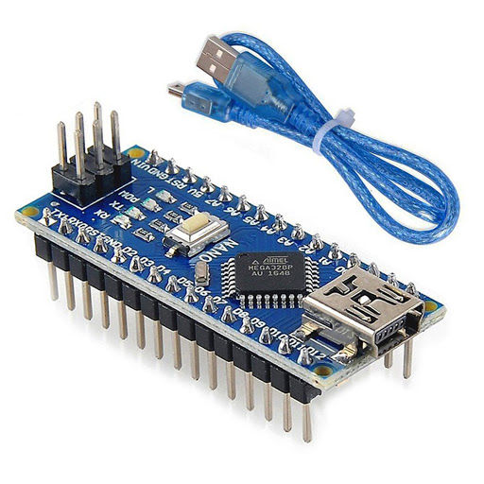
Figure 1: Arduino Nano
  - Geared Motor:
A gear motor is a type of motor that is coupled to a gearbox, which was designed to change the speed of the motor's output-ideally the RPM and torque. The gearbox reduces the high-speed rotation of the motor into a lower speed while increasing the torque by great measures. The relationship between speed and torque is determined by the gear ratio-for example, a higher gear ratio results in lower RPM but greater torque.

They find their perfect application in robotics, conveyor belts, and electric vehicles, where a very fine control of the rotational speed and higher power delivery are required. Most of the commonly used DC gear motors operate on various voltages and offer a wide range of RPM values, typically ranging from a few RPM to several thousand, depending on the gear ratio. Their ability to deliver consistent performance at low speeds makes them irreplaceable in devices that require controlled, powerful, and stable motion.

5
It’s salient features are:
- Operating Voltage(V): 12
- Rated Speed (RPM): 200
- Rated Torque(kg-cm): 1.5
- Stall Torque(kg-cm): 5.4
- Load Current (A): 0.3
- No Load Current (A):0.06

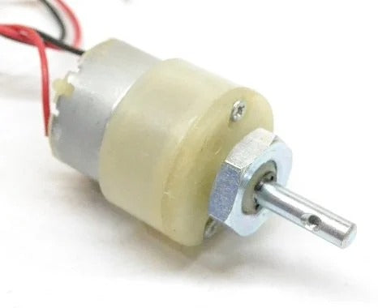
Figure 2: Gear Motor

3.3 L2938N Motor Driver
The L298N is a dual H-bridge motor driver module that controls two DC motors or one stepper motor. It operates at 5V-46V, handles 2A per motor, and supports PWM for speed and direction control. Commonly used with microcontrollers like Arduino, it amplifies control signals to drive motors efficiently.
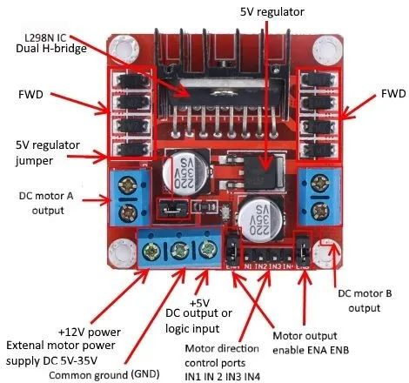
Figure 3: L2938N Motor Driver

6

3.4 Ultrasonic Sensor
An ultrasonic sensor measures distance by emitting ultrasonic sound waves and detecting their echo after bouncing off an object. It calculates the distance based on the time taken for the echo to return. Commonly used models like the HC-SR04 operate in a range of 2 cm to 400 cm and are highly effective in obstacle detection for robotics, automation, and navigation systems. Ultrasonic sensors are reliable, cost-effective, and unaffected by light conditions, making them ideal for real-time applications.
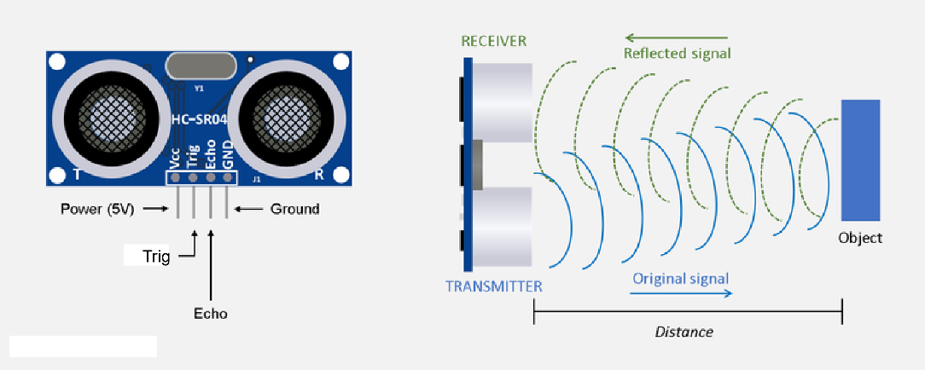
Figure 4: Ultrasonic Sensor and its working mechanism

3.5 Propulsion system
In a two-wing propulsion system, the common meaning is two propellers or wings for the development of thrust with regard to motion. These are commonly applied in boats, drones, and other vehicles that need to have their propulsion balanced.
Key Features of a Two-Wing Propulsion System:
Torque and Balance:
With two propellers, the thrust can be distributed evenly on either side of the vehicle, providing better balance and stability. In marine applications, it helps maintain a straight course and precise maneuvering.
Speed and Efficiency:
A two-propeller setup reduces drag compared to systems with more propellers, allowing for higher speeds while maintaining efficiency. Each propeller can achieve higher RPMs as power is split between just two units.

7
Directional Control:
With each propeller either speeding up, slowing down, or even changing direction, this setup provides very fine steering-the main advantage of this kind of aircraft, as sharp turns become easier to make, among other things. The propellers rotates in the opposite direction with respect to each other resulting in forward motion.

Power Requirements:
A two-wing propulsion system is power-efficient as compared to systems with more propellers. However, the torque may be lower than in multi-propeller configuration and thus unsuitable for applications where heavy loads are required to be moved.
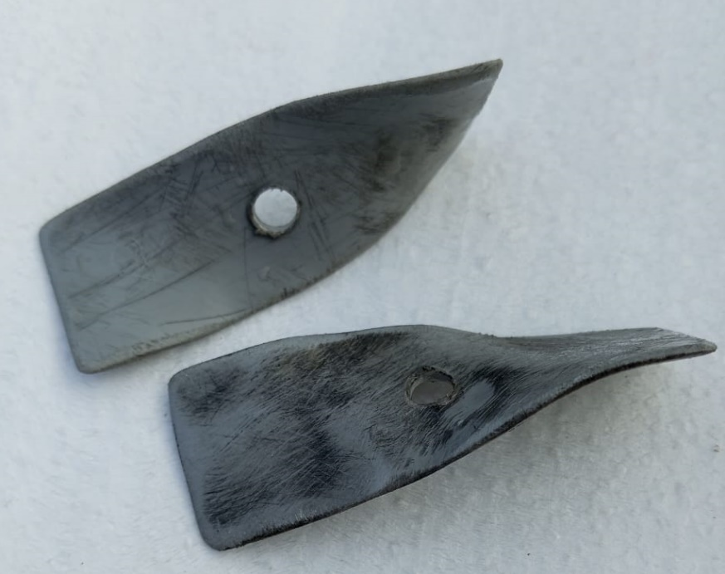
Figure 5: Propeller

8

- METHODOLOGY

Our main focus around this autonomous bot for now is to be competitive in the boat racing. For this, we dedicated our efforts to a case study of racing boats, their design, and the propulsion systems for maximum speed. We have used Arduino Nano for data processing from sensors and motor driver to amplify control signals to run the motors efficiently. We have also used two-blade propulsion system for higher speed as it reduces drag and increases the efficiency. Similarly, two-blade propulsion system also reduces power consumption.

4.1 Materials Used
- Arduino Nano: For processing sensor data and controlling motor actions.
- Ultrasonic Sensors: For obstacle detection in the front, left, and right directions.
- L2938N Motor Driver: To manage motor speed and direction based on Arduino commands.
- Gear Motors: For propulsion, providing the required torque and RPM.
- Propellers: Used for thrust generation and efficient movement of the boat.
- PVC Sheets: For constructing the double-hulled structure, ensuring durability and buoyancy.
- Magnets: To secure removable covers, allowing easy access to internal components.
- Battery: To power the Arduino, motor driver, and motors.
- Wires and Connectors: For electrical connections between components.
- Breadboard/PCB: For assembling and testing circuits.
- Screws and Adhesives: For securing components and assembling the hull.

9
4.2 Design: Catamaran Boat and its benefits:
Some practical advantages of our proposal, with a catamaran design with narrow upward- opening control cabin with a magnetically secured lid, among others, are presented herewith: The double-hulled design has improved stability and buoyancy, which is very necessary to operate in dynamic water environments even in difficult conditions. Minimizing obstructions within the sensor’s field of detection reduces blind spots to improve obstacle detection and maintain accuracy.
Additionally, the magnetically attached lid allowed for easy and quick access to internal components such as Arduino and the battery for maintenance or troubleshooting without compromising the structural integrity of the hull. The water-resistant feature is furthered by keeping the important electronic components enclosed, therefore minimal exposure to splash or moisture. With a combination of practicality, safety and visibility for sensors, this design proves to be efficient in autonomous operations with a robust and user- friendly system.
4.3 System Block Diagram
The general execution starts by emitting sound waves from ultrasonic sensors to detect obstacles and capture reflected echoes. Further, the acquired data is sent to the Arduino Nano for processing information about the nature of adjustments to be made, after which the Arduino Nano outputs signals to the motor driver based on the analysis of this information. The latter drives the motors at adjustable speeds and power output enabling proper navigation and obstacle avoidance.
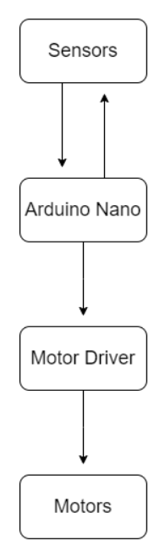
Figure 6: System Block Diagram
10

4.4 Activity Diagram (Flowchart)
Activity diagrams show the flow of sequential activity taking place in that system. Let us see the activity diagram as follows:
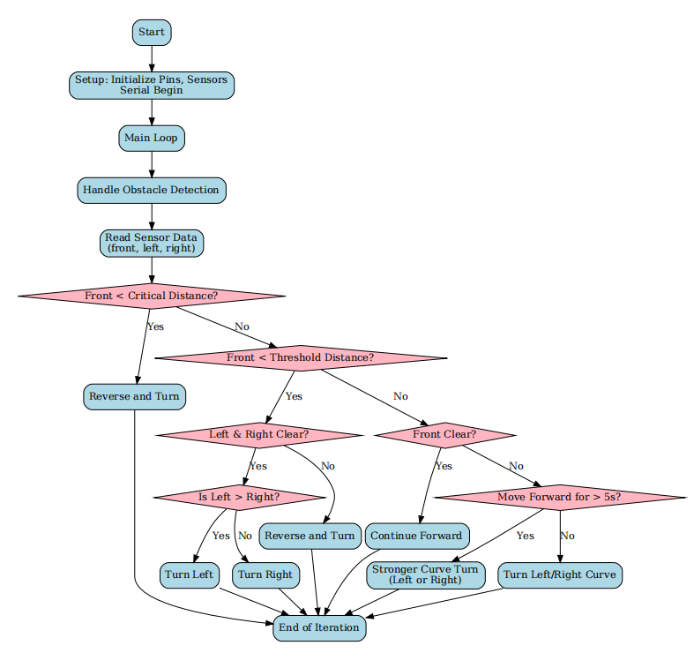

Figure 7: Flowchart

11
4.5 Interfacing Between Obstacles and Hardware
The interfacing between hardware components and obstacles in the autonomous boat relies on a streamlined circuit design. The ultrasonic sensor is the main input device, which continuously monitors the surroundings and detects obstacles by emitting ultrasonic waves and receiving their reflections. The sensor sends this data to the Arduino Nano, which then processes it to calculate the distance and proximity of the obstacles. When there are no obstacles, the boat moves forward with a steady speed. However, when the obstacles are detected, the system dynamically adjusts motor controls to execute needed maneuvers, such as turning left, right, taking sharp turn, reversing and execute smooth navigation based on the distance and programmed logic.

To address the prolonged forward motion and manage inertia, the system includes mechanism that triggers sharp turn if the boat moves in a straight path for more than five seconds. This features is carried out using Arduino’s timing functions and helps to counteract inertia which result in added control and stability. The Motor Driver (L2938N) plays its role in translating Arduino’s commands into precise motor actions, ensuring smooth transitions during turning, reversals or forward movements. All the components together create a responsive and adaptive navigation system which is capable of operating smoothly in dynamic environments, making this design well-suited for the real life applications.
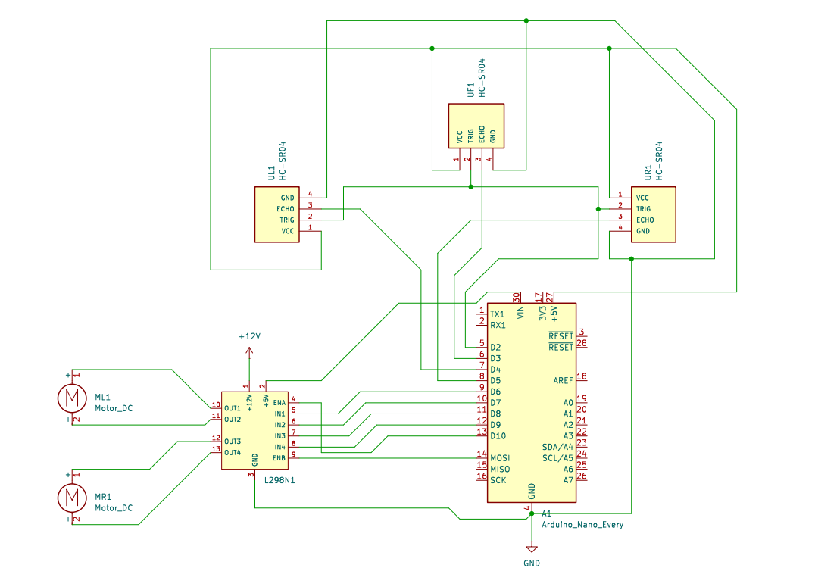
Figure 8 Interfacing/ Circuit

12
4.6 Coding and Programming
The coding and programming of the Arduino Nano is done to ensure the smooth functionality of the autonomous boat “Hydra”. The Arduino Nano is programmed to accept real time data from the sensors, process it and forward it to motor driver for precise movements. The complexities due to inertia are also cancelled with programming logic.
The code used in the project is:

#include <NewPing.h>

// Pins for ultrasonic sensors
#define TRIG_PIN 2
#define ECHO_PIN_FRONT 3
#define ECHO_PIN_LEFT 4
#define ECHO_PIN_RIGHT 5

// Motor control pins
#define MOTOR_LEFT_ENABLE 10
#define MOTOR_LEFT_IN1 6
#define MOTOR_LEFT_IN2 7
#define MOTOR_RIGHT_ENABLE 11
#define MOTOR_RIGHT_IN1 8
#define MOTOR_RIGHT_IN2 9

// Thresholds and settings

unsigned long forwardStartTime = 0; // Tracks when moveForward starts
bool isMovingForward = false; // Tracks if the robot is in forward motion

13
const int MIN_FORWARD_TIME=5000; //minimum forward moving time for stronger turn
const int MAX_DISTANCE_FRONT = 45; // Maximum distance for ultrasonic sensors (in cm)
const int MAX_DISTANCE_SIDE = 30;
const int TOLERANCE = 4;
const int CRITICAL_DISTANCE_SIDE = 4;
const int CRITICAL_DISTANCE_FRONT = 15;
const int THRESHOLD_DISTANCE_SIDE = 15; // Threshold distance for obstacle detection
const int THRESHOLD_DISTANCE_FRONT =40;
const int MOTOR_SPEED_FORWARD = 255;
const int MOTOR_SPEED_REVERSE = 255;
const int MOTOR_SPEED_TURN = 255;
unsigned int MOTOR_SPEED_CURVE_RIGHT = 140;
unsigned int MOTOR_SPEED_CURVE_LEFT = 160;
const int OBSTACLE_CRITICAL_LEFT = 2;
const int OBSTACLE_CRITICAL_RIGHT = 2;
const int MOTOR_SPEED_DEFAULT_RIGHT = 115;
const int MOTOR_SPEED_DEFAULT_LEFT = 135;
const int TURN_DELAY = 1000; // Delay during turning (in ms)
const int TURN_DELAY_Curve = 500;
const int REVERSE_DELAY = 800; // Delay during reversing (in ms)

// Create NewPing instances for each sensor
NewPing sonarFront(TRIG_PIN, ECHO_PIN_FRONT, MAX_DISTANCE_FRONT);
NewPing sonarLeft(TRIG_PIN, ECHO_PIN_LEFT, MAX_DISTANCE_SIDE);
NewPing sonarRight(TRIG_PIN, ECHO_PIN_RIGHT, MAX_DISTANCE_SIDE);

14

// Function prototypes
unsigned int getDistance(NewPing &sensor);
void controlMotor(int enablePin, int in1, int in2, int speed, bool forward);
void moveForward();
void stopMotors();
void turnLeft();
void turnRight();
void turnLeftCurve();
void turnRightCurve();
void reverseAndTurn();
void handleObstacleDetection();
void logSensorData(unsigned int front, unsigned int left, unsigned int right);

void setup() {
Serial.begin(9600);

// Set motor control pins as outputs
pinMode(MOTOR_LEFT_ENABLE, OUTPUT);
pinMode(MOTOR_LEFT_IN1, OUTPUT);
pinMode(MOTOR_LEFT_IN2, OUTPUT);
pinMode(MOTOR_RIGHT_ENABLE, OUTPUT);
pinMode(MOTOR_RIGHT_IN1, OUTPUT);
pinMode(MOTOR_RIGHT_IN2, OUTPUT);

Serial.println("Robot initialized.");
}

15

void loop() {
// Handle obstacle detection and navigation
handleObstacleDetection();

// Small delay to avoid spamming
delay(100);
}

// Function to get the distance from a sensor
unsigned int getDistance(NewPing &sensor) {
unsigned int distance = sensor.ping_median(5) / US_ROUNDTRIP_CM;
if (distance == 0) {
if(&sensor == &sonarFront){
distance = MAX_DISTANCE_FRONT; // Assume max distance front if front sensor fails
}
else{
distance = MAX_DISTANCE_SIDE;
}
}
return distance;
}

// General motor control function
void controlMotor(int enablePin, int in1, int in2, int speed, bool forward) {
digitalWrite(in1, forward ? LOW : HIGH);
digitalWrite(in2, forward ? HIGH : LOW);
analogWrite(enablePin, speed);
}
16
// Moves the robot forward
void moveForward() {
if (!isMovingForward) {
forwardStartTime = millis(); // Start the timer
isMovingForward = true;
}

controlMotor(MOTOR_LEFT_ENABLE, MOTOR_LEFT_IN1, MOTOR_LEFT_IN2, MOTOR_SPEED_FORWARD, true);
controlMotor(MOTOR_RIGHT_ENABLE, MOTOR_RIGHT_IN1, MOTOR_RIGHT_IN2, MOTOR_SPEED_FORWARD, true);
Serial.println("Moving forward.");
}

// Stops the robot
void stopMotors() {
analogWrite(MOTOR_LEFT_ENABLE, 0);
analogWrite(MOTOR_RIGHT_ENABLE, 0);
Serial.println("Motors stopped.");
}

// Turns the robot left
void turnLeft() {
controlMotor(MOTOR_LEFT_ENABLE, MOTOR_LEFT_IN1, MOTOR_LEFT_IN2, MOTOR_SPEED_TURN, false);
controlMotor(MOTOR_RIGHT_ENABLE, MOTOR_RIGHT_IN1, MOTOR_RIGHT_IN2, MOTOR_SPEED_TURN, true);
delay(TURN_DELAY);
stopMotors();
Serial.println("Turning left.");
}
17
// Turns the robot right
void turnRight() {
controlMotor(MOTOR_LEFT_ENABLE, MOTOR_LEFT_IN1, MOTOR_LEFT_IN2, MOTOR_SPEED_TURN, true);
controlMotor(MOTOR_RIGHT_ENABLE, MOTOR_RIGHT_IN1, MOTOR_RIGHT_IN2, MOTOR_SPEED_TURN, false);
delay(TURN_DELAY);
stopMotors();
Serial.println("Turning right.");
}

// Executes a left curve
void turnLeftCurve() {
unsigned long startTime = millis(); // Start time for curve adjustment
while ((millis() - startTime) < TURN_DELAY_Curve) {
unsigned int distanceLeft = getDistance(sonarLeft);
unsigned int distanceRight = getDistance(sonarRight);

if ((distanceLeft > THRESHOLD_DISTANCE_SIDE) || (distanceRight > THRESHOLD_DISTANCE_SIDE)) {
controlMotor(MOTOR_LEFT_ENABLE, MOTOR_LEFT_IN1, MOTOR_LEFT_IN2, MOTOR_SPEED_CURVE_LEFT, true); // Slow left motor
controlMotor(MOTOR_RIGHT_ENABLE, MOTOR_RIGHT_IN1, MOTOR_RIGHT_IN2, MOTOR_SPEED_FORWARD, true); // Full right motor
} else {
break; // Exit curve if obstacles are no longer detected
}
}
stopMotors(); // Stop motors after curve
Serial.println("Completed left curve.");
}
18
// Executes a right curve
void turnRightCurve() {
unsigned long startTime = millis(); // Start time for curve adjustment
while ((millis() - startTime) < TURN_DELAY_Curve) {
unsigned int distanceLeft = getDistance(sonarLeft);
unsigned int distanceRight = getDistance(sonarRight);

if ((distanceLeft > THRESHOLD_DISTANCE_SIDE) || (distanceRight > THRESHOLD_DISTANCE_SIDE)) {
controlMotor(MOTOR_LEFT_ENABLE, MOTOR_LEFT_IN1, MOTOR_LEFT_IN2, MOTOR_SPEED_FORWARD, true); // Full left motor
controlMotor(MOTOR_RIGHT_ENABLE, MOTOR_RIGHT_IN1, MOTOR_RIGHT_IN2, MOTOR_SPEED_CURVE_RIGHT, true); // Slow right motor
} else {
break; // Exit curve if obstacles are no longer detected
}
}
stopMotors(); // Stop motors after curve
Serial.println("Completed right curve.");
}

void strongerCurveTurn(bool turnLeft) {
Serial.println(turnLeft ? "Executing stronger left curve." : "Executing stronger right curve.");

if (turnLeft) {
// Strong left turn
controlMotor(MOTOR_LEFT_ENABLE, MOTOR_LEFT_IN1, MOTOR_LEFT_IN2, MOTOR_SPEED_TURN, false); // Reverse left motor

19

controlMotor(MOTOR_RIGHT_ENABLE, MOTOR_RIGHT_IN1, MOTOR_RIGHT_IN2, MOTOR_SPEED_FORWARD, true); // Full right motor
} else {
// Strong right turn
controlMotor(MOTOR_LEFT_ENABLE, MOTOR_LEFT_IN1, MOTOR_LEFT_IN2, MOTOR_SPEED_FORWARD, true); // Full left motor
controlMotor(MOTOR_RIGHT_ENABLE, MOTOR_RIGHT_IN1, MOTOR_RIGHT_IN2, MOTOR_SPEED_TURN, false); // Reverse right motor
}

delay(800); // Longer delay for stronger turn
stopMotors();
}
void reverse(){

controlMotor(MOTOR_LEFT_ENABLE, MOTOR_LEFT_IN1, MOTOR_LEFT_IN2, MOTOR_SPEED_TURN, false);
controlMotor(MOTOR_RIGHT_ENABLE, MOTOR_RIGHT_IN1, MOTOR_RIGHT_IN2, MOTOR_SPEED_TURN, false);
delay(REVERSE_DELAY);
}
// Reverses and then turns
void reverseAndTurn() {
stopMotors();
delay(500); // Pause to stabilize before reversing
reverse();
delay(REVERSE_DELAY); // Allow time for reversing

unsigned int distanceLeft = getDistance(sonarLeft);
unsigned int distanceRight = getDistance(sonarRight);
20

int T = distanceLeft - distanceRight;

if (abs(T) <= TOLERANCE) {
turnLeft();
delay(500);
}
else if (distanceLeft > distanceRight) {
turnLeft();
delay(500);
Serial.println("Reversing and turning left.");
}
else {
turnRight();
delay(500);
Serial.println("Reversing and turning right.");
}
}

// Handles obstacle detection and navigation
void handleObstacleDetection() {
unsigned int distanceFront = getDistance(sonarFront);
unsigned int distanceLeft = getDistance(sonarLeft);
unsigned int distanceRight = getDistance(sonarRight);

logSensorData(distanceFront, distanceLeft, distanceRight);

int T = distanceLeft - distanceRight;
21

if ((distanceFront < CRITICAL_DISTANCE_FRONT)) {
reverseAndTurn();
isMovingForward = false; // Reset forward motion tracking
}
else if (distanceFront <= THRESHOLD_DISTANCE_FRONT) {
// Front obstacle detected
isMovingForward = false; // Reset forward motion tracking
if (distanceLeft > THRESHOLD_DISTANCE_SIDE && distanceRight > THRESHOLD_DISTANCE_SIDE) {
if (abs(T) <= TOLERANCE) {
turnLeft(); // Prefer left if distances are nearly equal
} else if (distanceLeft > distanceRight) {
turnLeft();
} else {
turnRight();
}
} else if (distanceLeft > THRESHOLD_DISTANCE_SIDE) {
turnLeft();
} else if (distanceRight > THRESHOLD_DISTANCE_SIDE) {
turnRight();
} else {
reverseAndTurn();
}
}
// Refactored control logic
else {
// Front is clear

22

if (abs(T) <= TOLERANCE) {
moveForward();
}
// Handle close obstacles on sides
else if ((distanceLeft < OBSTACLE_CRITICAL_LEFT) || (distanceRight < OBSTACLE_CRITICAL_RIGHT)) {
// Adjust motor speeds for curve turns
MOTOR_SPEED_CURVE_RIGHT = MOTOR_SPEED_DEFAULT_RIGHT;
MOTOR_SPEED_CURVE_LEFT = MOTOR_SPEED_DEFAULT_LEFT;

if (distanceLeft < OBSTACLE_CRITICAL_RIGHT) {
turnRightCurve(); // Turn right if the left side is too close
} else {
turnLeftCurve(); // Turn left if the right side is too close
}
}
// Check if moving forward for too long
else if (isMovingForward && ((millis() - forwardStartTime) > MIN_FORWARD_TIME)) {
isMovingForward = false; // Reset forward motion tracking

// Decide stronger curve turn based on distances
if (distanceLeft > distanceRight) {
strongerCurveTurn(true); // Stronger left turn
} else {
strongerCurveTurn(false); // Stronger right turn
}
}

23

// Fallback: decide turns based on side distances
else if (distanceLeft > distanceRight) {
turnLeftCurve();
} else {
turnRightCurve();
}
}
}

// Logs sensor data for debugging
void logSensorData(unsigned int front, unsigned int left, unsigned int right) {
Serial.print("Front: ");
Serial.print(front);
Serial.print(" cm, Left: ");
Serial.print(left);
Serial.print(" cm, Right: ");
Serial.println(right);
}

24

- OUTPUT AND ANALYSIS
The output of the autonomous boat system demonstrates its ability to detect obstacles and adjust its movement in real-time. When the ultrasonic sensor identifies an obstacle, the data is processed by the Arduino Nano, which sends appropriate signals to the motor driver. The motor driver then controls the motors to execute the necessary movement. For instance, if an obstacle is detected in front, the boat moves backward; if on the right, it turns left, and if on the left, it turns right.
This coordinated process ensures smooth navigation and effective obstacle avoidance. The system operates with accuracy and stability, responding almost instantaneously to changes in its environment. By combining efficient data processing and precise motor control, the boat achieves reliable and consistent performance, making it suitable for various navigation scenarios.
The overall dimension of the boat is 26x12x11.

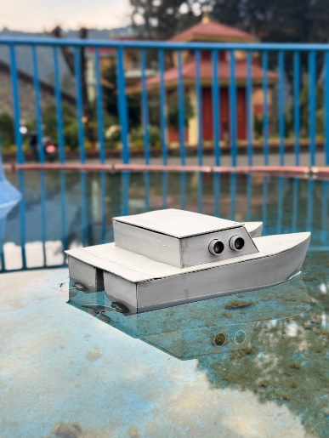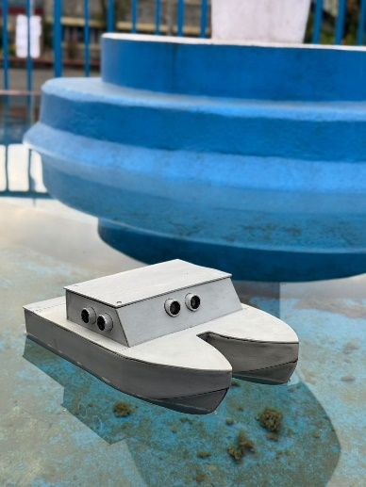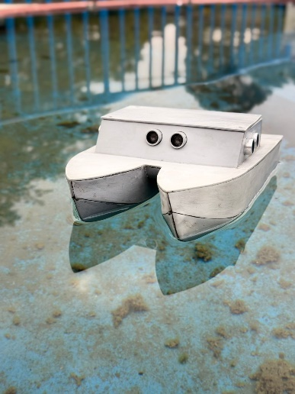
Figure 9: Final Prototype of the Hydra and the Hydra in motion.

25

- CONCLUSION AND FUTURE ENHANCEMENT
This autonomous boat prototype showcases the effectiveness of using ultrasonic sensors, Arduino Nano, a motor driver, and motors to identify and evade obstacles. With runtime processing and subsequent alteration to its movements, this system has worked quite effectively to negotiate a variety of different environments. The project showcases realistic applications for autonomous navigation technology at a strong foundational level leading to deployment into practical environments.

Building on this success, the prototype has been considered for surveillance applications, with a feasibility case study currently underway. Future enhancements are planned for expanding its capabilities, integrating cameras for real-time monitoring, GPS modules for precise tracking, and advanced sensors to handle even more complex environments. The upgrades will allow the boat to be used as a versatile and efficient way of surveillance, broadening potential applications in security and environmental monitoring.

26

