Assignment 3

A Project: Boat Club

Requirements

1. An admin can perform CRUD functionalities.
2. An admin can also perform search such as
   1. Get all members
      1. Get members by name
      2. Get members by gender
      3. Get members by age [≤, ≥, =, >, <]
   2. Get all boats
      1. Get all boats by length [≤, ≥, =, >, <]
      2. Get all boats by manufacture year.
      3. Get all boats by its type.
   3. Get all boats of a specific member
   4. Get a member from a specific boat.

Task 2

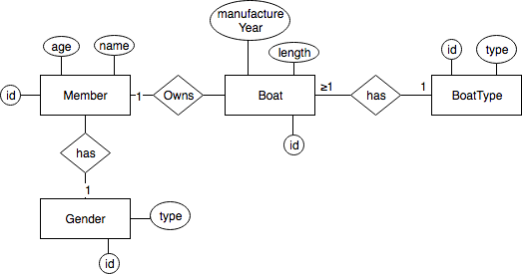

Task 3

SQL Design

member(id, name,age,gender)

gender(id, type)

boat(id, year, length, member_id*, type_id)

boat_type(id,type)