Assessing the Role of Age and Cumulative Smoking Exposure in Lung Cancer Risk
Saraa Al-Jawad
Authors
Saraa Al Jawad
Author affiliations
- Institute of Bioinformatics, University of Georgia, Athens, GA, USA.

1. Summary/Abstract
Lung cancer remains one of the leading causes of cancer-related mortality worldwide, with age and smoking exposure recognized as major risk factors. Understanding how these factors contribute to lung cancer risk is essential for improving prevention strategies and risk assessment. In this study, we examine the relationship between age, cumulative smoking exposure, and lung cancer risk using a structured data analysis approach in R. Exploratory data analysis was performed to evaluate distributions, trends, and potential associations among variables, followed by statistical modeling to assess the independent and combined effects of age and smoking exposure on lung cancer outcomes. This analysis aims to determine whether increasing age and greater cumulative smoking exposure are associated with elevated lung cancer risk and to assess the relative strength of these factors.

2. Introduction

2.1 General Background Information
Lung cancer is one of the leading causes of cancer-related mortality worldwide and remains a major public health concern. Despite advances in screening and treatment, lung cancer often presents at advanced stages, leading to poor prognosis and high mortality rates. Identifying and understanding key risk factors is therefore essential for prevention efforts and early risk assessment.
Approximately 85% of lung cancer cases occur in current or former smokers, underscoring the dominant role of tobacco exposure in disease development. Long-term cigarette smokers have been shown to face substantial cumulative risk of lung cancer by older ages, highlighting the strong dose–response relationship between smoking exposure and disease risk. Beyond smoking alone, risk prediction research has emphasized the importance of incorporating additional clinical and environmental factors to better estimate individual susceptibility. These findings support the need for structured risk assessment approaches that evaluate both smoking history and other relevant predictors when examining lung cancer risk (1).
Age and smoking exposure are well-established risk factors for lung cancer. Risk increases with age due to cumulative biological changes and prolonged exposure to carcinogens over time. Similarly, greater cumulative smoking exposure is strongly associated with increased lung cancer incidence and remains the primary preventable risk factor. Examining these variables together allows for a clearer understanding of how they both contribute to disease risk.

2.2 Description of data and data source
The data used in this analysis consist of individual-level observations on lung cancer risk factors and disease status. The dataset contains 5,000 observations and 30 variables, including demographic characteristics, smoking-related variables, and clinical indicators.
The primary variables of interest for this study are age, cumulative smoking exposure (pack-years), and lung cancer status. Additional variables such as smoking status and chronic obstructive pulmonary disease (COPD) are included for descriptive purposes.

2.3 Questions/Hypotheses to be addressed
The primary research question of this analysis is whether age and cumulative smoking exposure are associated with lung cancer risk.This project seeks to examine how lung cancer risk varies across different age groups and levels of smoking exposure.
The main hypotheses are: 1. Increasing age is associated with a higher risk of lung cancer. 2. Greater cumulative smoking exposure is associated with an increased risk of lung cancer. 3. Smoking exposure contributes more strongly to lung cancer risk than age when both factors are considered together.

3. Methods

3.1 Planned analysis approach
Exploratory data analysis was conducted to examine the distributions of key variables and identify potential patterns or relationships between age, smoking exposure, and lung cancer status. Summary statistics and simple visualizations were used to better understand the data and assess data quality.
Following exploratory analysis, statistical modeling approaches will be applied to evaluate the association between age, smoking exposure, and lung cancer risk. Models will be used to assess the independent and combined effects of these predictors on lung cancer outcomes. Additional variables in the dataset may be considered in extended analyses as the project progresses, particularly in later stages of the course when multivariate and machine learning methods are introduced.

3.2 Data acquisition
The dataset used in this analysis was obtained from a publicly available online source and downloaded in CSV format. The dataset contains individual-level information on lung cancer risk factors and disease status, including demographic and smoking-related variables.

3.3 Data import and cleaning
The dataset was imported from a CSV file stored in the project repository. Basic cleaning steps were performed to ensure key variables were in the correct format for analysis. Specifically, age and cumulative smoking exposure (pack-years) were converted to numeric variables, and lung cancer status, smoking status, and COPD were treated as categorical variables (factors). The cleaned dataset was used for all descriptive summaries and figures.

3.4 Statistical analysis
At this stage of the project, the primary focus was on data cleaning and exploratory analysis. Descriptive statistics and graphical methods were used to examine distributions and identify potential relationships between lung cancer risk, age, and cumulative smoking exposure.
Formal statistical modeling, including logistic regression to evaluate independent and combined effects of predictors on lung cancer risk, will be conducted in subsequent stages of the project.

4. Results

4.1 Exploratory/Descriptive analysis
Table 1 summarizes the key characteristics of participants stratified by lung cancer risk. Individuals with lung cancer were slightly older (median age 56 years) compared to those without lung cancer (median age 54 years). The interquartile ranges of age were nearly identical between groups, indicating comparable variability in age distribution.
Smoking exposure differed substantially between groups. The median cumulative smoking exposure (pack-years) among individuals without lung cancer was 0, whereas individuals with lung cancer had a median of 19 pack-years. This indicates markedly higher lifetime smoking exposure among those with lung cancer.
The proportion of smokers was considerably higher in the lung cancer group compared to the non-cancer group. Similarly, the prevalence of chronic obstructive pulmonary disease (COPD) was substantially greater among individuals with lung cancer.
Overall, smoking-related variables demonstrated more pronounced differences between groups than age alone.
Table 1: Summary of key variables by lung cancer risk.
Risk | N | Median Age | IQR Age | Median  Pack-Years | IQR  Pack-Years | %  Smokers | %  COPD
No | 3,756 | 54 | 16 | 0 | 0 | 27.42 | 2.96
Yes | 1,244 | 56 | 15 | 19 | 12 | 100.00 | 55.14
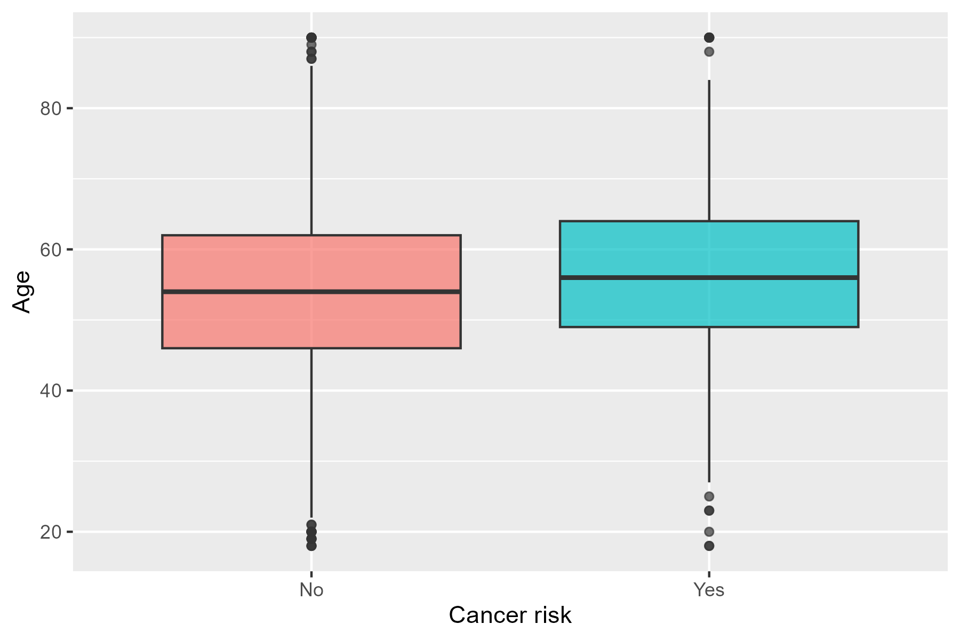
Figure 1: Age distribution by lung cancer risk.
Figure 1 illustrates the distribution of age by lung cancer risk. Although there is overlap between groups, the median age appears slightly higher among individuals with lung cancer. The overall spread of ages is comparable across both groups.
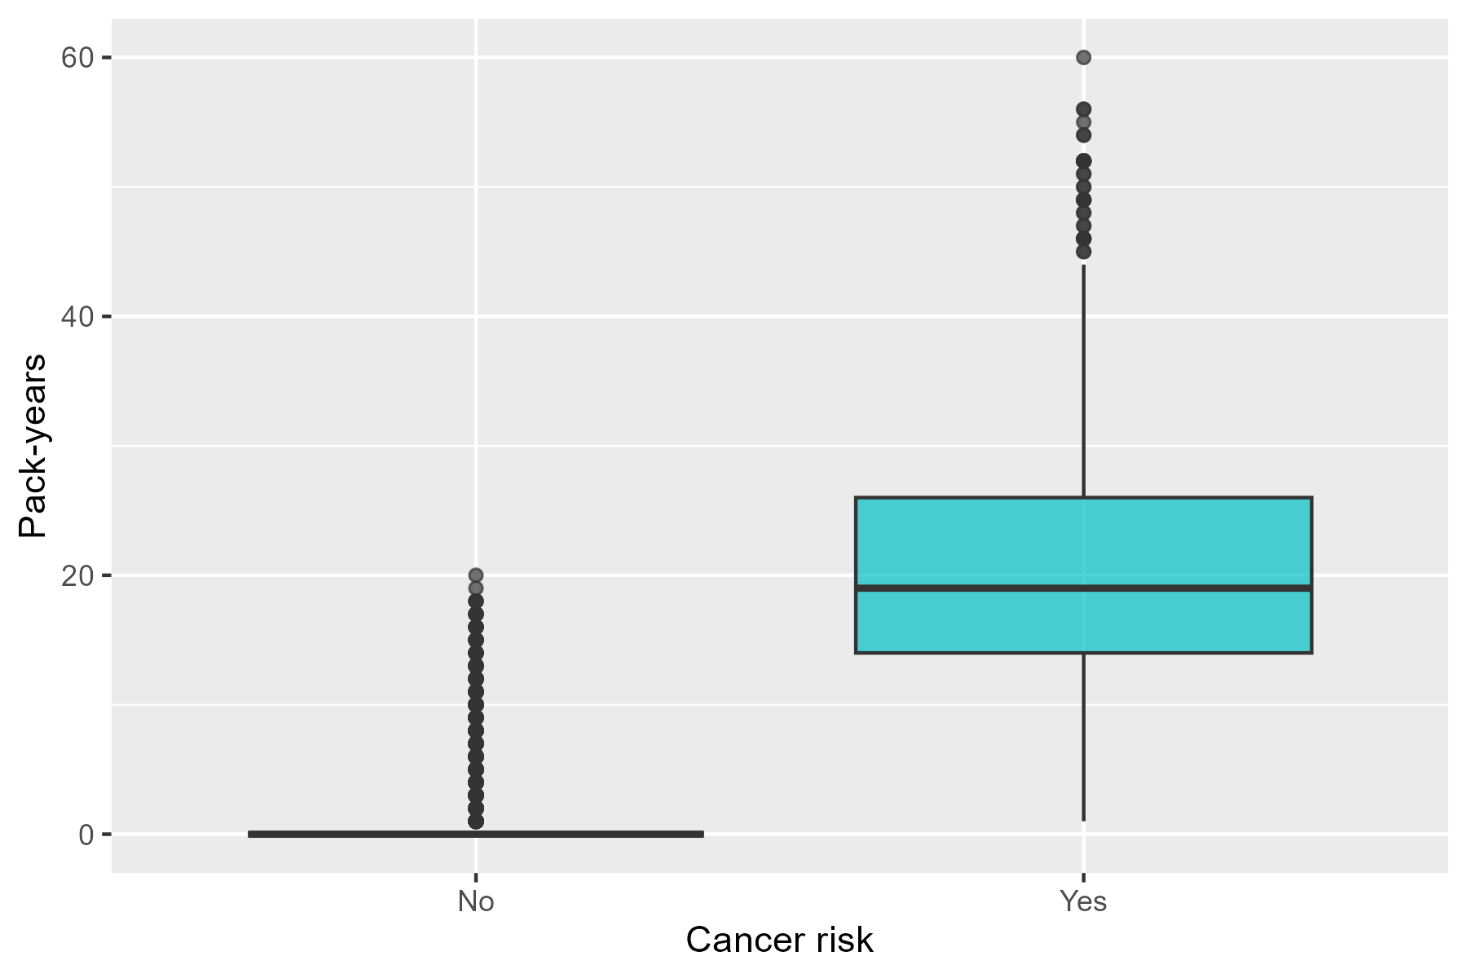
Figure 2: Cumulative smoking exposure (pack-years) by lung cancer risk.
Figure 2 shows the distribution of cumulative smoking exposure by lung cancer risk. Individuals with lung cancer demonstrate substantially higher pack-years compared to those without lung cancer. The non-cancer group shows a large proportion of individuals with zero pack-years, whereas the lung cancer group exhibits a broader distribution with higher median exposure.
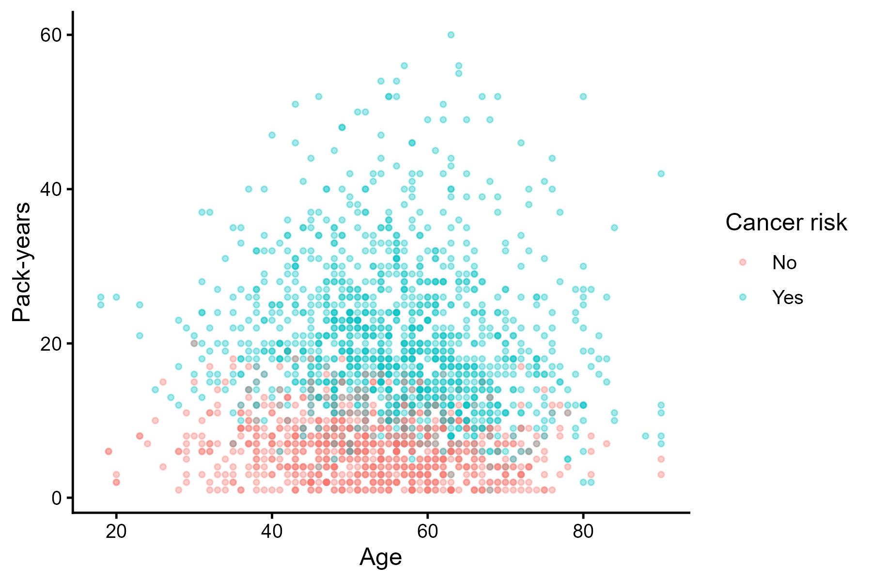
Figure 3: Relationship between age and pack-years by lung cancer risk.
Figure 3 displays age versus cumulative smoking exposure stratified by lung cancer risk. Cumulative smoking exposure tends to increase with age, reflecting accumulation of tobacco exposure over time. Individuals with lung cancer cluster at higher levels of cumulative smoking exposure across a wide range of ages, suggesting that smoking exposure may better differentiate lung cancer cases from non-cases than age alone.
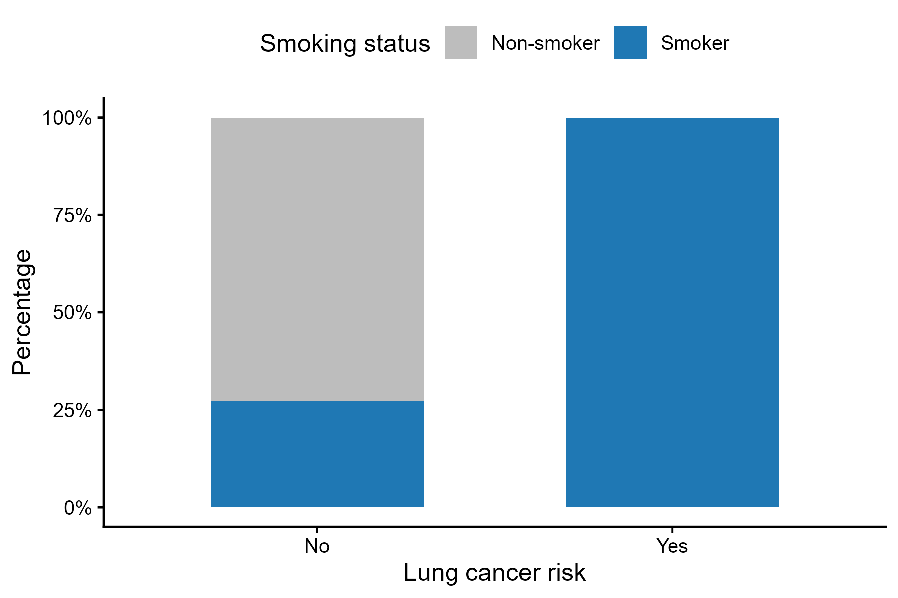
Figure 4: Percentage of smokers by lung cancer risk.
Figure 4 shows the percentage of smokers by lung cancer risk. In this dataset, all individuals classified as having lung cancer were smokers, whereas approximately 27% of individuals without lung cancer were smokers. This indicates a strong association between smoking status and lung cancer in the dataset.

4.2 Basic statistical analysis
To get some further insight into your data, if reasonable you could compute simple statistics (e.g. simple models with 1 predictor) to look for associations between your outcome(s) and each individual predictor variable. Though note that unless you pre-specified the outcome and main exposure, any “p<0.05 means statistical significance” interpretation is not valid.

4.3 Full analysis
Use one or several suitable statistical/machine learning methods to analyze your data and to produce meaningful figures, tables, etc. This might again be code that is best placed in one or several separate R scripts that need to be well documented. You want the code to produce figures and data ready for display as tables, and save those. Then you load them here.
```

5. Discussion

5.1 Summary and Interpretation
Summarize what you did, what you found and what it means.

5.2 Strengths and Limitations
Discuss what you perceive as strengths and limitations of your analysis.

5.3 Conclusions
What are the main take-home messages?

6. Supplementary materials
The raw data used in this analysis are stored in the project repository under data/raw-data/. All data processing, cleaning, and exploratory analyses were conducted using reproducible R scripts located in the code/ directory.

7. References
1. Spitz MR, Hong WK, Amos CI, et al. A risk model for prediction of lung cancer. Journal of the National Cancer Institute. 2007;99(9):715–726.

