Supplementary Material

1. Supplementary Material

1.1 Additional Figures
Figure S1 shows the ROC curve for Model 1.
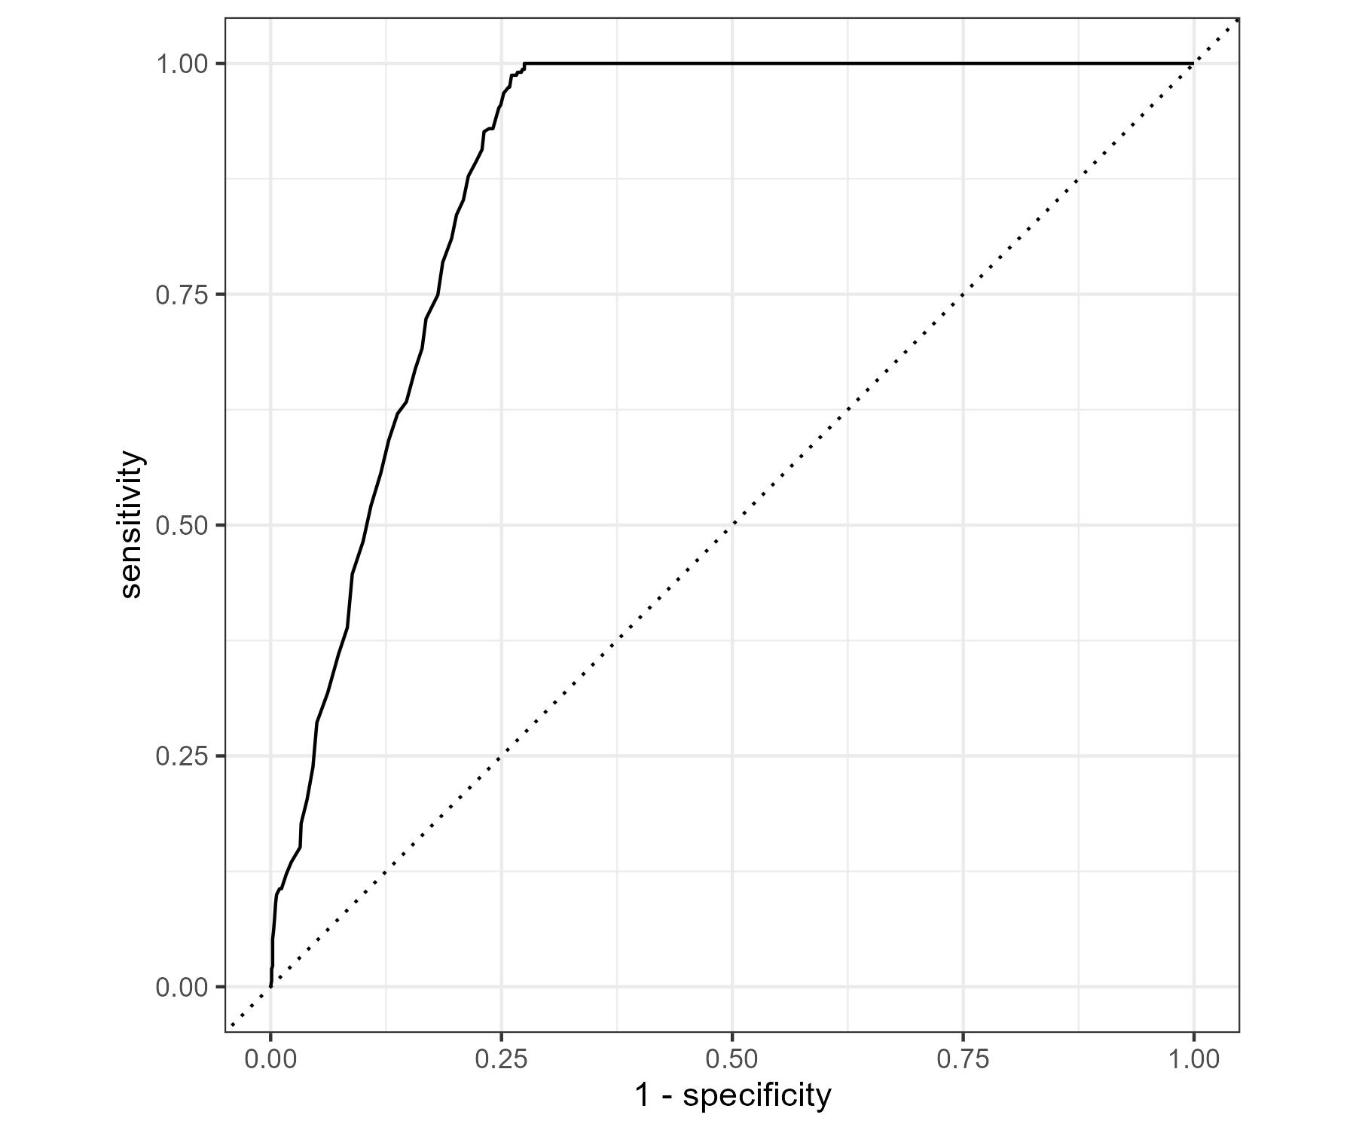
Figure S2 shows the ROC curve for Model 2.
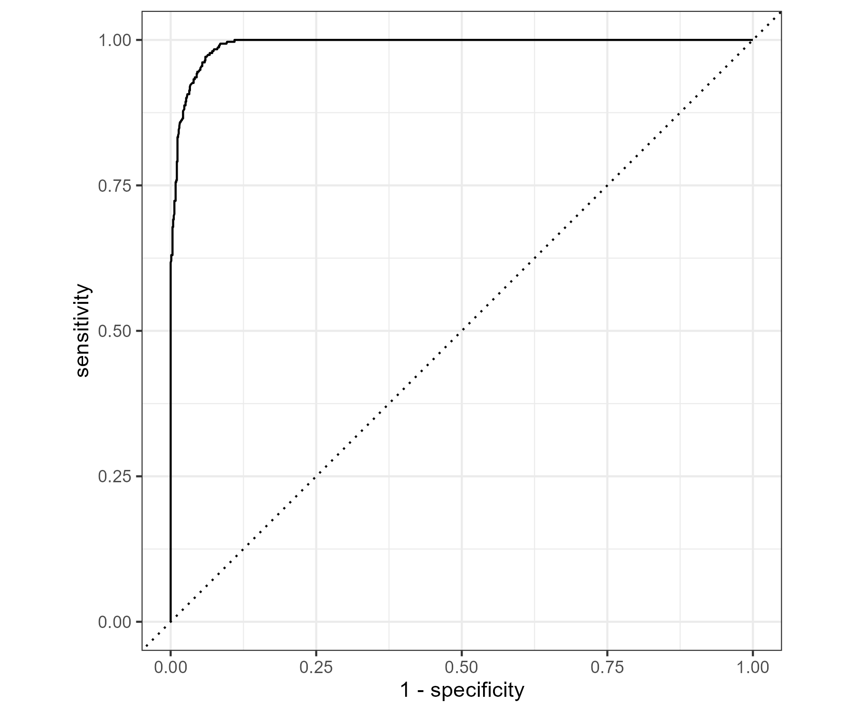

1.2 Additional Tables
Table S1 provides additional model comparison results supporting the findings reported in the main text.
Model | Test_Accuracy | Test_Sensitivity | Test_Specificity | Test_AUC | CV_Accuracy | CV_Sensitivity | CV_Specificity
Age + smoker | 0.8064 | 0.8136315 | 0.7845659 | 0.8862082 | 0.8098579 | 0.8104286 | 0.8080961
Age + pack_years | 0.9536 | 0.9680511 | 0.9099678 | 0.9917268 | 0.9485286 | 0.9676902 | 0.8906618

