A Comparative Study of RAG Techniques for Generating Image Captions

Group 6 — Sparse / BM25 RAG
Phase 1 Technical Report

Data Exploration, Preprocessing and Knowledge-Base Construction
Release: frozen dataset v1.1

Authors: Abdelbaki Mallak ,Ahfir Rima
Belbouab Maroua,Ben Ali Khodja Malak(G1)

supervisor: Mrs Sebti Sarra / Dr. K.Belttar

2025/2026

Abstract
This report documents the first phase of a comparative study of Retrieval-Augmented Generation (RAG) techniques for image captioning on MS COCO. Our group is assigned the sparse (BM25) retrieval technique. Phase 1 produces the shared, frozen and audited data foundation for all later experiments: a knowledge base of 10,000 COCO train2017 images (50,000 captions), a disjoint validation set of 100 images and a stratified test set of 1,000 val2017 images.
We describe the data audit, the construction of the splits, and a two-level (image and caption) anti-leakage audit. The caption-level audit found that 223 knowledge-base captions were identical, after normalisation, to test or validation captions, which would have inflated the scores of a lexical retriever; these captions were excluded from the retrieval side only (release v1.1). We then describe caption cleaning, object extraction directly from the images with YOLOv8m (78,381 objects over 11,100 images), a statistical exploration before and after preprocessing, dense text and image embeddings (SBERT and OpenCLIP) and the FAISS vector indexes built over the knowledge base. All steps are reproducible from the repository, and every random choice uses a fixed seed (42).

1. Introduction
Automatic image captioning is a core task at the intersection of computer vision and natural language processing. Recent Vision-Language Models produce fluent captions but can omit objects that are present, invent objects that are not (hallucination), and lack precision about attributes and relations. Retrieval-Augmented Generation grounds the generation process in external knowledge such as reference captions of similar images (Lewis et al., 2020), with the aim of improving accuracy, relevance and visual grounding.
The overall project asks how different RAG techniques affect the quality, relevance and visual grounding of captions generated on a subset of COCO. Ten techniques are studied, each assigned to three groups so that results can be compared within a technique. Our group works on Sparse / BM25 RAG, i.e. lexical retrieval of reference captions (Robertson et al., 1994). All groups share one common dataset, so that differences between techniques are not caused by differences in data.
This report covers Phase 1 only (data exploration and preprocessing, deadline 4 November 2026). Model training, validation and evaluation belong to the next phases (Section 11).

2. Problem Statement and Phase 1 Objectives
A fair comparison of RAG techniques requires a clean, reproducible and leakage-free dataset. In Phase 1 we therefore had to:
- build and freeze three splits (knowledge base, validation, test) from COCO and store their IDs in versioned files;
- audit the data and prove that no test image or test reference caption can be retrieved during retrieval or generation;
- preprocess captions (raw and cleaned fields kept separate) and extract object metadata directly from the images;
- generate image and text embeddings and build a vector knowledge base with documented index parameters;
- carry out a statistical exploration of the data, before and after preprocessing;
- validate that the frozen release works with a retrieval pipeline.

3. Assigned RAG Technique: Sparse / BM25 Retrieval
BM25 is a lexical ranking function that scores a document (here, a reference caption) against a query by the weighted overlap of their terms, using term frequency, inverse document frequency and length normalisation. Unlike dense retrieval, it does not compare meanings but exact words, so it is fast, needs no training, and is easy to interpret, but it cannot match paraphrases.
Two consequences shape the Phase 1 design:
- Caption cleaning defines what the retriever sees. BM25 will be built on the cleaned caption field, so the cleaning rules (Section 6.1) are documented precisely and the raw captions are always kept.
- Caption-level leakage is critical. A test caption that also exists in the knowledge base would be matched word for word and would artificially inflate retrieval scores. This is why we audit leakage at caption level and not only at image level (Section 5.4).
Dense embeddings (SBERT, OpenCLIP) are also produced in Phase 1, because the project requires image and text embeddings in the knowledge base and because they enable within-project comparison and hybrid variants.

4. System Architecture and Repository
The Phase 1 pipeline transforms raw COCO data into frozen, shared artefacts. Each stage reads the output of the previous one:
Step | Stage | Main outputs | Location
1 | Data audit and split creation | ID files, manifests, leakage reports, exclusion list | splits/, report/
2 | Caption cleaning | Raw, cleaned and tokenised captions (v1.1) | data/captions_processed_v1.1.json
3 | Object extraction (YOLOv8m) | Objects, confidences and boxes per image | data/metadata.json
4 | Embeddings and vector index | .npy embeddings, FAISS indexes, mapping | embeddings/, index/
5 | Exploration and quality control | Statistics, figures, sanity checks | exploration/, report/

Table 1. Phase 1 pipeline.
The repository is organised by role: data/ (captions and metadata), src/ (audit and split scripts), splits/ (manifests, IDs, exclusion list), embeddings/, index/, exploration/ (tables and figures), report/ (audit records) and docs/ (report sections). The root README.md gives installation and reproduction instructions and requirements.txt the package versions.

5. Dataset and Knowledge Base

5.1 Splits
Images and captions come from MS COCO 2017 (Lin et al., 2014). Table 2 gives the three frozen splits. In total, 10,100 distinct train2017 images are used (knowledge base and validation together).
Split | Source | Images | Captions | Purpose
kb (knowledge base) | COCO train2017 | 10,000 | 50,000 (49,777 after exclusion) | RAG knowledge base
val (tuning) | COCO train2017, disjoint from kb | 100 | 500 | Hyperparameter tuning
test | COCO val2017, stratified | 1,000 | 5,000 | Final evaluation only

Table 2. Frozen splits (release v1.1).
The project specification mentions a 100-image test subset in one place and a 1,000-image test set in another. We use the 1,000-image set, from which a 100-image subset can be drawn for comparison if required.

5.2 Data audit
Before any selection, both annotation sets were audited for duplicated image IDs, images missing on disk, orphan captions, empty captions and images with fewer than five captions.
Check | train2017 | val2017
Images | 118,287 | 5,000
Captions | 591,753 | 25,014
Duplicate image IDs / missing on disk | 0 / 0 | 0 / 0
Orphan captions / empty captions | 0 / 0 | 0 / 0
Images with fewer than 5 captions | 0 | 0
Images with exactly 5 / 6 / 7 captions | 117,972 / 312 / 3 | 4,987 / 12 / 1

Table 3. Data audit results.
No image had to be excluded. A few images carry six or seven captions; to obtain exactly five per image in every split, captions are sorted by annotation ID and the first five are kept. This rule is deterministic and independent of caption content (it removed 24 captions from 23 knowledge-base images and 3 captions from 3 test images).

5.3 Split construction
Knowledge base and validation. All train2017 images were sorted by ID and shuffled once with seed 42. Images were accepted in shuffled order, after checking that each opens and decodes (RGB conversion with EXIF correction) and has a new MD5 content hash, until 10,100 valid images were collected. The first 10,000 form the knowledge base and the last 100 the validation set, so the two are disjoint by construction. No image was rejected.
Test set. The 1,000 test images come from val2017 and are stratified by scene complexity, defined as the number of annotated object instances:
Stratum | Objects per image | Pool size | Selected
Simple | ≤ 3 | 2,062 | 300
Medium | 4 – 7 | 1,192 | 400
Complex | ≥ 8 | 1,698 | 300

Table 4. Stratified test set.
The medium stratum receives the largest quota so that typical multi-object scenes are well represented, while simple and complex scenes remain available for error analysis. Each test image keeps its stratum label in test_manifest.json. The sorted ID files (kb_ids.json, val_ids.json, test_ids.json), full manifests and split_meta.json (seed, quotas, caption policy) are stored in splits/.

5.4 Anti-leakage audit

Image level
We checked ID overlap between every pair of splits and content overlap with MD5 hashes (kb and val against test, and val against kb). All overlaps are 0. Because no test image is indexed in the knowledge base, a test image cannot be retrieved for itself.

Caption level
Image-level checks are not enough for a lexical retriever: two different images can have the same short caption. We compared every test and validation caption with every knowledge-base caption at three levels: exact string, lowercase, and normalised (lowercase, punctuation removed, whitespace collapsed, which matches the cleaning used for retrieval).
Level | Test captions found in kb | Test images affected | Val captions found in kb | Val images affected
Exact | 91 | 84 | 8 | 7
Lowercase | 98 | 89 | 9 | 8
Normalised | 101 | 91 | 10 | 9

Table 5. Caption-level leakage found in release v1.0.
At the normalised level, 91 of the 1,000 test images (9.1%) and 9 of the 100 validation images had at least one caption that also exists in the knowledge base. The image-level audit alone would have reported no leakage.

Correction (release v1.1)
To remove this leakage without changing the splits, the matching captions are excluded from the knowledge-base side only; test and validation captions are untouched and no image is removed. 223 knowledge-base captions (belonging to 218 images, at most two per image) were excluded, so the knowledge base keeps 10,000 images and 49,777 captions. Each excluded caption is listed in splits/excluded_captions.json with the test or validation image it matched. The exclusion affects the retrieval index only; kb_manifest.json is unchanged, so every later step must read the exclusion list before indexing. After exclusion, none of the validation or test captions appears in the cleaned knowledge base (0 matches at exact and normalised level, verified).

5.5 Freezing and reproducibility
The ID files are frozen since version 1.0. Version 1.1 keeps exactly the same IDs and adds the exclusion list and the caption-level leakage report; any further change must be published as a new version. The notebook and scripts recompute the SHA-256 hashes of the three ID files and compare them with the frozen release; a full re-run reproduced all files exactly. Rules for all groups: never use test reference captions in retrieval, indexing, prompting or tuning; apply the exclusion list before indexing; use the validation set only for tuning and the test set only for final evaluation.

6. Preprocessing

6.1 Caption cleaning
Original reference captions are kept unchanged for evaluation. For retrieval and indexing only, a fixed sequence of rules is applied identically to every split: (1) convert to lowercase; (2) replace every character that is not a–z, a digit, a space or an apostrophe by a space; (3) collapse repeated whitespace and strip the ends; (4) split on whitespace to obtain tokens. Apostrophes are kept ("man's" stays one token). No stopword removal, stemming or lemmatisation is applied at this stage; such choices are left to the retrieval stage. Each record stores captions_raw, captions_clean and tokens under separate field names to avoid evaluation leakage.

6.2 Object extraction from the images
Objects are extracted directly from the images (not from the captions), so each image is tied to its own objects. We use YOLOv8m (Ultralytics 8.4.207, pretrained COCO weights) on a Tesla T4 GPU, one image at a time, with a confidence threshold of 0.25. A threshold of 1 applies only when metadata is taken from human-written COCO captions; for detector predictions it would remove every object, and 0.25 is the usual YOLO baseline balancing precision and recall.
Split | Images | Objects | Mean / image | Median | Max | Without objects
kb | 10,000 | 70,721 | 7.07 | 5 | 51 | 84
val | 100 | 684 | 6.84 | 4.5 | 29 | 2
test | 1,000 | 6,976 | 6.98 | 5 | 77 | 2
Total | 11,100 | 78,381 | 7.06 |  |  | 88

Table 6. Object detections per split.
data/metadata.json stores, per image, the objects with label, conf and bbox ([x_min, y_min, x_max, y_max] in pixels), together with the detector name, version and threshold. The 88 images without any detection (0.8%) are kept with an empty list.

6.3 Image preprocessing
Images are converted to RGB with EXIF orientation corrected during the audit. Resized or normalised copies are not saved: resizing and normalisation are done on the fly during encoding with the preprocessing pipeline of the CLIP model, which saves disk space and keeps a single source of truth for the images.

7. Statistical Exploration
The exploration is carried out in two stages, before and after preprocessing, and the object statistics start from the objects extracted from the images. All tables and figures are produced by exploration/exploration_analysis.ipynb (fixed seed 42) and stored in exploration/.

7.1 Captions before and after preprocessing
The comparison below uses the 50,000 raw knowledge-base captions (before) and the 49,777 cleaned captions of release v1.1 (after; it therefore also reflects the 223 excluded captions).
Statistic | Before (raw) | After (v1.1 clean)
Captions | 50,000 | 49,777
Mean / median words per caption | 10.46 / 10 | 10.48 / 10
Min / max words | 7 / 49 | 7 / 49
Total tokens | 523,216 | 521,583
Vocabulary size (distinct tokens) | 15,992 | 9,799
Tokens seen once (hapax legomena) | 7,573 | 3,963
Type-token ratio | 0.0306 | 0.0188
Captions containing an uppercase letter | 85.2% | 0%
Captions containing punctuation | 76.0% | 0%
Captions ending with . ! ? | 75.0% | 0%

Table 7. Knowledge-base captions before and after preprocessing.
Caption length is essentially unchanged by cleaning, but the vocabulary shrinks by 39% (15,992 to 9,799 distinct tokens) because case and attached punctuation no longer create distinct word forms. This matters for BM25, whose index is built on the cleaned field.
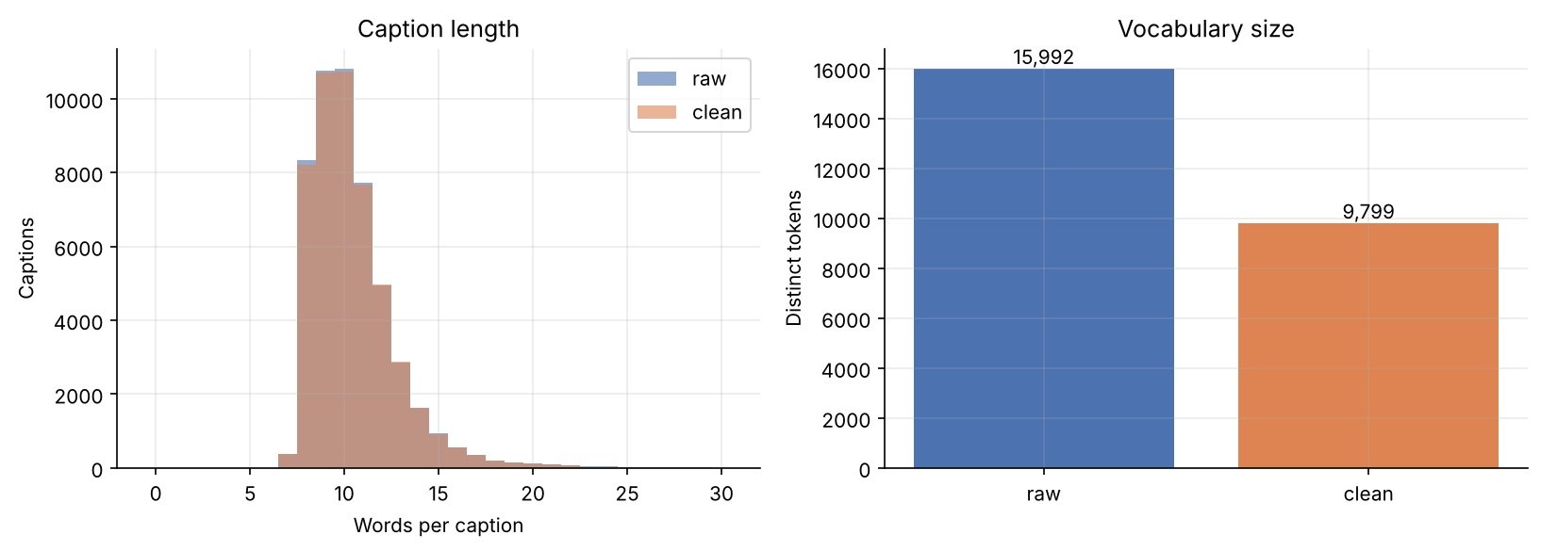
Figure 1. Caption length distribution and vocabulary size, before and after preprocessing.

7.2 Object classes
The detector reports all 80 COCO classes. The most frequent are person (24,670 detections, 31.5%, present in 6,051 images), car (3,942), chair (3,352), bottle (2,160) and cup (2,040). Person alone represents almost a third of all detections, so the metadata is more reliable for frequent classes than for rare ones. Figure 2 shows the 50 most frequent classes (log scale).
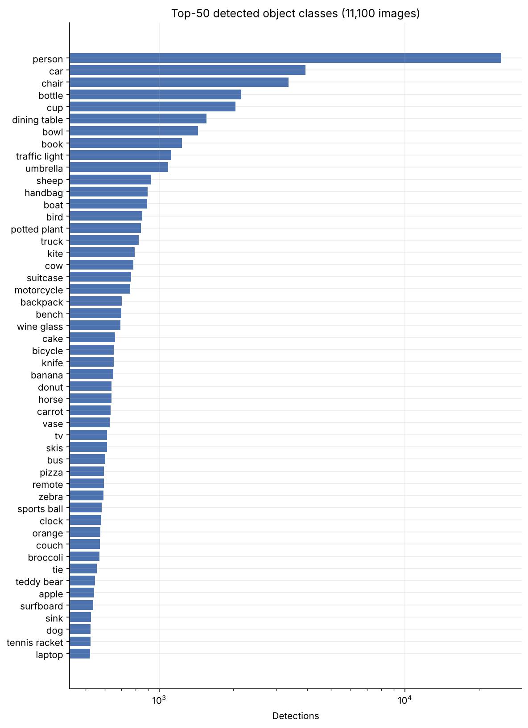
Figure 2. Top-50 detected object classes.

7.3 Scene complexity
Images contain on average 7.06 detected objects (median 5, maximum 77) and 2.9 distinct classes. The test set follows its stratification: the mean number of detected objects is 2.31 for the simple stratum, 5.44 for the medium and 13.68 for the complex one, which confirms that the detector-based counts agree with the annotation-based stratification.
Split | 0 | 1–3 | 4–7 | 8–12 | 13+ | Objects per image
kb | 0.8 | 39.4 | 26.7 | 16.3 | 16.8 | % of images in each bucket
val | 2.0 | 38.0 | 31.0 | 11.0 | 18.0
test | 0.2 | 33.2 | 35.8 | 16.8 | 14.0

Table 8. Scene complexity (percentage of images per bucket of detected objects).
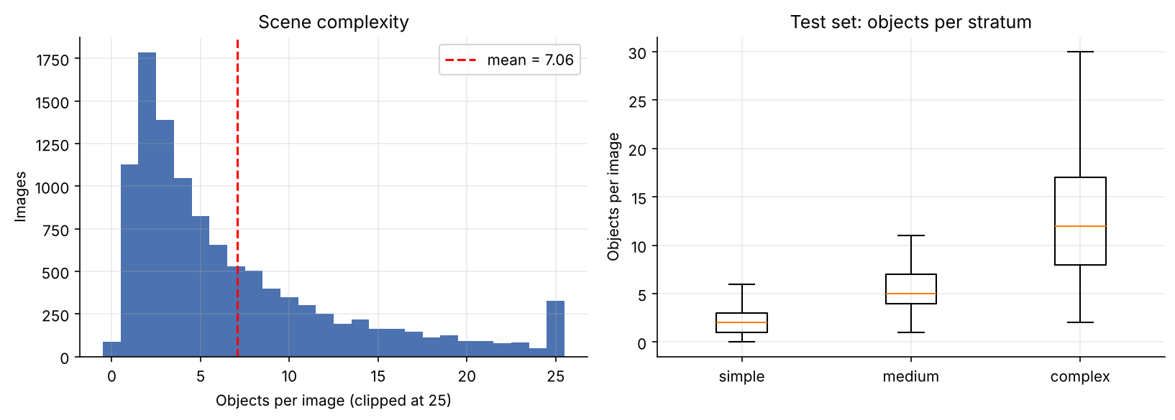
Figure 3. Objects per image (left) and per test stratum (right).

7.4 Detection confidence and object size
Detection confidence has a mean of 0.646 and a median of 0.682; 32.7% of detections lie between 0.25 and 0.5, 24.7% between 0.5 and 0.75 and 42.5% at 0.75 or above. Raising the threshold quickly reduces coverage, which justifies the permissive 0.25 choice for a retrieval-oriented use of the metadata: at 0.9 only 1.29 objects per image remain and 2,724 images have no object. By COCO size convention, 22.6% of detections are small, 39.8% medium and 37.7% large.
Confidence filter | Objects kept | Mean objects / image | Images without objects | Classes kept
>= 0.25 (used) | 78,381 | 7.06 | 88 | 80
>= 0.5 | 52,714 | 4.75 | 176 | 80
>= 0.7 | 37,692 | 3.40 | 391 | 80
>= 0.9 | 14,345 | 1.29 | 2,724 | 80

Table 9. Sensitivity of the object metadata to the confidence threshold.
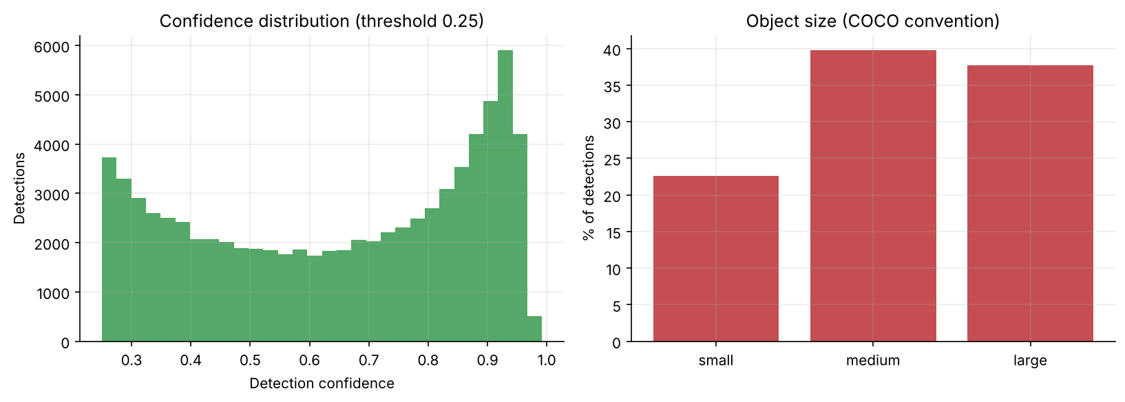
Figure 4. Confidence distribution and object size distribution.

7.5 Co-occurrence of classes
Figure 5 shows how often the 20 most frequent classes appear together in the same image. The most frequent pairs are person–car (845 images), person–chair (766), person–dining table (591), chair–dining table (528) and cup–dining table (512), which reflects everyday street and dining scenes.
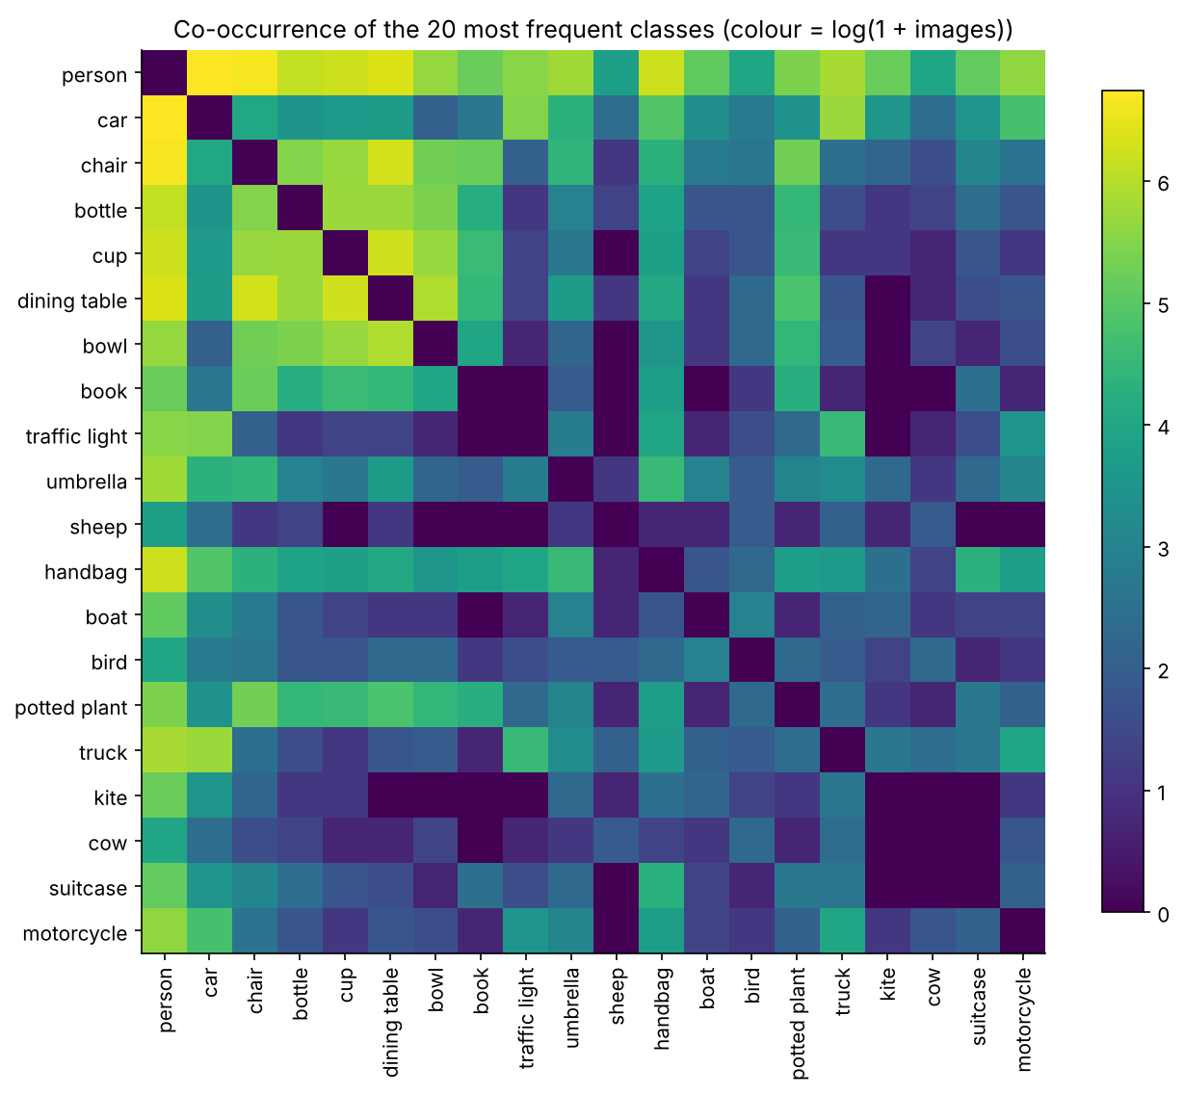
Figure 5. Co-occurrence matrix of the 20 most frequent classes (colour = log(1 + number of images)).

7.6 Spatial relationships
Spatial relations are computed from the bounding boxes of detections with confidence ≥ 0.5 (at most the 12 most confident objects per image; 149,261 object pairs in total). The relation of object A with respect to B is inside or contains when at least 80% of the smaller box lies in the larger one, overlaps when IoU ≥ 0.05, and otherwise above, below, left_of or right_of along the dominant axis between box centres. For two objects of the same class the direction is arbitrary, so their relation is made symmetric (beside, stacked, nested) and reported separately.
Pair type | Relation | Pairs | Share within type
Different class | right_of / left_of | 24,603 / 24,397 | 28.7% / 28.5%
Different class | below / above | 11,629 / 10,182 | 13.6% / 11.9%
Different class | overlaps | 6,497 | 7.6%
Different class | inside / contains | 4,252 / 4,128 | 5.0% / 4.8%
Same class | beside | 46,659 | 73.4%
Same class | stacked | 8,201 | 12.9%
Same class | overlaps / nested | 6,943 / 1,770 | 10.9% / 2.8%

Table 10. Spatial relations between object pairs.
Horizontal relations dominate (57% of different-class pairs) and objects of the same class are mostly side by side (e.g. person beside person: 26,474 pairs; car beside car: 2,639), which is typical of crowds and parked vehicles. These relations can serve as additional metadata for the later phases.
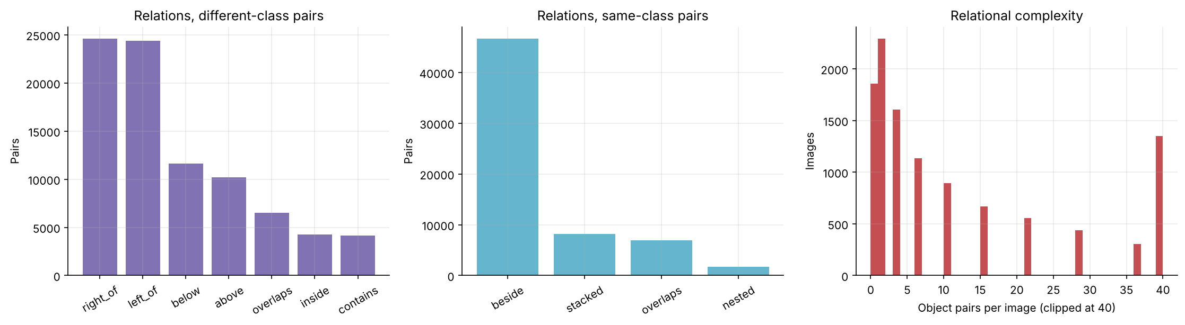
Figure 6. Spatial relations (different-class and same-class pairs) and number of pairs per image.

7.7 Diversity: attributes and context
The images are not stored in the repository, so attributes are estimated from the cleaned captions (and, for indoor/outdoor, also from the detected classes). They are weak labels: an image counts only when its captions explicitly mention the attribute, so the percentages are lower bounds on the true frequencies and describe the diversity of the data rather than ground truth.
- Colours. White is mentioned for 20.4% of images, followed by black (10.8%), red (9.0%), blue (7.8%), green (7.5%) and brown (5.4%).
- Context. About 36% of images are labelled indoor and 56% outdoor (7–8% unclear); the proportions are very similar in the three splits (indoor: kb 35.7%, val 37.0%, test 36.2%), which suggests that the test set is not biased towards one context.
- Time of day. Only about 6% of images mention day or night explicitly (kb: 3.5% day, 2.6% night), so the day/night distribution cannot be estimated reliably from captions.
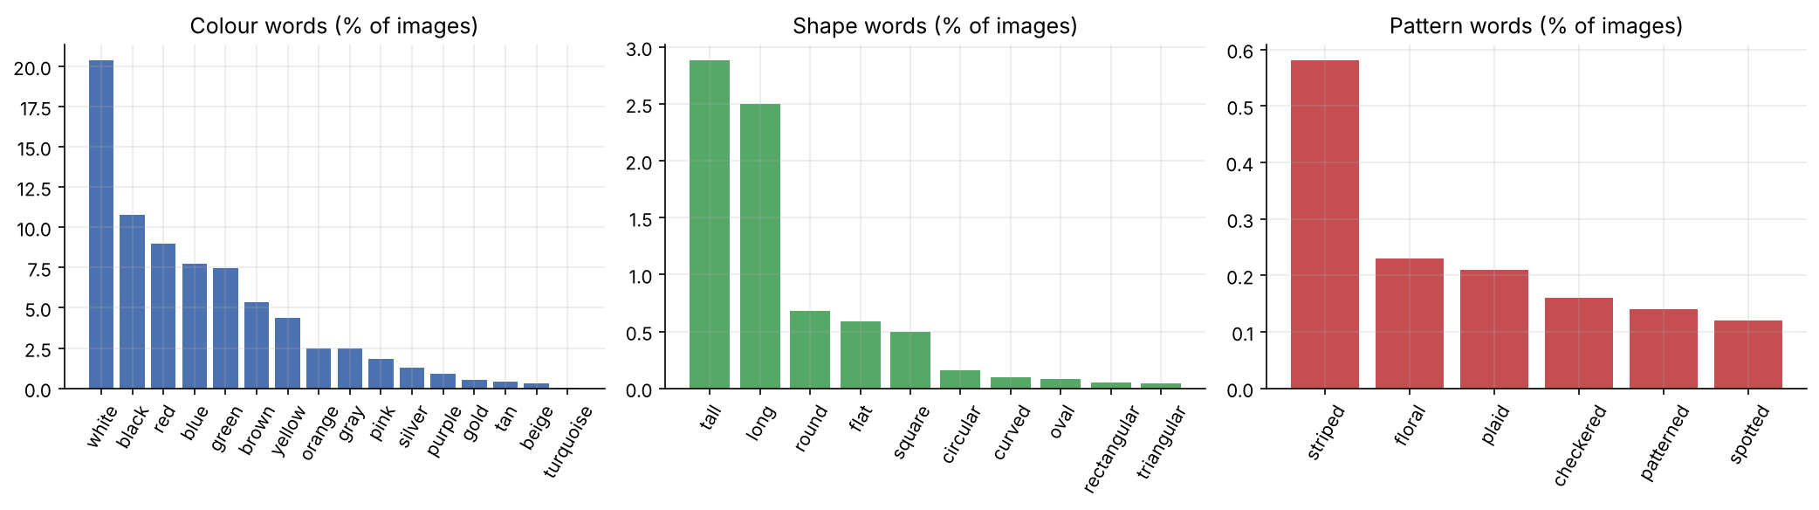
Figure 7. Colour, shape and pattern words (percentage of images whose captions mention them).
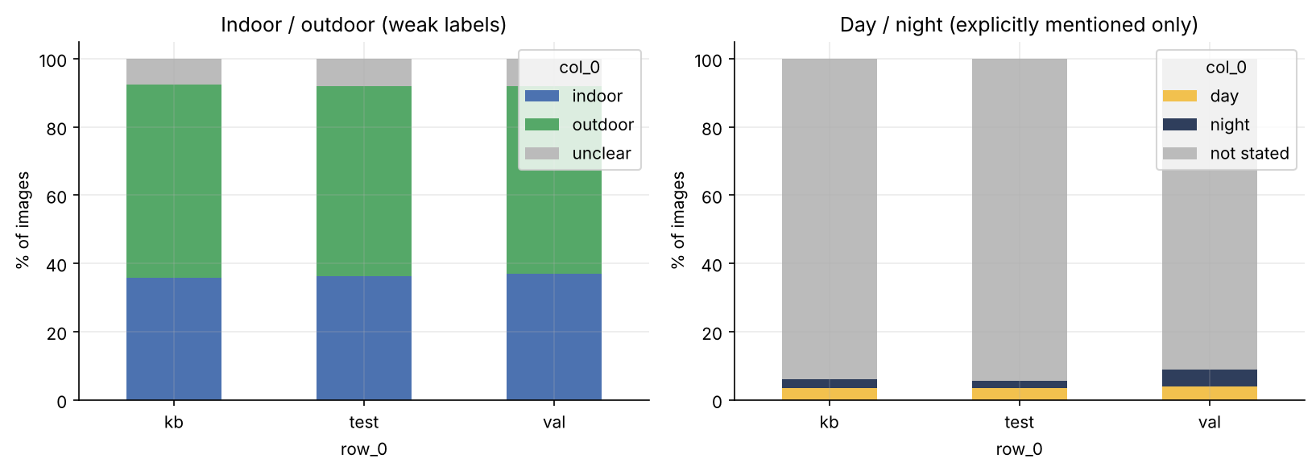
Figure 8. Indoor/outdoor and day/night labels per split (weak labels).

7.8 Scene complexity and caption length
A scatter plot of detected objects per image against mean caption length (Figure 9) shows an almost flat relation: Pearson r = 0.093, with a slope of only 0.017 words per additional object (10,000 knowledge-base images). Annotators write captions of similar length whatever the number of objects, so many objects of a complex scene are not mentioned in the captions. This is a useful warning for caption evaluation, since reference captions describe only part of the scene.
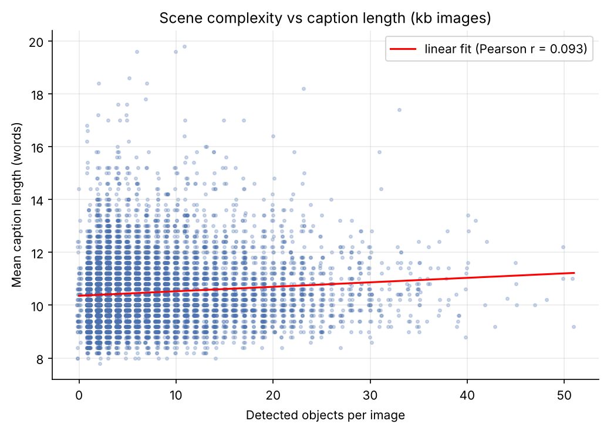
Figure 9. Detected objects per image versus mean caption length (knowledge-base images).

7.9 Part-of-speech distribution
Figure 10 and Table 11 give the part-of-speech distribution of 10,000 sampled cleaned captions (104,451 tagged tokens, NLTK tagger, simplified to ten classes). Captions are dominated by nouns (35.5%), followed by determiners (21.0%), prepositions (17.1%), verbs (11.7%) and adjectives (8.2%); these five classes cover 93.4% of the tokens, while adverbs (0.65%) are almost absent. The high noun share is consistent with captions that mainly name the objects and the scene, while verbs and prepositions typically express actions and spatial relations. For BM25, determiners and prepositions (38.0% of the tokens) are very frequent function words that receive a low inverse document frequency, so the content words (nouns, verbs and adjectives, 55.4%) will carry most of the score; whether explicit stopword removal changes the results is left to the retrieval phase. Tagging was applied to the cleaned (lowercase, unpunctuated) captions, so a few ambiguous words may be mis-tagged.
Part of speech | Tokens | Share (%)
Noun | 37,084 | 35.50
Determiner | 21,903 | 20.97
Preposition | 17,821 | 17.06
Verb | 12,213 | 11.69
Adjective | 8,580 | 8.21
Conjunction | 2,467 | 2.36
Pronoun | 1,385 | 1.33
Numeral | 1,282 | 1.23
Other | 1,042 | 1.00
Adverb | 674 | 0.65
Table 11. Part-of-speech distribution (NLTK tagger, 10,000 sampled cleaned captions).
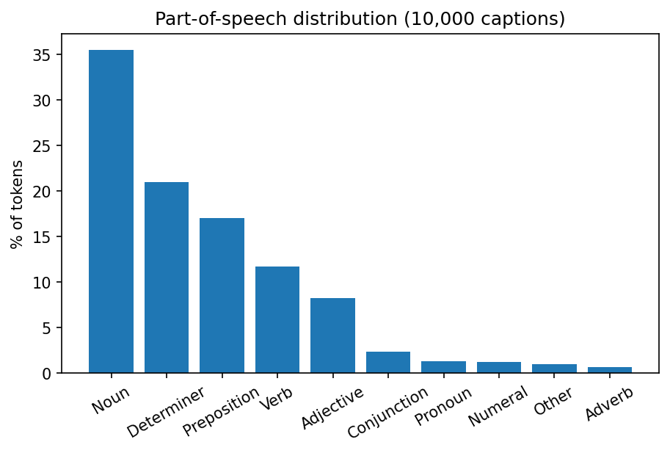
Figure 10. Part-of-speech distribution of 10,000 sampled cleaned captions (share of tokens).

8. Embeddings and Vector Knowledge Base

8.1 Encoders
Component | Model | Dim. | Role
Text encoder | sentence-transformers/all-MiniLM-L6-v2 (SBERT; Reimers and Gurevych, 2019) | 384 | Semantic text embeddings of captions; compact and fast
Image / text encoder | OpenCLIP ViT-B-32 (laion2b_s34b_b79k; Radford et al., 2021) | 512 | Shared image–text space for text-to-image and image-to-image retrieval

Table 12. Encoders.
All vectors are L2-normalised before saving and indexing, so that inner product equals cosine similarity. Embeddings were generated with batch size 128 and saved as .npy files in embeddings/: kb_sbert_text_embeddings.npy (10,000 × 384), kb_clip_text_embeddings.npy (10,000 × 512), kb_clip_image_embeddings.npy (10,000 × 512) and kb_image_ids.npy. The file kb_mapping.json/csv links every vector to its image ID, caption and metadata summary (number of detected objects and classes).
One caption per image (the first, replaced by a non-leaking caption when it was excluded; 75 captions were replaced) represents the visual scene in the dense knowledge base. The lexical BM25 index of the next phase will use all 49,777 retained captions.

8.2 Vector indexes
For 10,000 vectors we use exact flat inner-product indexes (faiss.IndexFlatIP; Johnson et al., 2021) rather than approximate ones (IVF, HNSW): they guarantee exact search without quantisation noise or extra hyperparameters, and search time is negligible at this scale.
Index | File | Dim. | Vectors | Size (MB) | Build time (s)
SBERT captions | kb_sbert_flat_ip.index | 384 | 10,000 | 15.4 | 0.037
CLIP captions | kb_clip_text_flat_ip.index | 512 | 10,000 | 20.5 | 0.020
CLIP images | kb_clip_image_flat_ip.index | 512 | 10,000 | 20.5 | 0.019

Table 13. FAISS indexes (type: flat; metric: cosine similarity via inner product). Parameters and versions are stored in index/index_config.json.

8.3 Quality control and retrieval sanity check
Quality control found no NaN or infinite values, no zero vectors, 10,000 unique image IDs, and vector order identical to the ID file. The embedding matrices and index files were checked for the expected shapes and sizes. For the retrieval sanity check, validation captions were used as queries against the knowledge-base index (top-3). Retrieved captions were semantically consistent with the queries: for example, the query "A bathroom with blue walls, a toilet, and sink." retrieved "A bathroom with a blue shower curtain and blue walls." (cosine 0.84) as first result. As the queries are validation captions and the exclusion list was applied, no test caption or test image can appear in the results.

9. Quality Control Summary
Check | Result | Where
Split sizes kb / val / test | 10,000 / 100 / 1,000 | splits/split_meta.json
ID and content overlap between splits | 0 | report/leakage_audit.json
Test / val captions found in cleaned kb | 0 / 0 | report/caption_leakage_stats.json
Excluded kb captions | 223 (218 images) | splits/excluded_captions.json
Empty cleaned captions | 0 | data/captions_processed_v1.1.json
Metadata records match split IDs | 11,100, no duplicates | data/metadata.json
NaN / Inf in embeddings | 0 | embeddings/
Duplicate IDs in index | 0 | embeddings/kb_image_ids.npy
Frozen ID files reproducible (SHA-256) | Yes | src/make_splits.py

Table 14. Summary of validation checks.

10. Limitations
- MD5 hashes detect only byte-identical images; near-duplicates (resized or re-encoded copies) are not detected, and content checks cover the 11,100 selected images only.
- The caption audit detects identical captions after normalisation; paraphrases with the same meaning are not detected. The exclusion removes 0.45% of the knowledge-base captions.
- Test stratification uses only the number of annotated objects; other aspects (interactions, context) are described in the exploration but not controlled.
- The detector knows only the 80 COCO classes, its detections were not manually verified or compared with COCO instance annotations, and about a third have confidence below 0.5. The 0.25 threshold is a choice, not ground truth.
- Colour, shape, indoor/outdoor and day/night statistics are weak labels derived from captions and object classes, not from image content.
- The dense knowledge base indexes one caption per image, while the BM25 index will use all retained captions.
- A single random seed was used, so the splits represent one sample of possible selections.

11. Conclusion and Next Steps
Phase 1 delivers a frozen, audited and reproducible dataset (release v1.1): 10,000 knowledge-base images with 49,777 retained captions, 100 validation images, 1,000 stratified test images, object metadata extracted from the images, dense embeddings and FAISS indexes. The main finding is methodological: the image-level audit found no problem, but the caption-level audit revealed that 9.1% of test images had a caption also present in the knowledge base, which would have inflated BM25 scores. It was corrected without changing the splits.
The next phases (model training and validation, deadline 2 December 2026; model evaluation, 21 December 2026) will build the BM25 index on the cleaned captions, run the baseline without RAG and the BM25 RAG pipeline, tune top-k and the other hyperparameters on the 100 validation images, and evaluate on the test set with the required metrics, hallucination analysis, statistical tests and ablations.

Appendix A. Team Contributions and Reproduction
Member | Role | Main contributions
[Member 1] | Data and splits | Data audit, frozen splits, anti-leakage audit, exclusion list, src/ scripts,this report
[Member 2] | Preprocessing and metadata | Caption cleaning, YOLOv8m object extraction, captions_processed_v1.1.json, metadata.json, detector documentation
[Member 3] | Embeddings and knowledge base | SBERT and OpenCLIP embeddings, FAISS indexes, mapping, retrieval sanity check
[Member 4] | Exploration and repository | Statistical exploration, figures, README, requirements,

Table A1. Contributions per member (fill in names).
Reproduction. Install the dependencies with pip install -r requirements.txt. Run notebooks/data-audit-and-splits-01.ipynb (or src/make_splits.py) for the splits, notebooks/02-preprocessing-and-metadata.ipynb for captions and metadata (Kaggle GPU recommended), notebooks/03_embeddings_and_retrieval_sanity_check.ipynb for embeddings and indexes (it requires splits/excluded_captions.json), and exploration/exploration_analysis.ipynb for all statistics and figures.

