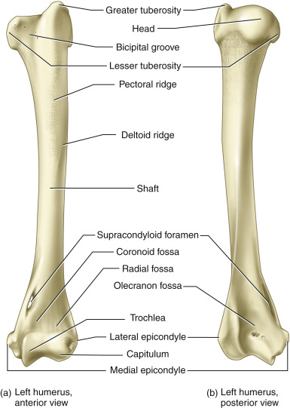  LM | Definition
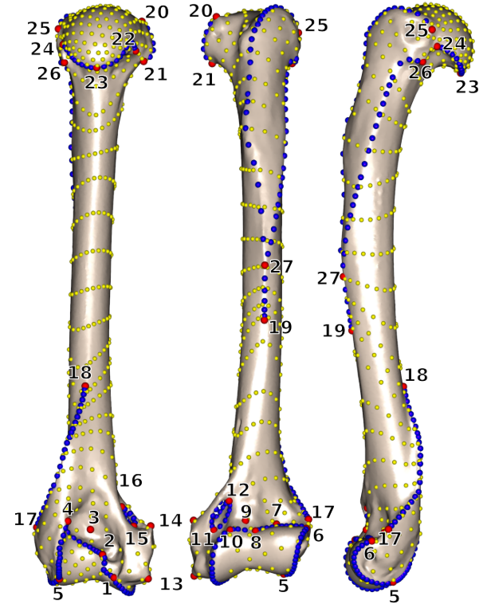  1 | Most disto-medial point of the trochlea
2 | Most medio-proximal point of the caudal side of the trochlea
3 | Point of maximum of curvature of the olecranon fossa
4 | Most latero-proximal point of the caudal side of the trochlea
5 | Most distal point of contact between the trochlea and the capitulum
6 | Most latero-proximal point of the cranial side of the capitulum
7 | Point of maximum of curvature of the radial fossa
8 | Maximum concavity of the cranial margin of the trochlea
9 | Point of maximum of curvature of the coronoid fossa
10 | Most medio-proximal point of the cranial side of the trochlea
11 | Most distal point of the cranial side of the supracondylar foramen
12 | Most proximal side of the cranial side of the supracondylar foramen
13 | Most distal tip of the medial epicondyle
14 | Most proximal tip of the medial epicondyle
15 | Most distal point of the caudal side of the supracondylar foramen
16 | Most proximal point of the caudal side of the supracondylar foramen
17 | Most disto-cranial point of the lateral epicondylar crest
18 | Most proximal point of the lateral epicondylar crest
19 | Most distal point of the deltopectoral crest
20 | Upper tip of the lesser tuberosity
21 | Most disto-medial point of the lesser tuberosity
22 | Most medio-caudal point of contact between the lesser tuberosity and humeral head
23 | Disto-caudal tip of the humeral head
24 | Latero-caudal point of contact between the greater tuberosity and the humeral head
25 | Most antero-proximal point of the greater tuberosity crest
26 | Tip of the tuberosita teres minor
27 | Contact point between tricipital line and greater trochanter crest
28
29
CV | Init LM | Term LM | No Pts | CV | Init LM | Term LM | No Pts
1 | 1 | 2 |  | 10 | 15 | 16
2 | 2 | 4 |  | 11 | 16 | 15
3 | 4 | 5 |  | 12 | 17 | 18
4 | 5 | 6 |  | 13 | 20 | 21
5 | 6 | 8 |  | 14 | 22 | 23
6 | 8 | 10 |  | 15 | 23 | 24
7 | 10 | 1 |  | 16 | 25 | 27
8 | 11 | 12 |  | 17 | 26 | 27
9 | 12 | 11 |  | 18 | 27 | 19

