Melanoma Classification
Deep Learning Project Report

Machine Learning and Data Mining 2 (MLDM2) · FS26
Natalie Jakab · Gwendoline Vocat · Sarruja Sabesan

This report documents the development of a deep learning pipeline for automated melanoma classification using the SIIM-ISIC Melanoma Classification 2020 dataset. The task involves multimodal data (skin lesion images combined with clinical patient metadata) and a severe class imbalance of approximately 2% positive cases. We implement and compare a multimodal model against an image-only baseline, with a focus on architecture decisions, class imbalance handling, threshold analysis, and clinical interpretation of results.

Table of Contents
1. Problem Statement 3
2. Dataset 3
2.1 Overview 3
2.2 Train / Val / Test Split 3
3. Data Preprocessing & Feature Engineering 3
3.1 Image Preprocessing 3
3.2 Metadata Feature Engineering 4
4. Model Architecture 4
4.1 Multimodal Model 4
4.2 Baseline Model (Image-Only) 5
4.3 Training Configuration 5
5. Handling Class Imbalance 6
5.1 Weighted Loss Function 6
5.2 Weighted Random Sampler 6
5.3 pos_weight Hyperparameter Search 6
6. Evaluation & Results 6
6.1 Multimodal vs. Baseline (Threshold = 0.50) 6
6.2 Threshold Analysis 7
6.3 Error Analysis 7
7. Discussion 9
7.1 Multimodal vs. Baseline 9
7.2 Class Imbalance 9
7.3 Limitations 9
7.4 Future Work 9
8. Conclusion 9
References 10

1. Problem Statement
Melanoma is the most dangerous form of skin cancer. Early and accurate detection is critical for patient outcomes, as survival rates drop significantly with late-stage diagnosis. The SIIM-ISIC 2020 competition provides a curated dataset of dermoscopic skin lesion images alongside structured patient metadata, making it an ideal benchmark for multimodal deep learning research.
The primary challenge is a severe class imbalance: approximately 98% of samples are benign (non-cancerous) and only ~2% are malignant (melanoma). Standard accuracy metrics are therefore misleading. A model predicting "benign" for every sample achieves 98% accuracy which makes it clinically useless. This motivates the use of AUC-ROC as the primary metric and careful threshold selection informed by clinical priorities.
In a medical context, False Negatives (missed melanomas) are far more harmful than False Positives (unnecessary follow-up). This asymmetry directly influences our choice of loss function, sampling strategy, and classification threshold.

2. Dataset

2.1 Overview
We use the SIIM-ISIC Melanoma Classification 2020 dataset, accessed via Kaggle. Due to the large size of the original dataset (~116 GB), we use a pre-processed version with images resized to 224x224 pixels (~3.5 GB). The dataset contains 33’126 training samples with labels.

Property | Value
Total training samples | 33’126
Positive cases (melanoma) | 584 (1.76%)
Negative cases (benign) | 32’542 (98.24%)
Image resolution | 224 x 224 pixels (RGB)
Metadata features | Age, sex, anatomical site
Split (train / val / test) | 70% / 15% / 15% — stratified
Table 1: Dataset overview – SIIM-ISIC Melanoma Classification 2020

2.2 Train / Val / Test Split
To ensure a representative distribution of melanoma cases across all subsets, we applied stratified splitting. Since only 1.76% of samples are positive, a purely random split could result in validation or test sets with very few or even zero melanoma cases, making evaluation unreliable. Our final split is 70% training (23’188 samples), 15% validation (4’969), and 15% test (4’969), each maintaining the original class ratio.
All preprocessing parameters are fitted exclusively on the training set and then applied to the validation and test sets to prevent data leakage and ensure unbiased evaluation.

3. Data Preprocessing & Feature Engineering

3.1 Image Preprocessing
All images are resized to 224x224 pixels to match the input requirements of the EfficientNet-B0 backbone. Pixel values are normalized using ImageNet statistics (mean=[0.485, 0.456, 0.406], std=[0.229, 0.224, 0.225]), since the backbone was pretrained on ImageNet.
During training, the following augmentations are applied to improve generalization:

- random horizontal and vertical flips
- random rotation (±15°)
- color jitter

No augmentation is applied during validation or testing to ensure fair evaluation.

3.2 Metadata Feature Engineering
Three clinical features are extracted and encoded as numerical vectors for the metadata branch of the model:
Feature | Encoding | Dim
Age (age_approx) | Min-max normalization [0,1] — fitted on training set only | 1
Sex | One-hot encoding: male=[1,0], female=[0,1] | 2
Anatomical site | One-hot: torso, lower/upper extremity, head/neck, palms/soles, oral/genital | 6
Table 2: Metadata feature encoding and dimensionality
Missing values are filled with 0 before encoding. Age normalization bounds are computed on the training set only, then reused for validation and test preprocessing.

4. Model Architecture

4.1 Multimodal Model
Our main model processes image and metadata in parallel branches before fusing them into a single classification head. The multimodal design allows image and clinical metadata features to be processed separately before fusion. EfficientNet-B0 was selected as the image backbone due to its strong performance-efficiency trade-off for medical image classification and its effectiveness under limited computational resources compared to larger CNN architectures. Figure 1 illustrates the overall multimodal architecture, while Table 3 summarizes the individual branch components and output dimensions.
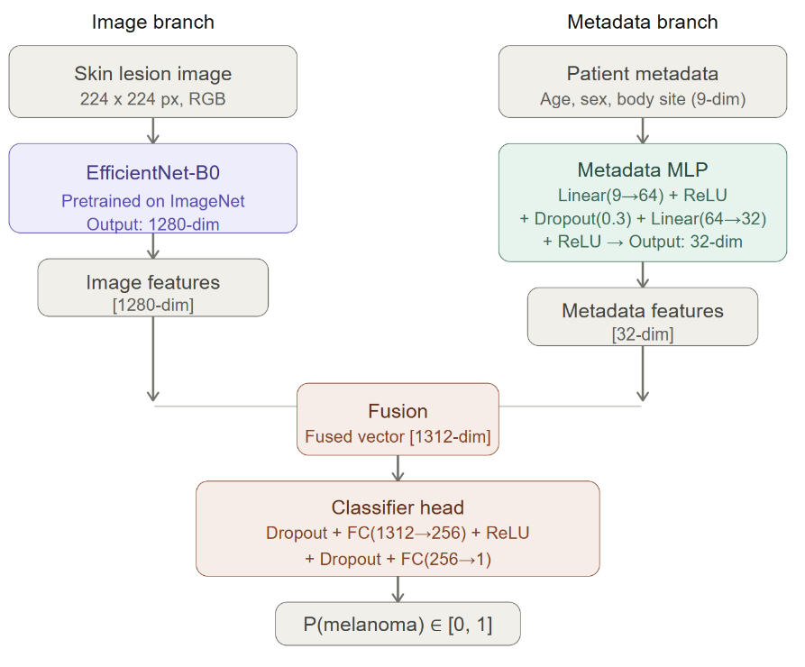
Figure 1: Multimodal model architecture
Branch | Component | Output Dim
Image | EfficientNet-B0 (pretrained ImageNet) | 1’280
Metadata | MLP: Linear(9→64) + ReLU + Dropout(0.3) + Linear(64→32) + ReLU | 32
Fusion | Concatenation of image + metadata features | 1312
Classifier | Dropout(0.3) + Linear(1312→256) + ReLU + Dropout(0.3) + Linear(256→1) | 1 (logit)
Output | Sigmoid → probability [0, 1] | —
Table 3: Multimodal model architecture – branch components and output dimensions
Total trainable parameters: ~4.2M. The EfficientNet-B0 backbone uses pretrained ImageNet weights and is fine-tuned end-to-end, improving convergence and generalization despite the limited number of positive samples. An alternative projected feature fusion architecture was also explored, where image features were projected to a lower-dimensional representation before concatenation in order to balance image and metadata contributions. However, it achieved lower validation AUC and was therefore not used for the final model.

4.2 Baseline Model (Image-Only)
For comparison, we train an image-only baseline using the same EfficientNet-B0 backbone. The metadata branch is removed and the 1’280-dimensional image feature vector is passed into a classifier head (Dropout → Linear(1280→256) → ReLU → Dropout → Linear(256→1)). This allows us to isolate the contribution of clinical metadata to model performance.

4.3 Training Configuration
Hyperparameter | Value
Loss function | BCEWithLogitsLoss with pos_weight=50
Optimizer | Adam, lr = 1e-4
Batch size | 32
Max epochs | 30 stopped at 7 (patience=5)
Sampler | WeightedRandomSampler (oversamples positives)
Dropout | 0.3
Hardware | NVIDIA T4 GPU (LightningAI)
Framework | PyTorch Lightning
Table 4: Training configuration and hyperparameters
The training history confirms stable convergence: train loss decreases consistently across all steps, while validation AUC-ROC plateaus around 0.90 after approximately 6 epochs. The increasing validation loss alongside stable AUC suggests the model begins to overfit in later epochs, which justifies the early stopping strategy used during training.
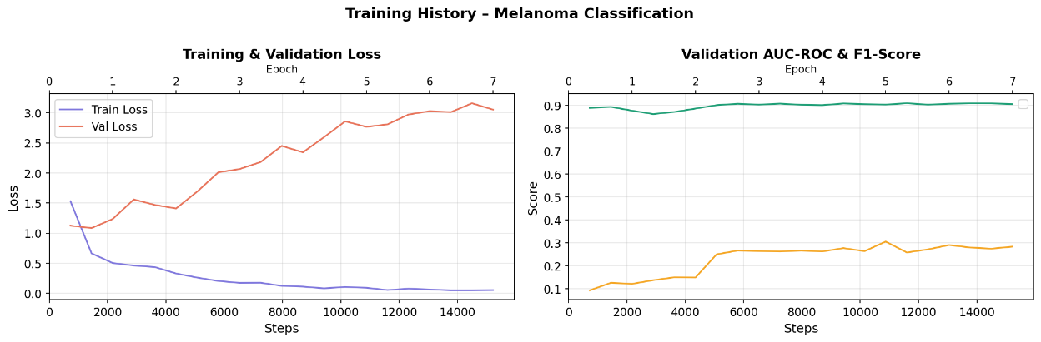
Figure 2: Training and validation loss (left) and validation AUC-ROC & F1-Score (right) for the multimodal model.

5. Handling Class Imbalance
With only ~1.76% positive cases, class imbalance is the central challenge of this task. We address it using three complementary strategies: a weighted loss function, oversampling via WeightedRandomSampler, and systematic tuning of the pos_weight hyperparameter.

5.1 Weighted Loss Function
BCEWithLogitsLoss with pos_weight = 50 penalizes missed melanomas (False Negatives) approximately 50 times more heavily than False Positives. This ratio is motivated by the inverse class frequency (98/2 ≈ 49) and by the clinical asymmetry: a missed melanoma has far more severe consequences than an unnecessary follow-up appointment.

5.2 Weighted Random Sampler
During training, melanoma cases are oversampled using PyTorch's WeightedRandomSampler. Each sample is assigned a weight inversely proportional to its class frequency, increasing the likelihood that positive and negative samples are represented more evenly across batches.

5.3 pos_weight Hyperparameter Search
We systematically evaluate three values of pos_weight to understand the Sensitivity–Specificity trade-off:
pos_weight | AUC-ROC | Sensitivity | Specificity | TP | FN | FP
25 | 0.9124 | 0.402 | 0.977 | 35 | 52 | 112
50 (selected) | 0.9126 | 0.632 | 0.932 | 55 | 32 | 331
75 | 0.9182 | 0.598 | 0.939 | 52 | 35 | 297
Table 5: pos_weight hyperparameter search results on the test set
pos_weight = 50 is selected as the preferred configuration, achieving the highest Sensitivity (0.632) and the fewest missed melanomas (FN = 32). Although pos_weight = 75 yields a marginally higher AUC (0.9182), it detects three fewer melanomas, which is clinically undesirable.

6. Evaluation & Results

6.1 Multimodal vs. Baseline (Threshold = 0.50)
Both models are evaluated on the held-out test set. AUC-ROC is used as the primary evaluation metric because it is threshold-independent and robust to severe class imbalance.
The multimodal model achieves higher AUC-ROC and Sensitivity, meaning it detects more melanoma cases correctly. The baseline achieves marginally better Specificity and F1-Score. Overall, image features remain the dominant source of predictive information, while clinical metadata provide a small but consistent performance improvement. This observation is consistent with findings reported in the literature on this dataset.
Metric | Multimodal | Baseline (image only)
AUC-ROC | 0.9126 | 0.9090
F1-Score | 0.2326 | 0.2374
Sensitivity (Recall) | 0.6322 | 0.6207
Specificity | 0.9322 | 0.9357
True Positives (TP) | 55 | 54
False Negatives (FN) | 32 | 33
False Positives (FP) | 331 | 314
Table 6: Multimodal vs. baseline model performance at threshold = 0.50
The relatively low F1-scores (0.23) despite high AUC (0.91) are a direct consequence of the severe class imbalance. F1 is sensitive to the absolute number of True Positives, which remains low when only ~1.76% of samples are positive. AUC, being threshold-independent, better reflects the model's true discriminative ability under such imbalance.
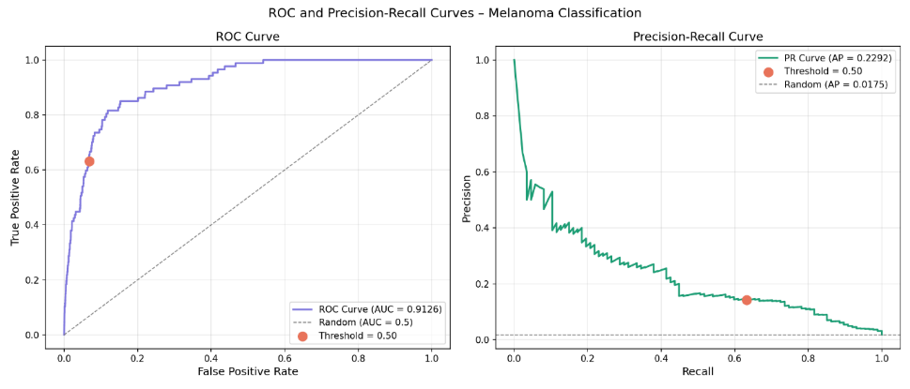
Figure 3: ROC Curve (left) and Precision-Recall Curve (right) of the multimodal model on the test set

6.2 Threshold Analysis
The default threshold of 0.50 is not necessarily optimal for medical screening. By lowering the threshold, we accept more False Positives in exchange for fewer missed melanomas. The table below shows this trade-off for the multimodal model:
Threshold | Sensitivity | Specificity | F1-Score | TP | FN | FP
0.05 | 0.782 | 0.894 | 0.202 | 68 | 19 | 517
0.10 | 0.736 | 0.907 | 0.212 | 64 | 23 | 452
0.20 | 0.736 | 0.917 | 0.229 | 64 | 23 | 407
0.30 | 0.701 | 0.922 | 0.230 | 61 | 26 | 382
0.50 (default) | 0.632 | 0.932 | 0.233 | 55 | 32 | 331
Table 7: Threshold analysis – sensitivity-specificity trade-off for the multimodal model
At threshold 0.05, Sensitivity reaches 0.782. The model detects 68 out of 87 melanomas. In a real-world screening scenario, thresholds of 0.05 – 0.10 would be preferred because missing a melanoma has life-threatening consequences, while a false alarm results only in a follow-up biopsy.

6.3 Error Analysis
False Positives tend to be atypical benign lesions with irregular pigmentation or borders that visually resemble melanoma. False Negatives are the most clinically critical errors, often appearing as early-stage melanomas with subtle visual features. Lowering the classification threshold reduces the number of False Negatives but increases false alarms.
Figure 4 reveals systematic error patterns across body site and model confidence. False Negatives (missed melanomas) occur most frequently on the torso, upper extremity, and lower extremity body sites, which also contain the majority of melanoma cases in the dataset. This suggests that these errors primarily reflect lesion difficulty rather than a systematic body-site-specific bias. The confidence histogram further highlights that many False Negatives cluster near very low predicted probabilities (p ≈ 0.00), meaning the model was highly confident in its incorrect benign prediction. These highly confident misses represent the most clinically dangerous prediction errors.
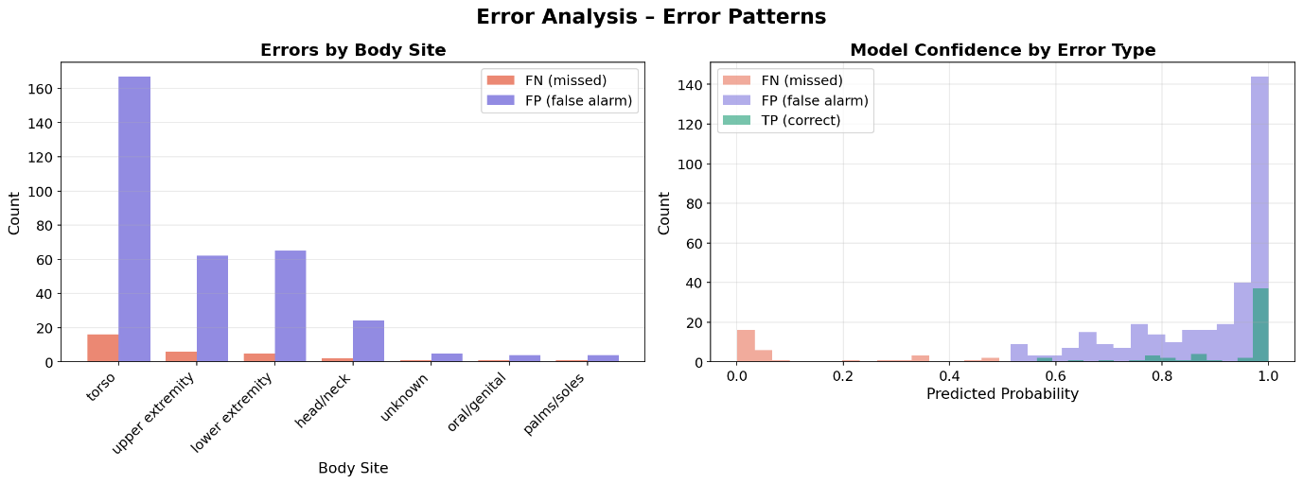
Figure 4: Error pattern analysis by body site and model confidence
Figure 5 shows the most confidently misclassified images. False Negatives (top row) often present as subtle, early-stage lesions with uniform coloration and regular borders. False Positives (bottom row) tend to be atypical benign lesions with irregular pigmentation, asymmetric borders, or dark pigment clusters that visually mimic melanoma. These patterns highlight the inherent difficulty of dermoscopic classification even for trained models, and motivate the use of a lower classification threshold in clinical screening to reduce the number of missed melanomas.
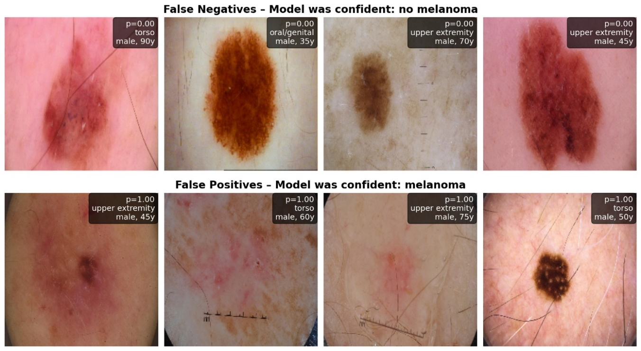
Figure 5: FN examples (top) ; FP examples (bottom)

7. Discussion

7.1 Multimodal vs. Baseline
The multimodal model consistently outperforms the baseline on AUC-ROC and Sensitivity, though the gains are modest. Patient metadata (age, sex, body site) provides complementary signal to image features, but cannot overcome the dominance of visual information in dermoscopy. Finer clinical variables (e.g. lesion history, patient risk factors) might provide stronger multimodal gains.

7.2 Class Imbalance
The combination of pos_weight and WeightedRandomSampler proved effective: the model avoids collapsing to a trivial all-negative prediction while maintaining competitive AUC. The optimal pos_weight of 50 aligns with the inverse class frequency, suggesting that a data-driven initialization of this hyperparameter is a reasonable starting point.

7.3 Limitations
The model does not achieve the target Sensitivity of ≥0.80 at threshold 0.50. The threshold would likely need to be lowered to ~0.05 to approach clinically acceptable recall, at a significant cost to specificity. F1-scores in the 0.20 – 0.24 range reflect the inherent difficulty of this imbalanced task and are consistent with other published solutions on this dataset.
Additionally, due to computational constraints, all results are based on a single stratified train/val/test split rather than cross-validation. While this is common practice for large-scale image datasets, performance estimates may still vary depending on the specific split.

7.4 Future Work
Future work could explore probability calibration to improve threshold reliability, larger EfficientNet variants (B3 – B5) for higher representational capacity, additional clinical features such as lesion history and patient risk factors, and explainability methods such as Grad-CAM to visualize which lesion regions drive model predictions.

8. Conclusion
We developed and evaluated a multimodal deep learning pipeline for melanoma classification combining EfficientNet-B0 image features with clinical metadata. Our model achieves an AUC-ROC of 0.9126, outperforming the image-only baseline (0.9090) and demonstrating that clinical metadata provides consistent marginal improvements.
In summary, this project demonstrates that combining image features with clinical metadata, addressing class imbalance through weighted loss and oversampling, and carefully tuning the classification threshold can provide clinically relevant improvements in melanoma detection. For clinical deployment, we recommend a threshold of 0.05 – 0.10 to maximize Sensitivity and minimize missed melanomas, accepting the associated increase in False Positives as a clinically justified trade-off.
The model is intended as a clinical decision-support tool rather than a replacement for dermatologists.

References
[1] Rotemberg et al. (2021). A patient-centric dataset of images and metadata for identifying melanomas using clinical context. Nature Scientific Data.
[2] Tan, M., & Le, Q. (2019). EfficientNet: Rethinking Model Scaling for Convolutional Neural Networks. ICML.
[3] King, B. et al. (2020). SIIM-ISIC Melanoma Classification. Kaggle Competition.
[4] Falcon, W. et al. (2019). PyTorch Lightning. GitHub.
[5] Pre-processed 224x224 images: https://www.kaggle.com/datasets/arroqc/siic-isic-224x224-images

Table of Figures
Figure 1: Multimodal model architecture 4
Figure 2: Training and validation loss (left) and validation AUC-ROC & F1-Score (right) for the multimodal model. 5
Figure 3: ROC Curve (left) and Precision-Recall Curve (right) of the multimodal model on the test set 7
Figure 4: Error pattern analysis by body site and model confidence 8
Figure 5: FN examples (top) ; FP examples (bottom) 8

Table of Tables
Table 1: Dataset overview – SIIM-ISIC Melanoma Classification 2020 3
Table 2: Metadata feature encoding and dimensionality 4
Table 3: Multimodal model architecture – branch components and output dimensions 5
Table 4: Training configuration and hyperparameters 5
Table 5: pos_weight hyperparameter search results on the test set 6
Table 6: Multimodal vs. baseline model performance at threshold = 0.50 7
Table 7: Threshold analysis – sensitivity-specificity trade-off for the multimodal model 7

