TEAM NAME:- AALIM BOTS

Participant 1:-
Abacus user id:- sarsarahman
Abdurrahman.S
3rd , CSE,
Aalim Muhammed Salegh College of Engineering.
Ph.no:-9840903819
Email-sarsarahman@gmail.com

Participant 2:-
Abacus user id:- azulrox
Abdullah.S.A.K.
3rd , CSE,
Aalim Muhammed Salegh College of Engineering.
Ph.no:-9940064100
Email- cool.azul.jaamm@gmail.com

Softwares used:
- TCWIN45 for C++ Programs.
- Eclipse helios for Java Programs.
===============================================================
Description for all the programs are as follows…..
Q1:
Execution of the loop for given 't' [ t < 1000 ] times, with codes for adding up positive values alone, inside the loop will give the required output.
if(i>=0)
result=result+i;
The variable 'i' [ -1000 <= i <= 1000 ] is the input, if 'i' is positive it wil get added to result ,else it wil be avoided. The output is printed after executing above codes 't' times.
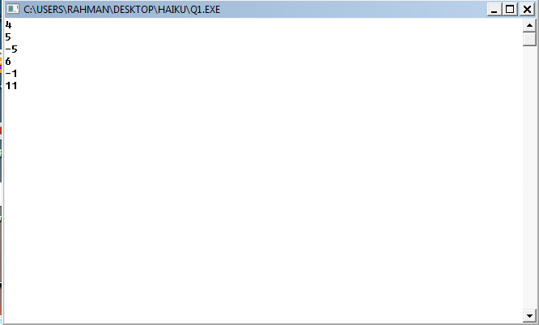

Q2:
For 't' (t<=10000) times, the next power of 2 is found for the given values, by repeatedly finding 'power of 2 values' and comparing it with given input value n(0<=n<=10^9).
for(int k=0;z<=y;k++)
z=pow(2,k);
In the above code, variable 'k' denotes the k’th power of 2,variable 'y' is the given input, variable 'z' holds the power value, thus comparing the 'z' value with 'y' after each execution of the above loop will give us the required output.
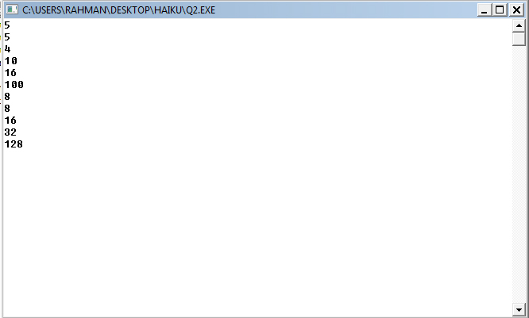

Q3:
For 't' (t<10001) times, the greatest common divisor of the given input values are found by recursively executing the gcd method and print the output.

static int gcd(int a, int b)
{
if(b == 0)
return a;
else
return gcd(b, a % b);
}

Input values a and b are passed as parameters to the gcd method, where if variable 'b' is 0 then it returns 'a' to the calling method,else it recursively calls gcd method with parameters as 'b' and 'a%b'.

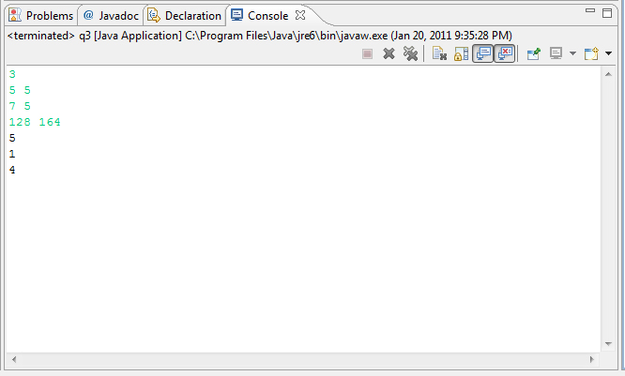
Q4:
For 't' (t<=2000) times, the number of trailing zero's of the factorial of the given input n (0<=n<=10^9) is found by incrementing a temporary variable for each zero's at the end of the factorial value.

There's a method to find the number of zero's in a 'factorial of a number'.

Formula : round(n/5) + round(n/25) + round(n/125)+.......+round(n/5^n)
Here, round function indicates that only the integer part of (n/5^n)
should be taken.

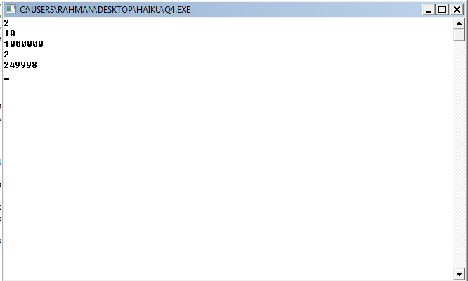

Q5:
For 'z'(1 ≤ Z ≤ 1000) times, the n’th (1 ≤ n ≤ 113) pp value is found by looping a pp snippet for n times.
for(int k=2;j<x;k++)
if(isprime(k)&&ispal(k))
{ pp[j]=k;
j++;}

'x' is the given input, 'j' and 'k' are temporary variables where 'j' is used to check the condition 'j<x' and 'k' is used to find whether it is a pp number or not - using 'isprime()' and 'ispal()' methods, pp[j] is the array to store the j'th pp value, j is incremented until given xth pp value is reached.
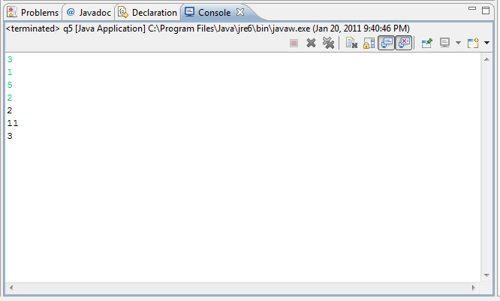

Q6:
For 't' (t<=100) times, the n'th (0<=n<101) line of the Pascal’s triangle is found by repeatedly executing the snippet for pascal triangle.

static void pascal(int last)
{int[] n= new int[101];
for (int i= 0; i <=last; i++) {
n[i]= 1;
for (int j= i; --j > 0; n[j]+= n[j-1]);
for(int j= 0; j <= i; j++)
if(i==last){System.out.print(n[j]+" ");}
}

The parameter 'last' is the line to be found in Pascal’s triangle, the temporary variables 'i' and 'j' run in nested for-loops to find the Pascal’s triangle, where 'i' keeps the count of number of lines in the triangle, if 'i' is equal to 'last' ,then the current values in the n[] array is the required output.
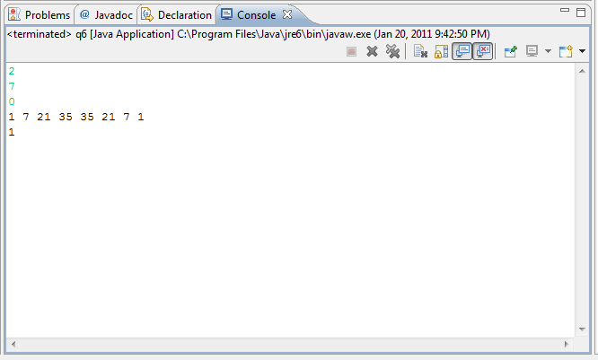

Q7:
For 'N' (n equal to about 100) times, the two input values (positive integers) are reversed and added up, the sum is reversed again by using the reverse method.
static int reverse(int num)
{int reverse=0,remainder;
while(num > 0)
{remainder = num % 10;
reverse = reverse * 10 + remainder;
num = num / 10;
}return reverse;
}

The input value to be reversed is passed as parameter 'num' to reverse method, where the last digit of given value is separated and added up to a new variable repeatedly until all the digits are added to the variable 'reverse' and thus value in the 'num' variable is reversed and returned. Thus both inputs are reversed and returned to the calling method, their sum is again passed to reverse method to get the output.
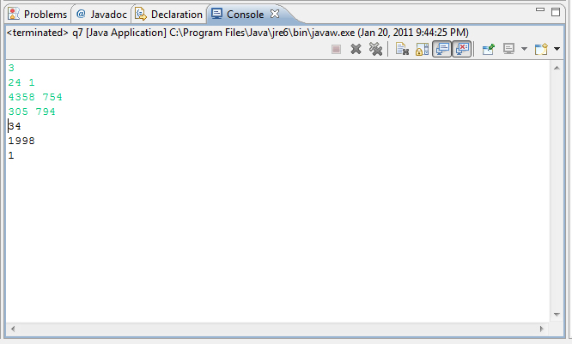

Q8:
For 't' (t<100) times, determination of one string to be anagram of the other is done by comparing the length and each characters present in both the strings where the strings must not be more than100 characters.

static boolean isAnagram(String s1, String s2) {
if (s1.length() != s2.length()) return false;
char [] a1 = s1.toCharArray();
char [] a2 = s2.toCharArray();
for (int i = a1.length - 1; i >= 0; --i)
{int j;
for (j = a2.length - 1; j >= 0; --j)
{if (a1[i] == a2[j]) {a2[j]='#';
break;}
}if (j < 0) return false;
}return true;
}

In the above codes, variable 'a1' and 'a2' store the given strings in array form, for each character in 'a1' the character in 'a2' is compared, and after doing comparison for all the characters in the given string, if ‘j’ is a negative value then the given strings are not anagrams, else they are anagrams.
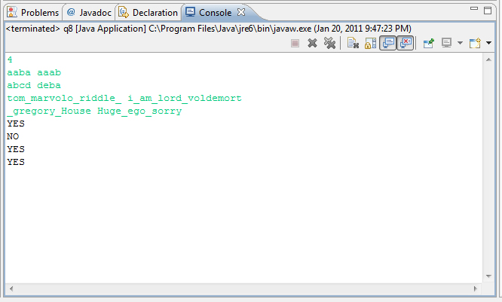

Q9:
For 't' (t<101) lines, the given string is converted into RPN form by applying infix to postfix concepts. The string can consist of two-argument operators: +, -, *, /, ^, brackets ( ) and letters a-z (operands).

The given string is stored in a variable and its characters are read one by one, if its an operand, they are placed in the output, else they are pushed/popped from operator stack by comparing their precision values and sent to the output. After reading all the characters of the given input, the left operators in the operator stack are popped to the output.
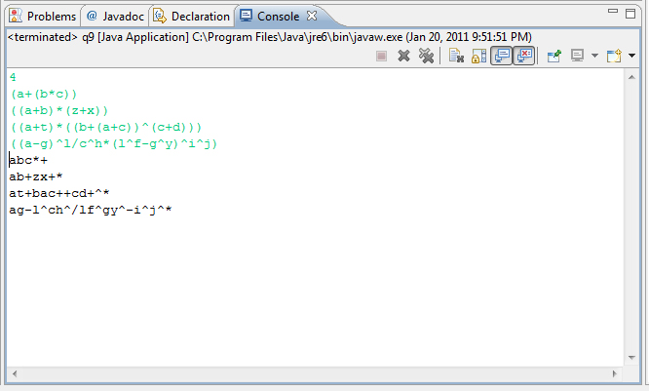

Q10:
For 't' lines, the direction that will be faced after traversing through the input Grid is found by executing the grid snippet. Each line in input must consist of two values indicating row and column values.

The size of the grid is passed as parameter to the Grid method, the direction is found by comparing the grid size values with various conditions like,
'if(m==n)','else if(m>=2&&m>n)','else if(m>=2&&m<=n)' and executing the codes for each conditions where 'm' and 'n' are variables denoting the size of the grid.
