**Split Sensor Communications Network to Monitor Microclimates**

**The Solution to Understanding and Mitigating Climate Change**

By Quotayba Yousif, Irving Becerril, Sarah Scheps, Katy Cable, and Ahmed Fadlalla

**Abstract**

Climate change operates in unpredictable ways, often providing scant clues about its next focal points of impact. Monitoring the weather effectively serves as a strategic guide, directing our attention and resources towards the most severely affected regions of New York State. By pinpointing these areas and devising strategies to mitigate their challenges, we begin to craft solutions that not only address immediate concerns but also preemptively tackle similar issues elsewhere. This approach yields invaluable data insights, reshaping our past practices to safeguard our future. Central to this effort is the development of a modular weather monitoring system, comprised of interchangeable components that allow for seamless adaptation to evolving needs. Such modularity extends to user interaction, where individuals can directly engage with the system by acquiring monitors and interfacing with a central hub. This foundational design enables the expansion of sensor networks across broader regions, enhancing accessibility to localized weather data. Researchers from the New York Department of Environmental Conservation (NYDEC) leverage these central hubs to access real-time weather information, informing their studies and prioritizing areas most vulnerable to the impacts of climate change.

**1. The Problem**

**a. Problem Statement**

The New York State Department of Environmental Conservation needs a better understanding of the impact of climate change on microclimates within New York State so that they can mitigate adverse effects and take appropriate preventative measures.

**b. Problem Introduction**

Climate change poses significant risks to the New York State, impacting public health, safety, and the economy through unpredictable weather patterns. Localized climate data on microclimates could be crucial for mitigating these effects, but current systems either lack accuracy or accessibility. Although such systems like weather satellites up in space help close this information gap, they face limitations such as cost and accessibility.This could hinder the improvement of disaster preparedness, agricultural planning and informing public health advisories directly to the public. Making this data accessible encourages community engagement as well.

**2. Inspiration**

Our design was influenced by existing weather monitoring systems like the Ambient Weather WS-2000 and the AcuRite 75077A3M, which are, themselves, good given their pricing. Some of their functionalities include vast data collection of multiple weather metrics (wind speed/direction, IV radiation intensity, etc.), simple yet informative UI, and long ranges. However, these systems often lack in one or multiple areas. To address these issues, our system emphasizes cost-effectiveness by maintaining our budget under $150 by using affordable and reliable sensors, simplicity in operation, and enhanced weather data due to more accurate monitoring. Our approach aims to make this more affordable and accessible for everyone and make more impactful data available for the scientists at NYDEC. In essence, the system would address critical needs for detailed microclimate monitoring, greater public welfare, and sustainable development through technological innovation.

**3. System Requirements**

**a. Use Case Diagram**

As in Figure 1, a device owner will be able to go to the central monitor to manually check the data. After the information has been processed by the NYSDEC, they’ll be able to go to the application on the monitor to check generalized data by area or specific data graphs for that system. This allows for the NYSDEC to collect all relevant microclimate information and be able to provide an optional service to the clientele.

*****Figure 1: Use Case Diagram showing the system user interaction.*

**b. Functional Requirements**

* **Data Acquisition:** The system must be capable of collecting and processing climate conditions through sensors, enabling users to view and download the data in CSV format.
* **Accuracy:** Testing sensor must adhere to a well-defined and acceptable maximum value of uncertainty (±5%) when compared to other weather data.
* **Communication:** The data acquired must be transmitted to a central unit and to a display via wireless transmission in the form of a comma-separated values file. Transmissions should occur approximately every 10 minutes.
* **Process Data:** The raw data that is being collected by the sensors should go through some type of function/system that transforms them into understandable data.
* **User Interactive Monitor:** The system must have an I/O module for the user to interact with the system to show, manage, share, and download the collected data.

1. **Log In:** The system must give the user the ability to log in to communicate and access the data on the DEC Server.

2. **Display Data:** System must be able to show the processed data values that are being measured by the local device’s sensors and the other devices.

3. **Download Data:** The System must give the authorized users the ability to download and process the data in CSV format,

**c. Non-Functional Requirements**

* **Usability:** The product should be able to be used by regular consumers without technological experience.
* **Maintainability:** Product should give clear trouble shooting messages and effectively indicate which part of the system is affected. Damaged parts must be easily replaced without the need to replace the whole device.
* **Reliability:** Product must be able to function reliably in various weather conditions and temperatures for long periods of time.
* **Upgradability:** NYDEC must have the ability to update and upgrade the system as needed, since unpredictable needs might always arise.

**d. Design Constraints**

* **Budget:** $150
* **Time:** 9 weeks (due 04-29-2024)

**4. System Design**

**a. Design Overview & Justification**

Design 1, as depicted in Figure 2, has been selected as the preferred design. This system is designed to accommodate multiple field sensors and user monitors. The field sensors transmit data wirelessly to the main module, which then wirelessly transmits this data to the user monitors. Additionally, the main module sends the received data over the internet to the NYSDEC Server for further processing and statistical analysis. This setup enables seamless data transmission and comprehensive monitoring capabilities, facilitating efficient data analysis and decision-making processes.

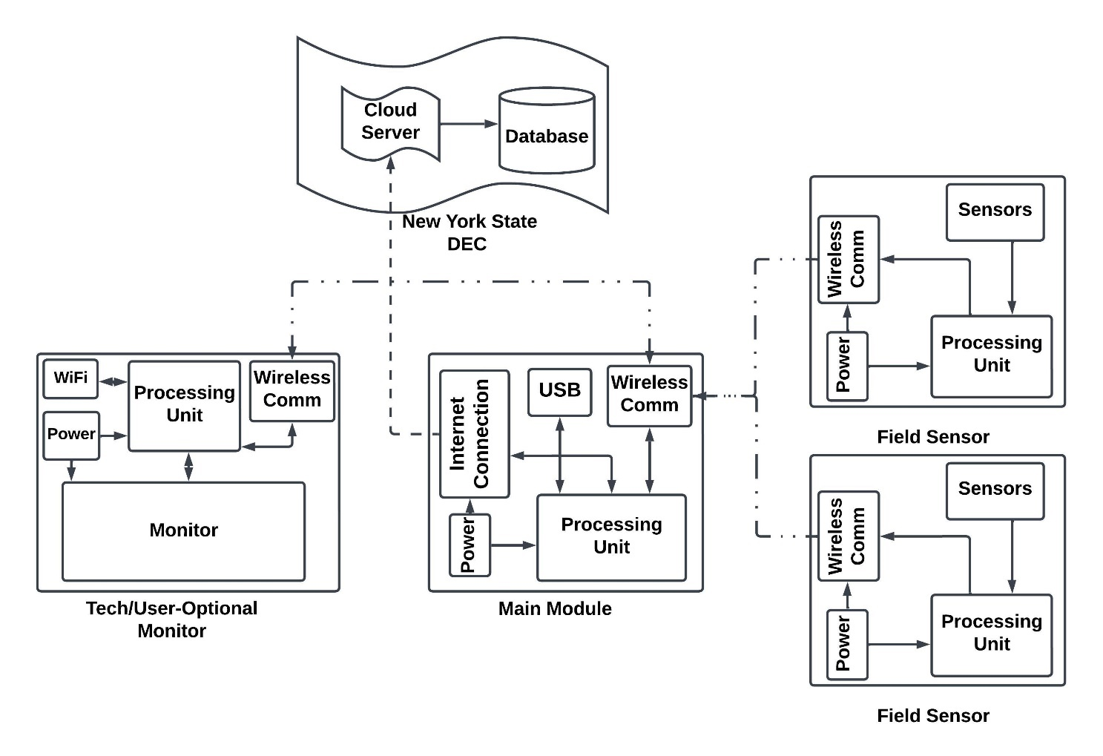

Figure 2: **Design 1**, Network of wireless sensors with optional monitor.

Design 2 and 3 can be physically designed to be upgradable (extendable) but they will never be as easy and efficient as Design 1, the upgrading of Design 1 can be as simple as placing the sensor in its location and the system will recognize and initiate the connection with no need for professions hand.

Design 1, due to the separate sensor modules, will probably be the most straightforward to maintain as well. The design allows for easy removal of sensors, or simply easy access. If one sensor gets damaged, it is likely that the other sensors will be fine. Designs 2 and 3, while they allow for removal and maintenance, they make it hard to work on just one sensor and due to the design, if one sensor gets damaged, it may affect the rest of the sensors as well.

Due to all these factors, Design 1 has proven to be the best choice for the NYSDEC’s problem. It will be the most cost-effective and allows for the option of consumer purchases. It will be the easiest to maintain, upgrade, and repair. It will also allow for each sensor to be placed in an environment that best suits it, making it one of the most reliable. 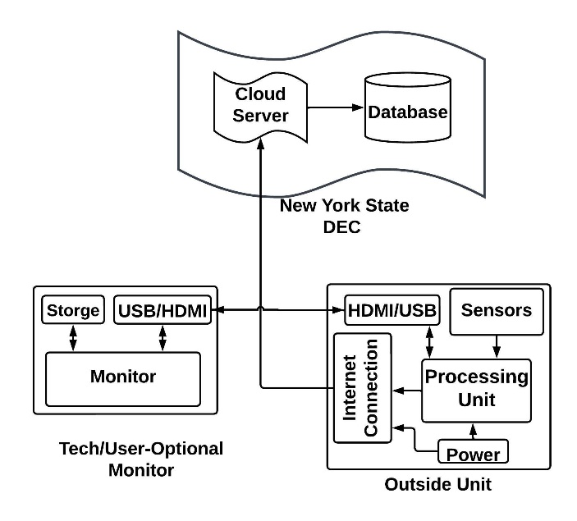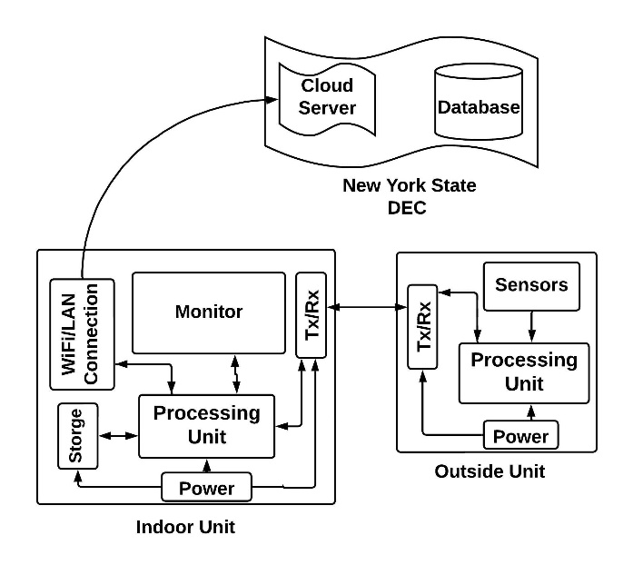

Figure 4: Design 3, Outdoor and Indoor Unit Combination

Figure 3: Design 2, Outdoor Unit with Built-in Sensors

**Evaluation Matrix:**

**i. System Design Decision**

All the designs assume that the DEC will buy and distribute the devices across NYS, therefore, to limit the financial burden, the design should be cost efficient. The collected data must be highly reliable as it will be used in research and decision making. It must be able to be upgraded as new information regarding climate change comes out or sensor technology improves. Finally, the device in question should be able to communicate when a sensor unit is damaged and said units must be easily replaceable.

**ii. Alternative Design Decision**

|  |  |  |  |  |  |  |  |
| --- | --- | --- | --- | --- | --- | --- | --- |
| **Criteria** | **Weight** | **Design 1** | | **Design 2** | | **Design 3** | |
|  |  | Value | Total | Value | Total | Value | Total |
| **Cost** | 40% | 90 | 36.0 | 60 | 24.0 | 65 | 26.0 |
| **Reliability** | 30% | 85 | 25.5 | 85 | 25.5 | 80 | 24.0 |
| **Upgradability** | 10% | 95 | 09.5 | 65 | 06.5 | 75 | 07.5 |
| **Maintainability** | 20% | 90 | 18.0 | 50 | 10.0 | 70 | 14.0 |
| **Total** |  |  | 89.0% |  | 66.0% |  | 71.5% |

Design 2 and 3 has potentially the lowest cost per device as it will cost less to produce the device, but it will be much more expensive to cover even a small area since it will need a device for every house.

All the designs assumed to have good reliability based on the discussion on the first paragraph, Design 1 and 2 are assumed to have a slightly better reliability since they will be much more data collected from each area.

Design 2 and 3 can be physically designed to be upgradable (extendable) but they will not be as easy and efficient as Design 1, the upgrading of Design 1 can be as simple as placing the sensor in its location and the system will recognize and initiate the connection with no need for professions hand.

Design 1, due to the separate sensor modules, will probably be the most straightforward to maintain as well. The design allows for easy removal of sensors, or simply easy access. If one sensor gets damaged, it is likely that the other sensors will be fine. Designs 2 and 3, while they allow for removal and maintenance, they make it hard to work on just one sensor and due to the design, if one sensor gets damaged, it may affect the rest of the sensors as well.

Due to all these factors, Design 1 has proven to be the best choice for the NYSDEC’s problem. It will be the most cost-effective and allows for the option of consumer purchases. It will be the easiest to maintain, upgrade, and repair. It will also allow for each sensor to be placed in an environment that best suits it, making it one of the most reliable.

**b. Black Box Diagram**

The *Sensors* collect and take measurements from the surrounding area, while the *User Selections* are the options made by the user on the type and the way to show the collected data to the monitor, as well as selecting the format, the area, and the period to export the data. *Climatic data* are the data displayed to the monitor or exported in a certain format as specified by the user.

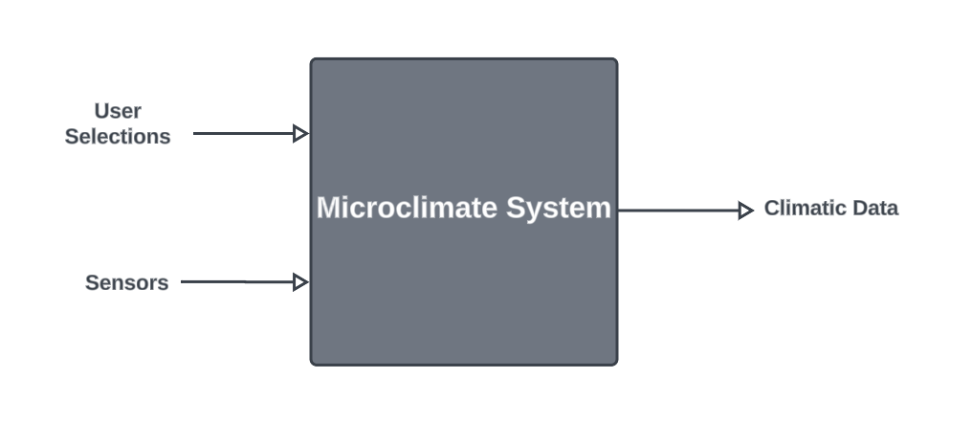

Figure 5: Black Box Diagram, showing the inputs and the outputs of the system.

**c. Logical Design**

The system is a network of devices that collect climatic data around New York State and upload it to the DEC server. Each device has a small network of sensors (as shown in Figure 6) that are specified and distributed based on research conducted by the NYSDEC. Maintenance workers would be able connect to the main device module to read specific data or determine the state of the various sensors connected to it.

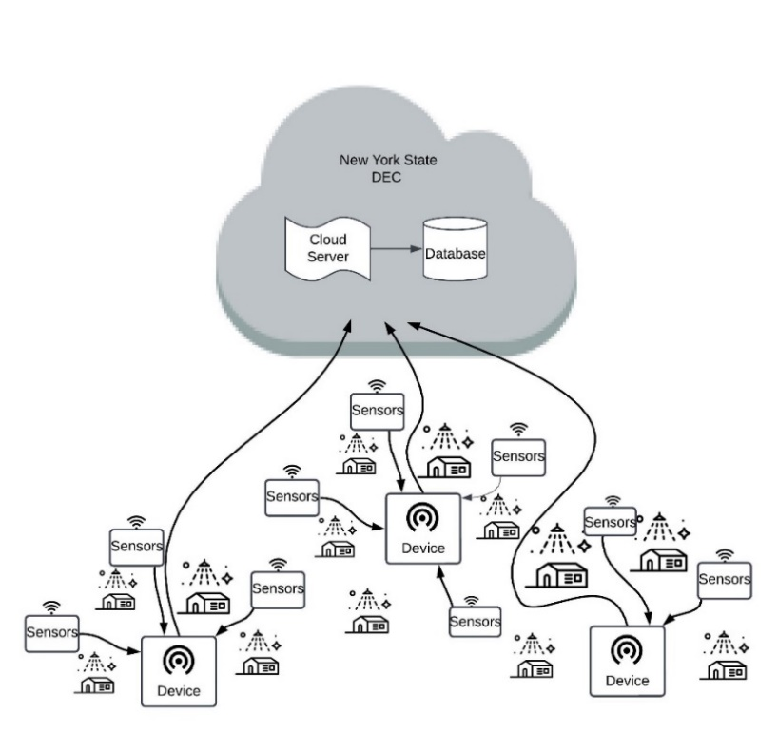

Figure 6: Devices Network data flow diagram.

Figure 7: Logical Design with detained block party.

**d. Wireframe Model**

The model shown below demonstrates an app design for a monitor device that allows for someone to make an account and access data for deferent location by communicating with DEC Server, the home page shows the different types of relevant weather data that can be expanded for more thorough information. The monitor can also pair with the device itself to download data directly, check the status of the sensors (for maintenance reasons), and to activate new sensors (in the case of a future update). The design also allows for a display mode so the monitor can be hung on a wall to act as a normal display.

Figure 8: Wireframe Model, app for Home User and/or NYDEC User

**e. Physical Design**

The design below demonstrates an RSPI 4B controlling a touch screen device, communicating with an NRF24LO1 through SPI communication, and transmitting data via WIFI to the NYSDEC. The system will run the wireframe design shown in Figure 8 above. The nRF24L01 was chosen specifically due to its long communicating range which reaches up to 1km, in addition to a wide range of channels (more than 100 different Channels), The Raspberry Pi 4B was chosen because of the need for a processor with an operating system to facilitate the use of high-level programming language (PYTHON and PyQT6).

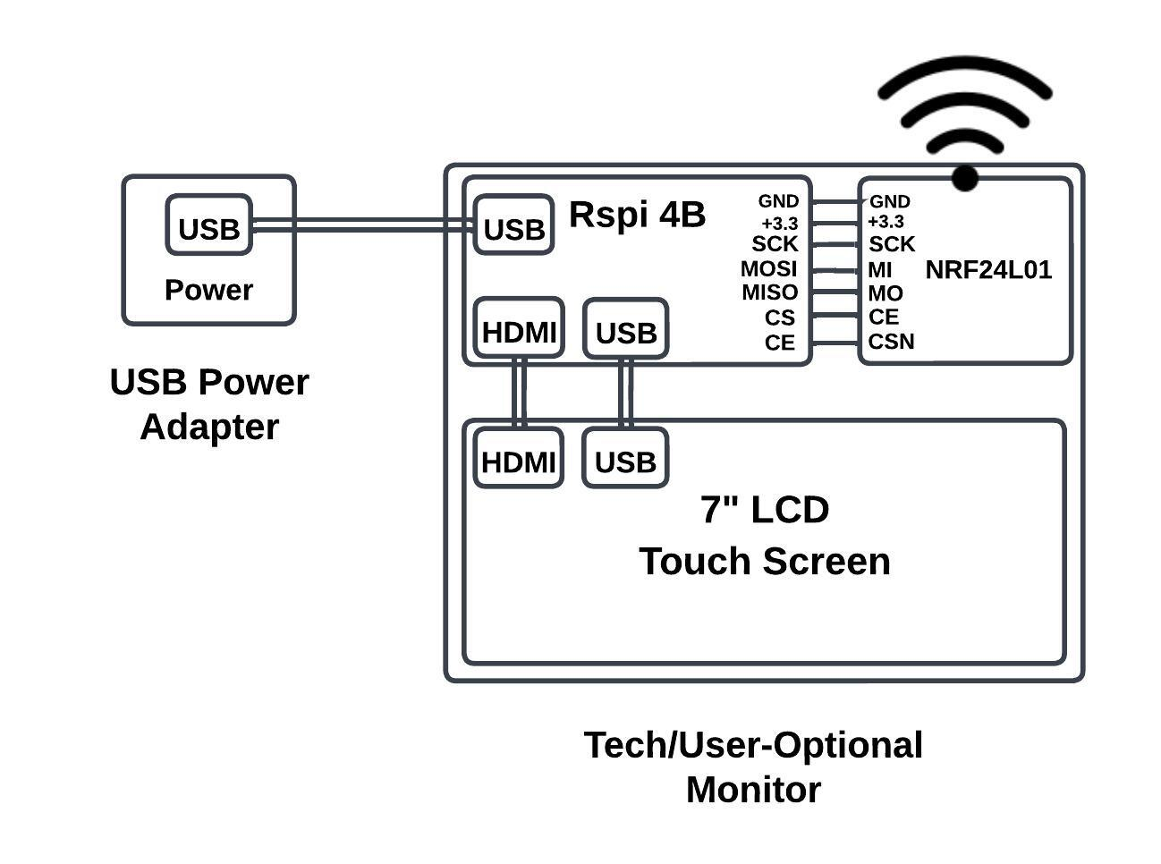

Figure 9: Physical Design for the UI Subsystem

The physical design below depicts the setup of a field unit. It includes an Arduino Nano as a processing unit, a combined temperature and humidity sensor, made by Adafruit, which connects to the Arduino via the I2C protocol, and an NRF24 radio frequency transmitter which transmits in the 2.4GHz radio band. The Arduino will supply the power and data to the transmitter. We chose Arduino Nano because it has a low power consumption of 19mA. It has a clock speed of 16MHz and operating voltage of 5V. This matched the specifications we needed and is compatible with the sensors and transmitter that are connected. The SHT-30 sensors have a low measurement duration between 2.5ms and 12.5ms. Also, an I2C interface that has communication speeds of up to 1MHz. An accuracy tolerance range for temperatures between 10C-55C and relative humidity is 10-90 percent. The RF module that were using for this design has a 1Mbps data rate in the air and covers a distance of 50 to 200 feet which satisfies our design criteria.

Figure 10: Physical Design for the Sensor Subsystem

**f. Bill of Materials**

|  |  |
| --- | --- |
| **Materials for UI Subsystem** | **Costs** |
| [Raspberry Pi 4B](https://www.raspberrypi.com/products/raspberry-pi-4-model-b/) 4G | $58.99 |
| [7” Touch Screen Display](https://www.amazon.com/gp/product/B0C7BZPC34/ref=ox_sc_act_title_1?smid=A57KAEU12OVD3&th=1) | $56.99 |
| NRF24L01 2PCs | $12.29 |
| Dupont Wires F-F | $4.90 |
|  |  |
| **Total** | $133.17 |

|  |  |
| --- | --- |
| **Materials for Sensor Subsystem** | **Costs** |
| Arduino Nano | $24.90 |
| Temperature + Humidity Sensor – SHT-30 | $24.95 |
| Mini – B to USB A cable | $7.99 |
| Bread board | $3.50 |
| NRF24L01 2PCs | $7.35 |
|  |  |
| **Total:** | $68.69 |

**5. Semester Planning a. Gannt Chart**

Figure 11: Gantt Chart for Overall Project. Implementation and Testing will be Iterative