Simulating the start of an Ebola outbreak

Thibaut Jombart

17 May, 2018

# Dependencies

To install and load the packages needed for these analysis, one may use:

install.packages("readxl")  
install.packages("distcrete")  
install.packages("epitrix")  
install.packages("incidence")  
install.packages("earlyR")  
devtools::install_github("reconhub/projections")

library("distcrete")  
library("epitrix")  
library("incidence")  
library("earlyR")  
library("projections")

# Loading the data

We start by reading the data in:

linelist <- readxl::read_xlsx("toy_linelist.xlsx")  
linelist  
## # A tibble: 19 x 3  
## ID `Date of onset` genDeR  
## <dbl> <dttm> <chr>   
## 1 1. 2017-05-01 00:00:00 male   
## 2 2. 2017-05-02 00:00:00 male   
## 3 3. 2017-05-02 00:00:00 female  
## 4 4. 2017-05-06 00:00:00 <NA>   
## 5 5. 2017-05-11 00:00:00 male   
## 6 6. 2017-05-11 00:00:00 male   
## 7 7. 2017-05-01 00:00:00 male   
## 8 8. 2017-05-08 00:00:00 female  
## 9 9. 2017-05-08 00:00:00 male   
## 10 10. 2017-05-12 00:00:00 male   
## 11 11. 2017-05-02 00:00:00 <NA>   
## 12 12. 2017-05-09 00:00:00 male   
## 13 13. 2017-05-09 00:00:00 female  
## 14 14. 2017-05-10 00:00:00 male   
## 15 15. 2017-05-11 00:00:00 female  
## 16 16. 2017-05-11 00:00:00 female  
## 17 17. 2017-05-11 00:00:00 female  
## 18 18. 2017-05-11 00:00:00 female  
## 19 19. 2017-05-13 00:00:00 male

and do a bit of cleaning:

linelist <- as.data.frame(linelist)  
names(linelist) <- clean_labels(names(linelist))  
  
linelist$date_of_onset <- as.Date(linelist$date_of_onset)  
linelist  
## id date_of_onset gender  
## 1 1 2017-05-01 male  
## 2 2 2017-05-02 male  
## 3 3 2017-05-02 female  
## 4 4 2017-05-06 <NA>  
## 5 5 2017-05-11 male  
## 6 6 2017-05-11 male  
## 7 7 2017-05-01 male  
## 8 8 2017-05-08 female  
## 9 9 2017-05-08 male  
## 10 10 2017-05-12 male  
## 11 11 2017-05-02 <NA>  
## 12 12 2017-05-09 male  
## 13 13 2017-05-09 female  
## 14 14 2017-05-10 male  
## 15 15 2017-05-11 female  
## 16 16 2017-05-11 female  
## 17 17 2017-05-11 female  
## 18 18 2017-05-11 female  
## 19 19 2017-05-13 male

# Epicurve

i <- incidence(linelist$date_of_onset)  
plot(i)

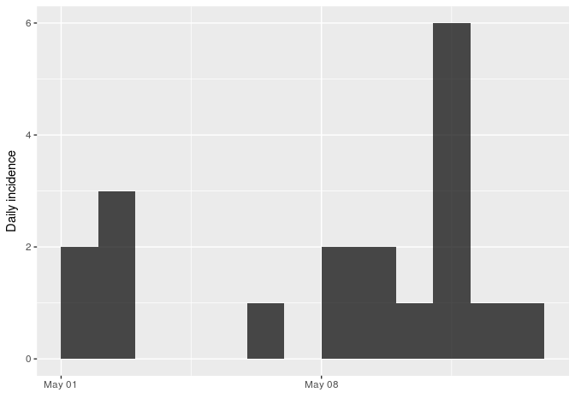

###### 

###### Page break