**Final Project: Introduction to Space Mission Analysis**

A.Y. 2022-2023

**Professors:**

C. Colombo, A. Muciaccia, M. Rusconi

**Report n.**

B7

**Authors:**

|  |  |  |
| --- | --- | --- |
| **Personal Code** | **Last Name** | **First Name** |
| 10795356 | Frassinella | Luca |
| 10674321 | Marconcini | Giacomo |
| 10735389 | Orsenigo | Samuele |

**Delivery date:** 12/07/23

**Table of contents**

1. **Introduction** 2

2. **Initial and final orbit characterisation** 2

2.1. Initial orbit characterisation 2

2.1.1 Initial orbit parameters 2

2.1.2 Consideration on the result and calculation of other useful parameters 3

2.2. Final orbit characterisation 3

2.2.1 Final position and velocity from assigned final orbital parameters. 3

2.2.2 Consideration on the result and calculation of other useful parameters 3

2.3. Graphical representation of the initial and final orbit 3

3. **Transfer trajectory definition and analysis** 4

3.1. Standard Strategy and Variation 4

3.2. Optimal circular Bielliptic strategy 5

3.3. Two-impulse manoeuvres 6

3.3.1. “Direttissima” Manoeuvre 7

3.3.2. Optimized Secant Manoeuvre 7

4. **Conclusions** 8

5. **Appendix** 9

1. **Introduction**

The purpose of this report is the analysis of the possible strategies for an orbital transfer and to select the best one based on a set of criteria. The objective of the transfer is to move a spacecraft from its initial orbit to a target orbit with specific orbital parameters provided by the instructor.

Our main objective is to shed light on the entire process: starting from the organization of the team, the challenges we faced, and all the decisions.

From an organizational perspective, we divided the project into three main phases. The first involved an individual study of the problem, in which each team member created their functions and implemented the basic strategy. After a series of comparisons and back testing, we integrated our solutions into a library of functions and wrote the standard strategy code.

The second phase focused on developing alternative strategies. We began with a brainstorming session to find the best ideas, and each of us worked on a specific class of transfers.

After testing the different strategies, we moved on to the final phase of the project, which involved writing the report and producing the PowerPoint presentation.

# Initial and final orbit characterisation

## Initial orbit characterisation

### **Initial orbit parameters**

The initial given data for the initial position and velocity of the satellite are:

|  |  |  |  |  |  |
| --- | --- | --- | --- | --- | --- |
| **Position [km]** | | | **Velocity [km/s]** | | |
|  |  |  |  |  |  |
| 5088.9118 | -3196.5659 | -8222.7989 | 1.9090 | 5.6220 | -1.0700 |

We used the function *car2kep.m* to determine the orbital parameters of the initial orbit:

|  |  |  |  |  |  |
| --- | --- | --- | --- | --- | --- |
| **[km]** | **[-]** | **[deg]** | **[deg]** | **[deg]** | **[deg]** |
| 9518.19 | 0.0706 | 55.60 | 78.33 | 84.77 | 173.33 |

### **Consideration on the result and calculation of other useful parameters**

The initial orbit has a very low eccentricity value, which means that it is close to a circular orbit.   
To better characterize the orbit, it is possible to calculate the period of the orbit as well as the velocity and the altitude of the apocentre and pericenter using the orbital parameters. It is also possible to calculate the specific orbit energy using the data of the starting point:

|  |  |  |
| --- | --- | --- |
|  | **r [km]** | **v [km/s]** |
| **Pericenter** | 8846.21 | 6.946 |
| **Apocentre** | 10190.17 | 6.029 |

## Final orbit characterisation

### **Final position and velocity from assigned final orbital parameters.**

The given parameters for the final orbit are:

|  |  |  |  |  |  |
| --- | --- | --- | --- | --- | --- |
| **[km]** | **[-]** | **[deg]** | **[deg]** | **[deg]** | **[deg]** |
| 14020 | 0.3576 | 75.75 | 55.94 | 103.88 | 24.84 |

We used the function *kep2car.m* to determine the position and velocity of the target point:

|  |  |  |  |  |  |
| --- | --- | --- | --- | --- | --- |
| **Position [km]** | | | **Velocity [km/s]** | | |
|  |  |  |  |  |  |
| -4703.1 | -3790.9 | 6980.7 | -2.7762 | -5.8928 | -3.9362 |

### **Consideration on the result and calculation of other useful parameters**

The final orbit is more elliptical than the initial one, with the apocenter radius being twice the radius of the pericenter. Despite increases in inclination, the final orbit remains a direct orbit.

The specific orbital energy can be determined using the data associated with the final point. In order to provide a more precise description of the final orbit, the orbital period, semi-latus rectum, radius, velocity, and altitude at both the pericenter and the apocenter can be calculated.

|  |  |  |
| --- | --- | --- |
|  | **r [km]** | **v [km/s]** |
| **Pericenter** | 9006.45 | 7.75 |
| **Apocentre** | 19033.55 | 3.67 |

## 

Figure 1: Initial orbit and starting point

Figure 2: Final orbit and target point

## Graphical representation of the initial and final orbit

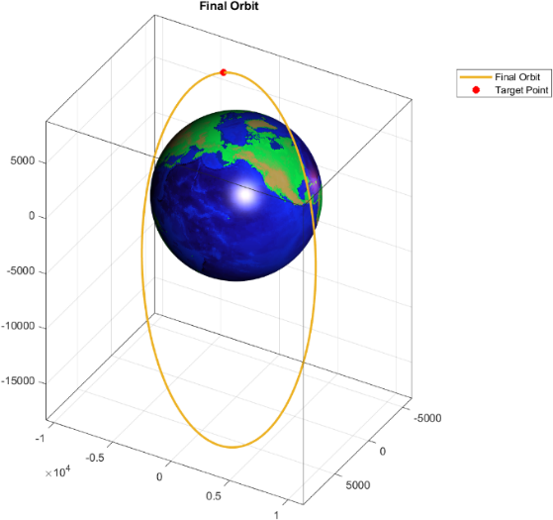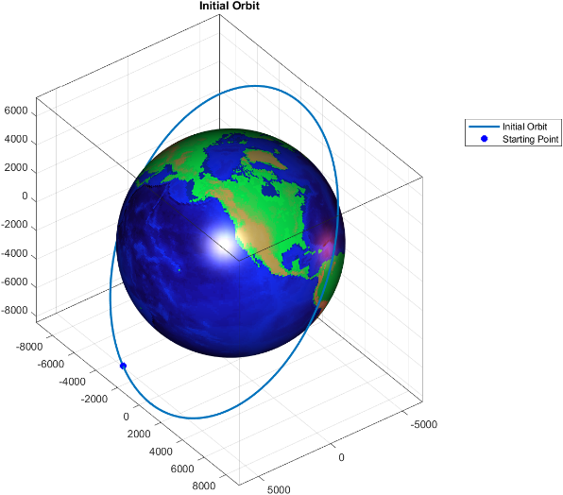

# Transfer trajectory definition and analysis

## Standard Strategy and Variation

The standard strategy involves three different types of manoeuvres, executed in this order:

* Change of orbital plane (CP)
* Change of periapsis argument (CPA)
* Change of orbit shape using the Homann transfer strategy (COS)

After implementing the standard strategy we discuss about what combination of the three impulses could be the most advantageous one in terms of total velocity cost and total transfer time.

Theoretically we have two points to change plane, two to change periapsis argument and four combinations of points to change shape with the Homann strategy (in fact, starting from the initial orbit, we can do these different Homann transfers: pericenter-apocenter, pericenter-pericenter, apocenter-pericenter, apocenter-apocenter); these four points are lowered to two when we discard two strategies because of the mutual orientation of the two orbits, in fact, based on the direction and versus of the eccentricity vector, only two Homann transfers can be done: if the eccenticity vectors of the two orbits have the same versus we can only do the pericenter-apocenter and apocenter-pericenter transfer; if the eccentricity vectors have opposite versus we can only do the other two maneuvers (apocenter-apocenter and pericenter-pericenter).

We can also discard the combinations where the first maneuver is the CPA because, after changing the orbital plane, this maneuver must be repeated (because the plane change implies the change of periapsis argument when we are not on the line of nodes).

Therefore, we remain with eight combinations with different results summarized in this table

|  |  |  |
| --- | --- | --- |
|  | **(km/s)** | **(s)** |
| **Standard strategy (S1)** | 4.0343 | 21994 |
| **COS at pericenter – CP – CPA (S2)** | 3.3616 | 21976 |
| **COS at apocenter – CP – CPA** | 3.3667 | 22105 |
| **CP – COS at pericenter – CPA** | 4.3006 | 222652 |
| **CP – move to descendent node – CPA – COS at pericenter** | 4.0343 | 31306 |
| **CP – CPA – COS at apocenter** | 4.0394 | 14844 |
| **CP – COS at apocenter – CPA** | 4.3057 | 14825 |
| **CP – move to descendent node – CPA – COS at apocenter** | 4.0394 | 14914 |

As we can see, the best combination in terms of total is the one with COS at pericenter as the first maneuver, then CP at the ascendent node as the second maneuver and then CPA as the last meneuver.

Another interesting fact that we can take from this table is that doing the COS at the apocenter after the CP lowers the total time elapsed by almost 33% compared to the standard strategy.

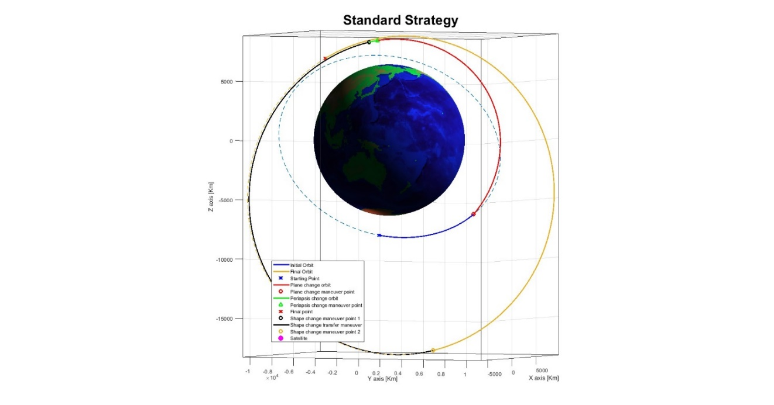**Visual representation of the S1 and S2 strategies with respective results:**

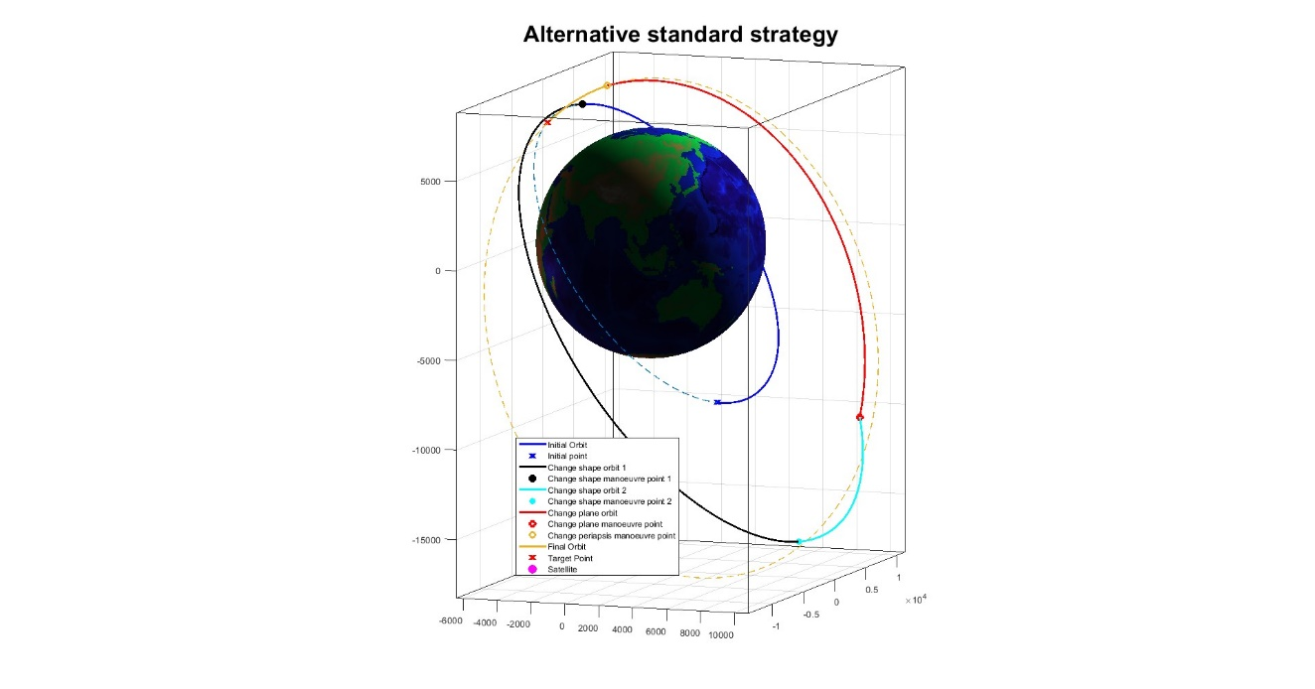

.

Figure 4: Alternative Standard Strategy (S2)

|  |  |
| --- | --- |
| **Δv (km/s)** | **t (s)** |
| 3.3615 | 21976 |

Figure 3: Standard Strategy (S1)

|  |  |
| --- | --- |
| **Δv (km/s)** | **t (s)** |
| 4.0343 | 21995 |

## Circular Bielliptic Strategy

The next strategy was based on a code to optimize the bielliptic transfer strategy. This strategy is often beneficial because the changing of the orbital plane and shape are realized in a very distant point which is far less expensive in terms of , even if the transfer time inevitably rises. The challenge of this strategy is that the first impulse of the bielliptical transfer rises with a bigger radius, while the impulse of change of plane is lower with a bigger distance from Earth, so the total of the strategy is affected by the bielliptical radius and it must have an optimal value for this parameter.   
To optimize this problem, we decided to iterate the bielliptic strategy with a bielliptic radius that went from a value of to a value of . We decided to limit the maximum to a value of because we noticed that, for a bigger radius, the total of the strategy would just grow, as can be seen in the following figure.

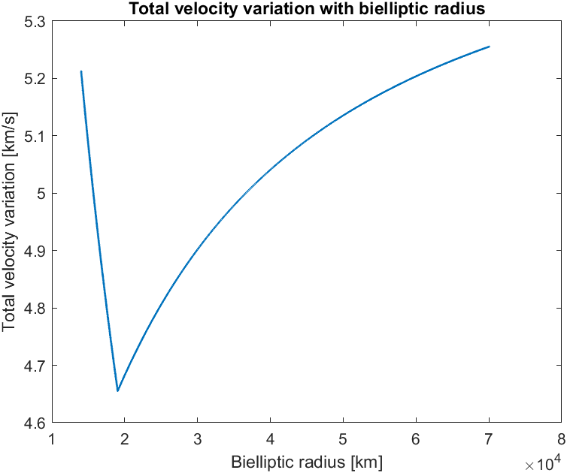

Figure 5: Total velocity cost with different bielliptic radius

In our case study, we decided to circularize both the initial and the final orbit to facilitate the bielliptic transfer, avoiding problems deriving from the different orientation of the orbits. This simplification resulted in an increment in the total of the strategy, even if the optimization computed the optimal radius.

To summarize, these were the different maneuvers in the strategy:

1. Transfer from the initial point to the point of circularization of the first orbit
2. Circularization of the first orbit and transfer until the initial point of the bielliptic to initialize the first elliptic transfer.
3. First elliptic transfer from the pericenter to the apocentre of the first transfer orbit with the optimal bielliptic radius.
4. Change of orbital plane in the apocentre of the elliptic orbit.
5. Second elliptic transfer with a radius that allowed us to reach a circular orbit that intersected the final orbit.
6. Decircularization of the orbit to obtain the final orbit.
7. Transfer in the final orbit to the target point.

As we can see, using the optimal bielliptic radius the second transfer orbit of the bielliptic overlaps with the second circular orbit. This results in a cost of the second circularization equal to 0 km/s, which is the key to having the minimum total cost for this strategy.

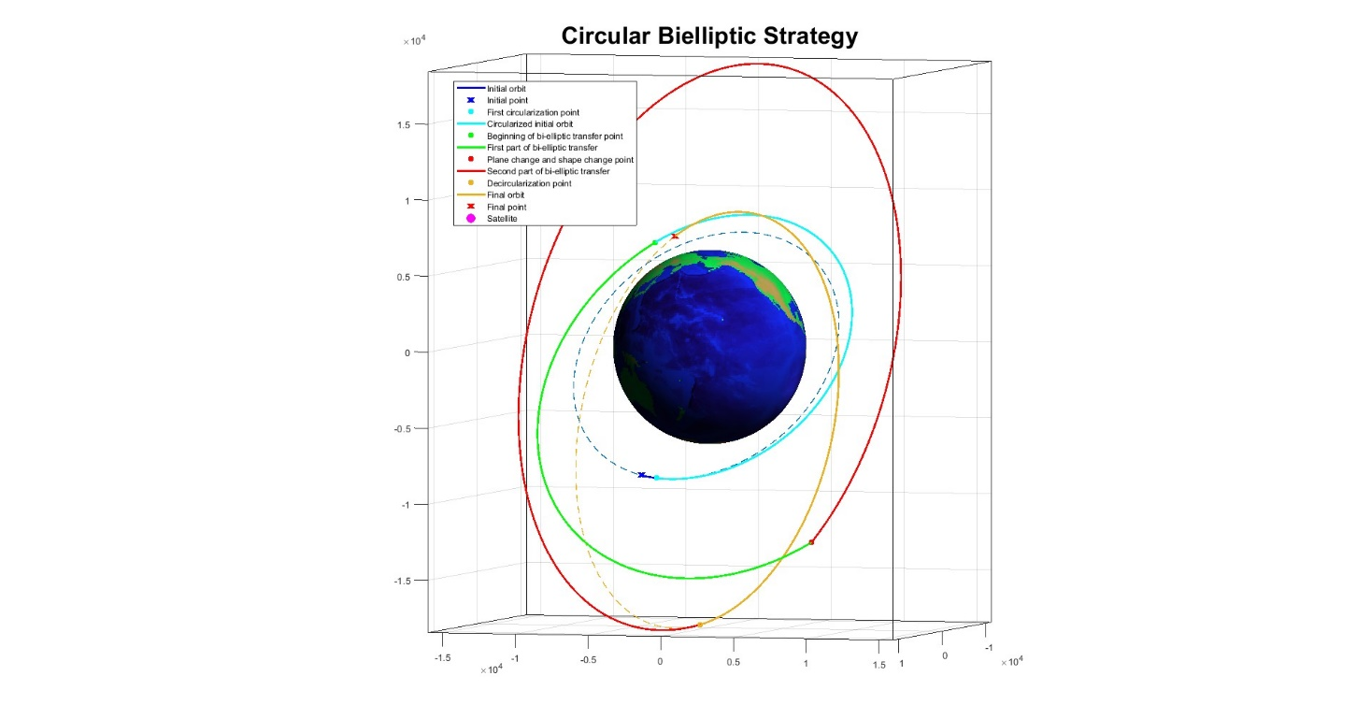

|  |  |
| --- | --- |
| (km/s) | (s) |
| 4.665 | 57979 |

Figure 6: Circular Bielliptic Strategy (S3)

## Two-impulse manoeuvres

The next two strategies are based on two-impulse maneuvers. Both of them use a function called *findOrbit.m*, which is responsible for calculating the connecting orbit between two points on known orbits. The function relies on geometric considerations and uses numerical calculations to evaluate a large number of transfer orbits that connect a point A to point B. For the two required maneuvers, we have all the orbital parameters, making it possible to calculate the velocity cost for the orbit change. The function *findOrbit.m* will subsequently compute the minimum total required for these two transfers, returning the most efficient orbit. While the function produces valid results, we acknowledge the lack of a strong mathematical theory behind its operation. Additionally, *findOrbit.m* only considers elliptical orbits as they require less energy, and it excludes all orbits with apogees within Earth's atmosphere. However, this doesn't rule out further developments and improvements in the future.

3.3.1. “Direttissima” Manoeuvre

Thanks to *findOrbit.m*, we can implement a direct strategy that connects the initial and final points. The maneuver costs 4.98 km/s with a transfer time of 93 minutes. This strategy is quite expensive due to the significant plane change required, but it turns out to be the fastest.

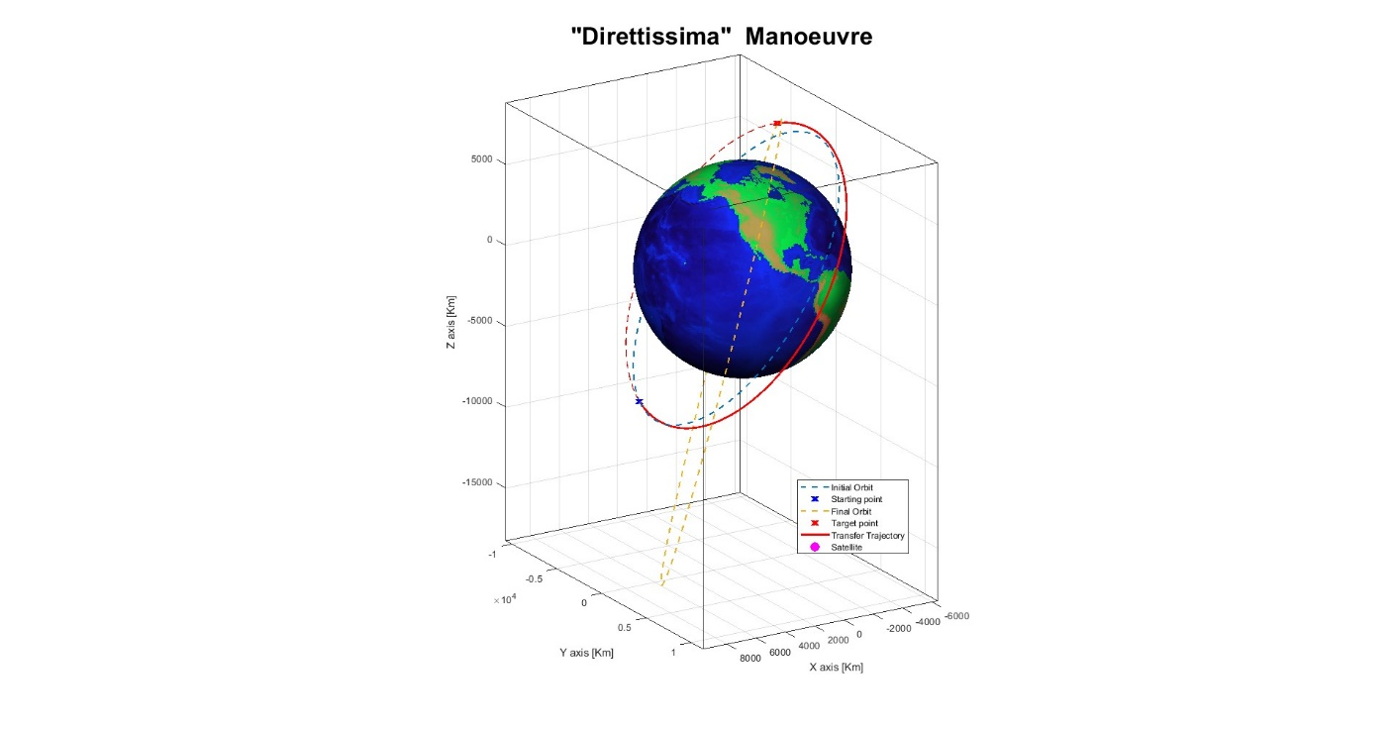

Figure 7: “Direttissima” Manoeuvre (S4)

|  |  |
| --- | --- |
| **Δv (km/s)** | **t (s)** |
| 4.9811 | 5613 |

3.3.2. Optimized Secant Manoeuvre

The following strategy involves a classic two-impulse secant maneuver. The objective is to intercept the final orbit at a specific point, stabilize on it, and wait until reaching the target point. Since we determined that the highest cost in the base strategy is in the plane change, intersecting the orbit directly along the intersection line of the planes is more convenient. By doing so, we identified two interesting points on the final orbit: the ascending node and the descending node. To use *findOrbit.m*, a maneuver point on the initial orbit is required. Out of curiosity, we decided to use a loop to check for the existence of a preferred maneuver point that minimizes the cost. In the report, we present results only for the ascending node as the maneuver point, as it provided the best and most significant results. The graphs (Figure 9) illustrate the fuel and time costs varying with the true anomaly of the first maneuver point with a discretization of one degree. For some degrees, *findOrbit.m* did not find any elliptical orbit that met the imposed constraints. In the second figure, we run a more precise analysis with a discretization of 0.1 degrees. We obtained the best result by starting from th=24.00, with a cost of 2.85 km/s in 5 h and 51 minutes.

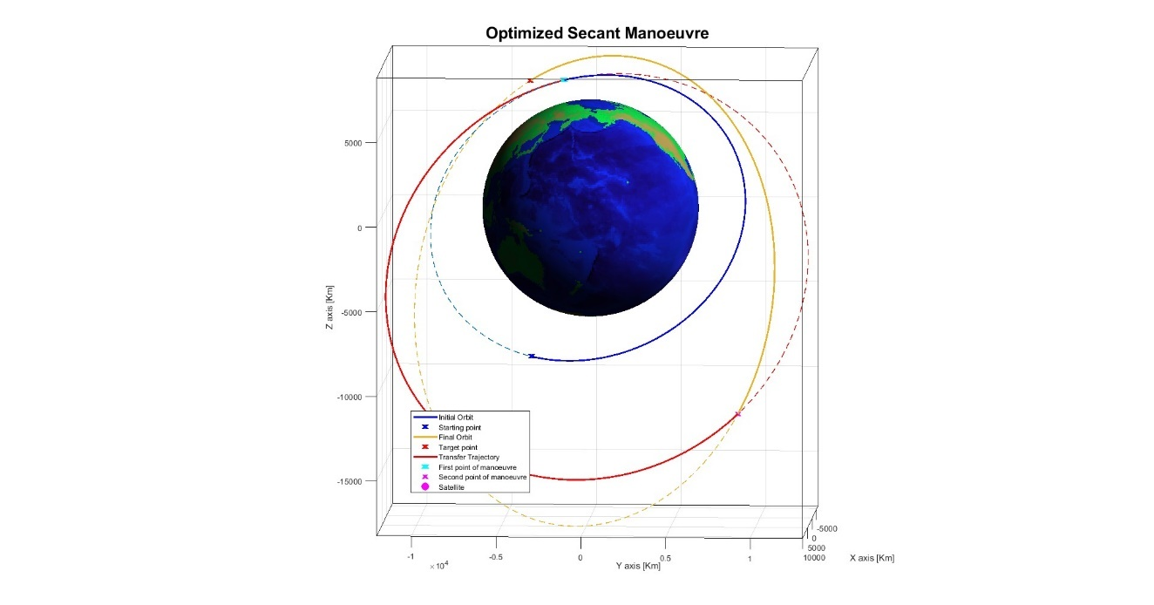

Figure 8: Optimized Secant Manoeuvre (S5)

|  |  |
| --- | --- |
| **Δv (km/s)** | **t (s)** |
| 2.8502 | 21028 |

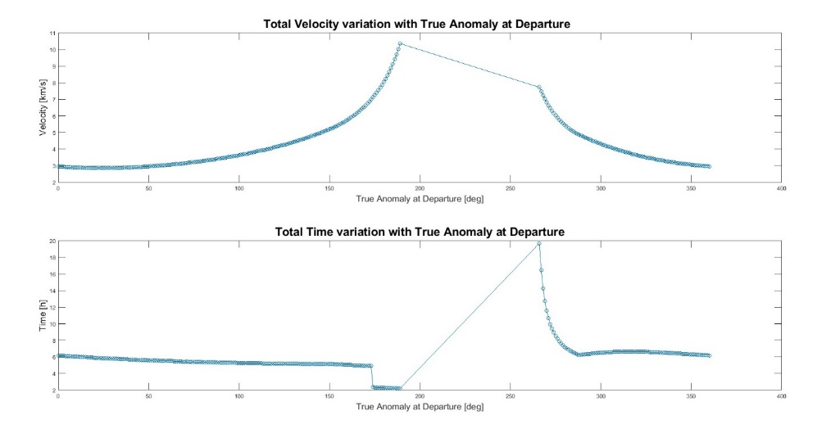

Figure 9: Total Velocity and Time variation with true anomaly at departure

# Conclusions

|  |  |  |  |  |  |
| --- | --- | --- | --- | --- | --- |
| Strategy | **S1** | **S2** | **S3** | **S4** | **S5** |
| **(km/s)** | 4.0343 | 3.3616 | 4.6552 | 4.9811 | 2.8502 |
| **(s)** | 21995 | 21976 | 57979 | 5613 | 21028 |

The analysed strategies resulted in different possible and transfer times , meaning that the application of a specific strategy is strictly related to the goal of the mission: in this last section we will compare the different strategies to see if they increased or decreased the total performance parameters of the standard one (S1).

The best strategy studied combining the different maneuvers proved to be the COS-CP-CPA (S2) one, which decreased the total velocity cost of the standard strategy by 17% while maintaining a very similar transfer time.  
The circular bielliptic (S3) was developed to carry out a reduction in terms of velocity cost, but its results showed that it is not convenient as it improves the cost by 15% while also having a transfer time which is more than doubled form the standard strategy.  
The two impluses strategies carried out the best possible results in terms of transfer time and velocity cost: the “Direttissima” maneuver (S4) decreases the total transfer time by 74%, but it is not optimal regarding the propellant consumption, increasing the total by 23%.

The secant maneuver (S4) proves to be the most efficient one for propellant consumption, lowering the total velocity cost from the standard strategy by 29%, while the transfer time is reduced by 4%.

In conclusion, if the restrictive parameter of the mission is the total velocity cost, the best possible strategy is the secant one; instead, if the restrictive parameter is the total transfer time, the most advantageous strategy is the “Direttissima” maneuver. The COS-CP-CPA strategy proves to be a significant upgrade and a valid alternative to the standard strategy in terms of total velocity cost, while the bielliptical strategy proves to be disadvantageous in both aspects of the study.   
Overall, in case both and are restrictive parameters, the best strategy is the secant one as it improves both parameters from the standard strategy.

# Appendix

Table 1: Standard Strategy S1 [;

|  |  |  |  |  |  |  |  |
| --- | --- | --- | --- | --- | --- | --- | --- |
| **t (s)** | **a (km)** | **e (-)** | **i (deg)** | **Ω (deg)** | **ω (deg)** | **θ (deg)** | **Δv (m/s)** |
| *0* | 9518.19 | 0.0706 | 55.60 | 78.33 | 84.77 | 173.33 | - |
| *1494* | 9581.19 | 0.0705 | 55.60 | 78.33 | 84.77 | 224.62 | *3036.8* |
| 9518.19 | 0.0706 | 75.75 | 55.94 | 94.23 | 224.62 |
| *4925* | 9518.19 | 0.0706 | 75.75 | 55.94 | 94.23 | 4.82 | *76.9* |
| 9518.19 | 0.0706 | 75.75 | 55.94 | 103.88 | 355.18 |
| *5032* | 9518.19 | 0.0706 | 75.75 | 55.94 | 103.88 | 0.00 | *898.2* |
| 13939.97 | 0.3654 | 75.75 | 55.94 | 103.88 | 0.00 |
| *13222* | 13939.97 | 0.3654 | 75.75 | 55.94 | 103.88 | 180.00 | *22.3* |
| 14020.00 | 0.3576 | 75.75 | 55.94 | 103.88 | 180.00 |
| ***21995*** | 14020.00 | 0.3576 | 75.75 | 55.94 | 103.88 | 24.84 | ***4034.3*** |

Table 2: Alternative Standard Strategy S2 [;

|  |  |  |  |  |  |  |  |
| --- | --- | --- | --- | --- | --- | --- | --- |
| **t (s)** | **a (km)** | **e (-)** | **i (deg)** | **Ω (deg)** | **ω (deg)** | **θ (deg)** | **Δv (m/s)** |
| *0* | 9518.19 | 0.0706 | 55.60 | 78.33 | 84.77 | 173.33 | *-* |
| *4818* | 9581.19 | 0.0705 | 55.60 | 78.33 | 84.77 | 0.00 | *898.2* |
| 13939.97 | 0.3654 | 55.60 | 78.33 | 84.77 | 0.00 |
| *13008* | 13939.97 | 0.3654 | 55.60 | 78.33 | 84.77 | 180.00 | *22.3* |
| 14020.00 | 0.3576 | 55.60 | 78.33 | 84.77 | 180.00 |
| *16664* | 14020.00 | 0.3576 | 55.60 | 78.33 | 84.77 | 224.62 | *2097.8* |
| 14020.00 | 0.3576 | 75.75 | 55.94 | 94.23 | 224.62 |
| *21366* | 14020.00 | 0.3576 | 75.75 | 55.94 | 94.23 | 4.82 | *343.2* |
| 14020.00 | 0.3576 | 75.75 | 55.94 | 103.88 | 355.18 |
| ***21976*** | 14020.00 | 0.3576 | 75.75 | 55.94 | 103.88 | 24.84 | ***3361.5*** |

Table 3: Optimized Circular Bielliptic S3 [;

|  |  |  |  |  |  |  |  |
| --- | --- | --- | --- | --- | --- | --- | --- |
| **t (s)** | **a (km)** | **e (-)** | **i (deg)** | **Ω (deg)** | **ω (deg)** | **θ (deg)** | **Δv (m/s)** |
| *0* | 9581.19 | 0.0705 | 55.60 | 78.33 | 84.77 | 173.33 | *-* |
| *5313.3* | 9581.19 | 0.0705 | 55.60 | 78.33 | 84.77 | 180.00 | *224.8* |
| 10190.01 | 0.0000 | 55.60 | 78.33 | 84.77 | 0.00 |
| *23072.60* | 10190.01 | 0.0000 | 55.60 | 78.33 | 84.77 | 44.62 | *883.9* |
| 14612.03 | 0.3026 | 55.60 | 78.33 | 129.39 | 180.00 |
| *23072.60* | 14612.03 | 0.3026 | 55.60 | 78.33 | 129.39 | 180.00 | *1883.5* |
| 14612.03 | 0.3026 | 75.75 | 55.94 | 138.86 | 180.00 |
| *36139.41* | 14612.03 | 0.3026 | 75.75 | 55.94 | 138.86 | 180.00 | *754.6* |
| 19033.8 | 0.0000 | 75.75 | 55.94 | 138.86 | 0.00 |
| *57466.40* | 19033.8 | 0.0000 | 75.75 | 55.94 | 138.86 | 145.02 | *908.4* |
| 14020.00 | 0.3576 | 75.75 | 55.94 | 103.88 | 0.00 |
| ***57978.64*** | 14020.00 | 0.3576 | 75.75 | 55.94 | 103.88 | 24.84 | ***4655.2*** |

**Table 4: “Direttissima” Manoeuvre S4** [;

|  |  |  |  |  |  |  |  |
| --- | --- | --- | --- | --- | --- | --- | --- |
| **t (s)** | **a (km)** | **e (-)** | **i (deg)** | **Ω (deg)** | **ω (deg)** | **θ (deg)** | **Δv (m/s)** |
| *0* | 9518.19 | 0.0705 | 55.6003 | 78.3328 | 84.7671 | 173.3256 | *-* |
| *0* | 9518.19 | 0.0705 | 55.6003 | 78.3328 | 84.7671 | 173.3256 | *764.2* |
| 9605.49 | 0.0616 | 57.35 | 86.63 | 62.53 | 190.98 |
| *5613* | 9605.49 | 0.0616 | 57.35 | 86.63 | 62.53 | 53.57 | *4216.9* |
| 14020.00 | 0.3576 | 75.75 | 55.94 | 103.88 | 24.84 |
| ***5613*** | 14020.00 | 0.3576 | 75.75 | 55.94 | 103.88 | 24.84 | ***4981.1*** |

**Table 5: Optimized Secant Manoeuvre S5** [;

|  |  |  |  |  |  |  |  |
| --- | --- | --- | --- | --- | --- | --- | --- |
| **t (s)** | **a (km)** | **e (-)** | **i (deg)** | **Ω (deg)** | **ω (deg)** | **θ (deg)** | **Δv (m/s)** |
| *0* | 9518.19 | 0.0705 | 55.6003 | 78.3328 | 84.7671 | 173.3256 | *-* |
| *5354* | 9518.19 | 0.0705 | 55.6003 | 78.3328 | 84.7671 | 24.00 | *850.9* |
| 13558.64 | 0.3446 | 55.60 | 78.33 | 103.16 | 5.61 |
| *15226* | 13559.09 | 0.3446 | 55.60 | 78.33 | 103.14 | 206.23 | *1999.8* |
| 14020.00 | 0.3576 | 75.75 | 55.94 | 103.88 | 214.98 |
| ***21028*** | 14020.00 | 0.3576 | 75.75 | 55.94 | 103.88 | 24.84 | ***2850.8*** |