

<https://github.com/MithilShah/kubernetes-course/blob/master/kubernetes_statefulsets/mysql_statefulset.yaml>

mysql –u root –p –h mysql-set-0.mysql.default.svc.cluster.local

mysql-set-0 🡪 pod

mysql 🡪 service

default 🡪 namespace

svc.cluster.local

**mysql-client in Kubernetes to test your connection to mysql server**

kubectl run mysql-client --image=mysql:5.7 -it --rm --restart=Never -- /bin/bash

mysql -h mysql-service -uroot -proot_password -e 'SHOW databases;'

OR

mysql -h mysql-service -uroot -proot_password

then use your mysql queries and commands as usual.

**expose-mysql-0.yaml**

apiVersion: v1

kind: Service

metadata:

name: mysqlpod-0

spec:

type: LoadBalancer

externalTrafficPolicy: Local

selector:

statefulset.kubernetes.io/pod-name: mysql-set-0

ports:

- protocol: TCP

port: 3306

targetPort: 3306

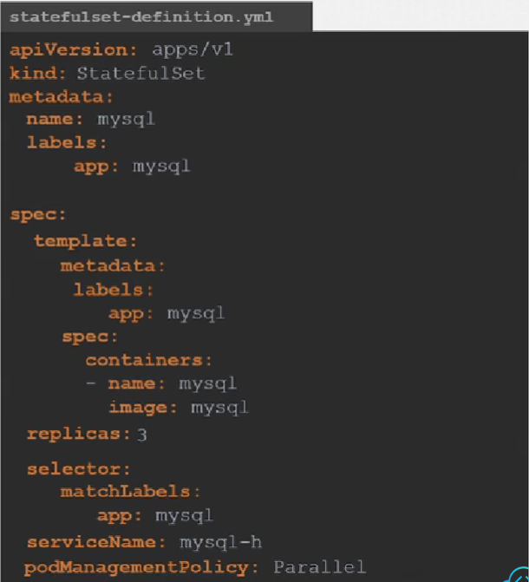

You can add the podManagementPolicy line where you can bring all the pods in sts all at once.

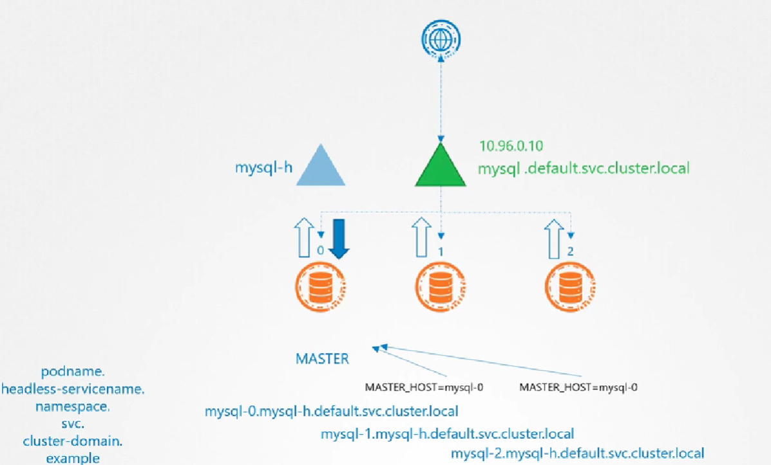

Service name must be specified:

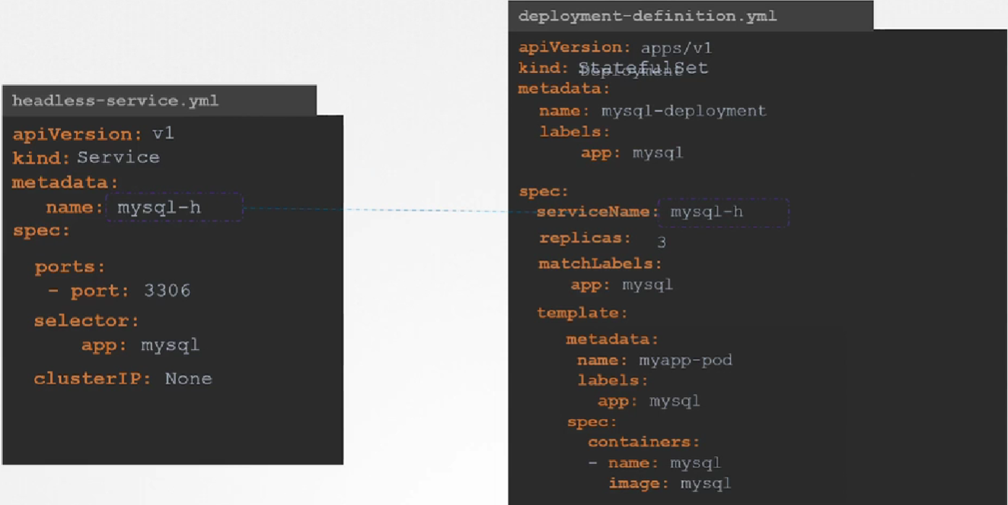

Static provisioning of storage

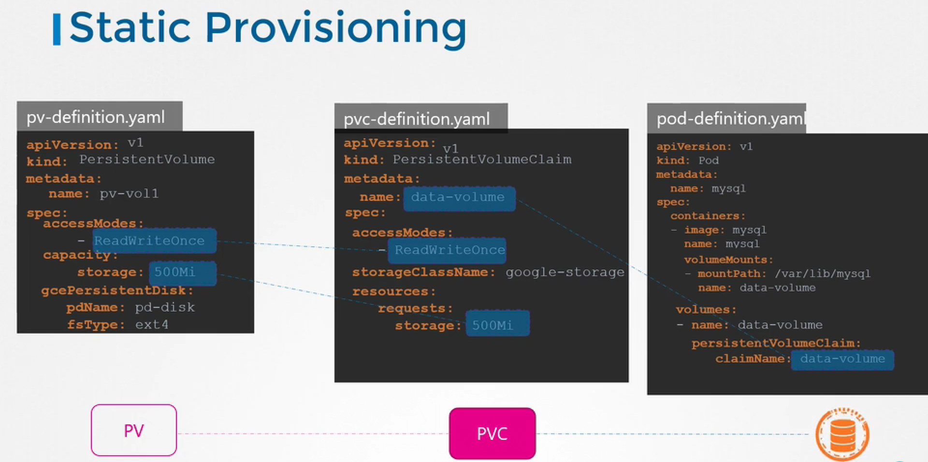

Dynamic provisioning of storage

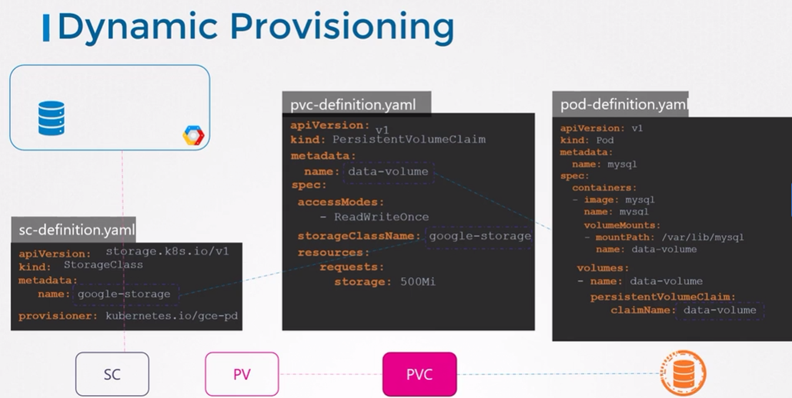

Volume Claim Templates

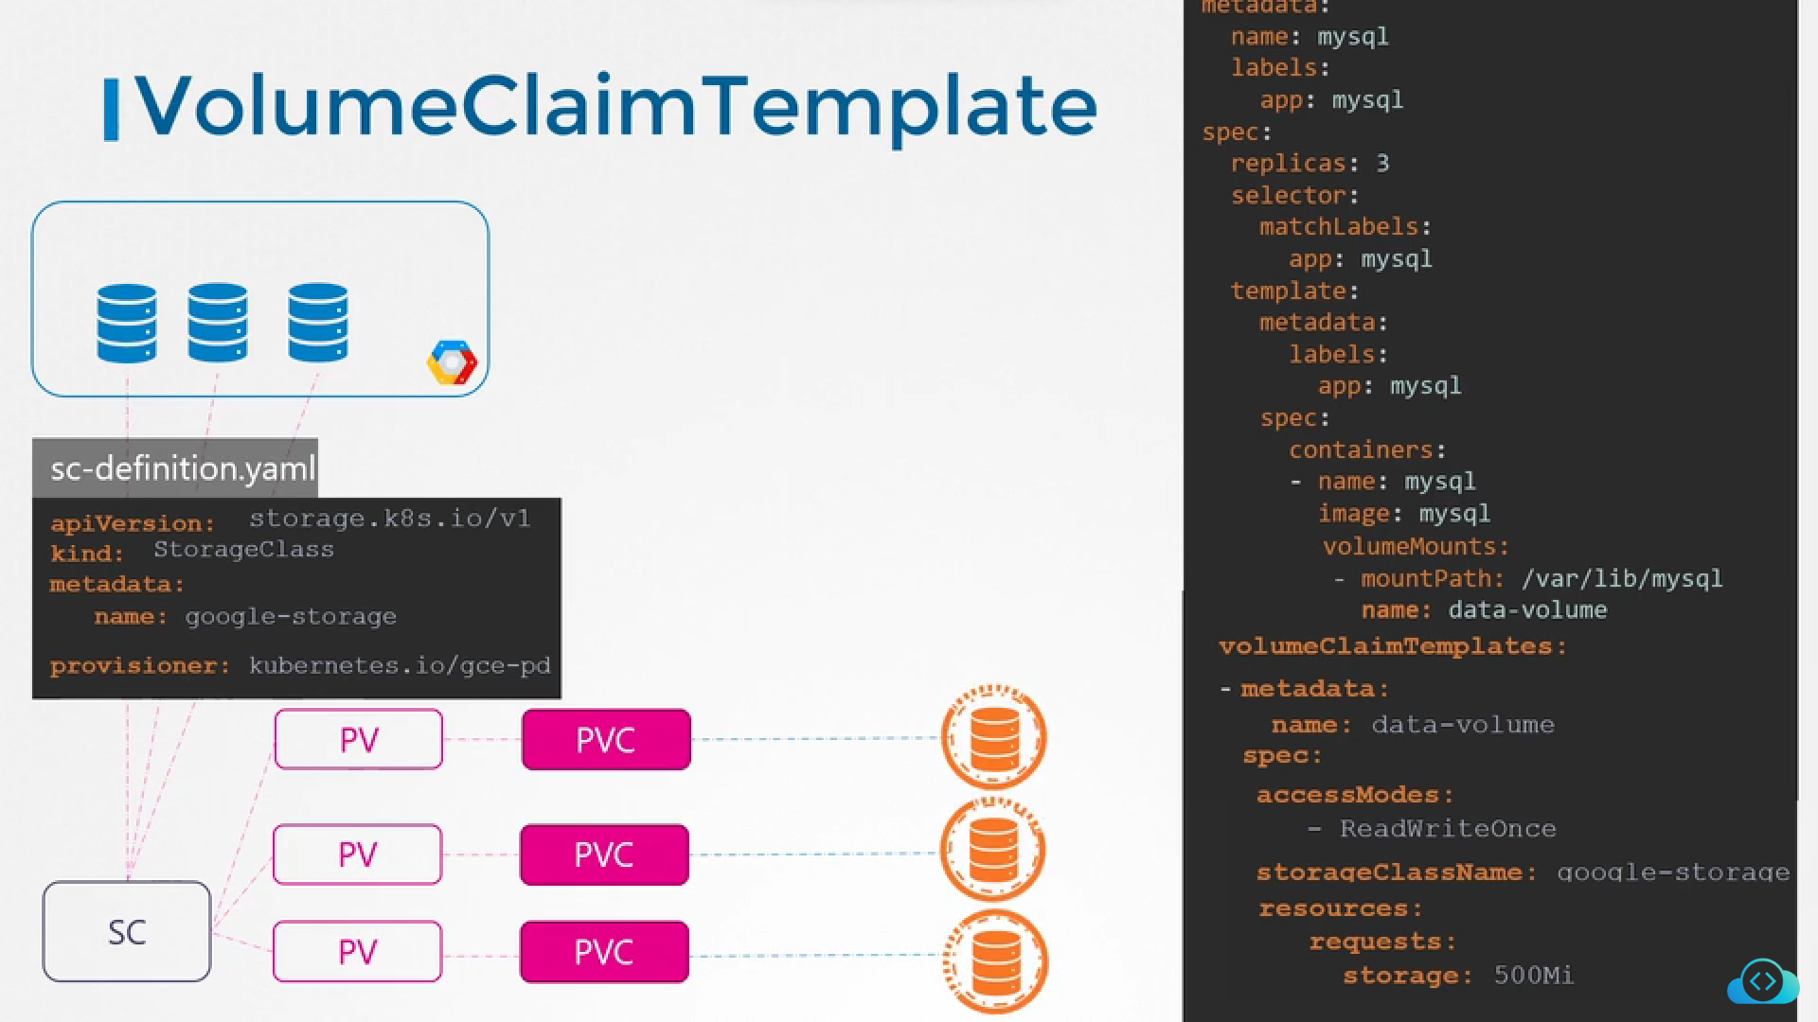

Run replicated applications: https://kubernetes.io/docs/tasks/run-application/run-replicated-stateful-application/