ASSIGNMENT 1 – TASK 1: KNN ON BREAST CANCER DATASET
Implementation, Experiments and Results
1. Objective
The aim was to implement K-Nearest Neighbours (KNN) from scratch and use it to classify breast cancer cases as malignant or benign.
I tested different K values and distance measures to see which combination gives the best result. The final model was evaluated using accuracy, confusion matrix, precision and recall.
2. Dataset and Preparation
I used the Breast Cancer dataset for this task. The dataset contains 569 records and 30 features related to breast tumors.
The diagnosis column contains two classes:
- M – Malignant
- B – Benign
The unnecessary ID-related columns were removed before using the data.
The dataset was divided into 80% training data and 20% test data. The training data was used by KNN to find the nearest examples, while the test data was used to evaluate the predictions.
The feature values were standardized before applying KNN so that features with larger numerical ranges would not have more influence on the distance calculation. The standardization was fitted using the training data and then applied to both the training and test data.
3. KNN Setup
KNN predicts the class of a new data point by looking at its closest training examples. The class that occurs most often among these neighbours is selected as the prediction.
The following K values were tested:
K = 3, 4, 9, 20 and 47
The following distance measures were tested:
- Euclidean
- Manhattan
- Minkowski
- Cosine
- Hamming
A total of 25 combinations of K and distance measure were tested.

4. Experimentation
For each combination, predictions were made on the test data and the accuracy was calculated.
The accuracy values were compared to find the best combination of K and distance measure.
Experiment | Best K | Distance | Accuracy
Full test set | 9 | Euclidian | 96.49 %
Figure 1: KNN Experimentation: K-Value vs Test Accuracy Profile
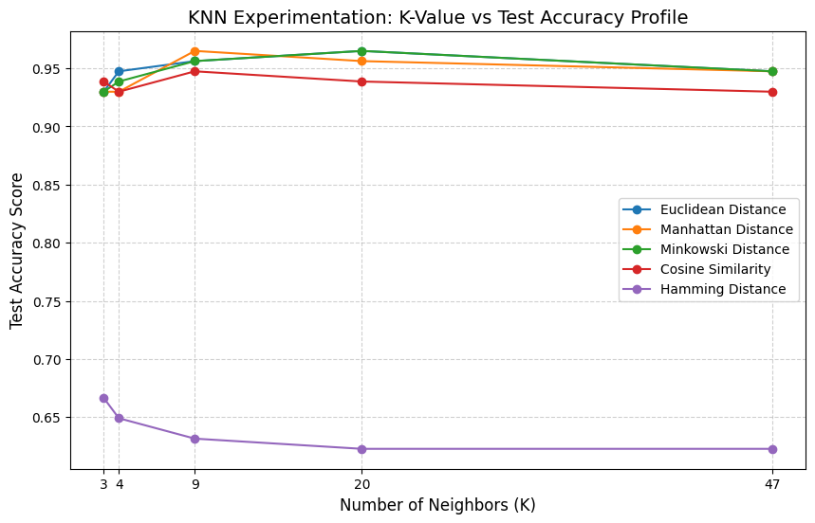

The graph shows how the test accuracy changes for different K values. The performance also changes depending on the distance measure used.
The best combination was selected based on the highest test accuracy.

5. KNN Decision Boundary
A decision boundary was also plotted to get a visual idea of how KNN separates the two classes.
Figure 2: KNN Decision Boundary Space
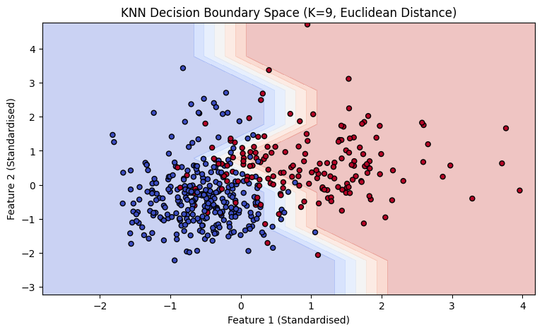

The decision boundary shows how the model separates the two classes based on the selected features. Different regions represent the areas where the model predicts different classes.

6. Confusion Matrix
The final model was evaluated using a confusion matrix.
Figure 3: Confusion Matrix of the Best Model
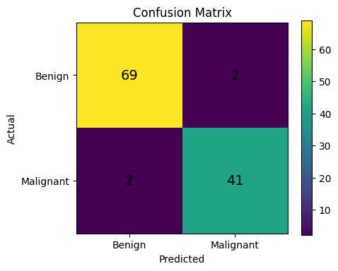

The confusion matrix shows the number of cases that were correctly and incorrectly classified. It gives a simple view of how well the model identifies malignant and benign cases.

7. Accuracy, Precision and Recall
Precision and recall were also calculated for the final model.
Precision shows how reliable the model is when it predicts a case as malignant.
Recall shows how many of the actual malignant cases were correctly identified.
The obtained values are shown in the graph below:

Figure 4: KNN Model Performance
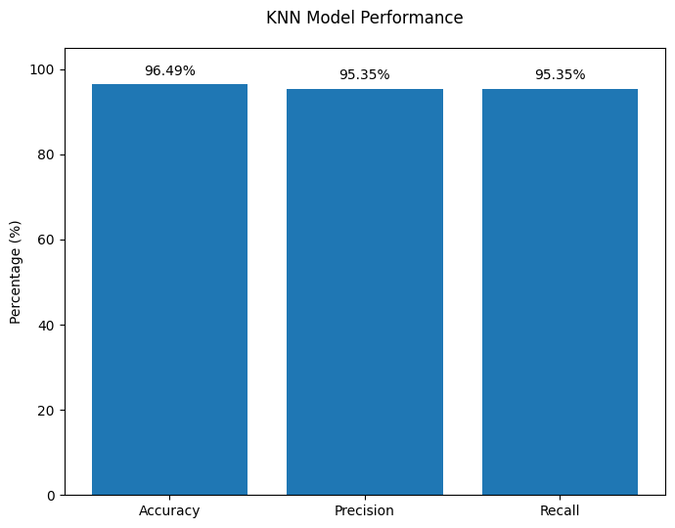

8. Final Results and Conclusion
The best result was obtained using K = 9 with Euclidean distance, giving an accuracy of 96.49%.
The model achieved a precision of 95.35% and a recall of 95.35%.
Overall, the experiment showed that the choice of K and distance measure affects the performance of KNN. Testing different combinations helped identify the configuration that performed best on the test data.
This assignment helped in understanding how KNN works and how changing K and the distance measure can affect its classification results.

9. Limitation
One limitation of this experiment is that the best configuration was selected based on the test results. Ideally, a separate validation set could be used to select the best K and distance measure, while the test set could be kept only for the final evaluation.

