Assignment 1 – Task 2: KNN on CIFAR-10
Implementation, Experiments and Results

1. Objective
The aim was to implement K-Nearest Neighbours (KNN) from scratch and use it for CIFAR-10 image classification. I tested different K values, distance measures, sample sizes and PCA settings to see which combination gives the best result.

2. Architecture / Flow
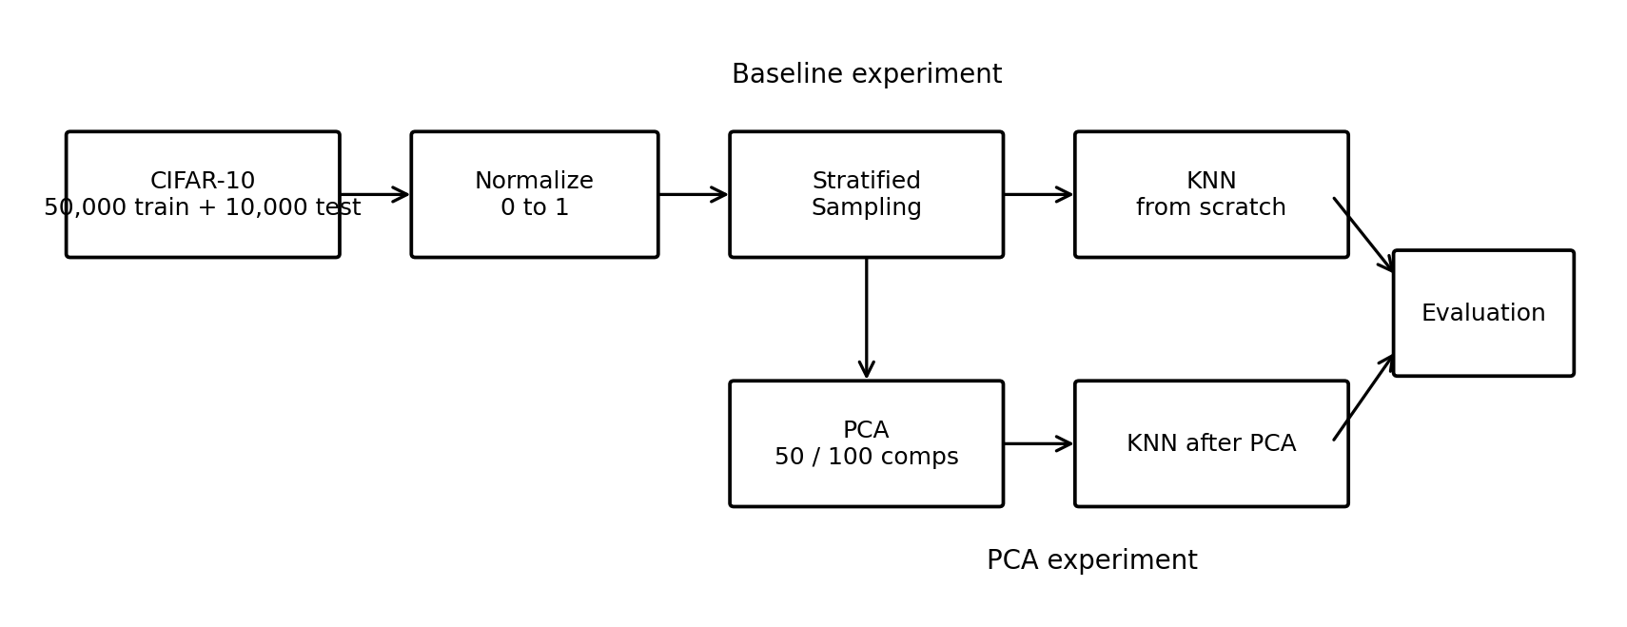
Figure 1: Overall flow used in the task
First, I loaded and normalized the CIFAR-10 images. Since KNN becomes slow with a large dataset, I selected equal numbers of images from each class. I first ran KNN directly on the pixels, then repeated it with more data. Finally, I reduced the features using PCA and ran KNN again. The predictions were evaluated using accuracy, confusion matrix, precision and recall.

3. KNN Setup
- CIFAR-10: 10 classes, 32 × 32 RGB images.
- Pixel values were normalized to 0–1.
- K values tested: 3, 4, 9, 20 and 47.
- Distances tested: Euclidean, Manhattan, Minkowski, Cosine and Hamming.
For each test image, KNN finds the nearest training images and predicts the class that occurs most often among the selected neighbours.

4. Experiment 1 – Baseline
I used 100 training and 20 test images per class, giving 1000 training and 200 test images. I tested all distance measures with the selected K values.
Experiment | Best K | Distance | Accuracy
1000 / 200 | 4 | Manhattan | 30.0%
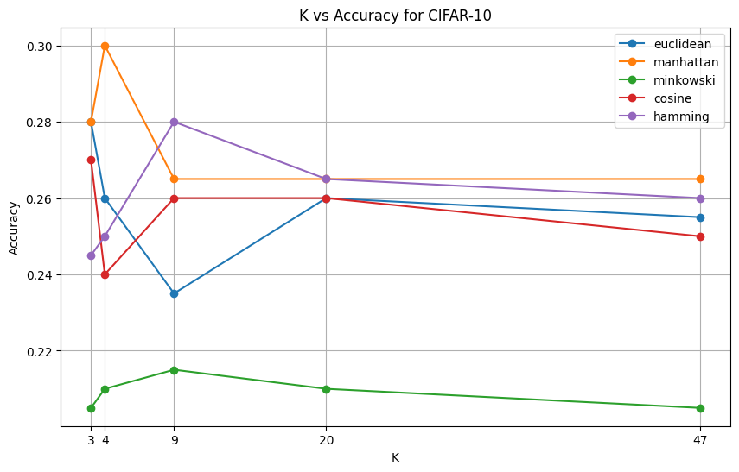

Figure 2: Accuracy for different K values and distance measures
The graph shows that changing K and distance changes the accuracy, but the overall performance is low. The best result in this experiment was 30% with K = 4 and Manhattan distance.

5. Experiment 2 – More Data
I increased the sample to 200 training and 40 test images per class, giving 2000 training and 400 test images. The same K and distance combinations were tested.
Experiment | Best K | Distance | Accuracy
2000 / 400 | 47 | Euclidean | 29.75%
The accuracy was slightly lower than the first experiment. Therefore, simply increasing the number of images did not improve the result.

6. PCA Experiment
The original image has 3072 pixel values. I used PCA to reduce this number before applying KNN. I tested 50 and 100 components. PCA was fitted on the training data and the same transformation was applied to the test data.
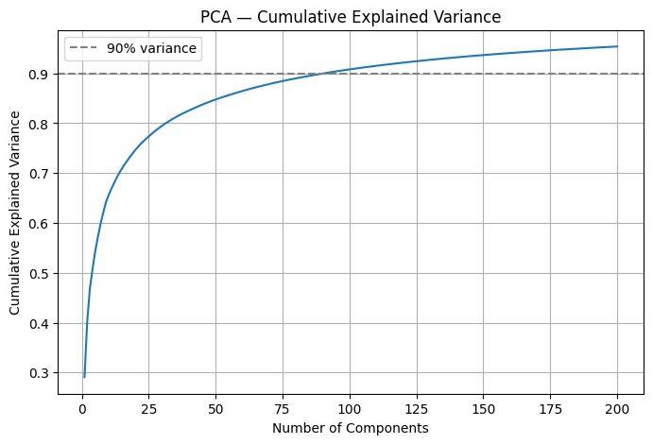
Figure 3: Cumulative explained variance with PCA
This plot shows how the retained information increases as more PCA components are used. I then tested KNN using the selected PCA sizes.
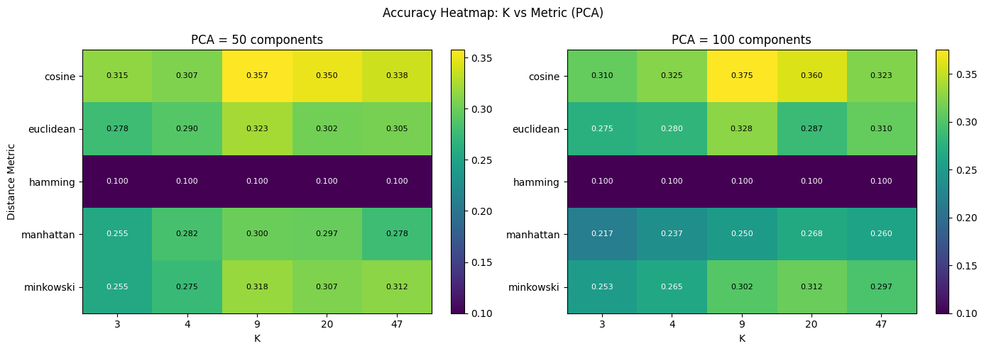
Figure 4: KNN accuracy after PCA
The heatmap compares K and distance methods. Cosine distance gives the stronger results after PCA, especially for K = 9.

7. Best Result
Setting | Best value
PCA components | 100
Distance | Cosine
K | 9
Accuracy | 37.5%
Average precision | 0.3963
Average recall | 0.375

Figure 5: Accuracy progression across experiments
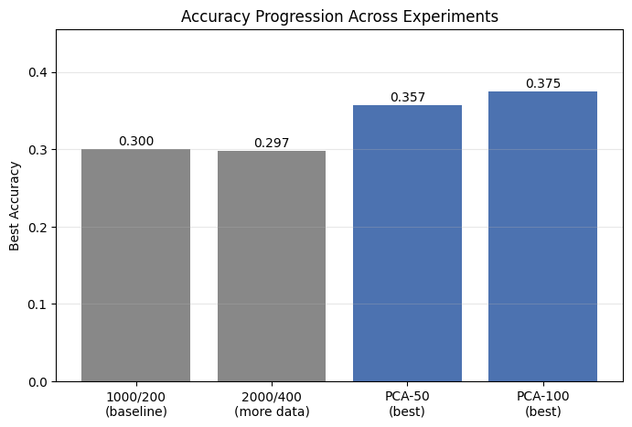

This plot gives the main comparison. The accuracy was 30% for the baseline, 29.75% with more data, 35.75% with 50 PCA components and 37.5% with 100 components. The biggest improvement came from PCA.

8. Best Model Evaluation
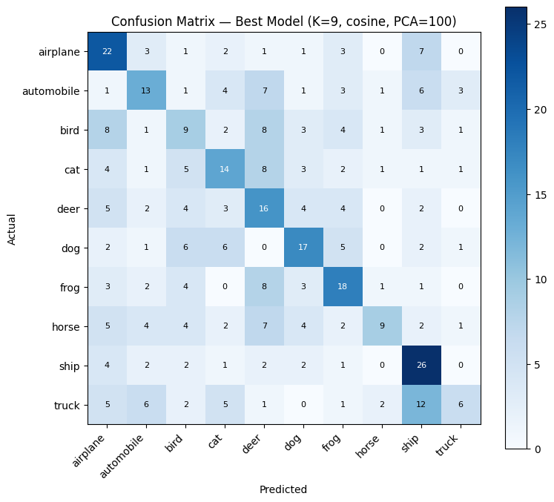
Figure 6: Confusion matrix of the best model
The diagonal represents correct predictions. The matrix shows that some classes are easier to recognize than others. There is more confusion between visually similar classes.
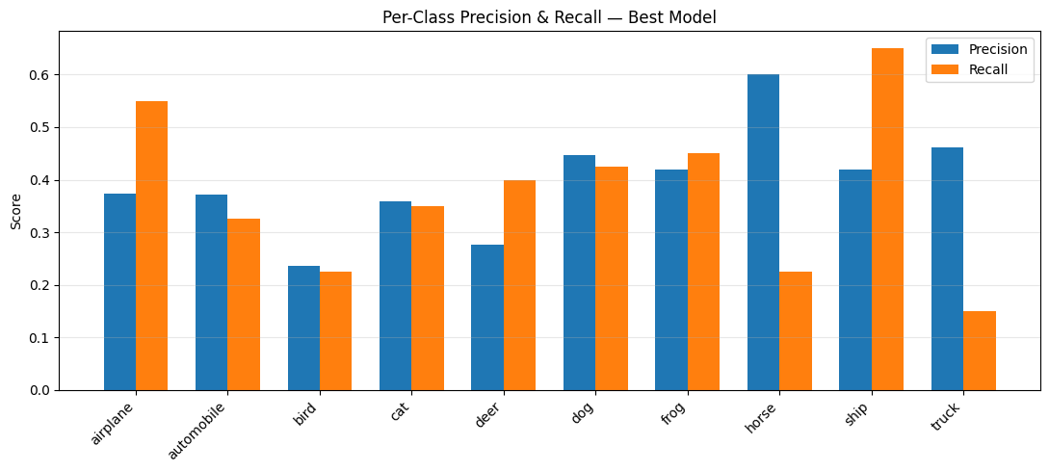
Figure 7: Precision and recall for each class
This plot shows the class-wise performance. Ship has high recall (0.65), while airplane has 0.55. Bird and truck have lower recall, so the model misses more images from these classes. Horse has the highest precision (0.60).

9. Final Results and Conclusion
Stage | Data | Best setting | Accuracy
Baseline | 1000 / 200 | K=4, Manhattan | 30.0%
More data | 2000 / 400 | K=47, Euclidean | 29.75%
PCA 50 | 2000 / 400 | K=9, Cosine | 35.75%
PCA 100 | 2000 / 400 | K=9, Cosine | 37.5%
The best result was 37.5% using 100 PCA components, Cosine distance and K = 9. Increasing the data alone did not help, while PCA gave a clear improvement. The experiment shows that reducing the image features before KNN was more useful than simply using more training images.

One limitation is that the best settings were selected using the test results. A separate validation set would be better for choosing the final settings.

