SCHEME :K
Name : Roll No.: Year : 20 20 Exam Seat No. :

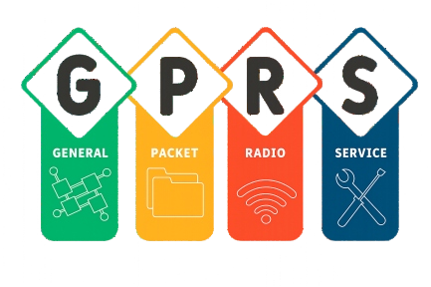
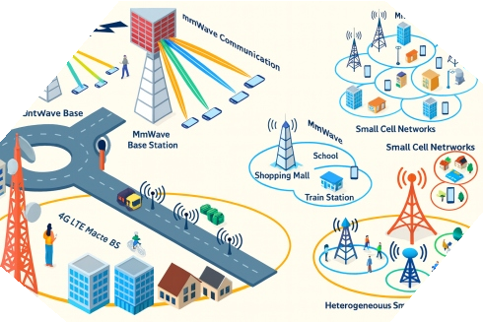


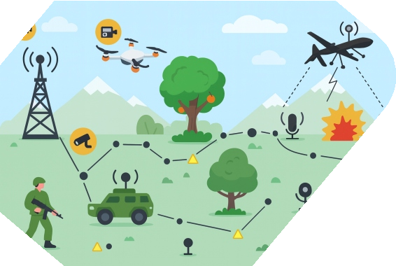
LABORATORY MANUAL FOR
WIRELESS AND MOBILE NETWORK (316325)

COMPUTER ENGINEERING GROUP

MAHARASHTRA STATE BOARD OF TECHNICAL EDUCATION, MUMBAI (Autonomous)(ISO21001:2018)(ISO/IEC27001:2013)

Vision
To ensure that the Diploma level Technical Education constantly matches the latest requirements of Technology and industry and includes the all-round personal development of students including social concerns and to become globally competitive, technology led organization.

Mission
We, at MSBTE are committed to offer the best in class academic services to the students and institutes to enhance the delight of industry and society. This will be achieved through continual improvement in management practices adopted in the process of curriculum design, development, implementation, evaluation and monitoring system along with adequate faculty development programmes.

MSBTE believes in the following:
Core Values

- Skill development in line with industry requirements
- Industry readiness and improved employability of Diploma holders
- Synergistic relationship with industry
- Collective and Cooperative development of all stake holders
- Technological interventions in societal development
- Access to uniform quality technical education

A Practical Manual For

Wireless and Mobile Network
(316325)

Semester-VI
IF

Maharashtra State Board of Technical Education, Mumbai
(Autonomous) (ISO 21001:2018) (ISO/IEC 27001:2013)

‘K’ Scheme Curriculum

MAHARASHTRA STATE BOARD OF TECHNICAL EDUCATION
(Autonomous) (ISO 21001:2018)(ISO/IEC 27001:2013)
Address: 4th floor, Govt. Polytechnic Building, 49, Kherwadi, Bandra (E), Mumbai- 400 051
Tel: 022 62542100
Email: secretary@msbte.com

Maharashtra State Board of Technical Education Certificate
This is to certify that Mr./Ms……………………….……………………………. Roll No………….…….…of………..…….………Semester of Diploma in…………...…...……………………………………………............of Institute
Name……………….....……………………………….…(Inst. Code: )
has completed the term work satisfactorily in Course Wireless and Mobile Network (Course Code: 316325) for the academic year 20……. to 20 as
prescribed in the curriculum.

Place ………………. Enrollment No……………………

Date: …..................... Exam Seat No. ………………......

Course Teacher Head of the Department Principal



Preface
The primary focus of any engineering laboratory/field work in the technical education system is to develop the much-needed industry-relevant competencies and skills. With this in view, MSBTE embarked on this innovative 'K' Scheme curricula for engineering Diploma programmes with outcome-based education as the focus and accordingly, relatively large amount of time is allotted for the practical work. This displays the great importance of laboratory work making each teacher, instructor and student to realize that every minute of the laboratory time need to be effectively utilized to develop these outcomes, rather than doing other mundane activities. Therefore, for the successful implementation of this outcome-based curriculum, every practical has been designed to serve as a 'vehicle' to develop this industry identified competency in every student. The practical skills are difficult to develop through 'chalk and duster' activity in the classroom situation. Accordingly, the “K” scheme laboratory manual development team designed the practical's to focus on outcomes, rather than the traditional age-old practice of conducting practical's to verify the theory (which may become a byproduct along the way).
This laboratory manual is designed to help all stakeholders, especially the students, teachers and instructors to develop in the student the pre-determined outcomes. It is expected from each student that at least a day in advance, they have to thoroughly read the concerned practical procedure that they will do the next day and understand minimum theoretical background associated with the practical. Every practical in this manual begins by identifying the competency, industry relevant skills, course outcomes and practical outcomes which serve as a key focal point for doing the practical. Students will then become aware about the skills they will achieve through procedure shown there and necessary precautions to be taken, which will help them to apply in solving real-world problems in their professional life.
This manual also provides guidelines to teachers and instructors to effectively facilitate student-centered lab activities through each practical exercise by arranging and managing necessary resources in order that the students follow the procedures and precautions systematically ensuring the achievement of outcomes in the students.
Wireless mobile networks are an essential part of any computer networks. Similarly, a course on wireless networks is an essential part of any computer group. We hope that students will also find it useful. It provides a clear description of practical performance, execution and working of wireless networks.
Although all care has been taken to check for mistakes in this laboratory manual, yet it is impossible to claim perfection especially as this is the first edition. Any such errors and suggestions for improvement can be brought to our notice and are highly welcome.

Program Outcomes (POs) to be achieved through Course:

PO1 | Basic and Discipline specific knowledge: Apply knowledge of basic mathematics, science and engineering fundamentals and engineering specialization to solve the engineering problems.
PO2 | Problem analysis: Identify and analyses well-defined engineering problems using codified standard methods.
PO3 | Design/ development of solutions: Design solutions for well-defined technical problems and assist with the design of systems components or processes to meet specified needs.
PO4 | Engineering Tools, Experimentation and Testing: Apply modern engineering tools and appropriate technique to conduct standard tests and measurements.
PO5 | Engineering practices for society, sustainability and environment: Apply appropriate technology in context of society, sustainability, environment and ethical practices.
PO6 | Project Management: Use engineering management principles individually, as a team member or a leader to manage projects and effectively communicate about well-defined engineering activities.
PO7 | Life-long learning: Ability to analyses individual needs and engage in updating in the context of technological changes.

List of Relevant Skills

By performing the laboratory practicals of the Wireless and Mobile Network course, students develop the following industry-relevant skills required to maintain mobile and wireless communication systems:
- Mobile device hardware diagnosis and component testing skills.
- Wireless network setup, configuration, and troubleshooting skills.
- RF communication and mobile network operation skills.
- Simulation and analysis skills for coding, modulation, MANET, WSN, and signal processing.
- Mobile IP configuration and wireless protocol implementation skills across GSM/GPRS/5G/Wi-Fi standards.
These skills match contemporary industry requirements in network operations, IoT, and wireless system maintenance.

Practical Course Outcome Matrix
Course Outcomes (COs)

CO1 | Identify various terminologies used in GSM network systems.
CO2 | Establish a wireless network with the given technology.
CO3 | Differentiate between various generations of mobile networks.
CO4 | Explain the 5G network system architecture.
CO5 | Establish wireless sensor networks for the given application.

Sr.  No. | Title of the Experiment | CO1 | CO2 | CO3 | CO4 | CO5
1 | *Identify different sections of a mobile phone | ✓
2 | *Perform the process of call connection and call release of the cellular mobile system (Using any simulation tool) | ✓
3 | *Detect the hardware details of the mobile handset (Using any relevant mobile application) | ✓
4 | *Detect the operating system and its version  (Windows, BlackBerry, macOS) using any relevant mobile application | ✓
5 | Establish a Personal Area Network for two or more devices |  | ✓
6 | Transfer an image, audio, and video file using Bluetooth protocol with varying distances between  two or more devices |  | ✓
7 | *Make a Hotspot connection on Wi-Fi on any 2 devices |  | ✓
8 | *Configure Wi-Fi settings in mobile devices using mobile tethering to connect two devices (e.g., a  mobile phone to a laptop) |  | ✓
9 | *Install and authenticate eSIM (virtual SIM) on a mobile handset |  |  | ✓
10 | *Identify the Dual SIM interface section, Touchscreen display section, the battery charging circuit, power management unit of 4G/5G  smartphone and test working |  |  | ✓
11 | Using an appropriate mobile app, locate and find the Internet signal strength of the mobile tower |  |  | ✓

 | 12 | Check network availability and network topology using any open share website |  |  |  | ✓
 | 13 | *Implement manual and auto selection of network using mobile handset |  |  |  | ✓
 | 14 | *Create seamless wireless connectivity using multiple access points |  |  |  | ✓
 | 15 | *Develop a mobile application for wireless technology (using wizards like Appypie or similar) |  |  |  | ✓
 | 16 | Apply RFID technology for real-life applications using the RFID kit |  | ✓
 | 17 | *Implementhe t line coding technique Unipolar NRZ using MATLAB/Simulink |  |  |  |  | ✓
 | 18 | *Implement line coding technique, Bipolar RZ using MATLAB/Simulink |  |  |  |  | ✓
 | 19 | *Implement the line coding technique Manchester NRZ using MATLAB/Simulink |  |  |  |  | ✓
 | 20 | *Simulate binary amplitude shift keying using MATLAB/Simulink |  |  |  |  | ✓
 | 21 | Simulate binary phase shift keying using MATLAB/Simulink |  |  |  |  | ✓
 | 22 | Simulate frequency shift keying using MATLAB/Simulink |  |  |  |  | ✓
 | 23 | *Implement pulse code modulation using MATLAB/Simulink |  |  |  |  | ✓
 | 24 | Implement delta modulation using MATLAB/Simulink |  |  |  |  | ✓
 | 25 | *Implement a WSN node to determine the position of the node and blink the LED using Cupcarbon  simulator and Senscript |  |  |  |  | ✓
 | 26 | *Analyse a Wi-Fi network using related software (e.g., NetSpot, Wi-Fi analyzers) |  |  |  |  | ✓
 | 27 | Use network simulators such as NS3 or OMNeT++ to create a basic MANET |  |  |  |  | ✓
 | 28 | Set up mobile IP addressing on a local network using Cisco Packet Tracer or other software |  |  |  |  | ✓

Guidelines to Teachers

- Teachers should align the explanation of the topic to the teaching learning outcome (TLOs).
- Refer to laboratory learning outcome (LLOs) for the execution of the practical to focus on the defined objectives.
- Promote life-long learning by training the students to equip themselves with essential knowledge, skills, and attitudes.
- If required, provide a demonstration for the practical, emphasizing the skills that the student should achieve.
- Teachers should allow students to exhibit their skills after the demonstration.
- Provide feedback and/or suggestions and share insights to improve effectiveness.
- Assess students’ skill achievement related to the COs of each unit.

Instructions for Students
- 100% attendance is compulsory for all practical sessions.
- Students must adhere to ethical practices.
- All the students must follow the schedule of practical sessions, complete the assigned work/activity, and submit the assignment within the stipulated time as instructed by the course teacher.
- Students shall listen carefully to the explanation given by the teacher about the importance of the subject, learning structure, and course outcomes.
- Students shall understand the purpose of the experiment and its practical implementation.
- Students shall write the answers to the questions during the practical.
- Students should feel free to discuss any difficulty faced during the conduct of the practical.
- Student shall attempt to develop related hands-on skills and gain confidence.
- Students should develop the habit of submitting the write-ups on the scheduled dates and time.

Content Page

List of Practical and Formative Assessment Sheets

Sr. No | Practical Title | Date of Performance | Date of Submission | Assessment Marks (25) | Teacher’s Sign | Remark
1 | *Identify different sections of a mobile phone
2 | *Perform the process of call connection and call release of the cellular mobile system (Using any simulation tool)
3 | *Detect the hardware details of the mobile handset (Using any relevant mobile application)
4 | *Detect the operating system and its version (Windows, BlackBerry, macOS) using any relevant mobile application
5 | Establish a Personal Area Network for two or more devices
6 | Transfer an image, audio, and video file using Bluetooth protocol with varying distances between two or more devices
7 | *Make a Hotspot connection on Wi-Fi on any 2 devices
8 | *Configure Wi-Fi settings in mobile devices using mobile tethering to connect two devices (e.g., a mobile phone to a laptop)
9 | *Install and authenticate eSIM (virtual SIM) on a mobile handset
10 | *Identify the Dual SIM interface section, Touchscreen display  section, the battery charging circuit, the power management

 | unit of 4G/5G smartphone and test working
11 | Using an appropriate mobile app, locate and find the Internet signal strength of the mobile tower
12 | Check network availability and network topology using any open share website
13 | *Implement manual and auto selection of the network using a mobile handset
14 | *Create seamless wireless connectivity using multiple access points
15 | *Develop a mobile application for wireless technology (using wizards like Appypie or similar)
16 | Apply RFID technology for real- life applications using the RFID kit
17 | *Implement the line coding technique Unipolar NRZ using MATLAB/Simulink
18 | *Implement line coding technique, Bipolar RZ using MATLAB/Simulink
19 | *Implement the line coding technique Manchester NRZ using MATLAB/Simulink
20 | *Simulate binary amplitude shift keying using MATLAB/Simulink
21 | Simulate binary phase shift keying using MATLAB/Simulink
22 | Simulate frequency shift keying using MATLAB/Simulink

23 | *Implement pulse code modulation using MATLAB/Simulink
24 | Implement delta modulation using MATLAB/Simulink
25 | *Implement a WSN node to determine the position of the node and blink the LED using Cupcarbon simulator and Senscript
26 | *Analyse a Wi-Fi network using related software (e.g., NetSpot, Wi- Fi analyzers)
27 | Use network simulators such as NS3 or OMNeT++ to create a basic MANET
28 | Set up mobile IP addressing on a local network using Cisco Packet Tracer or other software
Total

*Total marks to be transferred to the proforma published by MSBTE Note:
- '*' Marked Practical’s (LLOs) Are mandatory.
- Minimum 80% of above list of lab experiment are to be performed.
- Judicial mix of LLOs are to be performed to achieve desired outcomes.

Practical No. 1: Identify different sections of a mobile phone.

Practical Significance
In today’s wireless communication era, mobile phones represent a sophisticated combination of electronic, software, and communication subsystems. Understanding the structure and functioning of different sections within a mobile handset, such as the transmitter, receiver, power management, display, SIM, and user interface sections, is the foundation for maintaining and troubleshooting modern mobile devices. This practical can help students to gain hands-on familiarity with internal mobile hardware and their interactions with GSM network components. By identifying and testing key sections, students develop diagnostic skills essential for the telecommunications and mobile repair industry. Additionally, the exercise enhances understanding of signal flow from the microphone to the antenna, power distribution, and interface handling, skills crucial for roles in mobile servicing, IoT device maintenance, and embedded systems integration.

Industry / Employer Expected Outcome(s)
Maintain mobile and wireless communication systems.

Course Level Learning Outcome(s)
CO1 – Identify various terminologies used in GSM network systems.

Laboratory Learning Outcome(s)
LLO 1.1: Identify different sections and components of a mobile phone, such as the ringer section, dialer section, receiver section and transmitter section, camera, microphone, speaker, and flashlight.

Relevant Affective Domain Related Outcome(s)
  - Follow precautionary measures.
  - Follow naming conventions.
  - Follow ethical practices.
  - Handle equipment carefully and ensure proper shutdown after testing.

Relevant Theoretical Background
A mobile phone (or cellular handset) is a portable transceiver that operates through a cellular network, dividing service areas into cells each served by a base transceiver station (BTS). Understanding its internal architecture helps in analyzing communication flow and electrical design.

Major Sections of a Mobile Phone
  - Power Management Section: Converts and regulates battery voltage (typically 3.7 V DC) to supply multiple internal subsystems such as RF circuits, logic units, and display. It includes charging circuits, voltage regulators, and protection ICs.
  - RF (Radio Frequency) Section: Handles transmission and reception of radio signals. The transmitter modulates and amplifies outgoing signals using GSM modulation (e.g., GMSK) before sending them to the antenna, while the receiver demodulates incoming signals and filters noise.

  - Baseband / Audio Section: Converts analog voice to digital form using ADC, performs compression and channel coding, and then passes data to the DSP. The reverse process happens for received signals.
  - Digital Signal Processor (DSP) and Microcontroller Unit (MCU): The DSP handles voice/data signal processing; the MCU manages keypad input, display control, system logic, and coordination with the base station via signaling protocols.
  - Memory Section: Includes ROM/Flash for firmware storage, SRAM for runtime memory, and the
SIM card for subscriber identity and authentication.
  - Display and User Interface Section: Comprises LCD/OLED display, keypad or touch interface, camera module, and audio I/O peripherals (speaker, microphone, vibrator motor, and LED flash).
  - Antenna Section: Provides impedance-matched RF interface to transmit and receive radio waves effectively.
Signal Flow in GSM Handset: Voice captured by the microphone is digitized, encoded, and modulated. The RF front-end transmits it through the antenna. Conversely, received RF signals are filtered, demodulated, decoded, and converted back to audible form through the speaker.
Practical Relevance: Testing individual sections—voltage measurement at test points, waveform analysis at transmitter/receiver stages, and verifying SIM and display circuits helps diagnose common hardware issues such as power failure, signal loss, or display malfunction.

Simplified Block Diagram of a Mobile Phone
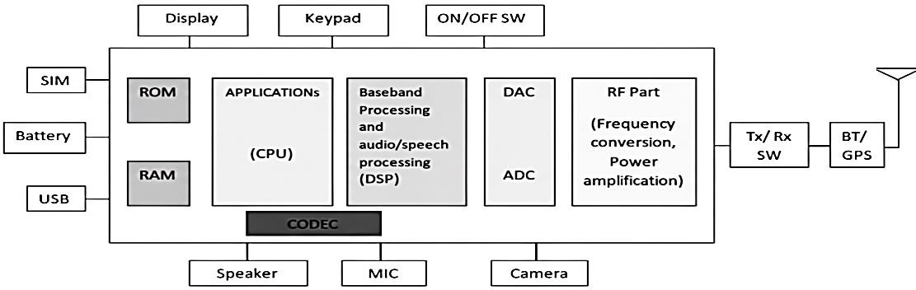
Fig.1.1: Block diagram of Mobile Unit

Required Resources / Apparatus / Equipment with Specifications

Sr. No. | Equipment / Apparatus | Specification | Quantity
1 | GSM Trainer Kit (2G/ 3G/  4G support) | With test points for Tx/Rx, SIM, LCD, and  audio | 1
2 | SIM Card | Standard / Micro SIM with network | 1
3 | CRO / DSO | Dual trace ≥ 20 MHz bandwidth | 1
4 | Multi-meter | Digital, 3 ½ digit | 1
5 | Spectrum Analyzer | Up to 1 GHz | 1
6 | Connecting Wires | Banana-type patch cords | 4

- Precautions to be followed
  - Handle the computer system and GSM trainer carefully.
  - Strictly follow instructions while measuring voltages or connecting probes.
  - Do not insert or remove the SIM card with power ON.
  - Ensure the CRO/DSO ground is properly connected before measurement.
  - Follow general safety and ESD precautions.

Procedure
  - Power ON the GSM trainer kit and insert a valid SIM card in the designated slot.
  - Connect the power supply (≈ 5 V DC) and ensure indicator LEDs are ON.
  - Testing Transmitter/Receiver Sections:
    - Make a call from the trainer to another mobile; observe the signal on the spectrum analyzer.
    - Repeat for an incoming call and note RX/TX waveform levels.
  - Testing Battery/Charger Section:
Measure voltages at test points (TP1–TP5) using a digital multimeter and record results.
  - Testing Power Management Unit:
Verify VCC, VDD_IO, and V_CPU points as per circuit documentation.
  - Testing Display and User Interface:
Press keys or receive a call; observe LED, ringer, and vibrator responses.
  - Testing SIM Section:
Measure the SIM VCC, RST, and CLK signals; verify the clock waveform on the CRO.
  - Record all observed values in the observation table.
  - Switch OFF the trainer and disconnect all test leads.

Observation Table

Sr.  No. | Test Section / Procedure  Step | Test Points / Parameters | Expected Observation | Measured / Observed  Value | Remarks / Inference
1 | Power ON & Initialization | Power Supply Input (VCC), Indicator LEDs | 5V DC input, Power LED ON, Module boots with signal LED  blinking
2 | SIM Section Test | SIM_VCC, SIM_RST, SIM_CLK | VCC ≈ 3.0–3.3 V;  RST ≈ 2.8–3.0 V; CLK ≈ 3.2 MHz–3.6  MHz |  | Check for proper SIM detection
3 | Transmitter Section Test | RF Output (TX), Spectrum Analyzer reading | Signal observed when the call is initiated; Frequency in GSM band (890–915 MHz  for uplink) |  | Verify clean TX spectrum

4 | Receiver Section Test | RF Input (RX), Spectrum Analyzer reading | Signal observed during incoming call; Frequency 935–960  MHz (downlink) |  | Check RX waveform integrity
5 | Call Function Test | Call connection between the GSM kit and the external  phone | Successful connection, audio path established |  | Verify both TX and RX paths
6 | Battery / Charger Section Test | TP1–TP5 voltage points | TP1 ≈ 3.7 V, TP2 ≈ 5.0 V, TP3 ≈ 4.2 V, TP4 ≈ 3.8 V,  TP5 (Low battery  detect): Logic LOW |  | Compare with expected circuit values
7 | Power Management Unit | VCC, VDD_IO, V_CPU, VBAT, V_RF | VCC ≈ 5V,  VDD_IO ≈ 2.8–3.3V, V_CPU ≈ 1.8V,  VBAT ≈ 3.7V |  | Stable outputs indicate proper PMU operation
8 | Display / User Interface Section | Keypad matrix, LEDs, Ringer, Vibrator | LEDs toggle with keypress, Ringer & Vibrator activate on  call |  | Verify signal continuity to the MCU
9 | Microphone & Speaker Section | MIC voltage, SPK output waveform | MIC bias ≈ 2V;  Audio waveform  visible on CRO during call |  | Check audio signal clarity
10 | Antenna Section Test | RF connector / Antenna terminal | Signal transmission & reception consistent |  | Check  impedance matching (~50Ω)
11 | Network Registration Test | Network LED, AT Command “AT+CREG?” | LED blinks slowly on registration,  Response: +CREG: 0,1 |  | Confirm network access
12 | Charging Cycle Verification | Battery voltage vs. time | Gradual increase to 4.2V, current drops after full charge |  | Observe proper charge control
13 | Display Functionality Test | LCD module (if available) | Display shows status/text messages |  | Verify LCD data communication
14 | Shutdown Test | Power OFF sequence | All LEDs OFF, no residual voltage |  | Safe power- down verified

- Conclusion
………………………………………………………………………………………………….……………
…………………………………………………………………………………….…………………………
……………………………………………………………………….………………………………………
……………………………………………………………………………………………………………….

Practical-related Questions

Note: Below are a few sample questions for reference. Teachers must design more such questions to ensure the achievement of the identified CO.
  - List major functional sections of a mobile phone.
  - State the purpose of the power management unit.
  - Describe the function of the SIM card in GSM architecture.
  - Differentiate between transmitter and receiver sections.

Space for Answer
…………………………………………………………………………………….…………………………
……………………………………………………………………….………………………………………
………………………………………………………….……………………………………………………
…………………………………………….…………………………………………………………………
……………………………….………………………………………………………………………………
………………….……………………………………………………………………………………………
…….………………………………………………………………………………………………….………
………………………………………………………………………………………….……………………
…………………………………………………………………………….…………………………………
……………………………………………………………….………………………………………………
………………………………………………….……………………………………………………………
…………………………………….…………………………………………………………………………
……………………….………………………………………………………………………………………
………….………………………………………………………………………………………………….…
……………………………………………………………………………………………….………………
……………………………………………………………………………….………………………………
………………………………………………………………….……………………………………………
…………………………………………………….…………………………………………………………
……………………………………….………………………………………………………………………
………………………….……………………………………………………………………………………

…………….………………………………………………………………………………………………….
………………………………………………………………………………………………….……………
…………………………………………………………………………………….…………………………
……………………………………………………………………….………………………………………
………………………………………………………….……………………………………………………
…………………………………………….…………………………………………………………………
……………………………….………………………………………………………………………………
………………….……………………………………………………………………………………………
…………………………………………………………………………………………….…………………
……………………………………………………………………………….………………………………
……………………………………………………………………………….………………………………

References / Suggestions for Further Reading
  - https://www.electronicsforu.com/resources/mobile-phone-block-diagram-explained
  - https://www.youtube.com/watch?v=3ju9uXV-RJY
  - https://www.youtube.com/watch?v=KkLsWdkuAic
  - https://www.youtube.com/watch?v=vuLQ0wXNy8g
- Assessment Scheme (25 Marks)

Sr. No. | Performance Indicators | Weightage
Process-related (10 marks = 40%)
1. | Proper handling of the GSM trainer and instruments | 20%
2. | Accurate identification of sections and test points | 10%
3. | Correct measurement and recording of voltages | 10%
Product-related (15 marks = 60%)
4. | Observation accuracy and waveform clarity | 20%
5. | Answering practical-related questions | 20%
6. | Timely completion and submission of the report | 20%
Total (25 Marks) |  | 100%

Marks Obtained |  |  | Dated Signature of  Teacher
Process  related (10) | Product  related (15) | Total (25)

Practical No. 2: Perform the process of call connection and call release of the cellular mobile system (Using any simulation tool)

Practical Significance
The process of call connection and call release forms the core of cellular communication systems. Understanding how a mobile-initiated call is established, maintained, and terminated across the GSM network is crucial for engineers working with wireless and mobile communication technologies. This practical provides students with hands-on experience in simulating the call setup, routing, and release stages within a cellular environment. Using simulation tools, students can observe message exchanges among GSM entities such as the Mobile Station (MS), Base Station Subsystem (BSS), and Mobile Switching Centre (MSC). They will learn how registration, authentication, channel allocation, and handshaking occur before the call begins, and how signaling messages like SETUP, ALERTING, CONNECT, and RELEASE function in the system. The practical also reinforces theoretical concepts like mobility management, call routing, and control signaling, thereby building analytical skills for troubleshooting real-world GSM network issues and optimizing network performance.

Industry / Employer Expected Outcome(s)
Maintain the mobile and wireless communication system.

Course Level Learning Outcome(s)
CO1 – Identify various terminologies used in GSM network systems.

Laboratory Learning Outcome(s)
LLO 2.1: Analyze the process of call connection and call release of the cellular mobile system.

Relevant Affective Domain Related Outcome(s)
  - Follow precautionary measures.
  - Follow naming conventions.
  - Follow ethical practices.
  - Demonstrate teamwork during simulation and data interpretation.

Relevant Theoretical Background
A GSM (Global System for Mobile Communication) network is composed of multiple entities that cooperate to manage calls between users. Each call involves call setup, maintenance, and release phases.

Key Components of GSM Network
    - Mobile Station (MS): User’s handset or mobile device equipped with a SIM card.
    - Base Transceiver Station (BTS): Handles radio communication with mobile devices.
    - Base Station Controller (BSC): Manages multiple BTSs and allocates radio channels.
    - Mobile Switching Centre (MSC): Controls call setup, routing, and release.
    - Visitor Location Register (VLR) / Home Location Register (HLR): Maintain user information, location, and authentication.

    - Gateway MSC (GMSC): Interfaces GSM with external networks (e.g., PSTN).

Phases of Call Connection in GSM
- Mobile Originated Call Setup:
  - MS sends the SETUP message to the MSC via BTS/BSC.
  - MSC verifies subscriber credentials from VLR/HLR.
  - MSC allocates a Traffic Channel (TCH) via BSS.
  - Once the called number is reached, ALERTING and CONNECT messages are exchanged.
  - Speech path is established between the calling and called users.

Mobile Terminated Call Setup:
- GMSC receives the call from PSTN and queries HLR for routing information.
- HLR requests a temporary routing number (MSRN) from VLR.
- MSC identifies the mobile’s location area and pages the MS.
- After the MS responds, MSC sets up the TCH and connects the call.

Call Release Procedure:
- When either user ends the call, a DISCONNECT message is sent.
- The MSC sends RELEASE and RELEASE COMPLETE messages to free allocated resources.
- BSS releases the radio channel, and billing processes are updated.

Signaling Protocols
    - MAP (Mobile Application Part) – For communication between HLR, VLR, and MSC.
    - BSSAP (Base Station Subsystem Application Part) – For signaling between MSC and BSS.
    - LAPDm (Link Access Protocol) – For signaling between MS and BTS.
  - Importance of Simulation: Simulation software enables the visualization of these signaling exchanges and timing diagrams, providing students with a real insight into how a GSM network behaves dynamically during call setup and release, without requiring live network access.

Diagram
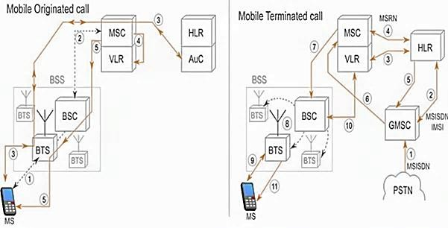
Fig.2.1 Simplified Diagram of GSM Call Flow

Required Resources / Apparatus / Equipment with Specifications

Sr.  No. | Equipment / Software | Specification / Details | Quantity
1 | GSM Simulation Tool | Any GSM simulator (e.g., GSM Network Simulator, MATLAB, OMNeT++, or NS3 module) | 1
2 | Computer System | Windows/Linux, 8GB RAM, i5 processor or higher | 1
3 | MATLAB/NS3/  OMNeT++ Software | Student version or open-source package | 1
4 | Internet Connectivity | For license activation or updates | 1
- Precautions to be followed
  - Handle the computer system carefully.
  - Save configuration files before running the simulation.
  - Close all background processes to prevent lag or crashes during execution.
  - Follow safety and ethical software usage practices.

Procedure
  - Launch Simulation Tool:
Open the selected GSM simulator or MATLAB environment.

Create GSM Network Model:
Configure network elements — MS, BTS, BSC, MSC, HLR, and VLR — in the simulation workspace.

Set Simulation Parameters:
Assign frequency bands, cell IDs, and subscriber numbers (MSISDN).

Simulate Call Connection:
    - Initiate a call from MS-A to MS-B.
    - Observe signaling messages: SETUP → ALERTING → CONNECT.
    - Record timestamps of message exchanges.

Simulate Call Release:
    - Terminate the call from either side.
    - Observe messages: DISCONNECT → RELEASE → RELEASE COMPLETE.

Analyze Network Logs:
View signaling traces in the event log or trace window.

Record Results:
Note call establishment delay, call duration, and release time.

Stop Simulation:
Save simulation data and close the tool.

Observation Table

Sr.  No. | Parameter | Expected Value / Action | Observed Result
1 | Call setup request sent  (SETUP) | Message successfully transmitted
2 | Channel allocation (TCH) | Assigned correctly
3 | Alerting message | Received within 2–3 s
4 | Connect message | Call established
5 | Disconnect message | Initiated by the user
6 | Release complete | Channel freed successfully
7 | Call setup time | ~3–5 seconds
- Conclusions
………………………………………………………………………………………………….……………
…………………………………………………………………………………….…………………………
……………………………………………………………………….………………………………………
……………………………………………………………………………………………………………….

Practical-related Questions

Note: Below are a few sample questions for reference. Teachers must design more such questions to ensure the achievement of the identified CO.
  - Differentiate between a mobile-originated call and a mobile-terminated call.
  - Explain the function of the Mobile Switching Center (MSC) during call setup.
  - Identify the main signaling protocols used in GSM call establishment.
  - State the significance of the Mobile Station Roaming Number (MSRN) and Location Area Identity (LAI) during call routing.

Space for Answer
…………………………………………………………………………………….…………………………
……………………………………………………………………….………………………………………
………………………………………………………….……………………………………………………
…………………………………………….…………………………………………………………………
……………………………….………………………………………………………………………………
………………….……………………………………………………………………………………………
…….………………………………………………………………………………………………….………
………………………………………………………………………………………….……………………
…………………………………………………………………………….…………………………………
……………………………………………………………….………………………………………………
………………………………………………….……………………………………………………………

…………………………………….…………………………………………………………………………
……………………….………………………………………………………………………………………
………….………………………………………………………………………………………………….…
……………………………………………………………………………………………….………………
………………………………………………………………………………….……………………………
…………………………………………………………………….…………………………………………
……………………………………………………….………………………………………………………
……………………………………….………………………………………………………………………
………………………….……………………………………………………………………………………
…………….………………………………………………………………………………………………….
………………………………………………………………………………………………….……………
…………………………………………………………………………………….…………………………
……………………………………………………………………….………………………………………
………………………………………………………….……………………………………………………
…………………………………………….…………………………………………………………………
……………………………….………………………………………………………………………………
………………….……………………………………………………………………………………………
…….………………………………………………………………………………………………….………
………………………………………………………………………………………….……………………
…………………………………………………………………………….…………………………………
……………………………………………………………….………………………………………………
………………………………………………….……………………………………………………………
…………………………………….…………………………………………………………………………
……………………….………………………………………………………………………………………
………….………………………………………………………………………………………………….…
……………………………………………………………………………………………….………………
………………………………………………………………………………………………………………..
………………………………………………………………………………………………….……………
…………………………………………………………………………………….…………………………
………………………………………………………………………………………………………………
………………..………………………………………………………………………………………………
….………………………………………………………………………………………………….…………
………………………………………………………………………………………………………………

………………..………………………………………………………………………………………………
………………..………………………………………………………………………………………………
………………………………………………………………………………………………………………
………………………………………………………………………………………………………………
………………………………………………………………………………………………………………
………………………………………………………………………………………………………………
………………………………………………………………………………………………………………
………………………………………………………………………………………………………………
………………………………………………………………………………………………………………
………………………………………………………………………………………………………………
………………………………………………………………………………………………………………
………………………………………………………………………………………………………………
………………………………………………………………………………………………………………

References / Suggestions for Further Reading
  - GSM System Engineering by Asha Mehrotra, Artech House, 1997.
  - https://www.rfwireless-world.com/Tutorials/GSM-call-flow.html
  - https://www.youtube.com/watch?v=NUK-HYzrspA&t=10s
  - https://www.youtube.com/watch?v=haZPBP9Z42k
- Assessment Scheme (25 Marks)

Sr.  No. | Performance Indicators | Weightage
Process-related (10 marks = 40%)
1. | Correct setup of the simulation model and  configuration | 20%
2. | Identification of signaling messages | 10%
3. | Accuracy of recorded results | 10%
Product-related (15 marks = 60%)
4. | Observation and documentation of the call release | 20%
5. | Correct answers to practical-related questions | 20%
6. | Timely completion and submission | 20%
Total (25 Marks) |  | 100%

Marks Obtained |  |  | Dated Signature  of Teacher
Process related  (10) | Product related  (15) | Total (25)

Practical No. 3: Detect the hardware details of a mobile handset using any relevant mobile application

Practical Significance
Every smartphone is an integration of complex hardware subsystems like processors, sensors, communication modules, memory units, and peripheral interfaces. Understanding these components helps diagnose performance issues, ensure compatibility, and optimize device functionality. In this practical, students can use mobile diagnostic applications to extract and analyze hardware details, including CPU model, GPU, memory capacity, sensor information, battery health, and network modules. Through this activity, learners gain exposure to how mobile system information is accessed via Android or iOS APIs. It builds essential analytical and troubleshooting skills relevant to the mobile servicing, embedded systems, and IoT device industries.

Industry / Employer Expected Outcome(s)
Maintain the mobile and wireless communication system.

Course Level Learning Outcome(s)
CO1 – Identify various terminologies used in GSM network systems.

Laboratory Learning Outcome(s)
LLO 3.1: Determine the hardware information of the mobile using relevant software.

Relevant Affective Domain Related Outcome(s)
  - Follow precautionary measures.
  - Follow naming conventions.
  - Follow ethical practices.
  - Handle mobile devices responsibly and maintain data privacy.

Relevant Theoretical Background Mobile Handset Hardware Architecture:
  - Core Components
The heart of any mobile handset lies in its core components, which manage processing, memory, and power.

System on a Chip (SoC)
The SoC is the central processing unit of the mobile phone. It's a single integrated circuit that houses several key components:
- CPU (Central Processing Unit): Executes instructions and performs calculations. Modern SoCs often feature multi-core CPUs (e.g., octa-core) for parallel processing, improving performance and responsiveness. Different cores can be optimized for different tasks (e.g., high-performance cores for demanding applications and energy-efficient cores for background tasks).
- GPU (Graphics Processing Unit): Handles graphics rendering for the display, games, and other visual applications. The GPU is crucial for a smooth user experience, especially with graphically intensive applications.

- DSP (Digital Signal Processor): Specialized processor for handling audio and video processing, as well as signal processing for communication. It efficiently handles tasks like noise reduction, audio encoding/decoding, and image processing.
- Memory Controller: Manages the flow of data between the CPU, GPU, and RAM.
- Connectivity Modules: Integrated modules for Wi-Fi, Bluetooth, GPS, and cellular communication.
- Image Signal Processor (ISP): Processes images captured by the camera sensor, enhancing image quality and performing tasks like autofocus and image stabilization.
- Neural Processing Unit (NPU): Accelerates machine learning tasks, enabling features like facial recognition, object detection, and natural language processing.

Memory
Mobile handsets utilize different types of memory for various purposes:
- RAM (Random Access Memory): Volatile memory used for storing data and instructions that the CPU is actively using. Larger RAM capacity allows for smoother multitasking and running more applications simultaneously.
- ROM (Read-Only Memory): Non-volatile memory that stores the device's firmware and operating system. This memory is typically read-only and cannot be easily modified by the user.
- Flash Memory (eMMC/UFS): Non-volatile memory used for storing user data, applications, and media files. eMMC (embedded MultiMediaCard) and UFS (Universal Flash Storage) are common types of flash memory, with UFS offering faster read/write speeds.

Power Management IC (PMIC)
The PMIC is responsible for managing the power supply to all components of the mobile phone. It regulates voltage levels, monitors battery health, and controls charging functions. Efficient power management is crucial for extending battery life.

Input/Output (I/O) Components
These components allow the user to interact with the device and for the device to interact with the outside world.

Display
The display is the primary output device for the mobile phone. Common display technologies include:
  - LCD (Liquid Crystal Display): A mature technology that offers good image quality and energy efficiency.
  - OLED (Organic Light Emitting Diode): Offers superior contrast, vibrant colors, and wider viewing angles compared to LCDs. OLED displays can also be flexible, enabling curved or foldable designs.

Touchscreen
The touchscreen allows users to interact with the device by touching the display. Common touchscreen technologies include:
  - Capacitive Touchscreen: Detects touch based on changes in capacitance. It is the most common type of touchscreen used in modern mobile phones.
  - Resistive Touchscreen: Detects touch based on pressure. Less common in modern smartphones due to lower sensitivity and image clarity.

Camera
Mobile phones typically have multiple cameras:
  - Front-facing Camera: Used for selfies and video calls.
  - Rear-facing Camera(s): Used for capturing photos and videos. Modern phones often have multiple rear cameras with different lenses (e.g., wide-angle, telephoto, ultrawide) to provide versatility in photography.

Audio Components
  - Speaker: Produces sound for calls, music, and other audio output.
  - Microphone: Captures audio for calls, voice recordings, and voice commands.
  - Headphone Jack (Optional): Allows connection of wired headphones or earphones. Many modern phones are omitting the headphone jack in favor of wireless audio solutions.

Sensors
Mobile phones are equipped with a variety of sensors:
  - Accelerometer: Measures acceleration and detects device orientation. Used for screen rotation, motion-based games, and fitness tracking.
  - Gyroscope: Measures angular velocity and provides more precise orientation data than the accelerometer. Used for enhanced motion tracking and stabilization.
  - Magnetometer: Measures magnetic fields and acts as a compass. Used for navigation and augmented reality applications.
  - Proximity Sensor: Detects when the phone is close to the user's face during a call, disabling the touchscreen to prevent accidental touches.
  - Ambient Light Sensor: Measures the ambient light level and adjusts the display brightness accordingly.
  - Barometer: Measures atmospheric pressure and can be used to determine altitude.
  - GPS (Global Positioning System): Receives signals from GPS satellites to determine the device's location.
  - Fingerprint Sensor: Used for biometric authentication. Can be located on the front, back, or side of the device, or even integrated into the display.

Connectivity Modules
  - Cellular Modem: Enables communication over cellular networks (e.g., 4G LTE, 5G).
  - Wi-Fi: Enables wireless internet connectivity.
  - Bluetooth: Enables short-range wireless communication with other devices (e.g., headphones, speakers, smartwatches).
  - NFC (Near Field Communication): Enables short-range wireless communication for contactless payments and data transfer.

Ports and Connectors
  - USB Port (Typically USB-C): Used for charging, data transfer, and connecting to other devices.
  - SIM Card Slot: Holds the SIM card, which identifies the user to the cellular network.
  - MicroSD Card Slot (Optional): Allows for expanding the device's storage capacity.

Power Source
- Battery: Provides power to the mobile phone. Lithium-ion (Li-ion) and Lithium-polymer (Li- Po) batteries are commonly used.

Interconnection
All these components are interconnected through a complex network of printed circuit boards (PCBs), connectors, and wiring. The SoC acts as the central hub, managing communication and data flow between the various components.

System Information Access Tools
Modern mobile OS platforms provide APIs for developers to query hardware and system properties. Diagnostic apps like Device Info HW, CPU-Z, or AIDA64 use these APIs to present data in a user- readable format, such as CPU architecture, kernel version, sensor details, and network interfaces. Understanding and analyzing this information allows us to correlate software diagnostics with physical hardware characteristics, which is an essential part of mobile maintenance and testing.

Diagram:
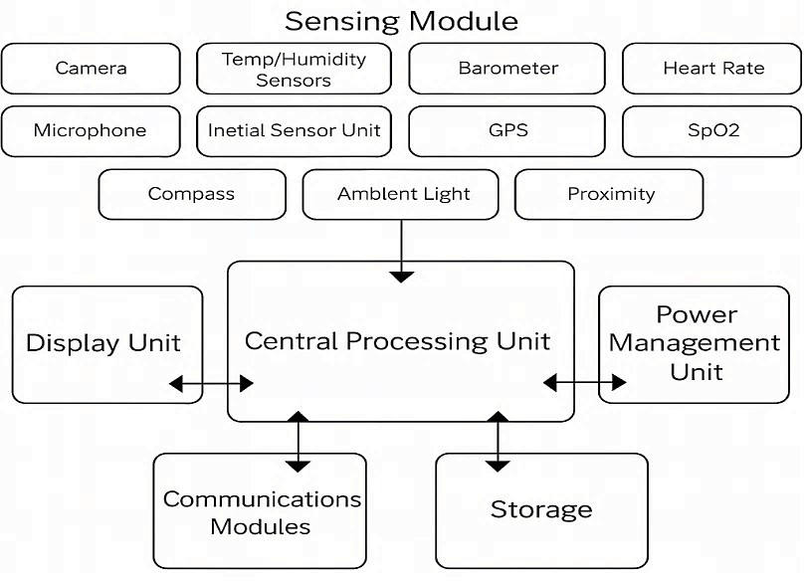
Fig.3.1: Mobile Hardware

Required Resources / Apparatus / Equipment with Specifications

Sr.  No. | Equipment / Software | Specification | Quantity
1 | Smartphone (Android or iOS) | Wi-Fi / Bluetooth enabled | 1
2 | Diagnostic App (e.g., Device Info HW, CPU-  Z, AIDA64) | Latest version from Play Store /  App Store | 1
3 | Internet Connectivity | For downloading diagnostic apps | 1
4 | Computer System (optional) | For report documentation | 1
- Precautions to be followed
  - Handle the computer and mobile device carefully.
  - Do not uninstall or modify system applications while performing the practical.
  - Ensure the mobile battery is sufficiently charged.
  - Avoid accessing private or user-sensitive data during testing.
  - Follow all safety and ethical data handling practices.

Procedure
  - Install Diagnostic Tool: Download and install Device Info HW, CPU-Z, or any equivalent mobile hardware information app from the official store.

  - Launch the Application: Open the app and grant necessary permissions (e.g., system information access).
  - View General Information: Note device model, brand, Android/iOS version, kernel, and build number.
  - Check Processor Details: Record CPU architecture, number of cores, clock speed, and GPU information.
  - Access Memory Information: View total RAM, internal storage, and available memory.
  - Check Battery Parameters: Record voltage, capacity (mAh), health, and temperature.
  - Review Sensor and Connectivity Modules: Identify sensors, Wi-Fi, Bluetooth, NFC, and GPS details.
  - Save or Screenshot Data: Capture results or export reports generated by the app.
  - Record Observations: Fill in all fields in the observation table below.
  - Interpret and Discuss Results: Compare findings across different devices if available.

Observation Table

Sr. No. | Parameter | Observed Value
1 | Device Model / Brand
2 | CPU Architecture & Cores
3 | GPU Type
4 | RAM (GB) / Storage (GB)
5 | Battery Capacity (mAh)
6 | Sensor Types Detected
7 | Network Modules (Wi-Fi, LTE, 5G)
8 | Android / iOS Version
- Conclusion
………………………………………………………………………………………………….……………
…………………………………………………………………………………….…………………………
……………………………………………………………………….………………………………………

Practical-related Questions

Note: Below are a few sample questions for reference. Teachers must design more such questions to ensure the achievement of the identified CO.
  - Identify the part that manages power distribution among all hardware components.
  - State the role of the CPU and GPU in mobile processing.
  - Analyze the impact of RAM capacity on overall device performance.
  - Explain the importance of monitoring battery temperature in mobile devices.

Space for Answer
…………………………………………………………………………………….…………………………
……………………………………………………………………….………………………………………

………………………………………………………….……………………………………………………
…………………………………………….…………………………………………………………………
……………………………….………………………………………………………………………………
………………….……………………………………………………………………………………………
…….………………………………………………………………………………………………….………
………………………………………………………………………………………….……………………
…………………………………………………………………………….…………………………………
……………………………………………………………….………………………………………………
………………………………………………….……………………………………………………………
…………………………………….…………………………………………………………………………
……………………….………………………………………………………………………………………
………….………………………………………………………………………………………………….…
……………………………………………………………………………………………….………………
………………………………………………………………………………….……………………………
…………………………………………………………………….…………………………………………
……………………………………………………….………………………………………………………
………………………………………….……………………………………………………………………
…………………………….…………………………………………………………………………………
……………….………………………………………………………………………………………………
….………………………………………………………………………………………………….…………
……………………………………………………………………………………….………………………
………………………………………………………………………….……………………………………
…………………………………………………………….…………………………………………………
……………………………………………….………………………………………………………………
………………………………….……………………………………………………………………………
…………………….…………………………………………………………………………………………
……….………………………………………………………………………………………………….……
…………………………………………………………………………………………….…………………
……………………………………………………………………………….………………………………
………………………………………………………………….……………………………………………
…………………………………………………….…………………………………………………………
……………………………………….………………………………………………………………………
………………………….……………………………………………………………………………………

…………….………………………………………………………………………………………………….
………………………….……………………………………………………………………………………
…………….………………………………………………………………………………………………….
………………………….……………………………………………………………………………………
…………….………………………………………………………………………………………………….
………………………….……………………………………………………………………………………
…………….………………………………………………………………………………………………….
………………………….……………………………………………………………………………………
…………….………………………………………………………………………………………………….
………………………….……………………………………………………………………………………
………………………….……………………………………………………………………………………
………………………….……………………………………………………………………………………
………………………….……………………………………………………………………………………

References / Suggestions for Further Reading
  - https://play.google.com/store/apps/details?id=ru.andr7e.deviceinfohw
  - https://www.youtube.com/watch?v=e2SeARsYbck
  - https://www.youtube.com/watch?v=5m_Oz_jAlas
  - https://www.youtube.com/watch?v=uBBp_WHEO0Q
- Assessment Scheme (25 Marks)

Sr. No. | Performance Indicators | Weightage
Process-related (10 marks = 40%)
1. | Correct installation and usage of the diagnostic app | 20%
2. | Accurate identification of hardware parameters | 10%
3. | Data recording and comparison between devices | 10%
Product-related (15 marks = 60%)
4. | Completeness and accuracy of the observation table | 20%
5. | Correct answers to practical-related questions | 20%
6. | Timely submission and presentation | 20%
Total (25 Marks) |  | 100%

Marks Obtained |  |  | Dated Signature of  Teacher
Process  related (10) | Product  related (15) | Total(25)

Practical No. 4: Detect the operating system and its version (Windows, BlackBerry, and macOS) using any relevant mobile application.

Practical Significance
The operating system (OS) acts as the central control layer that manages hardware resources, user interfaces, and application execution in mobile devices. Detecting and understanding the mobile OS and its version is essential for software compatibility, application testing, and network configuration. This practical introduces students to mobile operating systems, including Android, iOS, and Harmony OS, with an emphasis on version identification and key functional modules. Using diagnostic or system- information applications, students learn how the OS interacts with hardware and communication layers through drivers, middleware, and APIs. By conducting this experiment, learners gain insight into how updates impact security, performance, and compatibility with network standards such as GSM, LTE, and 5G. This understanding is directly applicable in mobile servicing, app development, and wireless network configuration roles where accurate system identification and version management are critical.

Industry / Employer Expected Outcome(s)
Maintain the mobile and wireless communication system.

Course Level Learning Outcome(s)
CO1 – Identify various terminologies used in GSM network systems.

Laboratory Learning Outcome(s)
LLO 4.1: Determine the system information of the mobile using relevant software.

Relevant Affective Domain Related Outcome(s)
  - Follow precautionary measures.
  - Follow naming conventions.
  - Follow ethical practices.
  - Respect data privacy and security while handling mobile software.

Relevant Theoretical Background
A mobile operating system provides the essential environment that links user applications with underlying hardware and network resources.

Mobile Operating System Structure
    - Kernel Layer: Manages memory, CPU scheduling, and device drivers. Android uses the Linux kernel, whereas iOS uses the Darwin (Unix-based) kernel.
    - Middleware: Contains libraries and frameworks (e.g., OpenGL ES, SQLite, WebKit) enabling multimedia, data storage, and communication functions.
    - Application Framework: Provides APIs for telephony, location, sensor, and UI management.
    - Application Layer: End-user apps such as dialer, messaging, and browser run here.

Common Mobile Operating Systems
OS | Developer | Kernel Base | Latest Version (as of 2025) | Remarks
Android | Google | Linux | Android 15 (Vanilla Ice Cream) | Open source, widely used
iOS | Apple Inc. | Darwin  (Unix) | iOS 18 | Closed source, optimized  for Apple devices
Harmony  OS | Huawei | Micro-kernel | Harmony OS 4 | IoT integrated platform
  - OS Version Information
Each mobile OS version introduces updates in:
    - Security Patches
    - User Interface (UI/UX)
    - Performance Optimization
    - Network and Protocol Support (VoLTE, 5G NR)

Detection Methods
    - System Settings: Manual checking under About Phone → Software Information.
    - Diagnostic Applications: Tools like Device Info HW, CPU-Z, AIDA64, or Phone INFO extract OS details programmatically using system APIs.
    - ADB (Advanced Debug Bridge): For developer-level detection on Android devices. Understanding the OS version is critical to ensure application compatibility, perform troubleshooting, and verify compliance with wireless communication standards.

Diagram
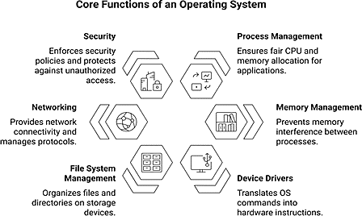
Fig. 4.1: Simplified Mobile OS functions

Required Resources / Apparatus / Equipment with Specifications

Sr.  No. | Equipment / Software | Specification / Details | Qty
1 | Smartphone (Android/iOS/Harmony OS) | Operational and internet-enabled | 1
2 | System Information App (Device Info HW /  CPU-Z / AIDA64) | Latest available version | 1
3 | Internet Connectivity | For app download and updates | 1
4 | Computer (optional) | For documentation or comparison | 1

- Precautions to be followed
  - Handle devices carefully to avoid data loss.
  - Do not change system files or enable developer/root modes.
  - Save screenshots of results instead of copying system files.
  - Avoid connecting unauthorized devices or external drives.
  - Follow ethical and safe data-handling practices.

Procedure
  - Install the Diagnostic Application:
Download and install a trusted hardware/software information tool from the official store.

Launch the Application:
Open it and allow system permission for reading OS information.

Access Software Information Tab:
Navigate to the System or Software Information section.

Record Operating System Details:
Note OS name, kernel version, build number, API level, and security patch date.

Identify OS Architecture:
Check whether the OS is 32-bit or 64-bit.

Verify System Uptime and Kernel Version:
Observe uptime and kernel string (e.g., Linux 5.15.41-android12).

Take Screenshots or Notes:
Capture results for record keeping.

Compare Different Devices (optional):
Repeat on another mobile to compare OS versions and interface differences.
  - Record All Values in the observation table.
  - Interpret Findings with respect to device age, security patch, and compatibility.

Observation Table

Sr. No. | Parameter | Observed Value | Remarks
1 | Device Model
2 | Operating System Name
3 | OS Version / Build Number
4 | Kernel Version
5 | API Level / Security Patch
6 | Architecture (32 / 64 bit)
7 | System Uptime
- Conclusion
………………………………………………………………………………………………….…………….
…………………………………………………………………………………….………………………….
……………………………………………………………………….……………………………………….
………………………………………………………………………………………………………………..

Practical-related Questions

Note: Below are a few sample questions for reference. Teachers must design more such questions to ensure the achievement of the identified CO.
  - How to identify the OS version of a mobile device without using third-party applications?
  - Explain the significance of security patch levels in maintaining mobile system integrity.
  - Describe the importance of avoiding rooting or modifying system partitions in mobile devices.
  - Analyze how the kernel version influences the overall performance of a mobile operating system.

Space for Answer
………………………………………………………………………………….……………………………
…………………………………………………………………….…………………………………………
……………………………………………………….………………………………………………………
………………………………………….……………………………………………………………………
…………………………….…………………………………………………………………………………
……………….………………………………………………………………………………………………
….………………………………………………………………………………………………….…………
……………………………………………………………………………………….………………………
………………………………………………………………………….……………………………………
…………………………………………………………….…………………………………………………
……………………………………………….………………………………………………………………
………………………………….……………………………………………………………………………
…………………….…………………………………………………………………………………………
……….…………………………………………………………………………………………………….…
……………………………………………………………………………………………….………………
………………………………………………………………………………….……………………………
…………………………………………………………………….…………………………………………
……………………………………………………….………………………………………………………
………………………………………….……………………………………………………………………
…………………………….…………………………………………………………………………………
……………….………………………………………………………………………………………………
….………………………………………………………………………………………………….…………
……………………………………………………………………………………….………………………
………………………………………………………………………….……………………………………
…………………………………………………………….…………………………………………………

……………………………………………….………………………………………………………………
………………………………….……………………………………………………………………………
…………………….…………………………………………………………………………………………
……….………………………………………………………………………………………………….……
…………………………………………………………………………………………….…………………
……………………………………………………………………………….………………………………
………………………………………………………………….……………………………………………
…………………………………………………….…………………………………………………………
……………………………………………………………………………………….………………………
………………………………………………………………………….……………………………………
…………………………………………………………….…………………………………………………
……………………………………………….………………………………………………………………

References / Suggestions for Further Reading
  - https://developer.android.com/about/versions
  - Android Programming for Beginners, John Horton, Packt Publishing, 2021.
  - https://www.youtube.com/watch?v=2hpm-UHnfAU
  - https://www.youtube.com/watch?v=Kk_Z8lKgDac
  - https://www.youtube.com/watch?v=plQI8LDwDLI
- Assessment Scheme (25 Marks)

Sr. No. | Performance Indicators | Weightage
Process-related (10 marks = 40%)
1. | Correct installation and navigation of the diagnostic tool | 10%
2. | Accurate identification of OS version and build details | 15%
3. | Observation of kernel and security patch information | 15%
Product-related (15 marks = 60%)
4. | Completeness of the observation table and screenshots | 20%
5. | Correct answers to practical-related questions | 20%
6. | Timely submission and presentation | 20%
Total (25 Marks) |  | 100%

Marks Obtained |  |  | Dated Signature of  Teacher
Process related  (10) | Product related  (15) | Total(25)

Practical No. 5: Establish a Personal Area Network for two or more devices

Practical Significance
A Personal Area Network (PAN) is a small-scale wireless network designed to interconnect devices such as mobile phones, laptops, tablets, and IoT devices within a short range, typically a few meters. Establishing a PAN enables seamless sharing of data, files, and internet connectivity without the need for wired connections. Bluetooth technology, Wi-Fi Direct, and infrared communication are common technologies used to build PANs. This practical allows students to understand how multiple devices can be connected wirelessly for communication and data sharing. In modern IT industries, PANs are widely used in healthcare devices, wearable technologies, wireless peripherals (mouse, keyboard, printer), and smart homes. Through this experiment, students can gain hands-on experience in setting up a PAN using Bluetooth or mobile tethering, by learning how to connect multiple devices securely, manage pairing/authentication, and analyze network performance.

Industry / Employer Expected Outcome(s)
Maintain the mobile and wireless communication system.

Course Level Learning Outcome(s)
CO2 -Establish a wireless network with the given technology.

Laboratory Learning Outcome(s)
LLO 5.1 Build a Personal Area Network of mobile devices.

Relevant Affective Domain-related Outcome(s)
  - Follow precautionary measures.
  - Follow naming conventions.
  - Follow ethical practices.
  - Work effectively in a team during practical implementation.

Relevant Theoretical Background
A Personal Area Network (PAN) is a computer network organized around a person’s workspace. Typically, PANs involve a mobile computer, a cell phone, and/or a handheld computing device such as a tablet. The range of a PAN is usually within 10 meters.

Technologies Used in PAN
  - Bluetooth: A short-range wireless communication protocol operating in the 2.4 GHz ISM band. It supports data exchange between devices up to 10–100 meters, depending on the Bluetooth version.
  - Wi-Fi Direct: Enables two or more devices to connect directly without needing a wireless access point, functioning like a mini-LAN.
  - Infrared (IR): An older, line-of-sight technology used in remote controls and early device-to- device communication.
  - Zigbee and UWB (Ultra-Wideband): Used for low-power, short-range IoT devices.

Bluetooth PAN (Piconet and Scatternet)
    - A piconet is formed when one master device connects with up to 7 active slave devices.
    - Multiple piconets can interconnect to form a scatternet, allowing a larger PAN.

Applications of PANs
    - File transfer between phones/laptops.
    - Wireless headsets, keyboards, and mice.
    - Tethering the internet from a smartphone to a laptop.
    - Wearable devices like fitness trackers communicate with mobile phones.

Security in PANs
    - Authentication and encryption are used in Bluetooth to prevent unauthorized access.
    - Devices must pair before communication.
    - Common threats include bluejacking, bluesnarfing, and eavesdropping.

Diagram
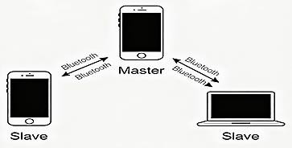
Fig. 5.1: Personal Area Network Setup (Bluetooth example)
Here, Smartphone 1 acts as a master device, pairing with Smartphone 2 and a laptop, forming a Bluetooth PAN.

Required Resources/apparatus/equipment with specifications
  - Smartphones (2 units): Bluetooth/Wi-Fi enabled, Android/iOS supported.
  - Laptop (1 unit): With Bluetooth adapter and Wi-Fi support.
  - Bluetooth Version: 4.0 or above recommended.
  - Wi-Fi Direct or Hotspot capability.
  - Mobile applications (optional): “Bluetooth File Transfer” or “SHAREit.”

Precautions to be followed
  - Handle the computer system with care.
  - Strictly follow the instructions for configuring Bluetooth/Wi-Fi.
  - Don’t forget to disconnect PAN after use to save battery.
  - Follow safety practices.
  - Ensure devices are within operational range (~10m).

Procedure
  - Switch ON Bluetooth on all devices (Mobile A, Mobile B, Laptop C).
  - On Mobile A, enable visibility mode and search for available devices.

  - Pair Mobile A with Mobile B using a passkey for authentication.
  - Verify successful pairing by sending a test image file from Mobile A to Mobile B.
  - Connect Mobile A with Laptop C via Bluetooth or Wi-Fi Direct.
  - Share files between Mobile A and Laptop C to confirm the connection.
  - Observe and record the time taken for transmission at varying distances (1m, 5m, 10m).
  - Disconnect devices after completion.

Observation Table

Device Pair | Connection Established: (Y/N) | Successful File Transfer: (Y/N)
Mobile A → Mobile B
Mobile A → Laptop C
- Conclusions
………………………………………………………………………………………………….……………
…………………………………………………………………………………….…………………………
……………………………………………………………………….………………………………………
……………………………………………………………………………………………………………….

Practical-related Questions

Note: Below are a few sample questions for reference. Teachers must design more such questions to ensure the achievement of the identified CO.
  - State the typical range of a standard Bluetooth Personal Area Network (PAN).
  - Differentiate between a piconet and a scatternet in terms of their topology and device connections.
  - List and summarize two advantages and two limitations of Personal Area Networks.
  - Explain the significance of authentication in ensuring security within Bluetooth PANs.

Space for Answer
…………………………………………………………………………………….…………………………
……………………………………………………………………….………………………………………
………………………………………………………….……………………………………………………
…………………………………………….…………………………………………………………………
……………………………….………………………………………………………………………………
………………….……………………………………………………………………………………………
…….………………………………………………………………………………………………….………
………………………………………………………………………………………….……………………
…………………………………………………………………………….…………………………………
……………………………………………………………….………………………………………………

………………………………………………….……………………………………………………………
…………………………………….…………………………………………………………………………
……………………….………………………………………………………………………………………
………….………………………………………………………………………………………………….…
……………………………………………………………………………………………….………………
………………………………………………………………………………….……………………………
…………………………………………………………………….…………………………………………
……………………………………………………….………………………………………………………
………………………………………….……………………………………………………………………
………………………………………………………………………………………………….……………
…………………………………………………………………………………….…………………………
……………………………………………………………………….………………………………………
………………………………………………………….……………………………………………………
…………………………………………….…………………………………………………………………
……………………………….………………………………………………………………………………
………………….……………………………………………………………………………………………
…….………………………………………………………………………………………………….………
………………………………………………………………………………………….……………………
…………………………………………………………………………….…………………………………
……………………………………………………………….………………………………………………
………………………………………………….……………………………………………………………
…………………………………….…………………………………………………………………………
……………………….………………………………………………………………………………………
………….………………………………………………………………………………………………….…
……………………………………………………………………………………………….………………
………………………………………………………………………………….……………………………
…………………………………………………………………….…………………………………………
……………………………………………………….………………………………………………………
………………………………………….……………………………………………………………………
………………………………………………………………………………………………….……………
…………………………………………………………………………………….…………………………
……………………………………………………………………….………………………………………

………………………………………………………….……………………………………………………
…………………………………………….…………………………………………………………………
……………………………….………………………………………………………………………………
………………….……………………………………………………………………………………………
…….………………………………………………………………………………………………….………
………………………………………………………………………………………….……………………
…………………………………………………………………………….…………………………………
…………………………………………………………………………….…………………………………
……………………………………………………………….………………………………………………
………………………………………………….……………………………………………………………
……………………………………………………………….………………………………………………
………………………………………………….……………………………………………………………

References / Suggestions for Further Reading
  - https://www.bluetooth.com/learn-about-bluetooth/
  - https://en.wikipedia.org/wiki/Personal_area_network
  - https://www.youtube.com/watch?v=T1YXVgMieNs
  - https://www.youtube.com/watch?v=0QHTV01VeKw
XV. Assessment Scheme (25 Marks)

Sr.  No. | Performance Indicators | Weightage
Process-related (10 marks = 40%)
1. | Switching on devices and enabling Bluetooth/Wi-Fi | 15%
2. | Successful pairing and authentication | 15%
3. | Sharing files between devices | 10%
Product-related (15 marks = 60%)
4. | Observation table completion | 20%
5. | Teamwork and following safety practices | 20%
6. | Timely submission and presentation | 20%
Total (25 Marks) |  | 100%

Marks Obtained |  |  | Dated Signature of Teacher
Process related (10) | Product related (15) | Total(25)

Practical No. 6: Transfer an image, audio, and video file using Bluetooth protocol with varying distances between two or more devices

Practical Significance:
File transfer through Bluetooth includes images, audio, and video, making it useful in daily applications such as sharing media files, contact information, or documents. As the distance between devices increases, the data rate, delay, and error rates may vary, which directly affects the quality of transmission. Students can learn how different file types (image, audio, video) behave during wireless transmission and how Bluetooth specifications, such as versions 4.0/5.0, impact speed and reliability. In the industry, Bluetooth is applied in IoT devices, healthcare monitoring systems, smart homes, automotive infotainment systems, and wearable devices. Through this experiment, students gain skills in establishing Bluetooth connectivity, authenticating paired devices, and analyzing performance in terms of transfer speed and energy consumption.

Industry / Employer Expected Outcome(s):
Maintain the mobile and wireless communication system.

Course Level Learning Outcome(s):
CO2 -Establish a wireless network with the given technology.

Laboratory Learning Outcome(s):
LLO 6.1 Implement Bluetooth protocol services.

Relevant Affective Domain-related Outcome(s):
  - Follow precautionary measures.
  - Follow naming conventions.
  - Follow ethical practices.
  - Handle mobile devices with care to avoid damage.

Relevant Theoretical Background:
Bluetooth is a wireless communication technology developed to replace RS-232 data cables. It uses frequency-hopping spread spectrum (FHSS) over the 2.4 GHz band, hopping 1600 times per second across 79 channels to reduce interference.

Key Characteristics:
- Range: Typically, 10 meters (Class 2 devices) to 100 meters (Class 1 devices).
- Data Rates: Bluetooth 2.0+EDR supports up to 3 Mbps; Bluetooth 5 supports higher speeds and longer ranges.
- Topology: A Bluetooth network forms a piconet with one master and up to 7 active slave devices. Multiple piconets can interconnect to form a scatternet.

Bluetooth File Transfer Protocol:
- File transfer is enabled via the OBEX (Object Exchange) protocol.
- Devices must first pair using authentication and PIN/passkey.

- After pairing, files can be shared securely.

Factors Affecting File Transfer Performance:
- Distance between devices: Larger distances reduce speed and may cause disconnections.
- File size and type: Larger video files take longer to transfer compared to small image/audio files.
- Interference: Other 2.4 GHz devices (Wi-Fi, microwaves) may cause delays.
- Battery levels: A Low battery may reduce device performance.

Applications of Bluetooth File Transfer:
- Sharing images and videos between smartphones.
- Transferring audio files from laptops to car infotainment systems.
- Sending documents between PCs and mobile devices.
- File exchange in areas without internet connectivity.

Diagram:

Fig. 6.1: Bluetooth file transfer process

Required Resources/apparatus/equipment with specifications:
  - Two smartphones (Android/iOS): Bluetooth v4.0 or above.
  - Laptop (optional): With Bluetooth adapter.
  - File types:
    - Image file (.jpg/.png, ~2–5 MB)
    - Audio file (.mp3, ~5–10 MB)
    - Video file (.mp4, ~20–50 MB)
  - Bluetooth File Transfer app or built-in OS support.

Precautions to be followed:
  - Handle the computer system with care.
  - Strictly follow the instructions for pairing and file transfer.
  - Don’t forget to disconnect Bluetooth after completion to save battery.
  - Follow safety practices.
  - Ensure devices are within Bluetooth operational range.

Procedure:
  - Switch ON Bluetooth on all devices (Mobile A, Mobile B, Laptop C if used).
  - On Mobile A, make the device visible for discovery.
  - Search for devices on Mobile B and select Mobile A.
  - Pair the devices by confirming the passkey on both devices.
  - Select an image file on Mobile A → Send via Bluetooth → Choose Mobile B.
  - Record time taken for transfer.
  - Repeat steps 5–6 for an audio file and a video file.

  - Perform file transfer at different distances (1m, 5m, 10m).
  - Observe and record changes in transfer speed and connection stability.
  - Disconnect devices after completion.

Observation Table:

File Type | Distance (m) | File Size (MB) | Time Taken (sec) | Success/Fail | Battery Level (%) | Remarks
Image | 1
Image | 5
Image | 10
Audio | 1
Audio | 5
Audio | 10
Video | 1
Video | 5
Video | 10
- Conclusions
………………………………………………………………………………………………….……………
…………………………………………………………………………………….…………………………
……………………………………………………………………….………………………………………
……………………………………………………………………………………………………………….

Practical-related Questions

Note: Below are a few sample questions for reference. Teachers must design more such questions to ensure the achievement of the identified CO.
  - Identify the frequency band utilized in Bluetooth communication systems.
  - List the purpose and advantages of using frequency hopping in Bluetooth technology.
  - Illustrate real-life scenarios where Bluetooth file transfer is effectively used.
  - Describe the relationship between transmission distance and data transfer speed in Bluetooth communication.

Space for Answer
…………………………………………………………………………………….…………………………
……………………………………………………………………….………………………………………
………………………………………………………….……………………………………………………
…………………………………………….…………………………………………………………………
……………………………….………………………………………………………………………………

………………….……………………………………………………………………………………………
…….………………………………………………………………………………………………….………
………………………………………………………………………………………….……………………
…………………………………………………………………………….…………………………………
……………………………………………………………….………………………………………………
………………………………………………….……………………………………………………………
…………………………………….…………………………………………………………………………
……………………….………………………………………………………………………………………
………….………………………………………………………………………………………………….…
……………………………………………………………………………………………….………………
………………………………………………………………………………….……………………………
…………………………………………………………………….…………………………………………
……………………………………………………….………………………………………………………
………………………………………….……………………………………………………………………
…………………………….…………………………………………………………………………………
…………….………………………………………………………………………………………………….
………………………………………………………………………………………………….……………
………………………………………………………………………………….……………………………
…………………………………………………………………….…………………………………………
……………………………………………………….………………………………………………………
………………………………………….……………………………………………………………………
…………………………….…………………………………………………………………………………
……………….………………………………………………………………………………………………
………….………………………………………………………………………………………………….…
……………………………………………………………………………………………….………………
………………………………………………………………………………………………………………
……………………………………………………………………………………………………………….
………………………………………………………………………………….……………………………
…………………………………………………………………….…………………………………………
……………………………………………………….………………………………………………………
………………………………………….……………………………………………………………………
…………………………….…………………………………………………………………………………
……………….………………………………………………………………………………………………

………….………………………………………………………………………………………………….…
……………………………………………………………………………………………….………………
……………………………………………………………………………………………………………….
……………………………………………………………………………………………………………….
……………………………………………………………………………………………….………………
……………………………………………………………………………………………………………….
……………………………………………………………………………………………………………….
……………………………………………………………………………………………………………….
……………………………………………………………………………………………………………….
……………………………………………………………….………………………………………………
………………………………………………….……………………………………………………………
………………………………………………….……………………………………………………………

XVI. References / Suggestions for Further Reading:
- https://www.bluetooth.com/learn-about-bluetooth/
- https://www.youtube.com/watch?v=OXpArkyUfDk
- https://www.youtube.com/watch?v=FmEY6_gQtVw
- https://www.youtube.com/watch?v=vQHkMjS8POA
XV. Assessment Scheme (25 Marks)

Sr. No. | Performance Indicators | Weightage
Process-related (10 marks = 40%)
1. | Device discovery and pairing | 20%
2. | Sending image, audio, and video files | 10%
3. | Measuring and recording transfer time | 10%
Product-related (15 marks = 60%)
4. | Observation table completion | 20%
5. | Teamwork and following safety practices | 20%
6. | Timely submission and presentation | 20%
Total (25 Marks) |  | 100%

Marks Obtained |  |  | Dated Signature of  Teacher
Process  related (10) | Product  related (15) | Total (25)

Practical No. 7: Make a Hotspot connection on Wi-Fi on any two devices

Practical Significance
A Wi-Fi hotspot enables one device, typically a smartphone, to share its mobile internet connection with other Wi-Fi-enabled devices. This practical demonstrates how to configure and connect devices using hotspot functionality. It is highly significant in mobile networking, where quick and wireless internet access is required for multiple devices without the need for a wired infrastructure. Students can gain the ability to configure hotspot settings, understand SSID and password management, and analyze connectivity between devices. In industry and daily applications, Wi-Fi hotspots are widely used for remote work, IoT connectivity, and providing emergency internet access. Mastering this concept builds foundational skills in wireless communication and equips students with knowledge essential for troubleshooting and maintaining mobile and wireless systems.

Industry / Employer Expected Outcome(s)
Maintain the mobile and wireless communication system.

Course Level Learning Outcome(s)
CO2 -Establish a wireless network with the given technology.

Laboratory Learning Outcome(s)
LLO 7.1 Create a hotspot connection between any two devices.

Relevant Affective Domain-related Outcome(s)
  - Follow precautionary measures.
  - Follow naming conventions.
  - Follow ethical practices.
  - Ensure hotspot security by using strong passwords.

Relevant Theoretical Background
A hotspot is a wireless access point that allows Wi-Fi-enabled devices to access the internet through a host device’s mobile data. Modern smartphones function as portable Wi-Fi routers.
- SSID (Service Set Identifier): The broadcasted name of the hotspot network.
- Authentication and Security: WPA2/WPA3 encryption prevents unauthorized access.
- DHCP: Assigns IP addresses dynamically to client devices.
- Bandwidth Sharing: The internet speed depends on mobile data availability and the number of devices connected.

Applications:
- Providing internet to laptops or tablets via smartphones.
- Emergency backup connectivity.
- IoT device integration.

Actual Circuit Diagram used in the laboratory with equipment specifications
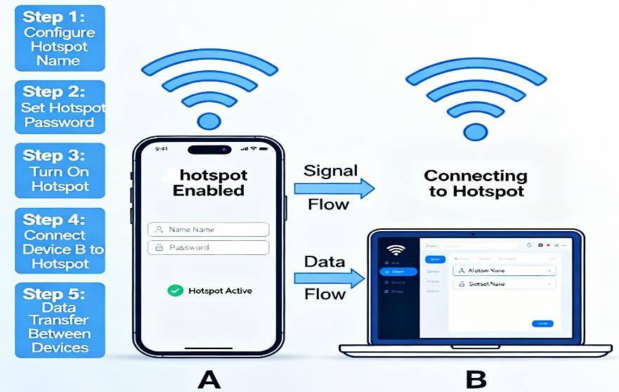
Fig. 7.1: Hotspot connection between two devices

Required Resources/apparatus/equipment with specifications
  - Smartphone with hotspot capability (Android/iOS, 4G/5G).
  - Another smartphone or laptop with Wi-Fi support.
  - Mobile data plan.

Precautions to be followed
  - Handle devices carefully.
  - Use strong passwords for hotspot security.
  - Disable hotspot after use to save battery.
  - Ensure devices are within range (10–20 meters).

Procedure
  - On Smartphone A, go to Settings → Network & Internet → Hotspot & Tethering.
  - Enable Wi-Fi Hotspot and configure SSID and password.
  - On Smartphone B/Laptop, enable Wi-Fi and search for Smartphone A’s SSID.
  - Enter the password and connect.
  - Verify internet access by browsing or downloading.
  - Record connection details.
  - Disconnect after completion.

Observation Table

Sr.  No. | Device Name / Type | Role in Connection | Hotspot Name (SSID) | Security Type (WPA/ WPA2) | Signal Strength (Excellent  /Good / Bad) | Data Transfer  Speed (Mbps) | Result (Connected /  Not Connected)
1 | Mobile A | Hotspot Provider (Access Point)
2 | Mobile B | Receiver /  Client Device

- Conclusion
………………………………………………………………………………………………….……………
…………………………………………………………………………………….…………………………
……………………………………………………………………….………………………………………
………………………………………………………………………………………………………………..

Practical-related Questions

Note: Below are a few sample questions for reference. Teachers must design more such questions to ensure the achievement of the identified CO.
  - Define SSID.
  - Explain the importance of password protection for hotspots.
  - List two applications of mobile hotspots.
  - Analyze how the number of connected devices affects speed.

Space for Answer
…………………………………………………………………………………….…………………………
……………………………………………………………………….………………………………………
………………………………………………………….……………………………………………………
…………………………………………….…………………………………………………………………
……………………………….………………………………………………………………………………
……………….………………………………………………………………………………………………
….………………………………………………………………………………………………….…………
……………………………………………………………………………………….………………………
………………………………………………………………………….……………………………………
…………………………………………………………….…………………………………………………
……………………………………………….………………………………………………………………
………………………………….……………………………………………………………………………
…………………….…………………………………………………………………………………………
……….………………………………………………………………………………………………….……
…………………………………………………………………………………………….…………………
……………………………………………………………………………….………………………………
………………………………………………………………….……………………………………………
…………………………………………………….…………………………………………………………
……………………………………….………………………………………………………………………
………………………….……………………………………………………………………………………

…………….………………………………………………………………………………………………….
………………………………………………………………………………………………….……………
…………………………………………………………………………………………….…………………
……………………………………………………………………………….………………………………
………………………………………………………………….……………………………………………
…………………………………………………….…………………………………………………………
……………………………………….………………………………………………………………………
………………………….……………………………………………………………………………………
…………….………………………………………………………………………………………………….
………………………………………………………………………………………………….……………
…………….………………………………………………………………………………………………….
………………………………………………………………………………………………….……………
………………………………………………………………………………………………….……………

References / Suggestions for Further Reading
  - https://www.android.com/intl/en_in/guide/mobile-hotspot/
  - https://www.youtube.com/watch?v=DXQ5xg8qPx0
  - https://www.youtube.com/watch?v=5XQKlIvsq4A
  - https://www.youtube.com/watch?v=oXLL2n6QX6M
- Assessment Scheme (25 Marks)

Sr.  No. | Performance Indicators | Weightage
Process-related (10 marks = 40%)
1. | Enabling hotspot and setting SSID/password | 20%
2. | Successful connection of the second device | 10%
3. | Verification of internet access | 10%
Product-related (15 marks = 60%)
4. | Observation table completion | 20%
5. | Teamwork and following safety practices | 20%
6. | Timely submission and presentation | 20%
Total (25 Marks) |  | 100%

Marks Obtained |  |  | Dated Signature of Teacher
Process related (10) | Product related (15) | Total (25)

Practical No. 8: Configure Wi-Fi settings in mobile devices using mobile tethering to connect two devices, such as a mobile phone to a laptop

Practical significance
Mobile tethering is a valuable technology that empowers users to share their mobile device's internet connection with other devices, such as laptops or additional smartphones, through Wi-Fi, Bluetooth, or USB. This functionality, also referred to as creating a “mobile hotspot,” transforms the mobile device into a portable router, enabling seamless internet access for devices that may lack cellular connectivity. Practical mastery of this skill provides students with flexibility in accessing the internet in a variety of settings, whether at work, at school, or while traveling, ensuring continued productivity and communication. It also exposes students to core wireless networking concepts, including hotspot setup, password protection, SSID configuration, and the challenges of connecting across heterogeneous systems.

Industry / Employer Expected outcome(s)
Maintain the mobile and wireless communication system.

Course Level Learning outcome(s)
CO2 - Establish a wireless network with the given technology.

Laboratory Learning outcome(s)
LLO 8.1 Configure Wi-Fi settings in mobile devices.

Relevant Affective Domain related outcome(s)
  - Follow precautionary measures.
  - Follow naming conventions.
  - Follow ethical practices.

Relevant Theoretical Background
Introduction: Tethering, also known as "phone-as-modem," enables a mobile device to share its internet connection with other devices. There are several modes of tethering, with Wi-Fi hotspot being the most widespread and user-friendly. When enabled, the mobile device acts as a wireless access point, broadcasting its own SSID and password-protected signal.
Architecture and Working: A Wi-Fi-enabled mobile phone contains a built-in wireless transceiver capable of functioning both as a client and a hotspot. When the mobile hotspot feature is activated, it:
- Creates a unique SSID (network name) and password.
- Allocates IP addresses to connected devices via DHCP.
- Routes data between the cellular data interface and connected Wi-Fi clients.
- Uses WPA2 or WPA3 security for encryption and authentication.

Key Steps:
  - Enabling Hotspot: Access the device’s network settings to configure and activate the Wi- Fi hotspot.

  - Configuration: Set up a secure SSID, choose an authentication protocol (usually WPA2/WPA3), and provide a strong password.
  - Connection: Other devices (laptops, phones) scan for available networks, select the created hotspot, and connect using the credentials.
  - Resource Sharing: All devices on the network can now access the internet via the host’s cellular data.

Typical Usage Scenarios:
    - Working remotely on a laptop using mobile data.
    - Connecting multiple devices in locations lacking broadband/Wi-Fi infrastructure.
    - Sharing the internet with colleagues or peers securely and efficiently.
Security Considerations: It’s essential to follow security best practices—use strong passwords, enable encryption, and disable the feature when not in use—to prevent unauthorized access or data misuse.

Diagram
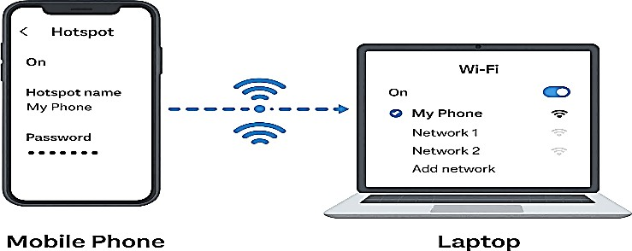
Fig. 8.1: Configuration of Wi-Fi

Required Resources/apparatus/equipment with specifications
- Wi-Fi enabled mobile device (Android/iOS, minimum Android 7 or iOS 11, recommended RAM 2 GB+, cellular data SIM)
- Laptop or secondary mobile device with Wi-Fi capability (Windows/macOS/Linux/Android/iOS)
- SIM card with active data plan
- USB cable (if USB tethering is also to be explored)
- Power adapters/backup for devices

XV. Precautions to be followed
- Handle the mobile and laptop with care.
- Strictly follow instructions when configuring the hotspot SSID and password.
- Do not share hotspot passwords with unauthorized persons.
- Follow safety and cybersecurity practices.

Procedure
- Turn ON the mobile device and verify there is sufficient data balance and battery.
- Open the device’s Settings menu and locate “Network & Internet” or “Connections.”
- Select “Hotspot & Tethering” (may appear as “Mobile Hotspot & Tethering”).

- Tap “Wi-Fi Hotspot,” switch it ON, and configure:
  - Network name (SSID).
  - Security type (preferably WPA2/WPA3).
  - Set a strong password.
- On the laptop/second device, turn ON Wi-Fi and search for available networks.
- Select the mobile hotspot SSID and enter the password to connect.
- After connection, verify internet access by browsing a website or pinging a public server.
- To disconnect, turn OFF the Hotspot feature on your mobile device.

Observation table

Sr.  No. | Device Connected | Device Type | OS  Version | Hotspot SSID | Password | Connection Status | Internet Working  (Yes/No)
1 | Laptop
2 | Mobile  Phone
- Conclusion
………………………………………………………………………………………………….……………
…………………………………………………………………………………….…………………………
……………………………………………………………………….………………………………………
……………………………………………………………………………………………………………….

Practical-related questions

Note: Below are a few sample questions for reference. Teachers must design more such questions to ensure the achievement of the identified CO.
  - Define mobile tethering and differentiate it from standard Wi-Fi networking.
  - Describe how the owner can monitor and control connected devices on the hotspot.
  - Analyze the advantages and limitations of using mobile tethering.
  - Evaluate the impact of simultaneous multiple device connections on hotspot performance.

Space for Answer
…………………………………………………………………………………….…………………………
……………………………………………………………………….………………………………………
………………………………………………………….……………………………………………………
…………………………………………….…………………………………………………………………
……………………………….………………………………………………………………………………
………………….……………………………………………………………………………………………
…….………………………………………………………………………………………………….………

………………………………………………………………………………………….……………………
…………………………………………………………………………….…………………………………
……………………………………………………………….………………………………………………
………………………………………………….……………………………………………………………
…………………………………….…………………………………………………………………………
……………………….………………………………………………………………………………………
………….………………………………………………………………………………………………….…
……………………………………………………………………………………………….………………
………………………………………………………………………………….……………………………
…………………………………………………………………….…………………………………………
……………………………………………………….………………………………………………………
………………………………………….……………………………………………………………………
…………………………….…………………………………………………………………………………
……………….………………………………………………………………………………………………
….………………………………………………………………………………………………….…………
……………………………………………………………………………………….………………………
………………………………………………………………………….……………………………………
…………………………………………………………….…………………………………………………
……………………………………………….………………………………………………………………
………………………………….……………………………………………………………………………
…………………….…………………………………………………………………………………………
……….………………………………………………………………………………………………….……
…………………………………………………………………………………………….…………………
……………………………………………………………………………………………………………….
………………………………………………………………………………………………….……………
…………………………………………………………………………………….…………………………
……………………………………………………………………….………………………………………
………………………………………………………….……………………………………………………
……………………………………………………………………………………………………………….
……….………………………………………………………………………………………………….……
…………………………………………………………………………………………….…………………
……………………………………………………………………………………………………………….
………………………………………………………………………………………………….……………

…………………………………………………………………………………….…………………………
……………………………………………………………………….………………………………………
………………………………………………………….……………………………………………………
……………………………………………………………………………………………………………….
………………………………………………………….……………………………………………………
……………………………………………………………………………………………………………….
……………………………………………………………………………………………………………….
……………………………………………………………………………………………………………….
………………………………………………….……………………………………………………………
………………………………………………….……………………………………………………………
………………………………………………….……………………………………………………………
………………………………………………….……………………………………………………………

References/Suggestions for further reading
  - E. Cianca et al., “Wireless Communications: Principles and Practice,” Pearson Education.
  - https://www.youtube.com/watch?v=x1hW3JljWyw&utm
  - https://www.youtube.com/watch?v=45H2cW71FI0&utm
  - https://www.youtube.com/watch?v=OyTd9hZmGWA
- Assessment Scheme (25 Marks)

Sr.  No. | Performance Indicators | Weightage
Process-related (10 marks = 40%)
1. | Correct configuration of the device hotspot | 20%
2. | Selection & security of SSID/password | 10%
3. | Connection verification & troubleshooting | 10%
Product-related (15 marks = 60%)
4. | Observation table completion | 20%
5. | Teamwork and following safety practices | 20%
6. | Timely submission and presentation | 20%
 | Total (25 Marks) | 100%

Marks Obtained |  |  | Dated Signature of  Teacher
Process related  (10) | Product  related (15) | Total (25)

Practical No. 9: Install and authenticate eSIM (virtual SIM) on a mobile handset

Practical Significance
eSIM, or “embedded SIM,” is a revolutionary technology that eliminates the need for traditional, removable SIM cards in mobile devices. Instead, device manufacturers embed a programmable chip inside the device, which can store and manage multiple carrier profiles electronically. This solution streamlines mobile connectivity, enabling users to change service providers, activate data plans, and access international roaming services with just a few taps, without physical SIM swapping. This practical develops skills such as scanning QR codes for carrier profile installation, using device settings for eSIM management, understanding security and authentication processes, and troubleshooting activation failures. As global smartphone and IoT device markets shift toward eSIM deployment, the ability to competently install and authenticate eSIM is highly relevant for professionals in telecommunications, mobile servicing, and enterprise IT.

Industry / Employer Expected Outcome(s)
Maintain the mobile and wireless communication system.

Course Level Learning Outcome(s)
CO3 - Differentiate between various generations of mobile networks.

Laboratory Learning Outcome(s)
LLO 9.1 Installation of eSIM on a mobile handset.
LLO 9.2 Authenticate eSIM (virtualSIM) on mobile handset.

Relevant Affective Domain Related Outcome(s)
  - Follow precautionary measures.
  - Follow naming conventions.
  - Follow ethical practices.

Relevant Theoretical Background
Introduction to eSIM: An eSIM is an embedded Subscriber Identity Module that replaces traditional SIM cards in mobile devices. It is permanently integrated into the device's motherboard and can be programmed remotely with carrier profiles. eSIM supports GSMA standards, ensuring cross-device compatibility, security, and network interoperability.

How eSIM Works:
- The user receives a QR code or activation details from the carrier.
- The mobile handset scans the QR code, prompting secure download of the carrier’s profile over the internet.
- Remote SIM provisioning technology securely writes the credentials to the eSIM hardware.
- The handset authenticates to the cellular network, enabling data, calls, and SMS service as with a physical SIM.

Advantages:
- No need for SIM card slots (better water/dust resistance).
- Supports multiple carrier profiles and easy switching between plans.
- Simplifies international roaming and profile transfer (especially valuable for travelers and IoT solutions).
- Facilitates smaller, lighter device designs.
- Enhanced security through encrypted profile management and reduced risk of SIM theft. Authentication and Security:eSIM technology enforces strong authentication via secure key provisioning, profile encryption, and device/carrier verification. Security is managed per GSMA Remote SIM Provisioning (RSP) standards, reducing unauthorized access to network services.

Typical Steps in eSIM Activation:
  - Device setup and compatibility check (ensure device supports eSIM and is carrier-unlocked).
  - Obtaining an activation QR code or code from the service provider.
  - Downloading and installing the eSIM profile through device settings.
  - Authentication and registration with the network.

Diagram
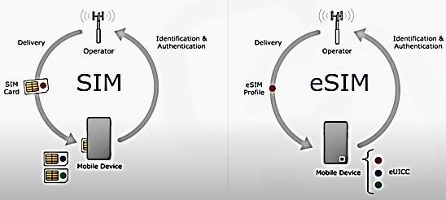
Fig. 9.1: eSIM activation
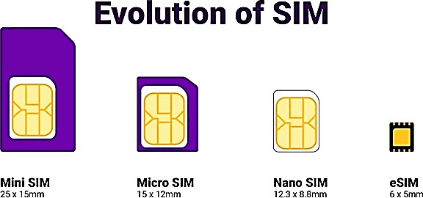

Fig. 9.2: SIM Evolution

Required Resources/apparatus/equipment with specifications
- eSIM-compatible mobile handset (Android/iOS, carrier-unlocked, recent OS version)
- Active internet connection (Wi-Fi or cellular)
- Carrier-issued eSIM activation QR code or activation details
- Computer/printer (to display/print QR code if needed)
- Any standard mobile device with a working camera (for QR scanning)

Precautions to be followed
  - Handle the mobile handset with care.
  - Strictly follow device and carrier instructions for eSIM installation.
  - Ensure the device is connected to a stable internet during activation.
  - Follow security practices—do not share QR codes or activation codes.

Procedure
  - Verify that the mobile handset supports eSIM functionality and has the latest operating system updates.
  - Ensure that the device is carrier-unlocked and has no existing eSIM profiles installed, or check if additional profiles can be added.
  - Obtain the activation QR code or relevant eSIM activation code from the cellular service provider.
  - Connect the device to a stable Wi-Fi or mobile data connection.
  - On the device, navigate to:
    - For Android: Settings > Network & Internet > SIMs > Add eSIM
    - For iOS: Settings > Cellular > Add Cellular Plan
  - Use the mobile device to scan the received QR code or enter the manual activation code if prompted.
  - Confirm the details if requested and allow the device to download and install the eSIM profile.
  - After installation, follow on-screen prompts to activate and set the new eSIM as the primary or secondary SIM as per requirement.
  - Wait for network authentication and confirmation message (can take a few minutes).
  - Make a test call or browse the internet to verify network connectivity.
  - Document the eSIM profile name, network provider, and connection status.

Observation Table

Step | Action | Observation/Status
1 | Device compatibility checked | Pass/Fail:
2 | eSIM profile received | Yes/No:
3 | QR code scanned/profile loaded | Success/Failure:
4 | Network registration status | Registered/Not Registered:
5 | Connectivity check | Working/Not Working:
- Conclusions
………………………………………………………………………………………………….……………
…………………………………………………………………………………….…………………………
……………………………………………………………………….………………………………………
……………………………………………………………………………………………………………….
……………………………………………………………………………………………………………….

Practical-related Questions

Note: Below are a few sample questions for reference. Teachers must design more such questions to ensure the achievement of the identified CO.
  - Define eSIM and differentiate it from a traditional SIM card.
  - List the steps to activate an eSIM profile on a mobile handset.
  - Explain the major advantages of using eSIM technology in smart devices.
  - How can users switch between multiple installed eSIM profiles on their device?

Space for Answer
…………………………………………………………………………………….…………………………
……………………………………………………………………….………………………………………
………………………………………………………….……………………………………………………
…………………………………………….…………………………………………………………………
……………………………….………………………………………………………………………………
………………….……………………………………………………………………………………………
…….………………………………………………………………………………………………….………
………………………………………………………………………………………….……………………
…………………………………………………………………………….…………………………………
……………………………………………………………….………………………………………………
………………………………………………….……………………………………………………………
…………………………………….…………………………………………………………………………
……………………….………………………………………………………………………………………
………….………………………………………………………………………………………………….…
……………………………………………………………………………………………….………………
………………………………………………………………………………….……………………………
…………………………………………………………………….…………………………………………
……………………………………………………….………………………………………………………
………………………………………….……………………………………………………………………
…………………………….…………………………………………………………………………………
……………….………………………………………………………………………………………………
….………………………………………………………………………………………………….…………
……………………………………………………………………………………….………………………
………………………………………………………………………….……………………………………
…………………………………………………………………….…………………………………………

……………………………………………………….………………………………………………………
………………………………………….……………………………………………………………………
…………………………….…………………………………………………………………………………
……………….………………………………………………………………………………………………
….………………………………………………………………………………………………….…………
………………………………………….……………………………………………………………………
…………………………….…………………………………………………………………………………
……………….………………………………………………………………………………………………
….………………………………………………………………………………………………….…………
………………………………………….……………………………………………………………………
…………………………….…………………………………………………………………………………
……………….………………………………………………………………………………………………
………………………………………………….……………………………………………………………

X.IV. References/Suggestions for Further Reading
- GSMA eSIM Overview – https://www.gsma.com/esim/
- Apple Support: Using eSIM on your iPhone – https://support.apple.com/en-us/HT209044
- Android Help: Set up an eSIM – https://support.google.com/android/answer/7521242
- https://youtu.be/XorwFnVc-Mw
- https://youtu.be/qPIYhdOY1ms
XV. Assessment Scheme (25 Marks)

Sr. No. | Performance Indicators | Weightage
Process-related (10 marks = 40%)
1. | Device compatibility and readiness check | 10%
2. | eSIM activation procedure and QR code handling | 15%
3. | Successful authentication and connectivity | 15%
Product-related (15 marks = 60%)
4. | Teamwork and following safety practices | 20%
5. | Observation entries and test evidence | 20%
6. | Timely submission and presentation | 20%
Total (25 Marks) |  | 100%

Marks Obtained |  |  | Dated Signature of Teacher
Process related (10) | Product related (15) | Total (25)

Practical No. 10: Identify the Dual SIM interface section, the Touchscreen display section, the battery charging circuit, the power management unit of a 4G or 5G smartphone, and test working

Practical Significance
Understanding these components and their functions is fundamental for diagnosing and repairing smartphones, optimizing device performance, and ensuring a reliable user experience. Through identification and functional testing, students gain hands-on experience essential for careers in mobile device servicing, manufacturing, and technical support. This exercise aligns with industry expectations by building competency in hardware diagnostics and system-level understanding of current wireless communication devices.

Industry / Employer Expected Outcome(s)
Maintain the mobile and wireless communication system.

Course Level Learning Outcome(s)
CO3 - Differentiate between various generations of mobile networks.

Laboratory Learning Outcome
LLO 10.1 Identify different parts of smartphones.

Relevant Affective Domain Outcomes
  - Follow electrical safety and device handling precautions.
  - Apply systematic and standardized component identification.
  - Practice ethical considerations in device disassembly and testing.

Relevant Theoretical Background
Modern smartphones integrate various sophisticated modules on a compact PCB. Key among these are:
- Dual SIM Interface Section: Located near SIM slots, this module allows simultaneous operation of two SIM cards. It incorporates card readers, multiplexers, signal lines, and control logic managing network selection and switching.
- Touchscreen Display Section: Comprises the display panel (LCD/OLED) and capacitive or resistive touchscreen layers. The display driver ICs process image rendering while the touchscreen controller (often an ASIC) interprets touch input. Connectors link these modules to the main processor.
- Battery Charging Circuit: Includes charging ICs, power transistors, and protective components managing input current from chargers. It implements charging algorithms, safeguards against over- voltage/over-current, and thermally regulates the battery.
- Power Management Unit (PMU): A dedicated IC (or integrated multiple ICs) manages voltage regulation, power sequencing, and distribution. It ensures power efficiency, handles battery power supply, toggles between power states, and protects against faults.

Identifying these sections entails recognizing PCB layout zones and components, aided by schematic diagrams and markings. Testing involves voltage measurements, signal verification, and functional validation using multimeters, oscilloscopes, and diagnostic software.

Apparatus / Equipment Required
- GSM Trainer Kit or Sample 4G or 5G smartphone (preferably disassemble model)
- Multimeter (digital with DC voltage/current measurement)
- Oscilloscope (for advanced signal analysis)
- Screwdriver kit for device disassembly
- Safety gloves and anti-static wrist strap
- Power supply and charging accessories

Precautions
  - Ensure the device is powered off before disassembly.
  - Handle components with anti-static precautions.
  - Avoid physical damage during open-and-close operations.
  - Follow safe testing procedures to avoid overloading circuits.

Diagram
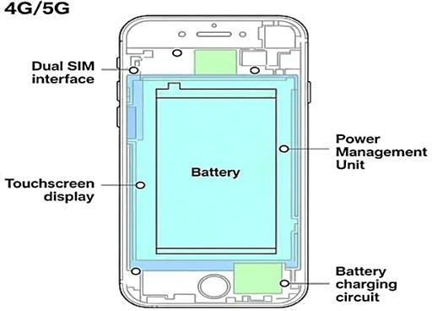

Fig. 10.1: Major sections of a Mobile handset
- Procedure
Procedure with GSM Trainer Kit:
  - Device and Kit Setup:
    - Power OFF the smartphone and the GSM trainer kit.
    - Connect the GSM trainer kit to the laboratory power supply as per manual specifications.
    - Ensure the GSM trainer kit is configured for 4G or 5G simulation modes if supported.

Identifying Dual SIM Interface using GSM Trainer Kit:
    - Insert SIM cards into the GSM trainer kit SIM slots as applicable.
    - Observe the trainer kit display and control panel for dual SIM activity indicators.
    - Use the GSM trainer’s interface to activate and switch between SIM interfaces.

    - Cross-reference the signals with the smartphone SIM tray and connectors to identify the corresponding dual SIM segment on the hardware.

Testing Touchscreen Display Section with GSM Trainer Kit:
    - Connect the smartphone display assembly or use the trainer kit’s touchscreen simulation module if available.
    - Use the GSM trainer’s diagnostic tools or interface to send touch input signals and observe response readings.
    - Record responsiveness and accuracy from the GSM trainer data to verify touchscreen functionality.

Battery Charging Circuit Simulation and Testing:
    - Use the GSM trainer kit’s power/charging circuit simulation feature if available.
    - Connect the battery charging circuit paths from the smartphone to the trainer kit.
    - Simulate charging cycles and measure voltage/current outputs on the trainer kit’s meters.
    - Verify protection features and charge regulation signals through trainer kit diagnostics.

Power Management Unit (PMU) Testing:
    - Access the PMU test points on the trainer kit.
    - Utilize the trainer’s monitoring tools to check voltage regulation outputs and power sequencing.
    - Simulate different power states (ON/OFF/Standby) and note the PMU response on the trainer display.
    - Compare readings with theoretical values to assess PMU health.

Functional Testing:
    - Power on the smartphone and observe the integration of the tested modules.
    - Use the GSM trainer kit's software interface for comprehensive diagnostics and module status reports.
    - Confirm operational status of dual SIM switching, touchscreen inputs, charging behavior, and power management efficiency by cross-verifying smartphone performance and trainer kit readings.

Documentation:
    - Record all measurements, observations, and deviations noted during trainer kit operations.
    - Summarize the functional status and any troubleshooting steps performed using the GSM trainer kit.

Procedure with a sample 4G or 5G smartphone:
- Device Preparation: Power off the smartphone completely and remove any external case or covers to access internal components.

Identify Dual SIM Interface:
  - Locate the SIM tray area.
  - Identify SIM interface chips and connectors on PCB.
  - Inspect pin connectivity and note labeling markings.

Identify Touchscreen Display Section:
  - Locate the ribbon cable connecting the touchscreen/display to the mainboard.
  - Identify the display driver IC and touchscreen controller.
  - Examine connectors and flex cables for damage.

Inspect Battery Charging Circuit:
  - Trace PCB area near charging port.
  - Identify charging IC, protection components (fuses, capacitors, resistors).
  - Measure voltage at charging IC input during charging (with charger connected).

Check Power Management Unit (PMU):
  - Locate PMU chip on PCB.
  - Measure output voltages at test points, verifying regulatory values.
  - Check for proper switching between power states (e.g., power on/off transitions).

Testing Functionality:
  - Power on the device and verify touchscreen responsiveness using test inputs.
  - Insert dual SIMs and check system recognition of both SIM cards.
  - Connect charger and monitor charging behavior (voltage, current, status LED).
Record Observations: Note down voltages, response details, and identify anomalies, if any.

Observation Table

Component | Test Point / Location | Expected Value / Behavior | Actual Measurement
Dual SIM Interface | SIM connector pins | Continuity, 3.3V (logic level)
Touchscreen Display | Touch controller  interface | Signal response to touches
Battery Charging  Circuit | Charging IC  input/output | 5V input, regulated 4.2V output
Power Management Unit | PMU output pins | Various regulated voltages (1.8V, 3.3V, 5V)

Test Point/Component | Function/Description | Expected Value / Behavior | Observed Value/Status
Tx Signal at Antenna | Transmit RF signal during call | [Record voltage/signal strength]
Rx Signal at Antenna | Receive RF signal during call | [Record voltage/signal strength]
Tx IQ Signal | Transmitted In-phase signal | [Observe and record]
Rx IQ Signal | Received In-phase signal | [Observe and record]
Battery Voltage (TP 12) | Voltage across the battery | [Expected: ~3.7V]
Battery Charging Voltage (TP 13) | Voltage during charging | [Expected: ~6V, charging state]

Test Point/Component | Function/Description | Expected Value / Behavior | Observed Value/Status
Power Management Voltage (VCC TP 51) | Output voltage of the power management | [Expected: 3.3V or 1.8V, depending on section]
RF Power Supply (TP 52) | RF section voltage | [Expected: ~2.8V]
Display Power (TP 6) | Voltage at LCD input | [Expected: 3.3V or 5V]
SIM Voltage (TP 12) | Power supply to SIM | [Expected: ~2.8V]
Call Signal Output | Signal during call initiation | [Record waveforms in CRO/oscilloscope]
Vibration/LED/Audio Output | Response toa proper call or command | [On/off states]
- Conclusion
………………………………………………………………………………………………….……………
…………………………………………………………………………………….…………………………
……………………………………………………………………….………………………………………
……………………………………………………………………………………………………………….

Practical-related Questions

Note: Below are a few sample questions for reference. Teachers must design more such questions to ensure the achievement of the identified CO.
  - List the main functions of the dual SIM interface in a smartphone.
  - How the touchscreen displays circuitry converts user inputs into signals?
  - Identify the components involved in the battery charging circuit and explain their roles.
  - Analyze the significance of the power management unit and its effect on device performance.

Space for Answer
………………………………………………………………………………….……………………………
…………………………………………………………………….…………………………………………
…………………………………………………………………………………………………………….…
……………………………………………………………………………………………….………………
………………………………………………………………………………….……………………………
…………………………………………………………………….…………………………………………

…………………………………………………………………………………………………………….…
……………………………………………………………………………………………….………………
………………………………………………………………………………….……………………………
…………………………………………………………………….…………………………………………
…………………………………………………………………………………………………………….…
……………………………………………………………………………………………….………………
………………………………………………………………………………….……………………………
…………………………………………………………………….…………………………………………
…………………………………………………………………………………………………………….…
……………………………………………………………………………………………….………………
………………………………………………………………………………….……………………………
…………………………………………………………………….…………………………………………
…………………………………………………………………………………………………………….…
……………………………………………………………………………………………….………………
………………………………………………………………………………….……………………………
…………………………………………………………………….…………………………………………
…………………………………………………………………………………………………………….…
……………………………………………………………………………………………….………………
………………………………………………………………………………….……………………………
…………………………………………………………………….…………………………………………
…………………………………………………………………………………………………………….…
……………………………………………………………………………………………….………………
………………………………………………………………………………….……………………………
…………………………………………………………………….…………………………………………
…………………………………………………………………………………………………………….…
……………………………………………………………………………………………….………………
………………………………………………………………………………….……………………………
…………………………………………………………………….…………………………………………
…………………………………………………………………………………………………………….…
……………………………………………………………………………………………….………………
………………………………………………………………………………….……………………………
…………………………………………………………………….…………………………………………
…………………………………………………………………………………………………………….…

……………………………………………………………………………………………….………………
………………………………………………………………………………….……………………………
…………………………………………………………………….…………………………………………
…………………………………………………………………………………………………………….…
……………………………………………………………………………………………….………………
………………………………………………………………………………….……………………………
…………………………………………………………………….…………………………………………
………………………………………………………………………………….……………………………
…………………………………………………………………….…………………………………………
…………………………………………………………………….…………………………………………
……………………………………………….………………………………………………………………
……………………………………………….……………………………………………………………

References / Further Reading:
  - “Mobile Phone Hardware Basics” - Electronics Tutorials.
  - https://www.youtube.com/watch?v=ldP8Z9-bQ7I
  - https://nsysgroup.com/blog/diagnostic-best-way/
  - https://www.lambdatest.com/learning-hub/mobile-device-testing
- Assessment Scheme (25 Marks)

Sr. No. | Performance Indicators | Weightage
Process-related (10 marks = 40%)
1. | Correct identification of components | 20%
2. | Accuracy of voltage and functionality tests | 10%
3. | Interpretation and recording of observations | 10%
Product-related (15 marks = 60%)
4. | Observation entries and test evidence | 20%
5. | Teamwork and following safety practices | 20%
6. | Timely submission and presentation | 20%
Total (25 Marks) |  | 100%

Marks Obtained |  |  | Dated Signature of Teacher
Process related (10) | Product related (15) | Total (25)

Practical 11: Using an appropriate Mobile App to locate and find the Internet Signal Strength of a Mobile Tower

Practical Significance
Understanding the real-time signal strength of a mobile tower is essential for optimizing mobile network performance and troubleshooting connectivity issues. This practical will help students to learn the use of various mobile applications to measure and interpret cellular signal strength —an important aspect of wireless communication. Signal strength directly impacts call quality, data transfer rates, and overall user experience. By locating the strongest signal areas using apps, students can practically appreciate how environmental factors, distance from the tower, obstacles like buildings, and interference affect signal quality. Scenario-based analysis, like comparing signals in different locations, enhances their understanding of coverage mapping, which is vital in network planning, troubleshooting, and optimizing network deployment.

Industry / Employer Expected Outcome(s)
Maintain the mobile and wireless communication system.

Course Level Learning Outcome(s)
CO3 - Differentiate between various generations of mobile networks.

Laboratory Learning Outcome(s)
LLO 11.1 Determine the location of the nearby tower. LLO 11.2 Determine internet connection strength.

Relevant Affective Domain Related Outcomes
  - Follow precautionary measures.
  - Follow naming conventions.
  - Follow ethical practices.

Relevant Theoretical Background
Wireless communication relies heavily on cellular towers, which transmit and receive radio frequency signals to and from mobile devices. The quality of these signals determines the strength and reliability of the internet, voice, and data services. Signal strength is often expressed in dBm (decibels relative to one milliwatt); higher values represent stronger signals, with typical values ranging from -50 dBm (excellent) to -120 dBm (weak). Modern smartphones are equipped with hardware and software capable of measuring and displaying signal strength information. Mobile applications such as 'OpenSignal,' 'Network Cell Info,' or 'Network Signal Info' harness device hardware to provide real-time data on signal parameters like signal strength, network type, tower locations, and more. Understanding signal maps is crucial for network planning and optimization.
Factors influencing signal strength include distance from the tower, physical obstructions (buildings, trees), interference from other electronic devices, and terrain. By using such apps, users can identify areas with poor coverage, optimal locations for improved reception, and troubleshoot connectivity

issues. These apps often utilize data from multiple sources, including cell towers and device sensors, to generate heat maps showing signal distribution across an area.

Diagram
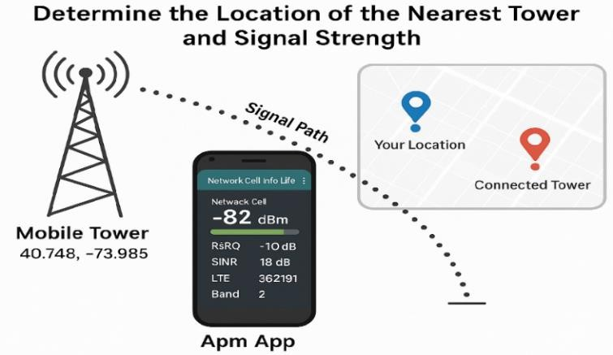
Fig. 11.1: Measurement of the Signal strength of the nearest tower

Resources / Apparatus / Equipment
- Smartphone (Android or iOS)
- Installable signal measurement app
- Active SIM card (for network detection)
- Location-enabled device (GPS capability)
- Notepad for observations

Precautions to be followed
  - Handle the mobile device carefully to prevent physical damage.
  - Ensure the device has a stable internet connection while downloading apps.
  - Do not operate in areas with high electromagnetic interference if sensitive to such conditions.
  - Follow privacy and ethical guidelines when collecting data about network signals.

Procedure
Step 1 – Install and Launch the App
- Open Google Play Store / App Store.
- Search and install Network Cell Info Lite (preferred for accuracy).
- Open the app and grant Location, Phone, and Network permissions.

Step 2 – Observe Real-Time Signal Parameters
On the main screen, the app displays several technical readings:
Parameter | Meaning | Ideal Range
RSRP (Reference Signal Received Power) | Tower signal strength | -50 to -70 dBm → Strong signal  -71 to -85 dBm → Moderate signal  -86 to -100 dBm → Weak signal  <-100 dBm → Very poor/unstable signal

RSRQ (Reference Signal Received Quality) | Quality of the signal | -9 to -12 dB
SINR (Signal-to-  Interference-plus-Noise Ratio) | Noise vs useful signal | Very stable data speed if SINR >20 dB, and  Network congestion or obstruction if Low SINR  (<5 dB)
Cell ID / eNB ID | Unique ID of the tower | Use the outdoor area for better reception if the Far  tower (>1 km)
LTE Band | Frequency band in use | e.g., Band 3 (1800 MHz), Band 40 (2300 MHz)

The app updates these values in real time as you move around.

Step 3 – View Tower Location on Map
- Tap on the “Map” tab in the app.
- The map will display:
  - Your current location (blue marker)
  - Connected tower location (red/green marker)
- Zoom in to see:
  - Tower’s latitude & longitude.
  - Operator name (Airtel, Jio, Vi, BSNL).
  - Distance between your device and tower.
If multiple towers appear, the one your phone is currently connected to is usually highlighted or has a stronger line connection on the map.

Step 4 – Measure Internet Strength (Speed Test)
- Open the “Speed Test” tab in the same app (or use OpenSignal).
- Tap “Start Test.”
- It measures: Download speed (Mbps) / Upload speed (Mbps)/ Ping/Latency (ms)

Parameter | Ideal Range
Download Speed | > 10 Mbps (Good)
Upload Speed | > 5 Mbps
Ping | < 50 ms (for smooth browsing/video  calls)

Step 5 – Identify the Tower Direction
  - Many apps (like OpenSignal or Network Cell Info Lite) show a compass arrow pointing toward the nearest tower.
  - Move slowly while watching the compass.
  - When the arrow aligns straight, you are facing the direction of the tower.

Step 6 – Record and Compare
Signal strength is shown in negative dBm values — closer to 0 = stronger signal.

Observation Table

Sr.  No. | Location  / Spot | App Used | Network Provider | Signal Strength (dBm) | Network Type (2G /3G  /4G /5G) | Download Speed (Mbps) | Upload Speed (Mbps) | Tower Direction  / Distance (if available)
1 | Inside Room
2 | Near Window
3 | Balcony
4 | Terrace
5 | Open Ground (100 m  away)
- Conclusion
………………………………………………………………………………………………….…………….
.…………………………………………………………………………………….…………………………
..……………………………………………………………………….……………………………………..
….…………………………………………………………………………………………………………….

Practical-related Questions

Note: Below are a few sample questions for reference. Teachers must design more such questions to ensure the achievement of the identified CO.
  - Defined the significance of the dBm value in signal strength measurement.
  - Analyze the effects of environmental factors on mobile tower signal strength.
  - List popular apps used for measuring mobile network signal strength.
  - Explain how understanding signal distribution assists in network planning.

Space for Answer
.…………………………………………………………………………………….…………………………
..……………………………………………………………………….……………………………………..
….…………………………………………………………………………………………………………….
………………………………………………………………………………………………….…………….
.…………………………………………………………………………………….…………………………
..……………………………………………………………………….……………………………………..
….…………………………………………………………………………………………………………….

………………………………………………………………………………………………….…………….
.…………………………………………………………………………………….…………………………
..……………………………………………………………………….……………………………………..
….…………………………………………………………………………………………………………….
………………………………………………………………………………………………….…………….
.…………………………………………………………………………………….…………………………
..……………………………………………………………………….……………………………………..
….…………………………………………………………………………………………………………….
………………………………………………………………………………………………….…………….
.…………………………………………………………………………………….…………………………
..……………………………………………………………………….……………………………………..
….…………………………………………………………………………………………………………….
………………………………………………………………………………………………….…………….
.…………………………………………………………………………………….…………………………
..……………………………………………………………………….……………………………………..
….…………………………………………………………………………………………………………….
………………………………………………………………………………………………….…………….
.…………………………………………………………………………………….…………………………
..……………………………………………………………………….……………………………………..
….…………………………………………………………………………………………………………….
………………………………………………………………………………………………….…………….
.…………………………………………………………………………………….…………………………
..……………………………………………………………………….……………………………………..
….…………………………………………………………………………………………………………….
………………………………………………………………………………………………….…………….
.…………………………………………………………………………………….…………………………
..……………………………………………………………………….……………………………………..
….…………………………………………………………………………………………………………….
.…………………………………………………………………………………….…………………………
..……………………………………………………………………….……………………………………..
….…………………………………………………………………………………………………………….
………………………………………………………………………………………………….…………….
.…………………………………………………………………………………….…………………………

..……………………………………………………………………….……………………………………..
….…………………………………………………………………………………………………………….
………………………………………………………………………………………………….…………….
.…………………………………………………………………………………….…………………………
..……………………………………………………………………….……………………………………..
….…………………………………………………………………………………………………………….
………………………………………………………………………………………………….…………….
.…………………………………………………………………………………….…………………………
..……………………………………………………………………….……………………………………..
….…………………………………………………………………………………………………………….
….…………………………………………………………………………………………………………….
………………………………………………….……………………………………………………………

References / Further Reading
  - https://www.androidauthority.com/how-to-measure-cell-signal-strength-880882/
  - https://www.youtube.com/watch?v=Z3g_IrbsA5Q
  - https://www.youtube.com/watch?v=MINBywFZrQw
  - https://www.youtube.com/watch?v=PKc_yVT26XoXV
Assessment Scheme (25 Marks)

Sr.  No. | Performance Indicators | Weightage
Process-related (10 marks = 40%)
1. | Correctly downloading and installing the app | 20%
2. | Accurate measurement of signal strength in at least  three locations | 10%
3. | Proper documentation of data with location details | 10%
Product-related (15 marks = 60%)
4. | Observation entries and test evidence | 20%
5. | Teamwork and following safety practices | 20%
6. | Timely submission and presentation | 20%
 | Total (25 Marks) | 100%

Marks Obtained |  |  | Dated Signature of Teacher
Process related (10) | Product related (15) | Total (25)

Practical No. 12: Check network availability and network topology using any open share website

Practical Significance
The ability to assess network availability and understand network topology is critical for efficient network planning, troubleshooting, and management. Network availability indicates whether a network service is operational and accessible in a specific geographic area, while network topology defines the arrangement and interconnectivity of various network elements such as base stations, routers, and switches. This practical enables leveraging publicly accessible online platforms that visualize real-time wireless network data, including tower locations, signal coverage, and topology maps. This knowledge aligns with industry needs for network analysts, telecom engineers, and field service technicians, preparing students for roles where network monitoring and optimization are pivotal.

Industry / Employer Expected Outcome(s)
Maintain the mobile and wireless communication system.

Course Level Learning Outcome(s)
CO4 - Explain the 5G network system architecture.

Laboratory Learning Outcome(s)
LLO 12.1 Identify network topology and check the availability of the network.

Relevant Affective Domain Related Outcomes
  - Follow precautionary measures.
  - Follow naming conventions.
  - Follow ethical practices.

Relevant Theoretical Background
Wireless networks consist of interconnected components providing seamless communication services across geographic regions. Network availability refers to the portion of time the network is accessible without downtime or failure, while network topology defines the layout and interconnection structure of network nodes. Common topologies include star, mesh, tree, and hybrid architectures that balance redundancy, scalability, and cost. Real-world network topologies are dynamic and adapt to traffic demands, faults, and physical constraints. Open share websites utilize crowdsourced or operator- generated data combined with mapping technologies to provide visualizations of live network availability and topology. These platforms leverage GPS data, signal measurements, and infrastructure databases to create layered maps showcasing:
- Base Station (Tower) Locations
- Coverage Areas
- Signal Strength
- Internode Connections and Routing Paths

Understanding topological layouts clarifies how data travels, where bottlenecks or single points of failure may occur, and strategies for fault tolerance, like redundant paths and load balancing.Examples of open share websites include OpenCellID, CellMapper, and NetworkCoverage. These help users visualize the distribution and connectivity of cellular networks on interactive maps, often including historic data trends and comparison across carriers and technologies (2G/3G/4G/5G).

Diagram
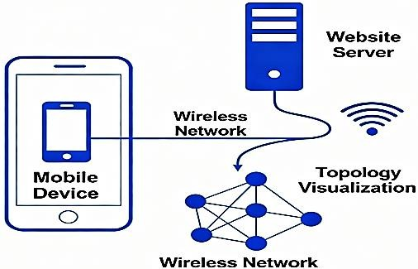
Fig. 12.1: Conceptual model shows network availability and network topology

Required Resources/Apparatus/Equipment with Specifications
- Computer or smartphone with internet access
- Web browser (Chrome, Firefox, Edge)
- Access to open share websites
- Active internet connection

Precautions to be followed
  - Handle computing devices carefully.
  - Ensure a secure internet connection to avoid cyber threats.
  - Respect the privacy and data usage policies of the websites used.
  - Use verified open share sites to avoid inaccurate or malicious data.

Procedure
  - Launch a web browser on a computer or smartphone connected to the internet.
  - Navigate to an open share website that provides wireless network maps and availability data (e.g.,OpenCellID or CellMapper).
  - Create an account if required or proceed as a guest user.
  - Set your geographic location in the website interface, either manually or via GPS.
  - Explore the map showing network towers, coverage areas, and topology layers.
  - Check the availability of networks from different carriers and technologies in your location.
  - Zoom in/out and analyze network topology—the connections between towers, routing paths, and coverage overlaps.
  - Record data on network availability, tower density, and topology characteristics for your selected area and repeat for different locations or carriers to compare network structures.
  - Summarize insights on network reach, topology complexity, and signal availability.

Open Share Website uses:
- OpenCelliD (opencellid.org): The largest open database of cell towers & mobile-network cells worldwide.
  - Explore tower locations (latitude/longitude) and cell IDs.
  - Use it to view the approximate topology of mobile networks (where towers exist) in India.
  - Has an API and downloadable dataset (subject to terms) if you want data for mapping/analysis.
- CellMapper (CellMapper.net): A crowdsourced map showing cellular tower locations and overage.
  - Pick India, select networks, view bands & nearby towers.
  - Visualize “which tower/cell you might be connected to” and see the distribution of towers around your location.
- nPerf Coverage Map (nPerf.com): A map showing 2G/3G/4G/5G coverage across India.
  - Shows how network availability varies by region and carrier.
  - Useful to understand broader availability rather than specific tower-IDs.
- OpenSignal Coverage Maps (OpenSignal.com): Free, user-crowdsourced coverage maps for many countries, including India.
  - Shows how “good” the network coverage is in different spots.
  - More for coverage/experience than detailed topology.
- Bhuvan by Indian Space Research Organization (https://bhuvan.nrsc.gov.in): Not purely telecom-network oriented, but a strong Indian geospatial portal where you can overlay lots of data layers.
  - If you can import tower data (from OpenCelliD or CellMapper) into Bhuvan, you can generate more localized topology/coverage visuals.
Example: here’s how you might use these:
  - Download tower/location data from OpenCelliD for the Maharashtra region. Use it to map “distance to nearest tower” for specific localities.
  - Use CellMapper to visually inspect how many towers cover your area and their approximate layout.
  - Use nPerf / OpenSignal to overlay “actual coverage/experience” on top of network topology — i.e., check whether areas with few towers correspond to poorer experience.
  - Use Bhuvan (or GIS software) to combine datasets (tower locations + terrain/building + coverage) to analyze “network topology” (how coverage depends on tower placement, terrain, etc).
  - For the observation table, pick a few spots (indoors/outdoors), note signal strength & carrier, and then use tower-map data to say “you are approx 500m from tower X, direction NE” etc.
Check Network Availability Using Wireshark: Network availability is basically checking whether devices on your network are responding.

Install & Launch Wireshark
  - Download from wireshark.org
  - Choose the interface (Wi-Fi or Ethernet) connected to your network.

Start Capturing Packets
  - Click the interface → Start.

  - You will see live packets (ARP, ICMP, DHCP, TCP).

Filter for Relevant Protocols
ARP (Address Resolution Protocol) → arp
  - Helps see which IPs are active.
  - Example: Who has 192.168.1.5? → Reply means the device is available.

ICMP (Ping Requests/Replies) → icmp
  - Shows if devices respond to ping.
  - DHCP → bootp (or dhcp in newer Wireshark)
  - Shows devices requesting IP addresses, meaning they are connected.

Analyze Packet Responses
  - If a device replies to ARP or ICMP → network/device is available.
  - Check the Time, Source, and Destination columns to see active communication.

Optional: Ping Multiple Devices
  - Use Windows/Linux terminal:
  - ping 192.168.1.1
  - ping 192.168.1.0/24 # For subnet ping
  - Watch responses in Wireshark → confirms availability.
- Observation Table

Sr.  No. | Location  / Spot | Website/App Used | Network Operator | Network Type (2G/3G/4G/5G) | Connected Tower ID / Name | Approx Tower Distance / Direction | Neighboring Towers (Distance & Direction) | Coverage Quality (Good / Moderate  / Poor)
1
2
3
4
5
For Wireshark:

Sr. No | Protocol | Source IP | Destination IP | Response  Received (Yes/No) | Device Type (Router/Switch/PC)
1
2
3

- Conclusion
………………………………………………………………………………………………….……………
…………………………………………………………………………………….…………………………
……………………………………………………………………….………………………………………
……………………………………………………………………………………………………………….

Practical-related Questions

Note: Below are a few sample questions for reference. Teachers must design more such questions to ensure the achievement of the identified CO.
  - Define network topology and list any three types of network topologies commonly used.
  - Perform a network availability test using any open share website. Record the parameters such as ping, download speed, upload speed, and latency. Interpret what these values indicate about your current network condition.
  - Which topology provides the best fault tolerance and scalability for large organizations?
  - Design a small local network topology diagram for a computer lab with 10 computers. Justify your choice of topology and explain how you would test its network availability using an open-source website.

Space for Answer
…………………………………………………………………………………….…………………………
……………………………………………………………………….………………………………………
………………………………………………………….……………………………………………………
…………………………………………….…………………………………………………………………
……………………………….………………………………………………………………………………
………………….……………………………………………………………………………………………
…….………………………………………………………………………………………………….………
………………………………………………………………………………………….……………………
…………………………………………………………………………….…………………………………
……………………………………………………………….………………………………………………
………………………………………………….……………………………………………………………
…………………………………….…………………………………………………………………………
……………………….………………………………………………………………………………………
………….………………………………………………………………………………………………….…
……………………………………………………………………………………………….………………
………………………………………………………………………………….……………………………
…………………………………………………………………….…………………………………………

……………………………………………………….………………………………………………………
………………………………………….……………………………………………………………………
…………………………….…………………………………………………………………………………
……………….………………………………………………………………………………………………
….………………………………………………………………………………………………….…………
……………………………………………………………………………………….………………………
………………………………………………………………………….……………………………………
…………………………………………………………….…………………………………………………
……………………………………………….………………………………………………………………
………………………………….……………………………………………………………………………
…………………….…………………………………………………………………………………………
……….………………………………………………………………………………………………….……
…………………………………………………………………………………………….…………………
……………………………………………………………………………….………………………………
………………………………………………………………….……………………………………………
…………………………………………………….…………………………………………………………
……………………………………….………………………………………………………………………
………………………….……………………………………………………………………………………
……………………………………………….………………………………………………………………
…………………….…………………………………………………………………………………………
……….………………………………………………………………………………………………….……
…………………………………………………………………………………………….…………………
……………………………………………………………………………….………………………………
………………………………………………………………….……………………………………………
…………………………………………………….…………………………………………………………
……………………………………….………………………………………………………………………
………………………….……………………………………………………………………………………
……………………………………………….………………………………………………………………
……………………………………………….………………………………………………………………
…………………….…………………………………………………………………………………………
……….………………………………………………………………………………………………….……
…………………………………………………………………………………………….…………………
……………………………………………………………………………….………………………………

………………………………………………………………….……………………………………………
…………………………………………………….…………………………………………………………
……………………………………….………………………………………………………………………
………………………….……………………………………………………………………………………
……………………………………………….………………………………………………………………
……………………………………………….………………………………………………………………
…………………….…………………………………………………………………………………………
……….………………………………………………………………………………………………….……
…………………………………………………………………………………………….…………………
……………………………………………………………………………….………………………………
………………………………………………………………….……………………………………………
…………………………………………………….…………………………………………………………
……………………………………….………………………………………………………………………
………………………….……………………………………………………………………………………

References / Suggestions for Further Reading:
  - https://infraon.io/blog/a-complete-guide-to-network-availability-monitoring-tools/
  - https://www.youtube.com/watch?v=MINBywFZrQw
  - https://www.youtube.com/watch?v=4znRDbg0SYA
  - https://www.youtube.com/watch?v=WJ0bmYCnOHI
- Assessment Scheme (25 Marks)

Sr. No. | Performance Indicators | Weightage
Process-related (10 marks = 40%)
1. | Accessing and navigating open share tools | 20%
2. | Accurate extraction of network availability data | 10%
3. | Analysis of network topology features | 10%
Product-related (15 marks = 60%)
4. | Observation entries and test evidence | 20%
5. | Teamwork and following safety practices | 20%
6. | Timely submission and presentation | 20%
Total (25 Marks) |  | 100%

Marks Obtained |  |  | Dated Signature of Teacher
Process related (10) | Product related (15) | Total (25)

Practical 13: Implement Manual and Auto Selection of a Network Using a Mobile Handset

Practical Significance
Network selection plays a vital role in maintaining mobile connectivity, especially in areas where multiple network providers operate. Mobile handsets offer two main modes to select networks—manual and automatic. Manual network selection allows users to choose a specific network provider, which is useful when roaming or resolving connectivity issues. Automatic selection enables the handset to detect and connect to the strongest available network based on signal strength and operator preference. Understanding and implementing these selection methods helps students grasp real-world telecom operations and user options. This practical aims to provide hands-on experience with configuring network selection on mobile devices, analyzing how networks are discovered, registered, and switched.

Industry / Employer Expected Outcome(s)
Maintain the mobile and wireless communication system.

Course Level Learning Outcome(s)
CO4 - Explain the 5G network system architecture.

Laboratory Learning Outcome(s)
LLO 13.1 Configure manual and auto selection network.

Relevant Affective Domain Related Outcomes
  - Follow precautionary measures.
  - Follow naming conventions.
  - Follow ethical practices.

Relevant Theoretical Background
Mobile networks operate on cellular standards such as GSM, LTE, and 5G. When a mobile device is powered on, it searches for nearby cells and attempts to register with a network using predefined criteria.
- Automatic Network Selection: The handset scans available networks and automatically selects the one based on priority, signal strength, and subscription data. This mode suits most users and helps maintain continuous connectivity without user intervention.
- Manual Network Selection: This allows a user to scan available Public Land Mobile Networks (PLMNs) and select one explicitly. Manual selection is essential in roaming or when a preferred network is unavailable automatically.
The process involves querying the device’s SIM and network stack, scanning frequencies for available networks, evaluating signal strength indicators such as RSSI, and sending registration requests. These procedures are governed by standards defined by organizations like 3GPP.
Understanding these mechanisms provides insights into mobility management, network access control, and user experience optimization.

Diagram
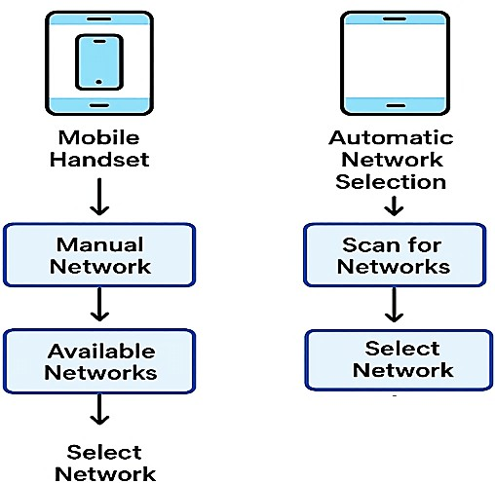

Fig. 13.1: Manual and Automatic Network Selection

Mode | How the Network is Selected | Who Chooses the Network | Common Use Case
Manual Network Selection | User opens network settings → Scans  → Views available networks → Selects one | User | When the signal is weak or switching between operators
Automatic Network Selection | Mobile periodically scans and connects to the strongest/home network | Mobile System | Daily use; default mode

Required Resources / Apparatus / Equipment
- Mobile handset with multi-network SIM capability.
- Active SIM card with access to multiple networks.
- Mobile device with manual and automatic network selection settings.
- Stable location with the presence of multiple mobile networks.

Precautions to be followed
  - Handle the mobile devices with care.
  - Follow the device manufacturer's instructions for network settings.
  - Avoid frequent network switching to prevent service interruptions.
  - Maintain safe usage practices.

Procedure
  - Power ON the mobile handset and insert the active SIM card.
  - Access the device’s network settings menu (typically under “Connections” or “Mobile Networks”).
  - Select the “Network Operators” or “Carrier” option.

For Manual Network Selection:
      - Choose to search for networks.
      - Wait for the handset to list all available networks.
      - Select a preferred network manually from the list.
      - Observe the device registering to the selected network.

For Automatic Network Selection:
      - Enable the automatic selection option.
      - The handset will scan and connect automatically to the best available network.
      - Observe the device switching networks based on signal strength.
    - Repeat the scanning and selection in different locations if possible.
  - Document registration status, selected networks, and observations.
  - Compare differences in connectivity and behavior between manual and automatic modes.

Observation Table

Step | Selection Mode | Network Name / Operator | Registration Status | Signal Strength (dBm) | Remarks
1 | Manual
2 | Automatic
3 | Manual
4 | Automatic
- Conclusions
………………………………………………………………………………………………….……………
….…………………………………………………………………………………….………………………
………………………………………………………………………….…………………………………….
.…………………………………………………………………………………………………………….....

Practical-related Questions

Note: Below are a few sample questions for reference. Teachers must design more such questions to ensure the achievement of the identified CO.
  - Identify situations in which manual network selection is preferred over automatic selection.
  - Analyze the network parameters that influence automatic network selection.
  - Evaluate the issues that may arise from frequent network switching.
  - Assess the impact of network selection modes on user experience.

Space for Answer
…………………………………………………………………………………….…………………………
……………………………………………………………………….………………………………………
………………………………………………………….……………………………………………………
…………………………………………….…………………………………………………………………
……………………………….………………………………………………………………………………
………………….……………………………………………………………………………………………
…….………………………………………………………………………………………………….………
………………………………………………………………………………………….……………………

…………………………………………………………………………….…………………………………
……………………………………………………………….………………………………………………
………………………………………………….……………………………………………………………
…………………………………….…………………………………………………………………………
……………………….………………………………………………………………………………………
………….………………………………………………………………………………………………….…
……………………………………………………………………………………………….………………
………………………………………………………………………………….……………………………
…………………………………………………………………….…………………………………………
……………………………………………………….………………………………………………………
………………………………………….……………………………………………………………………
…………………………….…………………………………………………………………………………
……………….………………………………………………………………………………………………
….………………………………………………………………………………………………….…………
……………………………………………………………………………………….………………………
………………………………………………………………………….……………………………………
…………………………………………………………….…………………………………………………
……………………………………………….………………………………………………………………
………………………………….……………………………………………………………………………
…………………….…………………………………………………………………………………………
……….………………………………………………………………………………………………….……
…………………………………………………………………………………………….…………………
…………………………….…………………………………………………………………………………
……………….………………………………………………………………………………………………
….………………………………………………………………………………………………….…………
……………………………………………………………………………………….………………………
………………………………………………………………………….……………………………………
…………………………………………………………….…………………………………………………
……………………………………………….………………………………………………………………
………………………………….……………………………………………………………………………
…………………….…………………………………………………………………………………………
……………………………………………………………………………………….………………………
………………………………………………………………………….……………………………………

…………………………………………………………….…………………………………………………
……………………………………………….………………………………………………………………
………………………………….……………………………………………………………………………
…………………….…………………………………………………………………………………………
……………………………………………………………………………………….………………………
………………………………………………………………………….……………………………………
…………………………………………………………….…………………………………………………
……………………………………………….………………………………………………………………
………………………………….……………………………………………………………………………
…………………….…………………………………………………………………………………………
………………………………………………….……………………………………………………………
………………………………………………….……………………………………………………………

References / Suggestions for Further Reading
  - https://www.zipitwireless.com/blog/automatic-vs.-manual-network-selection-which-is-best-for- cellular-devices/
  - https://onomondo.com/blog/improve-coverage-with-automatic-network-selection/
  - Manual selection (Android): https://www.youtube.com/watch?v=5E3XslqFdfg
  - Auto/automatic network selection: https://www.youtube.com/watch?v=ZaEoeXufVdA
- Assessment Scheme (25 Marks)

Sr. No. | Performance Indicators | Weightage
Process-related (10 marks = 40%)
1. | Correct implementation of manual selection | 20%
2. | Proper execution of automatic selection | 10%
3. | Accurate recording of observations | 10%
Product-related (15 marks = 60%)
4. | Observation entries and test evidence | 20%
5. | Teamwork and following safety practices | 20%
6. | Timely submission and presentation | 20%
Total (25 Marks) |  | 100%

Marks Obtained |  |  | Dated Signature of Teacher
Process related (10) | Product related (15) | Total(25)

Practical 14: Create seamless wireless connectivity using multiple access points

Practical Significance
Wireless connectivity is critical in modern networking environments to provide reliable and continuous internet access. In complex settings like offices, campuses, or large buildings, a single wireless access point (AP) may not offer comprehensive coverage. Using multiple access points strategically placed allows seamless wireless connectivity by enabling smooth roaming for devices without dropping the connection. This practical introduces students to deploying and configuring multiple APs to ensure uninterrupted wireless service and seamless handoff between APs as the user moves. Understanding handoff mechanisms like basic service set (BSS) transitions and coordination among APs prepares students for roles in network planning, implementation, and troubleshooting within the wireless communication domain.

Industry / Employer Expected Outcome(s)
Maintain the mobile and wireless communication system.

Course Level Learning Outcome(s)
CO4 - Explain the 5G network system architecture.

Laboratory Learning Outcome(s)
LLO 14.1 Establish wireless connectivity using access points.

Relevant Affective Domain Related Outcomes
  - Follow precautionary measures.
  - Follow naming conventions.
  - Follow ethical practices.

Relevant Theoretical Background
Wireless LANs (WLANs) often utilize multiple APs to extend coverage over a wide area. A wireless AP is a device that provides access to a network and assigns IP addresses, manages traffic, and controls connections. When multiple APs are used, a network becomes a Basic Service Set (BSS) or Extended Service Set (ESS).
- Basic Service Set (BSS): A network with a single AP.
- Extended Service Set (ESS): Multiple interconnected APs acting as one network. Seamless connectivity requires proper configuration of SSIDs, channels, and security settings across APs to allow smooth wireless station roaming without loss of connection, often managed by protocols like IEEE 802.11r (fast roaming), 802.11k (radio resource management), and 802.11v (network-assisted roaming). Devices connected to the network switch APs based on signal strength and quality, ideally without interrupting active sessions. This handoff process involves authentication and association mechanisms overseen by the APs and wireless client drivers. Proper channel allocation minimizes interference. Typically, non-overlapping channels are used in the 2.4 GHz or 5 GHz bands. Additional services like DHCP and RADIUS servers are often used to maintain consistent addressing and authentication across the network. Implementing multi-AP wireless networks improves reliability, user

mobility, network load distribution, and overall quality of service, essential for densely populated or mobile user environments.

Actual Circuit Diagram:
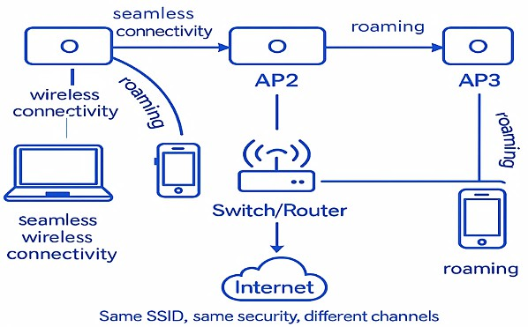
Fig. 14.1: A logical network diagram illustrating multiple APs' coverage and roaming.

Required Resources / Apparatus / Equipment:
- Multiple wireless access points compatible with the same network standards (e.g., IEEE 802.11ac or ax)
- Managed Ethernet switch or router
- Laptops or mobile devices with Wi-Fi capability
- Wireless network configuration software or access point management GUI
- Ethernet cables and power sources for APs

Precautions to be followed:
  - Handle networking equipment carefully to avoid physical damage.
  - Follow the manufacturer's guidelines for AP placement, avoiding interference sources.
  - Do not expose devices to excessive heat or moisture.
  - Ensure network security best practices are implemented (strong passwords, encryption).

Procedure:
  - Set up multiple wireless APs physically across the desired coverage area, ensuring proper spacing to reduce interference.
  - Connect APs to an Ethernet switch or router for network backbone connectivity.
  - Access each AP’s configuration interface via web GUI.
  - Configure all APs with the same SSID (network name) and security protocols (e.g., WPA2/WPA3).
  - Assign non-overlapping channels to APs (for the 2.4 GHz band, choose channels 1, 6, 11, or appropriate 5 GHz channels).
  - Enable roaming and fast transition protocols such as IEEE 802.11r if supported.
  - Set DHCP options to ensure IP addresses are assigned seamlessly across the network.
  - Connect client devices (laptops, smartphones) to the wireless network.
  - Move client devices across the AP's coverage zones and check for continuous connectivity and automatic handoff without interruption.

  - Use network monitoring tools to verify connection quality, signal strength, and seamless roaming.
  - Document all configurations, observations, and any connection drops.

Observation Table

AP Location | SSID | Channel | Signal Strength (dBm) | Device Connected | Roaming Success (Yes/No) | Remarks
Location 1
Location 2
Location 3
- Conclusion
………………………………………………………………………………………………….…………….
…………………………………………………………………………………….………………………….
……………………………………………………………………….……………………………………….
………………………………………………………………………………………………………………..

Practical-related Questions

Note: Below are a few sample questions for reference. Teachers must design more such questions to ensure the achievement of the identified CO.
  - Differentiate between Basic Service Set (BSS) and Extended Service Set (ESS).
  - Explain the importance of channel selection in multi-AP environments.
  - Describe the role of the IEEE 802.11r protocol in wireless roaming.
  - Evaluate challenges in deploying multiple APs and propose mitigation strategies.

Space for Answer
…………………………………………………………………………………….…………………………
……………………………………………………………………….………………………………………
………………………………………………………….……………………………………………………
…………………………………………….…………………………………………………………………
……………………………….………………………………………………………………………………
………………….……………………………………………………………………………………………
…….………………………………………………………………………………………………….………
………………………………………………………………………………………….……………………
…………………………………………………………………………….…………………………………
……………………………………………………………….………………………………………………
………………………………………………….……………………………………………………………

…………………………………….…………………………………………………………………………
……………………….………………………………………………………………………………………
………….………………………………………………………………………………………………….…
……………………………………………………………………………………………….………………
………………………………………………………………………………….……………………………
…………………………………………………………………….…………………………………………
……………………………………………………….………………………………………………………
………………………………………….……………………………………………………………………
…………………………….…………………………………………………………………………………
……………….………………………………………………………………………………………………
….………………………………………………………………………………………………….…………
……………………………………………………………………………………….………………………
………………………………………………………………………….……………………………………
…………………………………………………………….…………………………………………………
……………………………………………….………………………………………………………………
………………………………….……………………………………………………………………………
…………………….…………………………………………………………………………………………
……….………………………………………………………………………………………………….……
…………………………………………………………………………………………….…………………
……………………………………………………………………………….………………………………
………………………………………………………………….……………………………………………
…………………………………………………….…………………………………………………………
……………………………………….………………………………………………………………………
………………………….……………………………………………………………………………………
………………………….……………………………………………………………………………………
…………………………………………………….…………………………………………………………
……………………………………….………………………………………………………………………
………………………….……………………………………………………………………………………
………………………….……………………………………………………………………………………
…………………………………………………….…………………………………………………………
……………………………………….………………………………………………………………………
………………………….……………………………………………………………………………………
………………………….……………………………………………………………………………………

…………………………………………………….…………………………………………………………
……………………………………….………………………………………………………………………
………………………….……………………………………………………………………………………
………………………….……………………………………………………………………………………
………………………….……………………………………………………………………………………
………………………….……………………………………………………………………………………
………………………….……………………………………………………………………………………
………………………….……………………………………………………………………………………
………………………….……………………………………………………………………………………
………………………….……………………………………………………………………………………
………………………….……………………………………………………………………………………
………………………….……………………………………………………………………………………
………………………….……………………………………………………………………………………

References / Suggestions for Further Reading
  - https://www.madebywifi.com/blog/multiple-wifi-aps-on-the-same-network/
  - https://www.cablelabs.com/blog/multiple-access-point-architectures-wi-fi-whole-home-coverage
  - https://www.youtube.com/watch?v=klydLJm_v0A
  - https://www.youtube.com/watch?v=5Oc0wICju6U
- Assessment Scheme (25 Marks)

Sr. No. | Performance Indicators | Weightage
Process-related (10 marks = 40%)
1. | Accuracy of AP configuration | 20%
2. | Testing successful device roaming | 10%
3. | Adherence to safety and procedures | 10%
Product-related (15 marks = 60%)
4. | Observation entries and test evidence | 20%
5. | Teamwork and following safety practices | 20%
6. | Timely submission and presentation | 20%
 | Total (25 Marks) | 100%

Marks Obtained |  |  | Dated Signature of Teacher
Process related (10) | Product related (15) | Total (25)

Practical 15: Develop a mobile application for wireless technology using any wizards, such as www.appypie.com or any other website.

Practical Significance
Creating your own app is a powerful way to market your business. A good app can yield excellent results for your business. AppyPie delivers a rich user interface for a mobile application by using HTML5 with JavaScript and CSS.

Industry / Employer Expected Outcome(s)
Maintain the mobile and wireless communication system.

Course Level Learning Outcome(s)
CO4 – Explain the 5G network system architecture.

Laboratory Learning Outcome(s)
LLO 15.1 Develop a mobile application for wireless technology.

Relevant Affective Domain Related Outcomes
  - Demonstrate working as a leader/a team member.
  - Follow ethical practices.

Relevant Theoretical Background
Appy Pie is a mobile app platform released on Android and IoS platforms. It is an app that allows its users to create different types of mobile apps, which can then be released to the public and monetized. It also features its own marketplace to show off apps created through it. Appy Pie launched out of beta version of its WYSIWYG mobile app creation service on 14 April 2013.Appy Pie delivers a rich user interface for a mobile application by using HTML5 with JavaScript and CSS. Using Phone GAP API user interfaces can be created with JavaScript component libraries that render interactive user interface widgets using HTML5 elements.

Required Resources / Apparatus / Equipment:

Sr. No. | Instrument/Components | Specification | Quantity | Remarks
1. | Hardware: IBM PC  Compatible Computer System
2. | Any other resource used  www.appypie.com
- Precautions to be followed:
  - Create Login id and password carefully.
  - Follow stepwise procedure and shut down PC properly after performing.

Procedure:
  - Open www.appypie.com or any App building software. It involves 3 main steps
    - Select

    - Build
    - Publish
  - Click on Login: Create Login id and password and then proceed.
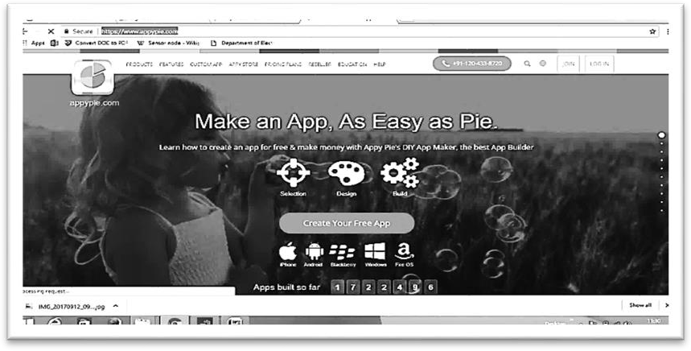
  - Select an operating system.
  - Click on “Android”.
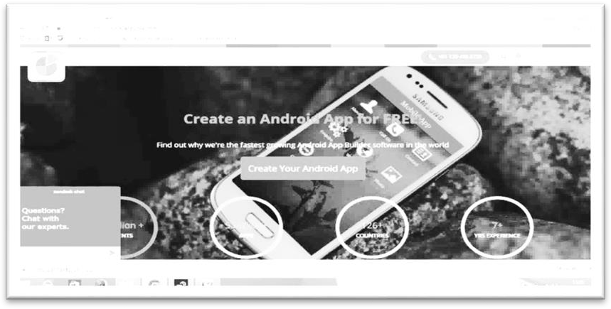
  - Click “Create Your Android App”.
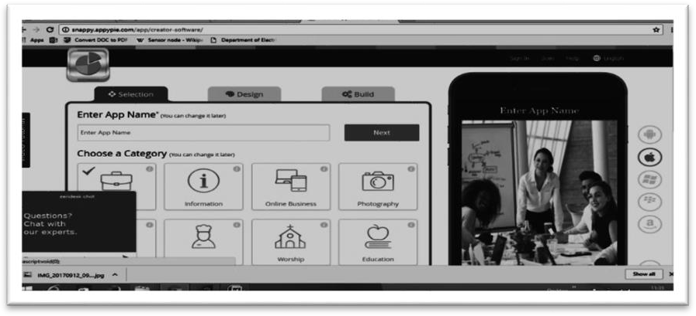
  - Enter App Name Eg: Make You Fly
  - Choose Category: Example: Travel

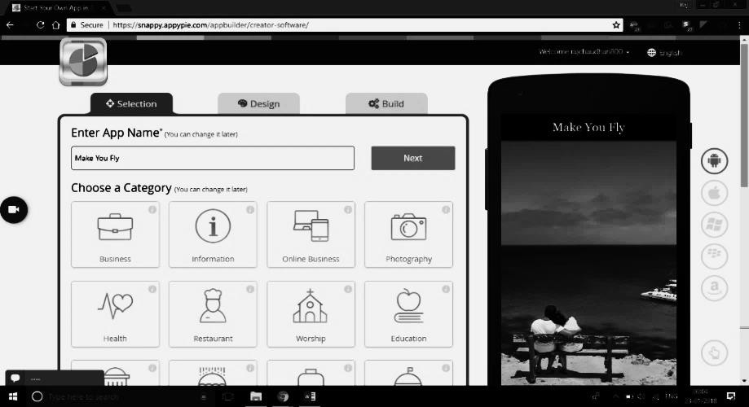
  - Click Next. Then you will be directed to “Enter your Facebook Page name “This is optional field”. You can skip it.
  - Click “Next”. You will be directed to following page:
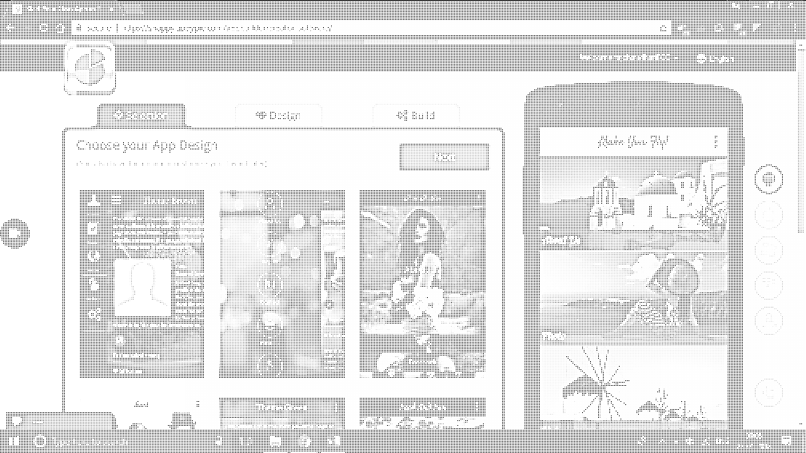
  - Choose “Layout”
  - Click “Next”.
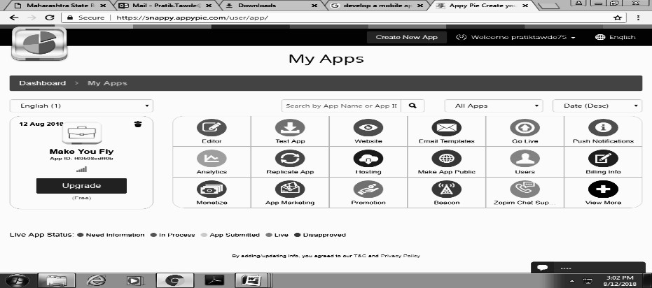
  - You will be directed to the following page:
  - You can select the number of pages of your App.
  - You can change the page name.
  - You can add Description either by typing the contents or from the websites.
  - You can add or delete or change related details as per your App requirements.
  - You can change “Page style and color scheme”.

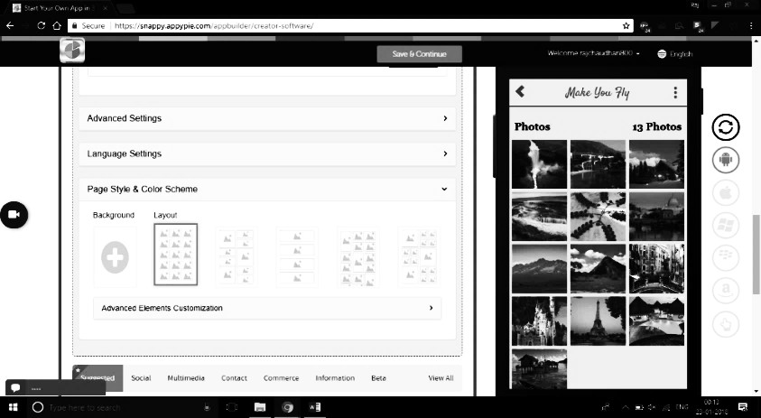
  - Click on “SAVE and FINISH”.
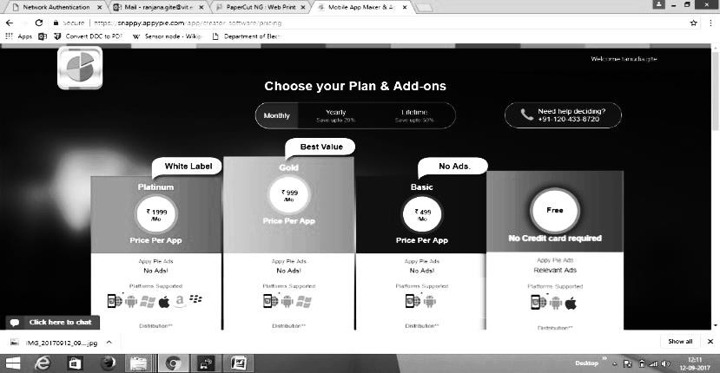
  - You will be directed to the following page:
  - Click on “FREE” Plan.
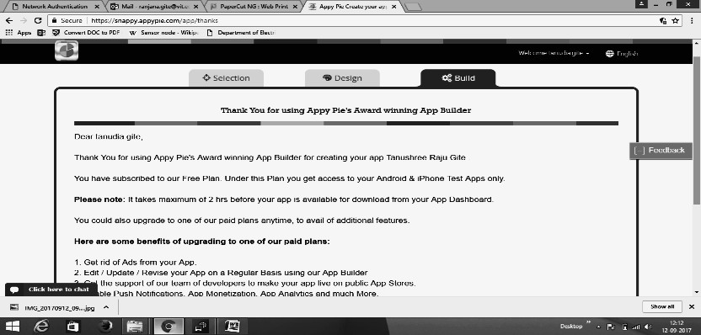
  - You will be directed to the following page:
  - Click on “Continue to My apps”.
  - Enter the Verification code sent on your mail id and click verify.
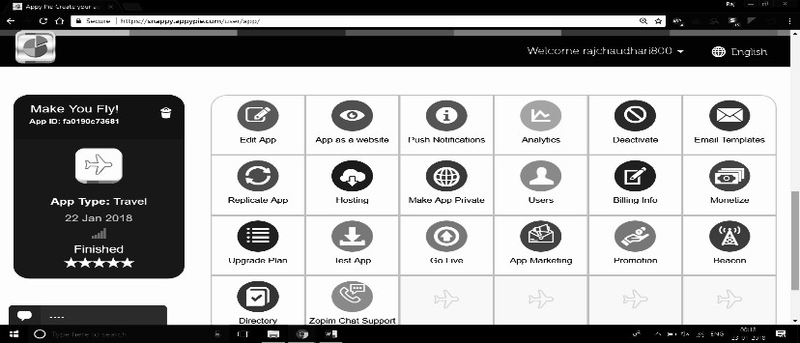
  - You will see this page.

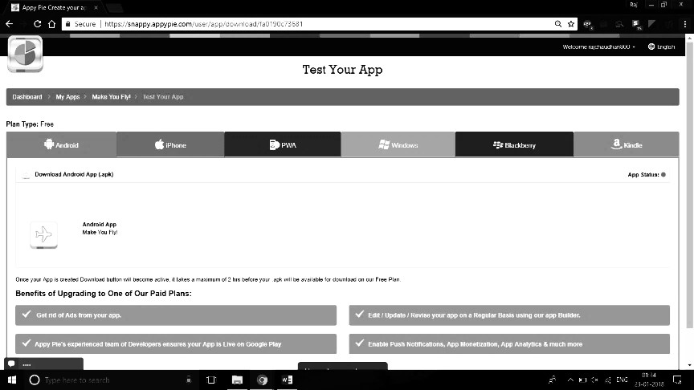
  - Click on “Test App”.
  - Type mail id so that you receive the App link on mail on your mobile phone and download the App on your mobile phone.
  - You will receive the App download link.
  - This will be a “.apk” file. You are required to download the file in your mobile phone and your App is ready.


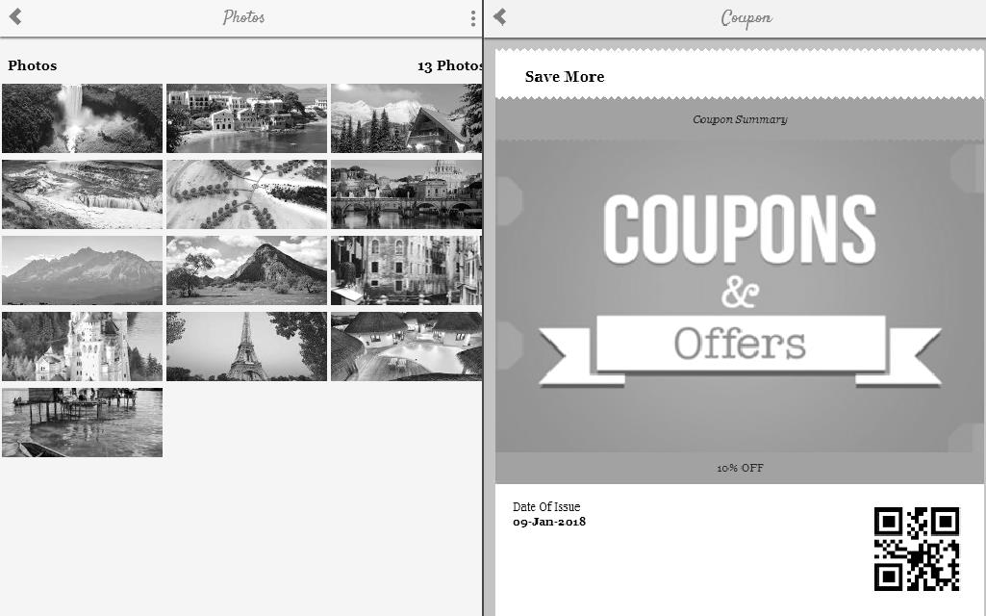

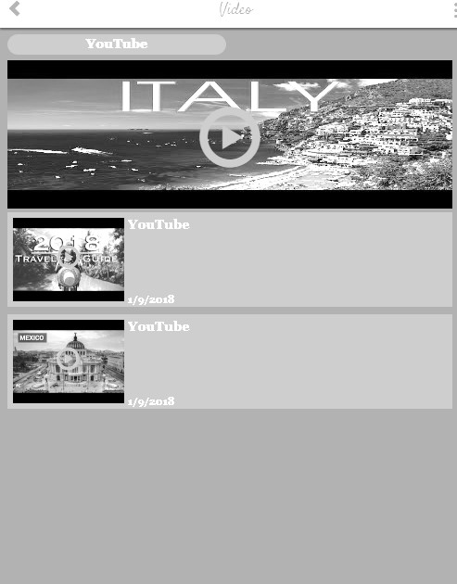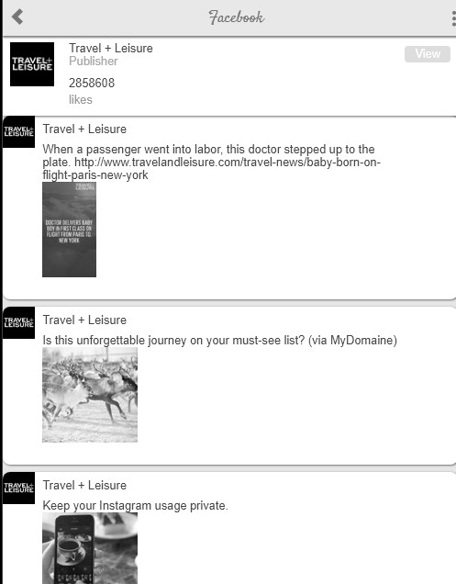

Conclusion
………………………………………………………………………………………………….…………….
…………………………………………………………………………………….………………………….
……………………………………………………………………….……………………………………….
………………………………………………………………………………………………………………..

Practical-related Questions

Note: Below are a few sample questions for reference. Teachers must design more such questions to ensure the achievement of the identified CO.
  - Define smartphone.
  - State different mobile development solutions.
  - Explain browser-based and native wireless applications.

Space for Answer
…………………………………………………………………………………….…………………………
……………………………………………………………………….………………………………………
………………………………………………………….……………………………………………………
…………………………………………….…………………………………………………………………
……………………………….………………………………………………………………………………
………………….……………………………………………………………………………………………
…….………………………………………………………………………………………………….………
………………………………………………………………………………………….……………………
…………………………………………………………………………….…………………………………
……………………………………………………………….………………………………………………
………………………………………………….……………………………………………………………
…………………………………….…………………………………………………………………………

……………………….………………………………………………………………………………………
………….………………………………………………………………………………………………….…
……………………………………………………………………………………………….………………
………………………………………………………………………………….……………………………
…………………………………………………………………….…………………………………………
……………………………………………………….………………………………………………………
………………………………………….……………………………………………………………………
…………………………….…………………………………………………………………………………
……………….………………………………………………………………………………………………
….………………………………………………………………………………………………….…………
……………………………………………………………………………………….………………………
………………………………………………………………………….……………………………………
…………………………………………………………….…………………………………………………
……………………………………………….………………………………………………………………
………………………………….……………………………………………………………………………

References / Suggestions for Further Reading:
  - https://www.appypie.com
- Assessment Scheme (25 Marks)

Performance indicators |  | Weightag  e
Process-related (10 marks = 40%) |  | 40%
1 | Use of WWW.appypie.com for developing mobile  application. | 20%
2 | Identifying other wizards for developing mobile application. | 15%
3 | Follow ethical practices | 05%
Product-related (15 marks = 60%) |  | 60%
4 | Observations and recording | 20%
5 | Answer to sample questions | 30%
6 | Timely Submission of report | 10%
Total (25 Marks) |  | 100%

Marks Obtained |  |  | Dated Signature of Teacher
Process related (10) | Product related (15) | Total (25)

Practical 16: Apply RFID technology for real life applications using RFID kit

Practical Significance
RFID, Radio Frequency Identification, is a technology that includes wireless data capture and transaction processing. Proximity (short range) and Vicinity (long range) are two major application areas where RFID technology is used. Track and trace applications are long-range or vicinity applications. Various real-time applications include asset tracking, people tracking, a library, attendance system.

Industry / Employer Expected Outcome(s)
Maintain the mobile and wireless communication system.

Course Level Learning Outcome(s)
CO2 – Establish a wireless network with the given technology.

Laboratory Learning Outcome(s)
LLO 16.1 Implement radio frequency connectivity.

Relevant Affective Domain Related Outcomes
  - Demonstrate working as a leader/a team member.
  - Follow ethical practices.
  - Follow precautionary measures.

Relevant Theoretical Background Components of RFID System:
RFID system consists of three components RFID tag, reader, and microcontroller.

A RFID tag:
It consists of a silicon microchip attached to a small antenna and mounted on a substrate and encapsulated in different materials like plastic or glass veil and with an adhesive on the back side to be attached to objects.

A reader:
It consists of a scanner with antennas to transmit and receive signals and is responsible for communication with the tag and receives the information from the tag

Processor or a Controller:
It can bea host computer with a Microprocessor or a microcontroller which receives the reader input and process the data.
Types of RFID Systems: Active and Passive: Passive RFID system using EM wave propagation method: The antenna present in the reader transmits electromagnetic waves which are received by the antenna present in the tag as potential difference across the dipole. This voltage is rectified and filtered to get the DC power. The receiver antenna is kept at different impedance which causes it to reflect a part of the received signal. This reflected signal is received by the reader and monitored accordingly.

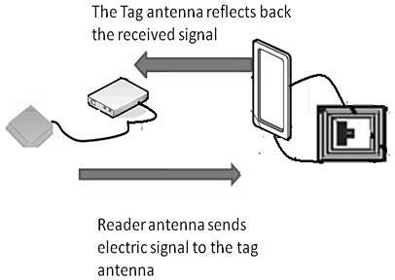
Active RFID system: In the active RFID system, the reader sends signal to the tag using an antenna. The tag receives this information and resends this information along with the information in its memory. The reader receives this signal and transmits to the processor for further processing.
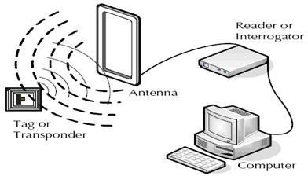
RFID Reader detector circuit: RFID readers transmit an electromagnetic (EM) field with their reader antenna. This EM field induces a current in the antenna for all RFID tags within reading distance. This induced current activates the RFID chip that is connected to the tag’s antenna. This chip then modulates a response (usually the unique ID number) that is transmitted back to the reader. The antenna of an RFID tag is usually a thin copper wire that is arranged in loops. The loops allow the emitted EM field of the RFID reader to induce current to the antenna of the tag.

Required Resources / Apparatus / Equipment:

Sr.  No. | Instrument  /Components | Specification | Quantity | Remarks
1. | RFID Trainer kit | Modular design for hands-on experiments, Supports both read-only and read/write tags (depends on kit  model) | 1
2. | RFID reader | Operating frequency 13.56 MHz | 1
- Precautions to be followed:
  - Handle RFID system and peripherals with care.

Procedure:
  - Connect the capacitor (82 pF) and the low current LED to the tag. They are connected in parallel. Also solder these two components to the copper tape to test RFID tags we need an RFID reader that can operate at a frequency of 13.56MHz.

  - Replace the connected capacitor and LED from our tag with an RFID chip (eg. the MIFARE 1k).By doing this, the activity of our tag is no longer visible through the LED, but our tag is then readable by the RFID reader and responds with the unique ID number of the chip.
  - With these simple steps, RFID reader detector testing is finished by bringing our DIY RFID detector close to an RFID reader), the connected LED lights up
  - If there are RFID readers available with a stronger EM field and therefore a higher maximum reading distance.

Observation Table

Sr.  No. | Parameter Observed | Expected Observation / Standard  Output | Actual Observation | Remarks
1 | RFID Reader Power  Status | LED should glow, indicating power  ON
2 | RFID Tag Type | Should detect valid HF/LF tag based  on kit specification
3 | RFID Tag UID  (Unique Identification Number) | Reader should display unique tag ID on serial monitor/LCD
4 | Tag Detection Range | Typically 2–5 cm (depending on kit)
5 | Response Time | Should detect tag within <1 second
- Conclusion
………………………………………………………………………………………………….…………….
…………………………………………………………………………………….………………………….
……………………………………………………………………….……………………………………….
………………………………………………………………………………………………………………..

Practical-related Questions

Note: Below are a few sample questions for reference. Teachers must design more such questions to ensure the achievement of the identified CO.
  - How does change in the length of antenna affect reading distances?
  - State the operating frequency of RFID reader used.
  - It is desired to make a database of the students in a college present at any particular day. Explain the approach to maintain and check a database for students of the college with RFID technology.

Space for Answer
…………………………………………………………………………………….…………………………
……………………………………………………………………….………………………………………
………………………………………………………….……………………………………………………
…………………………………………….…………………………………………………………………

……………………………….………………………………………………………………………………
………………….……………………………………………………………………………………………
…….………………………………………………………………………………………………….………
………………………………………………………………………………………….……………………
…………………………………………………………………………….…………………………………
……………………………………………………………….………………………………………………
………………………………………………….……………………………………………………………
…………………………………….…………………………………………………………………………
……………………….………………………………………………………………………………………
………….………………………………………………………………………………………………….…
……………………………………………………………………………………………….………………
………………………………………………………………………………….……………………………
…………………………………………………………………………….…………………………………
……………………………………………………………….………………………………………………
………………………………………………….……………………………………………………………
…………………………………….…………………………………………………………………………

References / Suggestions for Further Reading:
  - https://www.elprocus.com/rfid-basic-introduction-simple-application/
- Assessment Scheme (25 Marks)

Performance indicators |  | Weightage
Process-related (10 marks = 40%) |  | 40%
1 | Connecting components | 20%
2 | Obtaining results | 10%
3 | Understanding knowledge of RFID | 10%
Product-related (15 marks = 60%) |  | 60%
4 | Practical related questions and exercise | 20%
5 | Completion and submission of practical in time | 20%
6 | Expected Output/Observation | 20%
Total (25 Marks) |  | 100%

Marks Obtained |  |  | Dated Signature of Teacher
Process related (10) | Product related (15) | Total (25)

Practical 17: Implement line coding technique Unipolar NRZ using MATLAB and Simulink

Practical Significance
Electrical representation of binary codes is called “line code”. A line code is a code chosen for use within a communications system for transmitting a digital signal down a transmission line. Line coded signal is used to create an “RF signal” that can be sent through free space. The line coded signal can be converted to bits on an optical discoing this practical student will convert the given digital data into various line codes such as Unipolar NRZ.

Industry / Employer Expected Outcome(s)
Maintain mobile and wireless communication system.

Course Level Learning Outcome(s)
CO5 – Establish wireless sensor networks for the given application.

Laboratory Learning Outcome(s)
LLO 17.1 Simulate line coding technique Unipolar NRZ.

Relevant Affective Domain Related Outcomes
- Demonstrate working as a leader/a team member.
- Follow ethical practices.

Relevant Theoretical Background
A line code is the code used for data transmission of a digital signal over a transmission line. Unipolar Non-Return to Zero (NRZ)
In this type of unipolar signaling, a High in data is represented by a positive pulse called as Mark, which has a duration T0 equal to the symbol bit duration. A Low in data input has no pulse. Following Fig.
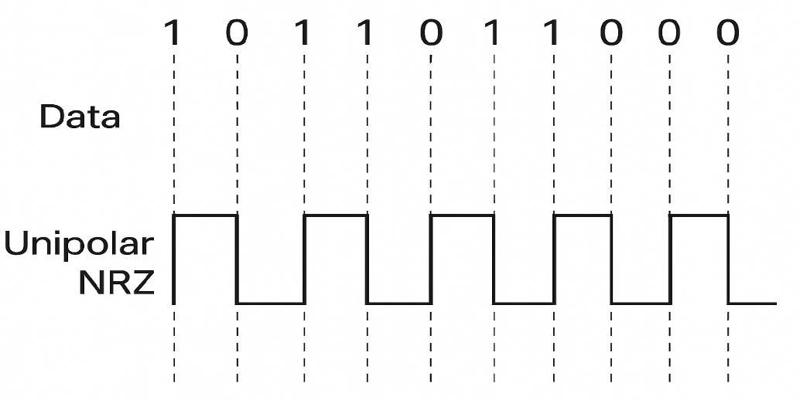
17.1 clearly depicts this.
Fig 17.1: Unipolar NRZ

Simple Simulation Code (Attach actual simulation code used in laboratory)
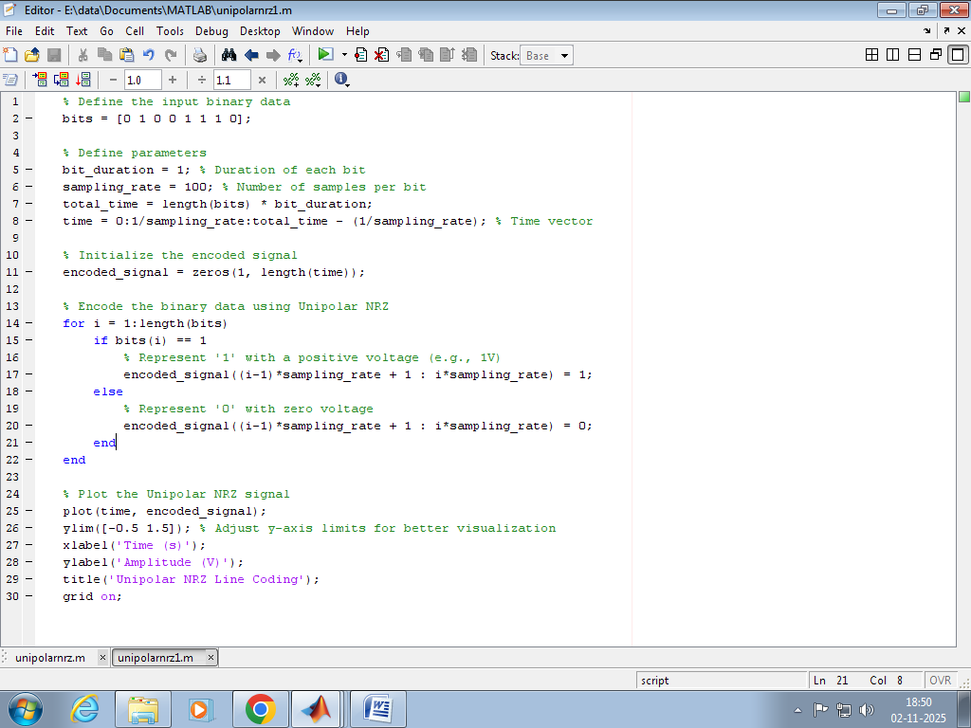
Fig 17.2 MATLAB Code
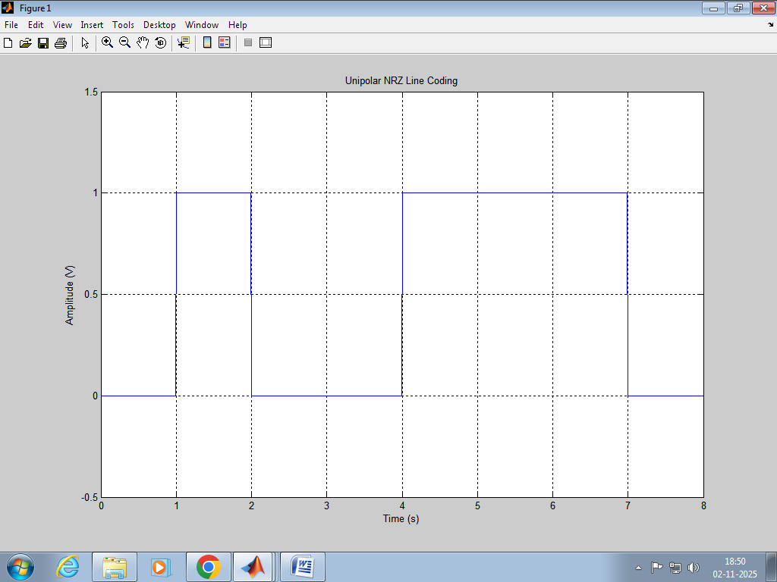
Fig 17.3 MATLAB Simulation Output

Required Resources / Apparatus / Equipment:

Sr.  No. | Instrument/Components | Specification | Quantity
1. | Computer | Latest Processor | 1
2. | Simulation Software | LabView/MATLAB/SCILAB/P Spice/HS Spice/Multisim/Proteus or any relevant open-source simulation software | 1
- Precautions to be followed:
  - Ensure proper earthing to the computer system.
  - Ensure compatibility of computer system with software.
  - Ensure proper installation of simulation software

Procedure:
To simulate line coding technique Unipolar NRZ
  - Open MATLAB and create a new script file.
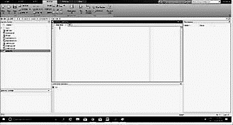
  - Write a program to simulate line coding technique Unipolar NRZ
  - Save and run file.

Observation Table (Students must attach the actual simulation output)
- Conclusion
………………………………………………………………………………………………….…………….
…………………………………………………………………………………….………………………….
……………………………………………………………………….……………………………………….
………………………………………………………………………………………………………………..

Practical-related Questions

Note: Below are a few sample questions for reference. Teachers must design more such questions to ensure the achievement of the identified CO.
  - Draw the Unipolar NRZ waveforms for a binary sequence 11001010
  - Draw the Unipolar NRZ waveforms for a binary sequence 11001100

Space for Answer
…………………………………………………………………………………….…………………………
……………………………………………………………………….………………………………………
………………………………………………………….……………………………………………………
…………………………………………….…………………………………………………………………
……………………………….………………………………………………………………………………
………………….……………………………………………………………………………………………
…….………………………………………………………………………………………………….………
………………………………………………………………………………………….……………………
…………………………………………………………………………….…………………………………
……………………………………………………………….………………………………………………
………………………………………………….……………………………………………………………
…………………………………….…………………………………………………………………………
……………………….………………………………………………………………………………………
………….………………………………………………………………………………………………….…
……………………………………………………………………………………………….………………
………………………………………………………………………………….……………………………
…………………………………………………………………….…………………………………………
……………………………………………………….………………………………………………………
………………………………………….……………………………………………………………………
…………………………….…………………………………………………………………………………
……………….………………………………………………………………………………………………
….………………………………………………………………………………………………….…………
……………………………………………………………………………………….………………………
………………………………………………………………………….……………………………………
…………………………………………………………….…………………………………………………
……………………………………………….………………………………………………………………
………………………………….……………………………………………………………………………

…………………….…………………………………………………………………………………………
……….………………………………………………………………………………………………….……
…………………….…………………………………………………………………………………………
……….………………………………………………………………………………………………….……
……….………………………………………………………………………………………………….……
…………………….…………………………………………………………………………………………
……….………………………………………………………………………………………………….……
…………………….…………………………………………………………………………………………
……….………………………………………………………………………………………………….……
……….………………………………………………………………………………………………….……
……….………………………………………………………………………………………………….……
……….………………………………………………………………………………………………….……
……….………………………………………………………………………………………………….……

References / Suggestions for Further Reading:
  - https://www.sqa.org.uk/elearning/NetTechDC01ECD/page_02.htm
  - https://en.wikipedia.org/wiki/Line_code
- Assessment Scheme (25 Marks)

Performance Indicators |  | Weightage
Process-related (10 marks = 40%) |  | 40%
01 | Handling of the components | 10%
02 | Identification of components | 10%
03 | Measuring value using suitable instrument | 10%
04 | Working in teams | 10%
Product-related (15 marks = 60%) |  | 60%
05 | Correctness of output | 10%
06 | Interpretation of Result | 10%
07 | Conclusions | 10%
08 | Practical related questions | 15%
09 | Submitting the journal in time | 15%
Total (25Marks) |  | 100 %

Marks Obtained |  |  | Dated Signature of Teacher
Process related (10) | Product related (15) | Total (25)

Practical 18: Implement line coding technique Bipolar RZ using MATLAB and Simulink

Practical Significance
Electrical representation of binary codes is called “line code”. A line code is a code chosen for use within a communications system for transmitting a digital signal down a transmission line. Line line-coded signal is used to create an “RF signal” that can be sent through free space. The line-coded signal can be converted to bits on an optical disc. In this practical, students will convert the given digital data into various line codes such as Bipolar RZ.

Industry / Employer Expected Outcome(s)
Maintain the mobile and wireless communication system.

Course Level Learning Outcome(s)
CO5 – Establish wireless sensor networks for the given application.

Laboratory Learning Outcome(s)
LLO 18.1 Simulate line coding technique, Bipolar RZ.

Relevant Affective Domain Related Outcomes
  - Demonstrate working as a leader/a team member.
  - Follow ethical practices.

Relevant Theoretical Background
This is an encoding technique which has three voltage levels, namely +, - and 0. Such a signal is called as duo-binary signal. An example of this type is Alternate Mark Inversion (AMI). For a 1, the voltage level gets a transition from + to – or from – to +, having alternate 1s to be of equal polarity. A 0 will have a zero voltage level. We have two types 1. Bipolar NRZ 2. Bipolar RZ or Manchester shown in figure 18.1
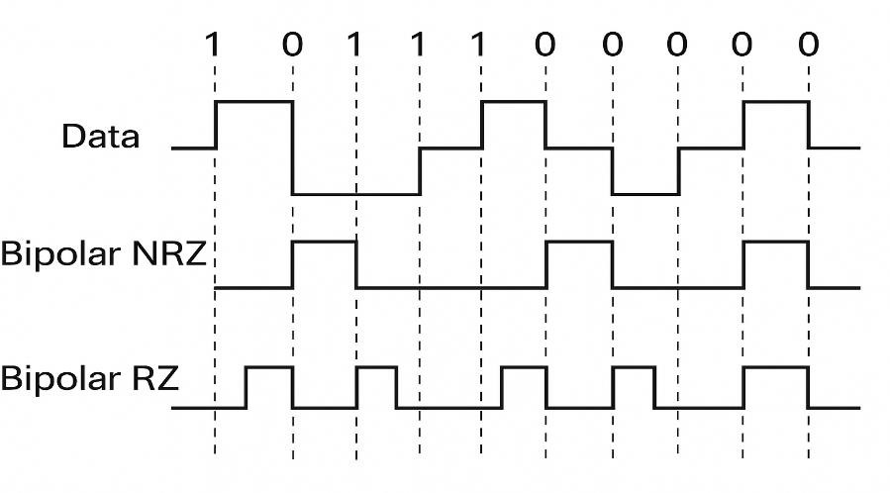
Fig 18.1: Bipolar RZ / NRZ

Required Resources/Apparatus/Equipment

Sr.  No. | Instrument/ Components | Specification | Quantity
1. | Computer | Latest Processor | 1
2. | Simulation  Software | LabView/MATLAB/SCILAB/P Spice/HS Spice/Multisim/Proteus or  any relevant open-source simulation software | 1
- Precautions to be followed:
  - Ensure proper earthing to the computer system.
  - Ensure compatibility of the computer system with software.
  - Ensure proper installation of simulation software

Procedure:
To simulate the line coding technique, Bipolar RZ
  - Open MATLAB and create a new script file.
  - Write a program to simulate the line coding technique Bipolar RZ
  - Save and run the file.

Observation Table (Students must attach the actual simulation code and output)
- Conclusion
………………………………………………………………………………………………….…………….
…………………………………………………………………………………….………………………….
……………………………………………………………………….……………………………………….
………………………………………………………………………………………………………………..

Practical-related Questions

Note: Below are a few sample questions for reference. Teachers must design more such questions to ensure the achievement of the identified CO.
  - Draw the Bipolar RZ waveforms for a binary sequence 11001010
  - Draw the Bipolar RZ waveforms for a binary sequence 11001100

Space for Answer
…………………………………………………………………………………….…………………………
……………………………………………………………………….………………………………………
………………………………………………………….……………………………………………………
…………………………………………….…………………………………………………………………
……………………………….………………………………………………………………………………
………………….……………………………………………………………………………………………
…….………………………………………………………………………………………………….………

………………………………………………………………………………………….……………………
…………………………………………………………………………….…………………………………
……………………………………………………………….………………………………………………
………………………………………………….……………………………………………………………
…………………………………….…………………………………………………………………………
……………………….………………………………………………………………………………………
………….………………………………………………………………………………………………….…
……………………………………………………………………………………………….………………
………………………………………………………………………………….……………………………
……………………………………………………………………………………………….………………
………………………………………………………………………………….……………………………
……………………………………………………………………………………………….………………
………………………………………………………………………………….……………………………

References / Suggestions for Further Reading:
  - https://www.sqa.org.uk/elearning/NetTechDC01ECD/page_02.htm
  - https://en.wikipedia.org/wiki/Line_code
- Assessment Scheme (25 Marks)

Performance Indicators |  | Weightage
Process-related (10 marks = 40%) |  | 40%
01 | Handling of the components | 10%
02 | Identification of components | 10%
03 | Measuring value using suitable instrument | 10%
04 | Working in teams | 10%
Product-related (15 marks = 60%) |  | 60%
05 | Correctness of output | 15%
06 | Interpretation of Result | 15%
07 | Conclusions | 10%
08 | Practical related questions | 15%
09 | Submitting the journal in time | 05%
Total(25Marks) |  | 100 %

Marks Obtained |  |  | Dated Signature of Teacher
Process related (10) | Product related (15) | Total (25)

Practical 19: Implement line coding technique Manchester NRZ using MATLAB and Simulink

Practical Significance
Electrical representation of binary codes is called “line code”. A line code is a code chosen for use within a communications system for transmitting a digital signal down a transmission line. Line coded signal is used to create an “RF signal” that can be sent through free space. The line coded signal can be converted to bits on an optical disc. In this practical students will convert the given digital data into various line codes such as Manchester NRZ.

Industry / Employer Expected Outcome(s)
Maintain mobile and wireless communication system.

Course Level Learning Outcome(s)
CO5 – Establish wireless sensor networks for the given application.

Laboratory Learning Outcome(s)
LLO 19.1 Simulate line coding technique Manchester NRZ.

Relevant Affective Domain Related Outcomes
  - Demonstrate working as a leader/a team member.
  - Follow ethical practices.

Relevant Theoretical Background
A line code is the code used for data transmission of a digital signal over a transmission line.

Manchester Encoding
Manchester encoding is a combination of RZ and NRZ-L. Here instead of using three values of voltages, we use only two, here logical 1 is represented in two halves, the first half consists of a negative voltage and the second half is represented as a positive voltage, and logical 0 is also represented in two halves, the first half consists of a positive voltage and the second half is represented as a negative voltage. The transition in the middle of the bit provides synchronization.
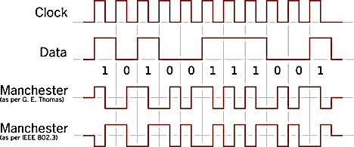
Fig 19.1: Manchester Encoding

Simple Simulation (Attach actual simulation code used in laboratory)
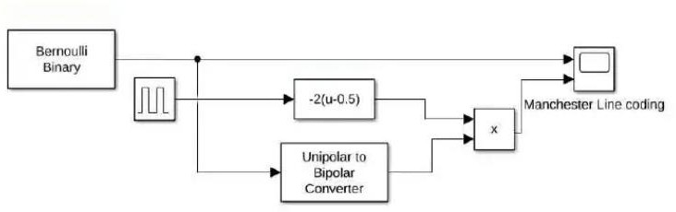
a. Sample Simulink Model
Fig 19.2: Simulink Model for Manchester Encoding

Required Resources / Apparatus / Equipment:

Sr.  No. | Instrument/Components | Specification | Quantity
1. | Computer | Latest Processor | 1
2. | Simulation Software | LabView/MATLAB/SCILAB/P Spice/HS  Spice/Multisim/Proteus or any relevant open-source simulation software | 1

- Precautions to be followed:
  - Ensure proper earthing to the computer system.
  - Ensure compatibility of computer system with software.
  - Ensure proper installation of simulation software

Procedure:
  - Switch on the computer and click on the MATLAB icon.
  - Go to start at the bottom of the command window, then select “Simulink” then go to library browser and drag it into creating file. (or) Once you open the Matlab then click on the Simulink icon. Go to file and select new and then select model. You will get a new window.
  - Arrange the functional blocks as shown in Simulink model.
  - Assign required parameters to each functional block.
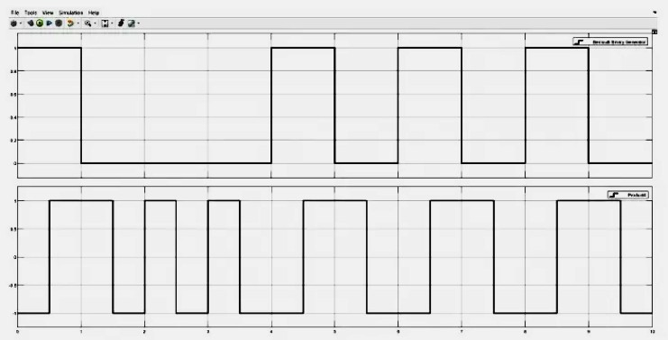
  - Observe the outputs on scope.
Fig 19.3: Simulink Output for Manchester Encoding

Observation Table (Students must attach the actual simulation output)
- Conclusion
………………………………………………………………………………………………….…………….
…………………………………………………………………………………….………………………….
……………………………………………………………………….……………………………………….
………………………………………………………………………………………………………………..

Practical-related Questions

Note: Below are a few sample questions for reference. Teachers must design more such questions to ensure the achievement of the identified CO.
  - Draw the Manchester Encoding waveforms for a binary sequence 11001010
  - Draw the Manchester Encoding waveforms for a binary sequence 11001100

Space for Answer
…………………………………………………………………………………….…………………………
……………………………………………………………………….………………………………………
………………………………………………………….……………………………………………………
…………………………………………….…………………………………………………………………
……………………………….………………………………………………………………………………
………………….……………………………………………………………………………………………
…….………………………………………………………………………………………………….………
………………………………………………………………………………………….……………………
…………………………………………………………………………….…………………………………
……………………………………………………………….………………………………………………
………………………………………………….……………………………………………………………
…………………………………….…………………………………………………………………………
……………………….………………………………………………………………………………………
………….………………………………………………………………………………………………….…
……………………………………………………………………………………………….………………
………………………………………………………………………………….……………………………
…………………………………………………………………….…………………………………………
……………………………………………………….………………………………………………………
………………………………………….……………………………………………………………………
…………………………….…………………………………………………………………………………

……………….………………………………………………………………………………………………
….………………………………………………………………………………………………….…………
….………………………………………………………………………………………………….…………
….………………………………………………………………………………………………….…………
….………………………………………………………………………………………………….…………
……………….………………………………………………………………………………………………
….………………………………………………………………………………………………….…………
….………………………………………………………………………………………………….…………
….………………………………………………………………………………………………….…………
….………………………………………………………………………………………………….…………
….………………………………………………………………………………………………….…………
….………………………………………………………………………………………………….…………

References / Suggestions for Further Reading:
  - https://www.sqa.org.uk/elearning/NetTechDC01ECD/page_02.htm
  - https://en.wikipedia.org/wiki/Line_code
- Assessment Scheme (25 Marks)

Performance Indicators |  | Weightage
Process-related (10 marks = 40%) |  | 40%
01 | Handling of the components | 10%
02 | Identification of components | 10%
03 | Measuring value using suitable instrument | 10%
04 | Working in teams | 10%
Product-related (15 marks = 60%) |  | 60%
05 | Correctness of output | 15%
06 | Interpretation of Result | 15%
07 | Conclusions | 10%
08 | Practical related questions | 15%
09 | Submitting the journal in time | 05%
Total(25Marks) |  | 100 %

Marks Obtained |  |  | Dated Signature of Teacher
Process related (10) | Product related (15) | Total (25)

Practical 20: Simulate binary amplitude shift keying using MATLAB and Simulink

Practical Significance
Amplitude Shift Keying (ASK) is a type of Amplitude Modulation which represents the binary data in the form of variations in the amplitude of a signal. Any modulated signal has a high frequency carrier. The binary signal when ASK modulated, gives a zero value for Low input while it gives the carrier output for High input. This practical is designed to explain how change of amplitude in to level corresponds to logic 1 and logic 0.

Industry / Employer Expected Outcome(s)
Maintain mobile and wireless communication system.

Course Level Learning Outcome(s)
CO5 – Establish wireless sensor networks for the given application.

Laboratory Learning Outcome(s)
LLO 20.1 Implement amplitude shift keying using any relevant software.

Relevant Affective Domain Related Outcomes
- Demonstrate working as a leader/a team member.
- Follow ethical practices.

Relevant Theoretical Background
Amplitude Shift Keying (ASK) is the digital modulation technique. In amplitude shift keying, the amplitude of the carrier signal is varied to create signal elements. Both frequency and phase remain constant while the amplitude changes. In ASK, the amplitude of the carrier assumes one of the two amplitudes dependent on the logic states of the input bit stream. This modulated signal can be expressed as: Amplitude shift keying (ASK) in the context of digital signal communications is a modulation process, which imparts to a sinusoid two or more discrete amplitude levels. These are related to the number of levels adopted by the digital message. For a binary message sequence there are two levels, one of which is typically zero. Thus the modulated waveform consists of bursts of a sinusoid. Figure
20.1 illustrates a binary ASK signal (lower), together with the binary sequence which initiated it (upper). Neither signal has been band limited.
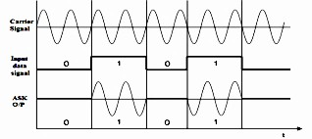
Figure 20.1: BASK I/P- O/P waveforms

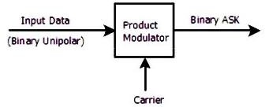
Figure 20.2 ASK modulator
[Courtesy:https://www.slideshare.net/aknigin/digital-communicationunit-3]
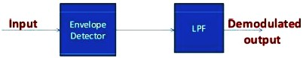
Figure 20.3 ASK demodulator
[Courtesy:http://www.evalidate.in/lab2/pages/Demod-ASK/DMASK/DMASK_I.html]
- Simple Simulation (Attach actual simulation code used in laboratory)
- Required Resources / Apparatus / Equipment:

Sr.  No. | Instrument/Components | Specification | Quantity
1. | Computer | Latest Processor | 1
2. | Simulation Software | LabView/MATLAB/SCILAB/P Spice/HS  Spice/Multisim/Proteus or any relevant open-source simulation software | 1
- Precautions to be followed:
  - Ensure proper earthing to the computer system.
  - Ensure compatibility of computer system with software.
  - Ensure proper installation of simulation software

Procedure:
To simulate binary amplitude shift keying (BASK)
  - Open MATLAB and create a new script file.
  - Write a program to simulate binary amplitude shift keying (BASK)
  - Save and run file

OR
For Simulation
- Switch on the computer and click on the MATLAB icon.
- Go to start at the bottom of the command window, then select “simulink” then go to library browser and drag it into creating file.(or) Once you open the MATLAB then click on Simulink icon. Go to file and select new and then select model. You will get a new window.
- Arrange the functional blocks as shown in simulink model.

- Assign required parameters to each functional block.
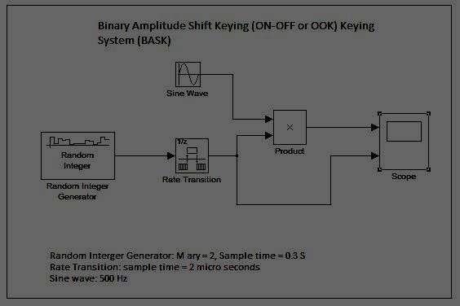
- Observe the outputs on scope.
Fig 20.4: Simulink Model of Amplitude Shift Keying Technique
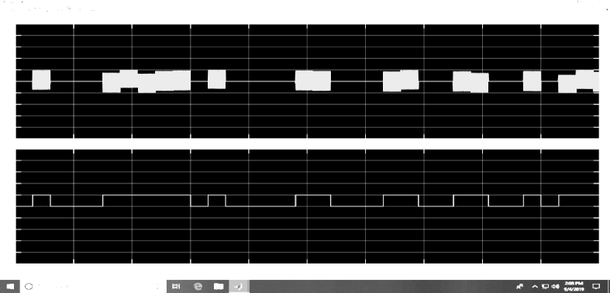
Fig 20.5: Simulink Output of Amplitude Shift Keying Technique

Observation Table (Students must attach the actual simulation output)
- Conclusion
………………………………………………………………………………………………….…………….
…………………………………………………………………………………….………………………….
……………………………………………………………………….……………………………………….

Practical-related Questions

Note: Below are a few sample questions for reference. Teachers must design more such questions to ensure the achievement of the identified CO.
  - Draw the BASK waveforms for a binary sequence 1100101
  - Draw the BASK waveforms for a binary sequence 1110100

Space for Answer
…………………………………………………………………………………….…………………………
……………………………………………………………………….………………………………………

………………………………………………………….……………………………………………………
…………………………………………….…………………………………………………………………
……………………………….………………………………………………………………………………
………………….……………………………………………………………………………………………
…….………………………………………………………………………………………………….………
………………………………………………………………………………………….……………………
…………………………………………………………………………….…………………………………
……………………………………………………………….………………………………………………
………………………………………………….……………………………………………………………
…………………………………….…………………………………………………………………………
……………………….………………………………………………………………………………………
………….………………………………………………………………………………………………….…
……………………………………………………………………………………………….………………
………………………………………………………………………………….……………………………
…………………………………………………………………….…………………………………………
……………………………………………………….………………………………………………………
………………………………………….……………………………………………………………………
…………………………….…………………………………………………………………………………
……………….………………………………………………………………………………………………
….………………………………………………………………………………………………….…………
……………………………………………………………………………………….………………………
………………………………………………………………………….……………………………………
…………………………………………………………….…………………………………………………
……………………………………………….………………………………………………………………
………………………………….……………………………………………………………………………
…………………….…………………………………………………………………………………………
……….………………………………………………………………………………………………….……
…………………………………………………………………………………………….…………………
……….………………………………………………………………………………………………….……
…………………………………………………………………………………………….…………………
…………………………………………………………………………………………….…………………
…………………………………………………………………………………………….…………………
………………………………………………………………………….……………………………………

…………………………………………………………….…………………………………………………
……………………………………………….………………………………………………………………
………………………………….……………………………………………………………………………
…………………….…………………………………………………………………………………………
……….………………………………………………………………………………………………….……
…………………………………………………………………………………………….…………………
……….………………………………………………………………………………………………….……
…………………………………………………………………………………………….…………………
……….………………………………………………………………………………………………….……
…………………………………………………………………………………………….…………………
…………………………………………………………………………………………….…………………

References / Suggestions for Further Reading:
  - http://www.srmuniv.ac.in/sites/default/files/files/TN0501%20lab%20mannual.pdf
  - https://www.google.co.in/search?q=ask+waveform&source
- Assessment Scheme (25 Marks)

Performance Indicators |  | Weightage
Process-related (10 marks = 40%) |  | 40%
01 | Handling of the components | 10%
02 | Identification of components | 10%
03 | Measuring value using suitable instrument | 10%
04 | Working in teams | 10%
Product-related (15 marks = 60%) |  | 60%
05 | Correctness of output | 15%
06 | Interpretation of Result | 15%
07 | Conclusions | 10%
08 | Practical related questions | 15%
09 | Submitting the journal in time | 05%
Total(25Marks) |  | 100 %

Marks Obtained |  |  | Dated Signature of Teacher
Process related (10) | Product related (15) | Total (25)

Practical 21: Simulate binary phase shift keying using MATLAB and Simulink

Practical Significance
PSK technique is widely used for wireless LANs, bio-metric, contactless operations, along with RFID and Bluetooth communications. BPSK has a bandwidth which is lower than that of BFSK signal. It has a very good noise immunity. This practical enables the students to generate and decode BPSK signal.

Industry / Employer Expected Outcome(s)
Maintain mobile and wireless communication system.

Course Level Learning Outcome(s)
CO5 – Establish wireless sensor networks for the given application.

Laboratory Learning Outcome(s)
LLO 21.1 Implement phase shift keying using any relevant software.

Relevant Affective Domain Related Outcomes
  - Demonstrate working as a leader/a team member.
  - Follow ethical practices.

Relevant Theoretical Background
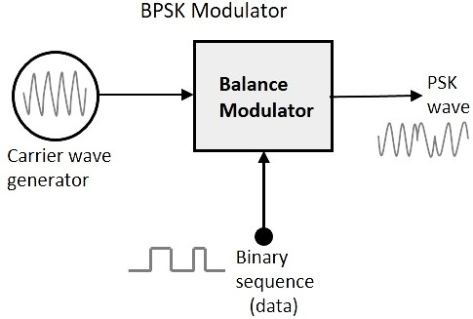
Phase Shift Keying (PSK) is the digital modulation technique in which the phase of the carrier signal is changed by varying the sine and cosine inputs at a particular time with respect to the given digital input Figure 21.1 shows BPSK modulator:
Figure 21.1: Generation of PSK/ BPSK Modulator
[Courstey:https://www.tutorialspoint.com/digital_communication/digital_communication_phase_shift_keying.htm]

In BPSK modulation, phase of the carrier signal is changed according to the data bit to be transmitted. Keeping its frequency and amplitude constant as shown in Figure 21.2:

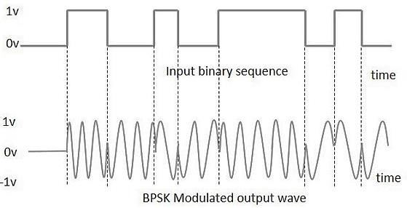
Figure 21.2: Waveform of BPSK modulation
[Courstey:https://www.tutorialspoint.com/digital_communication/digital_communication_phase_shift_keying.htm]

BPSK demodulator
Figure 21.3 shows BPSK demodulator. The BPSK modulating signal is demodulated with a synchronous detection system. The synchronous detection system uses a modulator to multiply the received signal and regenerated carrier wave. The frequency and phase of the regenerated carrier wave must match (synchronize with) the carrier wave used on the transmitting end.
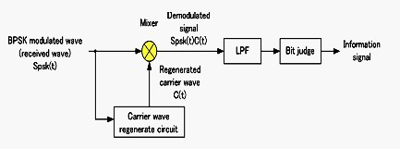
Figure 21.3: BPSK demodulator
[Courstey:https://www.tutorialspoint.com/digital_communication/digital_communication_phase_shift_keying.htm]
- Simple Simulation (Attach actual simulation code used in laboratory)
- Required Resources / Apparatus / Equipment:

Sr. No. | Instrument/ Components | Specification | Quantity
1. | Computer | Latest Processor | 1
2. | Simulation  Software | LabView/MATLAB/SCILAB/P Spice/HS Spice/Multisim/Proteus or  any relevant open-source simulation software | 1
- Precautions to be followed:
  - Ensure proper earthing to the computer system.
  - Ensure compatibility of computer system with software.
  - Ensure proper installation of simulation software

Procedure:
To simulate binary phase shift keying (BPSK)
  - Open MATLAB and create a new script file.
  - Write a program to simulate binary phase shift keying (BPSK)
  - Save and run file.

OR
For Simulation
- Switch on the computer and click on the MATLAB icon.
- Go to start at the bottom of the command window, then select “simulink” then go to library browser and drag it into creating file.(or) Once you open the MATLAB then click on simulink icon .Go to file and select new and then select model. You will get a new window.
- Arrange the functional blocks as shown in simulink model.
- Assign required parameters to each functional block.
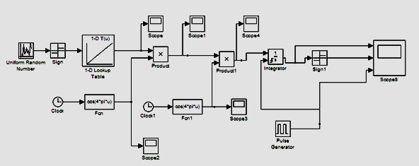
- Observe the outputs on scope.
Fig 21.4 Simulink Model of BPSK
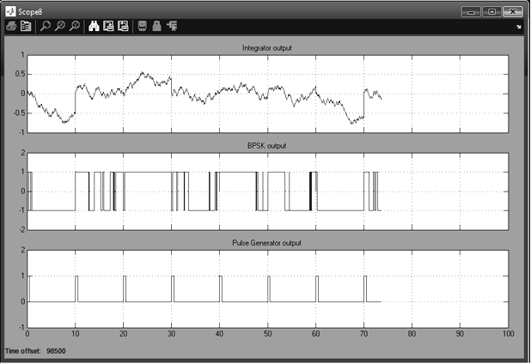
Fig 21.5 Simulink Output of BPSK

Observation Table (Students must attach the actual simulation output)

- Conclusion
………………………………………………………………………………………………….…………….
…………………………………………………………………………………….………………………….
……………………………………………………………………….……………………………………….
………………………………………………………………………………………………………………..

Practical-related Questions

Note: Below are a few sample questions for reference. Teachers must design more such questions to ensure the achievement of the identified CO.
  - Draw the BPSK waveforms for a binary sequence 11110000
  - Draw the BPSK waveforms for a binary sequence 10101010

Space for Answer
…………………………………………………………………………………….…………………………
……………………………………………………………………….………………………………………
………………………………………………………….……………………………………………………
…………………………………………….…………………………………………………………………
……………………………….………………………………………………………………………………
………………….……………………………………………………………………………………………
…….………………………………………………………………………………………………….………
………………………………………………………………………………………….……………………
…………………………………………………………………………….…………………………………
……………………………………………………………….………………………………………………
………………………………………………….……………………………………………………………
…………………………………….…………………………………………………………………………
……………………….………………………………………………………………………………………
………….………………………………………………………………………………………………….…
……………………………………………………………………………………………….………………
………………………………………………………………………………….……………………………
…………………………………………………………………….…………………………………………
……………………………………………………….………………………………………………………
………………………………………….……………………………………………………………………
…………………………….…………………………………………………………………………………
……………….………………………………………………………………………………………………
….………………………………………………………………………………………………….…………

…………………………….…………………………………………………………………………………
……………….………………………………………………………………………………………………
….………………………………………………………………………………………………….…………
…………………………….…………………………………………………………………………………
……………….………………………………………………………………………………………………
….………………………………………………………………………………………………….…………
…………………………….…………………………………………………………………………………
……………….………………………………………………………………………………………………
….………………………………………………………………………………………………….…………
…………………………….…………………………………………………………………………………
….………………………………………………………………………………………………….…………
…………………………….…………………………………………………………………………………
……………….………………………………………………………………………………………………

References / Suggestions for Further Reading:
  - http://www.ques10.com/p/3631/explain-the-operating-principle-working-of-trans-1/.
  - https://www.gaussianwaves.com/2010/04/bpsk-modulation-and-demodulation-2/
- Assessment Scheme (25 Marks)

Performance Indicators |  | Weightage
Process-related (10 marks = 40%) |  | 40%
01 | Handling of the components | 10%
02 | Identification of components | 10%
03 | Measuring value using suitable instrument | 10%
04 | Working in teams | 10%
Product-related (15 marks = 60%) |  | 60%
05 | Correctness of output | 15%
06 | Interpretation of Result | 15%
07 | Conclusions | 10%
08 | Practical related questions | 15%
09 | Submitting the journal in time | 05%
Total(25Marks) |  | 100 %

Marks Obtained |  |  | Dated Signature of Teacher
Process related (10) | Product related (15) | Total (25)

Practical 22: Simulate frequency shift keying using MATLAB and Simulink

Practical Significance
FSK technology is used for communication systems such as amateur radio, caller ID and emergency broadcasts. This practical is designed to explain how modem converts the binary data from a computer to FSK for transmission over telephone lines, cables, optical fiber, or wireless media. The modem also converts incoming FSK signals to digital low and high states, which the computer can understand. In this practical student are able to view shifts in frequency as per the input digital data.

Industry / Employer Expected Outcome(s)
Maintain mobile and wireless communication system.

Course Level Learning Outcome(s)
CO5 – Establish wireless sensor networks for the given application.

Laboratory Learning Outcome(s)
LLO 22.1 Implement frequency shift keying using any relevant software.

Relevant Affective Domain Related Outcomes
  - Demonstrate working as a leader/a team member.
  - Follow ethical practices.

Relevant Theoretical Background
Frequency-shift keying (FSK) is a method of transmitting digital signals. The two binary states, logic 0 (low) and 1 (high), are each represented by an analog waveform. Logic 0 is represented by a wave at a specific frequency, and logic 1 is represented by a wave at a different frequency. The simplest FSK is binary FSK (BFSK). BFSK uses a pair of discrete frequencies to transmit binary (0s and 1s) information. With this scheme, the "1" is called the mark frequency and the "0" is called the space frequency.
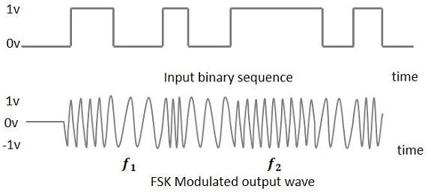
Figure 22.1: FSK Input –Output waveform

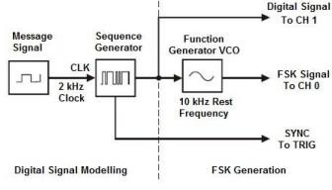
Figure 22.2: FSK Modulator
[Courtesy:http://www.evalidate.in/lab2/pages/FSKS/FSK/FSK_T.html]
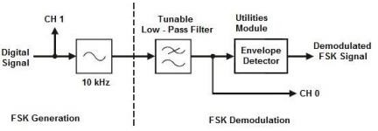
Figure 22.3: FSK demodulator
[Courtesy:http://www.evalidate.in/lab2/pages/Demod-FSK/DFSK/DFSK_T.html]
- Simple Simulation (Attach actual simulation code used in laboratory)
- Required Resources / Apparatus / Equipment:

Sr.  No. | Instrument/Components | Specification | Quantity
1. | Computer | Latest Processor | 1
2. | Simulation Software | LabView/MATLAB/SCILAB/P Spice/HS Spice/Multisim/Proteus or any  relevant open-source simulation software | 1
- Precautions to be followed:
  - Ensure proper earthing to the computer system.
  - Ensure compatibility of computer system with software.
  - Ensure proper installation of simulation software

Procedure:
To simulate frequency shift keying (FSK),
  - Open MATLAB and create a new script file.
  - Write a program to simulate frequency shift keying (FSK)
  - Save and run file.

Observation Table (Students must attach the actual simulation output)

- Conclusion
………………………………………………………………………………………………….…………….
…………………………………………………………………………………….………………………….
……………………………………………………………………….……………………………………….
………………………………………………………………………………………………………………..

Practical-related Questions

Note: Below are a few sample questions for reference. Teachers must design more such questions to ensure the achievement of the identified CO.
  - Draw the BFSK waveforms for a binary sequence 11001010
  - Draw the BFSK waveforms for a binary sequence 11001100

Space for Answer
…………………………………………………………………………………….…………………………
……………………………………………………………………….………………………………………
………………………………………………………….……………………………………………………
…………………………………………….…………………………………………………………………
……………………………….………………………………………………………………………………
………………….……………………………………………………………………………………………
…….………………………………………………………………………………………………….………
………………………………………………………………………………………….……………………
…………………………………………………………………………….…………………………………
……………………………………………………………….………………………………………………
………………………………………………….……………………………………………………………
…………………………………….…………………………………………………………………………
……………………….………………………………………………………………………………………
………….………………………………………………………………………………………………….…
……………………………………………………………………………………………….………………
………………………………………………………………………………….……………………………
…………………………………………………………………….…………………………………………
……………………………………………………….………………………………………………………
………………………………………….……………………………………………………………………
…………………………….…………………………………………………………………………………
……………….………………………………………………………………………………………………
….………………………………………………………………………………………………….…………

……………………………………………………………………………………….………………………
………………………………………………………………………….……………………………………
…………………………………………………………….…………………………………………………
………………………………………………………………………….……………………………………
…………………………………………………………….…………………………………………………
……………………………………………………………………………………….………………………
………………………………………………………………………….……………………………………
…………………………………………………………….…………………………………………………
………………………………………………………………………….……………………………………
…………………………………………………………….…………………………………………………
……………………………………………………………………………………….………………………

References / Suggestions for Further Reading:
  - ​http://www.allsyllabus.com/aj/note/ECE/Digital%20Communication/unit3/index.php #.W0MQ69UzbIU
  - http://www.evalidate.in/lab2/pages/Demod-FSK/DFSK/DFSK_T.html
  - http://www.rfwireless-world.com/Terminology/ASK-vs-FSK-vs-PSK.html
- Assessment Scheme (25 Marks)

Performance Indicators |  | Weightage
Process-related (10 marks = 40%) |  | 40%
01 | Handling of the components | 10%
02 | Identification of components | 10%
03 | Measuring value using suitable instrument | 10%
04 | Working in teams | 10%
Product-related (15 marks = 60%) |  | 60%
05 | Correctness of output | 15%
06 | Interpretation of Result | 15%
07 | Conclusions | 10%
08 | Practical related questions | 15%
09 | Submitting the journal in time | 05%
Total(25Marks) |  | 100 %

Marks Obtained |  |  | Dated Signature of Teacher
Process related (10) | Product related (15) | Total (25)

Practical 23: Implement pulse code modulation using MATLAB and Simulink

Practical Significance
Pulse-code modulation (PCM) is a method used to digitally represent sampled analog signals. It is the standard form for digital audio in computers and various Blu-ray, Compact Disc and DVD formats. This practical is designed to explain how different types of information signals which are analog in nature can be converted to digital form.

Industry / Employer Expected Outcome(s)
Maintain mobile and wireless communication system.

Course Level Learning Outcome(s)
CO5 – Establish wireless sensor networks for the given application.

Laboratory Learning Outcome(s)
LLO 23.1 Simulate pulse code modulation using any relevant software.

Relevant Affective Domain Related Outcomes
  - Demonstrate working as a leader/a team member.
  - Follow ethical practices.

Relevant Theoretical Background
A PCM stream is a digital representation of an analog signal, in which the magnitude of the analog signal is sampled regularly at uniform intervals, with each sample being quantized to the nearest value within a range of digital steps. The next step is to assign a binary sequence to each of those voltage samples, this step is called quantization. The purpose of a PCM system is to transmit to the distant end the value of a voltage sample at a certain moment in time.
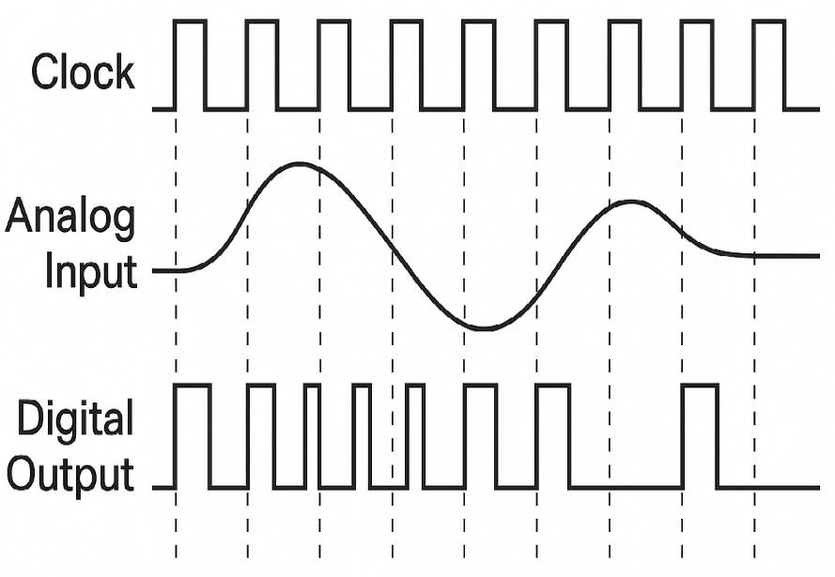
Figure 23.1: PCM input-output waveforms

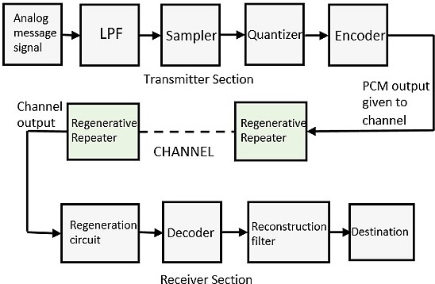
Figure 23.2: Basic Elements of PCM system [Courtsey:https://www.google.co.in/search?biw=1024&bih=662&tbm=isch&sa=1&ei=2zNEW8DyFZqYvQTMkIrADQ& q=pcm+de modulator+block+diagram&oq]
- Simple Simulation (Attach actual simulation code used in laboratory)
- Required Resources / Apparatus / Equipment:

Sr.  No. | Instrument/Components | Specification | Quantity
1. | Computer | Latest Processor | 1
2. | Simulation Software | LabView/MATLAB/SCILAB/P  Spice/HS Spice/Multisim/Proteus or any relevant open-source simulation software | 1
- Precautions to be followed:
  - Ensure proper earthing to the computer system.
  - Ensure compatibility of computer system with software.
  - Ensure proper installation of simulation software

Procedure:
To simulate pulse code modulation (PCM)
  - Open MATLAB and create a new script file
  - Write a program to simulate pulse code modulation (PCM)
  - Save and run file.

Observation Table (Students must attach the actual simulation output)
- Conclusion
………………………………………………………………………………………………….…………….
…………………………………………………………………………………….………………………….

Practical-related Questions

Note: Below are a few sample questions for reference. Teachers must design more such questions to ensure the achievement of the identified CO.
  - Draw and explain PCM transmitter and PCM receiver.
  - List advantages, disadvantages and applications of PCM.

Space for Answer
…………………………………………………………………………………….…………………………
……………………………………………………………………….………………………………………
………………………………………………………….……………………………………………………
…………………………………………….…………………………………………………………………
……………………………….………………………………………………………………………………
………………….……………………………………………………………………………………………
…….………………………………………………………………………………………………….………
………………………………………………………………………………………….……………………
…………………………………………………………………………….…………………………………
……………………………………………………………….………………………………………………
………………………………………………….……………………………………………………………
…………………………………….…………………………………………………………………………
……………………….………………………………………………………………………………………
………….………………………………………………………………………………………………….…
……………………………………………………………………………………………….………………
………………………………………………………………………………….……………………………
…………………………………………………………………….…………………………………………
……………………………………………………….………………………………………………………
………………………………………….……………………………………………………………………
…………………………….…………………………………………………………………………………
……………….………………………………………………………………………………………………
….………………………………………………………………………………………………….…………
……………………………………………………………………………………….………………………
………………………………………………………………………….……………………………………
…………………………………………………………….…………………………………………………
……………………………………………….………………………………………………………………
………………………………….……………………………………………………………………………

…………………….…………………………………………………………………………………………
……….………………………………………………………………………………………………….……
…………………………………………………………………………………………….…………………
……………………………………………………………………………….………………………………
………………………………………………………………….……………………………………………
……………………………………………………………………………….………………………………
……….………………………………………………………………………………………………….……
…………………………………………………………………………………………….…………………
……………………………………………………………………………….………………………………
………………………………………………………………….……………………………………………
……………………………………………………………………………….………………………………
………………………………………………………………….……………………………………………

References / Suggestions for Further Reading:
  - https://www.tutorialspoint.com/digital_communication/digital_communication_pulse_code_ modulation.html
  - https://en.wikipedia.org/wiki/Differential_pulse-code_modulation
- Assessment Scheme (25 Marks)

Performance Indicators |  | Weightage
Process-related (10 marks = 40%) |  | 40%
01 | Handling of the components | 10%
02 | Identification of components | 10%
03 | Measuring value using suitable instrument | 10%
04 | Working in teams | 10%
Product-related (15 marks = 60%) |  | 60%
05 | Correctness of output | 15%
06 | Interpretation of Result | 15%
07 | Conclusions | 10%
08 | Practical related questions | 15%
09 | Submitting the journal in time | 05%
Total(25Marks) |  | 100 %

Marks Obtained |  |  | Dated Signature of Teacher
Process related (10) | Product related (15) | Total (25)

Practical 24: Implement delta modulation using MATLAB and Simulink

Practical Significance
In PCM the signaling rate and transmission channel bandwidth are quite large since it transmits all the bits which are used to code a sample. To overcome this problem, Delta modulation is used. A delta modulation is an analog to digital and digital to analog signal conversion technique used for transmission of voice information.DM is the simplest form of differential pulse code modulation (DPCM) where the difference between successive samples is encoded in to n-bit data streams. In delta modulation, the transmitted data are reduced to a 1-bit data stream. This practical is designed to explain how different types of information signals which are analog in nature can be converted to digital form.

Industry / Employer Expected Outcome(s)
Maintain mobile and wireless communication system.

Course Level Learning Outcome(s)
CO5 – Establish wireless sensor networks for the given application.

Laboratory Learning Outcome(s)
LLO 24.1 Simulate delta modulation using any relevant software.

Relevant Affective Domain Related Outcomes
  - Demonstrate working as a leader/a team member.
  - Follow ethical practices.

Relevant Theoretical Background
Delta modulation is a Differential Pulse Code Modulation (DPCM) technique in which the difference signal is encoded into a single bit. Delta modulation provides a staircase approximation of the input sampled signal where only one bit per sample is transmitted. This one bit is sent by comparing the present sample value with the previous sample value and the result whether the amplitude is to be increased or decreased is transmitted. If the step is reduced,0 is transmitted and if the step is increased then 1 is transmitted. The figure illustrates the block diagram of Delta Modulation Transmitter:
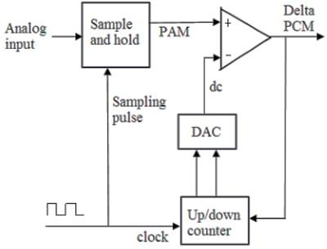
Figure 24.1: Delta Modulation Transmitter

Sample and hold circuit will sample the analog input signal in to Pulse amplitude modulated (PAM) signal. The Up-down counter stores the magnitude of the previous sample in the binary value. This binary number is converted in to equivalent voltage in the Digital to analog converter (DAC). The PAM signal and the DAC output are compared in the comparator. The Up-down counter is incremented or decremented depending on whether the previous sample is larger or smaller than the current sample. The output of the comparator generates the Delta pulse code modulated signal. The figure illustrates the block diagram of Delta Modulation Receiver
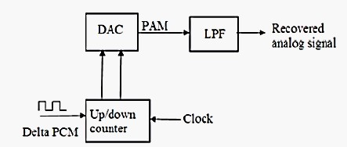
Figure 24.2: Delta Modulation Receiver
The receiver of the delta modulator consists of DAC, up/down counter and LPF. The Delta PCM signal is fed to the up/down counter. Based on the input received from the up/down counter, DAC will generate the output PAM signal. The output of DAC is given LPF which will filter out high frequency component. Thus the output signal of DAC in the transmitter and receiver is identical to the original information signal. There are two distortions; slope overload error and granular noise are present in DM.
- Simple Simulation (Attach actual simulation code used in laboratory)
- Required Resources / Apparatus / Equipment:

Sr.  No. | Instrument/Components | Specification | Quantity
1. | Computer | Latest Processor | 1
2. | Simulation Software | LabView/MATLAB/SCILAB/P  Spice/HS Spice/Multisim/Proteus or any relevant open-source simulation software | 1
- Precautions to be followed:
  - Ensure proper earthing to the computer system.
  - Ensure compatibility of computer system with software.
  - Ensure proper installation of simulation software

Procedure:
To simulate delta modulation (DM)
  - Open MATLAB and create a new script file.
  - Write a program to simulate delta modulation (DM)
  - Save and run file.

OR

For Simulation
- Switch on the computer and click on the MATLAB icon.
- Go to start at the bottom of the command window, then select “Simulink” then go to library browser and drag it into creating file.(or) Once you open the MATLAB then click on Simulink icon .Go to file and select new and then select model. You will get a new window.
- Arrange the functional blocks as shown in Simulink model.
- Assign required parameters to each functional block.
- Observe the outputs on scope.
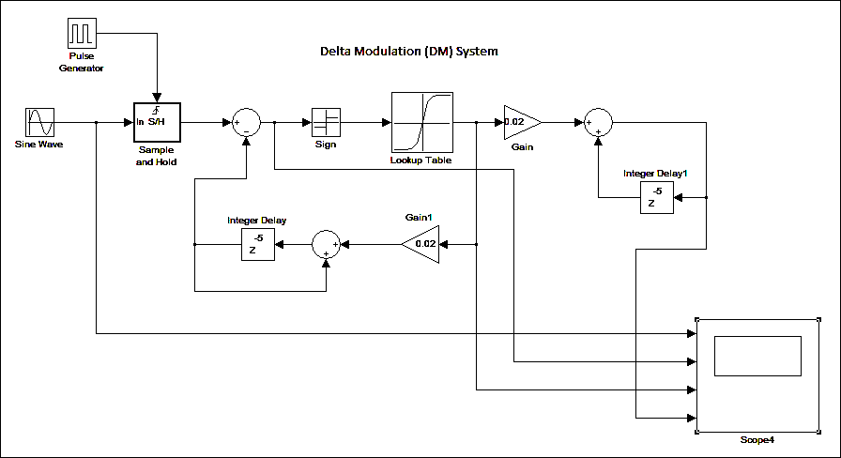
Fig 24.3 Simulink Model of Delta Modulation (DM)
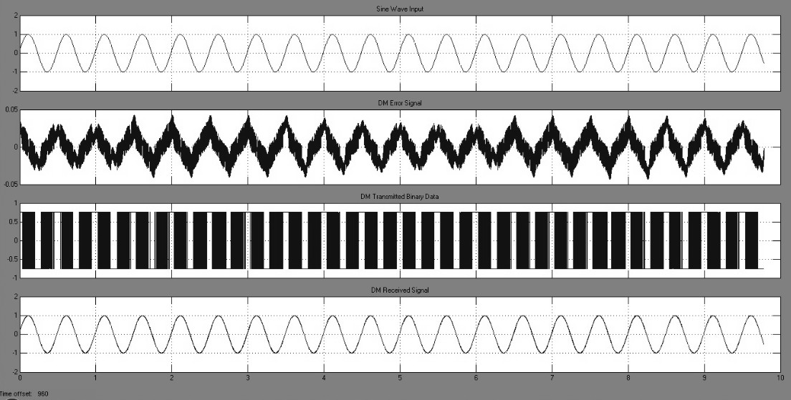
Fig 24.4 Simulink Output of Delta Modulation (DM)

Observation Table (Students must attach the actual simulation output)
- Conclusion
………………………………………………………………………………………………….…………….
…………………………………………………………………………………….………………………….
……………………………………………………………………….……………………………………….
………………………………………………………………………………………………………………..

Practical-related Questions

Note: Below are a few sample questions for reference. Teachers must design more such questions to ensure the achievement of the identified CO.
  - State the effect of increasing or decreasing amplitude of input signal on DM output.
  - List advantages, disadvantages and applications of Delta Modulation

Space for Answer
…………………………………………………………………………………….…………………………
……………………………………………………………………….………………………………………
………………………………………………………….……………………………………………………
…………………………………………….…………………………………………………………………
……………………………….………………………………………………………………………………
………………….……………………………………………………………………………………………
…….………………………………………………………………………………………………….………
………………………………………………………………………………………….……………………
…………………………………………………………………………….…………………………………
……………………………………………………………….………………………………………………
………………………………………………….……………………………………………………………
…………………………………….…………………………………………………………………………
……………………….………………………………………………………………………………………
………….………………………………………………………………………………………………….…
……………………………………………………………………………………………….………………
………………………………………………………………………………….……………………………
…………………………………………………………………….…………………………………………
……………………………………………………….………………………………………………………
………………………………………….……………………………………………………………………
…………………………….…………………………………………………………………………………
……………….………………………………………………………………………………………………
….………………………………………………………………………………………………….…………
……………………………………………………………………………………….………………………
………………………………………………………………………….……………………………………
…………………………………………………………….…………………………………………………
……………………………………………….………………………………………………………………
………………………………….……………………………………………………………………………

…………………….…………………………………………………………………………………………
……….………………………………………………………………………………………………….……
…………………………………………………………………………………………….…………………
…………………….…………………………………………………………………………………………
……….………………………………………………………………………………………………….……
…………………………………………………………………………………………….…………………
…………………….…………………………………………………………………………………………
……….………………………………………………………………………………………………….……
…………………………………………………………………………………………….…………………
…………………….…………………………………………………………………………………………
……….………………………………………………………………………………………………….……

References / Suggestions for Further Reading:
  - https://www.eng.auburn.edu/-troppel/courses/TIMS-manuals-r5/TIMS%20Experiment
%20Manuals /Student_Text/Vol-D1/D1-13.pdf
  - http://www.slideshare.net/stk_gpg/pulse-modulation-9526921?next_slideshow=1
  - https://www.slideshare.net/azizulhoque539/311-pulse-modulation
- Assessment Scheme (25 Marks)

Performance Indicators |  | Weightage
Process-related (10 marks = 40%) |  | 40%
01 | Handling of the components | 10%
02 | Identification of components | 10%
03 | Measuring value using suitable instrument | 10%
04 | Working in teams | 10%
Product-related (15 marks = 60%) |  | 60%
05 | Correctness of output | 15%
06 | Interpretation of Result | 15%
07 | Conclusions | 10%
08 | Practical related questions | 15%
09 | Submitting the journal in time | 05%
Total(25Marks) |  | 100 %

Marks Obtained |  |  | Dated Signature of Teacher
Process related (10) | Product related (15) | Total (25)

Practical 25: Implement WSN node to determine position on node and blink LED using cupcarbon simulator and senscript

Practical Significance
Wireless sensor networks (WSNs) are a technology in continuous evolution with great future and a huge quantity of applications. The implementation and deployment of a WSN imply important expenses, so it is interesting to simulate the operation of our design before deploying it. In addition, WSNs are limited by a set of parameters such as the low processing capacity, low storing capacity or limited energy. Energy consumption is the most limiting parameter since the network stability and availability depends on the survival of the nodes. To check the correct operation of a network, currently, there are several network simulators and day by day new proposals are launched.

Industry / Employer Expected Outcome(s)
Maintain mobile and wireless communication system.

Course Level Learning Outcome(s)
CO5 – Establish wireless sensor networks for the given application.

Laboratory Learning Outcome(s)
LLO 25.1 Simulate WSN using any relevant software.

Relevant Affective Domain Related Outcomes
  - Demonstrate working as a leader/a team member.
  - Follow ethical practices.

Relevant Theoretical Background
Wireless Sensor Networks (WSNs) are one of the fastest growing control and monitoring technologies in recent years. WSNs are destined to be one of the 10 technologies that will change the world and the foreseen future is impregnated by WSNs powered by batteries that will monitor our environment and even us. WSNs are composed by a set of spatially distributed sensors that are capable of collecting, storing and processing environmental information. Although in their beginnings they were connected by wires, nowadays, WSNs are wirelessly connected with other nodes for communicating and transmitting the collected data. In this sense, the application field of this technology is very broad and can be applied in different areas.

CupCarbon environment
CupCarbon simulation is based on the application layer of the nodes. This makes it a real complement to existing simulators. It does not simulate all protocol layers due to the complex nature of urban networks which need to incorporate other complex and resource consuming information such as buildings, roads, mobility, signals, etc. Moreover, CupCarbon represents the main kernel of the ANR project PERSEPTEUR that aims to develop algorithms foran accurate simulation of the propagation and interference of signals in a 3D urban environment.

Cupcarbon offers two simulation environments
The first simulation environment is a multi-agent environment, which enables the design of mobility scenarios and the generation of events such as fires and gas as well as the simulation of mobiles such as vehicles and flying objects (e.g. UAVs, insects, etc.). The second simulation environment represents a discrete event simulation of wireless sensor networks which takes into account the scenario designed on the basis of the first environment
- Simple Simulation (Attach actual simulation screenshot)
- Required Resources / Apparatus / Equipment:

Sr.  No. | Instrument/Components | Specification | Quantity
1. | Computer | Latest Processor | 1
2. | Simulation Software | Cupcarbon simulation software | 1
- Precautions to be Followed:
  - Ensure proper earthing to the computer system.
  - Ensure compatibility of the computer system with software.
  - Ensure proper installation of simulation software

Procedure:
PROJECT 1: To Display the Position of a Sensor Node
  - Create New Project
Click: Project -> New ProjectGive any Project Name (Example: WN1)
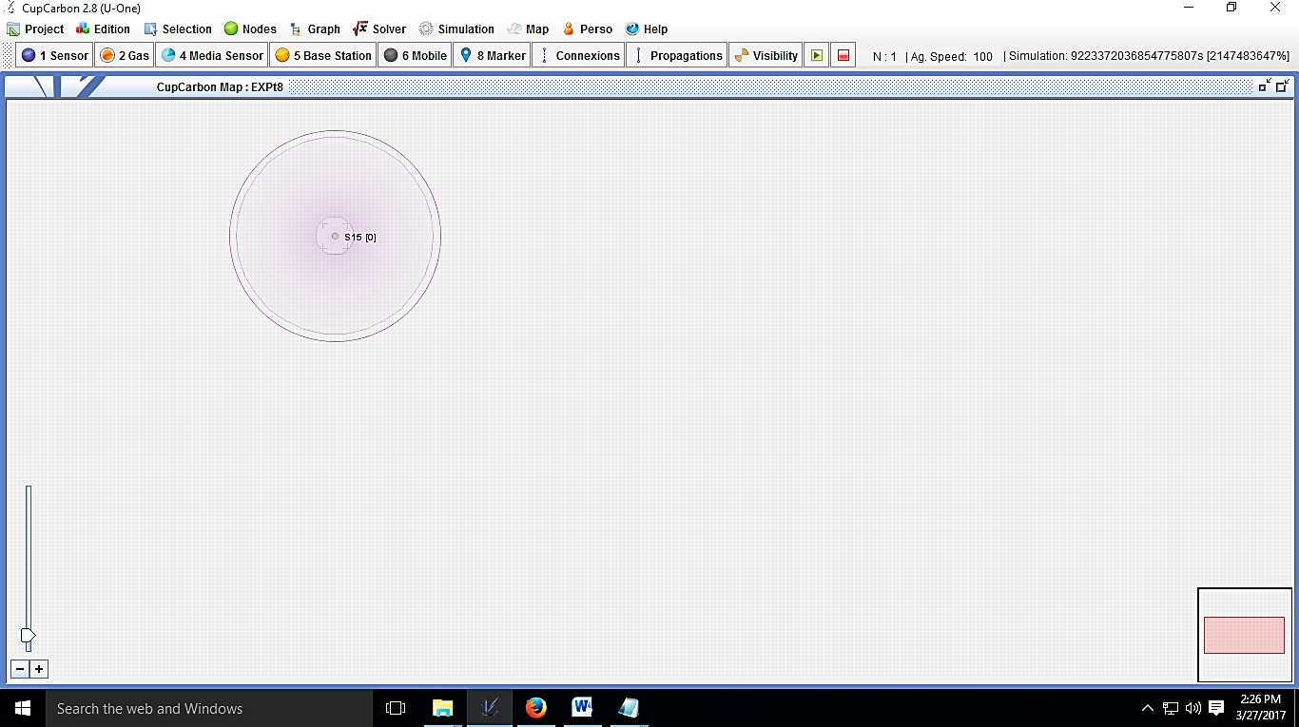
  - Select Sensor Node Click: Nodes → Add sensor

  - Create scripts
Click: Simulation -> Communication script Give a file name (Example: dispose)
The Senscript to display positions is as below loop
getpos x println $x delay 500
  - Script assignment: Device parameters Assign the script of each sensor.
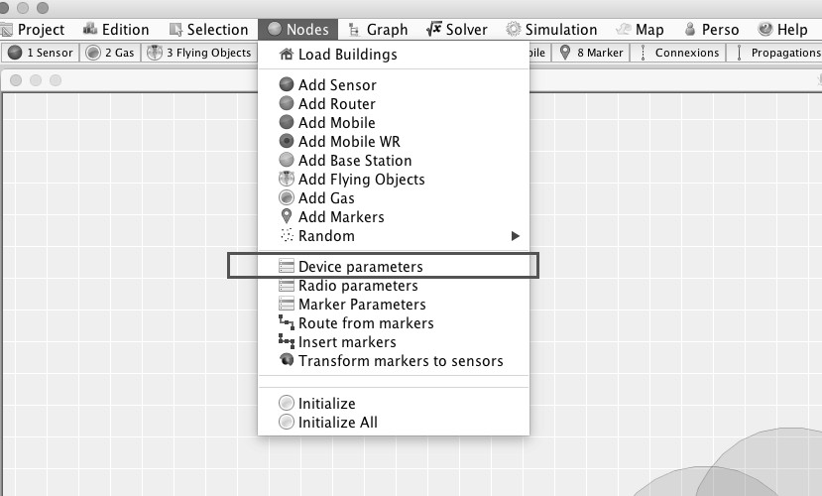
Select a sensor and then click on the item Device parameters in the menu nodes.
Once the device parameter window is opened, click on Enter to display its parameters. Select the corresponding script in the list (Example: dispose) of the Script file and then click on the button (blue arrow) in the right part.
  - Simulate: Open the simulation window: Simulation -> WSN Simulation
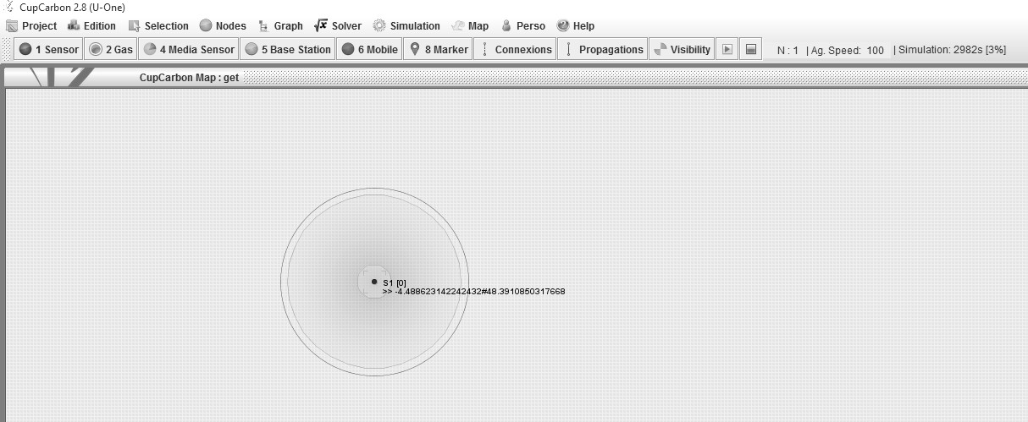

The position of WSN is displayed.

PROJECT 2: To Blink the Sensor Node(LED)
- Create New Project
Click: Project -> New Project
Give any Project Name (Different From previous)(Example : WN2)
- Select Sensor Node Click: Nodes → Add sensor
- Create scripts
Click: Simulation -> Communication script Give a suitable Filename (Example: blinkled1)
The Senscript to display positions is as below loop
mark 1
delay 1000
mark 0
delay 1000
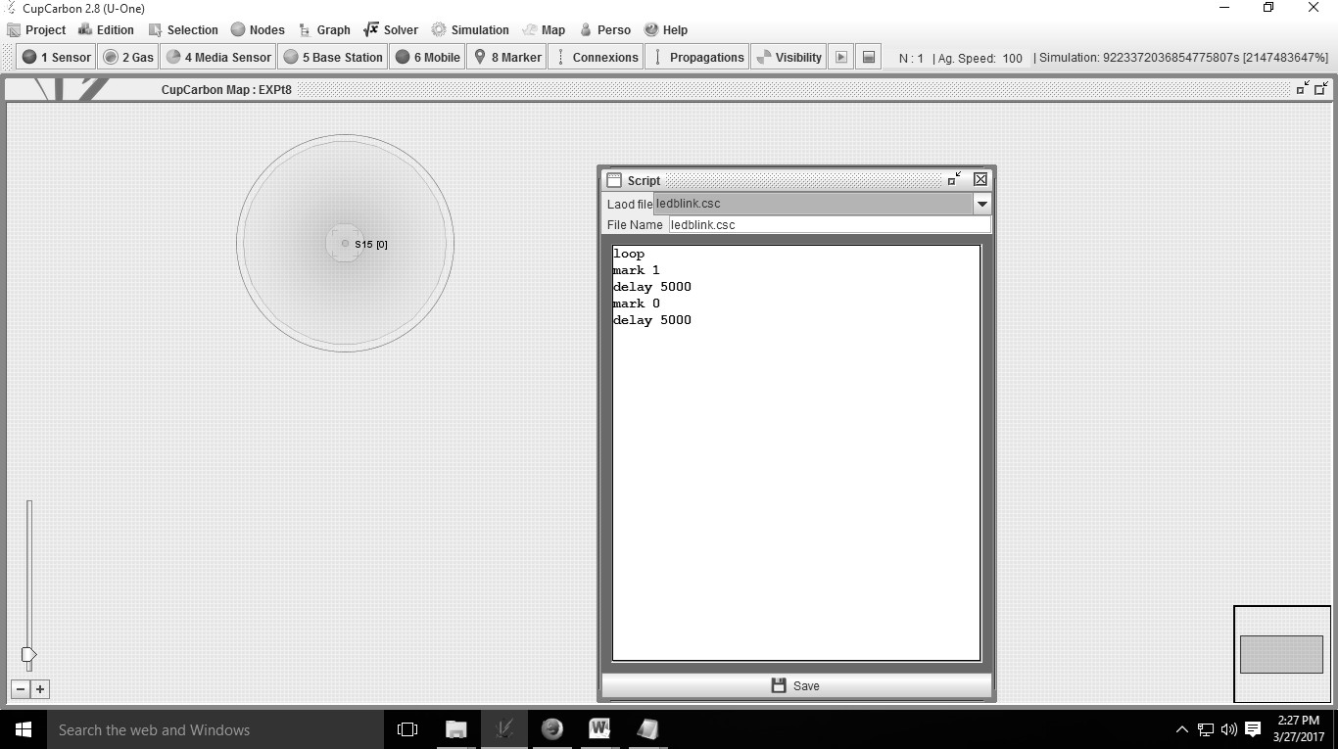

- Script assignment: Device parameters Assign the script of each sensor.
Select a sensor and then click on the item Device parameters in the menu nodes.
Once the device parameter window is opened, click on Enter to display its parameters.
Select the corresponding script in the list of the Script file and then click on the button (blue arrow) in the right part.

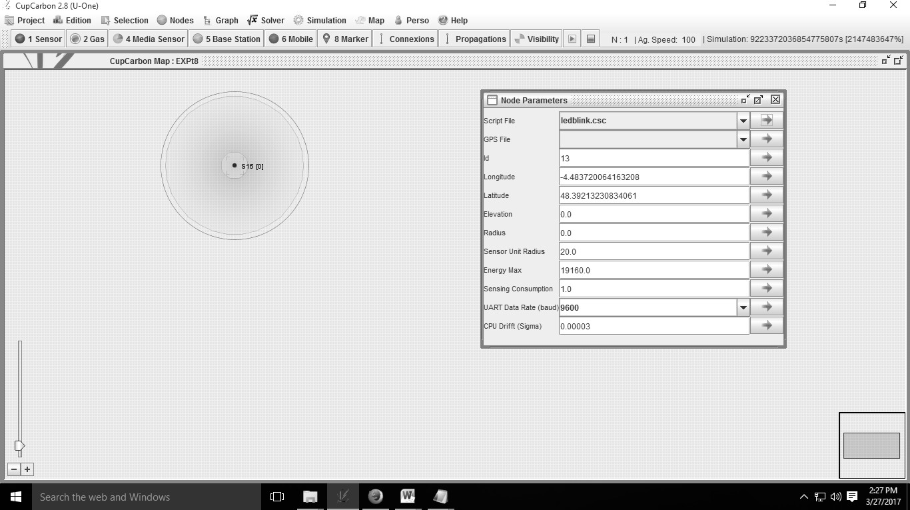
- Simulate
Open the simulation window: Simulation -> WSN Simulation
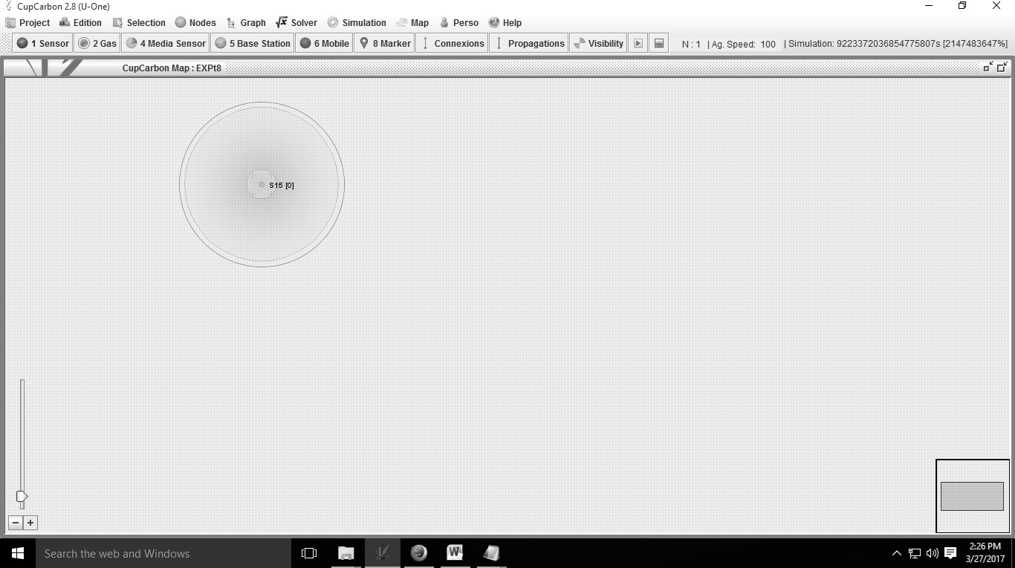
The LED blinks.

Observation Table (Students must attach the actual simulation output)
- Conclusion
………………………………………………………………………………………………….…………….
…………………………………………………………………………………….………………………….

Practical-related Questions

Note: Below are a few sample questions for reference. Teachers must design more such questions to ensure the achievement of the identified CO.
  - List different simulation software used in WSN
  - Compare various Hardware Sensor boards.

Space for Answer
…………………………………………………………………………………….…………………………
……………………………………………………………………….………………………………………
………………………………………………………….……………………………………………………
…………………………………………….…………………………………………………………………
……………………………….………………………………………………………………………………
………………….……………………………………………………………………………………………
…….………………………………………………………………………………………………….………
………………………………………………………………………………………….……………………
…………………………………………………………………………….…………………………………
……………………………………………………………….………………………………………………
………………………………………………….……………………………………………………………
…………………………………….…………………………………………………………………………
……………………….………………………………………………………………………………………
………….………………………………………………………………………………………………….…
……………………………………………………………………………………………….………………
………………………………………………………………………………….……………………………
…………………………………………………………………….…………………………………………
……………………………………………………….………………………………………………………
………………………………………….……………………………………………………………………
…………………………….…………………………………………………………………………………
……………….………………………………………………………………………………………………
….………………………………………………………………………………………………….…………
……………………………………………………………………………………….………………………
………………………………………………………………………….……………………………………
…………………………………………………………….…………………………………………………
……………………………………………….………………………………………………………………
………………………………….……………………………………………………………………………

…………………….…………………………………………………………………………………………
……….………………………………………………………………………………………………….……
…………………………………………………………………………………………….…………………
……………………………………….………………………………………………………………………
………………………….……………………………………………………………………………………
…………….………………………………………………………………………………………………….
………………………………………………………………………………………………….……………
……………………………………….………………………………………………………………………
………………………….……………………………………………………………………………………
…………….………………………………………………………………………………………………….
………………………………………………………………………………………………….……………

References / Suggestions for Further Reading:
  - https://www.elprocus.com/8086-assembly-language-programs-explanation/
  - http://mysc.altervista.org/beginners-guide-8086/
  - https://www.tutorialspoint.com/assembly_programming
- Assessment Scheme (25 Marks)

Performance Indicators |  | Weightage
Process-related (10 marks = 40%) |  | 40%
01 | Handling of the components | 10%
02 | Identification of components | 10%
03 | Measuring value using suitable instrument | 10%
04 | Working in teams | 10%
Product-related (15 marks = 60%) |  | 60%
05 | Correctness of output | 15%
06 | Interpretation of Result | 15%
07 | Conclusions | 10%
08 | Practical related questions | 15%
09 | Submitting the journal in time | 05%
Total(25Marks) |  | 100 %

Marks Obtained |  |  | Dated Signature of Teacher
Process related (10) | Product related (15) | Total (25)

Practical 26: Analyze a Wi-Fi network using related software (Like NetSpot or Wi-Fi analyzers)

Practical Significance
Using Wi-Fi analysis tools like NetSpot or Wi-Fi Analyzer, we can identify network interference, weak signal areas and ideal channels for configuration. This leads to improved connectivity, faster speeds and stable wireless performance. It helps in optimizing Wi-Fi networks for better speed and coverage, detects and reduces interference from neighboring networks also useful for troubleshooting network issues and assists in proper planning and design of wireless networks.

Industry / Employer Expected Outcome(s)
Maintain mobile and wireless communication system.

Course Level Learning Outcome(s)
CO5 – Establish wireless sensor networks for the given application.

Laboratory Learning Outcome(s)
LLO 26.1 Analyze performance of Wi-Fi Network.

Relevant Affective Domain Related Outcomes
  - Demonstrate working as a leader/a team member.
  - Follow ethical practices.

Relevant Theoretical Background
A Wi-Fi network analyzer is a tool used to scan and measure various parameters of wireless networks. These tools help network administrators or user’s identity.
  - Signal strength (RSSI)
  - Channel interference
  - Noise level
  - SSID (Service Set Identifier)
  - MAC address of access points
  - Frequency band (2.4 GHz/5 GHz)
This helps in optimizing Wi-Fi performance troubleshooting connectivity issues and selecting the best channel to minimize interference
- Simple Simulation (Attach actual website/software screenshot)
- Required Resources / Apparatus / Equipment:

Sr. No. | Instrument/Components | Specification | Quantity
1. | Computer/Laptop/Smartphone | Latest Processor | 1
2. | Simulation Software | NetSpot (For Windows/mac OS),Wi-Fi  Analyzer (For Android/Windows) | 1

- Precautions to be followed:
  - Ensure proper earthing to the computer system.
  - Ensure compatibility of computer system with software.
  - Ensure proper installation of simulation software

Procedure:
  - Install the software:
Download and install NetSpot or WiFi Analyzer on your laptop or smartphone.

Scan the available networks:
Open the app and allow it to scan for all Wi-Fi networks in the area.

Observe parameters:
Note down details such as:
    - SSID (network name)
    - Signal strength (in dBm)
    - Channel number
    - Frequency band (2.4GHz / 5GHz)
    - Security type (WPA2, WPA3, etc.)

Analyze results:
    - Identify which channels are overcrowded.
    - Find the signal strength of your own Wi-Fi network.
    - Detect weak areas or “dead zones” in your environment.
    - Determine the best channel and position for your router.
  - (Optional – For NetSpot users): Use the Survey Mode to create a heatmap of signal strength across different areas.

Observation Table

SSID Name | Signal Strength (dBm) | Channel | Frequency | Security | Remarks
Home_WiFi
OfficeNet
GuestNet
- Conclusion
………………………………………………………………………………………………….…………….
…………………………………………………………………………………….………………………….
……………………………………………………………………….……………………………………….
………………………………………………………………………………………………………………..

Practical-related Questions

Note: Below are a few sample questions for reference. Teachers must design more such questions to ensure the achievement of the identified CO.
  - Define Wi-Fi Analyzer and full form of SSID.
  - State frequency range used by Wi-Fi networks?

Space for Answer
…………………………………………………………………………………….…………………………
……………………………………………………………………….………………………………………
………………………………………………………….……………………………………………………
…………………………………………….…………………………………………………………………
……………………………….………………………………………………………………………………
………………….……………………………………………………………………………………………
…….………………………………………………………………………………………………….………
………………………………………………………………………………………….……………………
…………………………………………………………………………….…………………………………
……………………………………………………………….………………………………………………
………………………………………………….……………………………………………………………
…………………………………….…………………………………………………………………………
……………………….………………………………………………………………………………………

References / Suggestions for Further Reading:
  - https://www.youtube.com/watch?v=88giN9wVIsY&feature=youtu.be
- Assessment Scheme (25 Marks)

Performance Indicators |  | Weightage
Process-related (10 marks = 40%) |  | 40%
01 | Handling of the components | 10%
02 | Identification of components | 10%
03 | Measuring value using suitable instrument | 10%
04 | Working in teams | 10%
Product-related (15 marks = 60%) |  | 60%
05 | Correctness of output | 15%
06 | Interpretation of Result | 15%
07 | Conclusions | 10%
08 | Practical related questions | 15%
09 | Submitting the journal in time | 05%
Total(25Marks) |  | 100 %

Marks Obtained |  |  | Dated Signature of Teacher
Process related (10) | Product related (15) | Total (25)

Practical 27: Use network simulators such as NS3 or OMNeT++ to create a basic MANET

Practical Significance
MANET stands for Mobile Adhoc network. It is useful for testing MANET routing protocols before real deployment also Helps understand wireless communication in infrastructure-less networks. It is Important for research in IoT, disaster recovery, military communication, and vehicular networks (VANETs).

Industry / Employer Expected Outcome(s)
Maintain mobile and wireless communication system.

Course Level Learning Outcome(s)
CO5 – Establish wireless sensor networks for the given application.

Laboratory Learning Outcome(s)
LLO 27.1 Create a basic MANET

Relevant Affective Domain Related Outcomes
  - Demonstrate working as a leader/a team member.
  - Follow ethical practices.

Relevant Theoretical Background
A MANET (Mobile Ad Hoc Network) is a self-configuring network of mobile devices connected wirelessly without any centralized infrastructure (like routers or access points). Each node acts as both a host and a router, forwarding packets for other nodes.
Key Characteristics:
- Infrastructure-less: No fixed base stations.
- Dynamic topology: Nodes can freely move and change connections.
- Multi-hop communication: Data can travel through multiple nodes.
- Routing protocols: Used to maintain connectivity dynamically. Common Routing Protocols in MANET:
  - AODV (Ad-hoc On-Demand Distance Vector)
  - DSDV (Destination-Sequenced Distance Vector) DSR (Dynamic Source Routing)
Network Simulator Overview:
NS3 (Network Simulator 3):
    - Discrete-event network simulator used for research and education.
    - Written in C++ and Python.
    - Provides modules for Wi-Fi, TCP/IP, mobility, routing, and MANET protocols. OMNeT++:
      - Component-based simulation framework written in C++.
Supports MANET, VANET, and IoT simulations using frameworks like INET and Veins.

- Simple Simulation (Attach actual simulation code used in laboratory)
- Required Resources / Apparatus / Equipment:

Sr.  No. | Instrument/Components | Specification | Quantity
1. | Computer/Laptop/  Smartphone | Latest Processor | 1
2. | Simulation Software | NS3 (Network Simulator 3) or  OMNeT++ (Objective Modular Network Testbed in C++) | 1
- Precautions to be followed:
  - Ensure proper earthing to the computer system.
  - Ensure compatibility of the computer system with the software.
  - Ensure proper installation of simulation software

Procedure:
- Using NS3:
  - Install NS3 (if not already installed).
  - Open a terminal and navigate to the NS3 directory.
  - Create a new simulation script (e.g., manet-sim.cc).
  - Define:
    - Number of nodes (e.g., 10)
    - Mobility model (e.g., RandomWaypointMobilityModel)
    - Routing protocol (e.g., AODV)
    - Simulation time
  - Run the simulation:
  - /waf --run manet-sim
  - Observe the results in the NetAnim visualizer or trace files.

Using OMNeT++:
  - Open OMNeT++ IDE and create a new project.
  - Import the INET framework (for network components).
  - Define a network topology (nodes, mobility, and connections).
  - Configure MANET parameters in .ini file:
    - Number of nodes
    - Mobility pattern
    - Routing protocol (e.g., AODV, DSDV)
  - Build and run the simulation.
  - View results using OMNeT++’s animation and statistics tools.

Observation Table

Sr. No. | Parameter | Value / Observation | Remarks
1 | Number of Nodes
2 | Simulation Time
3 | Mobility Model
4 | Routing Protocol
5 | Transmission Range
6 | Packets Sent
7 | Packets Received
8 | Packet Delivery Ratio
9 | Average Delay
- Conclusion
………………………………………………………………………………………………….…………….
…………………………………………………………………………………….………………………….
……………………………………………………………………….……………………………………….
………………………………………………………………………………………………………………..

Practical-related Questions

Note: Below are a few sample questions for reference. Teachers must design more such questions to ensure the achievement of the identified CO.
  - Define MANET. Name any two routing protocols used in MANET.
  - List application of NS3/OMNeT++ in network research.

Space for Answer
…………………………………………………………………………………….…………………………
……………………………………………………………………….………………………………………
………………………………………………………….……………………………………………………
…………………………………………….…………………………………………………………………
……………………………….………………………………………………………………………………
………………….……………………………………………………………………………………………
…….………………………………………………………………………………………………….………
………………………………………………………………………………………….……………………
…………………………………………………………………………….…………………………………
……………………………………………………………….………………………………………………
………………………………………………….……………………………………………………………

…………………………………….…………………………………………………………………………
……………………….………………………………………………………………………………………
………….………………………………………………………………………………………………….…
……………………………………………………………………………………………….………………
……………………………………………………………………………………………….………………
………………………………………………….……………………………………………………………
…………………………………….…………………………………………………………………………
……………………….………………………………………………………………………………………
………….………………………………………………………………………………………………….…
……………………………………………………………………………………………….………………
……………………………………………………………………………………………….………………
……………………………………………………………………………………………….………………
……………………………………………………………………………………………….………………
……………………………………………………………………………………………….………………

References / Suggestions for Further Reading:
  - https://networksimulationtools.com/manet-simulation-tools/
- Assessment Scheme (25 Marks)

Performance Indicators |  | Weightage
Process-related (10 marks = 40%) |  | 40%
01 | Handling of the components | 10%
02 | Identification of components | 10%
03 | Measuring value using suitable instrument | 10%
04 | Working in teams | 10%
Product-related (15 marks = 60%) |  | 60%
05 | Correctness of output | 15%
06 | Interpretation of Result | 15%
07 | Conclusions | 10%
08 | Practical related questions | 15%
09 | Submitting the journal in time | 05%
Total(25Marks) |  | 100 %

Marks Obtained |  |  | Dated Signature of Teacher
Process related (10) | Product related (15) | Total (25)

Practical 28: Setup mobile IP addressing on a local network using Cisco Packet Tracer or any other software

Practical Significance
The experiment demonstrates how Mobile IP enables a device to maintain continuous connectivity while roaming across different networks without changing its original IP address. This concept is widely used in wireless communication, cellular networks, and IoT systems. It enables seamless mobility in wireless and cellular networks, Maintains session continuity for mobile devices, Useful in vehicular networks (VANETs) and mobile computing. Also forms the foundation for IPv6 mobility (Mobile IPv6).

Industry / Employer Expected Outcome(s)
Maintain the mobile and wireless communication system.

Course Level Learning Outcome(s)
CO5 – Establish wireless sensor networks for the given application.

Laboratory Learning Outcome(s)
LLO 28.1 Configure mobile IP addressing on a local network

Relevant Affective Domain Related Outcomes
  - Demonstrate working as a leader/a team member.
  - Follow ethical practices.

Relevant Theoretical Background
Mobile IP is a communication protocol that allows users to move between different IP networks while maintaining a permanent IP address. It ensures continuous network connectivity for mobile devices (mobile nodes) across different networks.

Key Components of Mobile IP:
  - Mobile Node (MN): The device that moves from one network to another (e.g., laptop, smartphone).
  - Home Agent (HA): A router located in the home network that maintains the mobile node’s permanent IP address and forwards packets.
  - Foreign Agent (FA): A router in the visited (foreign) network that provides a temporary address (care- of address) to the mobile node.
  - Care-of Address (CoA): The temporary IP address assigned to the mobile node when it connects to the foreign network.
  - Correspondent Node (CN): The device that communicates with the mobile node.

Working of Mobile IP:
- When a mobile node moves to a new network, it registers with the Foreign Agent (FA).
- The FA communicates with the Home Agent (HA), which updates its routing table.
- The HA tunnels data packets to the mobile node’s Care-of Address (CoA) through the FA.
- The mobile node can continue communication without changing its IP identity.

Simple Simulation:
- Sample
[Correspondent Node]
|
[Home Router (HA)] Home Network (10.0.0.0)
| Internet Cloud
|
[Foreign Router (FA)] ---- Foreign Network (20.0.0.0)
|
[Mobile Node (MN)]
- Attach actual simulation code used in the laboratory
- Required Resources / Apparatus / Equipment:

Sr. No. | Instrument/Components | Specification | Quantity
1. | Computer/Laptop/Smartphone | Latest Processor | 1
2. | Simulation Software | Cisco Packet Tracer Software | 1
- Precautions to be followed:
  - Ensure proper earthing to the computer system.
  - Ensure compatibility of computer system with software.
  - Ensure proper installation of simulation software

Procedure:
  - Open Cisco Packet Tracer.
  - Create two networks:
    - Home Network (with one router, switch, and PC)
    - Foreign Network (with another router, switch, and PC)
  - Connect the routers using a serial link.
  - Assign IP addresses:
    - Home Router: 10.0.0.1
    - Foreign Router: 20.0.0.1
    - Mobile Node: initially 10.0.0.2
    - Correspondent Node: 10.0.0.3
  - Configure static or dynamic routing (RIP / OSPF) between routers.
  - Configure the Home Agent (HA) and Foreign Agent (FA) roles manually (conceptually or using subnets).
  - Move the mobile node (PC) from the home network to the foreign network.
  - Assign a new IP (Care-of Address) from the foreign network (e.g., 20.0.0.2).
  - Test connectivity using ping commands:
    - Ping from Correspondent Node → Mobile Node before and after movement.
  - Observe how the node remains reachable through the new network.

Observation Table

Device | Network | IP Address | Role | Remarks
Router 1 | Home Network
Router 2 | Foreign Network
PC1 | Home Network
PC2 | Home Network
PC1  (Moved) | Foreign Network
- Conclusion
………………………………………………………………………………………………….…………….
…………………………………………………………………………………….………………………….
……………………………………………………………………….……………………………………….
………………………………………………………………………………………………………………..

Practical-related Questions

Note: Below are a few sample questions for reference. Teachers must design more such questions to ensure the achievement of the identified CO.
  - State main purpose of mobile IP
  - Compare between static and dynamic IP addressing.

Space for Answer
…………………………………………………………………………………….…………………………
……………………………………………………………………….………………………………………
………………………………………………………….……………………………………………………
…………………………………………….…………………………………………………………………
……………………………….………………………………………………………………………………
………………….……………………………………………………………………………………………
…….………………………………………………………………………………………………….………
………………………………………………………………………………………….……………………
…………………………………………………………………………….…………………………………
……………………………………………………………….………………………………………………
………………………………………………….……………………………………………………………
…………………………………….…………………………………………………………………………
……………………….………………………………………………………………………………………
…………………………………………….…………………………………………………………………

……………………………….………………………………………………………………………………
………………….……………………………………………………………………………………………
…….………………………………………………………………………………………………….………
………………………………………………………………………………………….……………………
…………………………………………………………………………….…………………………………
……………………………………………………………….………………………………………………
………………………………………………….……………………………………………………………
…………………………………………….…………………………………………………………………
……………………………….………………………………………………………………………………
………………….……………………………………………………………………………………………
…….………………………………………………………………………………………………….………
………………………………………………………………………………………….……………………

References / Suggestions for Further Reading:
  - https://youtu.be/n_llDUGTyOw
- Assessment Scheme (25 Marks)

Performance Indicators |  | Weightage
Process-related (10 marks = 40%) |  | 40%
01 | Handling of the components | 10%
02 | Identification of components | 10%
03 | Measuring value using suitable instrument | 10%
04 | Working in teams | 10%
Product-related (15 marks = 60%) |  | 60%
05 | Correctness of output | 15%
06 | Interpretation of Result | 15%
07 | Conclusions | 10%
08 | Practical related questions | 15%
09 | Submitting the journal in time | 05%
Total(25Marks) |  | 100 %

Marks Obtained |  |  | Dated Signature of Teacher
Process related (10) | Product related (15) | Total (25)

