Data Identification, Sourcing Strategy and Initial Analysis Planning
Project: What Drives Customer Satisfaction and Recommendation in Skincare?
Week 2 Task Report
Data Science with Python Analyst Internship (Beauty and Wellness)
Prepared by: Sarthak Sameer Gharat
Week: Week 2 of 6
Submission date: 09 October 2026
Tools: Python, pandas, SciPy, scikit-learn, Matplotlib, GitHub

Contents
1. Introduction
2. Response to Week 1 Feedback
3. Data Requirements
4. Data Sourcing Strategy
5. List of Potential Data Sources
6. Evaluation of Data Sources (Pros and Cons)
7. Data Collection Plan
8. Data Quality and Relevance Assessment
9. Data Cleaning and Preprocessing Plan
10. Preliminary Exploratory Analysis Plan
11. How the Data Tests the Hypotheses
12. Machine Learning Plan and Expected Outputs
13. Ethics, Privacy and Data Handling
14. Risks and Mitigation
15. Week-by-Week Timeline
16. Conclusion
References
Appendix A: Python Script Summary

1. Introduction
In Week 1, I defined my business problem: understanding what drives customer satisfaction and product recommendation in skincare, and whether we can predict if a customer will recommend a product. I set out eight research questions (RQ1 to RQ8) and six hypotheses (H1 to H6) and chose the public Sephora Products and Skincare Reviews dataset as my main data source.
This Week 2 report turns that idea into a practical data plan. It answers four questions: which data sources exist and which ones I will use, how I will collect and store the data, how good the data is for my problem, and what exploratory analysis, statistical tests and baseline model I will run first. The plan is supported by a Python script (Appendix A) that carries out the data audit, descriptive statistics, hypothesis tests and a baseline model as soon as the data is downloaded. The script and this report will be uploaded to my GitHub repository.
Figure 1 shows the overall data pipeline described in this report.
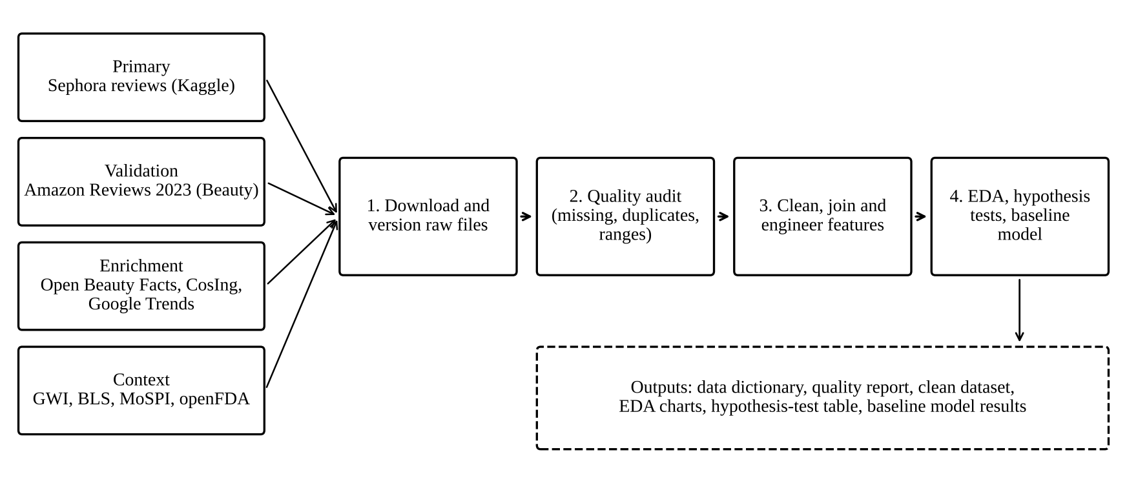
Figure 1: Data sourcing and preparation pipeline

2. Response to Week 1 Feedback
My Week 1 report received the feedback that it lacked concrete examples and specifics, and that it should include more detailed statistical tests, machine learning model outputs, a clearer timeline with tasks for each week, and a fuller ethics section covering privacy and data handling. Table 1 shows where each point is addressed in this report.
Table 1: How the Week 1 feedback is addressed
Feedback point | Where and how it is addressed in this report
Concrete examples and specifics | Real numbers from a first run on the full dataset (Section 11.2); exact files, column names, links, download commands, folder names and code snippets (Sections 5, 7 and 9); worked examples of how results will be read (Section 11).
More detailed statistical tests | Section 11 gives, for each hypothesis, the variables, unit of analysis, test, assumption checks, effect size, decision rule and multiple-testing correction.
Machine learning model outputs | Section 12 defines the models, validation design, metrics, the exact output tables that will be produced, the expected baseline scores, and the success threshold. Section 11.2 also reports real results from a first run on the full dataset, including baseline and logistic regression scores.
Clearer weekly timeline | Section 15 lists specific tasks, hours and deliverables for each remaining week, with a Gantt chart.
Ethics, privacy and data handling | Section 13 covers personal data, pseudonymisation, sensitive attributes, platform terms, storage, retention, access control, fairness checks and relevant laws (India DPDP Act 2023 and GDPR).

3. Data Requirements
Before searching for sources, I listed what data my problem actually needs. Each need is linked to the research questions and hypotheses from Week 1, so that every source I select has a clear purpose.
Table 2: Data needed for each research question
Data needed | Example variables | Used for | Main source
Customer rating and recommendation | rating (1 to 5), is_recommended (0/1) | RQ1 to RQ8, all hypotheses | Sephora reviews
Review text | review_text, review_title | RQ5, RQ6, H4, H5 | Sephora reviews
Product attributes | price_usd, brand_name, primary/secondary category, sephora_exclusive, limited_edition, new, online_only | RQ1 to RQ3, RQ7, H1, H3 | Sephora product_info
Popularity | loves_count, reviews (count) | RQ1, H6 features | Sephora product_info
Customer profile | skin_type, skin_tone, eye_color, hair_color | RQ4, H2, fairness checks | Sephora reviews
Review usefulness | helpfulness, total_feedback_count, total_pos/neg_feedback_count | H5, data quality weighting | Sephora reviews
Ingredients | ingredients list, INCI names, ingredient function | RQ5 themes, feature ideas | product_info, Open Beauty Facts, CosIng
Time | submission_time | Trends, timeliness check | Sephora reviews
External validation | rating, text, verified_purchase | Checking whether results hold on another platform | Amazon Reviews 2023
Market context | Search interest, spending, safety reports | Background and interpretation | Google Trends, BLS, MoSPI, openFDA

4. Data Sourcing Strategy
I followed a four-tier strategy so that the project depends mainly on one strong, well-documented dataset, while other sources are used only where they add clear value:
- Tier 1, Primary: a large, structured, free dataset that directly contains the target (recommendation) and the main predictors. This is the Sephora dataset.
- Tier 2, Validation: a second review dataset from a different retailer, used to check whether my main findings hold outside Sephora (external validity). This is the Amazon Reviews 2023 Beauty data.
- Tier 3, Enrichment: sources that add new variables to the primary data, such as ingredient functions or search interest over time.
- Tier 4, Context: governmental and industry sources used only for background, interpretation and benchmarking, not for modelling.
To choose between sources I scored each one on five criteria from 1 (poor) to 5 (excellent): relevance to my research questions, accessibility (cost, licence, effort to get it), reliability (how trustworthy and well documented it is), freshness (how recent and how often it is updated) and granularity (whether it is at review or product level). The scores are shown in Table 5. I also searched three types of resource as the task asked: governmental databases, social media data and public APIs from the beauty and wellness industry.

5. List of Potential Data Sources
Table 3 lists the thirteen sources I reviewed, grouped by type, with links to the public dataset or API.
Table 3: Potential data sources with links
# | Source | Type | What it provides | Link
S1 | Sephora Products and Skincare Reviews (Kaggle) | Open dataset | 8,000+ products (27 product columns) and about 1 million skincare reviews with rating, recommendation, text and skin profile | kaggle.com/datasets/nadyinky/sephora-products-and-skincare-reviews
S2 | Amazon Reviews 2023, Beauty_and_Personal_Care and All_Beauty (McAuley Lab, UCSD) | Open dataset | About 23.9 million beauty ratings and reviews (1996 to 2023) plus item metadata such as price, store and categories | amazon-reviews-2023.github.io
S3 | Cosmetics datasets: Sephora ingredients and skin-type suitability (Kaggle) | Open dataset | About 1,500 products with ingredient lists and flags for dry, oily, combination, normal and sensitive skin | kaggle.com/datasets/kingabzpro/cosmetics-datasets
S4 | Open Beauty Facts | Open database and API | Crowd-sourced cosmetic products with ingredients, brands and labels; full data dumps and JSON API | world.openbeautyfacts.org/data
S5 | EU CosIng cosmetic ingredient database | Government database | Official INCI ingredient names, functions (for example humectant, preservative) and regulatory restrictions | single-market-economy.ec.europa.eu/sectors/cosmetics/cosmetic-ingredient-database_en
S6 | openFDA Cosmetic Adverse Events | Government API | Serious adverse event reports linked to cosmetic products in the US, from 2001 | open.fda.gov/apis/cosmetic/event/
S7 | California Chemicals in Cosmetics (CDPH) | Government open data | Products reported to contain chemicals linked to health hazards, by brand and category | data.chhs.ca.gov/dataset/chemicals-in-cosmetics
S8 | US BLS Consumer Expenditure Surveys | Government statistics | Annual household spending on personal care products and services | bls.gov/cex/
S9 | MoSPI Household Consumption Expenditure Survey and data.gov.in | Government statistics (India) | Indian household spending on toilet articles and personal care, by state and urban/rural | mospi.gov.in and data.gov.in
S10 | Google Trends | Public web data | Relative search interest over time and by region for terms such as 'niacinamide' or 'sunscreen' | trends.google.com
S11 | Reddit Data API (r/SkincareAddiction, r/IndianSkincareAddicts) | Social media API | Posts and comments discussing products, routines and reactions | reddit.com/dev/api/
S12 | YouTube Data API v3 | Social media API | Video titles, view and like counts and comments for skincare reviews by creators | developers.google.com/youtube/v3
S13 | Global Wellness Institute and industry reports (McKinsey State of Beauty) | Industry research | Market size, growth rates and trend definitions | globalwellnessinstitute.org/industry-research/

6. Evaluation of Data Sources (Pros and Cons)
Table 4 discusses the main strengths and weaknesses of each source, focusing on accessibility, update frequency and reliability as required by the task.
Table 4: Pros and cons of each source
# | Pros | Cons | Frequency | Accessibility
S1 | Contains the exact target (is_recommended), review text and skin profile; very large; clean CSV; widely used so results can be compared | One retailer only; scraped once (2023), so it is a snapshot; reviewers self-select; US market | One-off snapshot | Free; Kaggle login; about 0.5 GB
S2 | Huge, academic source with documentation; verified_purchase flag; different retailer for validation | Very large files; no skin type; broad 'beauty' category mixes hair, tools and makeup | Released in versions (2014, 2018, 2023) | Free download in JSONL; research use
S3 | Ingredients already linked to skin types; small and easy to join | Small (about 1,500 products); older (around 2018); matching names to S1 is fuzzy | One-off | Free; Kaggle
S4 | Open licence; API and dumps; ingredient data | Crowd-sourced, so coverage of US prestige brands is patchy and some entries are incomplete | Daily updates | Free API, no key needed
S5 | Official and authoritative for ingredient function | No product or customer data; needs text matching of INCI names | Updated as regulations change | Free search and export
S6 | Official government safety signal; free API | Only serious events; under-reported; reports do not prove the product caused the event | Updated infrequently | Free; rate limits without API key
S7 | Official; links brands to hazardous chemicals | Only products sold in California and reported by companies; no customer data | Updated periodically | Free CSV
S8, S9 | Reliable national statistics; good for market context | Aggregated, so cannot be joined to reviews; S9 surveys are years apart | Annual (S8); every few years (S9) | Free
S10 | Shows seasonality and interest in ingredients; easy to get | Relative index (0 to 100), not absolute volume; sampling noise between downloads | Near real time | Free website; unofficial pytrends library
S11 | Rich, honest discussion; includes Indian community | API terms restrict use and volume; noisy; no ratings; possible personal data | Real time | Free with app registration and rate limits
S12 | Captures influencer effect on products | Quota limits; comments are noisy; no ratings | Real time | Free with API key and daily quota
S13 | Credible market figures | Summary reports only; some content paywalled | Annual | Free summaries
Table 5: Scoring matrix (1 = poor, 5 = excellent) and decision
# | Relevance | Accessibility | Reliability | Freshness | Granularity | Total /25 | Decision
S1 | 5 | 5 | 4 | 3 | 5 | 22 | Primary
S2 | 4 | 3 | 5 | 4 | 5 | 21 | Validation
S3 | 3 | 5 | 3 | 2 | 4 | 17 | Enrichment
S4 | 3 | 4 | 3 | 5 | 4 | 19 | Enrichment
S5 | 3 | 4 | 5 | 4 | 3 | 19 | Enrichment
S10 | 3 | 5 | 3 | 5 | 2 | 18 | Enrichment
S6 | 2 | 4 | 4 | 3 | 3 | 16 | Context
S7 | 2 | 5 | 4 | 3 | 3 | 17 | Context
S8, S9 | 2 | 5 | 5 | 2 | 1 | 15 | Context
S13 | 2 | 4 | 4 | 4 | 1 | 15 | Context
S11 | 3 | 2 | 2 | 5 | 4 | 16 | Optional (stretch)
S12 | 2 | 2 | 2 | 5 | 3 | 14 | Not used now
The final selection is: S1 as the primary dataset; S2 (All_Beauty subset first, because it is smaller) for external validation of H1 and H6; S4, S5 and S10 for enrichment; and S6 to S9 and S13 for context. Reddit (S11) is kept as a stretch goal for Week 4 only if time allows, because its API terms and data cleaning effort are high. YouTube (S12) is not used at this stage.

7. Data Collection Plan

7.1 Steps
- Set up the project. Create the GitHub repository with the folders data/raw, data/processed, notebooks, src, outputs and reports. Add data/ to .gitignore so that no raw data is pushed to GitHub.
- Download the primary data (S1). Using the Kaggle API:
pip install kaggle
kaggle datasets download -d nadyinky/sephora-products-and-skincare-reviews -p data/raw --unzip

- Record provenance. Save a sources.csv file with the source name, URL, download date, file names, file sizes, licence shown on the page and an MD5 checksum of each file, so the exact version can be traced later.
- Download the validation data (S2). Start with the All_Beauty review and metadata files (about 0.7 million ratings). Read them in chunks with pandas (chunksize = 200,000) and keep only rating, title, text, parent_asin, timestamp, verified_purchase and helpful_vote.
- Collect enrichment data. Export ingredient functions from CosIng (S5); query Open Beauty Facts (S4) only for the top 200 skincare brands in S1; download Google Trends (S10) weekly interest for 10 ingredient terms (for example niacinamide, retinol, hyaluronic acid, salicylic acid, vitamin C, ceramide, SPF, peptide, AHA, sunscreen) for the United States and India, 2019 to 2023, to match the review period.
- Collect context data. Download yearly personal care spending from BLS (S8) and the relevant MoSPI tables (S9), and count serious cosmetic adverse event reports by product category from openFDA (S6). These are kept in separate small tables and are never joined to individual reviews.
- Build a data dictionary. For every column used: name, description, type, allowed values, percentage missing and source. This is a Week 3 deliverable.

7.2 Joining the data
The Sephora product file and the review files are joined on product_id (many reviews to one product). Ingredient data from S3, S4 and S5 is joined by product name and brand, using lower-case text and fuzzy matching (for example a RapidFuzz similarity score of at least 90). Any match below the threshold is left unmatched rather than guessed. Google Trends data is joined by month to the review submission month. Amazon data is not joined to Sephora at all; it is analysed separately with the same code to compare results.

7.3 Sampling
Most statistical tests and charts can use the full Sephora data. For slower steps, such as sentiment scoring and model tuning, I will use a stratified random sample of 200,000 reviews (stratified by rating, with random_state = 42) so that the work runs on a normal laptop. Final models will be retrained on the full training set.

8. Data Quality and Relevance Assessment
I assessed the primary data on six standard quality dimensions. The 'expected issue' column is based on the dataset documentation and the column structure; the exact percentages will be measured by the audit function in the script (quality_audit_products.csv and quality_audit_reviews.csv). The pilot run already confirmed two of these issues: strong positive skew in ratings and a group of reviews with empty text.
Table 6: Data quality assessment of the Sephora dataset
Dimension | Expected issue | How I will check it | Action
Completeness | Optional profile fields (skin_tone, eye_color, hair_color, skin_type) are often blank; helpfulness is blank when nobody voted; review_title often blank; sale and value prices mostly blank | Percentage missing per column; missingness by rating group | Keep as 'not_reported' category; drop columns over 80% missing from modelling
Validity | Ratings outside 1 to 5, negative or zero prices, empty review text | Range and type checks | Remove invalid rows and log how many
Uniqueness | The same review repeated across review files; the same author reviewing a product twice | duplicated() on all columns and on author_id + product_id + review_text | Keep the first occurrence
Consistency | Price in reviews may differ from product_info; labels in mixed case | Compare price_usd in both files; check unique labels | Use product_info as the master for product fields
Timeliness | Data is a 2023 snapshot; older reviews may refer to old formulas | Distribution of submission_time by year | Report results by period; flag reviews before 2018
Representativeness | Only people who choose to review; mostly positive; US market; some incentivised reviews | Rating distribution; share recommended; text search for 'free product' or 'received this' | Use class weights; run a sensitivity test without incentivised reviews; validate on Amazon

8.1 Relevance
The Sephora data is highly relevant because it directly contains the target variable (is_recommended) and every main predictor named in my hypotheses: price, exclusivity labels, skin type, review text and review length. No other free source has all of these together at review level. Its main weakness for my problem is generalisability to Indian consumers. This is why I added the Amazon data for validation and Indian context sources (S9, S10 India, S11 Indian community) for interpretation, and why my conclusions will be framed as applying to online skincare shoppers on large retail platforms rather than to all consumers.

9. Data Cleaning and Preprocessing Plan
Table 7: Cleaning and preprocessing steps
Step | What will be done | Python example
Combine review files | Read all reviews_*.csv files and stack them | pd.concat([pd.read_csv(f, index_col=0) for f in files])
Remove duplicates | Exact duplicates, then same author + product + text | r.drop_duplicates(subset=[...])
Fix types | Convert submission_time to date; boolean flags to 0/1 | pd.to_datetime(r['submission_time'])
Validate ranges | Keep ratings 1 to 5 and prices above 0 | r[r['rating'].between(1, 5)]
Handle missing values | Profile fields to 'not_reported'; helpfulness left blank when no votes; drop rows with no is_recommended for H3 and H6 only | fillna('not_reported')
Text cleaning | Strip spaces, lower case for analysis copy, remove HTML and URLs; keep original text for sentiment because VADER uses capitals and punctuation | str.lower(), re.sub(r'http\S+', '', t)
Feature engineering | review_len_words, price_band (quartiles), low_rating (rating 1 or 2), review_year, ingredient count, has_SPF flag | pd.qcut(r['price_usd'], 4)
Outliers | Very long reviews and very high prices are kept but log-transformed for modelling | np.log1p(x)
Join tables | Add product flags and loves_count from product_info by product_id | r.merge(products, on='product_id')
Pseudonymise | Replace author_id with a hashed key, then remove author_id | hash_pandas_object(...)
Encoding and scaling | One-hot encode categories; scale numeric features for logistic regression only | pd.get_dummies(), StandardScaler
Prevent leakage | Split train and test by product_id (a product is only in one set); never use rating as a feature for predicting recommendation | GroupShuffleSplit

10. Preliminary Exploratory Analysis Plan

10.1 Key variables
- Target variables: is_recommended (binary) and rating (ordinal, 1 to 5).
- Main predictors: price_usd and price_band, sephora_exclusive, limited_edition, new, online_only, primary and secondary category, brand_name, skin_type, skin_tone, loves_count.
- Text-derived variables: review_len_words and, from Week 4, a VADER sentiment compound score (from -1 to +1).
- Supporting variables: helpfulness, total_feedback_count, submission_time.

10.2 Descriptive statistics
For numeric variables (rating, price, review length, helpfulness, loves_count) I will report count, mean, median, standard deviation, minimum, 25th, 75th and 95th percentiles, and skewness. Because price and review length are expected to be strongly right-skewed, I will report medians alongside means. For categorical variables I will report frequencies and percentages, the number of categories, and the recommendation rate and mean rating within each category. I will also report the class balance of is_recommended, because it decides which model metrics are meaningful.

10.3 Visualisation plan
Table 8: Planned charts and the question each one answers
Chart | Variables | Question answered
Bar chart | rating | How skewed towards 5 stars are the reviews? (RQ1)
Histogram (log scale) | price_usd, review_len_words | What is the typical price and review length?
Box plot | rating by price_band | Do expensive products score higher? (H1)
Grouped bar chart | mean rating and recommend rate by skin_type | Do skin types differ in satisfaction? (H2)
100% stacked bar | is_recommended by sephora_exclusive | Are exclusives recommended more? (H3)
Violin plot | review length by rating group | Are negative reviews longer? (H5)
Heatmap | Spearman correlation of numeric variables | Which variables move together; any multicollinearity?
Line chart | monthly review count and mean rating | Are there trends or seasonality over time?
Ranked bar chart | top and bottom 15 brands (min 100 reviews) | Which brands are strongest and weakest? (RQ7)
Missing-value matrix | all columns | Where is data missing and is it random?
All charts will be produced in black and white (grey scale and hatching) with Matplotlib and Seaborn so they print clearly. The script in Appendix A already creates the rating distribution, rating-by-price box plot, review length histogram and correlation heatmap.

11. How the Data Tests the Hypotheses
The significance level is 0.05 for every test. Because the dataset has about one million reviews, even tiny differences will be 'significant'. To avoid over-claiming, I will (a) always report an effect size with a stated threshold for a meaningful effect, (b) run product-level tests where a product's many reviews would otherwise be counted as independent observations, and (c) apply a Bonferroni correction across the family of tests (the script multiplies each p-value by the number of tests). Normality will be checked with histograms and Q-Q plots; since ratings are ordinal and skewed, non-parametric tests are the default.
Table 9: Detailed statistical test plan
H | Variables and unit | Test | Assumptions / checks | Effect size and meaningful level | Follow-up
H1 | Product price vs mean rating (products with 30+ reviews); rating by price quartile (review level) | Spearman correlation; Kruskal-Wallis | Monotonic relationship (scatter plot); independent groups | rho: 0.1 small, 0.3 medium; epsilon squared: 0.01 small | Dunn post-hoc test with Holm correction; repeat on Amazon data
H2 | Rating by skin_type (dry, oily, combination, normal); 'not_reported' excluded | Kruskal-Wallis (one-way ANOVA as a check) | Group sizes; Levene test for equal variance if ANOVA is used | epsilon squared 0.01 small | Dunn pairwise tests; repeat within main categories
H3 | sephora_exclusive (0/1) x is_recommended (0/1) | Chi-square test of independence | All expected counts above 5 | Cramer's V: 0.1 small, 0.3 medium; also odds ratio with 95% CI | Logistic regression controlling for price and category
H4 | VADER sentiment class (negative, neutral, positive) x rating group (1 to 2, 3, 4 to 5) | Chi-square; Spearman correlation of compound score with rating | Sentiment model checked on 200 hand-labelled reviews | Cramer's V; rho; Cohen's kappa for agreement | Read reviews where sentiment and rating disagree (sarcasm, mixed)
H5 | Review length (words) for low (1 to 2) vs high (4 to 5) ratings | Mann-Whitney U (one-sided) | Independent groups; similar distribution shape | Rank-biserial r: 0.1 small, 0.3 medium | Control for category with a regression on log length
H6 | Model predictions vs baseline on the same test set | Bootstrap 95% CI of AUC difference (1,000 resamples); McNemar test on errors | Same test products for all models | AUC gain of at least 0.10 over baseline | 5-fold GroupKFold to check stability

11.1 Worked examples of how results will be read
To make the decision rules concrete, these are examples of how I will interpret possible results. They are illustrations of the rule, not results.
- H1: if Spearman rho between price and mean product rating is 0.06 with p < 0.001, I will reject H0 statistically but report that the relationship is negligible (below 0.1), meaning price is not a useful driver of satisfaction on its own. If rho is 0.25, I will report a small-to-medium positive relationship.
- H3: if the chi-square test is significant but Cramer's V is 0.03, exclusivity has almost no practical effect; I will then check the odds ratio. An odds ratio of 1.15 would mean exclusive products have 15% higher odds of being recommended, which I would still describe as a small effect.
- H5: if the rank-biserial correlation is 0.20, low-rated reviews tend to be longer than high-rated reviews, with a small effect. This would support using review length as a model feature.

11.2 Pilot results from the first run on the full dataset
To test the plan, I downloaded the Sephora dataset and ran the script in Appendix A on all of the reviews (about 1.09 million). These are first-pass results produced before the full cleaning and feature work planned for Week 3, so they will be refined, but they already show what the data looks like and confirm the testing approach.
Ratings are heavily skewed towards positive. Around 700,000 reviews (roughly 64%) give 5 stars and about 200,000 give 4 stars, while only around 115,000 (roughly 11%) give 1 or 2 stars (Figure 2). The share of reviews that recommend the product is about 83%. This confirms that class imbalance is a real issue and that accuracy alone would be a misleading metric.
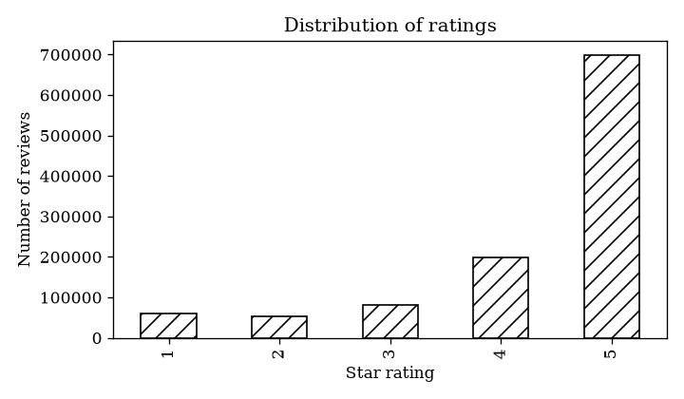
Figure 2: Distribution of star ratings (pilot run)
Price does not change individual ratings much. The box plots in Figure 3 are almost identical across the four price quartiles: in every band the middle 50% of ratings sit between 4 and 5, and 1 and 2 star ratings appear as outliers. This matches the very small effect size found in the test below.
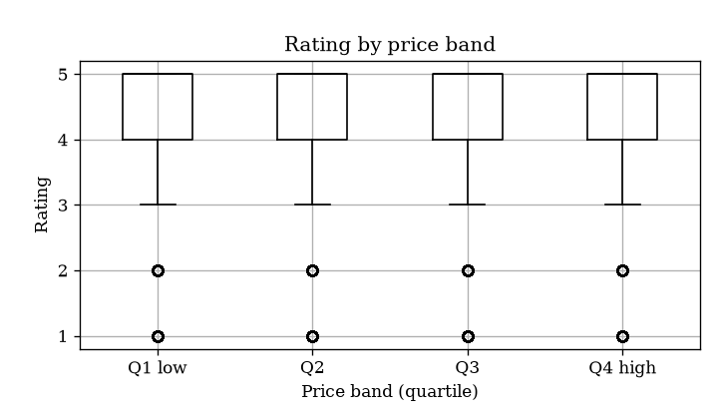
Figure 3: Rating by price band (pilot run)
Review length is roughly log-normal. On the log scale the distribution peaks at about 3.9, which means a typical review is around 50 words long, with a long tail reaching over 1,000 words (Figure 4). The small spike at zero shows a number of reviews with no text, which is a data quality issue to handle in cleaning (Section 9) and especially before sentiment scoring.
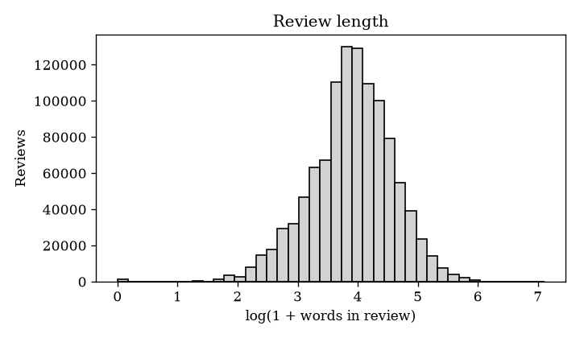
Figure 4: Distribution of review length (pilot run)
Correlations are weak overall. In Figure 5, the strongest relationship with rating is helpfulness (Spearman rho = 0.23). Rating is almost unrelated to price (0.01), review length (-0.03) and loves_count (0.01) at review level. Price is negatively related to loves_count (-0.20), meaning cheaper products tend to be more popular, and slightly positively related to review length (0.12). No pair is high enough to cause a multicollinearity problem in the models.
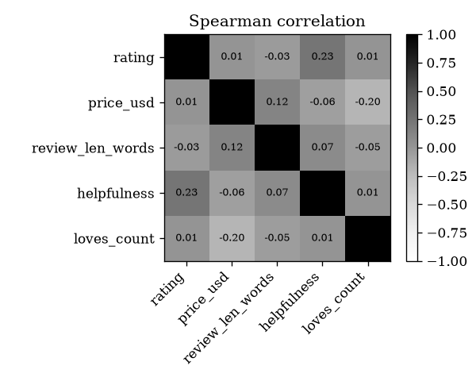
Figure 5: Spearman correlation matrix (pilot run)
Table 10: Pilot hypothesis test results (alpha = 0.05, Bonferroni-adjusted)
H | Test | Statistic | Adjusted p | Effect size | Interpretation
H1 | Spearman, product level (products with 30+ reviews) | rho = 0.165 | < 0.001 | Small (above 0.1) | Reject H0: higher-priced products have slightly higher average ratings
H1 | Kruskal-Wallis, rating by price band (review level) | H = 129.9 | < 0.001 | epsilon sq. = 0.0001 (negligible) | Significant but no practical difference between individual ratings
H2 | Kruskal-Wallis, rating by skin type | H = 67.2 | < 0.001 | epsilon sq. = 0.0001 (negligible) | Reject H0 statistically, but skin types rate products almost the same
H3 | Chi-square, exclusive x recommended | chi sq. = 119.9 | < 0.001 | Cramer's V = 0.011 (negligible) | Reject H0 statistically, but exclusivity has almost no practical effect
H5 | Mann-Whitney U, length of low (1-2) vs high (4-5) ratings, one-sided | U = 5.27 x 10^10 | 1.000 | r = 0.058 (negligible) | Fail to reject H0: low-rated reviews are not longer than high-rated ones
These results show exactly why Section 11 insists on effect sizes. With over a million reviews, four of the five tests are 'significant', yet only one effect (H1 at product level) is large enough to matter. The main finding so far is that structured product features such as price, skin type and exclusivity explain very little of customer satisfaction. H5 was not supported; the small effect size even points slightly the other way, which suggests that the longest reviews may be the mixed 3-star ones. I will check this in Week 3 by comparing review length across all five rating levels. H4 will be tested in Week 4.
Baseline model dry run. The baseline that always predicts 'recommend' scored a macro F1 of 0.453 and a ROC-AUC of 0.50. This matches the formula in Section 12.3 for a recommendation rate of about 83%. A simple logistic regression using only price, review length, loves_count, skin type and category scored a macro F1 of 0.462 and a ROC-AUC of 0.549. This is only slightly better than the baseline and well short of the +0.10 AUC target, so H6 is not yet supported with these features alone. Together with the hypothesis results, this points clearly to the review text as the most important missing information. It confirms the plan to add sentiment scores and TF-IDF text features in Weeks 4 and 5 before training the Random Forest and XGBoost models.
Each test will produce one row in a results table (hypothesis_tests.csv) with these columns: hypothesis, test, statistic, p-value, Bonferroni-adjusted p-value, effect size and decision. The pilot run in Section 11.2 already produced this file for H1, H2, H3 and H5.

12. Machine Learning Plan and Expected Outputs

12.1 Problem set-up
The task is binary classification: predict is_recommended (1 = recommends, 0 = does not). The rating column is excluded from the features because it is almost the same information as the target and would leak the answer. Features are price (log), review length (log), loves_count (log), product flags, category, brand (top 50, others grouped), skin type and, from Week 4, sentiment score and TF-IDF text features.

12.2 Models and validation
- Baseline: always predicts the majority class ('recommend'). This is the comparison point for H6.
- Logistic Regression: interpretable model with class_weight='balanced'; coefficients show the direction of each driver.
- Random Forest: captures non-linear effects; 300 trees; tuned for max_depth and min_samples_leaf.
- XGBoost: usually the strongest on tabular data; tuned for learning rate, depth and number of trees with early stopping.
Data is split 80/20 by product_id so that no product appears in both training and test data, and tuning uses 5-fold GroupKFold on the training part only. Because the classes are unbalanced, the main metrics are macro F1 and ROC-AUC, with precision and recall for the 'not recommended' class reported separately, since finding unhappy customers is the business priority.

12.3 Expected baseline score
The baseline score can be worked out in advance. If a share p of reviews recommend the product, the 'always recommend' model has accuracy p, an F1 of 2p/(1+p) for the positive class and 0 for the negative class, so its macro F1 is p/(1+p), and its ROC-AUC is 0.5. For example, if about 80% of reviews recommend, the baseline has 80% accuracy but a macro F1 of only 0.44. This shows why accuracy alone would be misleading. In the pilot run (Section 11.2) the baseline macro F1 was 0.453, which corresponds to p of about 0.83, so roughly 83% of reviews recommend the product.

12.4 Output tables that will be produced
The following tables will be filled in from the model runs and included in the Week 5 report. The two pilot rows contain real results from the first run; the empty cells are placeholders for Week 5.
Table 12: Model comparison table (first two rows from the pilot run; the rest to be completed in Week 5)
Model | Accuracy | Precision (0) | Recall (0) | Macro F1 | ROC-AUC | PR-AUC
Baseline (always recommend) | about 0.83 | 0 | 0 | 0.453 | 0.500 | -
Logistic Regression (pilot, structured features only) |  |  |  | 0.462 | 0.549
Logistic Regression (with text features)
Random Forest
XGBoost
Other outputs: a confusion matrix for the best model, an ROC curve comparing all models, a feature importance chart (permutation importance and SHAP values for XGBoost), logistic regression odds ratios with 95% confidence intervals, and a list of the 20 most confidently wrong predictions for error analysis.

12.5 Success criteria
- H6 is supported if the best model's ROC-AUC is at least 0.10 higher than the baseline and the 95% bootstrap confidence interval of the difference does not include zero.
- Business target: recall of at least 0.60 for the 'not recommended' class, so that most unhappy customers are identified.
- Fairness check: recall for the 'not recommended' class should not differ by more than 0.10 between skin types or skin tones.
The script in Appendix A already runs a dry-run of this design (baseline against a simple logistic regression with a product-grouped split) and saves baseline_model_results.csv, and has now been run on the full dataset (results in Section 11.2 and Table 12).

13. Ethics, Privacy and Data Handling

13.1 Personal data and privacy
- Identifiers: the Sephora data contains author_id, a platform user identifier. Although it is not a name, it can link several reviews to the same person. I will replace it with a hashed key during cleaning and delete the original column from all processed files and outputs.
- Text may contain personal details: reviewers sometimes mention their age, health conditions, pregnancy or location. I will not quote any review that contains such details in reports. Any example quotes will be short, anonymous and checked by hand.
- Sensitive attributes: skin tone and skin conditions are close to ethnicity and health information. They will only be used for group-level analysis, and results will only be reported for groups with at least 30 reviews so that individuals cannot be singled out.
- No re-identification: I will not try to link reviewers to social media accounts or any other data, and I will not combine sources at the person level.
- Social media data (if used): for Reddit, only public posts, collected through the official API within its rate limits and terms; usernames removed at collection; deleted posts not stored; data used only for aggregate topic analysis.

13.2 Data handling practices
Table 13: Data handling rules
Area | Practice
Storage | Raw data kept only on my personal laptop in data/raw (password-protected account, encrypted disk). It is never uploaded to GitHub; data/ is in .gitignore.
What goes on GitHub | Code, the data dictionary, aggregated results tables and charts only. A check before every commit confirms no CSV of raw reviews is included.
Access | Only I have access to the raw and processed data. No sharing by email or chat.
Licences and terms | Use each source only as allowed by its licence or terms of service, as recorded in sources.csv. No scraping of websites that forbid it; APIs are used instead.
Minimisation | Only the columns needed for the research questions are kept in processed files.
Retention | Raw and processed data will be deleted at the end of the internship; only the code and aggregated results are kept.
Reproducibility | Fixed random seed (42), package versions saved in requirements.txt, and a log of every row removed during cleaning.

13.3 Legal and fairness considerations
Even though the data is public, I will follow the principles of India's Digital Personal Data Protection Act 2023 and the EU General Data Protection Regulation: purpose limitation (use only for this study), data minimisation, and storage limitation. On fairness, I will check whether the model performs worse for some skin types or skin tones (Section 12.5), because a recommendation tool that works poorly for certain groups could disadvantage those customers. I will also avoid making health claims from the openFDA data, which shows reported events, not proven causes. Finally, I will be transparent that the data comes from customers who chose to review, so findings describe reviewers, not all customers.

14. Risks and Mitigation
Risk | Likelihood | Mitigation
Data too large for my laptop's memory | Medium | Load only needed columns with usecols; use chunks and a 200,000-review stratified sample for slow steps
Strong class imbalance (mostly positive reviews) | High | Macro F1 and ROC-AUC as metrics; class weights; report minority-class recall
Poor matching of ingredient data | Medium | Use fuzzy matching with a strict threshold; treat ingredient enrichment as optional
Results do not hold on Amazon data | Medium | Report this honestly as a limitation of generalisability
Data leakage inflating model scores | Medium | Exclude rating; split by product; tune only on training folds
Time pressure alongside other work | Medium | Weekly plan with fixed deliverables (Section 15); stretch goals clearly separated

15. Week-by-Week Timeline
Figure 6 shows the remaining work as a Gantt chart, and Table 14 lists the specific tasks, estimated hours and deliverables for each week.
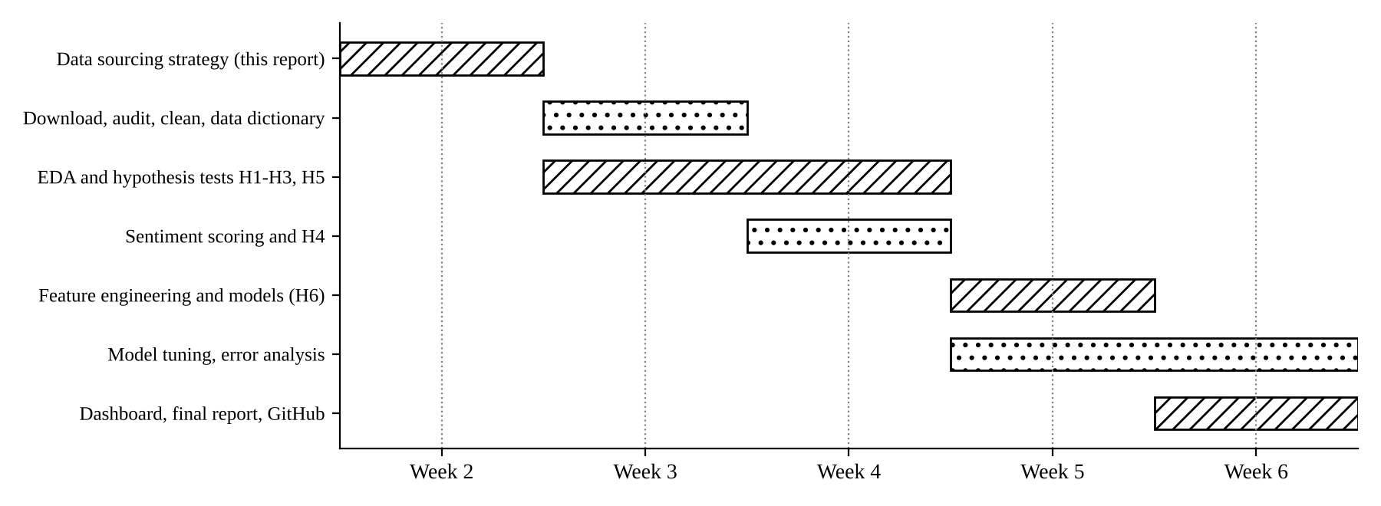
Figure 6: Project timeline (Weeks 2 to 6)
Table 14: Weekly tasks and deliverables
Week | Specific tasks | Hours | Deliverable
Week 2 | Review 13 sources; score and select sources; design collection plan, quality checks, EDA and test plan; write the audit script and run it on the full dataset (pilot results); set up GitHub repository | 32 | This report; week2_data_audit_and_eda.py on GitHub
Week 3 | Days 1-2: download S1 and S2, record checksums, run quality audit. Days 3-4: cleaning, joins, feature engineering, data dictionary. Days 5-7: descriptive statistics, the 10 planned charts, tests for H1, H2, H3 and H5 with effect sizes | 33 | Clean dataset, data dictionary, EDA notebook, hypothesis results table
Week 4 | Days 1-2: VADER sentiment scoring; validate on 200 hand-labelled reviews. Days 3-4: test H4; topic modelling (LDA) of negative reviews. Days 5-7: compare top themes by skin type; repeat H1 on Amazon data | 33 | Sentiment scores, H4 result, top complaint themes
Week 5 | Days 1-2: final feature set and product-grouped split. Days 3-5: train and tune Logistic Regression, Random Forest and XGBoost. Days 6-7: bootstrap test for H6, SHAP importance, fairness check, error analysis | 34 | Completed model comparison table, confusion matrix, ROC curve, feature importance
Week 6 | Days 1-3: Power BI or Streamlit dashboard. Days 4-5: business recommendations. Days 6-7: final report, README and clean-up of GitHub repository; delete raw data as per retention rule | 33 | Dashboard, final report, complete GitHub repository

16. Conclusion
This report sets out a structured plan for getting the right data for my skincare satisfaction problem. I reviewed thirteen public sources across open datasets, government databases, social media and industry APIs, compared their accessibility, update frequency and reliability, and scored them to make a clear selection: Sephora reviews as the primary dataset, Amazon beauty reviews for validation, ingredient and search-trend data for enrichment, and government statistics for context. I assessed the expected quality problems in the data and planned how to clean them, set out a detailed exploratory analysis and visualisation plan, and linked every hypothesis to a specific statistical test, effect size and decision rule. I have also defined the machine learning design, the exact outputs that will be produced and the success criteria, together with stronger privacy and data handling practices. A first run of the accompanying Python script on the full dataset showed that ratings are strongly positive (about 83% recommend), that price, skin type and exclusivity have statistically significant but practically negligible effects, and that a model without text features barely beats the baseline. This gives a clear direction for the coming weeks: the review text is where the real signal is likely to be.

References
Chen, T. and Guestrin, C. (2016) 'XGBoost: A scalable tree boosting system', Proceedings of the 22nd ACM SIGKDD Conference, pp. 785-794.
European Commission (2026) CosIng: Cosmetic ingredient database. Available at: https://single-market-economy.ec.europa.eu/sectors/cosmetics/cosmetic-ingredient-database_en
Global Wellness Institute (2025) 2025 Global Wellness Economy Monitor. Available at: https://globalwellnessinstitute.org/industry-research/
Government of India (2023) The Digital Personal Data Protection Act, 2023. New Delhi: Ministry of Law and Justice.
Hou, Y., Li, J., He, Z., Yan, A., Chen, X. and McAuley, J. (2024) 'Bridging language and items for retrieval and recommendation', arXiv:2403.03952. Dataset: https://amazon-reviews-2023.github.io/
Hutto, C.J. and Gilbert, E. (2014) 'VADER: A parsimonious rule-based model for sentiment analysis of social media text', Proceedings of ICWSM.
Inky, N. (2023) Sephora Products and Skincare Reviews [dataset]. Kaggle. Available at: https://www.kaggle.com/datasets/nadyinky/sephora-products-and-skincare-reviews
Lundberg, S.M. and Lee, S.-I. (2017) 'A unified approach to interpreting model predictions', Advances in Neural Information Processing Systems 30.
McKinsey & Company (2025) The State of Beauty 2025. McKinsey & Company.
Open Beauty Facts (2026) Open Beauty Facts data. Available at: https://world.openbeautyfacts.org/data
U.S. Bureau of Labor Statistics (2026) Consumer Expenditure Surveys. Available at: https://www.bls.gov/cex/
U.S. Food and Drug Administration (2026) openFDA Cosmetic Adverse Events API. Available at: https://open.fda.gov/apis/cosmetic/event/
Tomczak, M. and Tomczak, E. (2014) 'The need to report effect size estimates revisited', Trends in Sport Sciences, 1(21), pp. 19-25.

Appendix A: Python Script Summary
The script week2_data_audit_and_eda.py is in my GitHub repository. I ran it on the full Kaggle dataset placed in data/raw; the results are reported in Section 11.2. It contains seven functions:
Function | What it does and what it saves in outputs/
load() | Reads product_info.csv and stacks all reviews_*.csv files
quality_audit() | Data type, non-null count, percentage missing and unique values per column; duplicate count (quality_audit_*.csv)
clean() | Removes duplicates and invalid rows, fixes types, fills missing profile fields, creates review length, low_rating and price_band, pseudonymises author_id and joins product flags
describe() | Descriptive statistics with percentiles and skewness; class balance; rating by skin type (descriptive_numeric.csv, target_balance.csv, rating_by_skin_type.csv)
charts() | Black and white charts: rating distribution, rating by price band, review length, Spearman heatmap (fig_*.png)
hypothesis_tests() | H1, H2, H3 and H5 tests with effect sizes and Bonferroni correction (hypothesis_tests.csv)
baseline() | Baseline against logistic regression with a product-grouped split; macro F1 and ROC-AUC (baseline_model_results.csv)
Run with: python week2_data_audit_and_eda.py

