Predictive Modelling and Algorithm Selection
Project: What Drives Customer Satisfaction and Recommendation in Skincare?
Week 5 Task Report
Data Science with Python Analyst Internship (Beauty and Wellness)
Prepared by: Sarthak Sameer Gharat
Week: Week 5 of 6
Submission date: 17 October 2026
Code: src/week5_modeling.py (GitHub: sarthak-debug/skincare-recommendation-analysis)

Contents
1. Introduction
2. From the Business Problem to Predictive Tasks
3. Data Characteristics That Shape Model Choice
4. Candidate Algorithms for Task 1 (Classification)
5. Comparing the Algorithms
6. Task 2: Early-Warning Regression
7. Evaluation Metrics
8. Predictions About Model Performance
9. Validation and Robustness
10. Pitfalls, Overfitting and Underfitting
11. Interpreting Model Outcomes for the Business
12. Results on the Full Dataset
13. Next Steps
14. Conclusion
References
Appendix A: Script Functions and Outputs

1. Introduction
Over the last four weeks I defined a business problem (what drives satisfaction and recommendation in skincare), sourced and cleaned 971,500 Sephora reviews, and engineered 36 new features. The Week 4 feature test already showed that the engineered features raise the ability to predict recommendation from a ROC-AUC of 0.554 to 0.896. This week I select and justify the predictive algorithms, set out how they will be evaluated and validated, and explain how their outputs will be turned into business decisions.
The modelling is implemented in week5_modeling.py. It reuses the Week 4 feature code, tunes four classification algorithms with cross-validation grouped by product, compares them on products the models have never seen, and runs a set of robustness, fairness and overfitting checks. It also builds a second, regression model that forecasts how a new product's satisfaction will develop. The script was tested end to end on a 40,000-review test file before being run on the full data.

2. From the Business Problem to Predictive Tasks
A business question has to be turned into a precise prediction task before an algorithm can be chosen. The Week 1 problem leads to two tasks and one supporting technique (Figure 1).
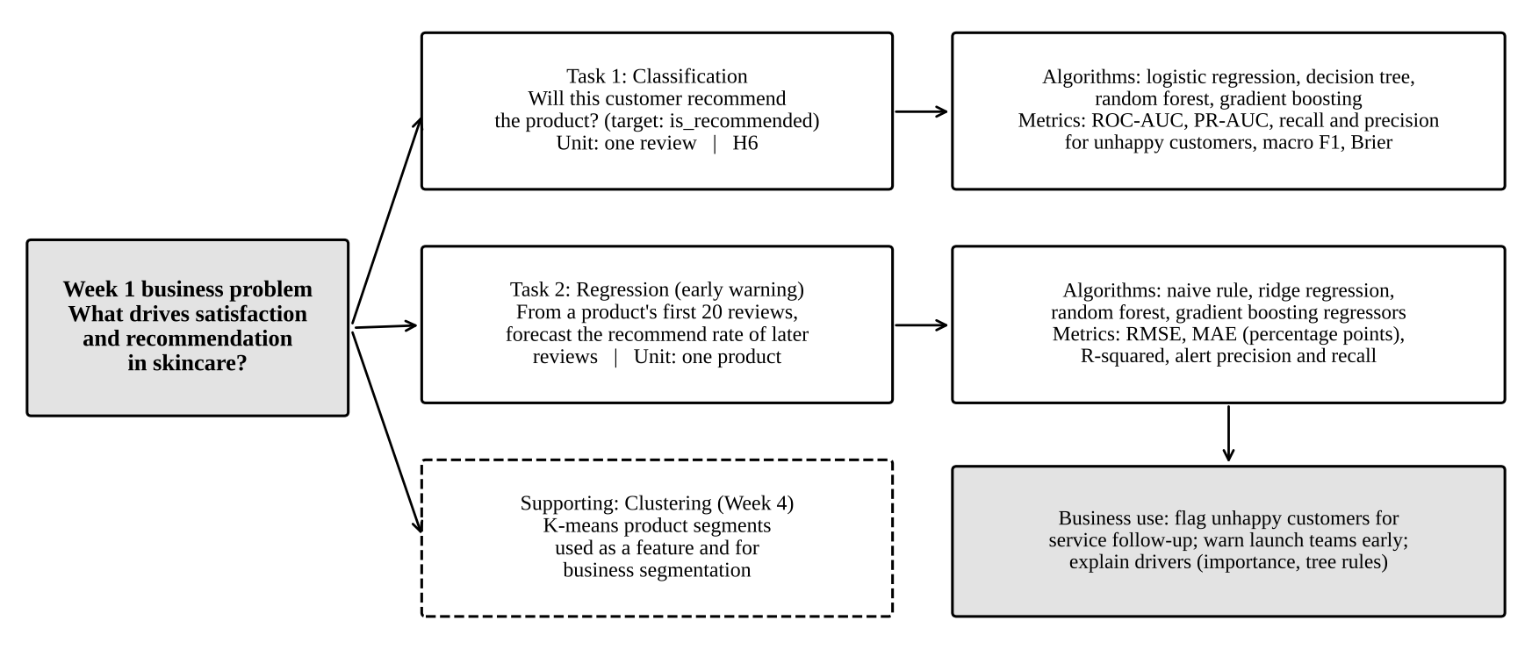
Figure 1: How the business problem maps to predictive tasks, algorithms and metrics
Table 1: Predictive tasks
 | Task 1: Classification | Task 2: Regression (early warning)
Business question | Which customers are unhappy, and what drives recommendation? | Which new products will disappoint later buyers?
Target | is_recommended (1 = yes, 0 = no) | Recommend rate of a product's reviews after its first 20
Unit | One review | One product
Data | 813,588 labelled reviews | Products with at least 50 reviews
Inputs | 56 features from Week 4 (product, price, brand, social proof, reviewer history, text) | Summary of the first 20 reviews plus product facts
Use | Flag unhappy customers; explain drivers | Warn a launch team early that satisfaction will fall
Hypothesis | H6: a model beats the baseline | Early reviews contain enough signal to forecast later ones
Clustering is not a prediction task here, but the k-means product segments from Week 4 are used both as a model feature and as a way to report results by product type.

3. Data Characteristics That Shape Model Choice
The right algorithm depends on the data. Table 2 lists the characteristics measured in earlier weeks and what each one means for model selection.
Table 2: Data characteristics and their implications
Characteristic (measured) | Implication for modelling
Large: 813,588 labelled reviews, 56 features | Methods must scale; SVM and k-nearest neighbours are too slow. Enough data for flexible models without overfitting, if they are regularised.
Imbalanced: about 84% recommend | Accuracy is misleading (84% by always saying 'yes'). Use class weights and metrics focused on the 16% minority.
Mixed types: numeric, binary, categorical (skin type, category, segment) | Need a preprocessing pipeline with one-hot encoding; tree models handle mixed types naturally.
Skewed numeric features (price skew 4.1, votes 69.9) | Log transforms for linear models; trees are unaffected by skew.
Missing values (e.g. 16% of profile fields, no earlier reviews for first reviews) | Median imputation with missing indicators; gradient boosting handles missing values internally.
Non-linear and interaction effects (Week 4 heatmap pockets) | Favours tree ensembles, which find interactions automatically.
Grouped: many reviews per product | Validation must split by product, or models will memorise products.
Time-ordered: reviews collected over several years up to 2023 | Check that a model trained on the past works on the most recent period.
Explainability needed by business users | Keep an interpretable model (logistic regression, shallow tree) alongside the most accurate one.

4. Candidate Algorithms for Task 1 (Classification)
I compare four algorithms that cover the main families: a linear model, a single tree, and two tree ensembles. All are available in scikit-learn, so they share one preprocessing pipeline and can be compared fairly.

4.1 Logistic regression
How it works: it estimates the log-odds of recommending as a weighted sum of the features, then converts this to a probability with the logistic function: P(recommend) = 1 / (1 + e^-(b0 + b1x1 + ... + bkxk)). An L2 penalty, controlled by C, shrinks the weights to prevent overfitting.
Why it fits: each coefficient has a direct meaning (an odds ratio), so it explains the drivers of recommendation in a way managers understand. It is fast on a million rows, and its probabilities are usually well calibrated. It also served as the Week 2 and Week 4 benchmark.
Weaknesses here: it assumes each feature has a straight-line effect on the log-odds, so it misses interactions (for example, fragrance only hurting oily skin) unless they are engineered by hand. It also needs scaling and imputation.
Tuned: C in {0.01, 0.03, 0.1, 0.3, 1, 3}, with class_weight='balanced'.

4.2 Decision tree
How it works: it repeatedly splits the data on the feature and threshold that best separate recommenders from non-recommenders (Gini impurity), creating a set of if-then rules.
Why it fits: the rules can be read by anyone, for example 'if sentiment is below 0.58 and the review does not mention repurchasing, predict not recommended'. It handles non-linear effects and interactions without engineering, and needs no scaling.
Weaknesses here: a single tree is unstable (small data changes give a different tree) and overfits easily if it grows deep. Section 10 shows this directly with a depth curve.
Tuned: max_depth in {4, 6, 8, 10, 12}, min_samples_leaf in {50, 200, 500}.

4.3 Random forest
How it works: it trains many deep trees, each on a bootstrap sample of rows and a random subset of features, and averages their votes. Averaging many different trees cancels out much of their individual overfitting.
Why it fits: it is robust, captures interactions, and needs little tuning. It also gives a reliable view of feature importance.
Weaknesses here: it is slower to train and predict, and its files are large, so it is trained on 150,000 rows. Its probabilities tend to be squeezed away from 0 and 1, and it is less interpretable than a single tree.
Tuned: max_depth in {10, 16, 22}, min_samples_leaf in {5, 20, 50}, max_features in {sqrt, 0.3}; 150 trees; class_weight='balanced_subsample'.

4.4 Gradient boosting (HistGradientBoostingClassifier)
How it works: it builds trees one after another, where each new tree corrects the errors of the trees before it. The histogram version groups each feature into 255 bins, which makes it very fast on large data. Early stopping ends training when a validation score stops improving.
Why it fits: it is usually the most accurate method for tabular data, handles missing values natively, scales to millions of rows, and gave the best result in the Week 4 ablation (AUC 0.896).
Weaknesses here: it has more settings to tune, can overfit if the learning rate is too high or the trees too large, and needs extra tools (permutation importance) to explain.
Tuned: learning_rate in {0.05, 0.08, 0.12}, max_leaf_nodes in {15, 31, 63}, l2_regularization in {0, 1}, max_iter in {300, 500}, with early stopping.

4.5 Algorithms considered but not selected
Algorithm | Reason not selected
Support vector machine | Training time grows faster than the square of the row count; impractical for 800,000 rows
K-nearest neighbours | Slow predictions and distances are not meaningful across mixed binary, categorical and numeric features
Naive Bayes | Assumes features are independent, which is clearly false (e.g. sentiment and complaint themes)
Neural networks | Little gain over gradient boosting on tabular data, harder to explain; better suited to raw text, which is a possible future step (e.g. fine-tuning a transformer on review text)
XGBoost / LightGBM | Very similar to HistGradientBoosting; scikit-learn's version avoids an extra dependency. Can be swapped in later.

5. Comparing the Algorithms
Table 3: Strengths and weaknesses in this context
Criterion | Logistic regression | Decision tree | Random forest | Gradient boosting
Interpretability | High (odds ratios) | High (rules) if shallow | Medium | Low without tools
Non-linear and interaction effects | Only if engineered | Yes | Yes | Yes
Scales to 800k rows | Yes | Yes | Slower | Yes (fast)
Handles missing values | Needs imputation | Needs imputation* | Needs imputation* | Natively
Needs scaling | Yes | No | No | No
Overfitting risk | Low | High if deep | Low | Medium (tuned)
Probability calibration | Good | Poor (steps) | Fair | Good
Expected accuracy | Good | Fair | Very good | Best
Role in this project | Explainer and benchmark | Readable rules for managers | Robust alternative | Main production model
* Recent scikit-learn versions allow missing values in trees, but the pipeline imputes them for a consistent comparison. The plan is not to pick one model and discard the rest: gradient boosting is expected to be the most accurate and would be used for scoring, while logistic regression and a shallow decision tree are kept to explain the drivers in plain terms.

5.1 How the comparison is made fair
pre = ColumnTransformer([('num', median_impute + scale, numeric),
('cat', constant_impute + OneHotEncoder(min_frequency=100), categorical),
('bin', fill_0, binary)])
for name, (model, grid) in MODELS.items():
best = random_search(Pipeline([('pre', pre), ('model', model)]), grid,
cv=GroupKFold(3), groups=product_id, scoring='roc_auc')
best.fit(train) # same training rows for every model
scores[name] = evaluate(best, test) # same unseen products for every model

6. Task 2: Early-Warning Regression
Week 4 found that a product's first ten reviews are on average 0.16 stars higher than later ones. A launch team that relies on early reviews may therefore think a product is doing well when later buyers will be less happy. Task 2 turns this into a forecasting problem.
- Unit and target: each product with at least 50 reviews. The target is the recommend rate of all its reviews after the first 20.
- Inputs (first 20 reviews only): mean and spread of ratings, early recommend rate, share of 1 to 2 star reviews, mean sentiment, share incentivised, complaint themes (breakout, irritation, no effect), review length, share of first-time and generous reviewers, share of oily and dry skin reviewers, how many days the first 20 reviews took (sales speed), plus price, price per mL relative to category, exclusivity, ingredient count, category and segment.
- Excluded: loves_count, because it was measured when the data was collected in 2023, long after launch, so a launch team would not have it.
- Models: (1) predict the average product; (2) naive rule: the later rate equals the early rate; (3) ridge regression (linear with L2 penalty); (4) random forest regressor; (5) gradient boosting regressor. Evaluation uses 5-fold cross-validation over products.
- Alert rule: flag a product when the forecast is more than 10 percentage points below its early recommend rate. The script measures how often a flagged product really falls by 10 points (alert precision), and how many real falls are caught (alert recall).

7. Evaluation Metrics
Because 84% of reviews recommend the product, a model that always predicts 'recommend' is 84% accurate but useless. Metrics must therefore focus on finding the 16% who do not recommend.
Table 4: Evaluation metrics
Metric | Meaning | Why it is used
ROC-AUC (main) | Probability that a random recommender gets a higher score than a random non-recommender; 0.5 = guessing, 1 = perfect | Threshold-free; the measure used for H6 and for tuning
PR-AUC (not recommended) | Area under the precision-recall curve for the minority class; no-skill = 0.16 | More sensitive than ROC-AUC when the class of interest is rare
Recall (not recommended) | Share of unhappy customers the model catches | Missing an unhappy customer is the costly error
Precision (not recommended) | Share of flagged customers who really are unhappy | Controls wasted follow-up effort
Macro F1 | Average F1 of both classes | Single balanced summary; used to choose the threshold
Accuracy | Share of all predictions correct | Reported only for completeness (baseline 84%)
Brier score + calibration curve | Mean squared error of predicted probabilities | Checks whether '70% likely' really means 70%
RMSE (Task 2) | Square root of the mean squared forecast error, in percentage points | Penalises large misses more heavily, which matters for alerts
MAE (Task 2) | Average absolute forecast error, in percentage points | Easy to explain: 'off by 7 points on average'
R-squared (Task 2) | Share of variation between products explained | Compares with predicting the average
Alert precision and recall (Task 2) | Quality of the 'satisfaction will drop' flag | The measure a launch team cares about
Choosing the decision threshold: models output a probability, and 0.5 is not automatically the best cut-off for an imbalanced problem. The script tests thresholds from 0.20 to 0.80, reports the share of customers flagged and the precision and recall at each threshold, and picks the one with the highest macro F1. A business can choose a different threshold depending on cost: if a missed unhappy customer costs much more than an unnecessary follow-up e-mail, a higher threshold that catches more unhappy customers is better.

8. Predictions About Model Performance
Stating expectations before seeing the results guards against explaining away whatever comes out. These predictions are based on the Week 4 ablation (logistic regression 0.874, gradient boosting 0.896 with the same features) and on the known properties of each algorithm.
Table 5: Predicted results, written before the full run
Model or check | Predicted ROC-AUC | Reasoning
Majority baseline | 0.50 | By definition
Logistic regression (tuned) | 0.87 to 0.88 | Week 4 gave 0.874; tuning C adds little
Decision tree (tuned depth) | 0.83 to 0.87 | Single tree is less accurate than ensembles
Random forest | 0.88 to 0.90 | Captures interactions; trained on fewer rows
Gradient boosting | 0.89 to 0.91 (best) | Week 4 gave 0.896; tuning and negation-aware themes may add a little
Without text features | About 0.75 | Week 4 set B gave 0.754
Without helpfulness votes | Drop of 0.00 to 0.02 | Ranked 2nd by mutual information, but overlaps with other features
Temporal split (newest 20% of reviews) | Slightly lower than random split | Some drift over time; prior-review features change
Early-warning regression | Beats the naive 'early = later' rule on RMSE | The naive rule ignores the early-review optimism found in Week 4

9. Validation and Robustness
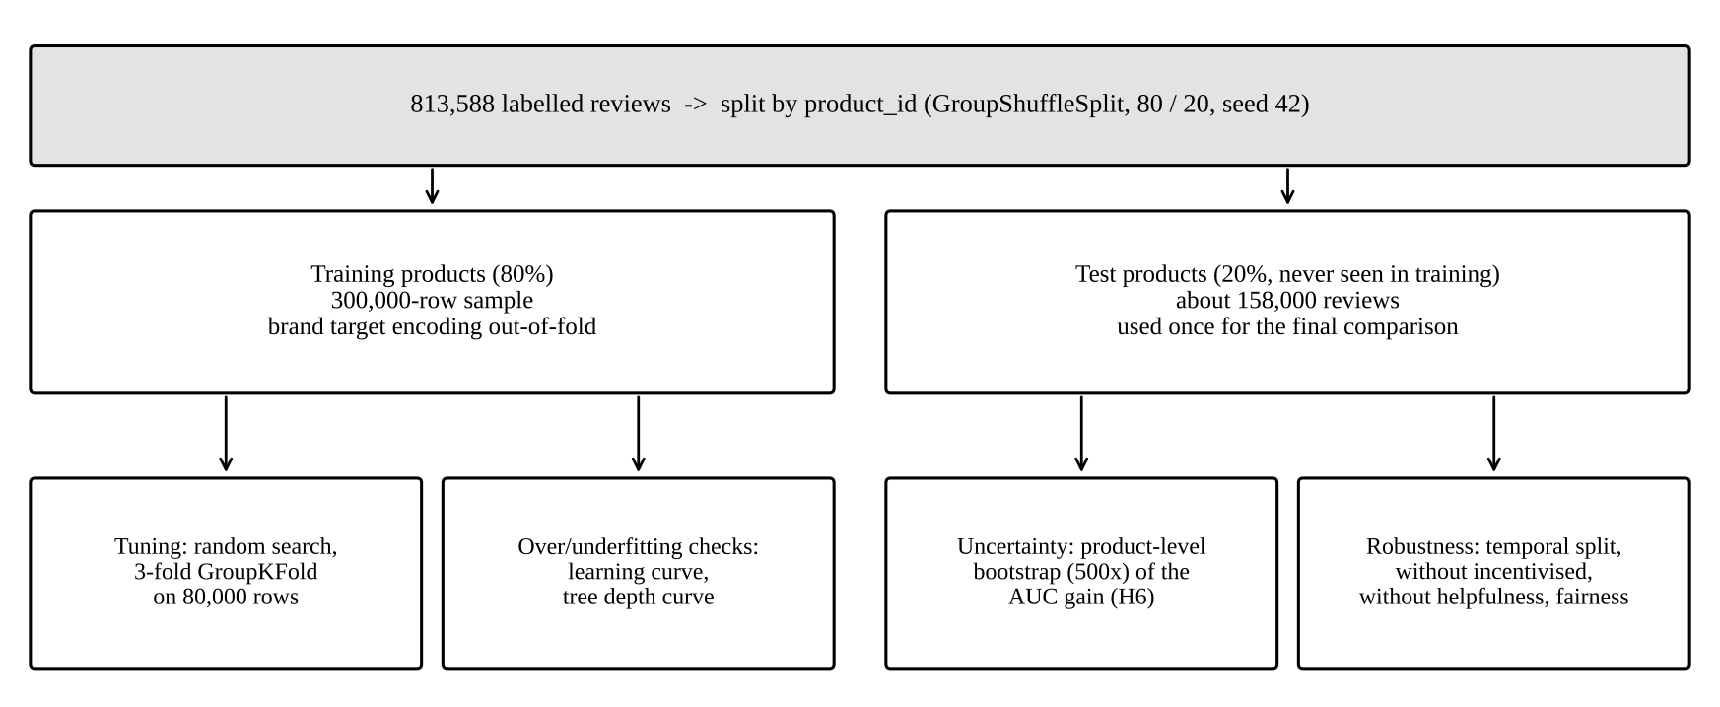
Figure 2: Validation design
Figure 2 shows the validation design. Its central rule is that the test products are touched only once, at the end. All tuning decisions are made with cross-validation inside the training products.
- Product-grouped hold-out. 20% of products, with all their reviews, are held out. A score on these products shows how the model would perform on a product it has never seen, which is the realistic use case for a new launch.
- Grouped cross-validation for tuning. Each candidate setting is scored with 3-fold GroupKFold on an 80,000-row training sample, again keeping each product in one fold. The script records both the training and validation AUC for every setting (cv_tuning_results.csv), so the gap between them, which indicates overfitting, is visible.
- Bootstrap confidence interval for H6. Products in the test set are resampled 500 times with replacement, and the AUC gain is recalculated each time. Resampling whole products, not single reviews, respects the fact that reviews of the same product are related. H6 is supported if the 95% interval for the gain over the 0.5 baseline lies entirely above zero. The same method tests whether the best model is genuinely better than logistic regression.
- Temporal validation. The model is trained on the oldest 80% of reviews and tested on the newest 20%. This checks that the model still works as customer behaviour changes over time.
- Sensitivity and leakage checks. The model is re-run without incentivised reviews, without helpfulness votes (which arrive after a review is posted), without loves_count (measured at collection time), and without any text features (the situation of scoring a shopper before they write a review).
- Fairness check. ROC-AUC and recall of unhappy customers are compared across skin types and skin tones (groups with at least 500 test reviews). The target from Week 2 is a recall gap of no more than 0.10 between groups.
- Calibration check. Predicted probabilities are grouped into ten bins and compared with the observed recommend rate, to check that the scores can be read as probabilities.

10. Pitfalls, Overfitting and Underfitting
Underfitting means a model is too simple to capture the real pattern: it scores poorly on both training and test data. Overfitting means a model learns noise in the training data: it scores very well on training data but worse on new data. The script produces two diagnostic charts for this. The tree depth curve trains decision trees from depth 1 to unlimited and plots training and test AUC: shallow trees underfit (both scores low), and very deep trees overfit (training AUC near 1.0 while test AUC falls). The learning curve trains gradient boosting on 5,000 to 300,000 rows. If the gap between training and test AUC narrows as data grows, more data is helping; if test AUC has flattened, the model needs better features rather than more rows.
Table 6: Pitfalls and mitigations
Pitfall | Warning sign | Mitigation in this project
Overfitting (deep trees, too many boosting rounds) | Train AUC far above validation AUC | Tuned max_depth and min_samples_leaf; L2 regularisation; early stopping; averaging in random forest
Underfitting (linear model, shallow tree) | Both train and test AUC low | Engineered interactions; non-linear tree ensembles; learning curve
Memorising products | Excellent random-split score, poor on new products | Split and cross-validate by product_id
Target leakage | Suspiciously high scores | rating never used; prior-only features; out-of-fold brand encoding; with/without helpfulness and loves_count
Class imbalance | High accuracy, near-zero recall of unhappy customers | class_weight='balanced'; minority-class metrics; threshold tuning
Tuning on the test set | Optimistic final score | Test products used once; tuning by GroupKFold on training data
Concept drift over time | Lower score on recent reviews | Temporal validation; plan to retrain regularly
Biased labels (incentivised reviews) | Model learns gifted-review style | Re-run without incentivised reviews
Keyword errors ('not greasy') | Themes as common in good as in bad reviews (Week 4) | Negation-aware theme patterns in Week 5
Unfair performance across groups | Lower recall for some skin types or tones | Fairness table; gap target of 0.10
Too many comparisons | One model wins by luck | Bootstrap confidence intervals for the AUC gain

10.1 Negation-aware complaint themes
Week 4 showed that keyword flags counted 'not greasy' as a greasiness complaint. The Week 5 script removes negated mentions before matching, by deleting any theme word that follows 'not', 'no', 'never', 'without', 'didn't' and similar words within three words, and by removing phrases like 'fragrance-free'. The before and after shares are saved in negation_theme_check.csv.
NEGATORS = r"(?:not|no|never|without|isn.t|wasn.t|doesn.t|didn.t|don.t|zero|nor)"
text = text.str.replace(r'(fragrance|scent|perfume|alcohol|oil)[\s-]*free', ' ', regex=True)
cleaned = text.str.replace(rf'\b{NEGATORS}\b(?:\W+\w+){{0,2}}?\W+(?:{pattern})\w*', ' ', regex=True)
df['theme_greasy'] = cleaned.str.contains(pattern) # 'not greasy at all' no longer counts

11. Interpreting Model Outcomes for the Business
A model only creates value if its outputs lead to action. The script produces three levels of explanation.
- Global drivers: permutation importance measures how much the test AUC drops when each feature is randomly shuffled. A large drop means the model relies on that feature. Logistic regression odds ratios show direction: for example, whether each extra point of the product's earlier average rating raises the odds of recommending.
- Readable rules: a depth-3 decision tree is written out as if-then rules (decision_tree_rules.txt) that a category manager can read without any statistics.
- Segment view: performance and predicted risk by skin type, skin tone, category and product segment show where the model is most and least reliable, and which customer groups carry the most risk.
Table 7: From model output to business action
Model output | Business action | Owner
High probability that a reviewer will not recommend | Customer service contacts them with advice or an alternative product before they leave the brand | Customer care, CRM
Top permutation-importance drivers (e.g. 'no effect' theme, early ratings) | Focus product claims and education on visible results; set realistic expectations on product pages | Marketing, product development
Early-warning flag: forecast drop of 10+ points | Investigate the formula or targeting before scaling advertising; adjust which shoppers the product is recommended to | Launch and e-commerce teams
Lower predicted satisfaction for a skin type in a category | Change on-site recommendations and add suitability labels such as 'best for dry skin' | Merchandising, recommendation engine
Large difference with and without incentivised reviews | Review the free-sample programme for that brand | Trust and safety, marketing
Fairness gap across skin tones | Collect more reviews from under-represented groups before using the model for those customers | Data science, inclusion
Choosing the threshold in business terms: if a follow-up costs about USD 1 (an automated e-mail) and a lost customer costs about USD 50 in future purchases, catching one more unhappy customer is worth up to 50 unnecessary e-mails. In that case the business should choose a threshold with high recall, even at lower precision. These cost figures are illustrative; the threshold table lets a business plug in its own costs.

12. Results on the Full Dataset
I ran week5_modeling.py on the full data: 300,000 training reviews and 158,628 test reviews from products the models had never seen. This section reports the results and compares them with the predictions made in Section 8.

12.1 Model comparison (Task 1)
Table 8: Test-set results for the tuned models (threshold 0.5)
Model (best settings) | ROC-AUC | PR-AUC not rec. | Macro F1 | Accuracy | Precision not rec. | Recall not rec. | Train time
Majority baseline | 0.500 | 0.158 | 0.457 | 0.843 | 0.000 | 0.000 | -
Logistic regression (C = 0.01) | 0.875 | 0.609 | 0.715 | 0.804 | 0.432 | 0.776 | 9 s
Decision tree (depth 12, leaf 200) | 0.868 | 0.599 | 0.692 | 0.777 | 0.397 | 0.797 | 14 s
Random forest (depth 10, leaf 50, 30% features) | 0.880 | 0.623 | 0.713 | 0.800 | 0.428 | 0.788 | 65 s
Gradient boosting (15 leaves, rate 0.12, L2 = 1) | 0.897 | 0.668 | 0.726 | 0.809 | 0.443 | 0.817 | 31 s
Gradient boosting is the best model on every metric that focuses on unhappy customers. It finds 82% of them (recall 0.817), and 44% of the customers it flags really are unhappy, compared with a 16% base rate. It also trains in about half a minute. Note that the baseline has the highest accuracy (84.3%) while finding no unhappy customers at all, which shows exactly why accuracy was not used to choose the model. Tuning chose strong regularisation for every model: C = 0.01 for logistic regression, a minimum of 200 reviews per leaf for the tree, depth 10 for the forest and small 15-leaf trees for boosting. In other words, the simpler settings generalised best to new products.

12.2 H6 and the bootstrap test
Table 9: Product-level bootstrap (500 resamples of test products)
Comparison | Mean AUC gain | 95% confidence interval | Conclusion
Gradient boosting vs majority baseline | +0.396 | 0.391 to 0.402 | H6 supported
Gradient boosting vs logistic regression | +0.022 | 0.020 to 0.024 | Boosting genuinely better
Neither interval comes close to zero, so H6 is strongly supported, and the advantage of gradient boosting over logistic regression is not due to chance. The gain over logistic regression is modest (+0.022), which supports the plan to keep logistic regression as the explainer: it gives up little accuracy in exchange for directly readable effects.

12.3 Predictions versus results
Table 10: Predictions from Section 8 compared with actual results
Model or check | Predicted | Actual | Verdict
Logistic regression | 0.87 to 0.88 | 0.875 | Correct
Decision tree | 0.83 to 0.87 | 0.868 | Correct (top of range)
Random forest | 0.88 to 0.90 | 0.880 | Correct (bottom of range)
Gradient boosting (best) | 0.89 to 0.91 | 0.897 | Correct; best as predicted
Without text features | About 0.75 | 0.791 | Better than expected (negation-aware themes and tuning)
Without helpfulness votes | Drop of 0.00 to 0.02 | Drop of 0.013 | Correct
Temporal split | Slightly lower | 0.905 (higher) | Wrong; see 12.4
Early warning beats naive rule | Yes | RMSE 9.0 vs 13.0 | Correct

12.4 Robustness and leakage checks
Table 11: Gradient boosting under different conditions
Check | ROC-AUC | PR-AUC not rec. | Recall not rec. | Brier
Reference: all features, product split | 0.896 | 0.666 | 0.820 | 0.131
Without helpful_wilson | 0.883 | 0.631 | 0.808 | 0.140
Without log_loves | 0.895 | 0.664 | 0.821 | 0.132
No text features | 0.791 | 0.431 | 0.737 | 0.188
Excluding incentivised reviews | 0.893 | 0.684 | 0.820 | 0.134
Temporal: train before 6 April 2022, test after | 0.905 | 0.668 | 0.813 | 0.117
- Leakage: removing loves_count changes nothing (0.896 to 0.895), so the popularity snapshot is not leaking information. Removing helpfulness votes costs 0.013 AUC. Because votes arrive after a review is posted, a model that scores reviews the moment they are written should drop this feature and accept AUC 0.883. A model used for later analysis can keep it.
- Without text: AUC 0.791 means that product, price, social-proof and reviewer-history features alone still identify many likely-unhappy shoppers. This version could score a shopper before they write anything, for example to choose who receives a follow-up e-mail.
- Incentivised reviews: results are almost unchanged without them (0.893), and PR-AUC is slightly higher, so gifted reviews do not distort the model.
- Temporal check (prediction wrong): I expected a lower score on the newest 20% of reviews, but it was higher (0.905). The likely reason is that this test is split by time, not by product: most recent reviews belong to products already in the training data, and by then those products have long review histories, which makes the social-proof features more informative. The temporal test is therefore not directly comparable with the product split. It does show that the model does not get worse on recent data, so there is no sign of harmful drift.
- Calibration: class_weight='balanced' improves recall but shifts the predicted probabilities upwards for unhappy customers. As a result, logistic regression's Brier score (0.142) is worse than the baseline's (0.133). The scores rank customers well but should not be read as exact probabilities until they are recalibrated, for example with isotonic calibration (CalibratedClassifierCV), which is planned for the Week 6 dashboard.

12.5 Overfitting and underfitting
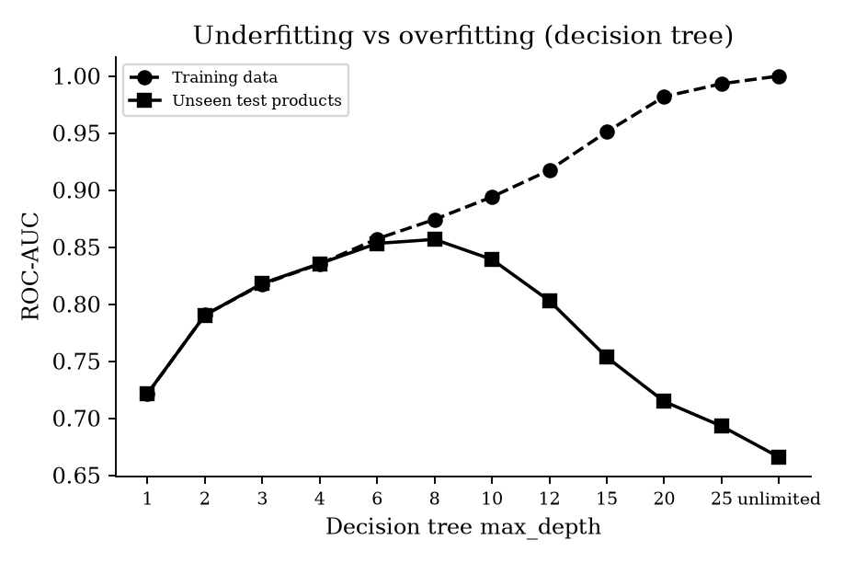
Figure 3: Decision tree training and test AUC by maximum depth
Figure 3 shows both problems clearly. With depth 1 the tree underfits: training and test AUC are both 0.72. Up to depth 6 the two lines move together, so the tree is learning real patterns. Test AUC peaks at depth 8 (0.857), and after that training AUC keeps rising while test AUC falls. An unlimited tree scores a perfect 1.000 on training data but only 0.666 on new products, because it has memorised the training reviews. Tuning avoided this by combining depth 12 with at least 200 reviews per leaf, which reached 0.868 on the test set, higher than any depth-only tree. This is the same mechanism that the random forest's averaging and boosting's small trees and early stopping use to control overfitting.

12.6 What drives the predictions
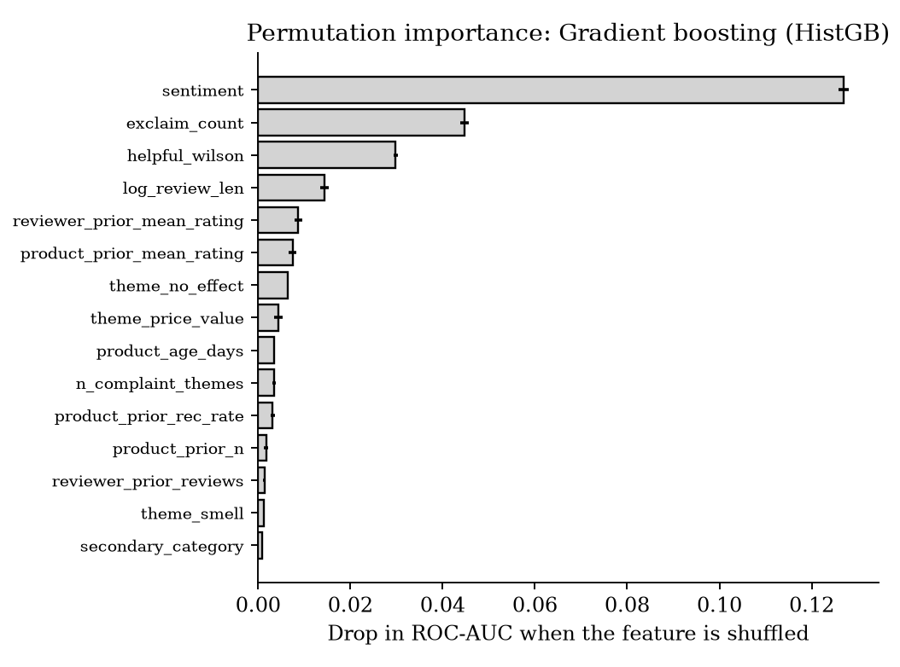
Figure 4: Permutation importance for gradient boosting (drop in test ROC-AUC when a feature is shuffled)
Sentiment is by far the most important feature: shuffling it lowers AUC by 0.127. It is followed by exclamation count (0.045), helpfulness (0.030) and review length (0.015). Next come the reviewer's own past average rating and the product's earlier average rating (about 0.008 each), and then the 'no effect' and 'price/value' complaint themes. Price, brand and skin type barely appear. This matches the Week 2 and Week 4 findings: what customers feel and say matters far more than what the product costs or who they are.
The depth-3 tree turns this into rules that a manager can read (decision_tree_rules.txt; leaf weights are class-balanced):
- Rule 1: if sentiment is 0.25 or below and the review has received helpfulness votes, predict 'not recommended' (about 90% of the balanced weight in that leaf).
- Rule 2: if sentiment is above 0.62, the review contains at least one exclamation mark and nobody has voted on it, predict 'recommended' (about 91%).
- Rule 3: moderately positive reviews without exclamation marks are mixed and are where most errors occur. This is where the full model's extra features earn their place.
The rules also reveal a pattern: reviews that receive helpfulness votes lean towards 'not recommended'. Shoppers seem to find critical reviews more useful, which is why helpfulness ranks so highly and why its timing matters (Section 12.4).

12.7 Fairness
Recall of unhappy customers ranges from 0.812 to 0.849 across skin types (largest gap 0.038) and from 0.777 to 0.828 across skin tones (largest gap 0.051). AUC ranges from 0.883 to 0.922. All gaps are well within the 0.10 target. The lowest recall is for the 'rich' (0.777, 921 test reviews) and 'deep' (0.798, 3,604 reviews) skin tones, which are also the groups with the fewest reviews. The model is acceptable for all groups, but these two should be monitored, and collecting more reviews from deeper skin tones would make the model more reliable for them.

12.8 Negation-aware themes
Table 12: Effect of ignoring negated mentions ('not greasy', 'fragrance-free')
Theme | Share before | Share after | Lift before (Week 4) | Lift after
Greasy | 20.0% | 14.2% | 0.93 | 1.32
Irritation | 15.7% | 12.3% | 1.14 | 1.42
Breakout | 15.6% | 14.4% | 1.45 | 1.52
Dryness | 21.4% | 18.9% | 0.96 | 1.06
Smell | 25.1% | 22.5% | 0.88 | 0.92
Handling negation removed many false complaints. Most clearly, 'greasy' changed from a theme that looked more common in happy reviews (lift 0.93) to a genuine complaint signal (lift 1.32). Irritation and breakout also became sharper. Smell is still more common in positive reviews, because customers often praise scent ('smells amazing'). Separating positive from negative mentions would need sentence-level sentiment, which is a sensible next improvement.

12.9 Task 2: Early-warning regression
Table 13: Forecasting the later recommend rate of 1,576 products (5-fold cross-validation by product)
Model | RMSE (points) | MAE (points) | R-squared | Spearman
Mean only (predict the average product) | 10.98 | 8.57 | 0.000 | -
Naive: later rate = early rate | 12.98 | 9.75 | -0.398 | 0.50
Ridge regression | 9.22 | 6.96 | 0.294 | 0.57
Random forest regressor (best) | 9.01 | 6.69 | 0.327 | 0.61
Gradient boosting regressor | 9.31 | 6.81 | 0.280 | 0.59
Trusting early reviews is worse than ignoring them. The naive rule, which assumes later buyers will be as happy as the first 20 reviewers, has a larger error (RMSE 13.0 points) than simply predicting the average product (11.0 points). This confirms the Week 4 finding that early reviews are optimistic. The random forest, which learns how much to discount early reviews using sentiment, incentivised share, complaint themes and reviewer habits, cuts the error to 9.0 points: 31% less than the naive rule and 18% less than the average. It explains about a third of the differences between products (R-squared 0.33). That is modest, but useful for an alert that only needs to rank products by risk.
Table 14: Early-warning alerts (forecast drop of more than 10 points)
Measure | Value | Meaning
Products evaluated | 1,576 | Products with 50+ reviews
Products that really fell by 10+ points | 429 (27%) | More than a quarter of products disappoint later buyers
Products flagged by the model | 465
Alert precision | 56% | Just over half of alerts are correct, 2.1 times the 27% base rate
Alert recall | 61% | Six in ten real drops are caught after only 20 reviews
For a launch team, this means that after the first 20 reviews, a model can point to a short list of products that deserve a closer look, and more than half of them will turn out to be real problems. The Week 4 Lumen Lab scenario is therefore realistic: more than one in four products lose at least 10 points of recommend rate after the early reviews.

12.10 Business conclusions
- Use gradient boosting to score reviews and flag likely-unhappy customers for follow-up. Use the version without helpfulness votes for real-time scoring (AUC 0.883).
- Use the no-text version (AUC 0.791) to choose shoppers for proactive help before they write a review.
- Run the early-warning model after each new product's 20th review, and review flagged launches before increasing advertising spend.
- Focus product messages on visible results and value: 'no effect' and 'price/value' are the strongest complaint drivers in the model.
- Monitor model performance for rich and deep skin tones, and recalibrate probabilities before showing them as percentages on the dashboard.

13. Next Steps
Table 15: Plan for the final week
Week | Tasks | Output
Week 5 (this week) | Done: full run, results compared with predictions (Section 12). Remaining: recalibrate probabilities; decide whether the production model keeps helpfulness votes | Model comparison, validation and robustness results
Week 6 | Dashboard showing at-risk customers, early-warning flags and driver charts; final recommendations; final report; tidy GitHub repository with a full README | Dashboard, final report, complete repository

14. Conclusion
This report connects the Week 1 business problem to two predictive tasks: classifying whether a customer will recommend a product, and forecasting a new product's later satisfaction from its first 20 reviews. The data's size, class imbalance, mixed feature types, product grouping and need for explanation led to four classification candidates: logistic regression, a decision tree, a random forest and gradient boosting. Each is described with its mechanism, its strengths and weaknesses in this context, and the settings tuned. For the regression task, ridge regression and two tree-ensemble regressors are compared with simple baselines using RMSE, MAE and R-squared. The evaluation focuses on unhappy customers through ROC-AUC, PR-AUC, recall, precision, calibration and threshold choice, and predictions were written down before the results were seen. Validation splits by product, tunes with grouped cross-validation, uses a product-level bootstrap for H6, and adds temporal, leakage, sensitivity and fairness checks, while depth and learning curves expose underfitting and overfitting. Finally, the report explains how model outputs become actions for customer care, marketing, launch teams and merchandising. On the full data, gradient boosting was the best classifier (ROC-AUC 0.897, catching 82% of unhappy customers). Its gain over the baseline (+0.396, 95% CI 0.391 to 0.402) strongly supports H6, and its gain over logistic regression (+0.022) is also statistically clear. The model is fair across skin types and tones (recall gaps of 0.05 or less) and holds up over time. The early-warning random forest cut the forecast error by 31% compared with trusting early reviews, and its alerts are right 56% of the time, against a 27% base rate.

References
Breiman, L. (2001) 'Random forests', Machine Learning, 45(1), pp. 5-32.
Davis, J. and Goadrich, M. (2006) 'The relationship between precision-recall and ROC curves', Proceedings of the 23rd International Conference on Machine Learning, pp. 233-240.
Efron, B. and Tibshirani, R.J. (1993) An Introduction to the Bootstrap. New York: Chapman and Hall.
Friedman, J.H. (2001) 'Greedy function approximation: a gradient boosting machine', Annals of Statistics, 29(5), pp. 1189-1232.
Grinsztajn, L., Oyallon, E. and Varoquaux, G. (2022) 'Why do tree-based models still outperform deep learning on typical tabular data?', Advances in Neural Information Processing Systems 35.
Hastie, T., Tibshirani, R. and Friedman, J. (2009) The Elements of Statistical Learning. 2nd edn. New York: Springer.
Inky, N. (2023) Sephora Products and Skincare Reviews [dataset]. Kaggle. Available at: https://www.kaggle.com/datasets/nadyinky/sephora-products-and-skincare-reviews
Kaufman, S., Rosset, S. and Perlich, C. (2012) 'Leakage in data mining: formulation, detection, and avoidance', ACM Transactions on Knowledge Discovery from Data, 6(4).
Ke, G. et al. (2017) 'LightGBM: a highly efficient gradient boosting decision tree', Advances in Neural Information Processing Systems 30.
Pedregosa, F. et al. (2011) 'Scikit-learn: Machine learning in Python', Journal of Machine Learning Research, 12, pp. 2825-2830.
Saito, T. and Rehmsmeier, M. (2015) 'The precision-recall plot is more informative than the ROC plot when evaluating binary classifiers on imbalanced datasets', PLoS ONE, 10(3).

Appendix A: Script Functions and Outputs
Function | What it does and saves in output/week5/
build_data(), negation_aware_themes() | Week 4 features, negation-aware themes, product segments (negation_theme_check.csv)
split(), tune() | Product-grouped split; random search with 3-fold GroupKFold (cv_tuning_results.csv)
classification() | Fits and tests all four models (model_comparison.csv, fig_roc_pr_curves)
bootstrap_h6() | Product-level bootstrap of AUC gains (bootstrap_h6.csv)
threshold_analysis(), calibration() | threshold_table.csv, confusion_matrix.csv, calibration_table.csv, fig_confusion_matrix, fig_calibration
fairness(), importance(), tree_rules() | fairness_by_group.csv, permutation_importance.csv, fig_permutation_importance, decision_tree_rules.txt
learning_curve(), depth_curve() | learning_curve.csv, tree_depth_curve.csv, fig_learning_curve, fig_tree_depth_curve
robustness_checks() | Temporal, no-text, no-helpfulness, no-loves, no-incentivised runs (robustness_checks.csv)
early_warning() | Task 2 regression (early_warning_regression.csv, early_warning_alerts.csv, fig_early_warning)

python src/week5_modeling.py # from the project folder; needs Week 3 and Week 4 outputs

