Exploratory Data Analysis and Feature Engineering
Project: What Drives Customer Satisfaction and Recommendation in Skincare?
Week 4 Task Report
Data Science with Python Analyst Internship (Beauty and Wellness)
Prepared by: Sarthak Sameer Gharat
Week: Week 4 of 6
Submission date: 17 October 2026
Code: src/week4_eda_features.py (GitHub: sarthak-debug/skincare-recommendation-analysis)

Contents
1. Introduction
2. Starting Point: What We Already Know
3. EDA Objectives and Business Questions
4. EDA Workflow
5. Basic EDA Techniques
6. Advanced EDA for Multi-Dimensional Data
7. Statistical Methods
8. Visualisation Plan and Python Libraries
9. Feature Engineering Plan
10. Feature Engineering Processes with Examples
11. Preventing Data Leakage
12. How the Features Improve Insights and Model Accuracy
13. Results on the Full Dataset
14. Hypothetical Decision Scenario
15. Next Steps
16. Conclusion
References
Appendix A: Script Functions and Outputs

1. Introduction
The aim of this project is to understand what drives customer satisfaction and recommendation in skincare, and to predict whether a customer will recommend a product. In Week 3 I built a cleaning pipeline that turned 1,094,411 raw Sephora reviews into 971,500 genuine reviews, with all ten validation checks passing. This week I explore that clean data in depth and create new features that capture customer behaviour and market patterns that the raw columns do not show directly.
The report has two connected halves. The first half (Sections 3 to 8) sets out the EDA plan: the business questions, the workflow, the basic and advanced techniques, the statistical tests and the visualisations, with the Python libraries used for each. The second half (Sections 9 to 13) covers feature engineering: a catalogue of new variables, worked examples of transformations, safeguards against data leakage, a design for measuring how much each group of features improves the model, and a hypothetical business scenario that shows how the features support better decisions.
Everything described here is implemented in one script, week4_eda_features.py, in my GitHub repository. It produces 33 output tables and charts and a feature dataset for Week 5. It was tested end to end on a 40,000-review test file and then run on the full clean dataset; the real results are in Section 13.

2. Starting Point: What We Already Know
The EDA builds on facts measured in Weeks 2 and 3. These shape which techniques are appropriate.
Table 1: Facts from earlier weeks that shape the EDA
Fact (measured) | Consequence for EDA and features
971,500 clean reviews of 8,494 products | Large sample: almost every test will be 'significant', so effect sizes must lead the interpretation
About 84% of clean reviews recommend the product (84.2% in Week 4) | Imbalanced target: use recommend rate and low-rating share, not just means; use ROC-AUC and macro F1 for models
Price skew 4.1, price per mL skew 19.4, helpfulness votes skew 69.9 | Use medians, log scales and rank-based (Spearman, Kruskal-Wallis) methods
Price, skin type and exclusivity had negligible effects in Week 2 | Single factors explain little; look for interactions and segments instead
Week 2 model without text: ROC-AUC 0.549 vs 0.50 baseline | Structured features alone are weak; text and behaviour features are needed
12.5% of reviews flagged as incentivised | Every test is repeated without them (sensitivity check)
11.2% of raw rows were syndicated copies (removed) | Product-level counts are now reliable for review-history features

3. EDA Objectives and Business Questions
EDA is most useful when each analysis answers a question that someone in the business cares about. Table 2 links each EDA question to the team that would use the answer.
Table 2: EDA questions and who uses the answer
# | Question | Analysis | Business user
Q1 | Which skin types are least satisfied, and in which product categories? | Skin type x category heatmap | Product development, merchandising
Q2 | Do customers get better value from premium products, once pack size is considered? | Price per mL vs rating, by category | Pricing
Q3 | What do unhappy customers complain about, and does it differ by skin type? | Complaint theme lift; themes by skin type | R&D, customer service
Q4 | Do early reviews influence later ones (herding)? | Rating by review position; prior mean vs rating | Launch and e-commerce teams
Q5 | Are incentivised reviews more positive? | Recommend rate and rating with and without the flag | Marketing, trust and safety
Q6 | Are there natural groups of products with different satisfaction? | PCA and k-means product segments | Category management
Q7 | Is satisfaction changing over time or by season? | Monthly trend, seasonality | Planning, marketing calendar
Q8 | Which features carry the most information about recommendation? | Mutual information, model ablation | Data science (Week 5)

4. EDA Workflow
Figure 1 shows the order of the analysis. It moves from simple to complex. Single variables are understood first, then pairs, then many variables together, and finally time and text. Feature engineering comes after the EDA because the features are built from patterns the EDA uncovers. The last stage measures whether each new feature actually helps, and this can send me back to engineer better features.
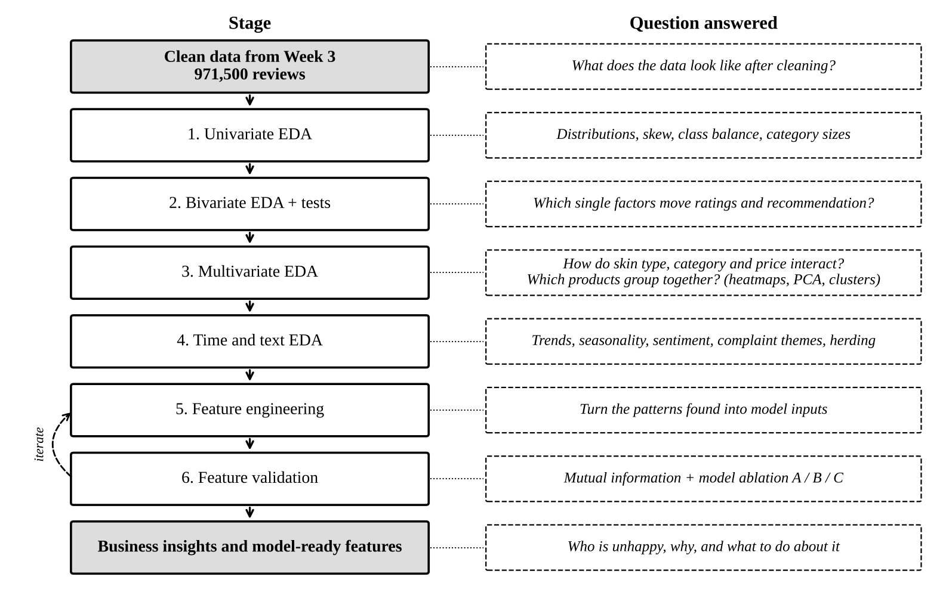
Figure 1: EDA and feature engineering workflow

5. Basic EDA Techniques

5.1 Univariate analysis
Each variable is summarised on its own. For numeric variables the script reports count, mean, standard deviation, 5th, 25th, 50th, 75th and 95th percentiles, skewness and kurtosis (univariate_numeric.csv). For categorical variables it reports counts and shares of each level (univariate_categorical.csv). The purpose is to check the shape of each variable before comparing them. For example, it shows whether a log scale is needed, whether some categories are too small to analyse, and how imbalanced the target is.

5.2 Bivariate analysis
Each candidate driver is compared with the outcomes: rating, recommend rate and the share of 1 to 2 star reviews. Groups with fewer than 200 reviews are hidden so that small groups do not create false patterns.
Table 3: Basic EDA techniques
Technique | Variables | Statistic | Chart
Distribution | rating, price, price per mL, length, sentiment | Percentiles, skew, kurtosis | Histogram (log axis), box plot
Frequency | skin type, tone, category, price band | Counts, shares | Sorted bar chart
Group comparison | Recommend rate by skin type, category, price band, segment, incentivised | Rate with 95% CI, chi-square | Bar chart, grouped bar chart
Numeric vs ordinal | Length, sentiment by star rating | Kruskal-Wallis, medians | Box plot per rating level
Pairwise correlation | All numeric features | Spearman rho | Correlation heatmap
Ranking | Brands with 500+ reviews | Recommend rate | Top 10 / bottom 10 table

6. Advanced EDA for Multi-Dimensional Data
The Week 2 results showed that single factors explain very little. The most valuable patterns are therefore likely to be combinations, such as a product type that works for dry skin but not for oily skin. These techniques look at many dimensions at once.
Table 4: Advanced EDA techniques
Technique | How it works | Why it suits this data
Two-way heatmap | Recommend rate for every skin type x category cell (min 200 reviews), shown as percentage points above or below the overall rate | Finds pockets of dissatisfaction that averages hide (Q1)
Principal Component Analysis (PCA) | Combines correlated product features (price, price per mL, popularity, ingredients, review count) into 2 components | Shows the main ways products differ and lets 8,494 products be plotted on one chart
K-means clustering | Groups products into k segments; k chosen from 3 to 7 by the highest silhouette score | Creates product segments for Q6 and a segment feature for the model
Mutual information | Measures how much knowing a feature reduces uncertainty about recommendation; captures non-linear links | Ranks old and new features on the same scale (Q8)
Interaction analysis | Compares a pattern within subgroups, e.g. fragrance effect for oily vs dry skin | Tests the idea that suitability depends on skin type
Time series | Monthly volume, mean rating and incentivised share; average by calendar month; 6-month moving average | Shows trends and seasonality (Q7)
Text EDA | VADER sentiment; 10 complaint and praise themes found with keyword patterns; lift of each theme in 1-2 vs 4-5 star reviews | Explains why customers are unhappy (Q3)
Herding analysis | Rating by position in the product's review history; correlation of the earlier average with the new rating | Tests for social influence (Q4)
Sensitivity analysis | Repeats every test without incentivised reviews | Checks that results do not depend on biased reviews (Q5)
Why both PCA and clustering: PCA reduces dimensions so that the structure can be seen, while k-means assigns each product to a group. Using them together means each segment can be shown on the PCA chart and also described in a profile table (median price, popularity, share exclusive, satisfaction). Features are standardised before both methods, because they are distance-based and would otherwise be dominated by loves_count, which runs into the hundreds of thousands. The target (recommendation) is deliberately not used to build segments, so the segments can be used fairly as a model feature.

7. Statistical Methods
Because ratings are ordinal and most variables are skewed, rank-based tests are the default. Every result is reported with an effect size and a Bonferroni-corrected p-value. With nearly one million rows, a p-value below 0.05 only shows that an effect is not zero; the effect size shows whether it matters.
Table 5: Statistical methods used in the EDA
Question type | Test | Effect size (meaningful if) | Used for
Two numeric or ordinal variables | Spearman correlation | rho: 0.1 small, 0.3 medium | H1 price and price per mL vs rating; H4 sentiment vs rating; herding
Ordinal outcome across 3+ groups | Kruskal-Wallis + Dunn post-hoc | epsilon squared: 0.01 small | H2 skin type; H5 length across 5 ratings
Two numeric groups | Mann-Whitney U | Rank-biserial r: 0.1 small | Early vs later reviews
Two categorical variables | Chi-square test of independence | Cramer's V: 0.1 small | H3 exclusivity; H4 sentiment class vs rating group
Agreement between two labels | Cohen's kappa | 0.4 moderate, 0.6 substantial | Does text sentiment agree with star rating?
Proportions in groups | Recommend rate with Wilson 95% CI | Difference of 2+ percentage points | Group comparisons, heatmap
Feature relevance | Mutual information | Relative ranking | Feature selection
Multiple tests | Bonferroni correction | - | All hypothesis tests

8. Visualisation Plan and Python Libraries
All charts are produced in black, white and grey, with hatching where needed, so that they print clearly and stay readable without colour. Table 6 lists each chart and the library that produces it.
Table 6: Visualisation plan
Chart (output file) | Library and function | Insight sought
Recommend rate by price band and skin type (fig_recommend_price_skin) | pandas pivot_table + Matplotlib bar | Does value perception differ by skin type?
Skin type x category heatmap (fig_heatmap_skin_category) | Matplotlib imshow with cell labels | Where are the pockets of dissatisfaction?
Sentiment by star rating (fig_sentiment_by_rating) | Matplotlib boxplot; SciPy spearmanr | H4: does text match stars?
Review length by star rating (fig_length_by_rating) | Matplotlib boxplot; SciPy kruskal | H5 re-tested across 5 levels
Complaint themes, low vs high reviews (fig_theme_lift) | Matplotlib barh | Why customers are unhappy
Monthly volume and rating (fig_monthly_trend) | Matplotlib bar + twin-axis line, rolling mean | Trends and seasonality
Rating by review position (fig_rating_by_position) | Matplotlib line | Herding: do early reviewers differ?
Product segments (fig_product_segments_pca) | scikit-learn PCA, KMeans; Matplotlib scatter with marker shapes | Natural product groups
Correlation of engineered features (fig_spearman_engineered) | pandas corr('spearman'); Matplotlib imshow | Redundant features; multicollinearity
Top 20 features by mutual information (fig_mutual_information) | scikit-learn mutual_info_classif; Matplotlib barh | Which features matter most

8.1 Why these libraries
- pandas: groupby, pivot_table and crosstab produce every summary table in one line, and they work directly on a million rows.
- Matplotlib: gives full control over hatching, marker shapes and greyscale, which is needed for print-friendly charts. Every chart is saved by the script, so the figures can be recreated exactly.
- Seaborn: useful for quick exploration in a notebook (sns.boxplot, sns.heatmap, sns.pairplot on a sample). Final report charts use Matplotlib directly for consistent styling.
- SciPy (scipy.stats): spearmanr, kruskal, mannwhitneyu and chi2_contingency for the tests in Table 5.
- scikit-learn: PCA, KMeans, silhouette_score, mutual_info_classif, cohen_kappa_score, and the model pipeline for feature validation.
- vaderSentiment: a rule-based sentiment scorer built for short social media text. It needs no training data, understands capitals, exclamation marks and negation, and scores about a million reviews in roughly ten minutes on a laptop.

8.2 Example: the skin type x category heatmap
g = df.groupby(['skin_type', 'secondary_category'])['is_recommended'].agg(['mean', 'size'])
g = g[g['size'] >= 200] # hide small cells
diff = (g['mean'].unstack() - df['is_recommended'].mean()) * 100 # pp vs overall

fig, ax = plt.subplots(figsize=(9, 3.4))
im = ax.imshow(diff, cmap='Greys_r', vmin=-lim, vmax=lim) # dark = worse
for i, j in cells: ax.text(j, i, f'{diff.iat[i, j]:+.1f}', ha='center')
fig.colorbar(im, label='percentage points vs overall')

Showing each cell as the difference from the overall recommend rate, rather than the raw rate, makes problem areas stand out immediately. With an 83% overall rate, a cell at 78% is easy to miss among raw percentages, but '-5.0' is not.

9. Feature Engineering Plan
The new features are grouped into eight families. Each one is designed to capture a hidden part of customer behaviour or the market that the raw columns do not show. Table 7 lists them with their formulas and the reason for each.
Table 7: Feature catalogue
Family | Feature | How it is built | Hidden behaviour captured
Price and value | price_rel_category | price / median price of the category | Is this premium for its type? (a USD 60 serum vs a USD 60 cleanser)
 | ppm_rel_category | price per mL / category median | Value for money independent of pack size
 | premium_tier | value (<0.75), mid, premium (>1.33) | Simple segment for marketing
Brand | brand_price_level, brand_n_products | log median brand price; number of products | Luxury vs mass brand positioning; brand breadth
 | brand_te | Smoothed out-of-fold brand recommend rate | Brand reputation (see Section 10.3)
Social proof (herding) | product_prior_n | Number of earlier reviews of the product | Product maturity and popularity at the time of review
 | product_prior_mean_rating, product_prior_rec_rate | Average of earlier reviews only | What the customer saw before buying; herding
 | is_early_review | One of the first 10 reviews | Early adopters and launch-period effects
Reviewer behaviour | reviewer_prior_reviews | Number of earlier reviews by the same reviewer | Experienced vs first-time reviewers
 | reviewer_prior_mean_rating | Reviewer's earlier average rating | Generous vs harsh reviewers (personal rating style)
 | is_first_review | No earlier reviews | One-off reviewers who may only write when very happy or upset
Text and sentiment | sentiment | VADER compound score (-1 to +1) | Emotional tone beyond the star rating
 | theme_* (10 flags), n_complaint_themes | Keyword patterns: breakout, irritation, dryness, greasy, smell, texture, packaging, value, no effect, repurchase | Why the customer is happy or unhappy
 | exclaim_count, caps_ratio | Count of '!'; share of capital letters | Intensity of emotion
Ingredient x skin | oily_x_fragrance, oily_x_salicylic, dry_x_hyaluronic, dry_x_alcohol | Skin type flag x ingredient flag | Product suitability for the customer's skin
 | skin_x_category | Combined category, e.g. 'oily | moisturizers' | Lets the model learn a separate effect per cell of the heatmap
Time | product_age_days, review_month | Days since the product's first review; calendar month | Novelty wearing off; seasonal skin needs
Segments | segment | K-means cluster of the product (Section 6) | Product archetype
Interaction | price_x_exclusive | log price x exclusive flag | Whether exclusivity changes how price is perceived
Earlier features from Week 3 are also used: log price, log loves, log review length, price per mL, ingredient count, ingredient flags, skin tone (as categories and as an ordered scale), Wilson helpfulness and the product flags.

10. Feature Engineering Processes with Examples

10.1 Normalisation
Skewed variables are first log-transformed, then standardised to a mean of 0 and a standard deviation of 1. This makes logistic regression coefficients comparable and stops large-number variables from dominating. The scaler is fitted on the training set only. Tree models such as gradient boosting do not need scaling, but the same pipeline is reused for consistency.
df['log_price'] = np.log(df['price_usd']) # skew 4.1 -> roughly symmetric
df['log_loves'] = np.log1p(df['loves_count'])
num_pipe = Pipeline([('impute', SimpleImputer(strategy='median', add_indicator=True)),
('scale', StandardScaler())]) # fitted on TRAIN only

10.2 Encoding categorical variables
- One-hot encoding for skin type, category, premium tier, segment and skin x category. Levels with fewer than 100 rows are merged into an 'infrequent' column (min_frequency=100), which stops the model from learning noise from tiny groups.
- Ordinal encoding for skin tone (1 = porcelain to 11 = ebony) and price band, where the order has meaning.
- Target encoding for brand (Section 10.3), because there are hundreds of brands and one-hot encoding would create hundreds of sparse columns.

10.3 Out-of-fold target encoding for brand
A brand's average recommend rate is a powerful feature, but calculating it from all the data would leak the answer: a review's own label would be included in its brand's average. To avoid this, the training data is split into five folds by product. Each fold's brand rate is calculated from the other four folds only. The test set uses rates calculated from the full training set. Small brands are pulled towards the overall average by smoothing with a weight of m = 50, so a brand with 3 reviews cannot get an extreme value by chance.
brand_te = (sum_recommended_in_brand + m * overall_rate) / (n_reviews_in_brand + m)

for train_folds, valid_fold in GroupKFold(5).split(train, groups=train['product_id']):
rates = smoothed_rate(train.iloc[train_folds].groupby('brand_name'))
train.loc[valid_fold, 'brand_te'] = train.loc[valid_fold, 'brand_name'].map(rates)
test['brand_te'] = test['brand_name'].map(smoothed_rate(train.groupby('brand_name')))

10.4 Interaction variables
An interaction variable is 1 only when two conditions are true together. For example, oily_x_fragrance = 1 when the customer has oily skin and the product contains fragrance. A logistic regression cannot discover such combinations by itself, so they must be created explicitly. The skin_x_category feature goes further by creating one level for every cell of the heatmap.
df['oily_x_fragrance'] = ((df['skin_type'] == 'oily') & (df['has_fragrance'] == 1)).astype('int8')
df['skin_x_category'] = df['skin_type'] + ' | ' + df['secondary_category']
df['price_x_exclusive'] = df['log_price'] * df['sephora_exclusive']

10.5 Time-aware 'prior' features
Herding and reviewer-history features must only use information that existed before the review was written. The data is sorted by date, and cumulative sums are calculated with the current row removed. The first review of a product therefore has no prior average, which is correct, because the customer saw no reviews.
df = df.sort_values('submission_time')
g = df.groupby('product_id')
df['product_prior_n'] = g.cumcount() # 0 for the first review
prior_sum = g['rating'].cumsum() - df['rating'] # exclude this review
df['product_prior_mean_rating'] = prior_sum / df['product_prior_n'] # NaN when n = 0

10.6 Text features
THEMES = {'breakout': r'broke me out|break ?out|pimple|acne|clogged',
'irritation': r'irritat|burn|sting|itch|rash|redness', ...}
for name, pattern in THEMES.items():
df['theme_' + name] = text.str.lower().str.contains(pattern).astype('int8')
df['sentiment'] = [vader.polarity_scores(t)['compound'] for t in text] # cached to disk

11. Preventing Data Leakage
A feature that secretly contains the answer makes a model look excellent in testing and fail in real use. Each feature family was checked against this risk.
Table 8: Leakage risks and safeguards
Risk | Example | Safeguard
Target in a feature | Star rating predicts recommendation almost perfectly | rating is never a model feature
Future information | A product's overall average includes later reviews | Only 'prior' features computed from earlier reviews
Own label in an average | Brand recommend rate includes the review itself | Out-of-fold target encoding with smoothing
Same product in train and test | Model memorises product quality | GroupShuffleSplit by product_id (0 shared products in Week 3)
Statistics fitted on all data | Scaler or imputer sees test rows | All transformers inside a scikit-learn Pipeline fitted on train only
Segments built with the target | Clusters based on satisfaction | Segments use only price, popularity, ingredients and review count
One feature, reviewer_total_reviews, counts all reviews by a reviewer including future ones. It is kept for EDA only and is deliberately excluded from the model.

12. How the Features Improve Insights and Model Accuracy

12.1 Better insights
- From 'what' to 'why': a low rating alone says a customer is unhappy; the theme flags say whether it was breakouts, smell or packaging, which points to the team that can fix it.
- From averages to segments: the skin x category features and product segments show where satisfaction is low, instead of one overall average that hides the problem.
- Fairer comparisons: price per mL relative to category compares like with like, so the pricing team can see whether premium products deliver more value.
- Trustworthy signals: the incentivised flag and herding features show how much of a product's rating comes from gifted reviews or early-review momentum rather than true satisfaction.

12.2 Better model accuracy: ablation design
To prove that the features help rather than just assume it, the script trains the same model on three growing feature sets and compares them on the same product-grouped test set (the same split as Week 3):
Table 9: Feature ablation design
Feature set | Contents | Question answered
A. Baseline | Week 2 features: log price, log review length, log loves, skin type, category | Reference point (Week 2 AUC was 0.549)
B. + engineered non-text | A + price/value, brand, herding, reviewer history, ingredient x skin, time, segments | Do behaviour and market features help without reading the text?
C. + text | B + sentiment, theme flags, exclamation and capitals | How much does the review text add?
C with gradient boosting | Same as C, HistGradientBoostingClassifier | Do non-linear models gain more from the features?
Each model reports ROC-AUC, macro F1, recall for the 'not recommended' class and PR-AUC for that class. The 'not recommended' class is the business priority because these are the unhappy customers. The success target from Week 2 was an AUC at least 0.10 above the baseline. The results on the full dataset are reported in Section 13.2.
Mutual information gives a second, model-free view of feature value and is shown as a ranked chart (fig_mutual_information). The standardised logistic regression coefficients for set B (logit_coefficients_setB.csv) show the direction of each effect, for example whether a higher prior product rating raises the chance of recommendation.

13. Results on the Full Dataset
I ran week4_eda_features.py on all 971,500 clean reviews. This section reports the main findings, taken directly from the output files. The overall recommend rate in the clean data is 84.2%.

13.1 Where dissatisfaction concentrates (Q1)
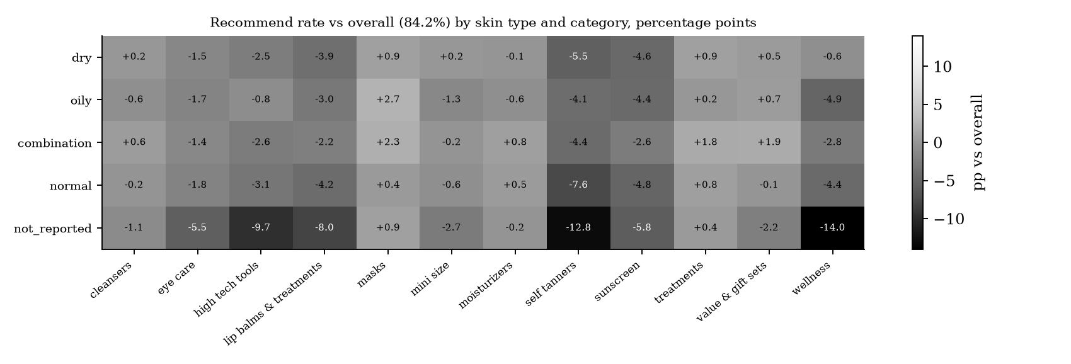
Figure 2: Recommend rate by skin type and category, in percentage points above or below the overall 84.2% (cells with 200+ reviews)
The heatmap shows that dissatisfaction is concentrated in a few places rather than spread evenly:
- Problem categories for everyone: self tanners are below average for every skin type (-4.1 to -7.6 points), and so is sunscreen (-2.6 to -4.8). These look like product-category problems, such as streaks, colour and white cast, rather than skin-type problems.
- Customers who do not report their skin type are less satisfied: they are well below average in wellness (-14.0 points), self tanners (-12.8), high tech tools (-9.7) and lip balms and treatments (-8.0). This supports the Week 3 decision to keep 'not_reported' as its own group rather than dropping or guessing it, because the missing value itself carries information.
- Skin-type-specific pockets: oily skin is below average in wellness (-4.9) and lip balms (-3.0) but above average in masks (+2.7). Combination skin does well in masks (+2.3) and value and gift sets (+1.9).
The largest gaps (5 to 14 points) are far bigger than the overall skin type effect in H2 (epsilon squared below 0.0001). This is exactly why the multi-dimensional view matters: averages hide the pockets.

13.2 Feature value: model ablation (Q8 and H6)
Table 10: Model ablation on the product-grouped test set
Feature set and model | Features | ROC-AUC | Macro F1 | Recall: not recommended | PR-AUC: not recommended
Majority baseline (always recommend) | 0 | 0.500 | 0.457 | 0.000 | 0.158
A. Baseline, logistic regression | 5 | 0.554 | 0.494 | 0.437 | 0.181
B. + engineered non-text, logistic regression | 42 | 0.754 | 0.597 | 0.699 | 0.344
C. + text, logistic regression | 56 | 0.874 | 0.714 | 0.772 | 0.606
C. + text, gradient boosting | 56 | 0.896 | 0.725 | 0.818 | 0.666
Set A scored a ROC-AUC of 0.554, almost identical to the 0.549 measured in Week 2. This confirms that the pipeline is reproducible. Adding the engineered non-text features (set B) raised the AUC by 0.20, twice the +0.10 success target set in Week 2, without reading a single word of the review. Adding text features (set C) raised it by a further 0.12, and gradient boosting gave the best result: AUC 0.896, finding 82% of unhappy customers compared with 44% for the baseline features. The PR-AUC for unhappy customers rose from 0.18 to 0.67, against a no-skill level of 0.16. H6 (a model can beat the baseline) is strongly supported; the bootstrap confidence interval for this will be calculated in Week 5. The models were trained on a random 300,000-row sample of the training set to keep the run time practical on a laptop; the test set was the full 158,000 rows.
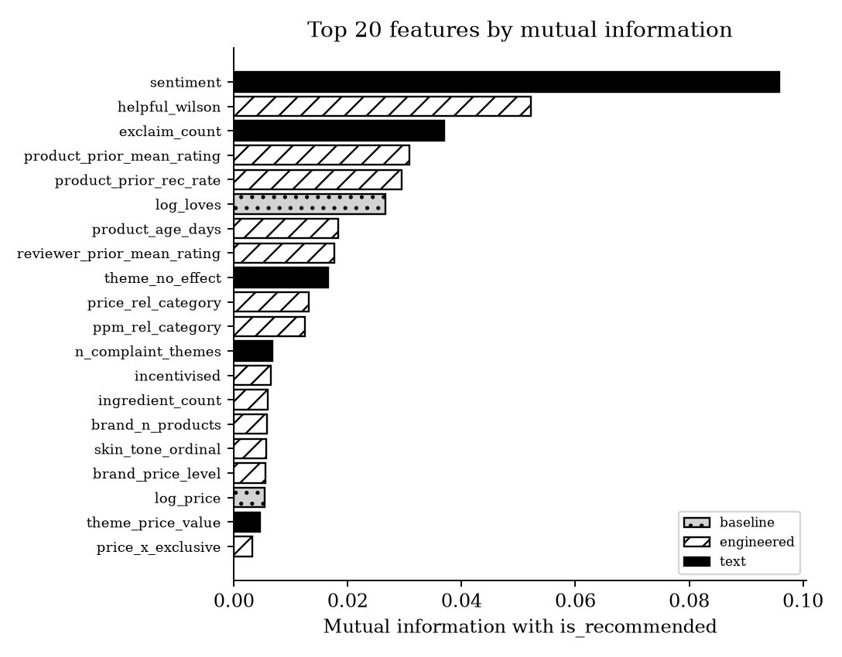
Figure 3: Top 20 features by mutual information with recommendation
Figure 3 ranks individual features. Sentiment carries the most information (0.096), followed by Wilson helpfulness (0.052), exclamation count, and the two social-proof features: the product's earlier average rating and earlier recommend rate. Of the 20 most informative features, 16 are new this week, while the original price and popularity features rank low. One caution: helpfulness votes arrive after a review is posted, so helpful_wilson would not be available if the model had to score a review the moment it is written. In Week 5 I will train the model with and without it and report both, so that the result is not inflated by information from the future.

13.3 Hypotheses re-tested on clean data
Table 11: Hypothesis results, all reviews and excluding incentivised reviews
H | Test | Effect (all) | Effect (excl. incentivised) | Conclusion
H1 | Spearman price vs mean product rating | rho = 0.172 | rho = 0.144 | Small positive effect; robust
H1 | Spearman price per mL vs mean product rating | rho = 0.026 (n.s.) | rho = 0.002 (n.s.) | No effect once pack size is considered
H2 | Kruskal-Wallis rating by skin type | eps sq. = 0.00008 | eps sq. = 0.00005 | Negligible overall; see heatmap pockets
H3 | Chi-square exclusive x recommended | V = 0.009 | V = 0.013 | Negligible
H4 | Spearman sentiment vs rating | rho = 0.317 | rho = 0.334 | Supported: medium agreement
H4 | Chi-square sentiment class x rating group | V = 0.278 | V = 0.279 | Supported
H5 | Kruskal-Wallis length across 5 ratings | eps sq. = 0.006 | eps sq. = 0.004 | Below the 0.01 threshold: negligible
The most useful new finding is about price. More expensive products do get slightly higher average ratings (rho = 0.17), but price per mL shows no relationship at all (rho = 0.03, not significant). Customers seem to reward products that cost more per item, which are often larger or more complete products, but they do not reward paying more per millilitre. For a pricing team, this suggests that charging a premium per mL is not rewarded with higher satisfaction.
Every conclusion is the same with and without incentivised reviews, so none of the findings depends on gifted reviews. H4 is supported but agreement is only medium (rho = 0.33). Text sentiment and stars often disagree, for example in mixed reviews such as 'love the texture but it broke me out'. This is why sentiment adds information beyond the star rating.

13.4 Complaint themes (Q3)
Table 12: Theme frequency in low (1-2 star) and high (4-5 star) reviews
Theme | In low reviews | In high reviews | Lift (low / high) | Recommend rate when mentioned
No effect ('did nothing', 'waste') | 12.5% | 0.9% | 13.7 | 34.2%
Price and value | 21.3% | 13.8% | 1.55 | 75.3%
Breakout | 21.8% | 15.0% | 1.45 | 80.0%
Irritation | 17.5% | 15.4% | 1.14 | 82.8%
Packaging | 13.4% | 13.2% | 1.01 | 83.3%
Dryness / greasy / smell / texture | 9.8% to 22.0% | 10.9% to 25.0% | 0.88 to 0.96 | 84.5% to 84.8%
The strongest signal of an unhappy customer is not a side effect but a lack of results: 'did nothing' or 'waste of money' is 13.7 times more common in low reviews, and only 34% of customers who say it still recommend the product. Value complaints and breakouts are the next strongest. Themes such as dryness, greasiness and smell appear just as often in positive reviews, which reveals a limitation of simple keyword flags: they cannot tell 'greasy' from 'not greasy at all', or 'smells awful' from 'no smell'. In Week 5 I will make these patterns negation-aware, for example by ignoring a match that follows 'not', 'no' or 'never' within three words.

13.5 Herding and reviewer habits (Q4)
Table 13: Social proof and reviewer habit results
Test | n | Effect | Interpretation
Spearman: product's earlier average rating vs this rating (10+ earlier reviews) | 949,970 | rho = 0.218 | Small-to-medium
Mean rating of a product's first 10 reviews minus later reviews | 21,530 | +0.155 stars | Early reviews are higher
Spearman: reviewer's own past average vs this rating (3+ past reviews) | 211,653 | rho = 0.411 | Medium-to-large
The first ten reviews of a product are on average 0.16 stars higher than later ones. This fits a launch effect: early reviewers are enthusiasts or receive free products, and later buyers are more critical. A product's early score is therefore an optimistic guide to how satisfied later customers will be. The strongest pattern is personal rating style: a reviewer's own past average predicts their next rating with rho = 0.41, much more strongly than any product attribute. Some customers are simply generous and others harsh, which is why the reviewer-history features rank highly in Figure 3.

13.6 Product segments (Q6)
Table 14: K-means product segments (2,294 skincare products with reviews; k = 5)
Segment (my label) | Products | Reviews | Median price | Median loves | Recommend rate | Share exclusive
0: Premium, non-exclusive | 663 | 217,000 | USD 76 | 17,838 | 86.0% | 1%
1: Popular Sephora exclusives | 577 | 300,679 | USD 36 | 74,119 | 83.7% | 100%
2: Niche, low visibility | 401 | 10,026 | USD 39 | 1,944 | 83.6% | 7%
3: Small mixed group | 91 | 3,628 | USD 54 | 12,092 | 87.4% | 49%
4: Popular mainstream, non-exclusive | 562 | 440,167 | USD 38 | 68,043 | 83.6% | 0%
The segments differ strongly in price, popularity and exclusivity, but much less in satisfaction (83.6% to 87.4%). The premium segment has a slightly higher recommend rate than the mainstream ones, which is consistent with the small positive price effect in H1. The two popular segments together account for three quarters of all reviews, so overall averages mainly describe mainstream USD 35 to 40 products.

13.7 What the results mean for the business
- Prioritise self tanners, sunscreen and wellness for product and content improvements; these categories underperform for almost every skin type.
- Encourage customers to state their skin type, and treat shoppers who do not as a higher-risk group in recommendations: they are up to 14 points less satisfied in some categories.
- Treat a new product's early rating with caution, because the first ten reviews are 0.16 stars higher on average than later ones.
- For pricing, a higher price per mL is not rewarded with higher satisfaction; premium positioning should rely on proven results, since 'no effect' is the strongest driver of dissatisfaction.
- For modelling, the engineered features double the model's ability to find unhappy customers, so they will form the core of the Week 5 model.

14. Hypothetical Decision Scenario
The following scenario is hypothetical. The brand, product and numbers are invented to illustrate how the engineered features would be used; they are not results from the data.
The signals it uses are the same ones that showed real effects in Section 13: early reviews running higher than later ones, incentivised reviews, skin type x category pockets and complaint themes.
Situation. 'Lumen Lab', a fictional mid-priced skincare brand, launches a new niacinamide moisturiser on a large beauty retail website. After six weeks it has 400 reviews and an average rating of 4.3 stars, close to the category average. On the usual dashboard, which shows only the average rating, nothing looks wrong, and the team plans to increase advertising.
What the engineered features reveal. Table 16 shows what a dashboard built on the Week 4 features would show for the same product.
Table 16: Signals from the engineered features (hypothetical)
Feature | Hypothetical signal | Interpretation
incentivised | 45% of reviews are incentivised (site average 12.5%) | The 4.3 average is inflated by gifted reviews
product_prior_rec_rate over time | Recommend rate falls from 92% (first 50 reviews) to 74% (last 100) | Early reviews created a positive impression that real buyers do not share
Rating excluding incentivised | 3.8 stars | True satisfaction is below the category average
skin_x_category, oily_x_fragrance | Oily-skin reviewers: 61% recommend; dry-skin: 90% | The product suits dry skin but not oily skin
theme_breakout, theme_greasy | Mentioned in 38% of oily-skin low reviews | The formula is too rich for oily skin
ppm_rel_category | 1.4 (40% more per mL than similar products) | Value-for-money complaints will grow if it underperforms
Decisions the features support. Instead of increasing advertising to everyone, the brand could:
- Target the product to dry and normal skin in ads and on the product page, and add a clear 'best for dry skin' label.
- Ask the retailer's recommendation engine to stop suggesting it to oily-skin shoppers, using the skin_x_category signal.
- Pause the free-sample review programme, because it is hiding the real satisfaction level.
- Brief R&D on a lighter, fragrance-free version for oily skin, based on the breakout and greasy themes.
- Set an early-warning alert: when product_prior_rec_rate for a new launch falls by more than 10 points between the first 50 and the next 100 reviews, flag it for review.
The outcome would be fewer unhappy customers and returns among oily-skin buyers, better spending of the advertising budget, and a product range shaped by evidence. This shows the central idea of the report: the same 400 reviews support very different decisions depending on which features are extracted from them.

15. Next Steps
Table 17: Plan for the remaining weeks
Week | Tasks | Output
Week 4 (this week) | Script run on the full data and findings added (done). Remaining: check 100 incentivised and 100 non-incentivised reviews by hand; make complaint patterns negation-aware; confirm when helpfulness votes become available | EDA results, feature dataset, ablation table
Week 5 | Tune Logistic Regression, Random Forest and XGBoost on feature set C; bootstrap test for H6; SHAP explanations; fairness check by skin type and tone | Final model, model comparison, feature importance
Week 6 | Dashboard with the early-warning signals from Section 13; business recommendations; final report | Dashboard, final report, complete GitHub repository

16. Conclusion
This report sets out a complete plan for exploring the clean skincare review data and engineering features from it. The EDA moves from univariate summaries to bivariate tests, then to multi-dimensional techniques: a skin type x category heatmap, PCA, k-means product segments, mutual information, time trends, text themes and a herding analysis. Every step is tied to a business question and to a specific Python library. Because the data is large and skewed, the statistical methods rely on rank-based tests, effect sizes, Bonferroni correction and a sensitivity check without incentivised reviews. The feature engineering plan adds 36 new variables in eight families, capturing value for money, brand reputation, social proof, reviewer habits, review text, ingredient suitability for each skin type, timing and product archetype. Worked examples show normalisation, three types of encoding, interaction variables and time-aware features, with explicit safeguards against leakage. An ablation design measures how much each family improves the model, and a hypothetical scenario shows how the features would change a real business decision. On the full dataset, the engineered features raised the model's ROC-AUC from 0.554 to 0.754 without reading any text, and to 0.896 with text features and gradient boosting. Recall of unhappy customers also rose from 44% to 82%. The EDA showed that satisfaction depends far more on review tone, reviewer habits and social proof than on price, skin type or exclusivity. It also showed that self tanners, sunscreen and wellness products, and customers who do not report their skin type, are where dissatisfaction concentrates.

References
Hutto, C.J. and Gilbert, E. (2014) 'VADER: A parsimonious rule-based model for sentiment analysis of social media text', Proceedings of ICWSM.
Inky, N. (2023) Sephora Products and Skincare Reviews [dataset]. Kaggle. Available at: https://www.kaggle.com/datasets/nadyinky/sephora-products-and-skincare-reviews
Jolliffe, I.T. and Cadima, J. (2016) 'Principal component analysis: a review and recent developments', Philosophical Transactions of the Royal Society A, 374(2065).
Kraskov, A., Stogbauer, H. and Grassberger, P. (2004) 'Estimating mutual information', Physical Review E, 69(6).
Micci-Barreca, D. (2001) 'A preprocessing scheme for high-cardinality categorical attributes in classification and prediction problems', ACM SIGKDD Explorations, 3(1), pp. 27-32.
Muchnik, L., Aral, S. and Taylor, S.J. (2013) 'Social influence bias: a randomized experiment', Science, 341(6146), pp. 647-651.
Pedregosa, F. et al. (2011) 'Scikit-learn: Machine learning in Python', Journal of Machine Learning Research, 12, pp. 2825-2830.
Rousseeuw, P.J. (1987) 'Silhouettes: a graphical aid to the interpretation and validation of cluster analysis', Journal of Computational and Applied Mathematics, 20, pp. 53-65.
Tukey, J.W. (1977) Exploratory Data Analysis. Reading, MA: Addison-Wesley.
Virtanen, P. et al. (2020) 'SciPy 1.0: fundamental algorithms for scientific computing in Python', Nature Methods, 17, pp. 261-272.
Zheng, A. and Casari, A. (2018) Feature Engineering for Machine Learning. Sebastopol: O'Reilly.

Appendix A: Script Functions and Outputs
Function | What it does and saves in output/week4/
engineer(), add_sentiment() | Builds all features in Table 7; VADER scores cached in data/processed/sentiment_cache.parquet
product_segments() | Silhouette search k = 3-7, k-means, PCA (cluster_silhouette, pca_*, segment_profiles, fig_product_segments_pca)
univariate(), bivariate() | univariate_numeric/categorical, recommend_by_group, brands_bottom10_top10, fig_recommend_price_skin
heatmap_skin_category() | heatmap_skin_category.csv, fig_heatmap_skin_category
time_trends() | monthly_trend, seasonality_by_month, fig_monthly_trend
text_eda() | theme_lift, low_review_themes_by_skin_type, fig_theme_lift, fig_sentiment_by_rating, fig_length_by_rating
herding() | herding_and_habits, rating_by_review_position, fig_rating_by_position
correlation() | spearman_matrix_features, fig_spearman_engineered
hypotheses() | hypothesis_tests_week4 (all and excluding incentivised), sentiment_vs_rating_agreement, median_length_by_rating
mutual_info() | mutual_information.csv, fig_mutual_information
ablation() | model_ablation.csv, logit_coefficients_setB.csv
main | features.parquet (local only) and feature_catalogue.csv

pip install vaderSentiment
python src/week4_eda_features.py # run from the project folder, after Week 3

