Data Cleaning and Preprocessing Pipeline Development
Project: What Drives Customer Satisfaction and Recommendation in Skincare?
Week 3 Task Report
Data Science with Python Analyst Internship (Beauty and Wellness)
Prepared by: Sarthak Sameer Gharat
Week: Week 3 of 6
Submission date: 17 October 2026
Code: src/week3_cleaning_pipeline.py (GitHub: sarthak-debug/skincare-recommendation-analysis)

Contents
1. Introduction
2. The Raw Data
3. Data Quality Issues in Public Beauty and Wellness Data
4. Pipeline Overview (Flowchart)
5. Step-by-Step Cleaning Process
6. Handling Missing Values
7. Detecting and Treating Outliers
8. Fixing Inconsistencies and Standardising Formats
9. Normalisation and Model-Ready Preprocessing
10. Domain-Specific Solutions for Beauty Data
11. Python Libraries and Why They Are Suitable
12. Validation Checks
13. Results on the Full Dataset
14. Documentation and Reproducibility
15. How the Cleaned Data Improves Analysis and Modelling
16. Privacy During Cleaning
17. Next Steps
18. Conclusion
References
Appendix A: Pipeline Functions and How to Run

1. Introduction
In Week 1, I defined the business problem of understanding and predicting customer satisfaction and recommendation for skincare products. In Week 2, I selected the Sephora Products and Skincare Reviews dataset as my primary source and ran a pilot analysis on about 1.09 million reviews. That pilot showed that the raw data cannot be used as it is. Ratings are heavily skewed, a group of reviews have no text, profile fields such as skin type are often blank, and the review files and product file disagree on some values.
This Week 3 report documents the cleaning and preprocessing pipeline I built to fix these problems. It explains each issue, the method used to handle it, the reason for choosing that method, and the Python code that does it. The pipeline is not only a plan: it is implemented as a single script, week3_cleaning_pipeline.py, which is in my GitHub repository. The script cleans the data in ten steps, writes a log of how many rows each step changed, runs ten automatic data checks, and produces a data dictionary and run record so that anyone can repeat the work and get the same result.
The report follows the order of the task: data quality issues first, then methods for missing values, outliers and inconsistencies, then normalisation, tools, reproducibility, and finally how the clean data improves the analysis and modelling planned for Weeks 4 and 5.

2. The Raw Data
The dataset has two linked parts. The product table describes each product, and the review tables hold one row per customer review. They are joined on product_id, with many reviews to one product.
Table 1: Raw files and important columns
File | Size | Key columns used in this project
product_info.csv | 8,494 products, 27 columns | product_id, brand_name, price_usd, sale_price_usd, value_price_usd, size, ingredients, loves_count, sephora_exclusive, limited_edition, new, online_only, primary/secondary/tertiary_category
reviews_0-250.csv to reviews_1500-end.csv (5 files) | 1,094,411 reviews, 19 columns | author_id, rating, is_recommended, helpfulness, total_feedback_count, total_pos_feedback_count, total_neg_feedback_count, submission_time, review_text, review_title, skin_tone, skin_type, eye_color, hair_color, product_id, brand_name, price_usd
Two features of the raw files matter for cleaning. First, each review file was saved with an extra unnamed index column, which must be removed. Second, some columns appear in both tables (brand_name, product_name and price_usd), so I need a rule for which copy to trust. I treat the product table as the master for product details, because it is one row per product and is easier to check.

3. Data Quality Issues in Public Beauty and Wellness Data
Before writing any cleaning code, I listed the problems that are common in publicly available beauty and wellness data, such as retailer reviews, scraped product listings and social media posts. Table 2 lists each issue, explains why it happens in this industry, and shows whether it appears in my dataset.
Table 2: Common data quality issues and where they appear
Issue | Why it happens in beauty and wellness data | In the Sephora data
Missing optional fields | Customers can skip profile questions such as skin tone, skin type, eye and hair colour. | Skin and hair fields are often blank; is_recommended is sometimes blank
Structurally missing values | Some values only exist in certain situations: a sale price only exists during a sale; helpfulness only exists after someone votes. | sale_price_usd and value_price_usd are mostly empty; helpfulness is blank when nobody voted
Duplicate and syndicated reviews | Retailers copy one review onto every size or shade of the same product, and scraping can collect a page twice. | Same author, text and timestamp across product variants
Mixed units | Sizes are written as 'oz', 'fl oz', 'mL' or 'g', often together, e.g. '1.7 oz/ 50 mL'. | size is free text, so prices cannot be compared across sizes
Inconsistent labels | Free-text or scraped labels differ in case and spacing. | Brand and category names, skin tone labels such as 'lightMedium'
Lists stored as text | Scrapers save lists such as ingredients or highlights as one string. | ingredients looks like "['Water, Glycerin, ...']"
Encoding and HTML leftovers | Web text contains '&amp;', '<br>', links and emojis. | Present in review_text and review_title
Personal information in text | Reviewers sometimes write e-mails, phone numbers or health details. | Possible in review_text
Incentivised reviews | Many brands give free products in exchange for reviews; these are usually more positive. | Phrases such as 'I received this product free'
Rating skew and self-selection | Happy customers review more often; unhappy ones may return the product silently. | Pilot: about 83% recommend; most ratings are 5 stars
Extreme values | Luxury products, sets and minis create very high or very low prices; some reviews are very long. | Price and review length are strongly right-skewed
Conflicting copies | The same field stored in two tables can drift apart over time. | price_usd in reviews vs product table
Time issues | Unparseable dates and old reviews of reformulated products. | submission_time stored as text

4. Pipeline Overview (Flowchart)
Figure 1 shows the full pipeline. The left column is the order of the steps, and the right column gives the reason for each step. The order matters. Text is cleaned before duplicate checks, so that two copies that differ only in spacing or HTML codes are recognised as the same. Validation happens before saving, so that bad data never reaches the analysis. Scaling happens last and only after the train/test split, so that information from the test set cannot leak into the model.
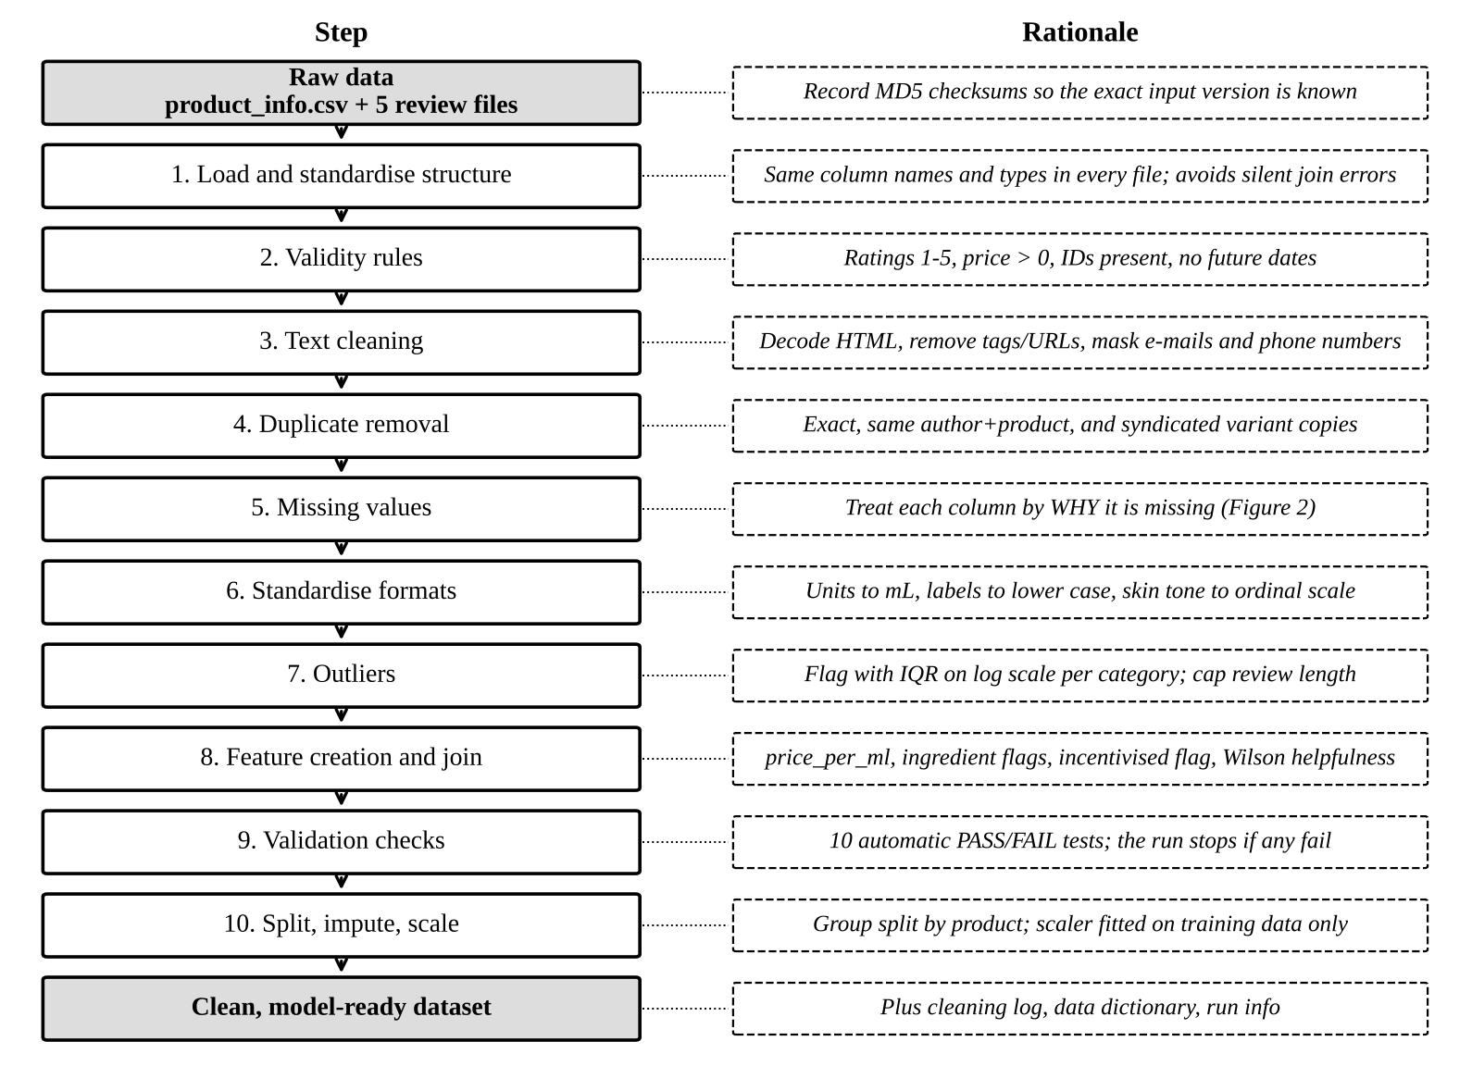
Figure 1: Data cleaning and preprocessing pipeline with the rationale for each step

5. Step-by-Step Cleaning Process
This section walks through each step of Figure 1. For every step I describe the problem, the method and the reason, followed by pseudo-code or the actual Python used. All steps are written as functions in the script, and every step that removes or changes rows calls log_step(), which records the step name, rows before, rows after and a note in cleaning_log.csv.

Step 1: Load and standardise the structure
The five review files are read and stacked into one table. author_id is read as text, because some IDs contain letters and pandas would otherwise guess different types for different files. Column names are converted to lower case with underscores, and the unnamed index column is removed. An MD5 checksum of each raw file is saved, so that it is always possible to prove which version of the data was used.
files = sorted(glob('data/raw/reviews_*.csv'))
reviews = pd.concat([pd.read_csv(f, index_col=0, dtype={'author_id': str},
low_memory=False) for f in files], ignore_index=True)
df.columns = (df.columns.str.strip().str.lower()
.str.replace(r'[^a-z0-9]+', '_', regex=True))
checksums = {file: md5(file) for file in all_raw_files} # saved in run_info.json

Step 2: Validity rules
Values that are impossible are removed or blanked. A rating must be a whole number from 1 to 5. A product price must be above zero. product_id and author_id must be present, because a review without them cannot be joined or de-duplicated. A review date cannot be in the future. is_recommended must be 0 or 1; any other value is set to missing rather than deleting the whole review, because the rating and text are still useful.
r['rating'] = pd.to_numeric(r['rating'], errors='coerce') # text -> NaN
r['submission_time'] = pd.to_datetime(r['submission_time'], errors='coerce')
r = r[r['rating'].between(1, 5)]
r = r[r['product_id'].notna() & r['author_id'].notna()]
r = r[r['submission_time'].isna() | (r['submission_time'] <= today)]
r.loc[~r['is_recommended'].isin([0, 1]), 'is_recommended'] = NaN

Step 3: Text cleaning
Review text is cleaned in a fixed order: decode HTML entities ('&amp;' becomes '&'), remove HTML tags and links, replace e-mail addresses and phone numbers with the placeholders [email] and [phone], and collapse repeated spaces. Capital letters and punctuation are kept, because the VADER sentiment tool planned for Week 4 uses them (for example, 'LOVE IT!!!' scores more positive than 'love it'). A separate lower-case copy can be made later for TF-IDF. The step also creates review_len_words, a has_text flag, and a likely_non_english flag, set when fewer than half of the characters are Latin letters, so that non-English reviews can be excluded from English sentiment scoring.
s = s.map(html.unescape) # &amp; -> &
s = s.str.replace(r'<[^>]+>', ' ', regex=True) # <br> and other tags
s = s.str.replace(r'https?://\S+|www\.\S+', ' ', regex=True)
s = s.str.replace(EMAIL_PATTERN, ' [email] ', regex=True) # privacy
s = s.str.replace(PHONE_PATTERN, ' [phone] ', regex=True) # privacy
s = s.str.replace(r'\s+', ' ', regex=True).str.strip()
has_text = word_count >= 1

Step 4: Duplicate removal at three levels
Duplicates are removed in three passes, from the safest to the most specific. First, exact duplicate rows are dropped. Second, rows with the same author, product and text are dropped, which catches the same review collected twice with a small difference such as the helpfulness count. Third, syndicated copies are dropped. Sephora shows one review on every size or variant of a product, so the same review can appear under several product_ids. If these copies were kept, popular products with many sizes would be counted several times and would distort every test. A review is treated as a syndicated copy only when the author, the text, the brand and the exact timestamp are all the same, and only when the review has text. This strict rule avoids deleting genuine short reviews such as 'love it', which different products can legitimately share.
r = r.drop_duplicates() # level 1
r = r.drop_duplicates(subset=['author_id', 'product_id', 'review_text']) # level 2
key = ['author_id', 'review_text', 'submission_time', 'brand_name']
syndicated = r.duplicated(subset=key, keep='first') & (r['has_text'] == 1)
r = r[~syndicated] # level 3

Steps 5 to 7 (missing values, standardising formats and outliers) are explained in Sections 6 to 8. Step 8 (feature creation) is in Section 10, step 9 (validation) in Section 12, and step 10 (split, impute and scale) in Section 9.

6. Handling Missing Values
I do not use a single rule such as 'drop every row with a blank'. In this data, that would delete most reviews, because optional profile fields are often empty. It would also bias the data towards customers who fill in every field. Instead, each column is handled according to why it is missing. Statisticians describe three types: missing completely at random (MCAR), missing at random given other variables (MAR), and missing not at random (MNAR), where the fact that a value is missing is itself informative. Figure 2 shows the four questions I ask for every column, and Table 3 shows the decision for each important column.
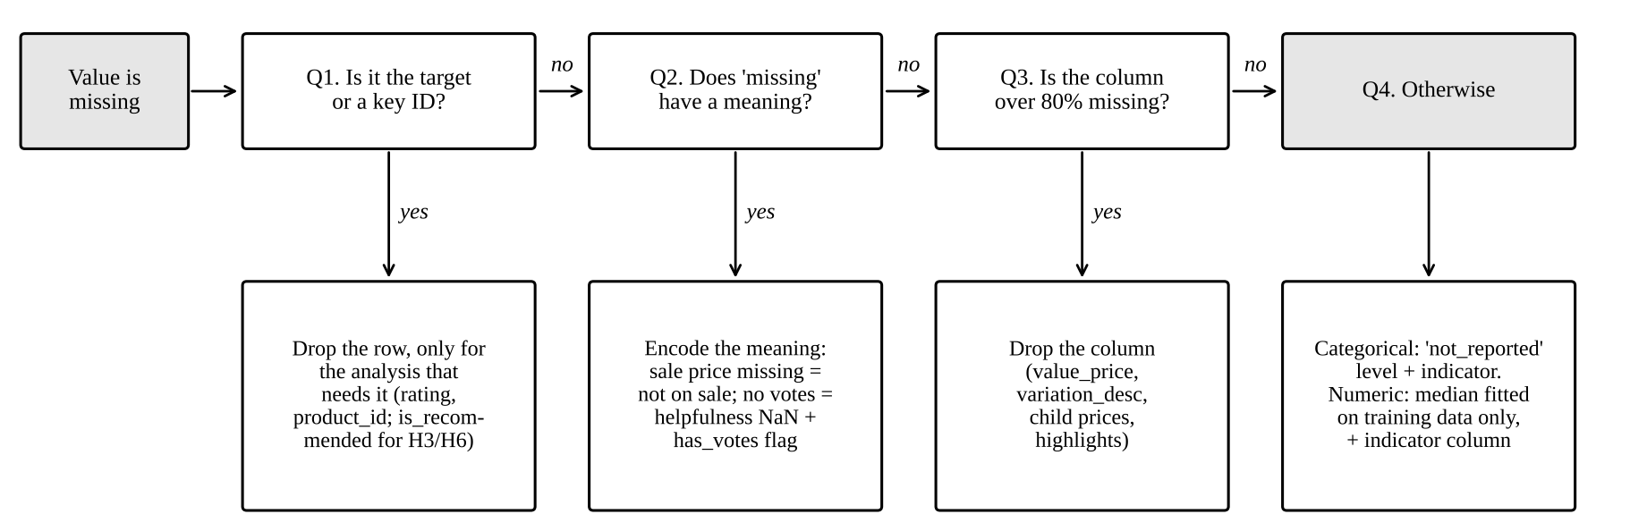
Figure 2: Decision process for missing values
Table 3: Missing value treatment by column
Column | Likely reason missing | Treatment | Why
rating | Scraping error (rare) | Drop row | Main outcome; cannot be guessed
is_recommended | Customer skipped the question | Keep row; drop only for H3 and H6 | Rating and text are still useful for H1, H2, H4, H5
review_text | Customer gave stars only | Keep; has_text = 0; exclude from text analysis | Stars-only reviews are real customer opinions
skin_type, skin_tone, eye_color, hair_color | Optional; MAR or MNAR | New level 'not_reported' + indicator column | Keeps all rows; lets me test whether non-reporters rate differently
helpfulness | Structural: nobody voted | Leave as NaN; add has_votes and total_feedback_count | 0 would wrongly mean 'unhelpful'
sale_price_usd | Structural: not on sale | Convert to on_sale = 0/1, drop the price | The meaning of missing is 'not on sale'
value_price_usd, variation_desc, child prices, highlights | Mostly empty | Drop column if over 80% missing | Too little information to use
ingredients | Not listed for some products (e.g. sets) | Keep; ingredient flags set to -1 = unknown | Distinguishes 'unknown' from 'not present'
size | Free text that cannot be parsed | size_ml = NaN; median imputation in model only | Price per mL is still known for most products
submission_time | Unparseable text | NaT; kept, excluded from time trends | Rest of the review is valid
Why median imputation and not mean or model-based imputation: numeric features such as size and price are strongly skewed, so the mean would be pulled up by a few very expensive products. The median is robust to that. I also add a missing-indicator column (SimpleImputer(add_indicator=True)) so the model can learn if missingness itself predicts the outcome. More complex methods such as KNN or iterative imputation were considered but rejected for now, because they are slow on a million rows and would hide the true uncertainty. Importantly, the imputer learns its medians from the training data only (Section 9).
for col in ['skin_type', 'skin_tone', 'eye_color', 'hair_color']:
r[col + '_missing'] = r[col].isna().astype('int8') # indicator
r[col] = r[col].fillna('not_reported') # explicit level

tot = r['total_feedback_count']
r['helpfulness'] = np.where(tot > 0, r['total_pos_feedback_count'] / tot, np.nan)
r['has_votes'] = (tot > 0).astype('int8')
p['on_sale'] = p['sale_price_usd'].notna().astype('int8')

7. Detecting and Treating Outliers
An outlier is not automatically an error. In beauty retail, a USD 400 cream is real, and so is a 1,000-word review. My rule is therefore: remove values that are impossible (Section 5, step 2), and flag or transform values that are extreme but possible. Table 4 compares the detection methods I considered.
Table 4: Outlier detection methods
Method | How it works | Use in this project
Domain rules | Hard limits from business logic | Rating 1-5, price > 0, size between 0 and 1,000 mL, no future dates: invalid values removed
IQR fences | Outside Q1 - k x IQR or Q3 + k x IQR | Main method for price, applied to log price within each secondary category, k = 3
Z-score | More than 3 standard deviations from the mean | Reported for comparison only; unreliable on skewed data because the mean and SD are themselves pulled by outliers
Percentile capping (winsorising) | Values above the 99.5th percentile set to that value | Review length for modelling (review_len_capped)
Log transform | log(x) or log(1 + x) | Price, loves_count and review length before scaling
Isolation Forest | Machine learning: isolates unusual combinations | Stretch goal for spotting suspicious reviewers in Week 5
Why IQR within category on the log scale: a USD 150 serum is normal, but a USD 150 lip balm is unusual. Using one fence for all products would flag every luxury serum and miss overpriced items in cheap categories. Prices are also multiplicative (products cost 2 times or 10 times more, not USD 20 more), so the log scale makes the distribution roughly symmetric and the IQR rule fair on both sides. I use k = 3 rather than the usual 1.5, because 1.5 would flag too many genuine luxury products. Flagged products are kept, with price_outlier = 1, so that results can be checked with and without them.
logp = np.log(p['price_usd'])
q1 = logp.groupby(p['secondary_category']).transform(lambda s: s.quantile(.25))
q3 = logp.groupby(p['secondary_category']).transform(lambda s: s.quantile(.75))
iqr = q3 - q1
p['price_outlier'] = ((logp < q1 - 3*iqr) | (logp > q3 + 3*iqr)).astype('int8')

cap = r['review_len_words'].quantile(0.995)
r['review_len_capped'] = r['review_len_words'].clip(upper=cap)

The script saves outlier_summary.csv, which reports for each numeric variable the median, quartiles, number of IQR and z-score outliers, maximum and skewness, so the effect of the treatment is documented.

8. Fixing Inconsistencies and Standardising Formats
Table 5: Inconsistencies and how they are standardised
Inconsistency | Example | Fix
Case and spacing in labels | ' Glow Co', 'glow co', 'Moisturizers ' | Trim, lower case, single spaces; empty strings, 'nan' and 'none' become missing
Mixed size units | '1.7 oz/ 50 mL', '1 oz', '50 g' | Parse to size_ml: mL used directly, oz x 29.5735, grams taken as approximately mL for creams
Ingredients stored as list-text | "['Water, Glycerin, ...']" | Remove brackets and quotes, lower case; count ingredients; create flags
Skin tone labels | 'fairLight', 'mediumTan', 'deep' | Lower case, then map to an ordinal scale 1 (porcelain) to 11 (ebony) as skin_tone_ordinal
Booleans stored as numbers or text | 1.0, '1', True | Convert to 0/1 integers (int8)
Dates stored as text | '2022-03-04' | Convert to datetime; derive review_year
Conflicting price copies | price_usd differs between files | Product table is the master; the share of mismatches is logged
Same brand in different tables | brand_name in both tables | Keep the product table copy after the join

def parse_size_ml(size):
s = size.lower()
if match('(number) ml', s): return number
if match('(number) oz', s): return number * 29.5735
if match('(number) g', s): return number # approx. for creams
return NaN # e.g. 'Mini', sets

p['size_ml'] = p['size'].apply(parse_size_ml)
p['price_per_ml'] = p['price_usd'] / p['size_ml']

9. Normalisation and Model-Ready Preprocessing
Normalisation puts features on comparable scales so that models such as logistic regression are not dominated by a variable just because its numbers are large (loves_count runs into the hundreds of thousands, while ingredient flags are 0 or 1). Table 6 explains which method is used where.
Table 6: Normalisation methods
Method | Formula | Used for
Log transform | log(x) or log(1 + x) | Price, loves_count, review length: removes strong right skew first
Standardisation (z-score) | (x - mean) / standard deviation, StandardScaler | All numeric features for logistic regression
Min-max scaling | (x - min) / (max - min) | Dashboard indices only; sensitive to outliers so not used for models
Robust scaling | (x - median) / IQR, RobustScaler | Alternative if outliers remain after the log transform
One-hot encoding | One 0/1 column per category | skin_type, skin_tone, category, price band; rare levels (under 50 rows) grouped
No scaling | Raw values | Random Forest and XGBoost do not need scaling; the same pipeline is reused with the scaler switched off
Preventing data leakage: the most common mistake in preprocessing is to calculate the mean, median or category list on the whole dataset before splitting. The test set then leaks into training, and scores look better than they really are. To avoid this, the pipeline first splits the data by product_id (GroupShuffleSplit), so that no product appears in both sets, and then fits the imputer, scaler and encoder on the training rows only. These steps are wrapped in a scikit-learn ColumnTransformer, so the same fitted steps are applied to the test set and to any new data later.
numeric = ['log_price', 'log_loves', 'log_review_len',
'ingredient_count', 'price_per_ml']
categorical = ['skin_type', 'skin_tone', 'secondary_category', 'price_band']

num_pipe = Pipeline([('impute', SimpleImputer(strategy='median', add_indicator=True)),
('scale', StandardScaler())])
cat_pipe = Pipeline([
('impute', SimpleImputer(strategy='constant', fill_value='not_reported')),
('onehot', OneHotEncoder(handle_unknown='infrequent_if_exist', min_frequency=50))])
pre = ColumnTransformer([('num', num_pipe, numeric), ('cat', cat_pipe, categorical)])

gss = GroupShuffleSplit(test_size=0.2, random_state=42)
train_idx, test_idx = next(gss.split(X, groups=product_id))
pre.fit(X_train) # learns medians, means, categories from TRAIN
X_train_ready = pre.transform(X_train)
X_test_ready = pre.transform(X_test) # same rules applied, nothing learnt from test

10. Domain-Specific Solutions for Beauty Data
Several problems in this data are specific to beauty retail, and general cleaning rules do not solve them. These are the solutions I designed for them.

10.1 Price per mL instead of price
A 15 mL travel size and a 50 mL full size of the same serum have very different prices but the same value. Comparing raw prices mixes product value with pack size. By parsing the size text into millilitres, I create price_per_ml, which allows a fairer test of H1 (does a more expensive product get better ratings?). I will run H1 with both measures and report whether the conclusion changes.

10.2 Detecting syndicated reviews across variants
Standard duplicate checks look for identical rows, but syndicated copies differ in product_id. The rule in Section 5 (same author, text, brand and timestamp) is designed specifically for how beauty retailers share reviews across shades and sizes.

10.3 Flagging incentivised reviews
Reviews written in exchange for free products are common in beauty, and research suggests they tend to be more positive. A regular-expression search flags phrases such as 'received this product free', 'complimentary', '#gifted' and 'in exchange for my honest review'. These reviews are flagged, not deleted, so that every hypothesis can be tested twice, with and without them, as a sensitivity check. This is an honest way to handle the issue, because the flag will miss some cases and catch a few false ones.
INCENTIVE = r'received (this|it|the product)[^.]{0,40}(free|complimentary|gift)'
r'|complimentary|#gifted|gifted by|in exchange for (my|an) (honest )?review'
r['incentivised'] = r['review_text'].str.contains(INCENTIVE, case=False, regex=True)

10.4 A fairer helpfulness score
The raw helpfulness value treats a review with 1 helpful vote out of 1 (100%) as more helpful than one with 90 out of 100 (90%). I add the Wilson score lower bound, a standard method for ranking proportions with few votes. It gives the lowest helpfulness value that is still plausible at 95% confidence, so reviews with very few votes are pulled down.
p_hat = positive_votes / total_votes (z = 1.96 for 95%)
wilson = (p_hat + z^2/(2n) - z * sqrt( p_hat(1-p_hat)/n + z^2/(4n^2) )) / (1 + z^2/n)

10.5 Ingredient features
The ingredients text is turned into an ingredient count and eight flags for ingredients that customers often mention: fragrance, denatured alcohol, niacinamide, retinoids, hyaluronic acid, salicylic acid, vitamin C and sunscreen filters. These allow questions such as 'do products with fragrance get more low ratings from customers with sensitive skin?' In later work, ingredient names can be matched to the official EU CosIng database to standardise synonyms (for example 'Aqua' and 'Water').

10.6 Skin tone as an ordered scale
Skin tone labels have a natural order from lightest to deepest. Treating them only as unrelated categories throws that information away. I keep the original label for group comparisons and add skin_tone_ordinal (1 to 11) so that trends across the shade range can be tested. Results by skin tone will only be reported for groups with at least 30 reviews.

11. Python Libraries and Why They Are Suitable
Table 7: Tools used in the pipeline
Library | Used for | Why it is suitable
pandas | Reading CSVs, filtering, joins, duplicates, group statistics, string methods (.str) | Standard tool for tabular data; vectorised string methods clean a million reviews in seconds without loops; merge(validate='many_to_one') catches join mistakes
NumPy | Log transforms, conditional columns (np.where), Wilson score formula | Fast array maths; handles NaN correctly
re and html (built in) | Regular expressions for sizes, e-mails, phones, incentive phrases; HTML decoding | No installation needed; precise pattern matching
scikit-learn | SimpleImputer, StandardScaler, OneHotEncoder, ColumnTransformer, Pipeline, GroupShuffleSplit | Fit and transform design prevents leakage; the same object is reused for test and new data
SciPy | Skewness and later statistical tests | Reliable statistical functions
pyarrow (Parquet) | Saving the clean data | Keeps data types (dates, categories); much smaller and faster than CSV
Matplotlib | Before/after missing-value chart, diagrams | Full control for black and white print-ready charts
hashlib, json, platform | File checksums, run record, version capture | Built in; makes the run traceable
Git and GitHub | Version control of code and documentation | Every change is recorded and can be reviewed
Alternatives considered: Polars is faster than pandas on very large data, but pandas is fast enough for one million rows and is better known, which helps reviewers. Pandera and Great Expectations offer formal data-validation frameworks; I wrote the ten checks directly in pandas to avoid extra dependencies, but the checks are written in the same style and could be moved into Pandera later. OpenRefine is good for manual cleaning, but a script is repeatable and is therefore better for this project.

12. Validation Checks
After cleaning, the script runs ten automatic checks and writes PASS or FAIL for each one to validation_report.csv. If any check fails, the script stops and does not save the clean dataset. This means a broken run can never quietly feed bad data into the analysis.
Table 8: Automatic validation checks
# | Check | What it protects against
1 | rating only 1-5 | Invalid ratings distorting averages
2 | is_recommended only 0, 1 or missing | Wrong target values in models
3 | price above 0 | Free or negative prices breaking log transforms
4 | no duplicate reviewer + product + text | Double-counting reviews
5 | no author_id column | Privacy: original IDs removed
6 | no e-mail addresses left in text | Privacy: personal data in text
7 | helpfulness between 0 and 1 | Calculation errors
8 | every review matched to a product | Failed joins
9 | no submission dates in the future | Date parsing errors
10 | skin_type has no blanks | Missing values not handled
The smoke test was run on a small synthetic file that copies the real column layout and deliberately includes bad values: ratings of 0 and 7, a 2030 date, unparseable dates, HTML codes, an e-mail address, a duplicated product row, a price of zero and repeated reviews. Every bad value was caught or fixed, and all ten checks passed. The pipeline was then run on the full dataset, where all ten checks also passed (Section 13).

13. Results on the Full Dataset
I ran the pipeline on the complete Sephora dataset on my own laptop. This section reports what it found and changed, taken directly from cleaning_log.csv, outlier_summary.csv and missing_before_after.csv. All ten validation checks passed, so the clean data was saved.

13.1 Rows through the pipeline
Table 9: Cleaning log on the full dataset (reviews)
Step | Rows before | Rows after | Removed / flagged
Load 5 review files | 1,094,411 | 1,094,411 | -
Rating within 1-5; IDs present; no future dates | 1,094,411 | 1,094,411 | 0 removed
Clean text | 1,094,411 | 1,094,411 | 1,453 with no text; 82 likely non-English
Exact duplicates | 1,094,411 | 1,094,187 | 224 removed
Same author + product + text | 1,094,187 | 1,093,853 | 334 removed
Syndicated copies across variants | 1,093,853 | 971,500 | 122,353 removed (11.2%)
Flag incentivised reviews | 971,500 | 971,500 | 121,774 flagged (12.5%)
Join to product master | 971,500 | 971,500 | 0 unmatched; 0.0% price mismatch
Rows with is_recommended (for H3 and H6) | 971,500 | 813,588 | 157,912 without a recommendation answer
Train / test split by product | 813,588 | 654,960 / 158,628 | 0 products shared; 49 model features
The product table needed very little cleaning: all 8,494 products had a unique ID and a valid price, 78% of the size texts were converted to millilitres, and two columns (variation_desc and value_price_usd) were over 80% empty and were dropped. The raw data also passed all basic validity rules: no ratings outside 1 to 5, no missing IDs and no future dates.
The biggest finding is the syndicated duplicates. 122,353 reviews (11.2% of the data) were copies of the same review shown under another size or variant of a product: same author, same text, same brand and the exact same timestamp. Ordinary duplicate checks found only 558 duplicates in total, so without the beauty-specific rule more than one in nine reviews would have been counted twice or more. Products with many sizes would have had their ratings over-weighted in every test. Because this rule removes a large share of rows, I will run H1 to H3 once with the copies included as a sensitivity check, to confirm that the conclusions do not depend on this single decision.
One in eight reviews is flagged as incentivised. 121,774 reviews (12.5%) contain phrases such as 'received this product free' or 'complimentary'. This confirms that incentivised reviewing is common enough to affect results, so every hypothesis will be tested with and without these reviews. The text-based flag will not be perfect, and I will check a random sample of 100 flagged and 100 unflagged reviews by hand in Week 4 to estimate its accuracy.
The two tables agree with each other: every review matched a product and no review showed a different price from the product table. The conflicting-copies issue in Table 2 is therefore not a problem in this version of the data, although the check stays in the pipeline for future versions.

13.2 Missing values before and after cleaning
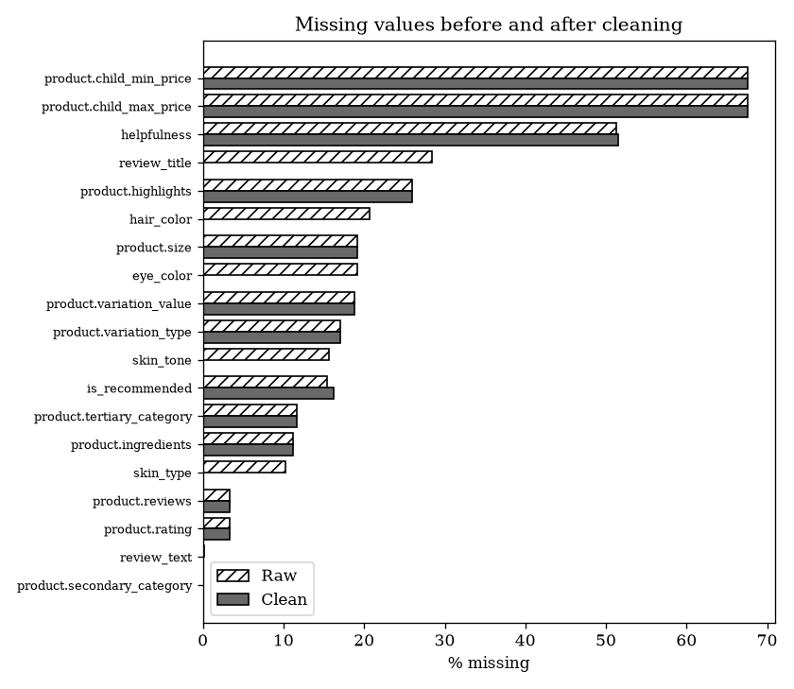
Figure 3: Percentage missing in each column, raw data and after cleaning
Figure 3 shows the effect of the missing-value rules from Section 6. The optional profile fields (hair colour about 21%, eye colour about 19%, skin tone about 16% and skin type about 10% missing) are now at 0% because blanks are recorded as their own 'not_reported' group, with an indicator column. Helpfulness stays about 51% missing on purpose. These are reviews nobody voted on, and filling them with 0 would wrongly label them unhelpful. The has_votes flag and Wilson score handle them instead. is_recommended rises slightly from about 15% to 16% missing, because the removed syndicated copies more often had an answer. Product fields such as child prices, highlights and variation details remain partly empty, but they are not used in the analysis or the model.
A note on review_title: the chart shows review_title falling from about 28% missing to 0%. Missing titles were not recovered. The text-cleaning step turns a missing title into an empty string, which pandas no longer counts as missing. This does not affect the analysis, because the title is not used as a feature and review text uses the separate has_text flag. I have since updated the script so that empty titles are stored as missing again, so future runs report this honestly.

13.3 Outliers
Table 10: Outlier summary on the clean data (review level)
Variable | Median | Q1 | Q3 | IQR outliers (1.5) | |z| > 3 | Max | Skew
price_usd | 40.00 | 29.00 | 64.00 | 41,414 | 14,774 | 1,900 | 4.12
price_per_ml | 0.95 | 0.33 | 1.80 | 47,558 | 8,422 | 130 | 19.40
review_len_words | 50 | 32 | 76 | 47,835 | 17,261 | 1,216 | 2.30
loves_count | 55,339 | 18,261 | 134,089 | 72,585 | 25,691 | 1,081,315 | 3.46
total_feedback_count | 0 | 0 | 3 | 127,485 | 5,279 | 5,464 | 69.85
Every numeric variable is strongly right-skewed (skew between 2.3 and 69.9), which supports the choices in Section 7:
- Price: half of all reviews are for products between USD 29 and USD 64, but the maximum is USD 1,900. The usual 1.5 x IQR rule on raw prices would mark 41,414 reviews as outliers, most of them genuine luxury products. This is why the pipeline flags price outliers on the log scale within each category instead of deleting them.
- Price per mL: the median is USD 0.95 per mL, but the skew of 19.4 is the highest of the price measures, driven by small luxury items such as eye creams and serums. It will always be log-transformed before modelling.
- Review length: a typical review is 50 words (middle half 32 to 76 words), with a longest review of 1,216 words. Capping at the 99.5th percentile limits the effect of the longest reviews without removing them.
- Helpfulness votes: the median review has 0 votes and the skew is 69.9, so a few reviews collect thousands of votes. This confirms that raw helpfulness percentages are unreliable and that the Wilson score is needed.
The two detection methods also disagree strongly. For example, the IQR rule flags 127,485 reviews on total_feedback_count but the z-score flags only 5,279. On skewed data the z-score is distorted by the same extreme values it is trying to find, so it is reported for comparison only.

13.4 What the results change
- Weeks 4 and 5 will use 971,500 genuine reviews instead of 1,094,411, with no double counting of products that come in several sizes.
- H3 and H6 will use the 813,588 reviews that have a recommendation answer. The training set has 654,960 rows and the test set 158,628, with no product in both.
- The incentivised flag (12.5%) and the syndication rule (11.2%) are both large enough to matter, so both will be used as sensitivity checks rather than assumed to be correct.
- Only 1,453 reviews have no text and 82 look non-English, so almost the whole dataset can go into the sentiment analysis in Week 4.

14. Documentation and Reproducibility
Reproducibility means that someone else, or I myself in a month, can run the same code on the same data and get exactly the same result. Table 12 lists how the pipeline makes that possible.
Table 12: Reproducibility practices
Practice | How it is done
Code, not manual edits | Every change happens in week3_cleaning_pipeline.py. Raw files are never edited, so the pipeline can always be re-run from scratch.
One settings block | All thresholds (80% missing, 99.5th percentile cap, IQR k = 3, random seed 42) are in a CONFIG dictionary at the top of the script, not hidden in the code.
Cleaning log | cleaning_log.csv lists every step with rows before, rows after and a note, so it is clear where every removed row went.
Data dictionary | data_dictionary.csv is created automatically: column name, type, % missing, number of unique values and an example.
Run record | run_info.json saves the date, run time, Python, pandas, NumPy and scikit-learn versions, the settings and an MD5 checksum of every raw file.
Fixed randomness | random_state = 42 for the train/test split; test product IDs are saved in test_product_ids.csv.
Pinned packages | requirements.txt lists the libraries; versions will be pinned (e.g. pandas==2.2.2) before the final submission.
Version control | Code and outputs are committed to GitHub each week with a clear message; raw and processed data are excluded by .gitignore.
Folder structure | data/raw (read-only), data/processed (generated), src (code), output (results), Report (documents).
Comments and docstrings | Every function has a short explanation of what it does and why.
To repeat the whole cleaning process, a reviewer only needs to download the dataset from Kaggle into data/raw and run one command: python src/week3_cleaning_pipeline.py.

15. How the Cleaned Data Improves Analysis and Modelling
Table 13: Link between cleaning steps and the Week 1 hypotheses
Hypothesis | Cleaning step that matters | Improvement
H1: price and rating | Syndicated duplicates removed; price_per_ml; product table as master price; price outlier flag | Products with many sizes no longer count several times; price can be compared fairly across pack sizes; results checked without outliers
H2: skin type | Standardised labels; 'not_reported' as its own group | No split groups such as 'Oily' and 'oily'; no silent loss of reviews; can test whether non-reporters differ
H3: exclusivity and recommendation | Clean 0/1 flags; rows without is_recommended excluded only here | Correct contingency table; no rows lost for other tests
H4: sentiment and rating | HTML removed but capitals kept; empty and non-English text excluded; incentivised flag | VADER gets clean input; sentiment is not calculated on empty strings; check with and without incentivised reviews
H5: review length | Text cleaned before counting words; capped length; empty reviews flagged | The Week 2 pilot found H5 unsupported; it will be re-tested on clean text across all five rating levels, which tests the idea that 3-star reviews are the longest
H6: prediction model | Group split by product; imputer and scaler fitted on training data only; new features | Honest test scores with no leakage; new features (price_per_ml, ingredient flags, Wilson helpfulness) may improve on the pilot AUC of 0.549
More generally, the clean dataset has consistent types (so calculations do not fail), one row per genuine review (so counts and tests are correct), documented treatment of every blank (so results can be explained), and features on comparable scales (so models train properly). The cleaning log and validation report also make the analysis easier to trust, because every decision can be traced.

16. Privacy During Cleaning
Privacy protection is built into the cleaning steps rather than added at the end. author_id is replaced by a salted hash (reviewer_key) and then deleted. E-mail addresses and phone numbers in review text are masked. The clean data is saved only in data/processed on my own computer, which is excluded from GitHub by .gitignore. Only aggregated outputs (logs, summaries and charts) are uploaded. Skin tone and other profile results are only reported for groups of at least 30 reviews, so no individual can be identified.

17. Next Steps
Table 14: Plan for the remaining weeks
Week | Tasks | Output
Week 3 (this week) | Pipeline built, tested and run on the full dataset (done). Remaining: full EDA on the clean data; re-run H1, H2, H3 and H5 with and without syndicated copies and incentivised reviews | Clean dataset, cleaning log, data dictionary, validation report
Week 4 | VADER sentiment on clean English text; check against 200 hand-labelled reviews; test H4; topic modelling of low-rated reviews | Sentiment scores and complaint themes
Week 5 | Train Logistic Regression, Random Forest and XGBoost using the preprocessor from Section 9; test H6 | Model comparison table, feature importance
Week 6 | Dashboard, recommendations and final report | Final report and complete GitHub repository

18. Conclusion
This report documents a complete data cleaning and preprocessing pipeline for skincare review data. I identified thirteen common data quality issues in public beauty and wellness data and showed where each appears in the Sephora dataset. Missing values are handled according to why they are missing, not with a single rule. Outliers are flagged within each category on the log scale rather than deleted. Units, labels and formats are standardised, and normalisation is applied only after a product-grouped split, to prevent leakage. I also designed solutions specific to beauty data: price per mL, detection of syndicated reviews, flags for incentivised reviews, a Wilson helpfulness score, ingredient features and an ordered skin tone scale. Run on the full dataset, the pipeline turned 1,094,411 raw reviews into 971,500 genuine reviews. Most of the removed rows were 122,353 syndicated copies that ordinary duplicate checks would have missed. It also flagged 121,774 incentivised reviews, and all ten validation checks passed. The pipeline is implemented in a tested Python script with ten automatic validation checks, a cleaning log, a data dictionary and a run record, so the work is transparent and can be repeated exactly. The clean dataset gives a reliable base for the sentiment analysis and modelling in Weeks 4 and 5.

References
Agresti, A. and Coull, B.A. (1998) 'Approximate is better than "exact" for interval estimation of binomial proportions', The American Statistician, 52(2), pp. 119-126.
European Commission (2026) CosIng: Cosmetic ingredient database. Available at: https://single-market-economy.ec.europa.eu/sectors/cosmetics/cosmetic-ingredient-database_en
Harris, C.R. et al. (2020) 'Array programming with NumPy', Nature, 585, pp. 357-362.
Hutto, C.J. and Gilbert, E. (2014) 'VADER: A parsimonious rule-based model for sentiment analysis of social media text', Proceedings of ICWSM.
Inky, N. (2023) Sephora Products and Skincare Reviews [dataset]. Kaggle. Available at: https://www.kaggle.com/datasets/nadyinky/sephora-products-and-skincare-reviews
Kaufman, S., Rosset, S. and Perlich, C. (2012) 'Leakage in data mining: formulation, detection, and avoidance', ACM Transactions on Knowledge Discovery from Data, 6(4).
Little, R.J.A. and Rubin, D.B. (2019) Statistical Analysis with Missing Data. 3rd edn. Hoboken: Wiley.
McKinney, W. (2010) 'Data structures for statistical computing in Python', Proceedings of the 9th Python in Science Conference, pp. 56-61.
Pedregosa, F. et al. (2011) 'Scikit-learn: Machine learning in Python', Journal of Machine Learning Research, 12, pp. 2825-2830.
Tukey, J.W. (1977) Exploratory Data Analysis. Reading, MA: Addison-Wesley.
Wickham, H. (2014) 'Tidy data', Journal of Statistical Software, 59(10), pp. 1-23.
Wilson, E.B. (1927) 'Probable inference, the law of succession, and statistical inference', Journal of the American Statistical Association, 22(158), pp. 209-212.

Appendix A: Pipeline Functions and How to Run
Function | What it does
load_raw() | Reads all raw files and records MD5 checksums
standardise_columns(), clean_str() | Consistent column names; trims and lower-cases text labels
clean_products() | Product duplicates, price validity, size to mL, price per mL, on_sale, ingredient features, price outlier flag, drops near-empty columns
clean_text() | HTML decoding, tag and URL removal, e-mail and phone masking
clean_reviews() | Validity rules, text cleaning, three-level duplicate removal, incentivised flag, profile missing values, helpfulness and Wilson score, derived fields, pseudonymisation
join() | Joins reviews to the product master with a many-to-one check; logs unmatched reviews and price mismatches
validate() | Runs the ten checks; the script stops if any fail
data_dictionary(), outlier_summary(), missing_chart() | Documentation outputs
build_preprocessor(), split_and_check() | Group split by product; imputer, scaler and encoder fitted on training data only

How to run, from the project folder:
pip install -r requirements.txt
python src/week3_cleaning_pipeline.py

Outputs: output/week3/cleaning_log.csv, validation_report.csv, data_dictionary.csv,
missing_before_after.csv/.png, outlier_summary.csv, run_info.json
Clean data (not uploaded): data/processed/reviews_clean.parquet

