Model Evaluation, Reporting and Business Impact
What Drives Customer Satisfaction and Recommendation in Skincare?
Week 6 Task Report: Final Project Report
Data Science with Python Analyst Internship (Beauty and Wellness)
Prepared by: Sarthak Sameer Gharat
Week: Week 6 of 6
Submission date: 18 October 2026
Repository: github.com/sarthak-debug/skincare-recommendation-analysis

Contents
Executive Summary
1. Introduction and Project Journey
2. The Evaluation Framework
3. Choosing the Right Metrics
4. Validation Plan: Stages of Testing
5. Results
6. Business Impact
7. Dashboard Mock-up
8. Recommendations
9. Implementation Roadmap and Monitoring
10. Limitations and Responsible Use
11. Final Summary for Decision-Makers
Glossary
References
Appendix A: Reproducing the Project

Executive Summary
The question. Beauty shoppers read reviews before they buy, yet most brands only look at the average star rating. This project asked: what really drives customer satisfaction and recommendation in skincare, and can we predict which customers will be unhappy and which new products will disappoint?
What we did. We analysed 971,500 genuine Sephora skincare reviews of 2,294 products, after cleaning 1.09 million raw reviews. We created 36 new measures of customer behaviour, tested four prediction methods, and checked the best one for accuracy, reliability and fairness.
What we found.
- The model works well. It identifies 82% of unhappy customers, compared with none for the usual approach of assuming everyone is satisfied. Its ranking quality (ROC-AUC 0.897 out of 1.0) is far above guessing (0.5), and this result is statistically certain.
- How customers feel and what they say matters most; price matters little. Review tone, complaints that a product 'did nothing', and a customer's own rating habits predict satisfaction. Price, brand and skin type on their own barely do. Paying more per millilitre does not make customers happier.
- Early reviews are too optimistic. A product's first reviews average 0.16 stars higher than later ones, and 27% of products lose at least 10 points of recommend rate after launch. Our early-warning model spots 61% of these after only 20 reviews.
- Problems are concentrated. Self tanners, sunscreen and wellness products underperform for most skin types. Customers who do not state their skin type are up to 14 points less satisfied.
- The model is fair. It works almost equally well for every skin type and skin tone (largest gap 5 points, against a 10-point limit).

Top five recommendations
- Use the model to contact likely-unhappy customers. In an illustrative scenario it returns about USD 5.30 for every USD 1 spent, and pays for itself if even 4% of contacted customers are kept.
- Check every new launch after its 20th review with the early-warning model before increasing advertising.
- Fix the 'it did nothing' problem: set realistic expectations and show visible results, because this is the strongest sign of an unhappy customer.
- Prioritise self tanners, sunscreen and wellness for product and content improvement.
- Encourage shoppers to share their skin type, and personalise recommendations by skin type and category.

1. Introduction and Project Journey
This is the final report of a six-week project. It brings together the technical work of earlier weeks and turns it into decisions. It is written for two audiences: business decision-makers, who can read the executive summary and Sections 5 to 8 and 11, and technical reviewers, who will find the evaluation details in Sections 2 to 5 and the Appendix. A glossary at the end explains every technical term in plain words.
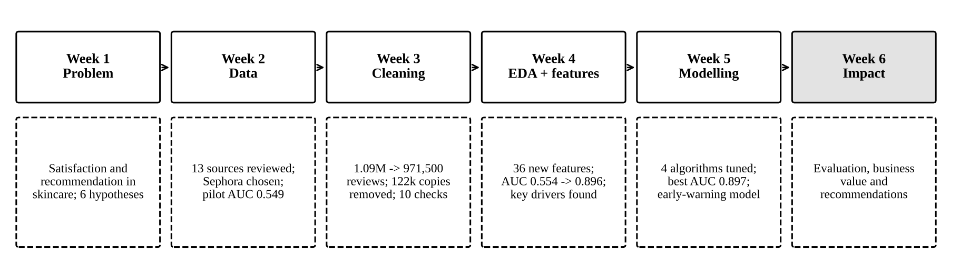
Figure 1: The six-week project journey
Each week built on the last. Week 1 defined the problem and six hypotheses. Week 2 chose the data source. Week 3 cleaned the data and found that 11% of reviews were duplicate copies shown under different product sizes. Week 4 explored the data and engineered features, raising the model's ranking quality from 0.554 to 0.896. Week 5 tuned and validated four algorithms and built an early-warning model. This week evaluates the final models against a formal framework and translates the results into business recommendations.

2. The Evaluation Framework
A model should not be used just because it scores well on one number. The framework in Figure 2 asks five questions, and the model must give a satisfactory answer to each before it is recommended for use.
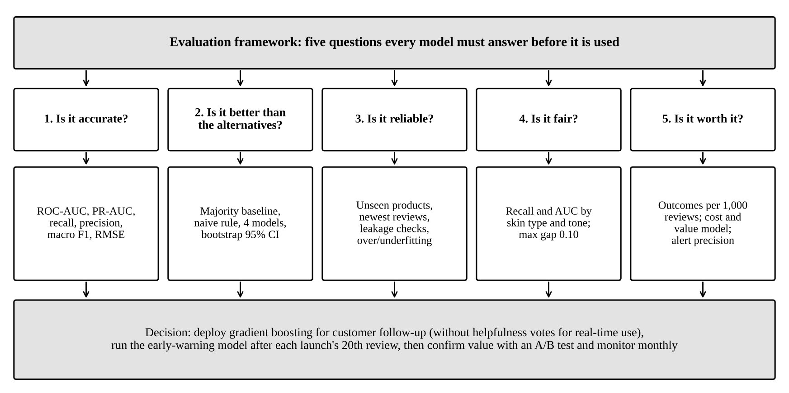
Figure 2: Evaluation framework: five questions and the evidence used to answer each
Table 1: The five evaluation questions
Question | Why it matters to the business | Evidence used
1. Is it accurate? | An inaccurate model wastes follow-up effort and misses unhappy customers | ROC-AUC, PR-AUC, recall, precision, F1 (classification); RMSE, MAE (forecasting)
2. Is it better than the alternatives? | A model is only worth building if it beats simple rules | Always-'yes' baseline, 'trust early reviews' rule, four algorithms, bootstrap confidence intervals
3. Is it reliable? | It must work on new products and future customers, not just past data | Unseen products, newest reviews, leakage checks, overfitting curves
4. Is it fair? | Beauty serves customers of every skin type and tone; poor performance for any group harms trust | Recall and AUC for each skin type and skin tone
5. Is it worth it? | The model must create more value than it costs | Outcomes per 1,000 reviews, illustrative cost and value model, alert precision

3. Choosing the Right Metrics
The most common metric, accuracy, is misleading here. Because 84% of reviewers recommend the product, a 'model' that always says 'they will recommend it' is 84% accurate, yet it never finds a single unhappy customer. The metrics below were chosen because they focus on the 16% of customers who matter most: the unhappy ones.
Table 2: Metrics, their meaning and our results
Metric | Plain-English meaning | Why chosen | Best result
ROC-AUC (main) | If we pick one happy and one unhappy customer at random, how often does the model rank the unhappy one as riskier? 0.5 = coin toss, 1.0 = perfect | Measures ranking quality regardless of the cut-off; used to choose and compare models | 0.897
Recall (unhappy) | Of all unhappy customers, the share the model catches | Missing an unhappy customer is the costly mistake | 82%
Precision (unhappy) | Of the customers the model flags, the share who really are unhappy | Controls wasted follow-up effort | 44% (vs 16% by chance)
PR-AUC (unhappy) | Overall precision-recall quality for the rare group; chance = 0.16 | More honest than ROC-AUC when the group of interest is small | 0.668
F1-score (macro) | Balance of precision and recall, averaged over both groups | One summary number; used to pick the cut-off | 0.726
Accuracy | Share of all predictions that are correct | Reported only to show why it misleads | 81% (baseline 84%)
Brier score | Average error of the predicted probabilities (lower is better) | Checks whether '70% likely' means 70% | 0.131
RMSE (early warning) | Typical size of a forecast error, in percentage points; large misses count more | Large misses are what cause bad launch decisions | 9.0 points
MAE (early warning) | Average forecast error, in percentage points | Easiest error measure to explain | 6.7 points
Alert precision and recall | Share of alerts that are real problems; share of real problems that get an alert | What a launch team experiences | 56% and 61%
Why both ROC-AUC and PR-AUC? ROC-AUC is a widely understood, threshold-free measure of how well the model separates the two groups. However, when the group of interest is small, ROC-AUC can look flattering. PR-AUC focuses entirely on the unhappy group, so the report uses both. A PR-AUC of 0.668 against a chance level of 0.16 confirms that the model is useful.
Why RMSE and MAE for forecasting? RMSE penalises large forecast errors more heavily than small ones, which matches the business risk: a forecast that is 25 points too optimistic is far more harmful than five forecasts that are 5 points off. MAE is reported alongside it because it is easier to explain ('on average the forecast is 6.7 points away').
Choosing the cut-off. The model gives each customer a risk score. The business decides the cut-off above which a customer is contacted. A lower cut-off catches more unhappy customers but creates more false alarms. The results in this report use a cut-off of 0.5, and Section 6 shows how the choice depends on the cost of a follow-up compared with the value of a kept customer.

4. Validation Plan: Stages of Testing
The model passes through eight stages of testing. The first six were completed during the project. The last two are planned for deployment, because only a live trial can prove business value.
Table 3: Validation stages
Stage | What is tested | Pass criterion | Result
1. Data validation (Week 3) | 10 automatic checks: valid ratings, no duplicates, no personal data, all reviews matched to products | All 10 pass | Passed (10/10)
2. Development (Week 5) | Tuning with 3-fold cross-validation grouped by product | Small gap between training and validation scores | Passed; simplest settings won
3. Hold-out test (Week 5) | Final score on 158,628 reviews of products never seen in training | AUC at least 0.10 above baseline (set in Week 2) | Passed (+0.397)
4. Statistical significance | 500 bootstrap resamples of test products | 95% interval for the gain above zero | Passed (0.391 to 0.402)
5. Stress tests | Newest reviews; no gifted reviews; no helpfulness votes; no popularity; no text; overfitting curves | AUC stays above 0.85 for the main use | Passed (0.882 to 0.905)
6. Fairness | Recall and AUC for each skin type and skin tone | Recall gap of 0.10 or less | Passed (max gap 0.051)
7. Business pilot (planned) | A/B test: model-targeted follow-up vs random follow-up | Higher retention or repeat purchase in the model group | To do
8. Live monitoring (planned) | Monthly AUC, recall, drift in inputs, fairness | AUC above 0.85; recall gap below 0.10 | To do

5. Results

5.1 Which model performed best?
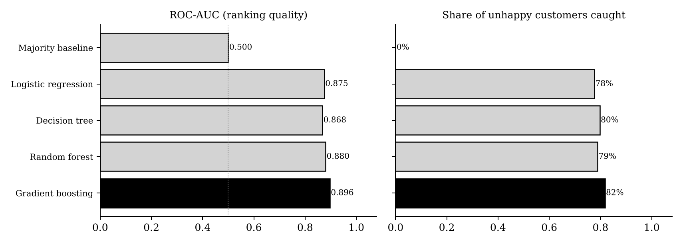
Figure 3: Ranking quality and share of unhappy customers caught, by model (test products never seen in training)
Table 4: Performance table (158,628 test reviews, cut-off 0.5)
Model | ROC-AUC | PR-AUC | Recall (unhappy) | Precision (unhappy) | Macro F1 | Accuracy
Always 'recommend' (baseline) | 0.500 | 0.158 | 0% | - | 0.457 | 84.3%
Logistic regression | 0.875 | 0.609 | 78% | 43% | 0.715 | 80.4%
Decision tree | 0.868 | 0.599 | 80% | 40% | 0.692 | 77.7%
Random forest | 0.880 | 0.623 | 79% | 43% | 0.713 | 80.0%
Gradient boosting (chosen) | 0.897 | 0.668 | 82% | 44% | 0.726 | 80.9%
In plain words: all four methods are far better than the baseline, and gradient boosting is the best on every measure that matters. It is chosen as the main model. Logistic regression is only slightly behind (0.875) and is kept because its results are easy to explain. Notice that the baseline has the highest accuracy while catching no unhappy customers. This is exactly why accuracy was not used to choose the model.

5.2 What the model means for every 1,000 customers
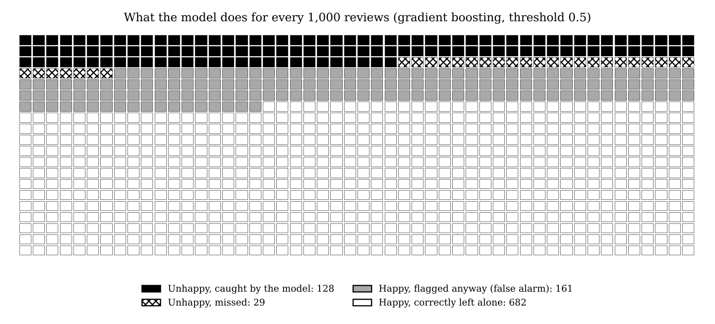
Figure 4: Outcomes for every 1,000 reviews (each square is one review)
Out of every 1,000 reviews, about 157 come from unhappy customers. The model flags 289 reviews as high risk. Of these, 128 really are unhappy (caught) and 161 are happy customers flagged by mistake (false alarms). Only 29 unhappy customers are missed. Without the model, a company wanting to reach the same 128 unhappy customers by random selection would have to contact about 815 people. With the model it contacts 289, which is 2.8 times more efficient. These counts are calculated from the model's measured recall (82%) and precision (44%).

5.3 How each step of the project improved the model
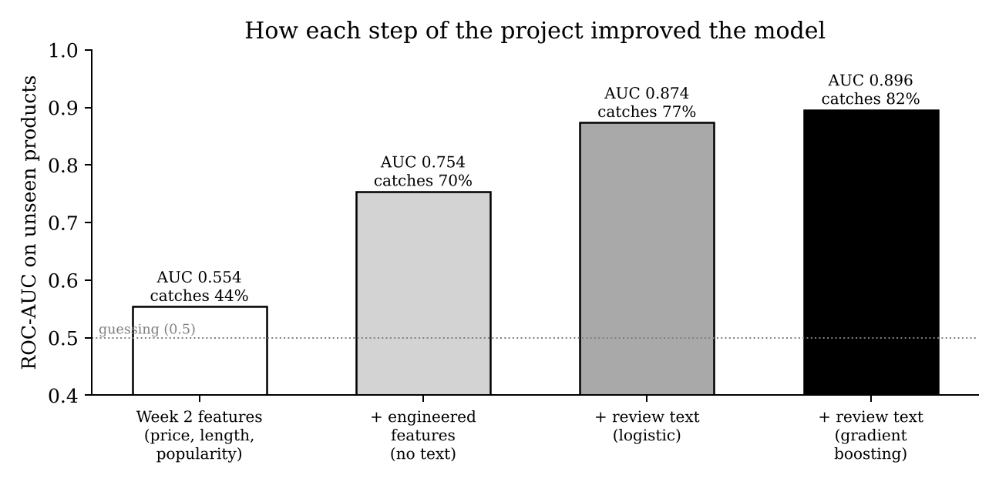
Figure 5: Model quality as the project added information (Week 4 feature test)
With only the basic product information available in Week 2 (price, review length, popularity), the model was barely better than guessing (0.554) and caught 44% of unhappy customers. The 36 engineered features raised this to 0.754 without reading a word of the review text. These features include value for money, the product's earlier ratings, the reviewer's past habits and ingredient-skin type matches. Adding review text features pushed it to 0.874, and the more flexible gradient boosting method reached 0.896. The biggest single gain came from turning raw data into meaningful business measures, not from a more complex algorithm.

5.4 Is the model reliable?
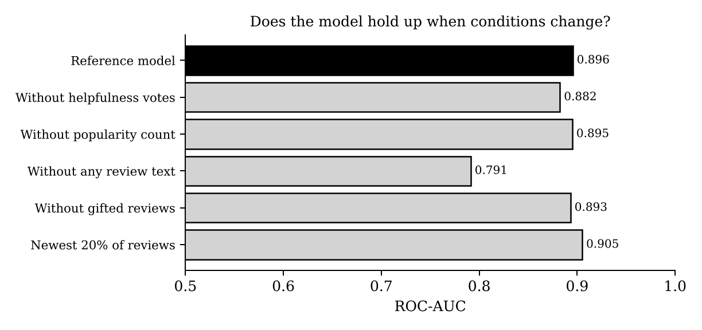
Figure 6: Model quality under different conditions
- Statistically certain: across 500 resamples of the test products, the gain over the baseline is +0.396 (95% interval 0.391 to 0.402), and the gain over logistic regression is +0.022 (0.020 to 0.024). Neither result is due to chance.
- Stable over time: on the newest 20% of reviews the model scores 0.905, so it has not become outdated.
- Not inflated by gifted reviews or popularity counts: removing either changes the score by 0.003 or less.
- One timing issue: helpfulness votes arrive after a review is posted. For real-time use, the model without them scores 0.882, a small and acceptable loss.
- Useful even before a review is written: with no text at all, the model still scores 0.791, so it can be used to choose shoppers for proactive help.
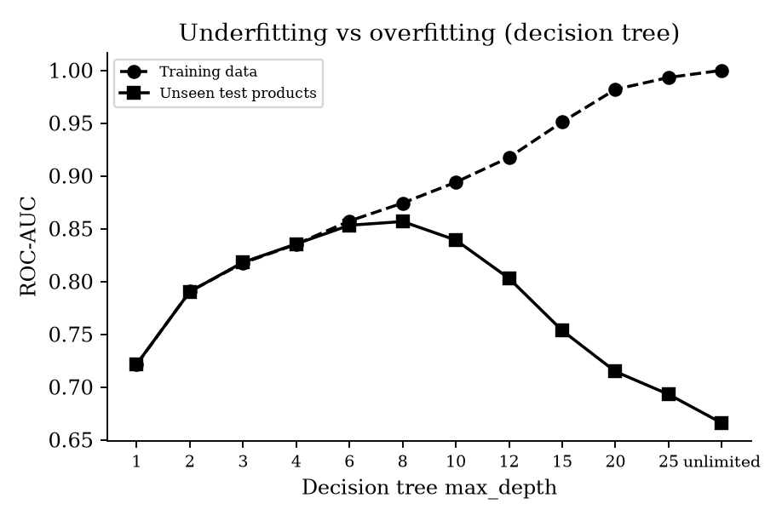
Figure 7: Over- and underfitting check (decision tree)
Figure 7 shows why the models were deliberately kept simple. A very shallow tree is too simple (it underfits: 0.72 on both training and new data). A very deep tree memorises the training data, scoring a perfect 1.00 on training data but only 0.67 on new products (it overfits). The best balance is in between, and tuning chose the simpler settings for every model.

5.5 Is the model fair?
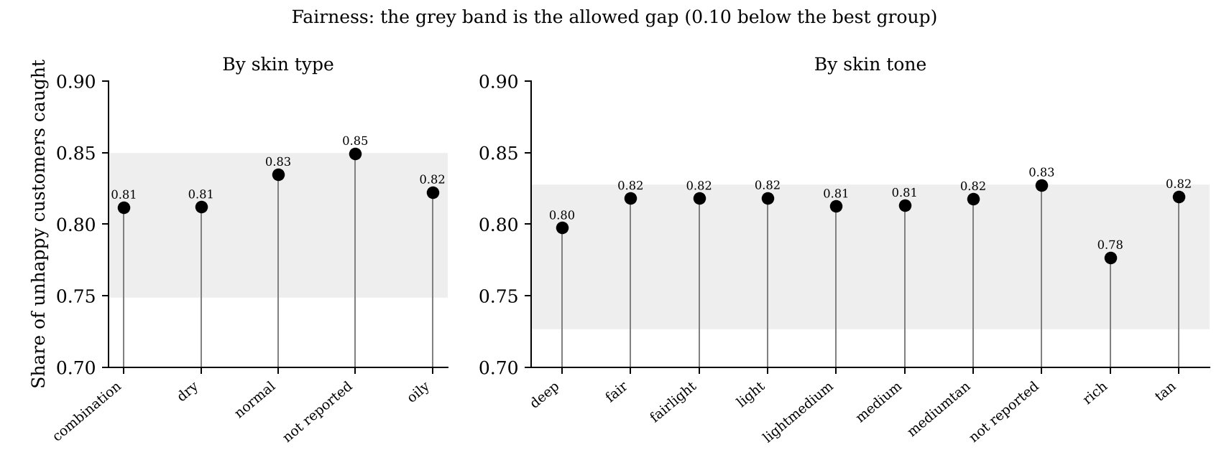
Figure 8: Share of unhappy customers caught for each skin type and skin tone
The model catches between 81% and 85% of unhappy customers for every skin type, and between 78% and 83% for every skin tone. All groups sit inside the allowed band. The two lowest values are for 'rich' (78%) and 'deep' (80%) skin tones, which are also the groups with the fewest reviews. The model is fit for use for all customers, but these groups will be watched closely in monitoring.

5.6 What drives satisfaction?
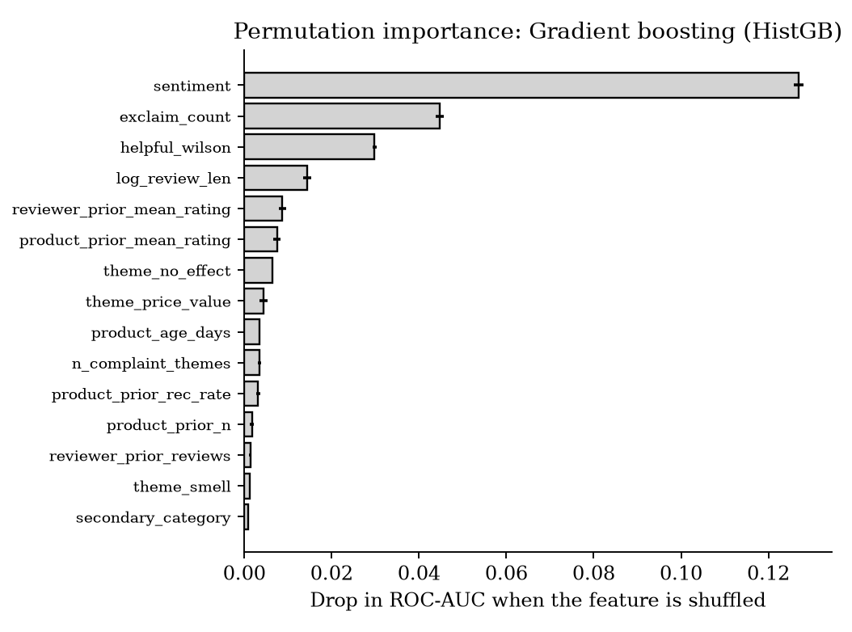
Figure 9: What the model relies on most (drop in ranking quality when each item is scrambled)
The tone of the review is by far the strongest signal, followed by emotional intensity (exclamation marks), whether other shoppers found the review helpful, and review length. Next come the reviewer's own rating habits and the product's earlier ratings. Price, brand and skin type contribute very little on their own.
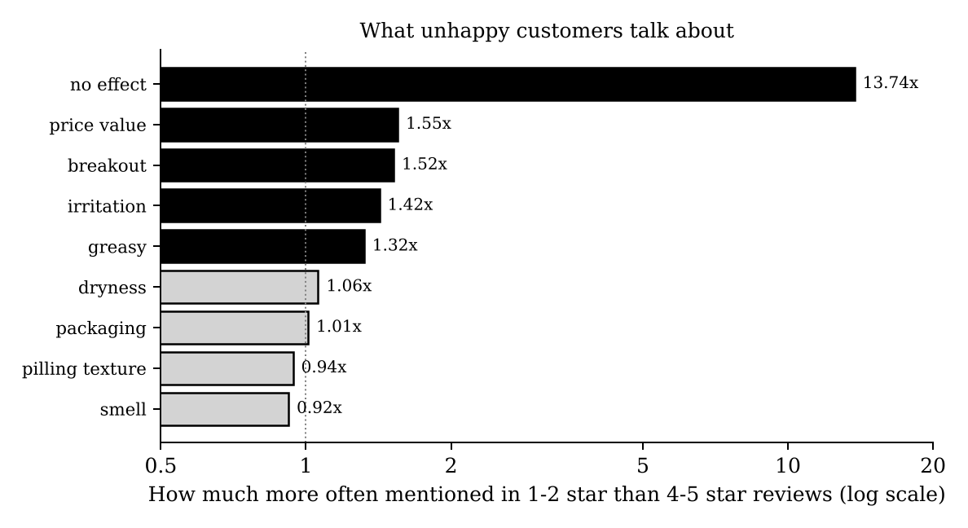
Figure 10: Topics mentioned more often by unhappy customers
The clearest warning sign is a customer saying a product 'did nothing' or was 'a waste'. This is 13.7 times more common in 1 to 2 star reviews, and only 34% of these customers still recommend the product. Value for money, breakouts, irritation and greasiness come next. Smell and texture are mentioned just as often by happy customers, usually as praise.
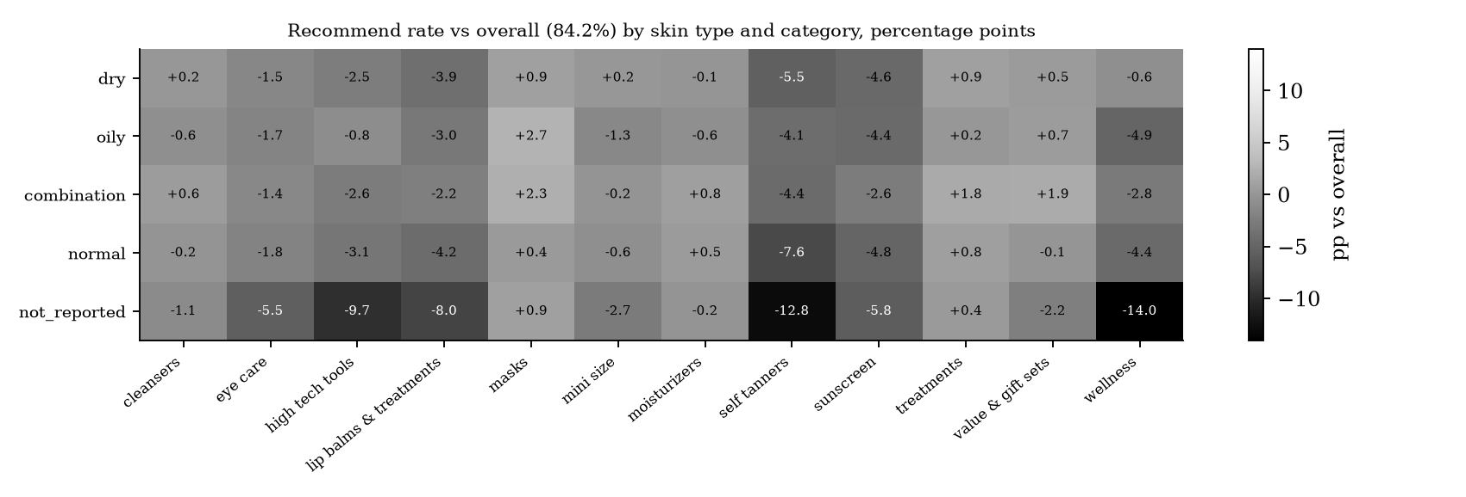
Figure 11: Recommend rate above or below the 84.2% average, by skin type and category (percentage points)
Dissatisfaction is concentrated rather than spread evenly. Self tanners and sunscreen are below average for every skin type. Customers who do not report their skin type are well below average in wellness (-14.0 points), self tanners (-12.8) and high-tech tools (-9.7). Masks do well for oily and combination skin.
Table 5: Other key findings
Finding | What it means
More expensive products get slightly higher ratings (rho 0.17), but price per mL has no effect (rho 0.03) | Charging more per millilitre is not rewarded with higher satisfaction
A product's first 10 reviews are 0.16 stars higher than later ones | Early ratings overstate how happy later buyers will be
A reviewer's own past average predicts their next rating (rho 0.41) | Some customers are generous and others harsh; ratings should be read in context
12.5% of reviews were written in exchange for free products | Results were checked with and without them and did not change
Sentiment and star rating agree only moderately (rho 0.33) | Text reveals mixed feelings that stars hide

5.7 Early warning for new launches
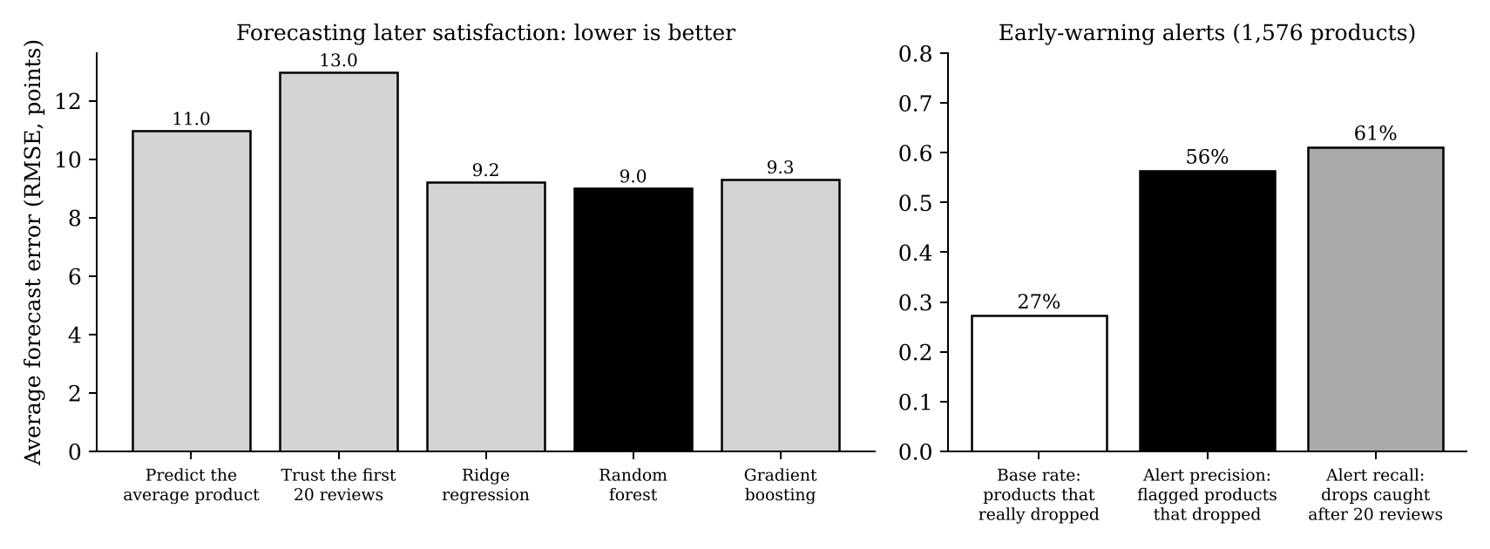
Figure 12: Forecast error of each method (left) and quality of the early-warning alerts (right)
The intuitive approach, assuming later buyers will be as happy as the first 20 reviewers, is the worst forecast of all (error 13.0 points). It is worse than simply predicting the average product (11.0 points), because early reviews are optimistic. The random forest model, which learns how much to discount early reviews, cuts the error to 9.0 points. When it raises an alert, the product really does lose 10 or more points 56% of the time, against a 27% base rate, and it catches 61% of all such drops after only 20 reviews.

5.8 Evaluation scorecard
Table 6: Final scorecard
Criterion | Target | Result | Status
Beats baseline (H6) | AUC +0.10 or more | +0.397 | Pass
Significance | 95% CI above 0 | 0.391 to 0.402 | Pass
Catches unhappy customers | Recall 60% or more (Week 2 target) | 82% | Pass
Works on unseen products | AUC 0.85 or more | 0.897 | Pass
Works on newest reviews | No meaningful drop | 0.905 | Pass
Fair across skin types and tones | Recall gap 0.10 or less | 0.051 | Pass
Real-time version | AUC 0.85 or more | 0.882 | Pass
Early warning beats simple rule | Lower RMSE than naive | 9.0 vs 13.0 | Pass
Calibrated probabilities | Brier below baseline for all models | Logistic 0.142 vs 0.133 | Needs work
Proven business value | A/B test | Not yet run | Planned

6. Business Impact
This section translates the findings into consequences for the main decisions in a beauty and wellness business.

6.1 Brand and product decisions
- Product development should focus on visible results. 'Did nothing' is the strongest predictor of an unhappy customer, more than irritation or breakouts. Clinical results, before-and-after evidence and realistic timelines matter more than new ingredients.
- Self tanners and sunscreen need formula or guidance improvements, because they underperform across skin types. Typical complaints include streaks, colour and white cast.
- Pricing should be based on proven value, not premium positioning alone, since a higher price per mL brings no extra satisfaction.

6.2 Marketing strategy
- Do not judge a launch by its first reviews. Use the early-warning forecast before scaling advertising spend, because 27% of products disappoint later buyers.
- Review gifted-sample programmes. One review in eight is incentivised. These reviews did not change the overall results, but they can make individual launches look better than they are.
- Target by suitability. The skin type x category view shows which audiences each product truly satisfies, so campaigns can target them and avoid customers likely to be disappointed.

6.3 Customer engagement
- Contact likely-unhappy customers early with routine advice, an alternative product or a loyalty offer, matched to their complaint (for example, oily-skin advice for breakouts).
- Ask for skin type at checkout or in the review form. Customers who do not share it are noticeably less satisfied, and knowing it enables better recommendations.
- Use the no-text model (AUC 0.791) to offer help before a customer writes a negative review.

6.4 Illustrative value of a follow-up programme
The figures below are illustrative. They combine the model's measured performance with assumed business costs, which a company should replace with its own figures.
Assumptions: 100,000 reviewing customers, USD 1 to contact a customer (for example, a personalised e-mail with a voucher), 20% of contacted unhappy customers kept, and USD 60 future value per kept customer.
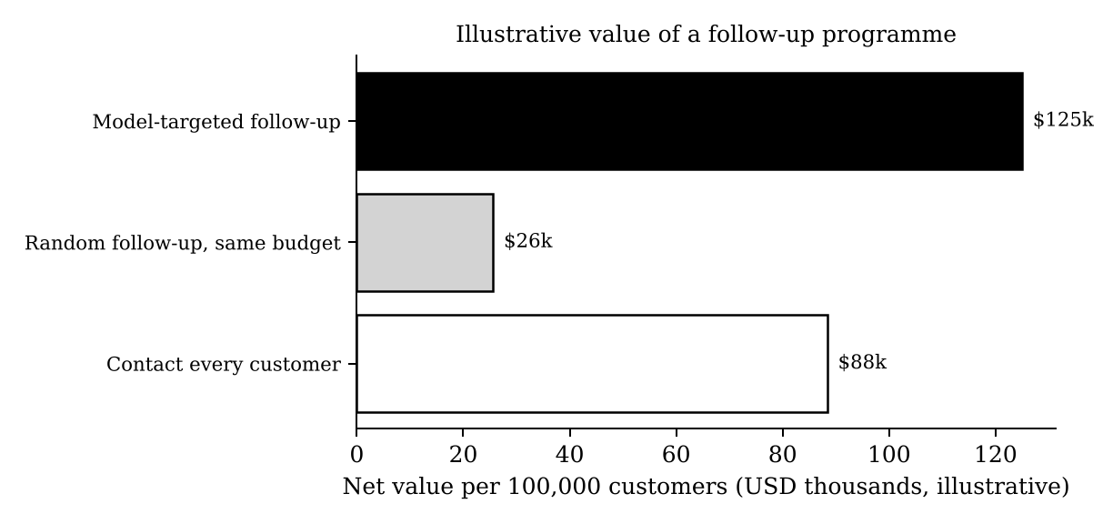
Figure 13: Net value of three follow-up strategies per 100,000 customers (illustrative)
Table 7: Illustrative business impact per 100,000 customers
Strategy | Contacted | Unhappy reached | Cost (USD) | Value kept (USD) | Return per USD 1
Model-targeted follow-up | 28,972 | 12,832 | 28,972 | 153,979 | 5.31
Random follow-up, same budget | 28,972 | 4,549 | 28,972 | 54,583 | 1.88
Contact every customer | 100,000 | 15,700 | 100,000 | 188,400 | 1.88
With the same budget, the model reaches 2.8 times as many unhappy customers as random selection, and it creates about USD 125,000 of net value against USD 26,000. Contacting everyone reaches slightly more unhappy customers but costs more than three times as much, for a lower net value (USD 88,000). The result is not sensitive to the assumptions: the model-targeted programme breaks even if only 3.8% of contacted unhappy customers are kept, far below the 20% assumed.

7. Dashboard Mock-up
Figure 14 is a mock-up of how the results would be presented to managers each week. The KPI values and heatmap cells use real project results, while the product and review names are illustrative.
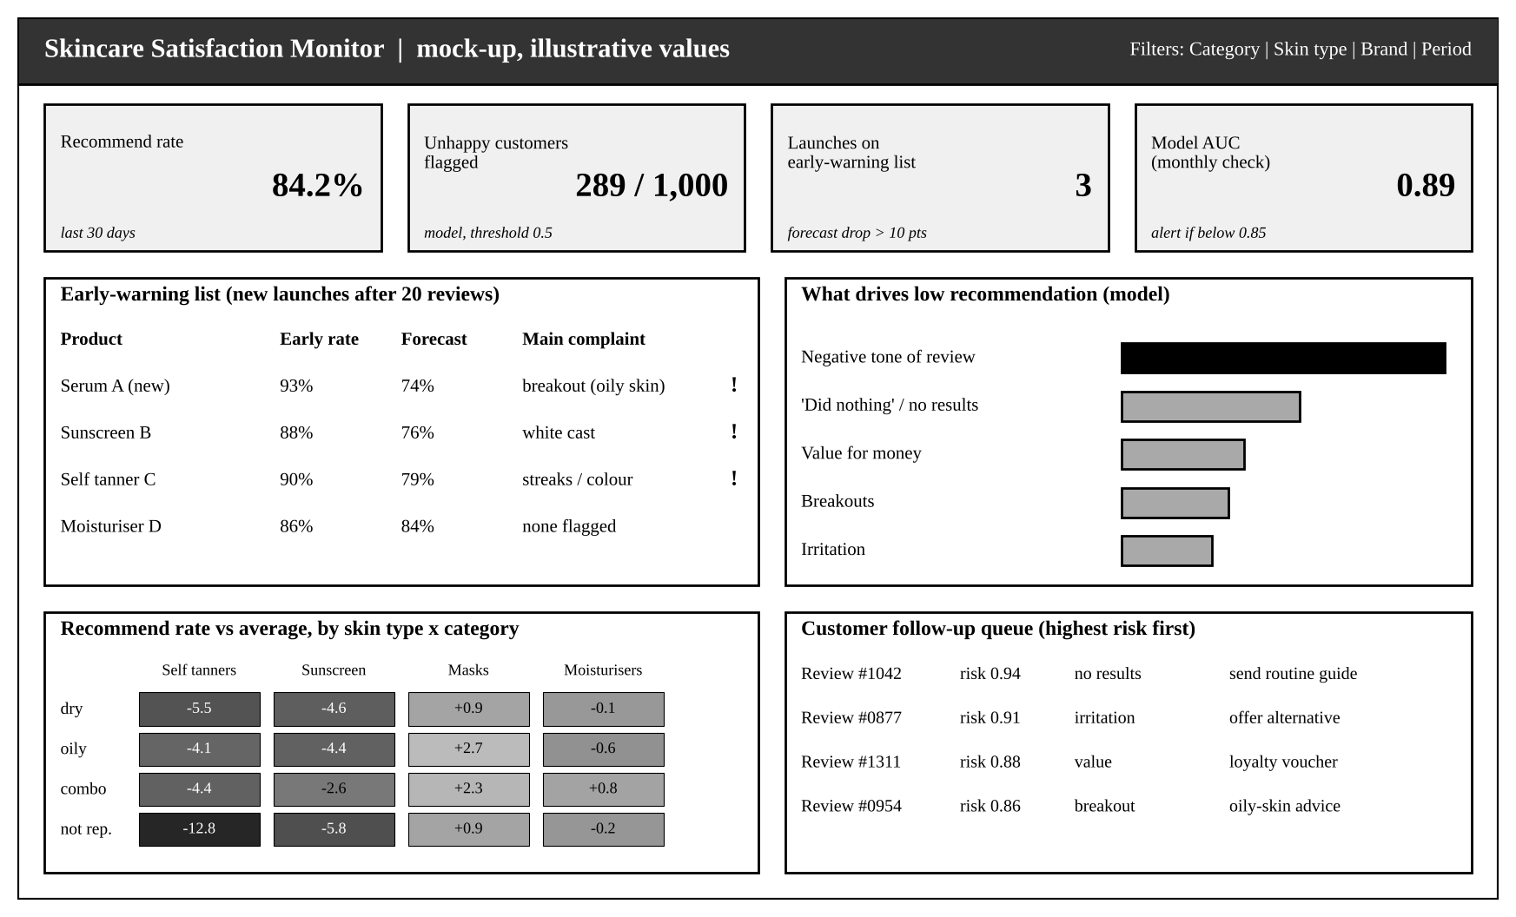
Figure 14: Mock-up of the Skincare Satisfaction Monitor
Table 8: Dashboard panels and their users
Panel | What it shows | Used by
KPI tiles | Recommend rate, customers flagged, launches on watch, model health | Leadership
Early-warning list | New launches forecast to drop more than 10 points, with the main complaint | Launch, brand and marketing teams
Drivers | What the model links to low recommendation | Product development, marketing
Skin type x category | Where satisfaction is above or below average | Merchandising, recommendation engine
Follow-up queue | Highest-risk reviews with a suggested action | Customer care

8. Recommendations
Table 9: Actionable recommendations
# | Action | Evidence | Owner | When | Success measure
1 | Launch a model-targeted follow-up programme for likely-unhappy customers | 82% of unhappy customers caught; 2.8x more efficient than random | Customer care, CRM | 0-3 months | Repeat purchase rate of contacted vs control group
2 | Run the early-warning model after each launch's 20th review | 56% alert precision vs 27% base rate; error 9.0 vs 13.0 | Launch team | 0-3 months | Share of launches reviewed before ad spend increase
3 | Make 'visible results' the core of product claims and education | 'Did nothing' is 13.7x more common in low reviews | Marketing, R&D | 3-6 months | Share of reviews mentioning 'no effect'
4 | Improve self tanners, sunscreen and wellness products and guidance | Below average for most skin types (up to -12.8 points) | Product development | 3-12 months | Recommend rate per category
5 | Ask for skin type and personalise recommendations | Non-reporters up to 14 points less satisfied | E-commerce | 0-6 months | Share of shoppers with skin type; recommend rate
6 | Report ratings with and without gifted reviews; review sampling programmes | 12.5% of reviews incentivised; early reviews 0.16 stars higher | Marketing, trust and safety | 0-3 months | Gap between gifted and organic ratings
7 | Base premium pricing on proven results, not pack size | Price per mL unrelated to satisfaction | Pricing | 6-12 months | Recommend rate of premium lines
8 | Collect more reviews from deep and rich skin tones and monitor model fairness | Lowest recall (78-80%) and smallest groups | Data science, inclusion | Ongoing | Recall gap below 0.10 every month

9. Implementation Roadmap and Monitoring
Table 10: Roadmap
Period | Actions | Decision point
Days 1-30 | Recalibrate model probabilities; build the dashboard; agree the cut-off with customer care using real costs | Is the dashboard trusted by its users?
Days 31-90 | A/B test: half of high-risk customers receive follow-up, half do not; early-warning alerts reviewed for every launch | Does follow-up increase repeat purchases enough to justify the cost?
Days 91-180 | Roll out follow-up if the test succeeds; add sentence-level sentiment to improve complaint detection | Scale up, adjust or stop
Ongoing | Monthly monitoring and retraining every quarter or when triggered | Retrain when any trigger in Table 11 fires
Table 11: Monitoring and retraining triggers
What is monitored | Normal range (from this project) | Action if outside
ROC-AUC on recent labelled reviews | 0.88 to 0.91 | Retrain if below 0.85
Recall of unhappy customers | About 80% | Review the cut-off if below 70%
Recall gap across skin types and tones | 0.05 or less | Investigate if above 0.10
Overall recommend rate | About 84% | Check for drift if it moves more than 3 points
Share of incentivised reviews | About 12.5% | Check whether new sampling campaigns are distorting inputs
Early-warning alert precision | About 56% | Retrain the regression model if below 40%

10. Limitations and Responsible Use
- One retailer, one market: the data comes from Sephora's US website up to 2023. Results may differ for Indian or other markets and should be checked with local data, for example from Indian beauty retailers, before being used there.
- Reviewers are not all customers: only customers who choose to write a review are included, and very happy or very unhappy customers are more likely to write one.
- Text needs reading for meaning: keyword themes now handle simple negation ('not greasy'), but they still cannot tell praise from complaint for topics like smell. Sentence-level sentiment would improve this.
- Probabilities need calibration: the model ranks customers well, but its scores should be recalibrated before being shown as percentages.
- Business value is not yet proven: the impact figures are illustrative and must be confirmed with an A/B test.
- Privacy and fairness: reviewer IDs were replaced with anonymous keys, e-mail addresses and phone numbers were masked, and raw data was never shared publicly. Skin tone and type are used only to check fairness and personalise help, never to exclude customers. Group results are only reported for groups with enough reviews.
- Human in the loop: the model should prioritise which customers and products people look at; it should not make automatic decisions such as removing products or reviews.

11. Final Summary for Decision-Makers
Customer reviews contain far more information than the average star rating shows. By cleaning nearly one million skincare reviews, turning them into meaningful measures of customer behaviour and testing four prediction methods carefully, this project built a model that identifies 82% of unhappy customers with a ranking quality of 0.897. The model is statistically far better than current practice, stable over time and fair across skin types and tones. A second model warns, after only 20 reviews, which new products are likely to disappoint later buyers.
The findings point to clear business priorities. Customers are unhappy mainly when a product does not visibly work, not because of its price. Early reviews make launches look better than they are. Dissatisfaction concentrates in self tanners, sunscreen and wellness products, and among shoppers whose skin type the business does not know. Acting on these insights means using the model to reach unhappy customers early, checking every launch before scaling spend, building product claims around visible results, and personalising by skin type. In an illustrative scenario, the follow-up programme returns about USD 5.30 for every dollar spent and breaks even if fewer than 4% of contacted customers are kept. The recommended next step is a 90-day A/B test to confirm this value in practice.

Glossary
Term | Meaning
A/B test | An experiment that compares two groups treated differently (e.g. contacted vs not contacted) to measure the true effect
Accuracy | Share of all predictions that are correct; misleading when one outcome is much more common
Bootstrap | Repeatedly resampling the data to measure how certain a result is
Calibration | Whether a predicted probability matches reality (a '70% risk' group should be unhappy 70% of the time)
Confidence interval (95%) | The range in which the true value lies with 95% confidence
Cut-off (threshold) | The risk score above which a customer is flagged
F1-score | A single number that balances precision and recall
Feature | A piece of information given to the model, e.g. price per mL or review sentiment
Gradient boosting | A method that builds many small decision trees, each correcting the mistakes of the previous ones
Overfitting / underfitting | Memorising the training data instead of learning general patterns / being too simple to learn the patterns
Precision | Of the customers flagged, the share who really are unhappy
Recall | Of all unhappy customers, the share the model finds
RMSE / MAE | Typical and average size of forecast errors (here in percentage points)
ROC-AUC | How well the model ranks unhappy customers above happy ones (0.5 = guessing, 1.0 = perfect)
Sentiment | A score from -1 (very negative) to +1 (very positive) describing the tone of a review

References
Breiman, L. (2001) 'Random forests', Machine Learning, 45(1), pp. 5-32.
Efron, B. and Tibshirani, R.J. (1993) An Introduction to the Bootstrap. New York: Chapman and Hall.
Friedman, J.H. (2001) 'Greedy function approximation: a gradient boosting machine', Annals of Statistics, 29(5), pp. 1189-1232.
Hutto, C.J. and Gilbert, E. (2014) 'VADER: A parsimonious rule-based model for sentiment analysis of social media text', Proceedings of ICWSM.
Inky, N. (2023) Sephora Products and Skincare Reviews [dataset]. Kaggle. Available at: https://www.kaggle.com/datasets/nadyinky/sephora-products-and-skincare-reviews
McKinsey & Company (2025) The State of Beauty 2025. McKinsey & Company.
Mehrabi, N. et al. (2021) 'A survey on bias and fairness in machine learning', ACM Computing Surveys, 54(6).
Pedregosa, F. et al. (2011) 'Scikit-learn: Machine learning in Python', Journal of Machine Learning Research, 12, pp. 2825-2830.
Provost, F. and Fawcett, T. (2013) Data Science for Business. Sebastopol: O'Reilly.
Saito, T. and Rehmsmeier, M. (2015) 'The precision-recall plot is more informative than the ROC plot when evaluating binary classifiers on imbalanced datasets', PLoS ONE, 10(3).
Sculley, D. et al. (2015) 'Hidden technical debt in machine learning systems', Advances in Neural Information Processing Systems 28.

Appendix A: Reproducing the Project
All code is in the GitHub repository. The raw data is not stored there because of its size and to protect reviewer privacy; it can be downloaded from Kaggle into data/raw. Each script writes its results to output/weekN.
Script | What it does
src/week2_data_audit_and_eda.py | First data audit, pilot tests and baseline model
src/week3_cleaning_pipeline.py | Cleaning pipeline with 10 validation checks
src/week4_eda_features.py | EDA, 36 engineered features, feature test
src/week5_modeling.py | Four tuned models, validation, fairness, early warning
src/week6_report_figures.py | All summary charts and the business impact table in this report

pip install -r requirements.txt
python src/week3_cleaning_pipeline.py
python src/week4_eda_features.py
python src/week5_modeling.py
python src/week6_report_figures.py # charts in output/week6/

