Guardian workflow and LLM evidence
  - How pod activity becomes evidence for local security analysis
24 October 2026 | Current implementation and an illustrative investigation
Guardian monitors a client Kubernetes cluster by combining network observations, kernel events, Kubernetes API audit records and pod permission snapshots. The local LLM can use this evidence to explain suspicious behavior against explicitly configured boundaries. Numeric risk scoring and automatic permission removal are not implemented.
This guide explains what information is collected, how it is joined, what reaches the model and where the evidence remains incomplete. The worked example is fictional and does not represent activity observed in a customer cluster.
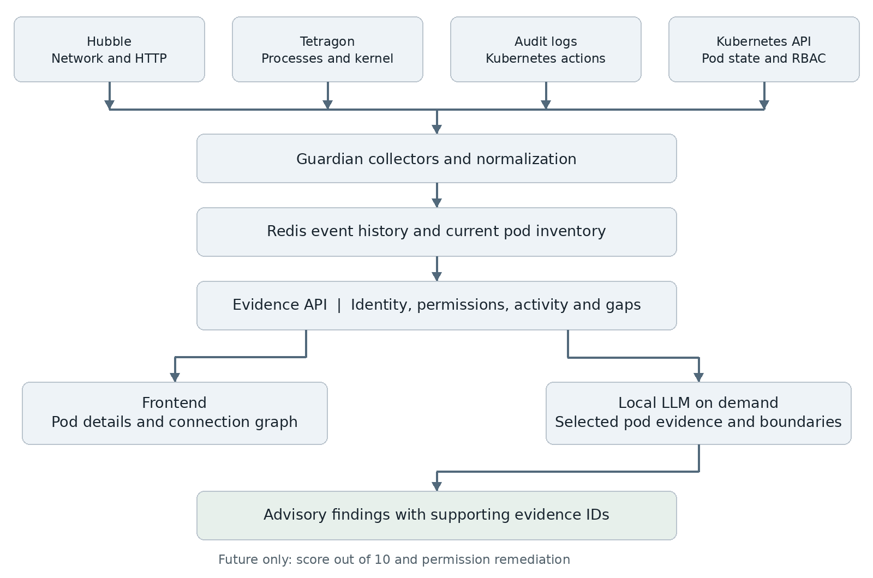
Figure 1 Four evidence sources converge in Guardian. Model evaluation is requested on demand; it is not a continuous scan of every pod.

What must be connected
Cilium and Hubble supply network visibility. Tetragon and loaded tracing policies supply runtime events. An API-server audit export supplies API actions. Guardian also needs read-only access to pod and RBAC resources. Adding application code alone does not enable these sources on a live cluster.

What information the model can receive
The system provides ten practical groups of evidence, with dozens of named fields. There is no fixed number of facts per pod: fields depend on exporter configuration, kernel support, audit settings, workload activity and retention. Empty fields mean unknown or unavailable, not safe.
Evidence group | Representative fields | Question it helps answer
1 Pod identity | Cluster, namespace, pod name and UID, node, owner, pod IP | Which workload and pod instance does this describe?
2 Container identity | Container name, image, image ID, container ID, init and ephemeral containers | Which container or image was involved?
3 Security configuration | Privileged mode, run-as identity, escalation controls, capabilities, seccomp, host PID/network/IPC | How much host or kernel access is configured?
4 Mounts and health | Host paths, secret and projected-volume references, resource limits, phase, restart counts, termination states | What is mounted and has its state changed?
5 RBAC grants | Service account, verbs, API groups, resources, resourceNames, namespace scope, role and binding provenance | What Kubernetes actions does its identity have permission to request?
6 API activity | Audit ID, stage, actor, verb, target, response code, source IP, user agent, authorization decision, token pod UID | Which API action was attempted and what did the server return?
7 Network activity | Source and destination pods/IPs, TCP/UDP fields, direction, verdict and drop reason | Who communicated with whom and was traffic dropped?
8 HTTP and DNS | Method, host, path, status, protocol, latency; DNS query, answers, response code and types | Which visible request or lookup was observed?
9 Runtime activity | Binary, UID, PID, exec ID, parent identity, capabilities, namespaces, selected file paths, numeric arguments and returns | What process or selected kernel operation was observed?
10 Changes and coverage | Before/after configuration or status, event IDs, timestamps, collector state and inventory age | What changed and how reliable is this view?

Secret values, file contents, process arguments, environment values, HTTP bodies, headers and query strings are excluded from the normalized evidence paths. Paths, DNS names and some exported status metadata can still contain sensitive information.

How Guardian builds the evidence

Collection and normalization
Hubble and Tetragon JSONL exports are followed as files. The independent audit reader follows POD_AUDIT_EXPORT_PATH without consuming the RBAC worker cursor. Normalization adds cluster identity, observation time and a stable hash identifier, keeps selected fields and strips sensitive payloads. Redis deduplicates source replay within the retention period.
Pod inventory and RBAC are refreshed by a background task, normally every 60 seconds. Guardian retains the current snapshot and records selected differences between successive snapshots. This polling can miss short-lived pods and intermediate changes. Collectors retry failures and expose their status.

Permission resolution
Kubernetes normally authorizes the service account used by a pod, rather than the pod name itself. Guardian finds applicable RoleBindings and ClusterRoleBindings, including service-account user and group subjects, then resolves their Role or ClusterRole rules. A RoleBinding grants its rules in the binding namespace even when its subject is a service account from another namespace.
The result retains verbs, resources, API groups, resourceNames and binding scope. Delete, create, workload mutation, exec/attach, credentials and escalation permissions produce evidence signals. A signal describes permission exposure; it does not show that the permission was used. Admission controls, other authorizers and actual credentials can affect whether an operation succeeds.

Identity and event correlation
Runtime records are matched to namespace and pod name, and pod UID when supplied. Audit activity is matched to the service-account identity. A matching authentication token pod UID gives stronger credential attribution; events without that UID are placed in a separate shared-identity collection. A stolen bound token could still be used outside its original pod.
Hubble observations form directed graph edges between endpoints. Edges count flow records, HTTP request observations and drops. These are not guaranteed counts of unique connections or unique business requests: multiple observation points can describe the same traffic.

Evidence preparation and evaluation
A selected pod bundle contains identity and configuration, resolved permissions, recent attributed events, shared-identity audit events, coverage and snapshot timestamps. The model context also includes configured boundaries and a graph. Namespace and pod parameters must both be supplied to include that selected pod bundle.
The local model is invoked only when the evaluation endpoint is called. Its response is advisory text. There is no enforcement action, risk score calculation, automatic evaluation scheduler or typed verdict validation in the current path.

Worked example of suspicious pod activity
Illustrative scenario: payments/web-7d9 runs a payment HTTP service. Its declared boundary allows traffic to the payments namespace and kube-system, disallows unresolved external destinations and allows only /app/server as a runtime executable. These boundaries are operator configuration, not automatically inferred business intent.
Inventory fact | Illustrative value
Pod and owner | payments/web-7d9; UID pod-web-01; ReplicaSet owner
Identity and image | Service account payments-web; image payments:v3; observed image/container IDs
Security context | Non-privileged container; runAsUser 1000; hostNetwork and hostPID false
RBAC exposure | RoleBinding web-maintainer grants create and delete on core pods in payments
Grant provenance | Role payments-maintainer; RoleBinding web-maintainer; scope payments

During one minute, assume all required sources emit the following eight records. E1 through E8 are readable document labels; production event IDs are hashes.
ID and time | Observed evidence | Interpretation limit
E1 10:00:01 | Hubble HTTP request: web-7d9 → payments/api, POST /charge | Normal-looking request metadata; no body or payment contents
E2 10:00:05 | Tetragon process_exec: /bin/sh, UID 1000, parent /app/server | Shell observed; reason for launch is unknown
E3 10:00:06 | File permission hook for a service-account token path; return 0 | Permission check passed; does not prove the token was read or stolen
E4 10:00:09 | Audit: delete payments/database-0, status 200; matching token pod UID | Server accepted the delete request; final termination is not established
E5 10:00:11 | Audit: create payments/debug-helper, status 201; same token binding | Creation succeeded; request body and new pod specification are excluded
E6 10:00:15 | Audit: get secrets, status 403; matching service account but no pod UID | Denied shared-identity attempt; cannot confidently assign it to web-7d9
E7 10:00:20 | Hubble: web-7d9 → an unresolved external IP on TCP 443 | Connection evidence; HTTPS path, content and exfiltration are unknown
E8 10:01:00 | Inventory difference: restart count changes from 0 to 1 | Restart occurred between snapshots; cause needs additional evidence

What this example sends to the LLM
For this scenario, the selected pod contributes one current inventory and permission snapshot, seven attributed event records, and one separately labelled shared-identity audit record. That is eight event records across four source types, plus boundary configuration and collector coverage. The graph adds endpoint relationships; it is another representation of network evidence, not independent proof.
The namespace event list can contain these same events again. Duplicate appearances must not be counted as independent confirmation. The example below is an abbreviated view of the actual context structure; omitted fields remain available in the full API response.
{
"cluster": "client-prod",
"boundaries": [{"namespace": "payments",
"allowed_destination_namespaces": ["payments", "kube-system"],
"allow_external": false, "allowed_binaries": ["/app/server"]}],
"events": ["namespace events omitted here"],
"graph": {"nodes": ["endpoints omitted"], "edges": ["flows omitted"]},
"coverage": {"hubble": {"state": "following"},
"tetragon": {"state": "following"},
"audit": {"state": "following"}},
"pod_evidence": {
"inventory_observed_at": "2026-10-24T10:01:00Z",
"pods": [{
"identity": {"namespace": "payments", "pod": "web-7d9",
"uid": "pod-web-01", "permissions": {
"service_account": "system:serviceaccount:payments:payments-web",
"grants": [{"binding_name": "web-maintainer",
"scope": "payments", "role_name": "payments-maintainer",
"rule": {"apiGroups": [""], "resources": ["pods"],
"verbs": ["create", "delete"]}}]}},
"events": ["E1 E2 E3 E4 E5 E7 E8 expanded in actual response"],
"shared_identity_audit_events": ["E6 expanded in actual response"]
}],
"event_limit_per_pod": 50,
"scoring_enabled": false, "remediation_enabled": false
}
}

How much evidence fits in one request
Evaluation defaults to limit 50 and accepts at most 100. With a selected pod, it can include up to N namespace events, up to N attributed pod events and up to N shared-identity audit events, plus inventory, grants, boundaries and a graph sampled from up to N network records. These limits are independent and can overlap; 3N is not a count of distinct actions.
The read-only context endpoint defaults to 100 and permits up to 500. There is no token-budget enforcement, historical window selector or automatic summarization, so large snapshots and grants can exceed a small local model context. Event limits cap records, not the total number of JSON fields or model tokens.

What the model could conclude
The following is an example of a defensible assessment, not a model response measured from a running cluster. The current endpoint returns free-form analysis, so this structure is a recommended way to interpret and present findings rather than an enforced output schema.

Supported finding
The payment workload shows behavior that warrants investigation. E2 records /bin/sh under /app/server, outside the configured allowed-binary boundary. E4 and E5 show the pod-bound service-account credentials deleting an existing pod and creating another pod. The current RBAC snapshot explains how create/delete permission is granted in payments. E7 shows traffic to an unresolved external destination, outside the configured network boundary.

Evidence that strengthens the concern
The sequence joins process evidence, a sensitive-file permission check, actual API actions and network activity. These sources establish separate observations close in time. They support a suspicious-activity hypothesis, but timing alone does not prove that the shell caused the API requests or that the file check yielded the credentials used.

Uncertainty the model must retain
E3 cannot prove token theft. E6 is denied activity associated with a shared service-account identity and lacks pod attribution. E7 does not reveal encrypted content or prove data exfiltration. A successful delete response does not by itself confirm that finalizers completed or that the target stopped. The RBAC snapshot is current and may differ from permissions at the exact event time.

Useful operator follow up
Review whether the application should hold create/delete permissions, whether maintenance explains the shell and workload actions, whether the newly created pod remains present, and which workloads share the service account. Preserve the audit IDs, runtime exec IDs, event timestamps and binding provenance during investigation.
Guardian currently performs none of these follow-up operations automatically. Removing a shared role or binding can affect multiple workloads. Future remediation needs an explicit decision policy, impact analysis and verification, rather than treating an unconstrained model answer as an instruction.

What remains outside the evidence
Ordinary HTTPS contents remain encrypted without separate inspection. Guardian does not provide application source logic, complete business transactions, file contents, every syscall, live CPU/memory usage or a lossless history. The model must not infer these from a connection or a permission flag.

What a future score would need
A future score out of 10 should use defined evidence weights, source freshness, attribution confidence, the intended workload boundary and repeated behavior. It should avoid counting duplicated flow observations twice and should report insufficient evidence when coverage is weak. Scoring is outside the current implementation.

Operating the workflow
API | Purpose
GET /telemetry/status | Collector status, retention settings and collection limitations
GET /telemetry/pods | Current pod inventory and RBAC grant provenance; optional namespace filter
GET /telemetry/pods/{namespace}/{pod}/evidence | Selected pod inventory, recent events and shared-identity evidence
GET /telemetry/events | Recent events, with namespace, kind and limit filters
GET /telemetry/graph | Observed directed endpoint graph with flow, HTTP and drop counts
GET /telemetry/llm-context | Read-only model input; supply namespace and pod for selected evidence
POST /telemetry/evaluate | On-demand local model evaluation; selected-pod parameters supported

Example selected-pod evaluation: POST /telemetry/evaluate?namespace=payments&pod=web-7d9&limit=50. The frontend provides status, a graph, recent events, pod selection and evidence inspection. Its existing general evaluation button is not automatically connected to the selected-pod picker; use the API parameters for a selected-pod evaluation.

Storage and freshness defaults
Redis keeps at most 50,000 recent event records per configured cluster identity. Reads filter out events observed more than seven days ago, and idle keys expire. The smaller of the count cap and time window limits available history. For example, 50,000 events at 100 events per second represents about 8 minutes 20 seconds, not seven days. Redis persistence must be enabled separately to survive restarts.
Inventory refresh defaults to 60 seconds. File readers process batches and poll about once per second; this is not a delivery-latency guarantee. Collector status indicates local reader health and last observation, not complete coverage of every node. Rotation, disconnections, export drops and delayed records can create gaps.

Live cluster requirements
Enable compatible Cilium/Hubble and Tetragon deployments, connect their exports, install and verify the observation policies, configure API-server audit export, bind Guardian read-only inventory permissions, set a unique cluster ID and configure workload boundaries. Test each source with known safe events and check its appearance in the evidence API before relying on model analysis.

Implementation references
Project: /home/saket-ubuntu/Guardian. Setup guide: docs/telemetry.md. Main components: services/telemetry.py, services/runtime_evidence.py, services/pod_evidence.py and api/routes/telemetry.py under backend/app. The supplied Kubernetes files cover observability values, tracing policies, audit policy and read-only access.
Current verification: 31 automated regression and API tests passed. Live cluster deployment, full node coverage, model accuracy and rendering of the running frontend were not validated by those tests.

