

Dealer Management System
User Manual
Service — Mobile App

Document: USER MANUAL-MOBILE APP_V1
Release Date: 10th Sept, 2026

Every application screen in this manual is annotated field by field, in the style of the JBM DMS screen guides.

Prepared by


Document Control
Document History
Version | Date of Prepare | Prepared / Updated By | Reviewed By | Reason for Change | Affected Sections
1.0 | 10th Sept 2026 | Harbans Kumar |  | Initial release | All

Revision History
Version | Date of Revision | Prepared / Updated By | Reviewed By | Reason for Change | Affected Sections

Approvals
Version | Date of Revision | Prepared / Updated By | Reviewed By | Reason for Change | Affected Sections

Contents
1. Introduction
1.1 Purpose · 1.2 Intended Users · 1.3 Prerequisite · 1.4 General Navigation
2. Login / Logout
i. Open the Application and Sign In · ii. Access the Home Dashboard · iii. Open the Menu and Select Logout · iv. Confirm the Logout
3. User Profile
v. View Your User Profile
4. Contact Us
vi. View JBM HQ Contact Details
5. Gate In / Gate Out
vii. Open Gate In / Gate Out and Find the Vehicle · viii. Gate In — Bus, Driver and Duty Details · ix. Gate In — Performance, SOC and Journey Details · x. Gate In — Schedule, Complaint and Vehicle Status · xi. Gate In — Wheel Condition, Attachments and Submit · xii. Gate Out — Select the Vehicle to Release · xiii. Gate Out — Shift and Journey Details · xiv. Gate Out — Wheel Condition, Attachments and Submit
6. Auto Job Cards (Daily / Ten-Day)
xv. Open the Auto Job Card List · xvi. View an Auto Job Card · xvii. Auto Job Card Statuses · xviii. Home Dashboard — Shift Engineer · xix. Open the Auto Job Card Inspection List · xx. Review and Process the Assigned Job · xxi. Validate Auto Job Card — Job Details · xxii. Validate Auto Job Card — Checklist
7. Assign Auto Job Cards
xxiii. Open Assign Auto Job Card and Select Jobs · xxiv. Review the Selected Job Card · xxv. Validation — Supervisor Required · xxvi. Select a Supervisor · xxvii. Confirm the Assignment · xxviii. Assignment Complete
8. DCR Charging
xxix. Open DCR Charging and Search Records · xxx. Search the Vehicle to Charge · xxxi. Vehicle and Charger Master Details · xxxii. Charger Details and Charge Timing · xxxiii. SOC, Energy and Final Status · xxxiv. Attachments and Submit
9. User Troubleshooting
10. JBM Officials Interviewed

1. Introduction
1.1 Purpose
The purpose of this manual is to provide step-by-step guidance to depot users for performing service-related activities through the JBM DMS Mobile Application.
The application enables depot users to:
▪ Access the application using authorized credentials.
▪ View and update permitted user profile information.
▪ Access JBM HQ contact details.
▪ Capture vehicle Gate-In and Gate-Out information.
▪ Identify vehicles using QR code, VIN, Bus Number, or Registration Number.
▪ Record driver complaints, breakdown and accidental information while gating in, along with other details.
▪ Trigger and manage auto-generated service jobs.
▪ Perform charging, vendor job card, and vehicle history activities, as enabled for the user.
1.2 Intended Users
User | Access
JBM Service Depot User | Authorized service operations
JBM Vendor Depot User | Authorized vendor operations

1.3 Prerequisite
The depot vehicle inventory must be available in the system before performing vehicle-related transactions. The inventory should contain the vehicle information required to identify and process depot vehicles, such as:
▪ Vehicle Identification Number
▪ Vehicle Registration Number
▪ Bus Number
▪ Assigned depot / vehicle mapping

1.4 General Navigation
The mobile application provides the following modules through the main menu or dashboard. The exact screen arrangement and labels are subject to the approved application design. Vendor Job Card, Vehicle History and Shift Remarks are opened from the same menu and dashboard, and are available where enabled for the user.
Functionality | Symbol / Icon
Login / Logout | 
Menu Bar | 
User Profile | 
Contact Us | 
Gate In / Gate Out | 
Auto Job Card List | 
Assign Auto Jobs | 
DCR Charging | 
Dashboard | 
Scroll Right | 
Scroll Left | 

2. Login / Logout
Objective
To allow authorized JBM Service and JBM Vendor depot users to securely access the JBM DMS Mobile Application.
In this section
i. Open the Application and Sign In
Sign-in screen
ii. Access the Home Dashboard
Home page with Quick Links
iii. Open the Menu and Select Logout
Side navigation panel
iv. Confirm the Logout
Confirm Logout dialog
Login validations
Validation | Expected behaviour
Valid credentials | User can access the application
Invalid username / password | Login is rejected
Unauthorized user | Access is not permitted
Blank mandatory fields | System prompts the user to enter required details

i. Open the Application and Sign In
▪ Launch the JBM DMS Mobile Application by tapping the JBMDMS icon on your device.
▪ Enter your authorized username and password in the respective fields.
▪ Tap SIGN IN to authenticate.
LOGIN / LOGOUT · STEP 1 OF 4
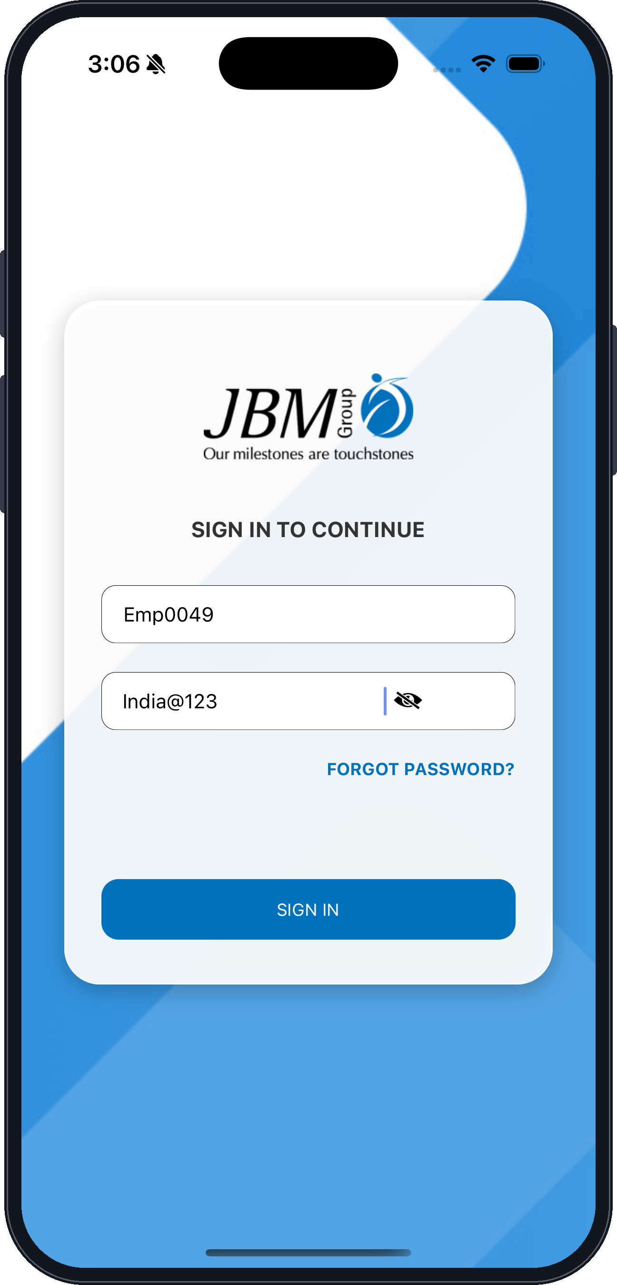
JBM branding — confirms you are on the correct application
SIGN IN TO CONTINUE — screen heading
Username — your authorized employee code (mandatory)
SIGN IN — authenticates you and opens the home page
Password — masked while you type (mandatory)
Show / hide password icon
FORGOT PASSWORD? — raise a reset request with your administrator
Fig. 1 — Sign-in screen
Note: Access is subject to the credentials and permissions configured by your administrator.

ii. Access the Home Dashboard
▪ On successful authentication the mobile application home page opens.
▪ Use Quick Links to open any module you are authorized for.
▪ Tap the menu icon at the top-left to open the side navigation panel.
LOGIN / LOGOUT · STEP 2 OF 4
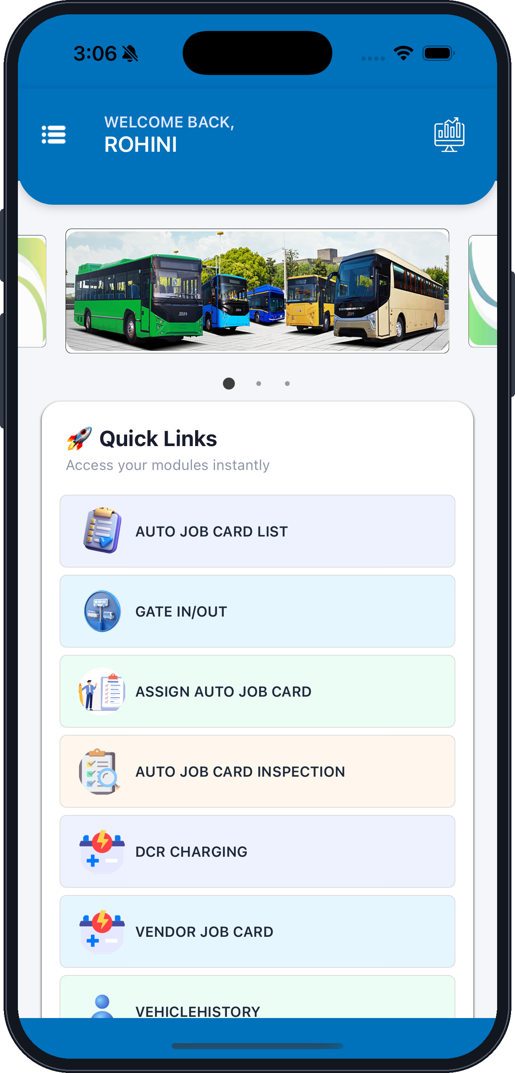
Menu icon — opens the side navigation panel
Logged-in user name
Vehicle banner — swipe to scroll
Quick Links — your authorized modules
DCR CHARGING
VENDOR JOB CARD
VEHICLEHISTORY
Dashboard icon
AUTO JOB CARD LIST
GATE IN/OUT
ASSIGN AUTO JOB CARD
AUTO JOB CARD INSPECTION
Fig. 2 — Home page with Quick Links
Note: Only the modules enabled for your role are listed; the arrangement may differ by user.

iii. Open the Menu and Select Logout
▪ Tap the menu icon of the application.
▪ The side panel lists every module available to you, plus My Profile and Contact Us.
▪ Select LOGOUT at the bottom of the panel.
LOGIN / LOGOUT · STEP 3 OF 4
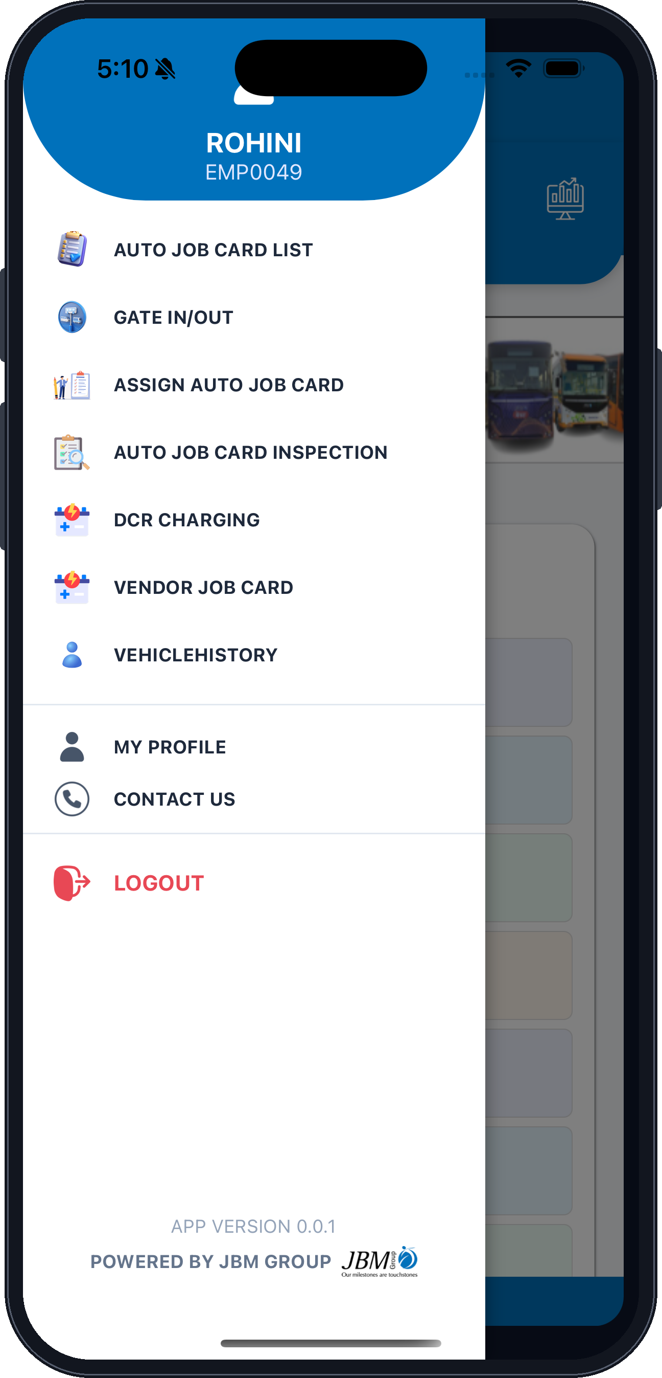
Logged-in user name and employee code
AUTO JOB CARD LIST
GATE IN/OUT
ASSIGN AUTO JOB CARD
MY PROFILE — view your profile details
CONTACT US — JBM HQ contact details
AUTO JOB CARD INSPECTION
DCR CHARGING
VENDOR JOB CARD
VEHICLEHISTORY
LOGOUT — ends the session
App version and JBM branding
Fig. 3 — Side navigation panel

iv. Confirm the Logout
▪ A confirmation dialog appears when you select Logout.
▪ Tap YES, LOG OUT to confirm; you are redirected to the login screen.
▪ Tap CANCEL to stay signed in and return to the home page.
LOGIN / LOGOUT · STEP 4 OF 4
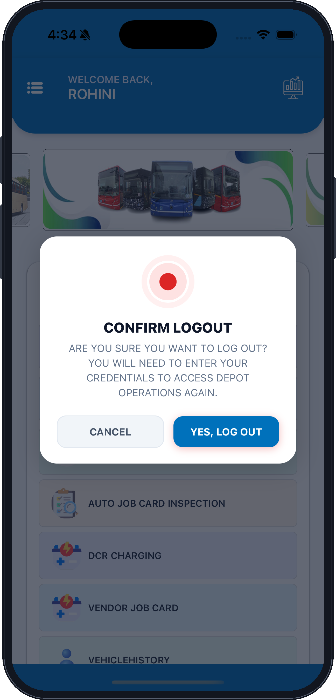
CONFIRM LOGOUT — dialog title
Confirmation message
CANCEL — dismisses the dialog, session continues
YES, LOG OUT — ends the session and returns to the login screen
Home page remains behind the dialog until you confirm
Fig. 4 — Confirm Logout dialog
Note: After logging out your credentials are required again to access depot operations.

3. User Profile
Objective
To allow users to view their profile and update the parameters permitted by JBM.
In this section
v. View Your User Profile
User Profile screen

v. View Your User Profile
▪ Tap the menu icon and select My Profile to view your details.
▪ Review the profile parameters maintained for your user account.
▪ Tap the back arrow to return to the home page.
USER PROFILE · STEP 1 OF 1
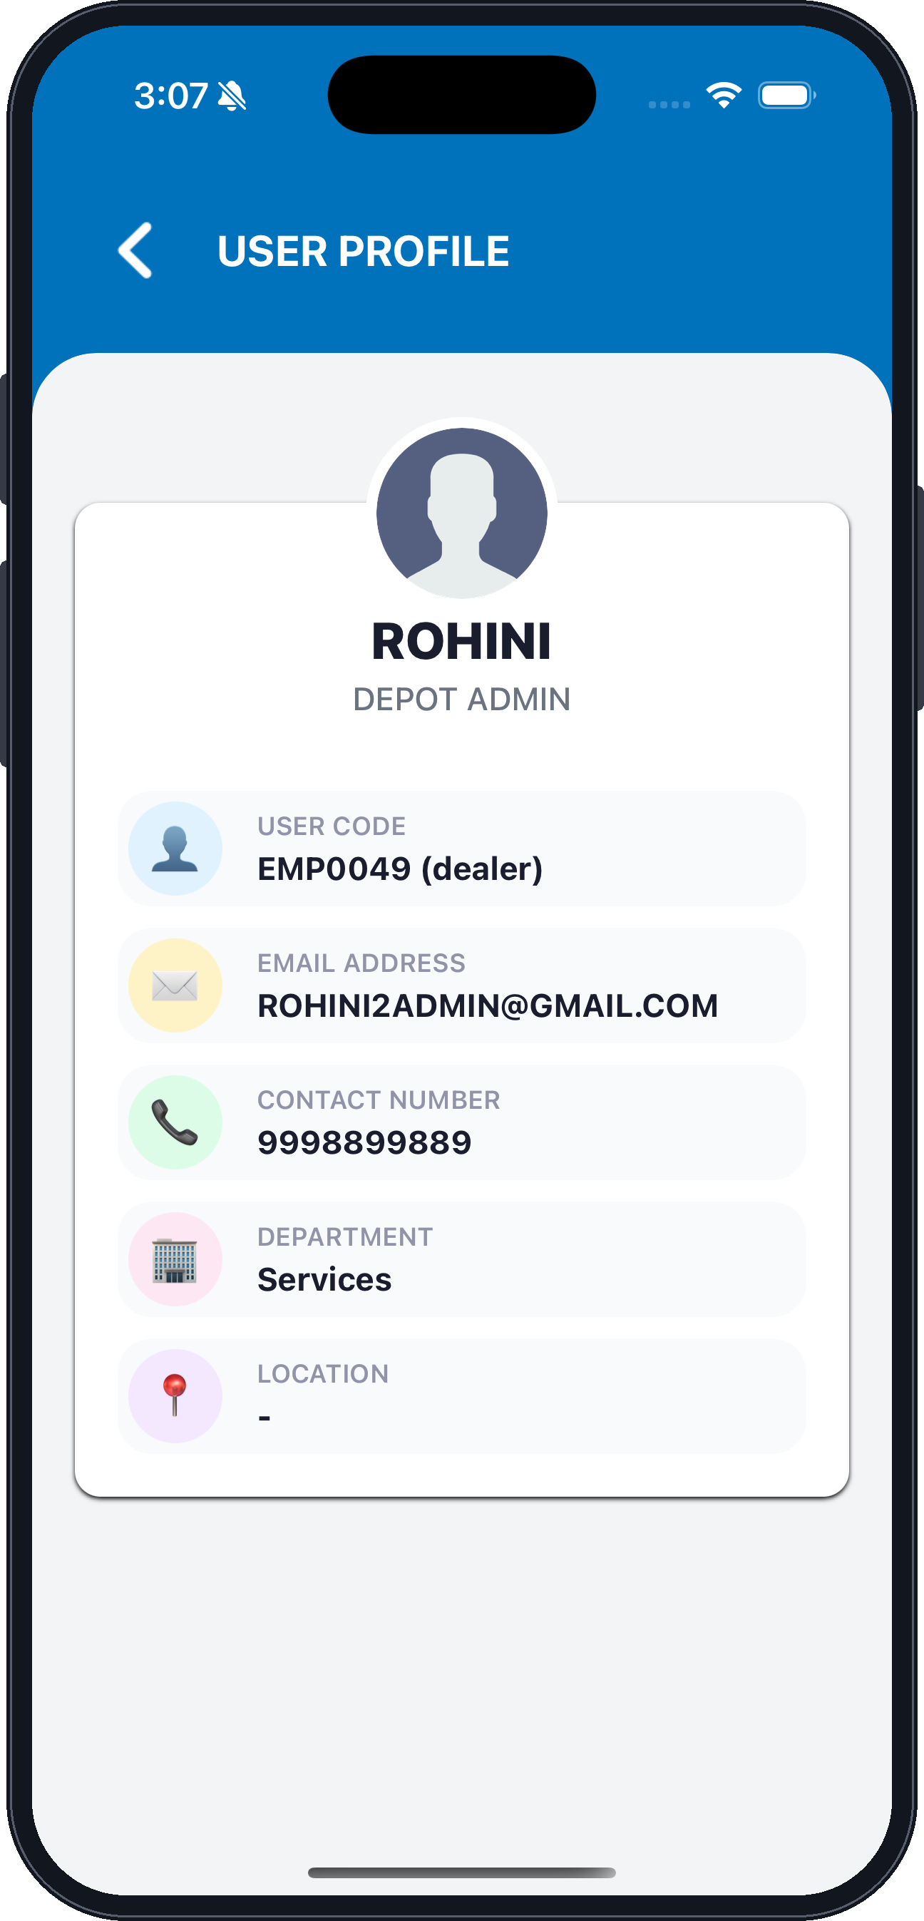
Back arrow — returns to the home page
USER PROFILE — screen title
Profile photo
User name
Role / designation
USER CODE — your employee code and user type
EMAIL ADDRESS
CONTACT NUMBER
DEPARTMENT
LOCATION
Fig. 5 — User Profile screen
Note: Only the parameters permitted by JBM can be updated; the rest are read-only.

4. Contact Us
Objective
To provide depot users with JBM HQ contact information for support and communication.
In this section
vi. View JBM HQ Contact Details
Contact Us screen

vi. View JBM HQ Contact Details
▪ Tap the menu icon and select Contact Us to view the details.
▪ Use the displayed address, contact number or email ID for assistance.
▪ Tap DROP US A LINE to open your mail application with the JBM mail ID.
CONTACT US · STEP 1 OF 1
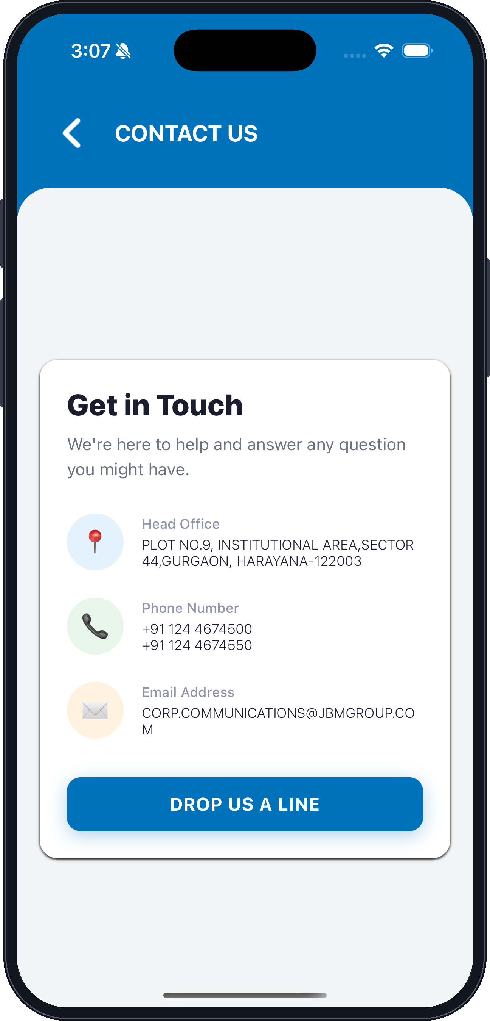
Back arrow — returns to the home page
CONTACT US — screen title
Get in Touch — section heading
Supporting text
Head Office — postal address
Phone Number — HQ landlines
Email Address — corporate communications mail ID
DROP US A LINE — opens your mail application
Fig. 6 — Contact Us screen
Note: Contact information is displayed from the data maintained by the authorized administrator / JBM team.

5. Gate In / Gate Out
Objective
The Gate In / Gate Out module is used to record the arrival and release of depot vehicles, capture driver complaints, and support the service process before a vehicle is released for out-shedding.
In this section
vii. Open Gate In / Gate Out and Find the Vehicle
Gate In / Gate Out vehicle list
viii. Gate In — Bus, Driver and Duty Details
Gate In Details — bus identification and duty assignment
ix. Gate In — Performance, SOC and Journey Details
Gate In Details — SOC, shift and journey readings
x. Gate In — Schedule, Complaint and Vehicle Status
Gate In Details — driver complaint and vehicle status
xi. Gate In — Wheel Condition, Attachments and Submit
Gate In Details — attachments and submission
xii. Gate Out — Select the Vehicle to Release
Gate In / Gate Out list showing vehicles eligible for gate-out
xiii. Gate Out — Shift and Journey Details
Gate Out Details — journey readings
xiv. Gate Out — Wheel Condition, Attachments and Submit
Gate Out Details — attachments and submission

vii. Open Gate In / Gate Out and Find the Vehicle
▪ Tap GATE IN/OUT from Quick Links; the default list of all vehicles for your assigned branch is displayed.
▪ Identify the vehicle by QR / VIN barcode scan, Bus Number, Registration Number or VIN, then tap SEARCH.
▪ Verify the Bus Number, Registration Number and VIN, then tap GATE IN against the correct vehicle.
GATE IN / GATE OUT · STEP 1 OF 8
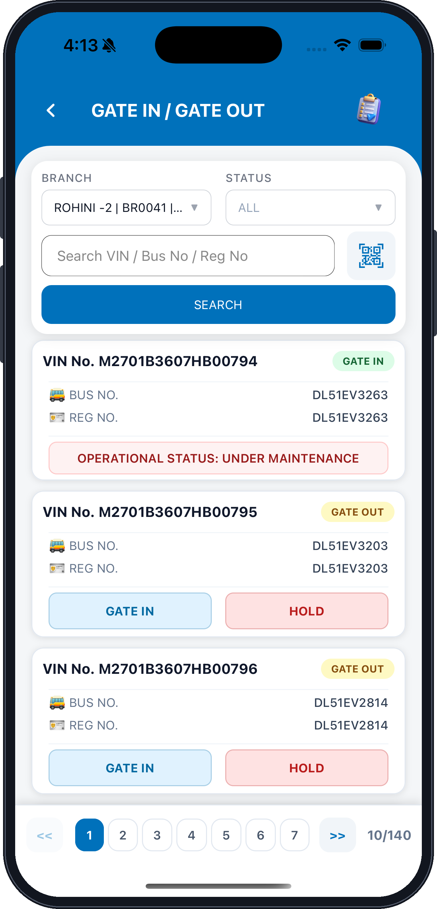
Back arrow
GATE IN / GATE OUT — screen title
BRANCH — your mapped depot
Search VIN / Bus No / Reg No — free-text search
SEARCH — runs the filter
VIN No. — vehicle identification number
GATE IN — records the vehicle's arrival
Pagination — 10 records per page
Job card shortcut
STATUS — filter by Gate In / Gate Out / All
QR / VIN barcode scanner
Status badge — the next permitted action
BUS NO. and REG NO. — verify before proceeding
OPERATIONAL STATUS — vehicle is under maintenance
HOLD — keeps the vehicle pending
Fig. 7 — Gate In / Gate Out vehicle list
Note: Assigned VIN access is controlled by the administrator — only vehicles mapped to your depot are listed.

viii. Gate In — Bus, Driver and Duty Details
▪ The Bus Details section is filled from the vehicle you selected — verify every value before proceeding.
▪ Tick the Accident checkbox and describe the case if the vehicle has arrived with accident damage.
▪ Under Driver & Duty Information record the driver, badge, duty number, route and performance values.
GATE IN / GATE OUT · STEP 2 OF 8
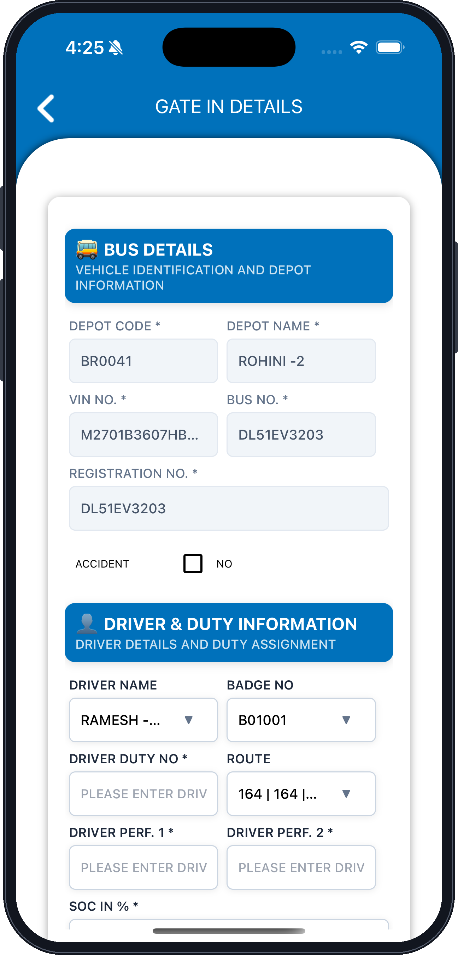
BUS DETAILS — vehicle identification and depot information
DEPOT CODE — auto-filled from your mapped depot
VIN NO. — vehicle identification number
REGISTRATION NO.
ACCIDENT — tick to change the default No to Yes
DRIVER NAME — select from the list
DRIVER DUTY NO. (mandatory)
DRIVER PERF. 1
DEPOT NAME
BUS NO.
DRIVER & DUTY INFORMATION — driver details and duty assignment
BADGE NO.
ROUTE
DRIVER PERF. 2
Fig. 8 — Gate In Details — bus identification and duty assignment
Note: Fields marked with an asterisk are mandatory and must be completed before the entry can be submitted.

ix. Gate In — Performance, SOC and Journey Details
▪ Complete the driver performance values and select the SOC In % range.
▪ Tick Breakdown if the vehicle has arrived with a breakdown, then select the Shift.
▪ Journey Details records the system date and time along with the odometer and hour-meter readings.
GATE IN / GATE OUT · STEP 3 OF 8
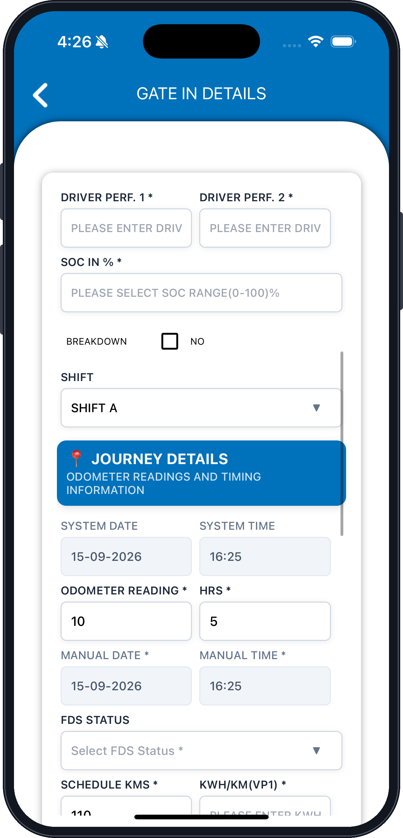
DRIVER PERF. 1
SOC IN % — select the 0–100% range
BREAKDOWN — tick to change the default No to Yes
SHIFT — the shift receiving the vehicle
SYSTEM DATE — set by the application
ODOMETER READING (mandatory)
MANUAL DATE
FDS STATUS
SCHEDULE KMS
DRIVER PERF. 2
JOURNEY DETAILS — odometer readings and timing information
SYSTEM TIME — set by the application
HRS — hour-meter reading
MANUAL TIME
KWH/KM (VP1)
Fig. 9 — Gate In Details — SOC, shift and journey readings
Note: The odometer / hour-meter reading must not be lower than the previously recorded value; a lower reading is rejected.

x. Gate In — Schedule, Complaint and Vehicle Status
▪ Select the FDS Status and enter the Schedule KMS and KWH/KM (VP1) values.
▪ Tick Driver Complaint and record the description in the Remark field, if any.
▪ Set Vehicle Status to Road Worthy or Not Road Worthy, then capture the four wheel temperatures.
GATE IN / GATE OUT · STEP 4 OF 8
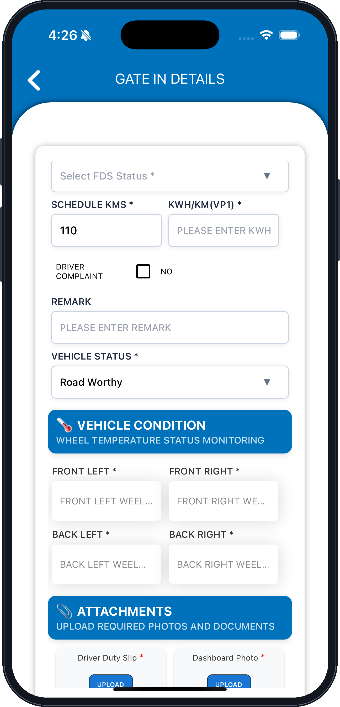
FDS STATUS — select from the list
SCHEDULE KMS (mandatory)
DRIVER COMPLAINT — tick to change the default No to Yes
REMARK — description of the complaint
VEHICLE STATUS — Road Worthy or Not Road Worthy
KWH/KM (VP1)
VEHICLE CONDITION — wheel temperature status monitoring
FRONT LEFT wheel temperature
FRONT RIGHT wheel temperature
BACK LEFT wheel temperature
BACK RIGHT wheel temperature
ATTACHMENTS — upload required photos and documents
Fig. 10 — Gate In Details — driver complaint and vehicle status

xi. Gate In — Wheel Condition, Attachments and Submit
▪ Complete the four wheel temperature readings under Vehicle Condition.
▪ Upload every required photo and document under Attachments.
▪ Verify all mandatory fields, then tap SUBMIT to save the Gate-In entry.
GATE IN / GATE OUT · STEP 5 OF 8
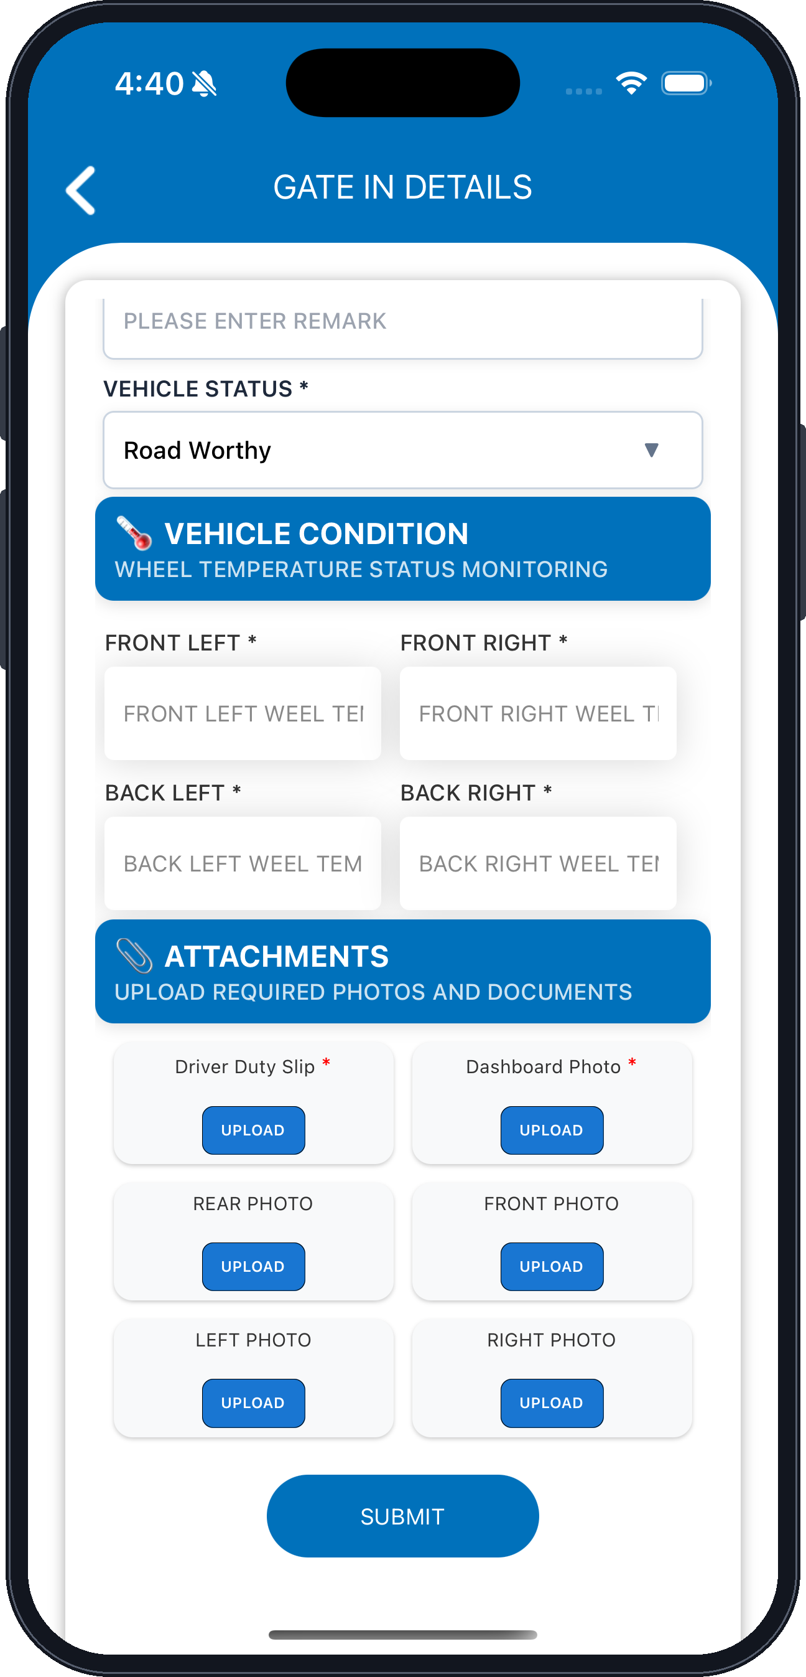
REMARK
VEHICLE STATUS — Road Worthy or Not Road Worthy
VEHICLE CONDITION — wheel temperature status monitoring
FRONT LEFT wheel temperature
BACK LEFT wheel temperature
Driver Duty Slip — mandatory upload
REAR PHOTO
LEFT PHOTO
FRONT RIGHT wheel temperature
BACK RIGHT wheel temperature
ATTACHMENTS — upload required photos and documents
Dashboard Photo — mandatory upload
FRONT PHOTO
RIGHT PHOTO
SUBMIT — saves the Gate-In transaction
Fig. 11 — Gate In Details — attachments and submission
Note: On saving a Not Road Worthy entry an auto pre-job card opens with the logged complaints and the vehicle is recorded as Under Maintenance.

xii. Gate Out — Select the Vehicle to Release
▪ Open the Gate In / Gate Out module and select the Gate-Out option.
▪ Search for the vehicle using Bus Number, Registration Number, VIN or QR scan.
▪ Tap GATE OUT against the vehicle that is to be released.
GATE IN / GATE OUT · STEP 6 OF 8
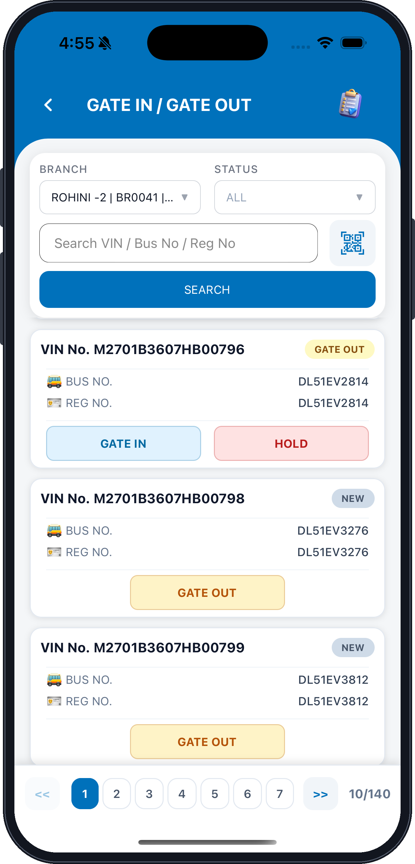
GATE IN / GATE OUT — screen title
BRANCH — your mapped depot
Search VIN / Bus No / Reg No
SEARCH — runs the filter
VIN No. of the gated-in vehicle
GATE IN — not applicable once the vehicle is inside
Pagination — 10 records per page
STATUS — filter the list
QR / VIN barcode scanner
GATE OUT badge — the next permitted action
BUS NO. and REG NO.
NEW badge — vehicle not yet gated in
GATE OUT — opens the Gate Out Details screen
Fig. 12 — Gate In / Gate Out list showing vehicles eligible for gate-out
Note: The system allows Gate-Out only for vehicles that have already been gated in and whose job card is closed.

xiii. Gate Out — Shift and Journey Details
▪ Select the Shift under which the vehicle is being released.
▪ Under Journey Details record the odometer reading, HRS, SOC Out % and the manual date and time.
▪ Enter the Schedule KMS, KWH/KM (VP1) and a remark for the transaction.
GATE IN / GATE OUT · STEP 7 OF 8
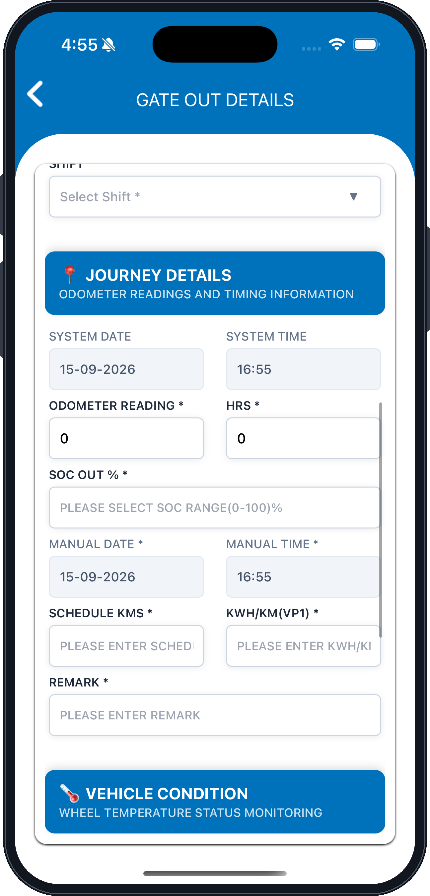
SHIFT — select the releasing shift
JOURNEY DETAILS — odometer readings and timing information
SYSTEM DATE — set by the application
ODOMETER READING (mandatory)
SOC OUT % — select the 0–100% range
MANUAL DATE
SCHEDULE KMS
REMARK (mandatory)
SYSTEM TIME — set by the application
HRS — hour-meter reading
MANUAL TIME
KWH/KM (VP1)
VEHICLE CONDITION — wheel temperature status monitoring
Fig. 13 — Gate Out Details — journey readings
Note: Confirm the gate-out date and time before submitting — the readings are validated against the last Gate-In entry.

xiv. Gate Out — Wheel Condition, Attachments and Submit
▪ Complete the four wheel temperature readings under Vehicle Condition.
▪ Upload the required photos and documents under Attachments.
▪ Tap SUBMIT to release the vehicle, or HOLD UP to keep the transaction pending.
GATE IN / GATE OUT · STEP 8 OF 8
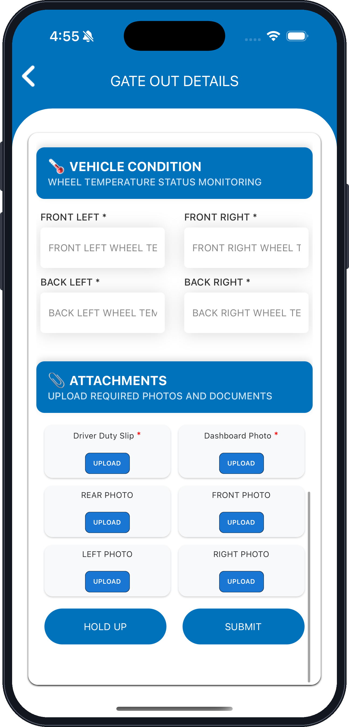
VEHICLE CONDITION — wheel temperature status monitoring
FRONT LEFT wheel temperature
BACK LEFT wheel temperature
Driver Duty Slip — mandatory upload
REAR PHOTO
LEFT PHOTO
HOLD UP — keeps the transaction pending
FRONT RIGHT wheel temperature
BACK RIGHT wheel temperature
ATTACHMENTS — upload required photos and documents
Dashboard Photo — mandatory upload
FRONT PHOTO
RIGHT PHOTO
SUBMIT — releases the vehicle
Fig. 14 — Gate Out Details — attachments and submission
Note: On confirmation the gate-out entry is submitted and the vehicle is released for out-shedding.

6. Auto Job Cards (Daily / Ten-Day)
Objective
To provide depot users with the list of auto-generated jobs based on daily and ten-day service schedules.
In this section
xv. Open the Auto Job Card List
Auto Job Card List with an expanded job card
xvi. View an Auto Job Card
View Auto Job Card — job details and checklist
xvii. Auto Job Card Statuses
Auto Job Card List — status of each job card
xviii. Home Dashboard — Shift Engineer
Home page for a shift engineer
xix. Open the Auto Job Card Inspection List
Auto Job Card Inspection list
xx. Review and Process the Assigned Job
Auto Job Card Inspection — expanded job card
xxi. Validate Auto Job Card — Job Details
Validate Auto Job Card — read-only job details
xxii. Validate Auto Job Card — Checklist
Validate Auto Job Card — checklist items

xv. Open the Auto Job Card List
▪ Select Auto Job Card List from Quick Links to view the auto-generated jobs for roadworthy vehicles.
▪ Filter the list by Branch and Status, or search by VIN, Bus Number or Registration Number.
▪ Expand a job card to review its details, then tap VIEW DETAILS.
AUTO JOB CARDS (DAILY / TEN-DAY) · STEP 1 OF 8
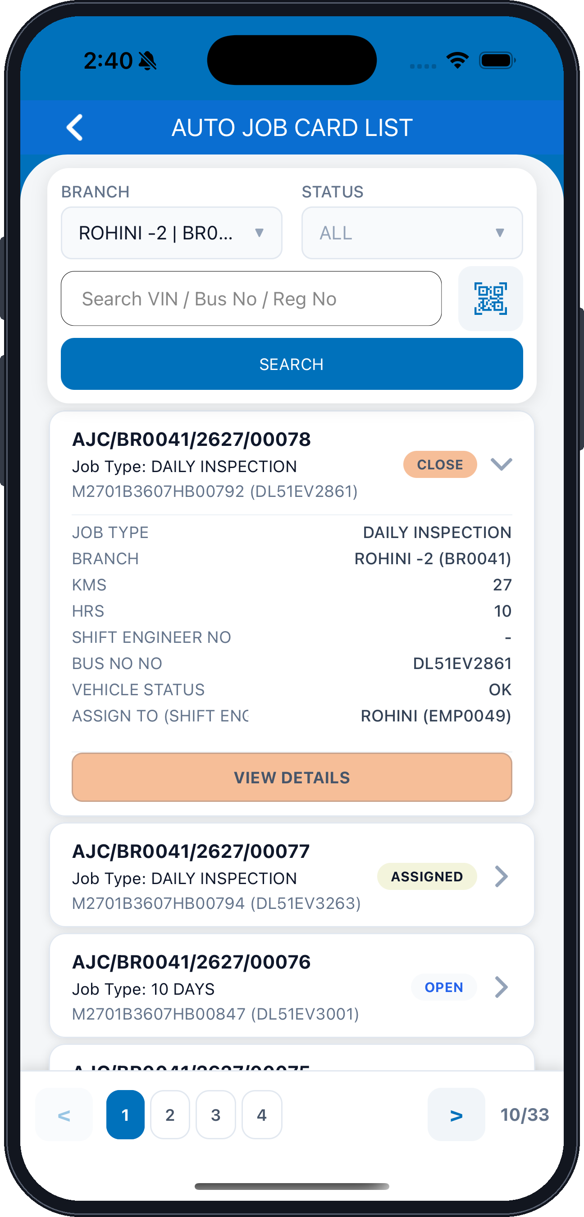
AUTO JOB CARD LIST — screen title
Back arrow
BRANCH — your mapped depot
Search VIN / Bus No / Reg No
SEARCH — runs the filter
Job card number
Job Type — Daily Inspection or 10 Days
VIN and registration number
Pagination — 10 records per page
STATUS — filter by job status
QR / VIN barcode scanner
Expand / collapse the job card
Status badge — Close, Assigned or Open
Job details — branch, KMS, HRS, bus and vehicle status
VIEW DETAILS — opens the job card
Fig. 15 — Auto Job Card List with an expanded job card
Note: Scheduling logic and auto-job generation rules follow the approved FRD and application configuration.

xvi. View an Auto Job Card
▪ The Job Details section shows the branch, shift engineer, job card number and job card type.
▪ Verify the registration, bus and VIN numbers along with the vehicle status and the KM / HRS readings.
▪ Expand a Checklist group to review its inspection items and their selected status.
AUTO JOB CARDS (DAILY / TEN-DAY) · STEP 2 OF 8
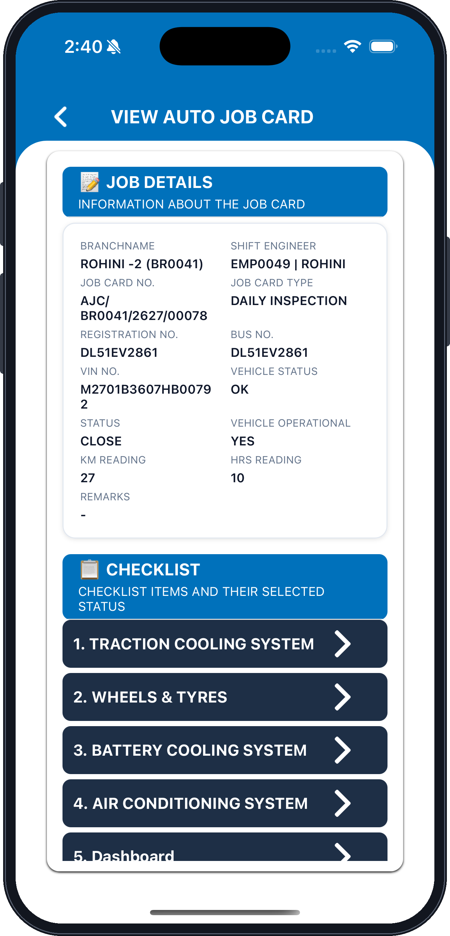
JOB DETAILS — information about the job card
BRANCHNAME
JOB CARD NO.
REGISTRATION NO.
VIN NO.
STATUS — job card status
KM READING
REMARKS
SHIFT ENGINEER
JOB CARD TYPE
BUS NO.
VEHICLE STATUS
VEHICLE OPERATIONAL
HRS READING
CHECKLIST — checklist items and their selected status
Checklist groups — tap to expand
Fig. 16 — View Auto Job Card — job details and checklist

xvii. Auto Job Card Statuses
▪ The list shows every auto-generated job card for the selected branch.
▪ The badge against each job card shows its current status — Close, Assigned or Open.
▪ Tap a job card, or its chevron, to open the job card details.
AUTO JOB CARDS (DAILY / TEN-DAY) · STEP 3 OF 8
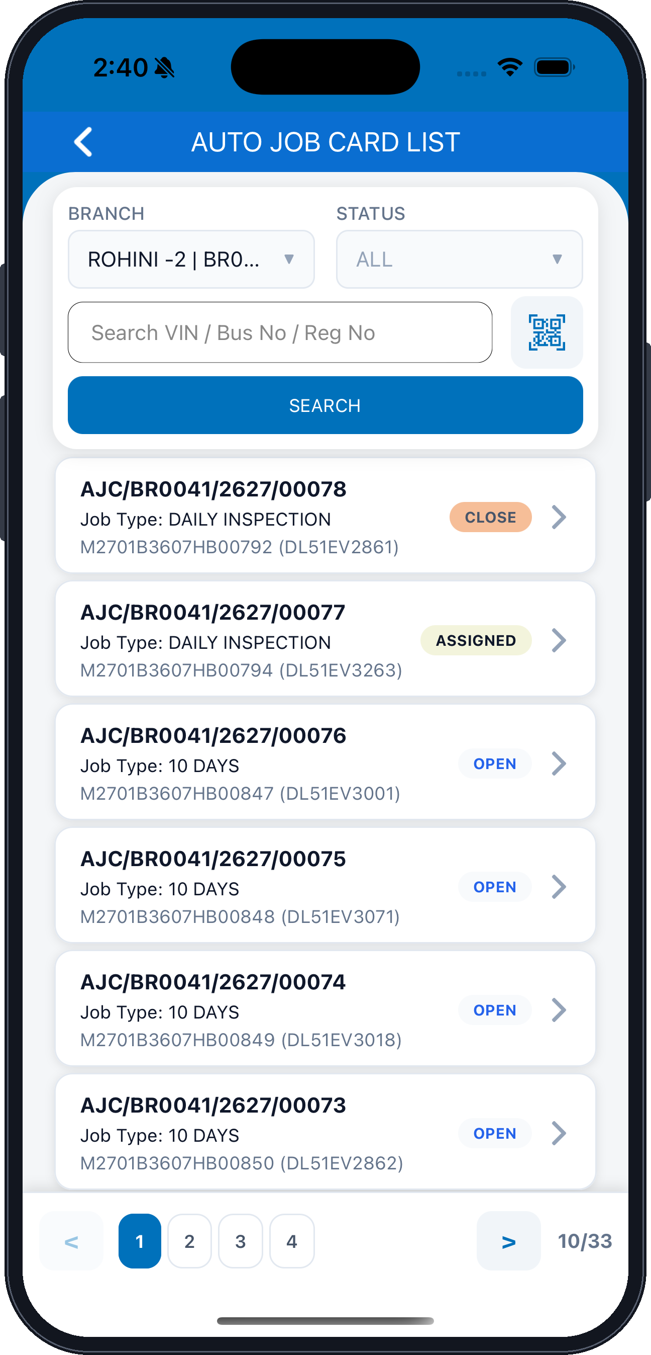
BRANCH — your mapped depot
Search VIN / Bus No / Reg No
SEARCH — runs the filter
Job card — number, job type, VIN and registration
Further job cards, newest first
STATUS — filter by job status
QR / VIN barcode scanner
CLOSE — the job card is completed
ASSIGNED — allotted to a shift engineer
OPEN — not yet assigned
Pagination — 10 of 33 records
Fig. 17 — Auto Job Card List — status of each job card

xviii. Home Dashboard — Shift Engineer
▪ A shift engineer signs in to the same home page, with the modules enabled for that role.
▪ The Quick Links list differs by role — only authorized modules are displayed.
▪ Select Auto Job Card Inspection to process a job assigned to you.
AUTO JOB CARDS (DAILY / TEN-DAY) · STEP 4 OF 8
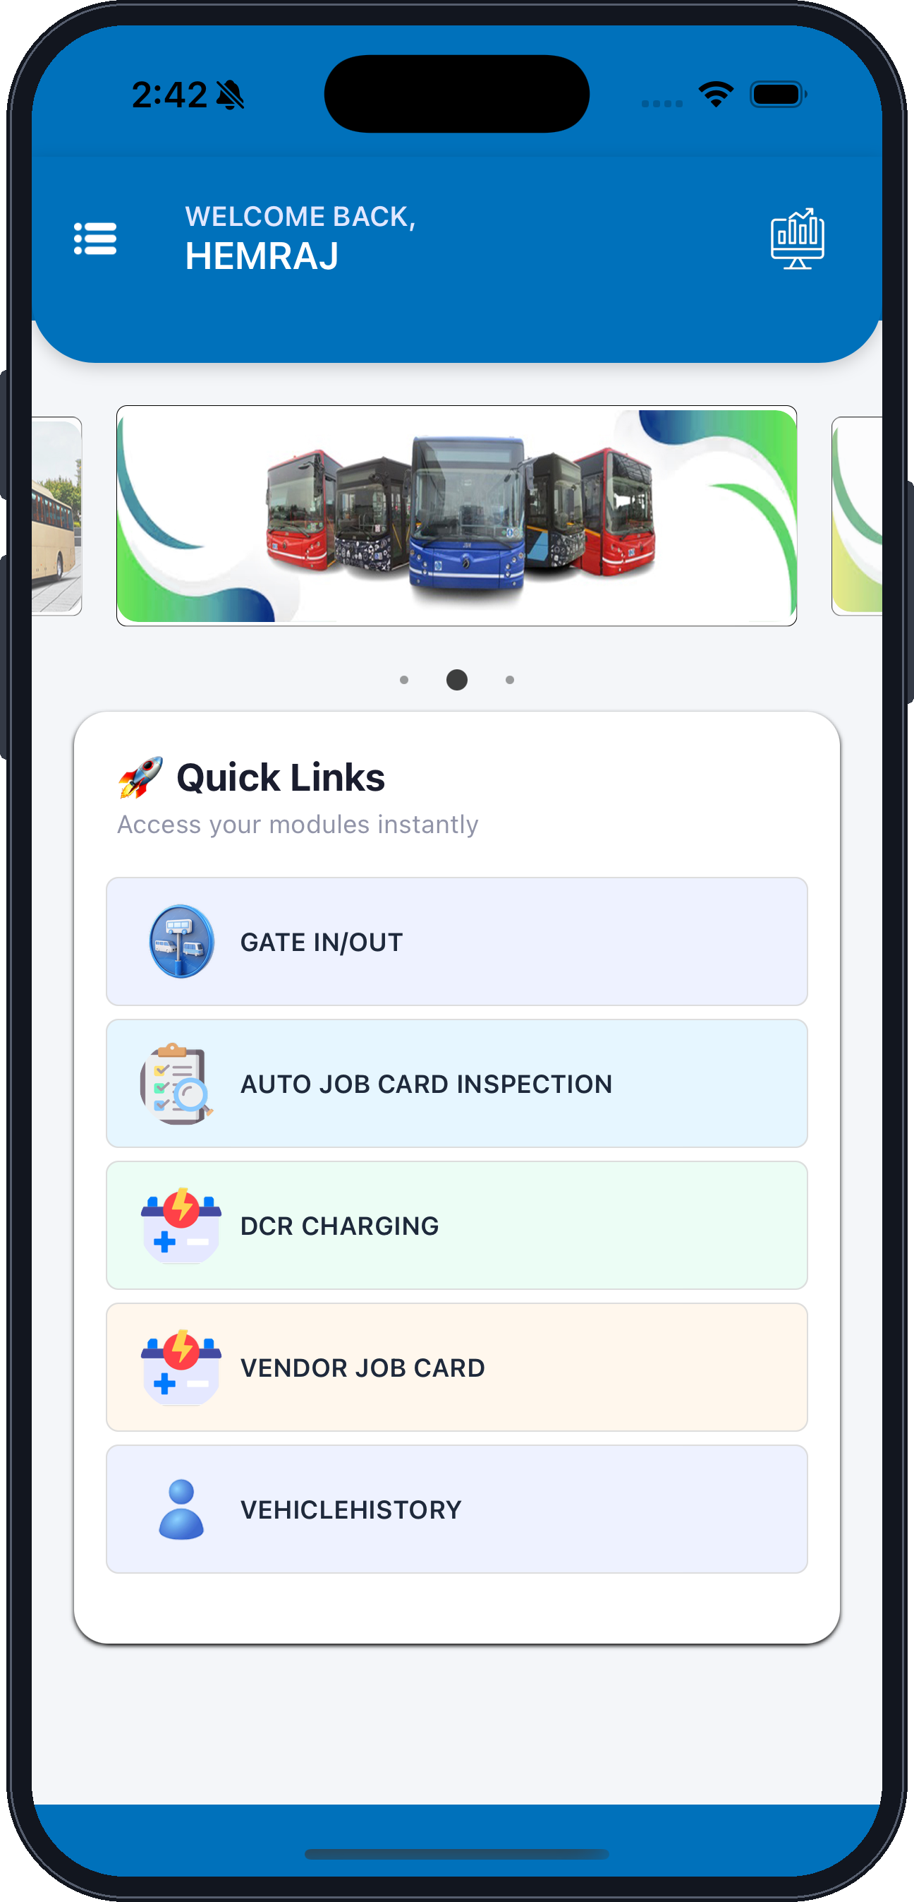
Menu icon — opens the side navigation panel
Logged-in shift engineer
Vehicle banner
Quick Links — modules for this role
VENDOR JOB CARD
VEHICLEHISTORY
Dashboard icon
GATE IN/OUT
AUTO JOB CARD INSPECTION
DCR CHARGING
Fig. 18 — Home page for a shift engineer

xix. Open the Auto Job Card Inspection List
▪ Select Auto Job Card Inspection from Quick Links.
▪ Filter by Branch and Status, or search by VIN, Bus Number or Registration Number.
▪ The list shows the job cards assigned to you, with their job type and status.
AUTO JOB CARDS (DAILY / TEN-DAY) · STEP 5 OF 8
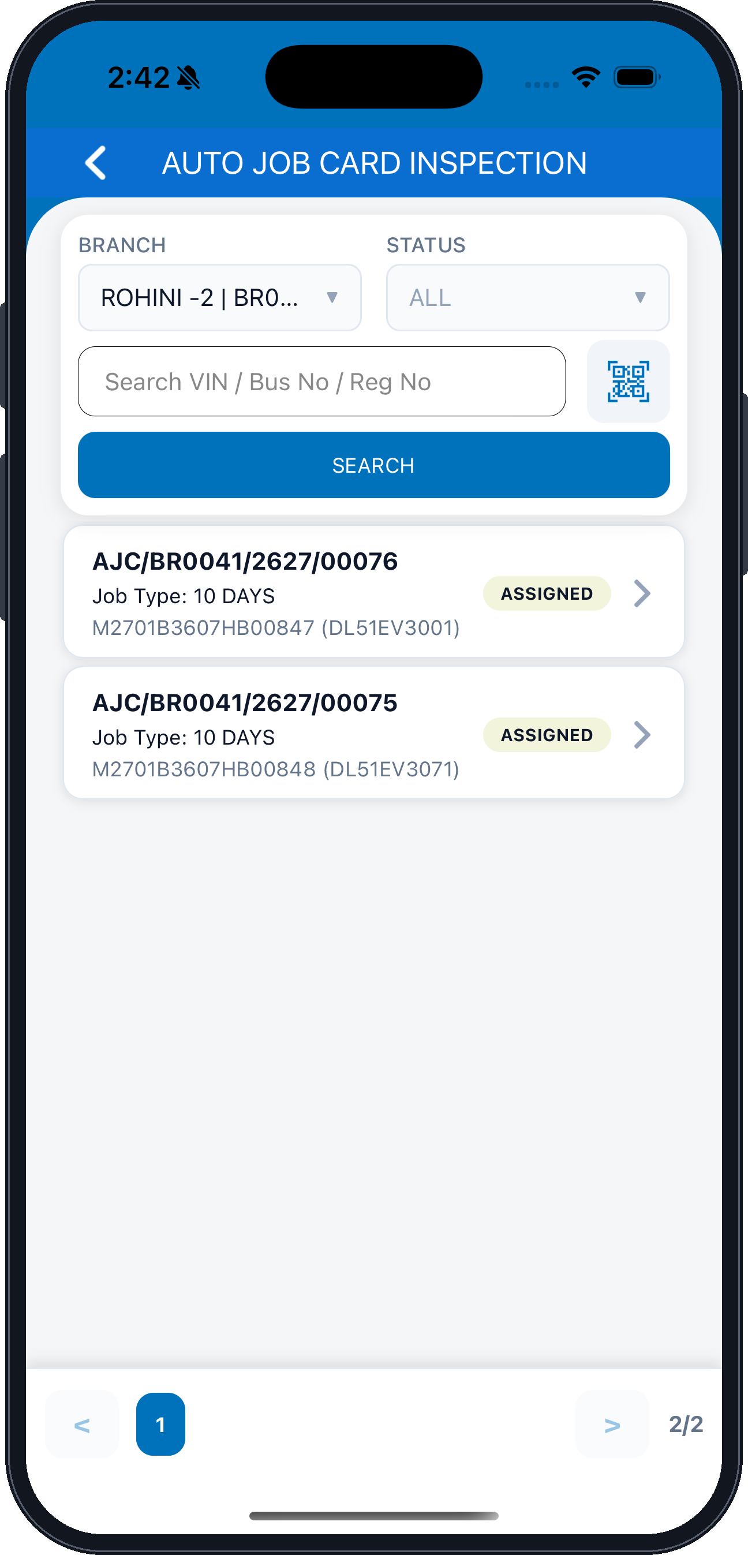
AUTO JOB CARD INSPECTION — screen title
BRANCH — your mapped depot
Search VIN / Bus No / Reg No
SEARCH — runs the filter
Job card number
Job Type — Daily Inspection or 10 Days
VIN and registration number
STATUS — filter by job status
QR / VIN barcode scanner
ASSIGNED — allotted to you
Chevron — expands the job card
Next assigned job card
Pagination — 2 of 2 pages
Fig. 19 — Auto Job Card Inspection list

xx. Review and Process the Assigned Job
▪ Expand the assigned job card to review its full details.
▪ Verify the job type, branch, bus number, vehicle status and the shift engineer it is assigned to.
▪ Tap PROCESS JOB to begin validating the job card.
AUTO JOB CARDS (DAILY / TEN-DAY) · STEP 6 OF 8
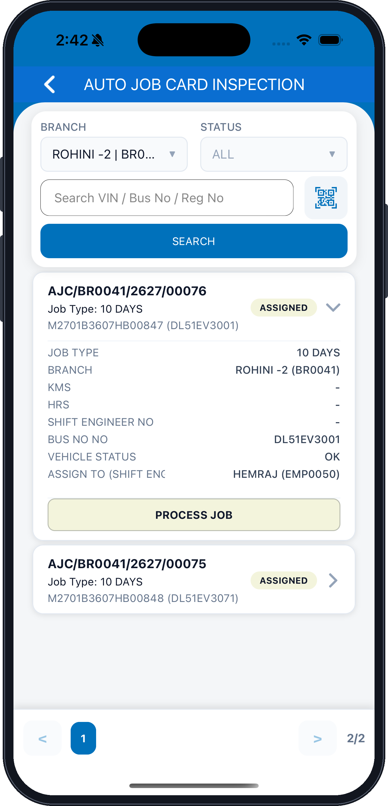
BRANCH — your mapped depot
SEARCH — runs the filter
Job card number
JOB TYPE
BRANCH
KMS
HRS
STATUS — filter by job status
ASSIGNED — allotted to you
Chevron — collapses the job card
SHIFT ENGINEER NO
BUS NO
VEHICLE STATUS
ASSIGN TO (SHIFT ENGINEER)
PROCESS JOB — opens the validation screen
Fig. 20 — Auto Job Card Inspection — expanded job card

xxi. Validate Auto Job Card — Job Details
▪ The Job Details section opens in read-only mode.
▪ Verify the job card number, shift engineer, job card type and vehicle identification.
▪ Scroll to the Checklist section to record the inspection results.
AUTO JOB CARDS (DAILY / TEN-DAY) · STEP 7 OF 8
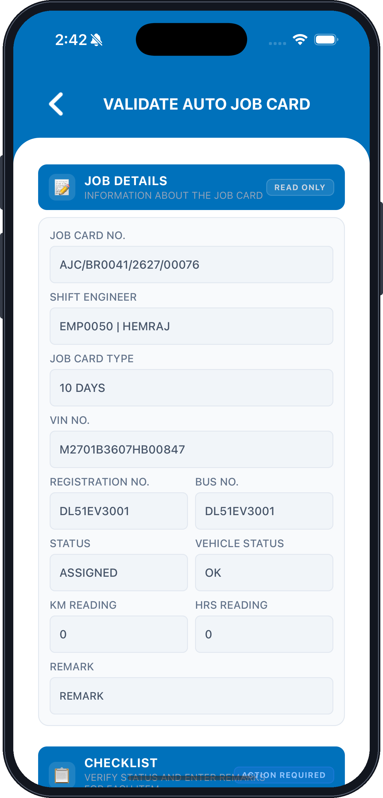
JOB DETAILS — information about the job card
JOB CARD NO.
SHIFT ENGINEER — the engineer processing the job
JOB CARD TYPE — Daily Inspection or 10 Days
VIN NO.
REGISTRATION NO.
STATUS
KM READING
REMARK
READ ONLY — these values cannot be edited here
BUS NO.
VEHICLE STATUS
HRS READING
CHECKLIST — verify status and enter remarks
Fig. 21 — Validate Auto Job Card — read-only job details

xxii. Validate Auto Job Card — Checklist
▪ Expand a checklist group to list the inspection items it contains.
▪ Set the Status for each item and enter a Remark where action is required.
▪ Complete every group before submitting the job card.
AUTO JOB CARDS (DAILY / TEN-DAY) · STEP 8 OF 8
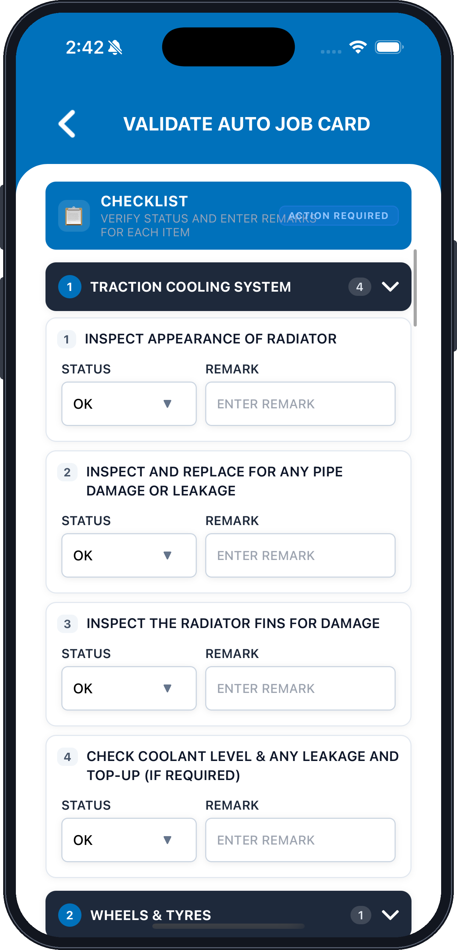
CHECKLIST — verify status and enter remarks for each item
Checklist group — tap to expand or collapse
Item 1 — inspection description
STATUS — select OK or the applicable result
Item 2 — inspection description
STATUS
Item 3 — inspection description
STATUS
Item 4 — inspection description
STATUS
ACTION REQUIRED — items still awaiting a status
Item count in this group
REMARK — mandatory where action is required
REMARK
REMARK
REMARK
Next checklist group
Fig. 22 — Validate Auto Job Card — checklist items

7. Assign Auto Job Cards
Objective
To assign auto generated jobs to the appropriate service supervisor or authorized users.
In this section
xxiii. Open Assign Auto Job Card and Select Jobs
Assign Auto Job Card — selecting job cards
xxiv. Review the Selected Job Card
Assign Auto Job Card — expanded job details
xxv. Validation — Supervisor Required
Validation error raised when no supervisor is selected
xxvi. Select a Supervisor
SELECT SUPERVISOR list
xxvii. Confirm the Assignment
Confirm Submission dialog
xxviii. Assignment Complete
Assign Auto Job Card — supervisor selected

xxiii. Open Assign Auto Job Card and Select Jobs
▪ Open the Assign Auto Job Card module from Quick Links.
▪ Filter by Branch, Supervisor and Status to narrow the list of unassigned jobs.
▪ Tick each job card to be assigned; the ASSIGN NOW button shows how many are selected.
ASSIGN AUTO JOB CARDS · STEP 1 OF 6
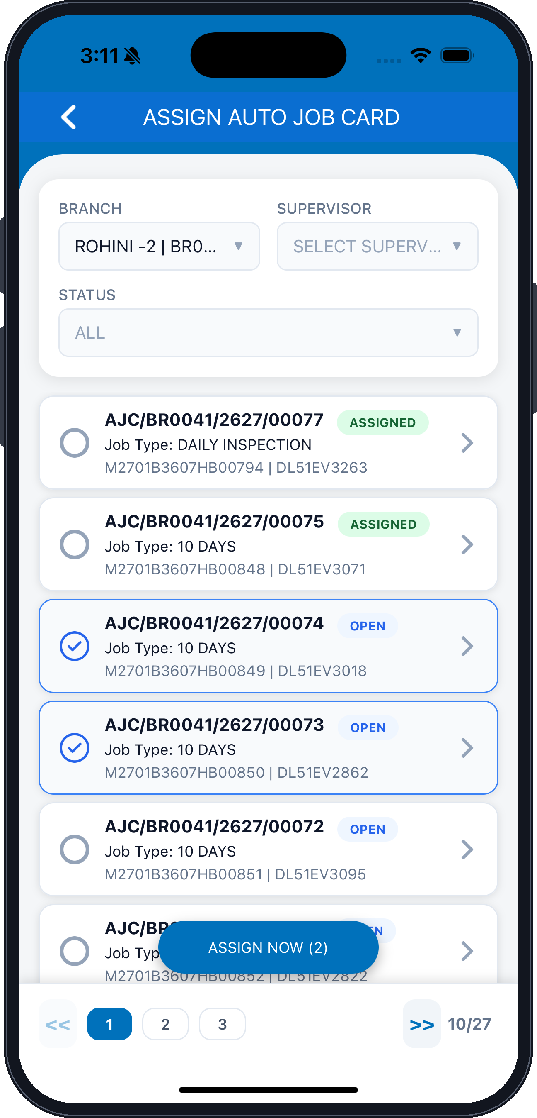
ASSIGN AUTO JOB CARD — screen title
BRANCH — your mapped depot
STATUS — filter by job status
Job card number
Selection control — tick to include this job card
Selected job card — highlighted with a tick
Pagination — 10 of 27 records
SUPERVISOR — the resource to assign the jobs to
ASSIGNED — already allotted, cannot be re-selected
Job Type and VIN / registration number
OPEN — available to assign
ASSIGN NOW (2) — the count reflects your selection
Fig. 23 — Assign Auto Job Card — selecting job cards

xxiv. Review the Selected Job Card
▪ Tap the chevron on a selected job card to expand its details.
▪ Verify the job type, branch name, VIN, chassis and registration numbers before assigning.
▪ The selection count on ASSIGN NOW updates as you tick or untick job cards.
ASSIGN AUTO JOB CARDS · STEP 2 OF 6
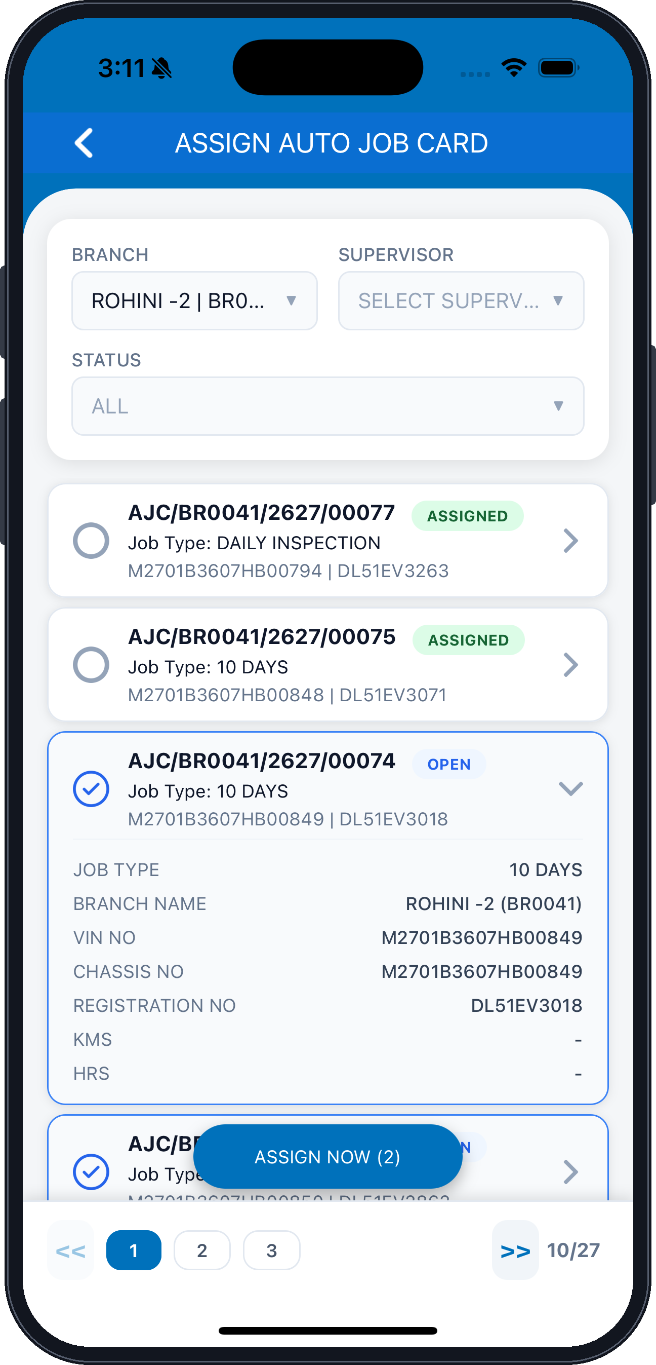
BRANCH
STATUS
Expanded job card
JOB TYPE
BRANCH NAME
VIN NO
SUPERVISOR — not yet selected
CHASSIS NO
REGISTRATION NO
KMS
HRS
ASSIGN NOW (2) — assigns every ticked job card
Fig. 24 — Assign Auto Job Card — expanded job details

xxv. Validation — Supervisor Required
▪ Tapping ASSIGN NOW without choosing a supervisor raises a validation error.
▪ Tap OK to dismiss the message.
▪ Select a supervisor, then assign the job cards again.
ASSIGN AUTO JOB CARDS · STEP 3 OF 6
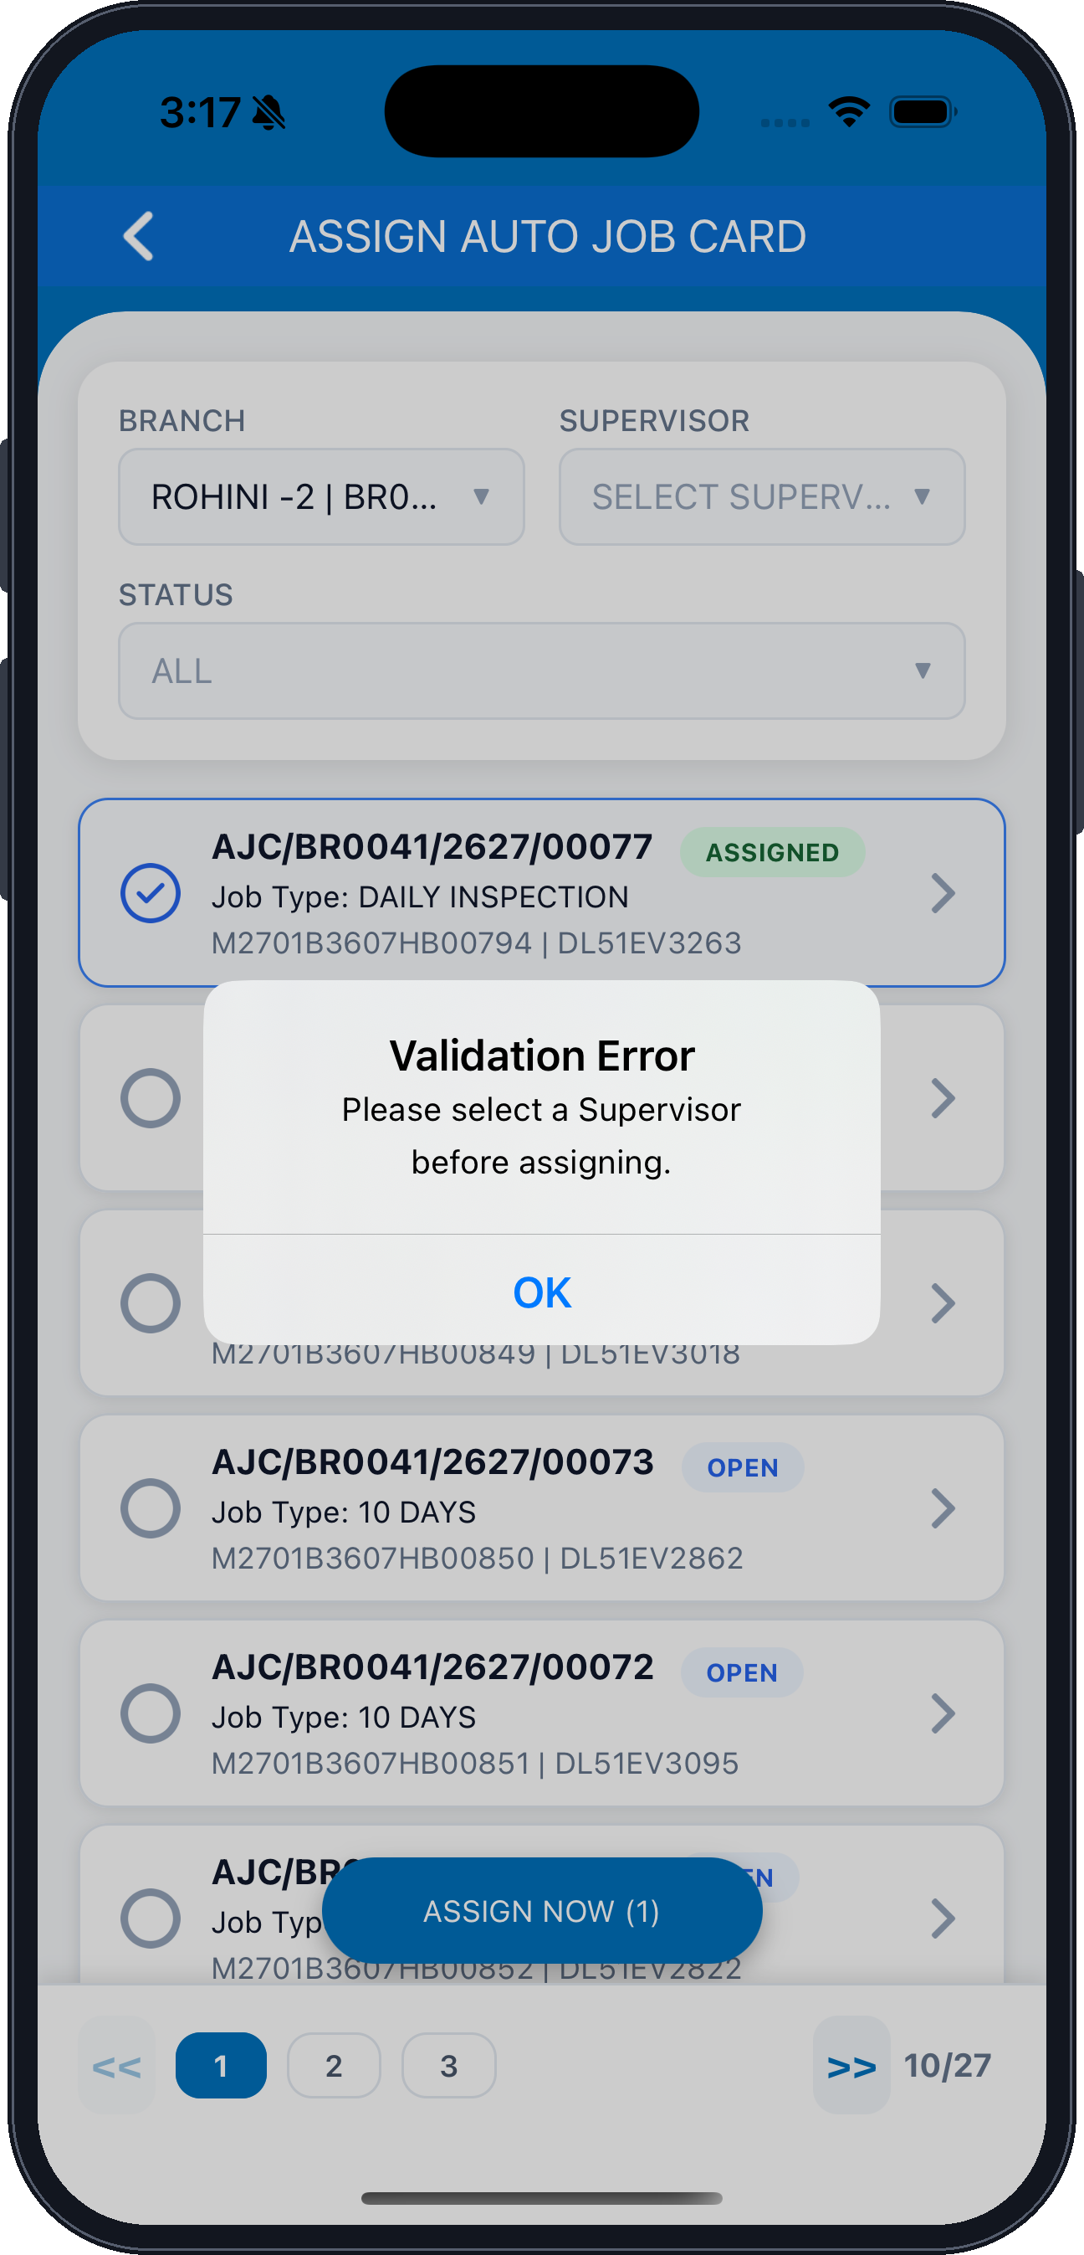
Validation Error — dialog title
Message — please select a Supervisor before assigning
OK — dismisses the message
SUPERVISOR — still empty, which triggers the error
ASSIGN NOW (1) — one job card is selected
Fig. 25 — Validation error raised when no supervisor is selected

xxvi. Select a Supervisor
▪ Tap the Supervisor field to open the SELECT SUPERVISOR list.
▪ Choose the authorized person / service resource the jobs are to be assigned to.
▪ Tap the close icon to dismiss the list without selecting.
ASSIGN AUTO JOB CARDS · STEP 4 OF 6
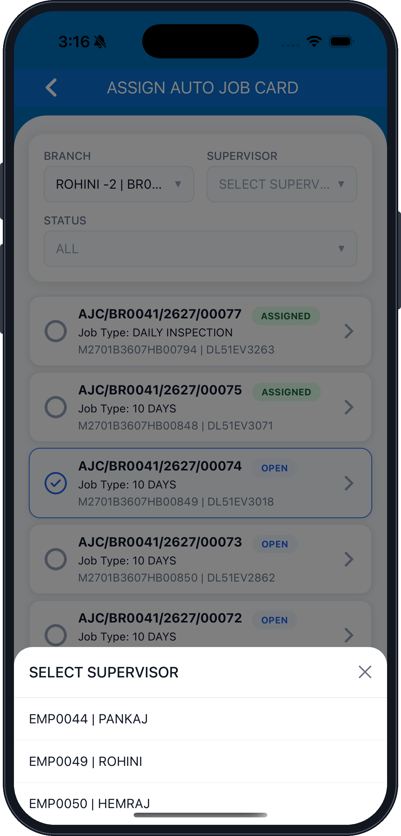
Selected job card, held behind the list
SELECT SUPERVISOR — list heading
EMP0044 | PANKAJ
EMP0050 | HEMRAJ
Close — dismisses the list
EMP0049 | ROHINI
Fig. 26 — SELECT SUPERVISOR list
Note: Assignment rights are subject to the role and permissions configured for your user.

xxvii. Confirm the Assignment
▪ With a supervisor selected, tap ASSIGN NOW to raise the confirmation.
▪ Tap Yes to assign the selected buses to that supervisor.
▪ Tap Not now to return to the list without assigning.
ASSIGN AUTO JOB CARDS · STEP 5 OF 6
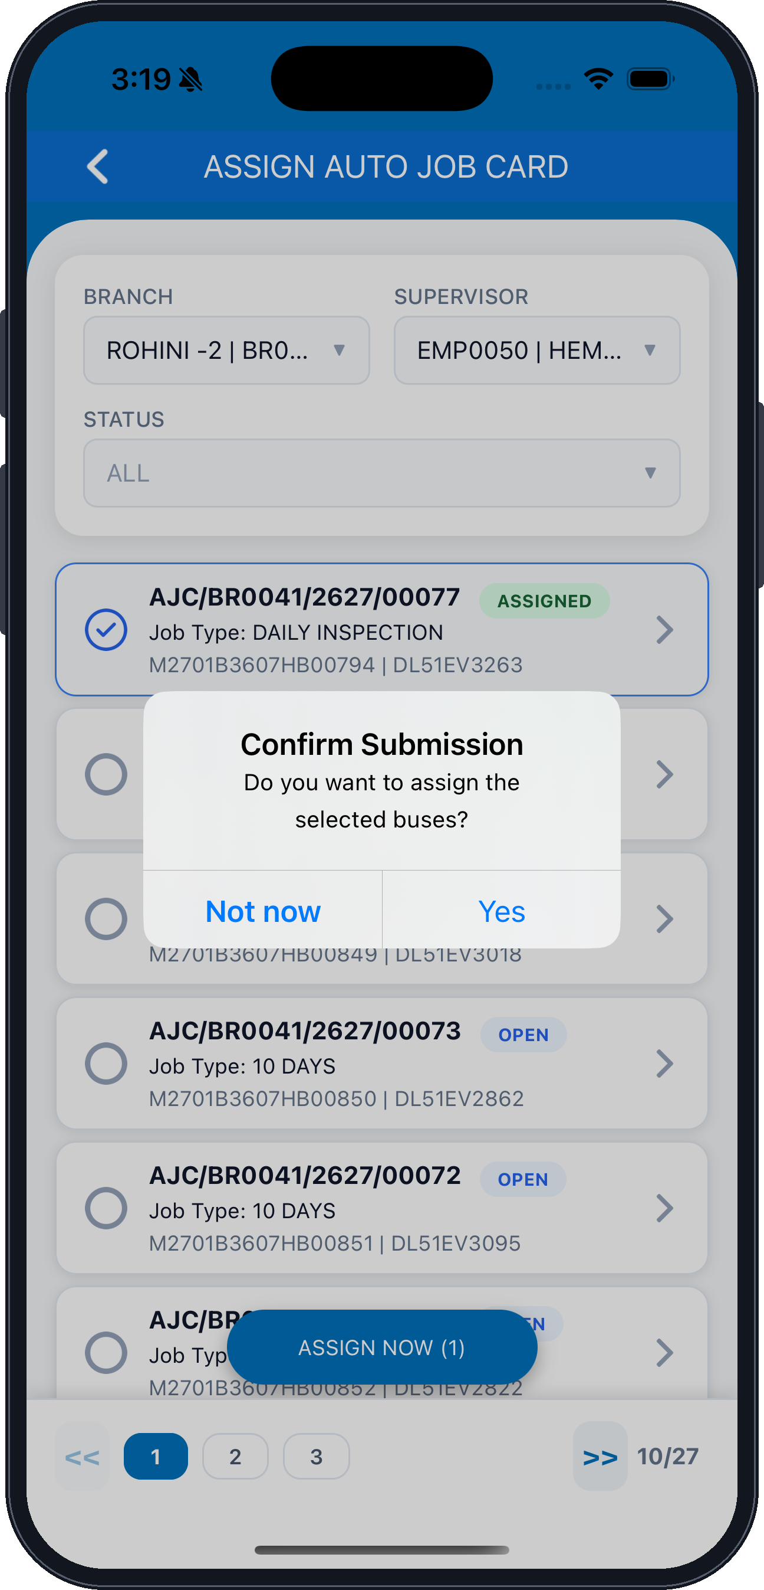
Confirm Submission — dialog title
Message — do you want to assign the selected buses?
Not now — cancels the assignment
SUPERVISOR — the selected resource
Yes — confirms and assigns
ASSIGN NOW (1)
Fig. 27 — Confirm Submission dialog

xxviii. Assignment Complete
▪ The selected supervisor is shown in the Supervisor field.
▪ Verify the job cards that remain ticked, then tap ASSIGN NOW.
▪ The auto job is assigned to the selected resource and becomes available for further service processing.
ASSIGN AUTO JOB CARDS · STEP 6 OF 6
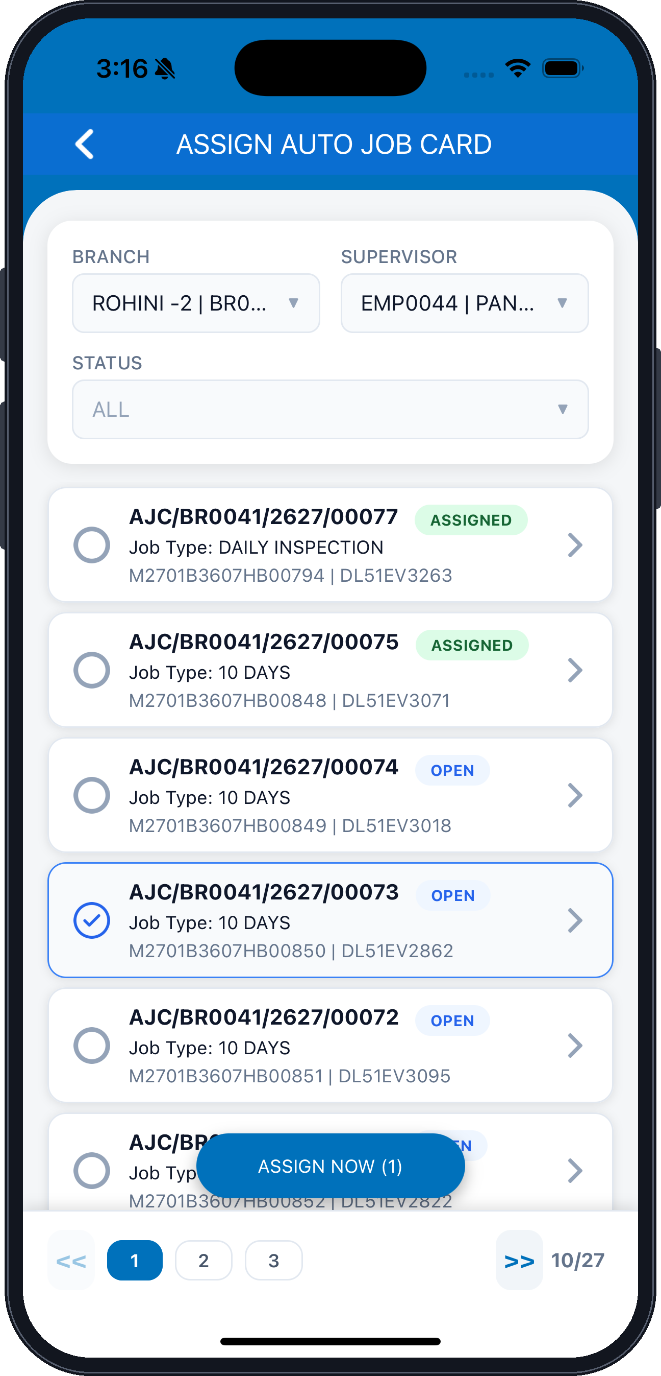
BRANCH
STATUS
Unticked job cards remain available
Selected job card, ticked
Pagination — 10 of 27 records
SUPERVISOR — EMP0044 | PANKAJ selected
ASSIGNED — already allotted
ASSIGN NOW (1) — assigns the ticked job card
Fig. 28 — Assign Auto Job Card — supervisor selected

8. DCR Charging
Objective
To allow depot users to view and capture vehicle charging-related information, as enabled by the JBM DMS application.
In this section
xxix. Open DCR Charging and Search Records
DCR Charging list
xxx. Search the Vehicle to Charge
DCR Charging Details — depot detail and vehicle search
xxxi. Vehicle and Charger Master Details
DCR Charging Details — vehicle details
xxxii. Charger Details and Charge Timing
DCR Charging Details — charger and timing
xxxiii. SOC, Energy and Final Status
DCR Charging Details — SOC, energy and final status
xxxiv. Attachments and Submit
DCR Charging Details — attachments and submission

xxix. Open DCR Charging and Search Records
▪ Select DCR Charging from Quick Links.
▪ Set the From Date, To Date, Branch and Status, then tap SEARCH.
▪ Tap the + button to create a new charging record.
DCR CHARGING · STEP 1 OF 6
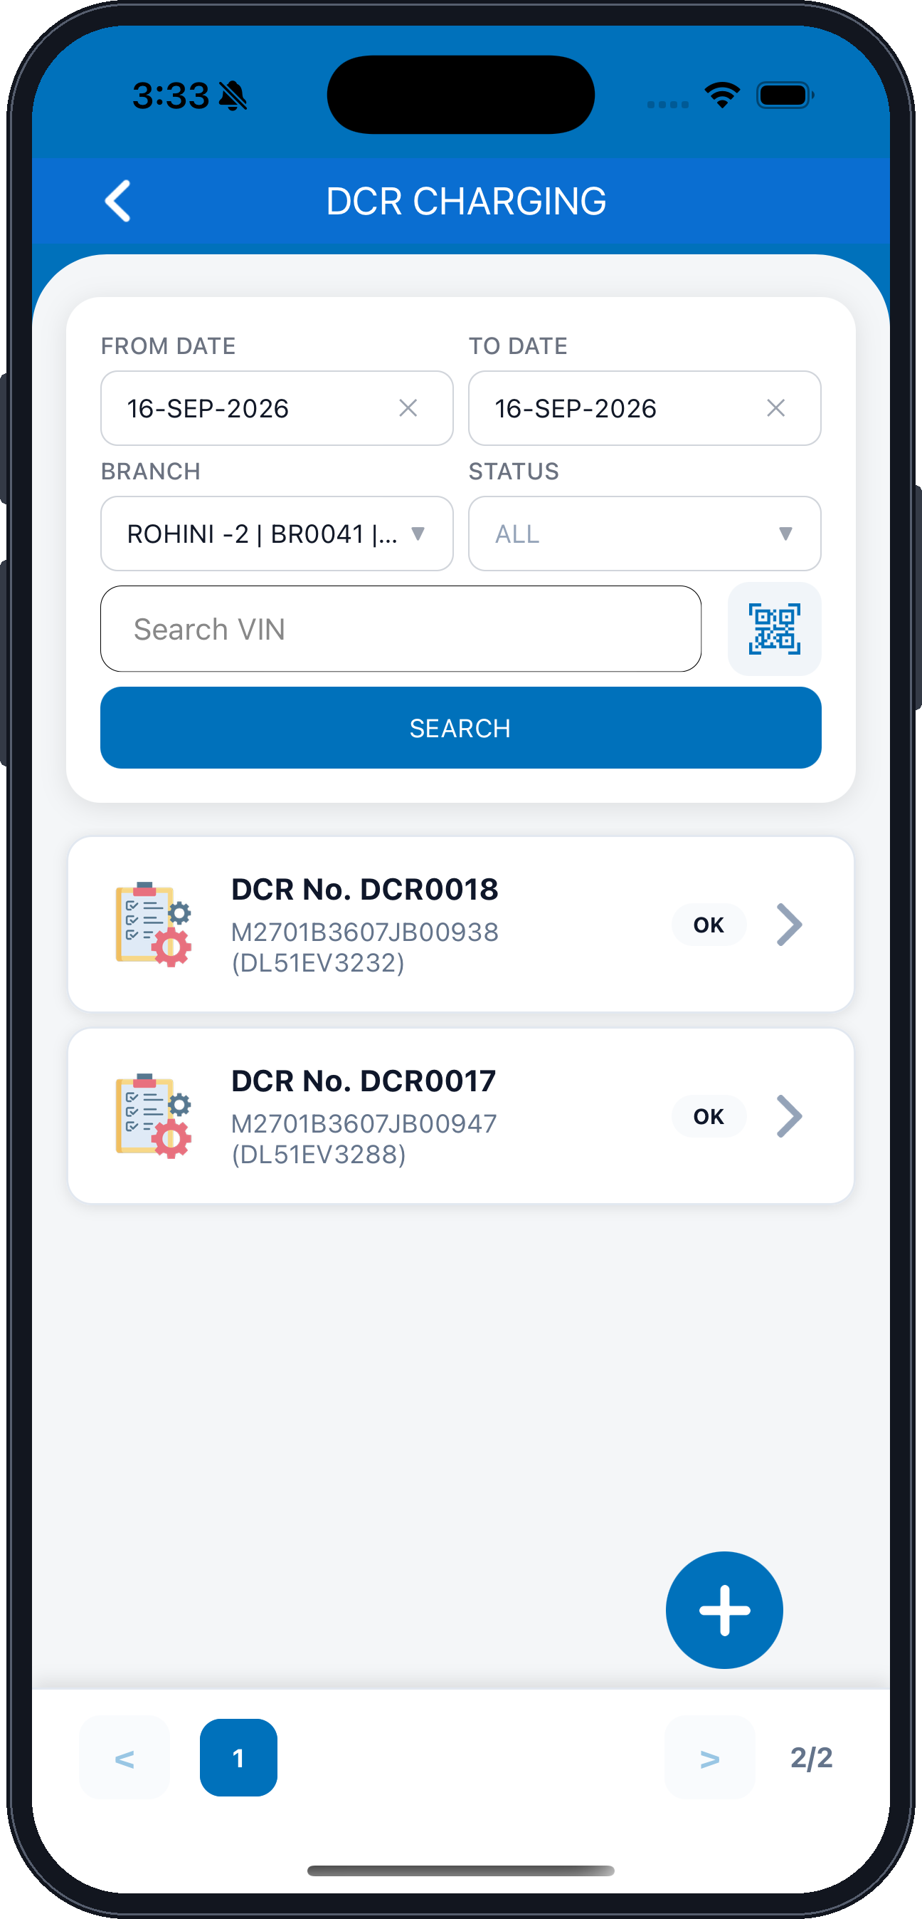
DCR CHARGING — screen title
FROM DATE — start of the search range
BRANCH — your mapped depot
Search VIN
SEARCH — runs the filter
Next DCR record
Pagination — 2 of 2 pages
TO DATE — end of the search range
STATUS — filter by charging status
QR / VIN barcode scanner
DCR record — number, VIN and registration
Status — OK
Chevron — opens the charging details
+ — creates a new charging record
Fig. 29 — DCR Charging list

xxx. Search the Vehicle to Charge
▪ Confirm the Branch in the Depot Detail & Search Vehicle section.
▪ Search the vehicle by VIN, Bus Number or Registration Number, or scan the QR / VIN barcode.
▪ Tap SEARCH to load the vehicle and its charging basics.
DCR CHARGING · STEP 2 OF 6
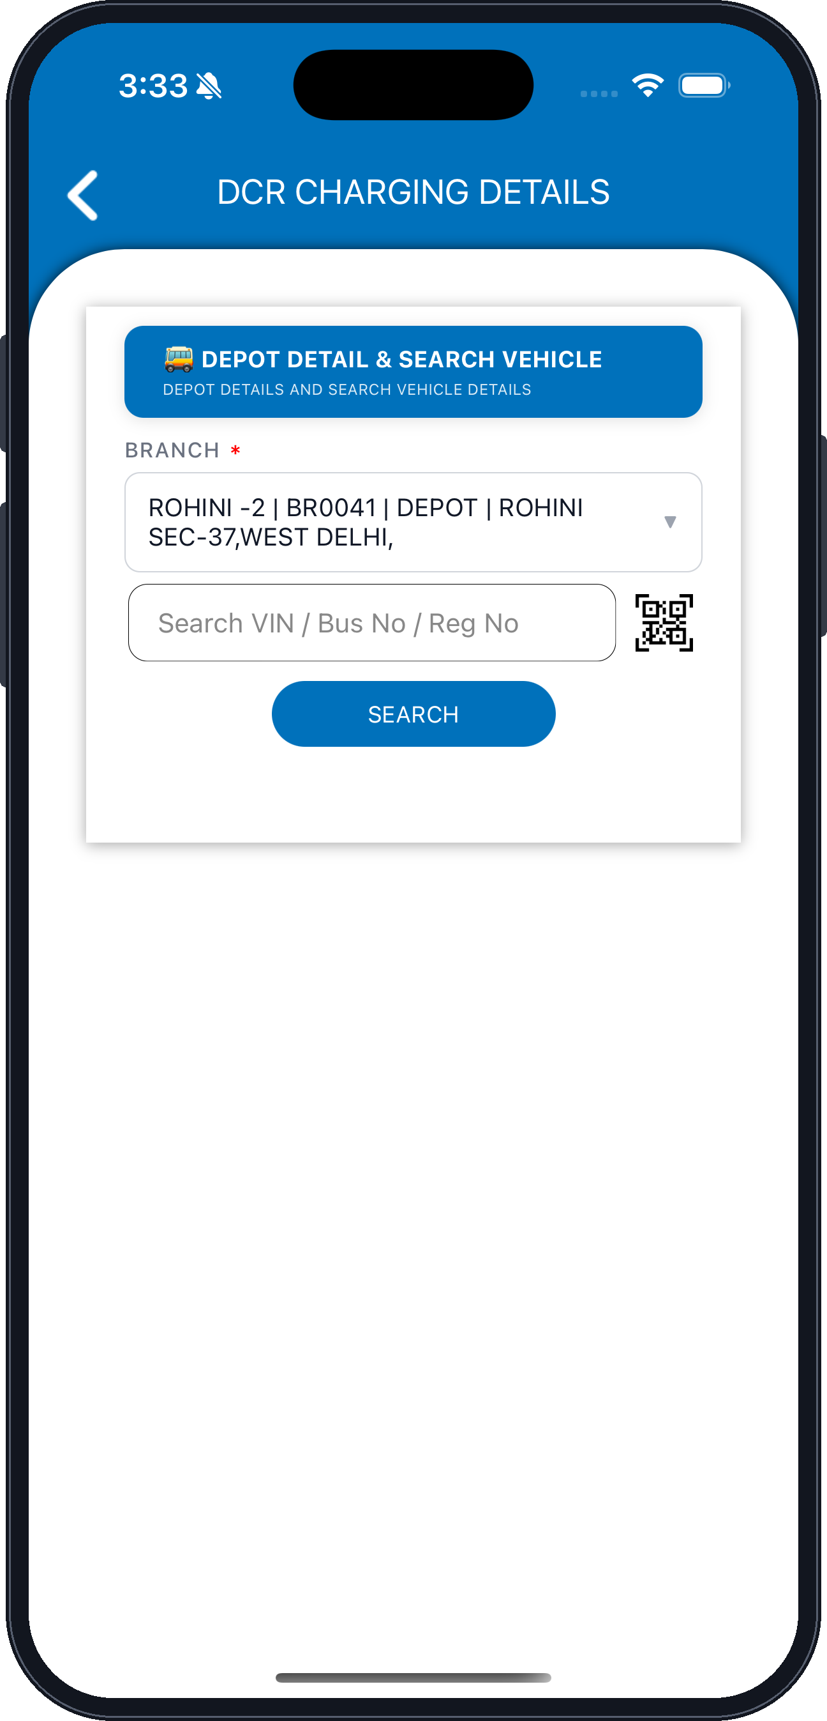
DCR CHARGING DETAILS — screen title
DEPOT DETAIL & SEARCH VEHICLE — depot details and vehicle search
BRANCH — mandatory
Branch, depot and address
Search VIN / Bus No / Reg No
QR / VIN barcode scanner
SEARCH — loads the selected vehicle
Fig. 30 — DCR Charging Details — depot detail and vehicle search

xxxi. Vehicle and Charger Master Details
▪ The Vehicle Details section is filled from the vehicle you searched.
▪ Select who the vehicle was charged by, and record the KMS reading and shift number.
▪ Charger Master Details carries the charger selection and capacity settings.
DCR CHARGING · STEP 3 OF 6
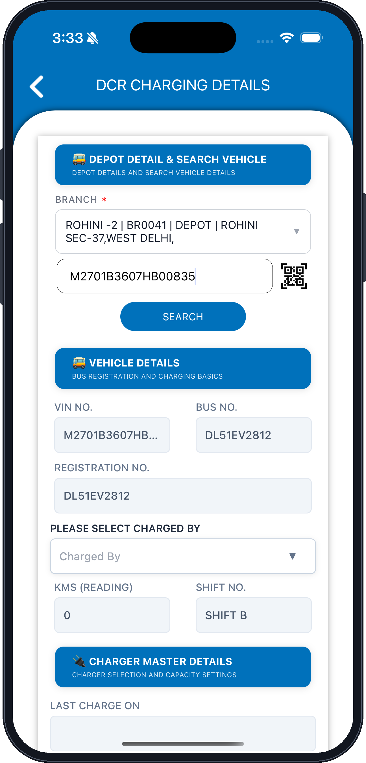
DEPOT DETAIL & SEARCH VEHICLE
BRANCH — depot and address
Searched VIN number
SEARCH
VIN NO.
REGISTRATION NO.
PLEASE SELECT CHARGED BY
KMS (READING)
VEHICLE DETAILS — bus registration and charging basics
BUS NO.
SHIFT NO.
CHARGER MASTER DETAILS — charger selection and capacity settings
LAST CHARGE ON
Fig. 31 — DCR Charging Details — vehicle details

xxxii. Charger Details and Charge Timing
▪ Select the Charger and verify its location, capacity and rating.
▪ Confirm the charger gun make for each gun, the error status and the charging gun type.
▪ Under Charge Timing & SOC record the manual start and end date and time.
DCR CHARGING · STEP 4 OF 6
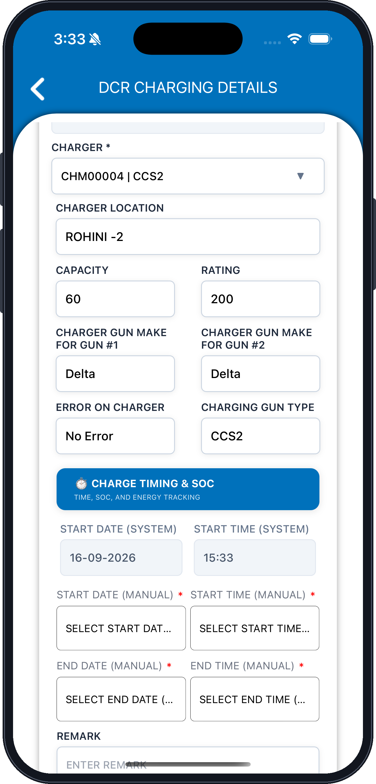
CHARGER — select the charger and gun (mandatory)
CHARGER LOCATION
CAPACITY
CHARGER GUN MAKE FOR GUN #1
ERROR ON CHARGER
START DATE (SYSTEM) — set by the application
START DATE (MANUAL) — mandatory
END DATE (MANUAL) — mandatory
REMARK
RATING
CHARGER GUN MAKE FOR GUN #2
CHARGING GUN TYPE
CHARGE TIMING & SOC — time, SOC and energy tracking
START TIME (SYSTEM) — set by the application
START TIME (MANUAL) — mandatory
END TIME (MANUAL) — mandatory
Fig. 32 — DCR Charging Details — charger and timing

xxxiii. SOC, Energy and Final Status
▪ Enter the start and end SOC ranges together with the charging time and kWh consumed.
▪ Set the SOC Charged Status, then select the Final Status and the person to inform.
▪ Add the attachment details and remarks for the charging record.
DCR CHARGING · STEP 5 OF 6
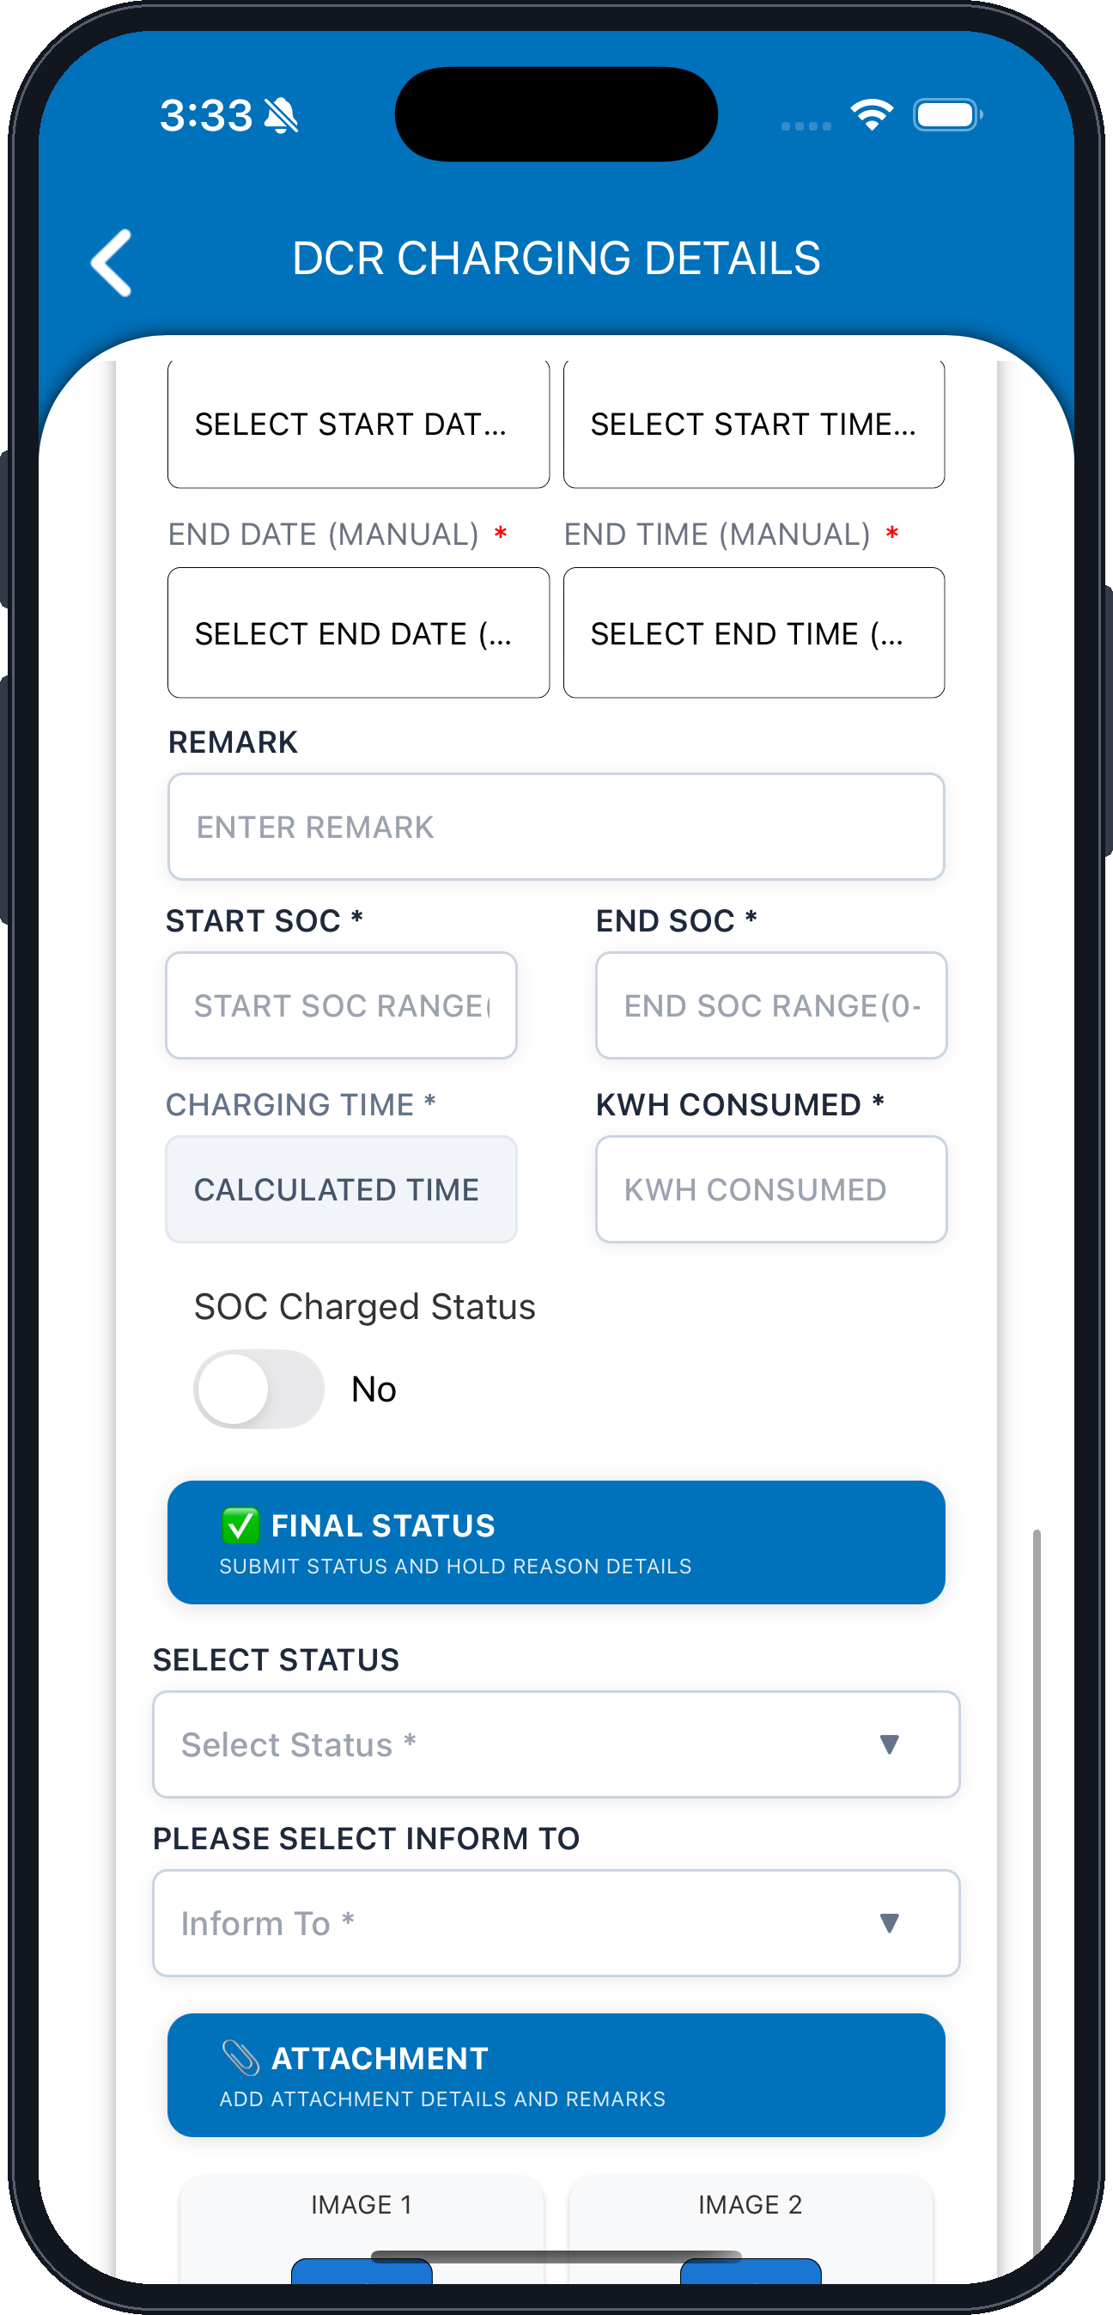
START DATE (MANUAL)
END DATE (MANUAL)
REMARK
START SOC — 0–100% range (mandatory)
CHARGING TIME — calculated by the application
SOC Charged Status — toggle Yes or No
SELECT STATUS — mandatory
PLEASE SELECT INFORM TO
IMAGE 1 — upload
START TIME (MANUAL)
END TIME (MANUAL)
END SOC — 0–100% range (mandatory)
KWH CONSUMED — mandatory
FINAL STATUS — submit status and hold reason details
ATTACHMENT — add attachment details and remarks
IMAGE 2 — upload
Fig. 33 — DCR Charging Details — SOC, energy and final status

xxxiv. Attachments and Submit
▪ Verify the SOC values, charging time and kWh consumed.
▪ Select the status and the Inform To recipient under Final Status.
▪ Upload the required images, then tap SUBMIT to save the charging record.
DCR CHARGING · STEP 6 OF 6
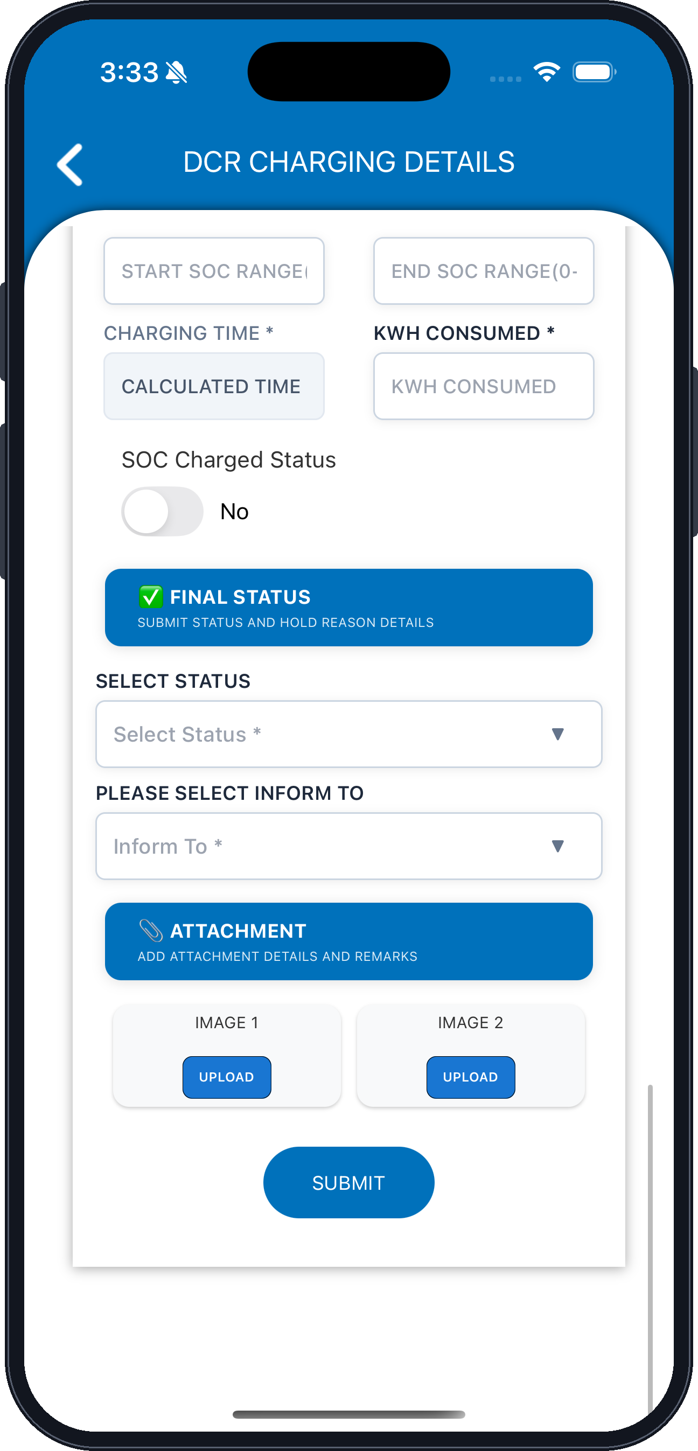
START SOC — 0–100% range
CHARGING TIME — calculated by the application
SOC Charged Status — toggle Yes or No
SELECT STATUS — mandatory
PLEASE SELECT INFORM TO
IMAGE 1 — upload
END SOC — 0–100% range
KWH CONSUMED
FINAL STATUS — submit status and hold reason details
ATTACHMENT — add attachment details and remarks
IMAGE 2 — upload
SUBMIT — saves the charging record
Fig. 34 — DCR Charging Details — attachments and submission
Note: The exact fields, validations and charging integration follow the approved Charging Details screen and functional requirements.

9. User Troubleshooting
Issue | Recommended action
Unable to login | Verify credentials and contact administrator if access is denied.
Vehicle not found | Verify Bus Number, Registration Number, or VIN.
VIN not authorized | Contact admin for assigned VIN access.
Odometer validation error | Enter a reading not less than the previous recorded reading.
Duplicate Gate-In error | Complete the previous Gate-Out loop first.
Gate-Out not allowed | Verify Gate-In status and job card closure.
Wheel temperature alert | Inform Shift Supervisor / Depot Manager and follow the service process.
Complaint not visible | Verify the Gate-In complaint was saved against the correct VIN.
Job card not available | Verify auto-job generation and assigned access.

10. JBM Officials Interviewed
Persons interviewed | Department | Remarks
Mr. Puneet Sharma
Mr. Gaurav Singla
Mr. Dinesh Kumar
Mr. Vinit Chavan

