to run zookeeper(open in new cmd)

C:\kafka>.\bin\windows\zookeeper-server-start.bat .\config\zookeeper.properties

to run kafka(open in new cmd)

C:\kafka>.\bin\windows\kafka-server-start.bat .\config\server.properties

to create topic(open in new cmd)

c:\kafka>.\bin\windows\kafka-topics.bat --create --zookeeper localhost:2181 --replication-factor 1 --partitions 1 --topic <topic name >

to produce message(open in new cmd)

c:\kafka>.\bin\windows\kafka-console-producer.bat --broker-list localhost:9092 --topic <topic name which you created>

to read message (open in new cmd)

c:\kafka>.\bin\windows\kafka-console-consumer.bat --bootstrap-server localhost:9092 --topic <topic name in which you want to consume message> --from-beginning

server window consumer window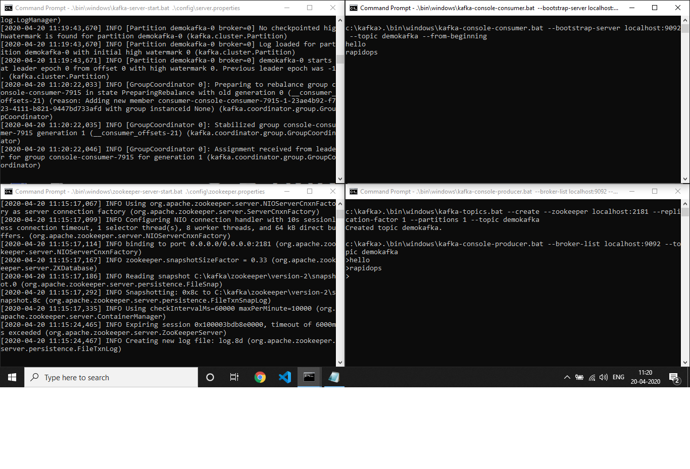

zookeeper window producer window