VISVESVARAYA TECHNOLOGICAL
UNIVERSITY
“JnanaSangama”, Belgaum -590014, Karnataka.


Database Management Systems (23CS3PCDBM)
Submitted by
Sarthak Thrishuleshwar (1BM24CS260)

in partial fulfilment for the award of the degree of
BACHELOR OF ENGINEERING
in
COMPUTER SCIENCE AND ENGINEERING



CERTIFICATE
This is to certify that the Lab work entitled “Database Management Systems (23CS3PCDBM)” carried out by Sarthak Thrishuleshwar (1BM24CS260), who is bonafide student of B. M. S. College of Engineering. It is in partial fulfilment for the award of Bachelor of Engineering in Computer Science and Engineering of the Visvesvaraya Technological University, Belgaum during the year 2025. The Lab report has been approved as it satisfies the academic requirements in respect of a Database Management Systems (23CS3PCDBM) work prescribed for the said degree.

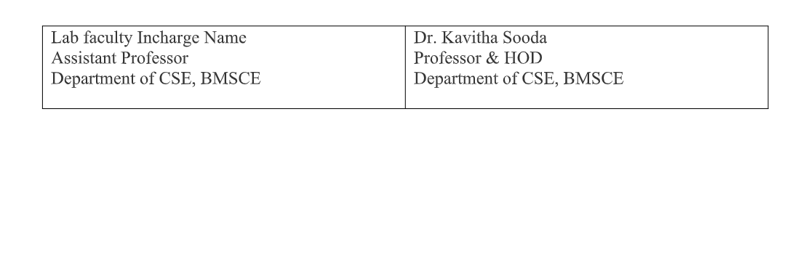

Index

SI  No | Date | Experiment Title | Page No.
1 |  | Insurance Database
2 |  | More Queries on Insurance Database
3 |  | Bank Database
4 |  | More Queries on Bank Database
5 |  | Employee Database
6 |  | More Queries on Employee Database
7 |  | Supplier Database
8 |  | More Queries on Supplier Database
9 |  | NOSQL Installation in Cloud
10 |  | NO SQL - Student Database
11 |  | NO SQL - Customer Database
12 |  | NO SQL – Restaurant Database
13 |  | LeetCode Practice
14 |  | LeetCode Practice

Experiment 1: Insurance Database

Specification of Insurance Database Application
The insurance database must maintain information about drivers, the cars they own, the accidents reported, and the participation of each driver and car in those accidents. Each driver in the system is uniquely identified by a driver ID, along with their name and address, and each car is uniquely identified by its registration number together with details such as model and manufacturing year. The system must allow storing ownership information that links a driver to one or more cars, while also allowing a car to be linked to one or more drivers if shared ownership occurs; duplicate ownership records for the same driver and car must not exist. Accident information must be stored using a unique report number assigned to each accident, along with the date on which the accident occurred and the location where it happened. Every accident reported in the system must have at least one participating driver and car, and this participation is recorded by linking the driver, the involved car, and the accident report together with the corresponding damage amount for that particular involvement. A participation record must reference an existing driver, an existing car, and an existing accident, and no two participation entries may repeat the same combination of driver, car, and accident report. The database must ensure that damage amounts are non-negative, accident dates are valid calendar dates, and car manufacturing years fall within reasonable limits. It must also preserve referential integrity so that ownership or participation entries cannot exist without valid driver, car, and accident information already present in the system. Deletion policies must prevent removal of drivers or cars that appear in past accident participation records unless historical consistency is preserved through controlled deletion rules or archival mechanisms. The system should maintain accurate links between drivers, cars, and accidents at all times, ensuring reliable retrieval of ownership histories, accident histories, and damage information for administrative, legal, and insurance-related purposes.

Entity Relationship Diagram

Schema Diagram

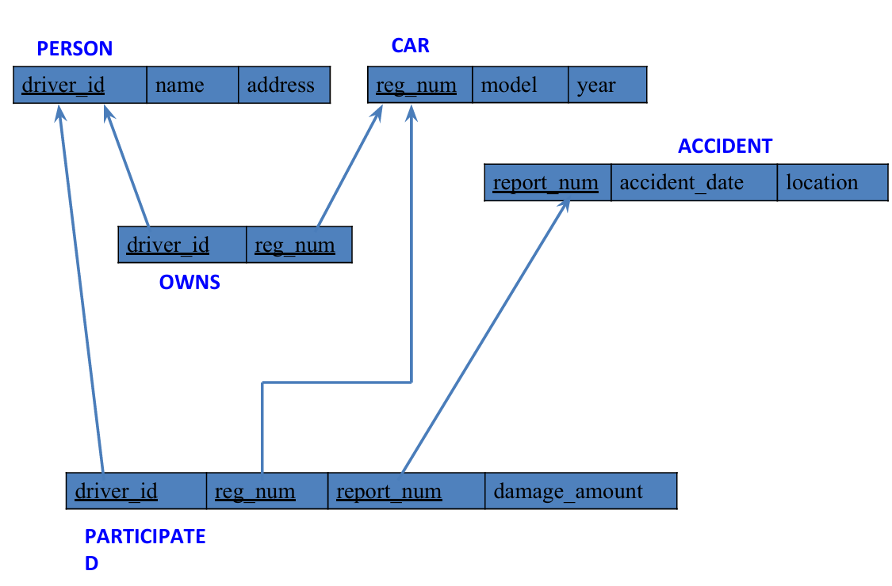
PERSON (driver_id: String, name: String, address: String)
CAR (reg_num: String, model: String, year: int)
ACCIDENT (report_num: int, accident_date: date, location: String)
OWNS (driver_id: String, reg_num: String)
PARTICIPATED (driver_id: String, reg_num: String, report_num: int, damage_amount: int)

Create Table

create database insurancedb;
use insurancedb;

CREATE TABLE PERSON (
driver_id VARCHAR (10) PRIMARY KEY,
name VARCHAR (30),
address VARCHAR (50)
);

CREATE TABLE CAR (
reg_num VARCHAR (15) PRIMARY KEY,
model VARCHAR (20),
year INT,
CONSTRAINT chk_year_range CHECK (year >= 1886 AND year <= 2100)
);

CREATE TABLE ACCIDENT (
report_num INT PRIMARY KEY,
accident_date DATE,
location VARCHAR (50)
);

CREATE TABLE OWNS (
driver_id VARCHAR (10),
reg_num VARCHAR (15),
PRIMARY KEY (driver_id, reg_num),
FOREIGN KEY(driver_id) REFERENCES PERSON(driver_id)
ON DELETE RESTRICT,
FOREIGN KEY(reg_num) REFERENCES CAR(reg_num)
ON DELETE RESTRICT
);

CREATE TABLE PARTICIPATED (
driver_id VARCHAR (10),
reg_num VARCHAR (15),
report_num INT,
damage_amount INT CHECK (damage_amount >= 0),
PRIMARY KEY (driver_id, reg_num, report_num),
FOREIGN KEY(driver_id) REFERENCES PERSON(driver_id)
ON DELETE RESTRICT,
FOREIGN KEY(reg_num) REFERENCES CAR(reg_num)
ON DELETE RESTRICT,
FOREIGN KEY(report_num) REFERENCES ACCIDENT(report_num)
ON DELETE CASCADE
);
Structure of Table
desc person;
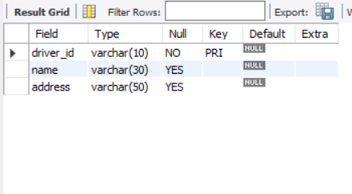

desc car;
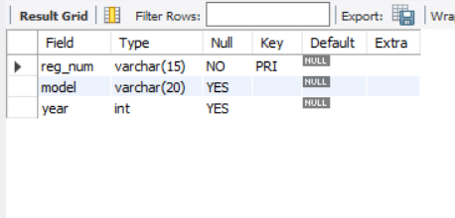

desc accident;
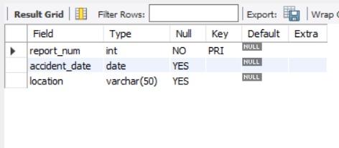
desc owns;
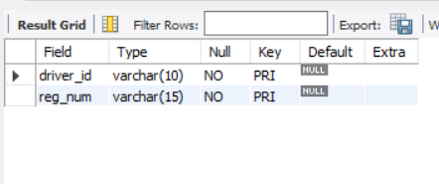

desc participated;
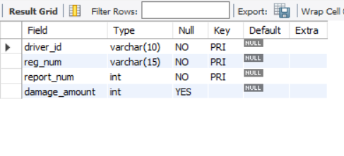
Inserting Values to Table
INSERT INTO PERSON VALUES
('A01','Richard','Srinivas nagar'),
('A02','Pradeep','Rajaji nagar'),
('A03','Smith','Ashok nagar'),
('A04','Venu','N R Colony'),
('A05','Jhon','Hanumanth nagar');
select * from person;
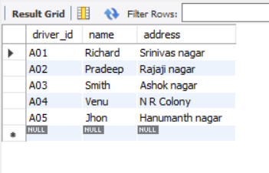

INSERT INTO CAR VALUES
('KA052250','Indica',1990),
('KA031181','Lancer',1957),
('KA095477','Toyota',1998),
('KA053408','Honda',2008),
('KA041702','Audi',2005);
select * from car;
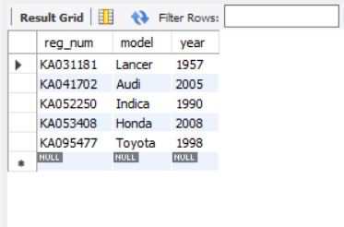

INSERT INTO ACCIDENT VALUES
(11,'2003-01-01','Mysore Road'),
(12,'2004-02-02','South end Circle'),
(13,'2003-01-21','Bull temple Road'),
(14,'2008-02-17','Mysore Road'),
(15,'2005-03-04','Kanakpura Road');
select * from accident;
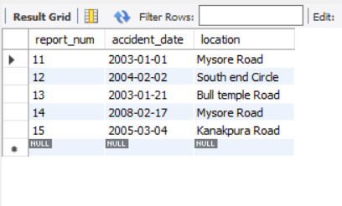

INSERT INTO OWNS VALUES
('A01','KA052250'),
('A02','KA053408'),
('A03','KA031181'),
('A04','KA095477'),
('A05','KA041702');
select * from owns;
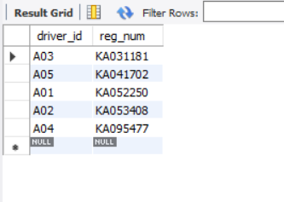

INSERT INTO PARTICIPATED VALUES
('A01','KA052250',11,10000),
('A02','KA053408',12,50000),
('A03','KA095477',13,25000),
('A04','KA031181',14,3000),
('A05','KA041702',15,5000);
select * from participated;
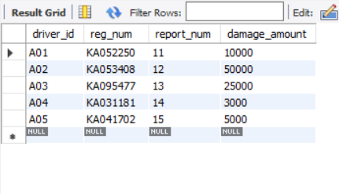

Queries (Questions & Output)

iii. Display Accident date and location
SELECT accident_date, location
FROM ACCIDENT;
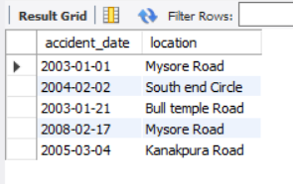
iv. Update the damage amount to 25000 for the car with a specific reg_num (example 'K A053408' ) for which the accident report number was 12.
UPDATE PARTICIPATED
SET damage_amount = 25000
WHERE reg_num = 'KA053408'
AND report_num = 12;
select * from participated;
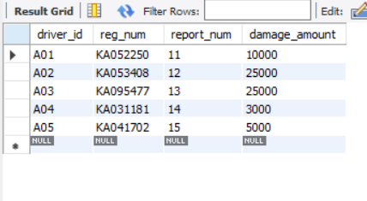

v. Add a new accident to the database.
INSERT INTO ACCIDENT (report_num, accident_date, location)
VALUES (16, '2024-03-10', 'MG Road');
select * from accident;
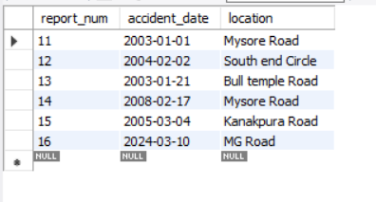
vi. Display driver id who did accident with damage amount greater than or equal to Rs.25000
SELECT DISTINCT driver_id
FROM PARTICIPATED
WHERE damage_amount >= 25000;
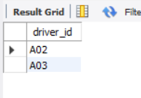
Experiment 2: More Queries on Insurance Database

Queries (Questions & Output)
i. Display the entire CAR relation in the ascending order of manufacturing year.
SELECT *
FROM CAR
ORDER BY year ASC;
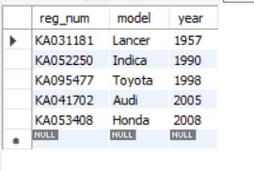
ii. Find the number of accidents in which cars belonging to a specific model (example 'Lancer') were involved.
SELECT COUNT (DISTINCT p. report_num)
FROM PARTICIPATED p
JOIN CAR c ON p.reg_num = c.reg_num
WHERE c. model = 'Lancer';
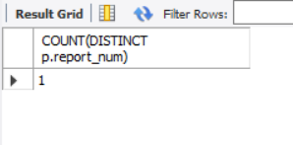
iii. Find the total number of people who owned cars that involved in accidents in 2008.
SELECT COUNT (DISTINCT o. driver_id)
FROM OWNS o
JOIN PARTICIPATED p ON o.reg_num = p.reg_num
JOIN ACCIDENT a ON p. report_num = a. report_num
WHERE YEAR (a. accident_date) = 2008;
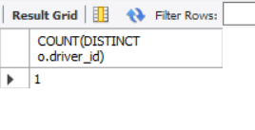
iv. List the entire participated relation in the Descending Order of Damage Amount.
SELECT *
FROM PARTICIPATED
ORDER BY damage_amount DESC;
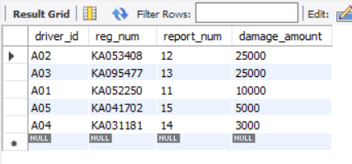
v. Find the Average Damage Amount.
SELECT AVG(damage_amount) AS avg_damage
FROM PARTICIPATED;
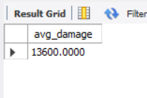
vi. Delete the tuple whose Damage Amount is below the Average Damage Amount
DELETE FROM PARTICIPATED
WHERE damage_amount < (
SELECT avg_damage
FROM (
SELECT AVG(damage_amount) AS avg_damage
FROM PARTICIPATED
) AS temp
);
select * from participated;
SET SQL_SAFE_UPDATES = 1;
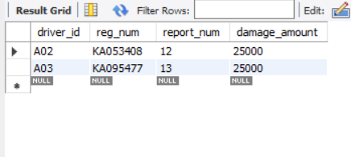
vii. List the name of drivers whose Damage is Greater than the Average Damage Amount.
SELECT DISTINCT pe.name
FROM PERSON pe
JOIN PARTICIPATED p ON pe. driver_id = p. driver_id
WHERE p. damage_amount > (
SELECT AVG(damage_amount)
FROM PARTICIPATED
);
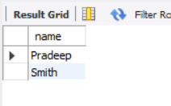
viii. Find Maximum Damage Amount.
SELECT MAX(damage_amount) AS max_damage
FROM PARTICIPATED;
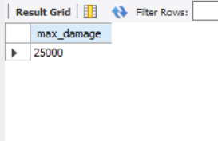

Experiment 3: Bank Database

BANKING ENTERPRISE DATABASE

The banking system must store information about branches, bank accounts, customers, deposit relationships, and loans so that branch details (identified by branch name together with city and total assets) are linked to accounts and loans, each account (identified by an account number) records the branch it belongs to and the current balance, customers are recorded with their name, street and city, and a depositor relationship associates a customer with an account; loans are recorded by a unique loan number together with the branch name that issued the loan and the loan amount. Account numbers and loan numbers must be unique identifiers, branch names are used to associate accounts and loans to a branch, and customer names (as modelled) are used to identify customers referenced by depositor entries; every depositor entry must reference an existing customer and an existing account so that ownership and access relationships are always valid, and duplicate depositor records linking the same customer and account are disallowed. The system must maintain referential integrity so accounts cannot reference a non-existent branch, depositor rows cannot reference missing customers or accounts, and loans must reference an existing branch; deletion of a branch, account, or customer that is referenced by dependent records should be controlled (either disallowed or handled by archival/controlled reassignment) to preserve historical transaction and loan consistency. Numeric and temporal constraints must be enforced: account balances should be constrained to valid values (for example non-negative where overdraft is not allowed), branch assets and loan amounts must be non-negative and within specified business limits, and updates to balance or loan amounts should be auditable. Cardinality rules implied by the schema are enforced: a branch may host many account sand issue many loans, an account belongs to exactly one branch, a customer may be linked to many accounts through depositor relationships, and an account may have many depositors if joint accounts are permitted by policy. Implementation must prevent orphaned records, ensure uniqueness where required, and rely on application logic or database-level triggers to enforce complex rules such as cascading effects on deletion, business rules about allowed balance operations or overdrafts, and any required validation when transferring accounts between branches or when converting a customer’s identifying details; the database should thus reliably support queries for branch-wise account lists, customer account ownership, account balances, and loan portfolios while preserving historical and referential integrity for auditing and regulatory reporting.

Entity & Relationship Diagram

Schema Diagram
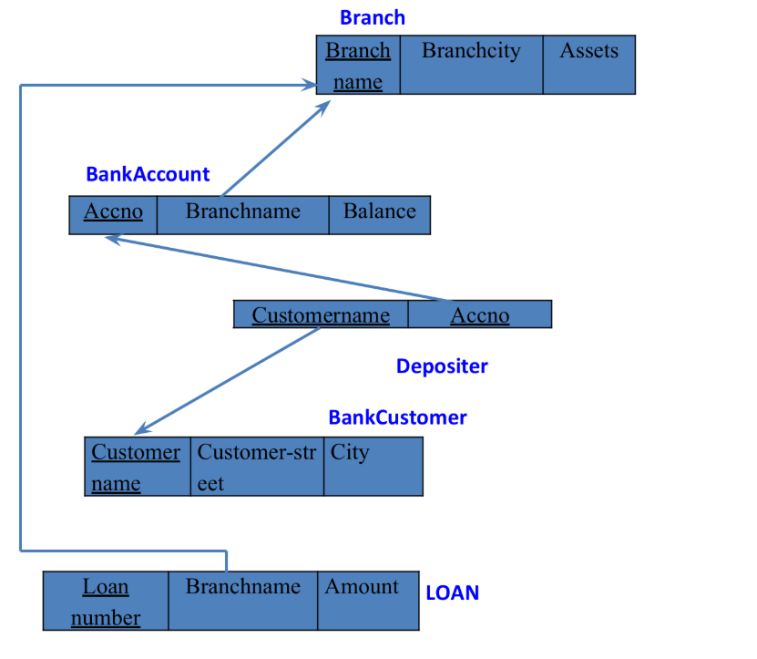

Branch (branch-name: String, branch-city: String, assets: real)
BankAccount (accno: int, branch-name: String, balance: real)
BankCustomer (customer-name: String, customer-street: String, customer-city: String)
Depositer (customer-name: String, accno: int)
LOAN (loan-number: int, branch-name: String, amount: real)

Creating Tables
CREATE TABLE Branch (
branch_name VARCHAR (30) PRIMARY KEY,
branch_city VARCHAR (30) NOT NULL,
assets DECIMAL (15,2) NOT NULL,
CHECK (assets >= 0)
);

CREATE TABLE BankAccount (
accno INT PRIMARY KEY,
branch_name VARCHAR (30) NOT NULL,
balance DECIMAL (15,2) NOT NULL,
CHECK (balance >= 0),
FOREIGN KEY (branch_name)
REFERENCES Branch(branch_name)
ON DELETE RESTRICT
ON UPDATE CASCADE
);

CREATE TABLE BankCustomer (
customer_name VARCHAR (30) PRIMARY KEY,
customer_street VARCHAR (50),
customer_city VARCHAR (30)
);

CREATE TABLE Depositer (
customer_name VARCHAR (30),
accno INT,
PRIMARY KEY (customer_name, accno),
FOREIGN KEY (customer_name)
REFERENCES BankCustomer(customer_name)
ON DELETE RESTRICT
ON UPDATE CASCADE,
FOREIGN KEY (accno)
REFERENCES BankAccount(accno)
ON DELETE RESTRICT
ON UPDATE CASCADE
);

CREATE TABLE Loan (
loan_number INT PRIMARY KEY,
branch_name VARCHAR (30) NOT NULL,
amount DECIMAL (15,2) NOT NULL,
CHECK (amount >= 0),
FOREIGN KEY (branch_name)
REFERENCES Branch(branch_name)
ON DELETE RESTRICT
ON UPDATE CASCADE
);
Structure of Tables
desc Branch;
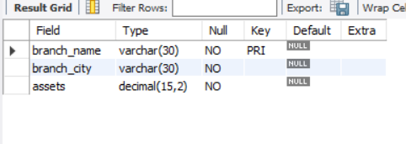
desc BankAccount;
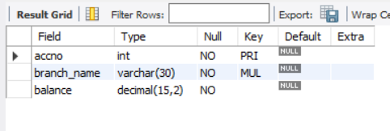
desc BankCustomer;
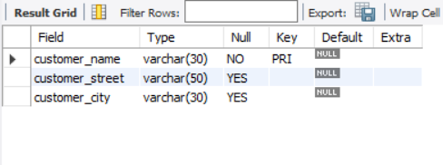
desc depositer;
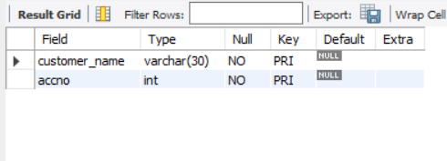
desc Loan;
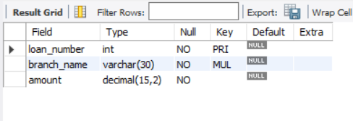

Inserting Values into the Table
INSERT INTO Branch VALUES
('SBI_Chamrajpet','Bangalore',50000),
('SBI_ResidencyRoad','Bangalore',10000),
('SBI_ShivajiRoad','Bombay',20000),
('SBI_ParliamentRoad','Delhi',10000),
('SBI_Jantarmantar','Delhi',20000);
select *from Branch;
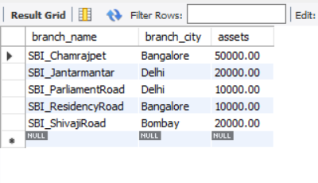
INSERT INTO BankAccount VALUES
(1,'SBI_Chamrajpet',2000),
(2,'SBI_ResidencyRoad',5000),
(3,'SBI_ShivajiRoad',6000),
(4,'SBI_ParliamentRoad',9000),
(5,'SBI_Jantarmantar',8000);
select *from BankAccount;
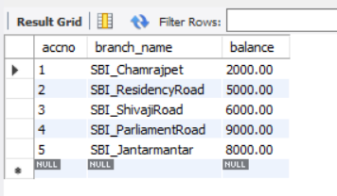
INSERT INTO BankCustomer VALUES
('Avinash','Bull_Temple_Road','Bangalore'),
('Dinesh','Bannerghatta_Road','Bangalore'),
('Mohan','NationalCollege_Road','Bangalore'),
('Nikil','Akbar_Road','Delhi'),
('Ravi','Prithviraj_Road','Delhi');
select *from BankCustomer;
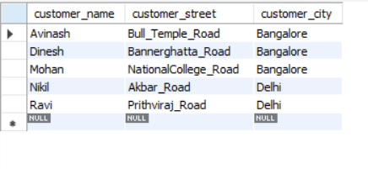

INSERT INTO Depositer VALUES
('Avinash',1),
('Dinesh',2),
('Nikil',4),
('Ravi',5),
('Avinash',3);
select *from depositer;
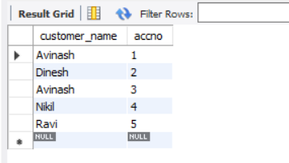

INSERT INTO Loan VALUES
(1,'SBI_Chamrajpet',1000),
(2,'SBI_ResidencyRoad',2000),
(3,'SBI_ShivajiRoad',3000),
(4,'SBI_ParliamentRoad',4000),
(5,'SBI_Jantarmantar',5000);
select *from Loan;
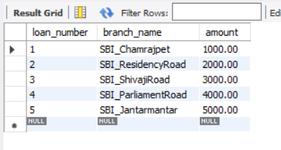

Queries (Questions & Output)
iii. Display the branch name and assets from all branches in lakhs of rupees and rename the assets column to 'assets in lakhs'.
SELECT branch_name, assets/100000 AS `assets in lakhs`
FROM Branch;
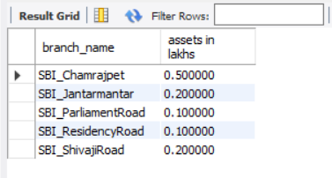
iv. Find all the customers who have at least two accounts at the same branch (ex. SBI_ResidencyRoad).
SELECT d. customer_name
FROM Depositer d
JOIN BankAccount b ON d. accno = b. accno
WHERE b. branch_name = 'SBI_ResidencyRoad'
GROUP BY d. customer_name
HAVING COUNT (*) >= 2;
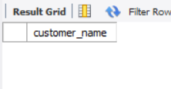
v. Create a view which gives each branch the sum of the amount of all the loans at the branch.
CREATE VIEW BranchLoanSum AS
SELECT branch_name, SUM(amount) AS total_loan
FROM Loan
GROUP BY branch_name;
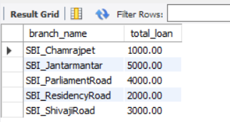

Experiment 4: More Queries on Bank Database
Queries (Questions & Output)
i. Find all the customers who have an account at all the branches located in a specific city (Ex. Delhi).
SELECT c. customer_name
FROM BankCustomer c
JOIN Depositer d ON c. customer_name = d. customer_name
JOIN BankAccount b ON d. accno = b. accno
JOIN Branch br ON b. branch_name = br. branch_name
WHERE br. branch_city = 'Delhi'
GROUP BY c. customer_name
HAVING COUNT (DISTINCT br. branch_name) = (
SELECT COUNT (*)
FROM Branch
WHERE branch_city = 'Delhi'
);
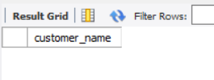
ii. Find all customers who have a loan at the bank but do not have an account.
SELECT DISTINCT l. loan_number
FROM Loan l
LEFT JOIN BankAccount b ON l. branch_name = b. branch_name
WHERE b. accno IS NULL;
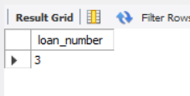
iii. Find all customers who have both an account and a loan at the Bangalore branch
SELECT DISTINCT d. customer_name
FROM Depositer d
JOIN BankAccount b ON d. accno = b. accno
JOIN Loan l ON b. branch_name = l. branch_name
JOIN Branch br ON b. branch_name = br. branch_name
WHERE br. branch_city = 'Bangalore';
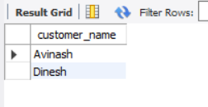
iv. Find the names of all branches that have greater assets than all branches located in Bangalore.
SELECT branch_name
FROM Branch
WHERE assets > ALL (
SELECT assets
FROM Branch
WHERE branch_city = 'Bangalore'
);
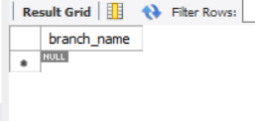
v. Demonstrate how you delete all account tuples at every branch located in a specific city (Ex. Bombay).
SET SQL_SAFE_UPDATES=0;
DELETE FROM Depositer
WHERE accno IN (
SELECT accno
FROM BankAccount
WHERE branch_name IN (
SELECT branch_name
FROM Branch
WHERE branch_city = 'Bombay'
)
);

DELETE FROM BankAccount
WHERE branch_name IN (
SELECT branch_name
FROM Branch
WHERE branch_city = 'Bombay'
);
SELECT * FROM BankAccount;
SET SQL_SAFE_UPDATES=1;
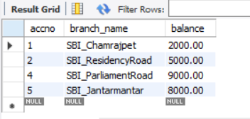
vi. Update the Balance of all accounts by 5%
UPDATE BankAccount
SET balance = balance * 1.05;
SELECT * FROM BankAccount;
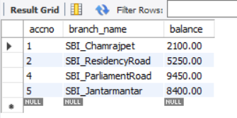

Experiment 5: Employee Database

Employee Database
The employee database must record each employee’s identifying number, name, manager reference, hire date, salary, and department affiliation while also tracking departmental details, project assignments (including the role an employee plays on a project), and any incentive payments given to employees. Every employee is represented by a unique employee number and has a hire date and salary that must be valid; the manager field is a self-referencing link that must, if present, point to an existing employee and must never create a circular management chain or reference the employee themself. Departments are identified by a unique department number and include a department name and location; every department referenced by an employee or by other structures must exist in the department table, and departments may contain zero or many employees. Projects are recorded with a unique project number, project name and project location; employees may be assigned to multiple projects and each project may have many employees, with each assignment carrying the employee’s job role for that project — duplicate assignments of the same employee to the same project are disallowed. Incentive payments are recorded with the employee reference, the incentive date and the incentive amount; an incentive entry must reference an existing employee and incentive amounts must be non-negative and dated on or after the employee’s hire date. Referential integrity must be enforced so that employee records cannot reference non-existent departments, projects, or managers, and assignment and incentive records cannot exist without corresponding employee, project, or department records as appropriate. Salary, incentive amounts, and any monetary fields must be constrained to valid numeric ranges and hire/ incentive dates must be valid calendar dates (and typically not future-dated unless business rules permit). Deletion and update policies must preserve historical consistency: deleting an employee who appears as a manager, as a project assignee, or in incentive records should be prevented or should be handled via controlled archival, reassignment, or soft-delete flags rather than hard deletion to preserve audit trails; similarly, changing a department or project identifier must either be disallowed if it would orphan historical records or handled by introducing immutable surrogate keys. Business rules include preventing circular manager chains, ensuring anemployee’s manager (if specified) cannot be the employee themself, disallowing duplicate project-assignments, requiring that incentive dates fall within the employee’s employment window, and optionally requiring at least one project assignment or at least one incentive record depending on policy for reporting. Implementation should use primary-key and foreign-key constraints for identity and linkage, unique constraints to prevent duplicate assignments, check constraints for monetary and date ranges, and application logic or triggers for complex temporal or graph constraints (like cycle detection in management relationships and enforcing non-overlap or other schedule-related rules if assignments gain temporal attributes later). The system must therefore reliably support queries such as employee reporting lines, department staffing lists, project rosters with job roles, incentive payment histories, salary analyses, and audit reports while maintaining data integrity, preventing inconsistent deletions, and preserving a complete historical record for HR and compliance needs.

