VISVESVARAYA TECHNOLOGICAL UNIVERSITY
“Jnana Sangama”, Belgaum -590014, Karnataka.

Full Stack Web Development Report
On

Accuweather

Submitted by

Sarthak Thrishuleshwar(1BM24CS260)
Sai Kalyan(1BM24CS252)
Shamanth P Rao(1BM24CS262)
Shashank S(1BM24CS266)

Under the Guidance of
Ms Sheetal VA

in partial fulfillment for the award of the degree of
BACHELOR OF ENGINEERING
in
COMPUTER SCIENCE AND ENGINEERING

B.M.S. COLLEGE OF ENGINEERING
(Autonomous Institution under VTU)
BENGALURU-560019
Sep 2025 – Jan 2026
B. M. S. College of Engineering,
Bull Temple Road, Bangalore 560019
(Affiliated to Visvesvaraya Technological University, Belgaum)
Department of Computer Science and Engineering

CERTIFICATE
This is to certify that the project work entitled Weather App carried out by Sarthak Thrishuleshwar(1BM24CS260), Sai Kalyan(1BM24CS252), Shamanth P Rao(1BM24CS262), Shashank S(1BM24CS266) who are bonafide students of B. M. S. College of Engineering. It is in partial fulfillment for the award of Bachelor of Engineering in Computer Science and Engineering of the Visveswaraiah Technological University, Belgaum during the year 2025-2026. The project report has been approved as it satisfies the academic requirements in respect of Full Stack Web Development(23CS3AEFWD) work prescribed for the said degree.

Signature of the Guide Signature of the HOD
************* Dr. Kavitha Sooda
Assistant Professor Prof & Head of Dept of CSE
BMSCE, Bengaluru BMSCE, Bengaluru

External Viva
Name of the Examiner Signature with date
1)
2)

B.M.S. COLLEGE OF ENGINEERING
DEPARTMENT OF COMPUTER SCIENCE AND ENGINEERING

DECALARATION

We, Sarthak Thrishuleshwar(1BM24CS260), Sai Kalyan(1BM24CS252), Shamanth P Rao(1BM24CS262), Shashank S(1BM24CS266) students of 3rd Semester, B.E, Department of Computer Science and Engineering, BMS College of Engineering, Bangalore, hereby declare that, this Full Stack Web Development entitled "Weather App " has been carried out by us under the guidance of Ms Sheetal VA, Assistant Professor, Department of CSE, BMS College of Engineering, Bangalore during the academic semester Sep 2025 - Dec 2026.
We also declare that to the best of our knowledge and belief, the development reported here is not from part of any other report by any other students.

Signature

Sarthak Thrishuleshwar(1BM24CS260)
Sai Kalyan(1BM24CS252)
Shamanth P Rao(1BM24CS262)
Shashank S(1BM24CS266)

TABLE OF CONTENTS

Serial  No. | TITLE | PAGE NO.
1 | Introduction | 1
1.1 | Overview | 1
1.2 | Motivation | 1
2 | Software Requirement Specification | 2
2.1 | Implementation/code | 2
2.2 | Results | 2
3 | ER diagram of the project | 3
4 | Schema of project | 4
5 | User Interface Design | 5
6 | Back End Design | 5
7 | Conclusion and Future work | 6
8 | References | 7

INTRODUCTION

- Overview
Weather App is a real-time weather tracking web application. It allows users to view current weather information for a selected location. The app provides weather alerts and features an interactive map where users can pick a location and see detailed weather data. The project uses modern web technologies, likely including React for the frontend, Vite for development, and external APIs for fetching real-time weather and map data.

1.2 Motivation
The motivation behind the project is to create a practical application that solves a real-world problem. Weather information is useful for planning daily activities, travel, and events. Additionally, building this app provides hands-on experience with web development, API integration, and interactive UI design. The project also serves as a portfolio project, demonstrating the developer’s ability to work with APIs, manage asynchronous requests, and implement dynamic features like maps and alerts.

SOFTWARE REQUIREMENTS

2.1 Hardware Requirements:
• Processor: Dual-core CPU or higher.
• RAM: Minimum 4 GB (8 GB recommended for smoother development).
• Storage: Around 500 MB free space for project files and Node modules.
• Internet Connection: Required for fetching API data and installing dependencies.
• No specialized hardware: Can run on standard development PCs or laptops.

2.2 Software Requirements:
• Node.js & npm: Required to install dependencies and run the development server.
• VS Code (or any code editor): For editing and managing project files.
• Git: To clone the repository and manage version control.
• Weather API key (e.g., OpenWeather): To fetch real-time weather data.
• Supabase (optional): For authentication or backend features if implemented.
• Modern web browser: Chrome, Edge, or Firefox to view and test the application.

3. ER DIAGRAM OF THE PROJECT

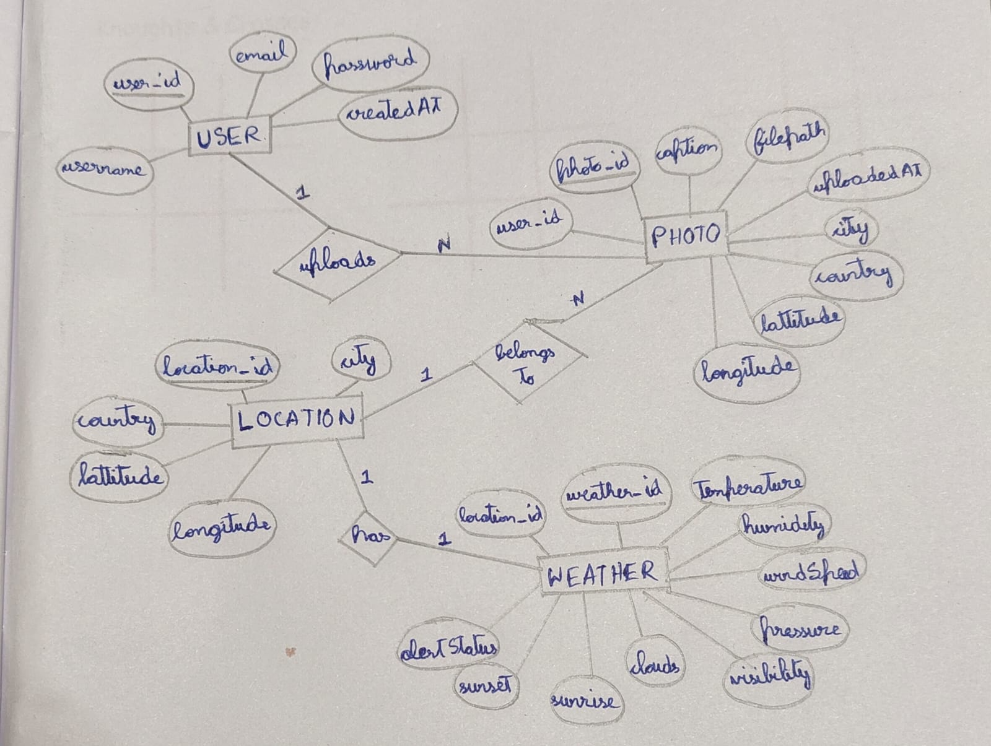

4. SCHEMA OF THE PROJECT

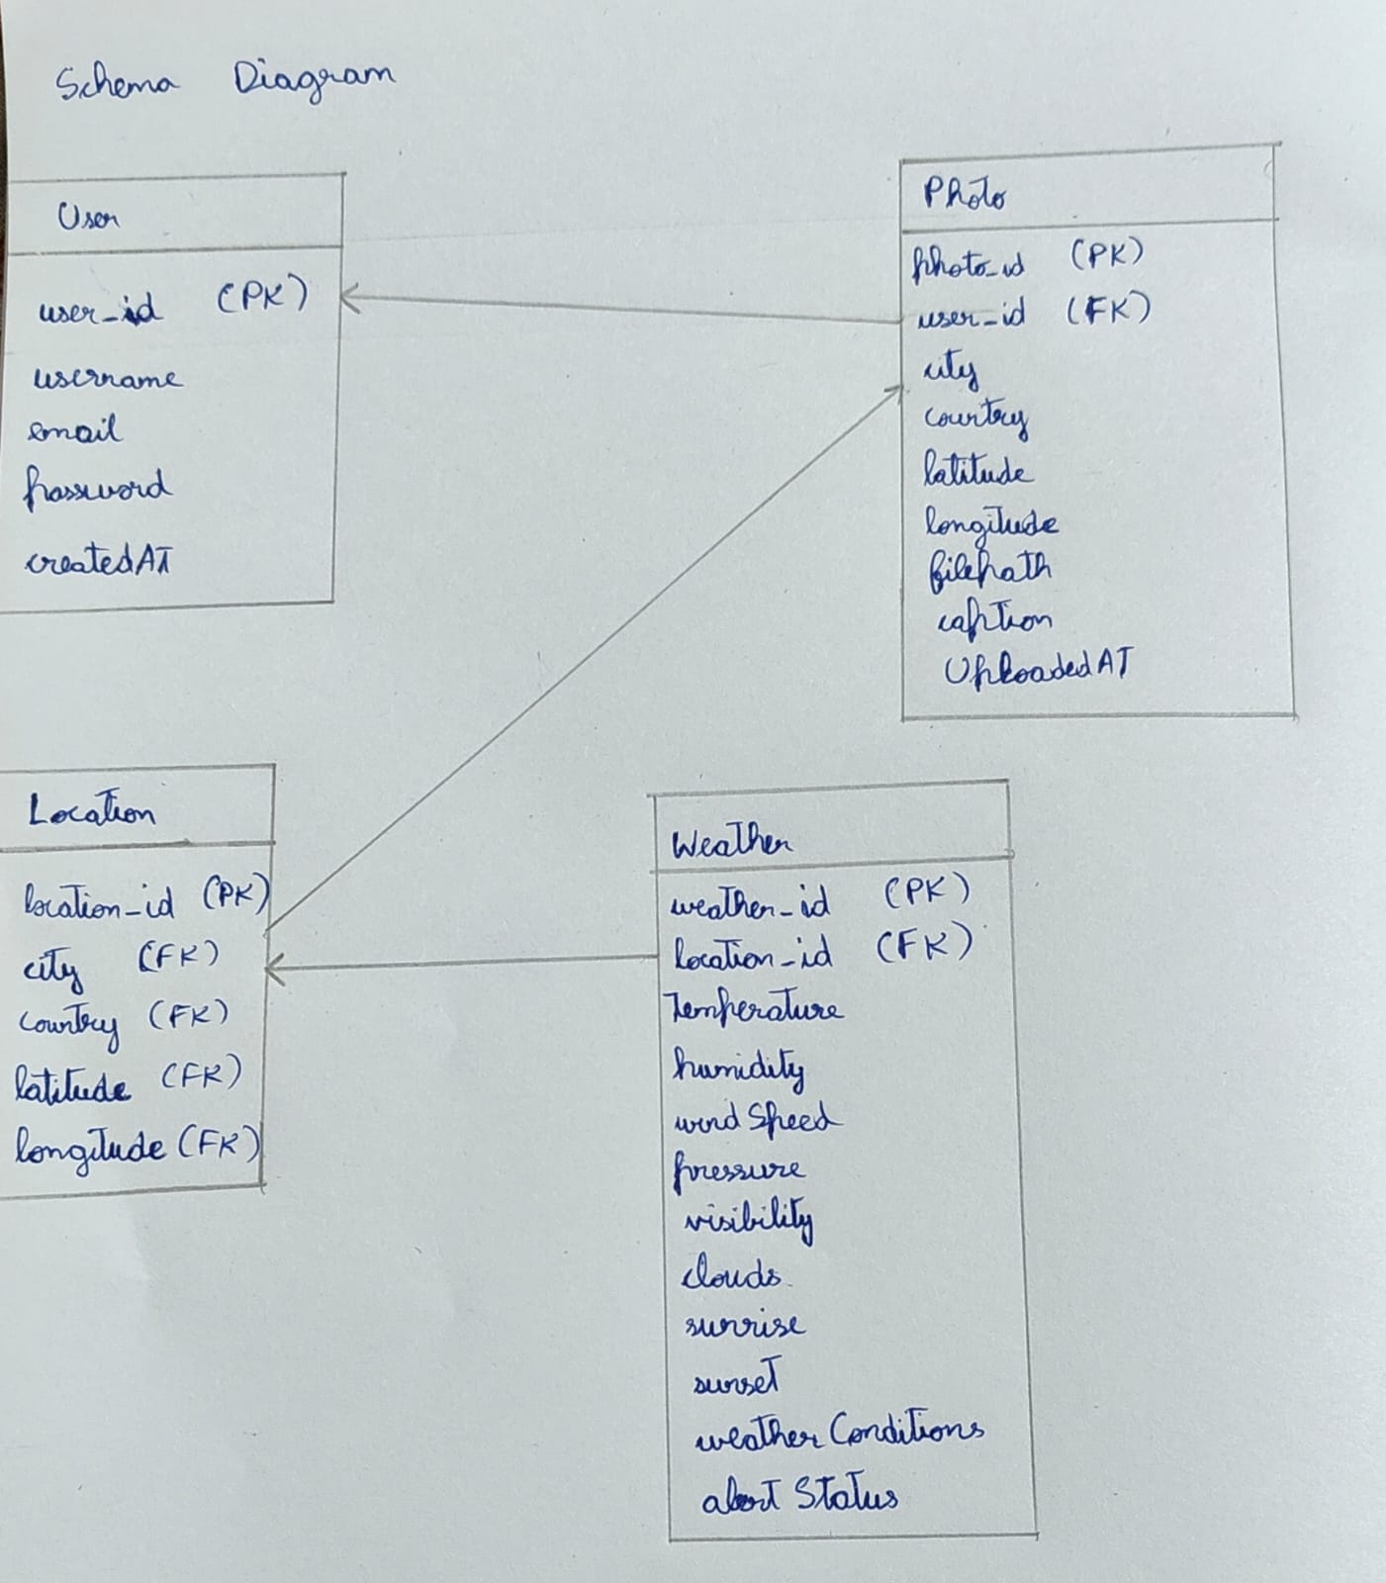

USER INTERFACE DESIGN

Attach various screenshots of each page along with a brief discussion. Please give Figure numbers and names to each of the screenshot attached.

BACK END DESIGN

Attach various screenshots of each page along with a brief discussion. Please give Figure numbers and names to each of the screenshot attached.

CONCLUSION AND FUTURE WORK

The Weather App successfully demonstrates the development of a real-time weather monitoring system using modern web technologies. The application provides accurate and up-to-date weather information such as temperature, humidity, wind speed, and weather conditions for user-selected locations. By integrating external weather APIs and interactive map features, the application delivers a user-friendly and responsive interface that enhances usability and accessibility. The project effectively showcases the use of API integration, dynamic data rendering, and frontend development practices. Overall, the Weather App meets its intended objectives and serves as a reliable tool for users to access weather information efficiently.

Although the Weather App achieves its core functionality, several enhancements can be implemented in the future to improve its capabilities. Advanced weather forecasting features such as hourly and weekly predictions can be added for better planning. Push notifications and real-time alerts for extreme weather conditions like storms or heavy rainfall can further enhance user safety. The application can also be extended to support multiple languages and themes to improve accessibility. Additionally, integrating a dedicated backend server for data caching and analytics can improve performance and scalability. Support for mobile platforms through a dedicated mobile application can also be considered as future enhancement.

REFERENCES

• OpenWeather API Documentation
https://openweathermap.org/api
Used for fetching real-time weather data such as temperature, humidity, and forecasts.
• React Official Documentation
https://react.dev/
Reference for building user interfaces using React components and hooks.
• Vite Documentation
https://vitejs.dev/
Used for fast development server and project bundling.
• Supabase Documentation
https://supabase.com/docs
Reference for user authentication and backend services.
• Leaflet.js Documentation (if maps are used)
https://leafletjs.com/
Used for implementing interactive maps.
• JavaScript MDN Web Docs
https://developer.mozilla.org/en-US/docs/Web/JavaScript
Reference for JavaScript language concepts and APIs.
• HTML MDN Web Docs
https://developer.mozilla.org/en-US/docs/Web/HTML
Reference for HTML structure and elements.
• CSS MDN Web Docs
https://developer.mozilla.org/en-US/docs/Web/CSS
Reference for styling and responsive design.
• GitHub Documentation
https://docs.github.com/
Used for version control and project hosting.
• VS Code Documentation
https://code.visualstudio.com/docs
Reference for development environment and extensions.

