Kubernetes Deployment Assignment (Minikube)

Objective
Deploy the Flask backend and Express frontend application locally on a Kubernetes cluster using Minikube.

Commands Used
- minikube start --driver=docker
- kubectl get nodes
- minikube image build -t flask-backend:latest .\Backen\flaskp
- minikube image build -t express-frontend:latest .\FrontEnd
- kubectl apply -f .\k8s\
- kubectl get deployments
- kubectl get pods
- kubectl get services
- minikube service express-frontend-service
- kubectl port-forward service/flask-backend-service 5000:5000
- kubectl get all

Deployment Summary
Both the Flask backend and Express frontend were containerized, built as Docker images inside Minikube, and deployed using Kubernetes Deployments and Services. The frontend was exposed through a NodePort service and the backend was accessed using kubectl port-forward.

Screenshots

Minikube Service Command
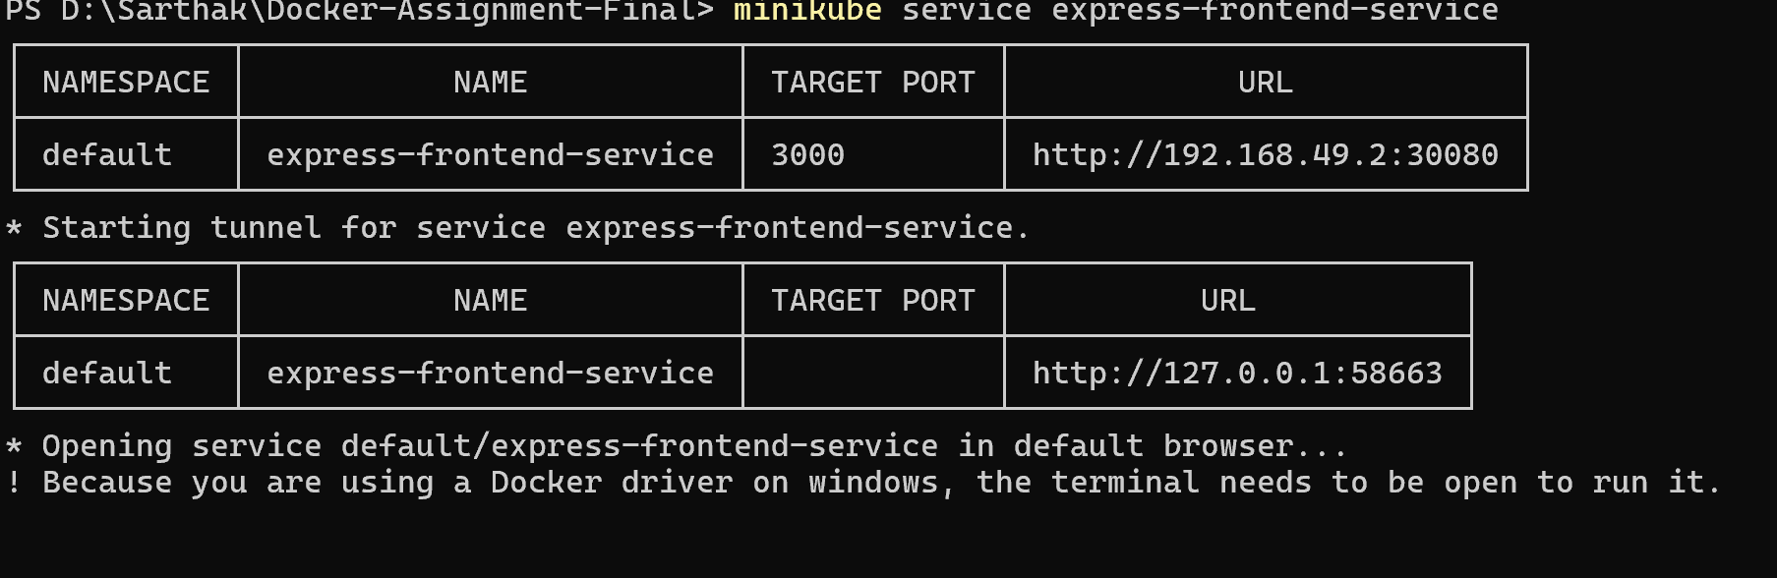

Express Frontend Running
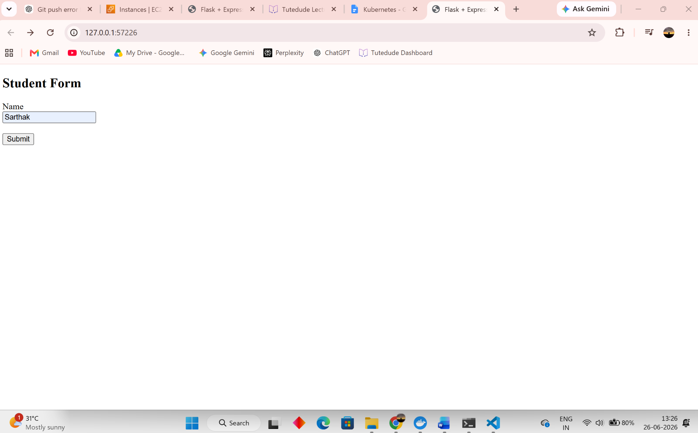

Flask Backend Running
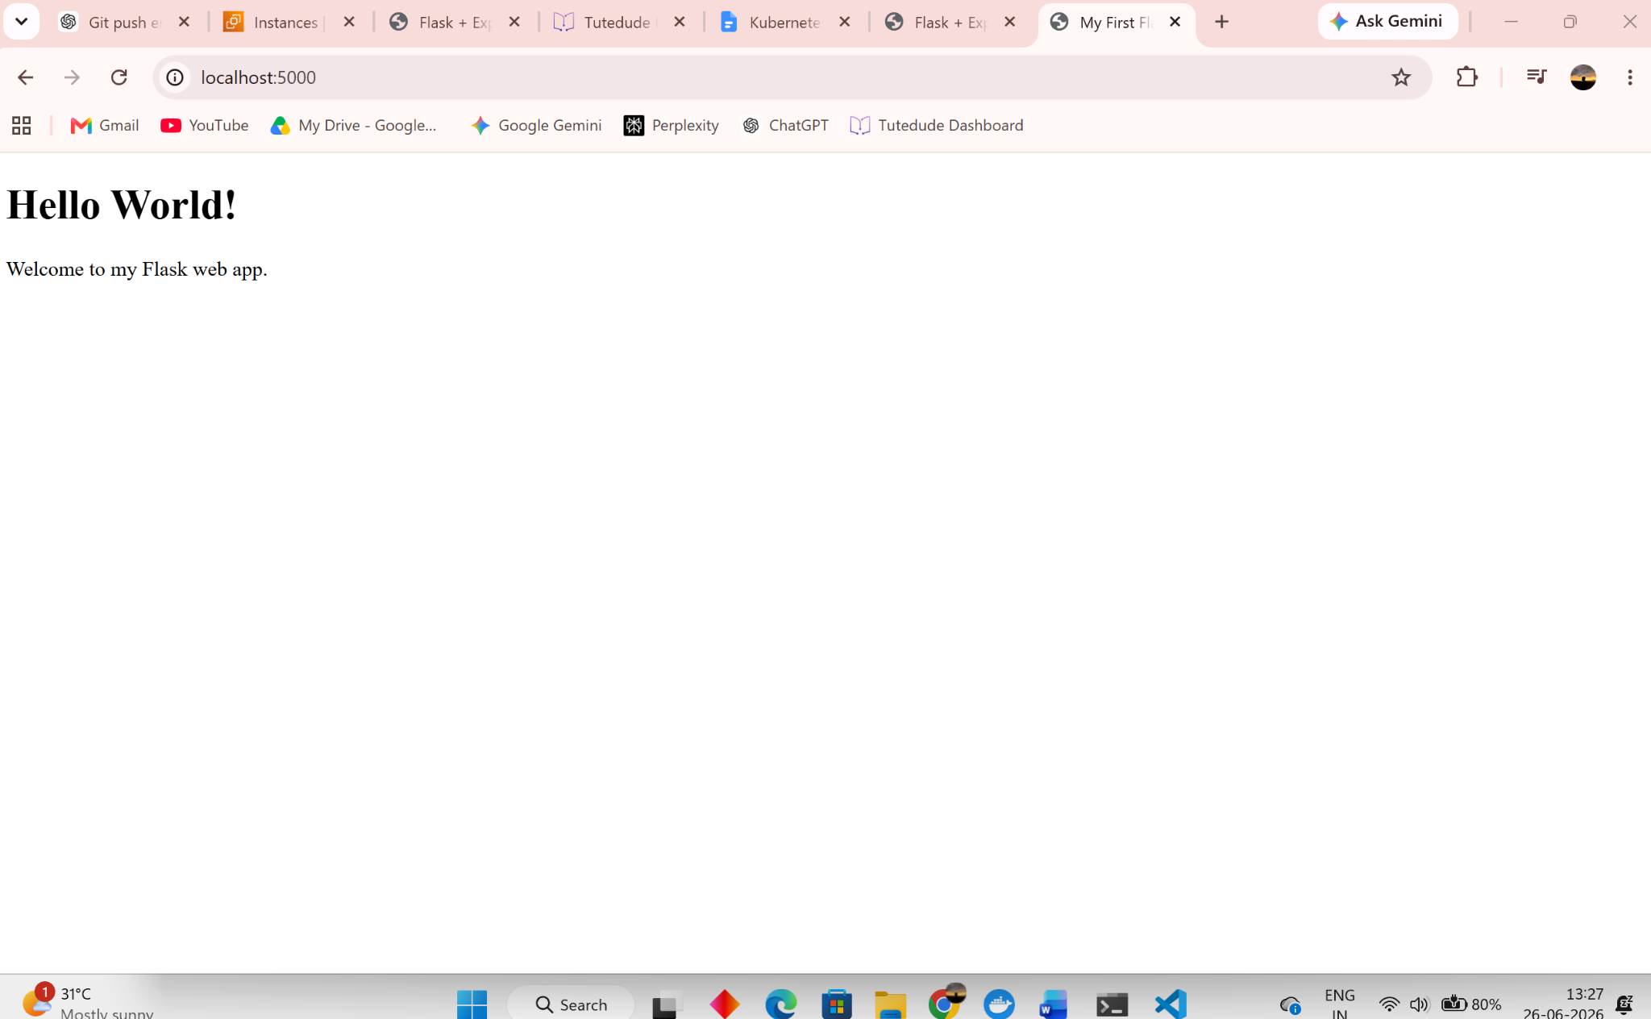

GitHub Repository
https://github.com/Sarthak-Thete/Docker_Assignment

