Docker Assignment Submission
Student: Sarthak Thete
Docker Hub Username: sarthakrthete

Project Summary
Developed an Express.js frontend connected to a Flask backend. Both services were containerized using Docker and orchestrated with Docker Compose.

Screenshots
1. Docker Compose Build
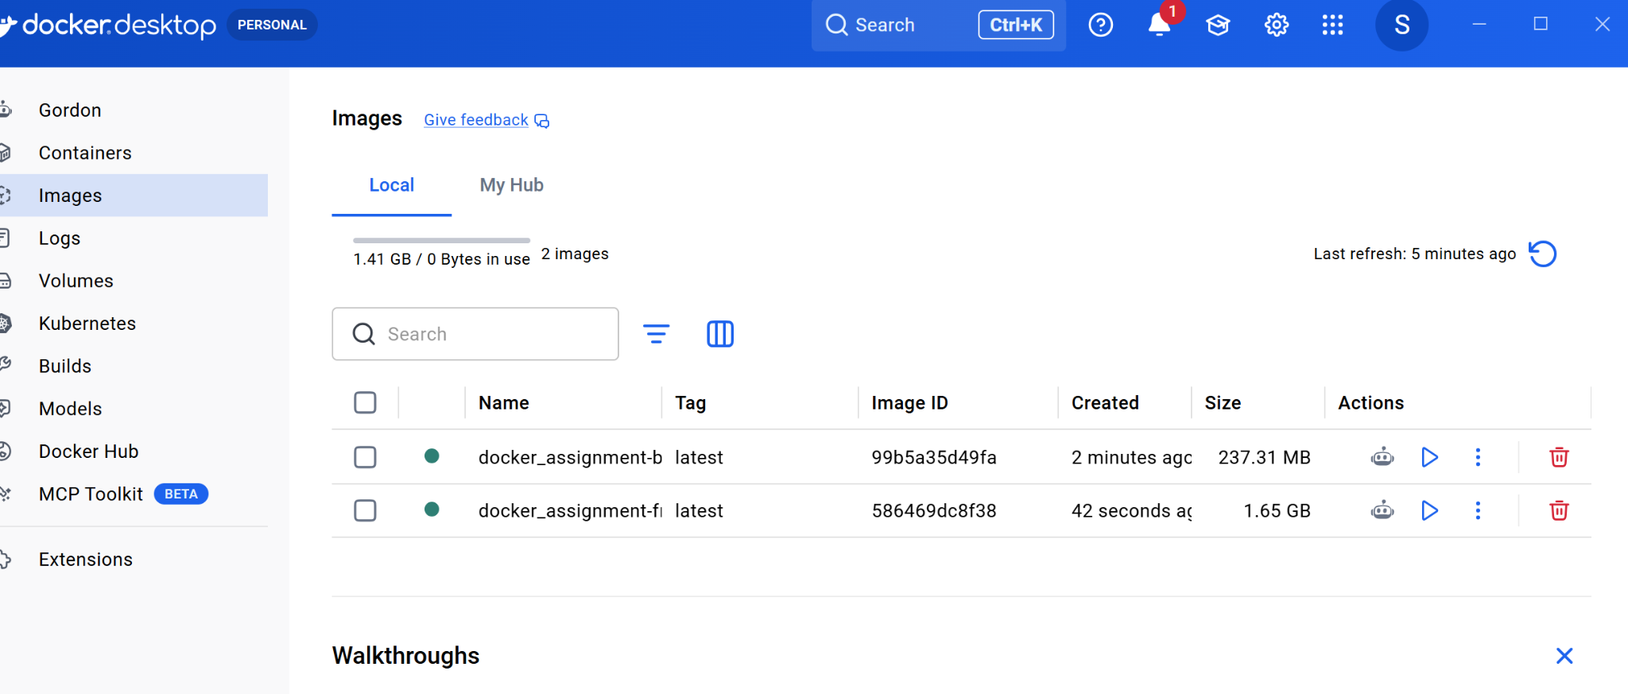
2. Docker Images & Backend Push
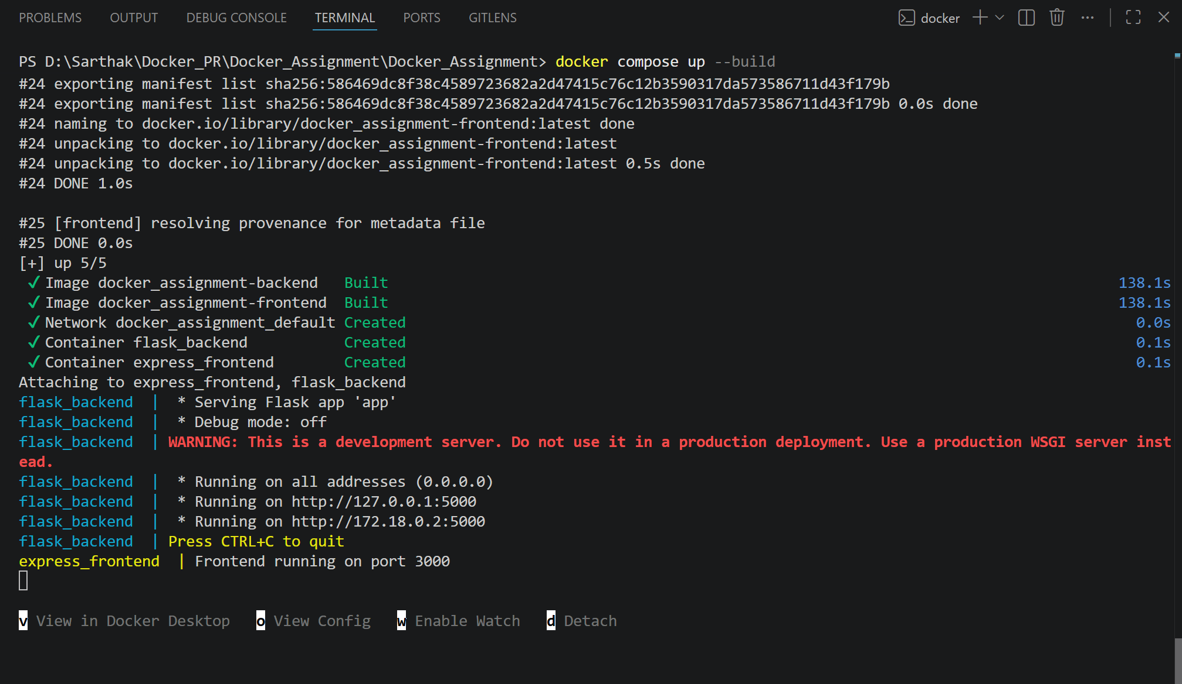
3. Frontend Push Successful
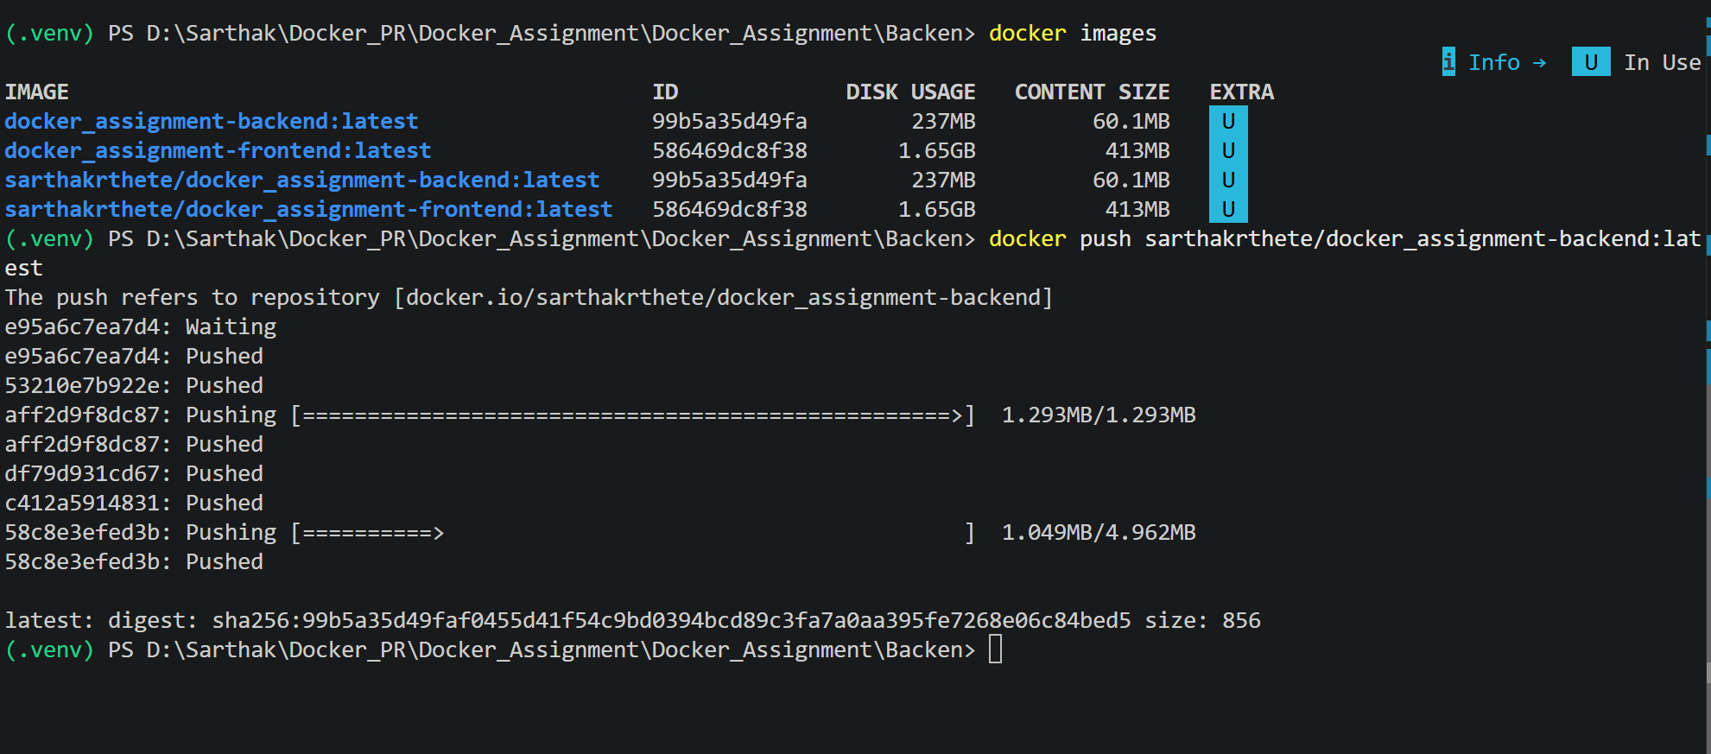
4. Docker Desktop Images
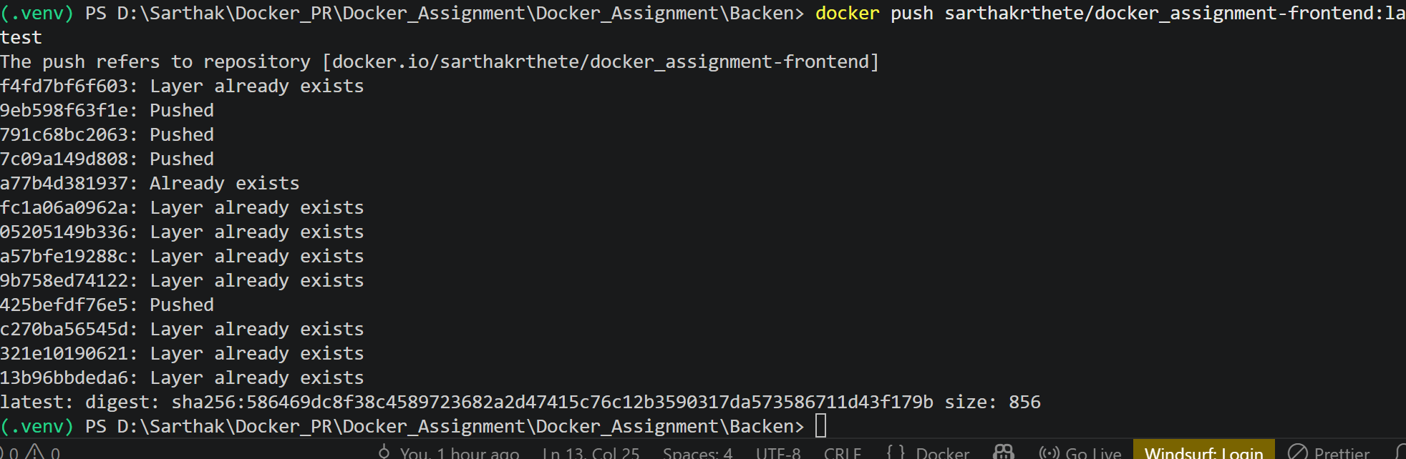

Submission Links
GitHub Repository: __________________________
Docker Hub Backend: https://hub.docker.com/r/sarthakrthete/docker_assignment-backend
Docker Hub Frontend: https://hub.docker.com/r/sarthakrthete/docker_assignment-frontend

