**Animal Adoption Website**

Submitted in partial fulfillment of the requirements

of the degree

**BACHELOR OF ENGINEERING IN**

**INFORMATION TECHNOLOGY**

By

**KARTIK PATIL- 221052002**

**SARTHAK TAMBDE- 221052004**

**SHUBHAM MODI- 221052009**

**PRANAV DUBEY- 221052010**

Guide

**Prof. Shaila Pawar**

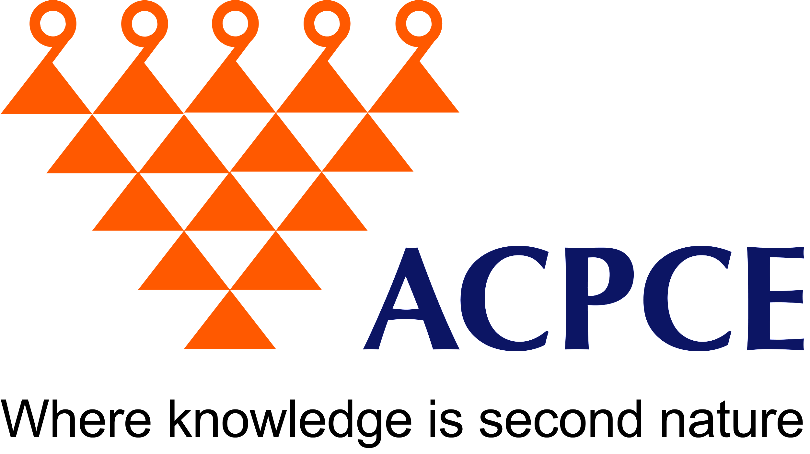

Department of Information Technology

A. C. Patil College of Engineering, Kharghar, Navi Mumbai University of Mumbai

2022-2023

Jawahar Education Society’s

A. C. Patil College of Engineering, Kharghar

CERTIFICATE

This is to certify that the Project entitled

“Animal Adoption Website”

is a bonafide work of

**KARTIK PATIL, SARTHAK TAMBDE, SHUBHAM MODI, PRANAV DUBEY**

submitted to the University of Mumbai in partial fulfillment of the requirement for the award of the degree of Bachelor of Engineering in Information Technology.

**Prof. Shaila Pawar Prof. Dr Varsha Bhole**

Guide Head of Department

**Dr. V. N. Pawar**

Principal

**Mini Project Approval**

This Mini Project entitled “Animal Adoption Website” by **Pranav Dubey (13), Shubham Modi (35), Kartik Patil (43), Sarthak Tambde (65),** for the course Mini Project – 2 A for Web Based Business Model (Sem V)is approved for the degree of **Bachelor of Engineering** in **Information Technology.**

**Examiners:**

**1 ………………………………………**

(Internal Examiner Name & Sign)

**2 …………………………………………**

(External Examiner name & Sign)

Date:

Place:

Abstract:

Our animal adoption website is a digital platform dedicated to connecting loving homes with homeless animals, fostering a sense of compassion and responsibility towards the welfare of our furry friends. This website serves as a comprehensive resource for potential adopters, providing a user-friendly interface and extensive profiles of animals in need. Through intuitive search options, users can browse and filter animals based on their preferences, making it easy to find the perfect pet that fits their lifestyle.

Key features of our website include:

* Detailed Animal Profiles: Each animal available for adoption has a dedicated profile with information on their breed, age, temperament, and special needs. High-quality photos and videos showcase their unique personalities, helping potential adopters make informed decisions.
* Adoption Resources: We offer a wealth of educational resources, including articles on responsible pet ownership, adoption procedures, and pet care tips to guide users on their journey to becoming pet parents.
* User-Generated Content: Our website encourages community engagement by allowing users to share their adoption stories, experiences, and photos. This not only fosters a sense of belonging but also promotes the adoption of animals in need.
* Seamless Adoption Process: We streamline the adoption process, allowing users to submit applications, schedule meet-and-greets, and complete all necessary paperwork online. This convenience minimizes barriers and makes adopting a pet easier than ever.
* Donations and Support: Our website also accepts donations to support the care and rehabilitation of homeless animals. Users can contribute to the cause and make a real difference in the lives of these animals.

By leveraging technology and the power of community, our animal adoption website aims to make a significant impact on the lives of animals in need and the people seeking companionship. We are dedicated to creating a world where every pet finds a loving forever home, one adoption at a time.

Top of Form

**List of Abbreviations:**

|  |  |  |
| --- | --- | --- |
| **SR NO** | **ABBREVIATIONS** | **FULL FORMS** |
|  | **AAW** | **ANIMAL ADOPTION WEBSITE** |
| **2.** | **HAP** | **HOMELESS ANIMAL PORTAL** |
| **3.** | **RAM** | **RANDOM ACCESS MEMORY** |
| **4.** | **GUI** | **GRAPHICAL USER INTERFACE** |

**List of Figures:**

|  |  |  |
| --- | --- | --- |
| **SR NO** | **FIGURE NO.** | **FIGURE NAME** |
|  | **1.1** | **Flowchart of Animal Adoption Website** |

**List of Tables:**

|  |  |  |
| --- | --- | --- |
| **SR NO** | **TABLE NO.** | **TABLE NAME** |
|  | **2.1** | **LITERATURE SURVEY** |

**List of Symbols:**

|  |  |  |
| --- | --- | --- |
| **SR NO** | **SYMBOLS** | **SYMBOLS MEANING** |
| **1.** | **-!** | **Negating a Condition** |
| **2.** | **+-** | **String Concatenation Addition/Subtraction** |
| **3.** | **==** | **Equal to Operator** |
| **4.** | **>=** | **Greater than or equal to** |

**Contents**

**Abstract**

**1. Introduction………………………………….............................. 6**

1.1 Introduction

1.2 Motivation

1.3 Problem Statement & Objectives

**2. Literature Survey……………………………………………….. 7**

2.1 Survey of Existing System

2.2 Mini Project Contribution

**3. Proposed System………………………………………...………. 9**

3.1 Introduction

3.2 Flow chart

3.3 Details of Hardware & Software

**4. Results and Discussion………………………….……………... 13**

Conclusion

References

**Chapter 1**

**Introduction**

**1.1 Introduction:**

At Cuddle Critter, we believe that every animal deserves a loving and caring forever home. Our platform connects compassionate individuals like you with adorable pets seeking their forever families. Whether you're looking for a loyal canine companion, a cuddly feline friend, or perhaps a small critter to brighten your life, we have a diverse selection of animals waiting to capture your heart. Why choose adoption? By adopting from our platform, you're not only giving a deserving animal a second chance at happiness but also promoting responsible pet ownership. All our animals have been given the best possible care, and we work closely with reputable shelters and rescue organizations to ensure that each adoption is a perfect match for both pet and owner. Our user-friendly interface allows you to search for your ideal pet based on various preferences, including species, age, size, and temperament. You can read heartwarming stories of rescued animals, browse their adorable photos, and even get to know their personalities through detailed profiles. In a world where countless animals are seeking love, care, and a place to call home, our mission is clear: to connect these four-legged souls with kind-hearted individuals and families who are ready to embrace the joy and responsibility of pet ownership. We understand that the decision to adopt a pet is a life-changing commitment, and we're here to guide you every step of the way.

**1.2 Motivation:**

An adoption website offers these animals a chance to find a forever home where they can be safe, happy, and loved. Animal Welfare: The primary motivation is to provide a loving and caring home for animals in need. There are countless animals in shelters and rescues that have been abandoned, mistreated, or are simply without a home.

Emphasis on Adopt, Not Shop: By promoting animal adoption, the website can help combat the unethical practices of puppy mills and other breeding facilities.

**1.3 Problem Statement & Objectives:**

* Lack of Awareness: There is a significant lack of awareness about the availability of animals for adoption, resulting in many potential pet owners turning to pet stores or breeders instead.
* Animal Overpopulation: Many animals, including dogs, cats, and small animals, are abandoned or surrendered to shelters due to overpopulation, straining the resources of animal rescue organizations.
* Difficulty in Finding Information: Potential adopters often struggle to find comprehensive and up-to-date information about available animals, the adoption process, and the benefits of adopting from shelters.

**Chapter 2**

**2.1 Literature Survey**

|  |  |  |
| --- | --- | --- |
| **TITLE** | **SCOPE** | **ADVANTAGES** |
| 1. Academic Journals | Google Scholar is a great resource for finding academic papers. You can use specific keywords like "animal adoption literature review" or "papers on animal adoption trends" to find relevant surveys. | **Saves Lives**: Adopting from a shelter or rescue organization saves the life of an animal that might otherwise be euthanized due to overcrowding. |
| 1. Research Gate | Research Gate is a platform that allows researchers to share and access papers. You can search for specific topics or authors related to animal adoption surveys. | **Provides a Loving Home**: It gives an animal a chance to live in a caring and nurturing environment, where they can thrive and be loved. |
| 1. PubMed | While PubMed primarily focuses on medical research, it also includes veterinary and animal welfare studies. Use keywords like "animal adoption trends" or "companion animal adoption" to find relevant literature. | **Possible Behavioral Problems**: Animals that have been through shelters or rescue situations may have experienced trauma or neglect, which could lead to behavioral challenges |

* 1. **Mini Project Contribution:**
* **Objective:** The objective of this mini project contribution is to enhance user engagement and create a sense of community on the animal adoption website by implementing a "User-Generated Stories" section. This section will allow website users to share their adoption experiences, stories, and photos of their adopted pets.
* **Description:** The "User-Generated Stories" section will be a dedicated space on the website where registered users can submit their adoption stories and related content. Here's how I plan to contribute to this project:
* **Design and Interface:** I will create a user-friendly interface for users to submit their stories, including text, images, and any additional media. The design will be in line with the website's existing layout and branding.
* **User Profiles:** Users who submit stories will have the option to create profiles with their own pet profiles, allowing them to connect with other pet owners on the website.
* **Moderation and Approval:** To maintain the quality of content, I will implement a moderation system to review and approve user-generated stories before they are published on the website. This will ensure that all content adheres to community guidelines and standards.
* **Interactive Features:** I will include interactive features such as likes, comments, and sharing options for each user-generated story to encourage engagement and interaction among users.
* **Search and Filter Functionality:** To help users easily find stories related to specific animal types, breeds, or adoption locations, I will implement search and filter options.
* **Privacy and Data Protection:** Ensure that user data is protected and that users have control over the visibility of their stories and profiles.
* **Benefits:** By implementing the "User-Generated Stories" section, the animal adoption website will experience several benefits, including:
* Increased user engagement and community building.
* Heart-warming and inspiring stories that encourage adoption.
* A sense of belonging and connection among pet owners.
* A growing library of valuable content that can be shared on social media and attract more users to the website.
* A positive impact on website traffic, user retention, and, ultimately, increased adoptions.

**Chapter 3**

**Proposed System**

**3.1 Introduction**

At Cuddle Critter, we believe that every animal deserves a loving and caring forever home. Our platform connects compassionate individuals like you with adorable pets seeking their forever families. Whether you're looking for a loyal canine companion, a cuddly feline friend, or perhaps a small critter to brighten your life, we have a diverse selection of animals waiting to capture your heart. Why choose adoption? By adopting from our platform, you're not only giving a deserving animal a second chance at happiness but also promoting responsible pet ownership. All our animals have been given the best possible care, and we work closely with reputable shelters and rescue organizations to ensure that each adoption is a perfect match for both pet and owner. Our user-friendly interface allows you to search for your ideal pet based on various preferences, including species, age, size, and temperament. You can read heartwarming stories of rescued animals, browse their adorable photos, and even get to know their personalities through detailed profiles. In a world where countless animals are seeking love, care, and a place to call home, our mission is clear: to connect these four-legged souls with kind-hearted individuals and families who are ready to embrace the joy and responsibility of pet ownership. We understand that the decision to adopt a pet is a life-changing commitment, and we're here to guide you every step of the way.

**3.2 Architecture/ Framework:**

**Fig 1.1 Flowchart of Animal Adoption Website**

**3.3 Details of Hardware & Software:**

**HARDWARE REQUIREMENTS:**

* Laptop needs at least 8GB RAM.
* Laptop with good storage capacity.
* High speed internet access.

**SOFTWARE REQUIREMENTS:**

* VISUAL STUDIO
* HTML, JAVASCRIPT, PHP, CSS
* SQL DATABASE

**Chapter 4**

**Result and Discussion**

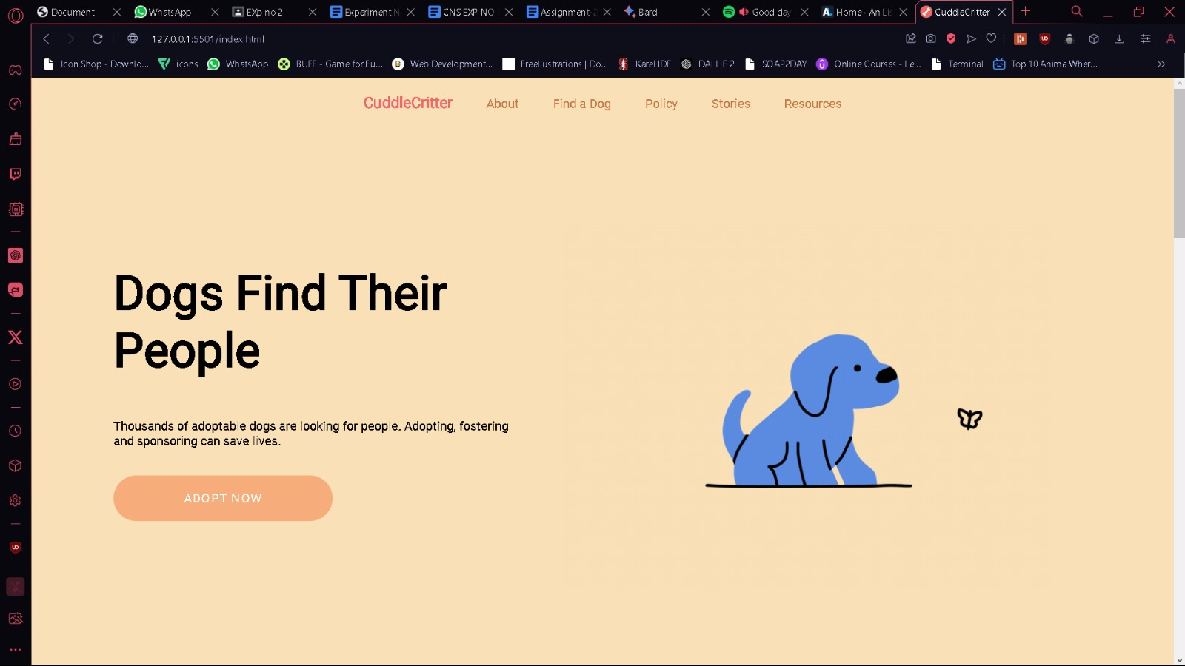

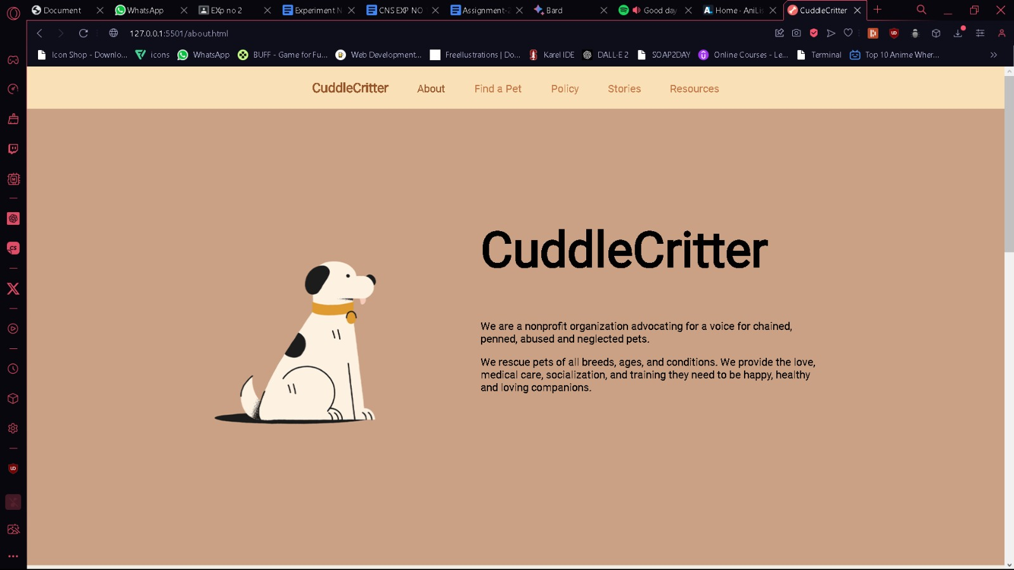

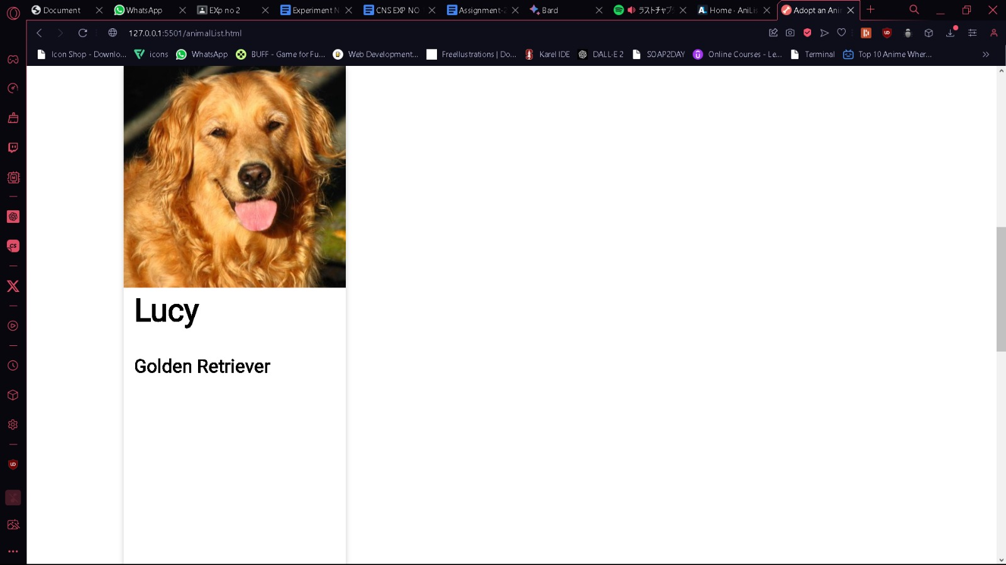

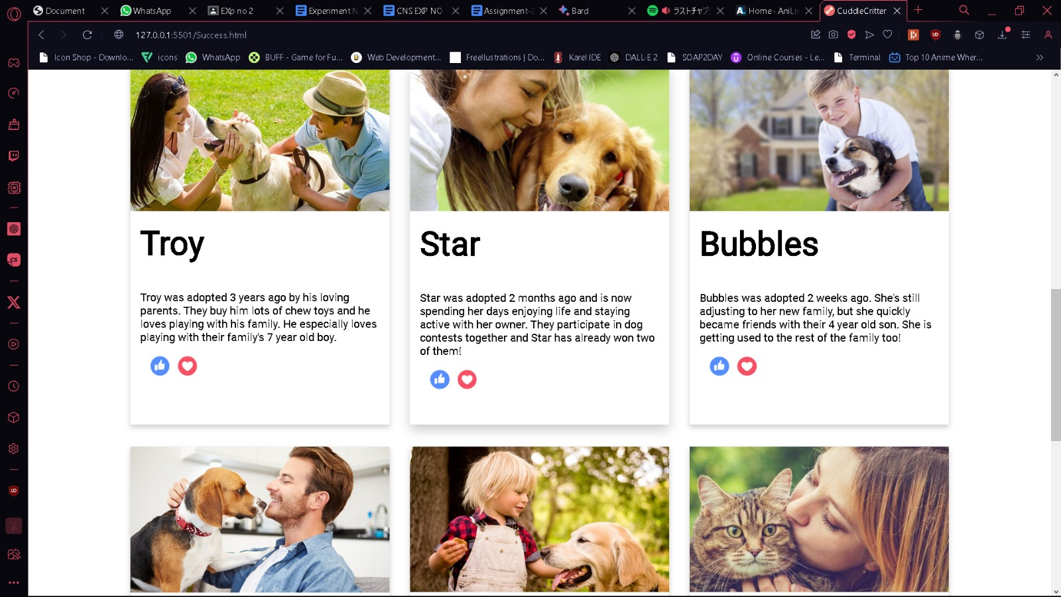

**Animal Adoption**

Welcome to our animal adoption website, where compassion and companionship come together. Our mission is to connect loving homes with deserving animals in need. Whether you're looking for a loyal canine friend, a playful feline companion, or any other wonderful creature to share your life with, you've come to the right place. Explore our diverse selection of adoptable animals, and let the journey to your new family member begin here. Join us in making a difference, one paw at a time!"

**Conclusion:**

In conclusion, our animal adoption website is not just a digital platform; it's a testament to the unwavering commitment to the well-being of animals and the celebration of the human-animal bond. It represents the collective efforts of a compassionate community dedicated to making the world a better place, one adoption at a time. As we come to the end of this journey through our website, we want to emphasize that it's not merely a tool for finding pets or for facilitating adoptions. It's a portal into a world where love, empathy, and responsibility come together to create heart-warming stories of transformation.

Our website serves as a bridge, connecting homeless animals with loving, caring individuals and families who are ready to open their hearts and homes. It's a place where animals find second chances and humans discover the profound joy that comes from giving a pet a forever home.

**References:**

[1] A research on Animal adoption by Research Gate.

[2] <https://www.researchgate.net/publication/312057960_Stray_Animal_Mobile_Website>

[3] Agile Development Process Model[Online].

[4] [https://www.cprime.com/resources/what-is-agile- what-is-scrum](https://www.cprime.com/resources/what-is-agile-%20what-is-scrum)

[5] Prevention of cruelty to animals Act 1960. [Online].

[6] https://en.wikipedia.org/wiki/Prevention_of_Cruelty_to_Animals_Act.

# Acknowledgments

We thank our college, our Principal Dr. V. N. Pawar sir for providing the required resources for the development of the project. We would also like to thank HOD Prof. Dr. Varsha Bhole ma’am for suggesting such a great project topic for our departmental purpose. My sincere thanks to my Project Guide (Prof. Shaila Pawar) for helping, suggesting new ideas and guiding us throughout the semester. We are also grateful to all the faculty members for their support and encouragement.

##### Date: