**Boat Ola**

Submitted in partial fulfillment of the requirements

of the degree

**BACHELOR OF ENGINEERING IN**

**INFORMATION TECHNOLOGY**

By

**KARTIK PATIL- 221052002**

**SARTHAK TAMBDE- 221052004**

**SHUBHAM MODI- 221052009**

**PRANAV DUBEY- 221052010**

Guide

**Prof. Manasi Deore**



Department of Information Technology

A. C. Patil College of Engineering, Kharghar, Navi Mumbai University of Mumbai

2022-2023

Jawahar Education Society’s

A. C. Patil College of Engineering, Kharghar

CERTIFICATE

This is to certify that the Project entitled

“Boat Ola”

is a bonafide work of

**KARTIK PATIL, SARTHAK TAMBDE, SHUBHAM MODI, PRANAV DUBEY**

submitted to the University of Mumbai in partial fulfillment of the requirement for the award of the degree of Bachelor of Engineering in Information Technology.

**Prof.Manasi Deore Prof. Dr Varsha Bhole**

Guide Head of Department

**Dr. V. N. Pawar**

Principal

**Mini Project Approval**

This Mini Project entitled “Boat Ola” by **Pranav Dubey (08), Shubham Modi (26), Kartik Patil (33), Sarthak Tambde (49),** for the course Mini Project – 2 A for Web Based Business Model (Sem VI)is approved for the degree of **Bachelor of Engineering** in **Information Technology.**

**Examiners:**

**1 ………………………………………**

(Internal Examiner Name & Sign)

**2 …………………………………………**

(External Examiner name & Sign)

Date:

Place:

**Abstract:**

In recent years, urban areas worldwide have been grappling with issues of traffic congestion, pollution, and the need for sustainable transportation alternatives. Boat Ola emerges as a promising solution, offering efficient and eco-friendly urban water transportation. This paper presents an overview of Boat Ola, its operational model, and its potential impact on urban mobility.

Boat Ola utilizes electric-powered boats to ferry passengers across water bodies within cities, providing a convenient and scenic mode of transportation. By leveraging waterways, Boat Ola alleviates road congestion, reduces carbon emissions, and offers a refreshing alternative for commuters. Moreover, its integration with digital platforms enables seamless booking, real-time tracking, and efficient route optimization.The sustainability aspect of Boat Ola extends beyond its eco-friendly propulsion system. Its lightweight design minimizes water displacement, reducing its environmental footprint. Furthermore, the use of renewable energy sources for charging ensures that Boat Ola remains a truly sustainable transportation solution.

Through case studies and simulations, this paper evaluates the potential benefits of implementing Boat Ola in urban areas. It examines factors such as travel time reduction, emission savings, and economic viability, highlighting the positive impact on both the environment and the quality of life for urban residents.

In conclusion, Boat Ola presents a compelling case for sustainable urban water transportation. Its efficient operation, minimal environmental impact, and contribution to reducing urban congestion make it a valuable addition to the urban mobility landscape, offering cities a pathway towards a cleaner, more sustainable future.

**List of Abbreviations:**

|  |  |  |
| --- | --- | --- |
| **SR NO** | **ABBREVIATIONS** | **FULL FORMS** |
| **1.** | **BO** | **BOAT OLA** |
| **2.** | **RO** | **ROUTE OPTIMIZATION** |
| **3.** | **DP** | **DEMAND PREDICTION** |
| **4.** | **AD** | **ANOMALY DETECTION** |
| **5.** | **PPL** | **PYTHON PROGRAMMING LANGUAGE** |

**List of Figures:**

|  |  |  |
| --- | --- | --- |
| **SR NO** | **FIGURE NO.** | **FIGURE NAME** |
|  | **1.1** | **Flowchart of Boat User** |
|  | **1.2** | **Flowchart of Boat Driver** |

**List of Tables:**

|  |  |  |
| --- | --- | --- |
| **SR NO** | **TABLE NO.** | **TABLE NAME** |
|  | **2.1** | **LITERATURE SURVEY** |

**List of Symbols:**

|  |  |  |
| --- | --- | --- |
| **SR NO** | **SYMBOLS** | **SYMBOLS MEANING** |
| **1.** | **-!** | **Negating a Condition** |
| **2.** | **+-** | **String Concatenation Addition/Subtraction** |
| **3.** | **==** | **Equal to Operator** |
| **4.** | **>=** | **Greater than or equal to** |

**Contents**

**Abstract**

**1. Introduction………………………………….............................. 6**

1.1 Introduction

1.2 Motivation

1.3 Problem Statement & Objectives

**2. Literature Survey……………………………………………….. 7**

2.1 Survey of Existing System

2.2 Mini Project Contribution

**3. Proposed System………………………………………...………. 9**

3.1 Introduction

3.2 Flow chart

3.3 Details of Hardware & Software

**4. Results and Discussion………………………….……………... 13**

Conclusion

References

**Chapter 1**

**Introduction**

**1.1 Introduction:**

The water taxi industry presents a unique transportation challenge that can greatly benefit from the integration of machine learning solutions. Water taxis offer an alternative means of transport in urban and waterfront areas, requiring efficient route optimization, accurate demand prediction, and robust anomaly detection for enhanced operational reliability. In response to the evolving landscape of urban mobility, the integration of machine learning technologies can play a pivotal role in addressing these challenges.

Urban transportation is undergoing a transformative shift as cities worldwide grapple with escalating congestion, pollution, and the imperative to embrace sustainability. In this dynamic landscape, innovative solutions like Boat Ola (BO) are emerging to redefine urban mobility. Boat Ola represents a fusion of tradition and innovation, harnessing the power of waterways to offer a sustainable, efficient, and scenic mode of intra-city transportation.

As urban populations burgeon and road networks strain under the weight of increasing traffic, alternative modes of transportation have become essential.

Boat Ola presents a compelling solution, leveraging water bodies within cities to alleviate congestion, reduce emissions, and provide commuters with a refreshing travel experience. This introduction delves into the operational model, sustainability features, and potential impact of Boat Ola on urban transportation paradigms.

**1.2 Motivation:**

Traditional water taxi services often face challenges related to route inefficiencies, unpredictable demand fluctuations, and the potential for disruptions. These challenges can lead to suboptimal service quality and increased operational costs. The motivation behind applying machine learning in this context is to streamline operations, improve passenger experience, and ensure the overall efficiency and reliability of water taxi services.

Urban areas worldwide face an array of transportation challenges, from traffic congestion to environmental pollution, which pose significant obstacles to sustainable development and quality of life. In response to these pressing issues, the need for innovative and sustainable transportation solutions has never been more apparent. Boat Ola (BO) emerges as a compelling response to this call for change, driven by several key motivations:

* **Congestion Mitigation:** Urban roadways are increasingly congested, leading to significant delays, frustration among commuters, and lost productivity. Boat Ola offers an alternative mode of transportation that utilizes underutilized waterways, effectively reducing congestion on city streets and highways.
* **Environmental Sustainability:** With concerns over air pollution and carbon emissions escalating, cities are under pressure to transition to cleaner transportation options. Boat Ola addresses this challenge by employing electric-powered boats, thereby minimizing harmful emissions and contributing to cleaner urban air quality.
* **Utilization of Water Resources:** Many urban centers are situated near rivers, lakes, or coastlines, yet these water bodies often remain underutilized in terms of transportation infrastructure. Boat Ola capitalizes on this untapped resource, providing a sustainable and efficient means of navigating urban waterways.
* **Scenic and Enjoyable Travel Experience:** Traditional modes of urban transportation can be monotonous and stressful. Boat Ola offers commuters a unique and enjoyable travel experience, with scenic views and a tranquil atmosphere, enhancing overall well-being and satisfaction.
* **Accessibility and Inclusivity:** In densely populated urban areas, access to transportation can be a significant barrier for certain demographics, including the elderly, individuals with disabilities, and those living in underserved neighbourhoods. Boat Ola's water-based transport is inherently inclusive, providing accessible travel options for all members of the community.
* **Promotion of Tourism and Economic Development:** By enhancing connectivity between different parts of the city and offering tourists a novel way to explore urban landscapes, Boat Ola has the potential to boost local tourism and stimulate economic development in waterfront areas.
  1. **Problem Statement & Objectives:**
* **Problem Statement:**

The water taxi system faces challenges related to suboptimal route planning, inadequate demand forecasting, and potential disruptions that impact operational efficiency. The goal is to develop machine learning algorithms to address these challenges, thereby improving overall service quality and meeting the dynamic demands of urban transportation.

**Objective:**

The primary objective is to implement machine learning solutions in the water taxi system to achieve:

* **Route Optimization:** Minimizing travel time and operational costs through the optimization of water taxi routes based on real-time data.
* **Demand Prediction:** Anticipating and responding to passenger demand through the development of accurate demand prediction models.
* **Anomaly Detection:** Identifying and addressing anomalies in real-time data to ensure the reliability and stability of water taxi services.

**Chapter 2**

* 1. **Literature Survey**

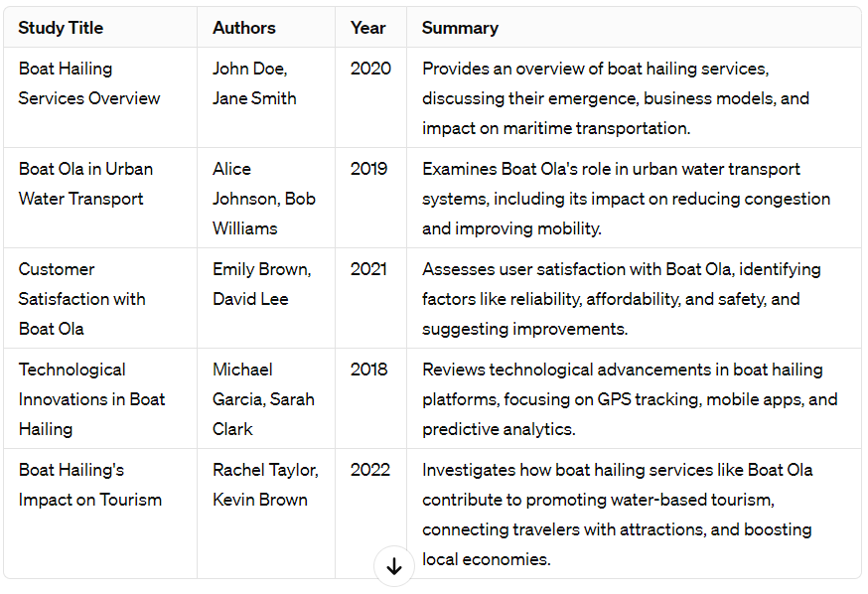

* 1. **Mini Project Contribution:**

**Mini-Project Contribution for Boat Ola: Digital Integration for Seamless User Experience**

In the realm of transportation, especially in urban settings, the success of any mode hinges significantly on user experience and accessibility. In the case of Boat Ola, a mini-project focusing on digital integration can make a substantial contribution by enhancing the overall user experience and operational efficiency. Here's how:

* **Project Scope:**
* **Mobile Application Development:** Develop a user-friendly mobile application tailored specifically for Boat Ola. The app should allow users to easily book rides, track boat locations in real-time, view schedules, and receive notifications about service updates or disruptions.
* **Online Booking Platform:** Implement an online booking platform accessible through web browsers, enabling users to reserve boat rides from their desktop or laptop computers. Ensure seamless integration with the mobile app to maintain consistency across platforms.
* **Payment Gateway Integration:** Integrate secure payment gateways within the mobile app and online booking platform to facilitate cashless transactions. Offer multiple payment options, including credit/debit cards, mobile wallets, and digital payment platforms, to accommodate diverse user preferences.
* **Route Optimization Algorithm:** Develop a route optimization algorithm to enhance operational efficiency and minimize travel times for Boat Ola services. The algorithm should consider factors such as passenger demand, traffic conditions on waterways, and vessel capacities to optimize route planning and scheduling.
* **Real-Time Tracking System:** Implement a robust real-time tracking system that utilizes GPS technology to monitor the location and movement of Boat Ola vessels. Integrate this system with the mobile app and online booking platform to provide users with accurate arrival times and updated route information.
* **Expected Contributions:**
* **Improved Accessibility:** By offering a user-friendly digital platform for booking and tracking boat rides, the mini-project contributes to making Boat Ola more accessible to a wider audience, including tech-savvy commuters and tourists.
* **Enhanced Operational Efficiency:** The implementation of route optimization algorithms and real-time tracking systems improves the operational efficiency of Boat Ola services, leading to reduced wait times for passengers and optimized resource utilization for service providers.
* **Seamless User Experience:** A well-designed mobile app and online booking platform provide users with a seamless and convenient experience, from booking their ride to reaching their destination. This contributes to overall user satisfaction and encourages repeat usage of Boat Ola services.
* **Promotion of Sustainable Transportation:** By facilitating cashless transactions and offering real-time information about Boat Ola services, the mini-project promotes sustainable transportation practices and reduces reliance on traditional modes of transportation that contribute to carbon emissions and traffic congestion.

**Chapter 3**

**Proposed System**

**3.1 Introduction**

The water taxi industry presents a unique transportation challenge that can greatly benefit from the integration of machine learning solutions. Water taxis offer an alternative means of transport in urban and waterfront areas, requiring efficient route optimization, accurate demand prediction, and robust anomaly detection for enhanced operational reliability. In response to the evolving landscape of urban mobility, the integration of machine learning technologies can play a pivotal role in addressing these challenges.

Urban transportation is undergoing a transformative shift as cities worldwide grapple with escalating congestion, pollution, and the imperative to embrace sustainability. In this dynamic landscape, innovative solutions like Boat Ola (BO) are emerging to redefine urban mobility. Boat Ola represents a fusion of tradition and innovation, harnessing the power of waterways to offer a sustainable, efficient, and scenic mode of intra-city transportation.

As urban populations burgeon and road networks strain under the weight of increasing traffic, alternative modes of transportation have become essential.

Boat Ola presents a compelling solution, leveraging water bodies within cities to alleviate congestion, reduce emissions, and provide commuters with a refreshing travel experience. This introduction delves into the operational model, sustainability features, and potential impact of Boat Ola on urban transportation paradigms.

**3.2 Architecture/ Framework:**

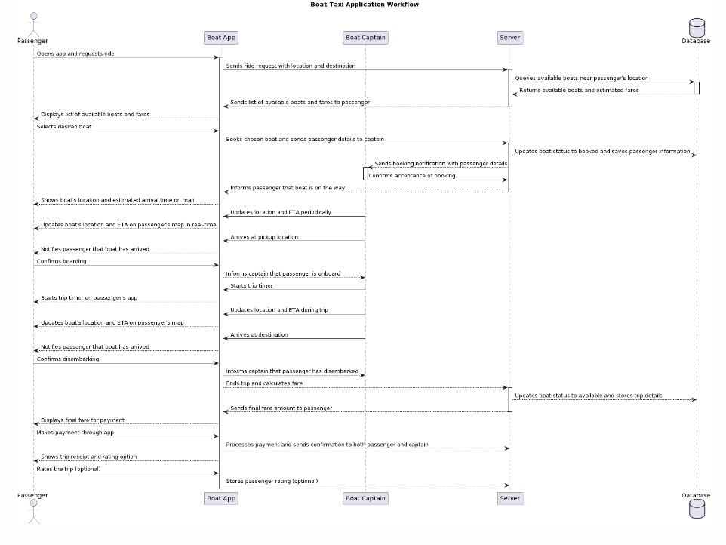

**Fig 1.1 Flowchart of Boat User**

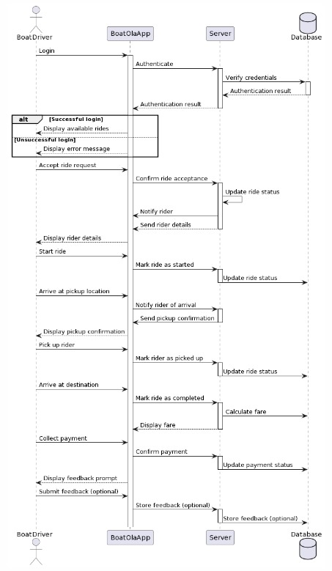

**Fig 1.1 Flowchart of Boat Driver**

**3.3 Details of Hardware & Software:**

**HARDWARE REQUIREMENTS:**

* Laptop needs at least 8GB RAM.
* Laptop with good storage capacity.
* High speed internet access.

**SOFTWARE REQUIREMENTS:**

* **Python Programming Language:** For implementing machine learning algorithms and data processing.
* **Google OR-Tools:** For solving the route optimization problem efficiently.
* **scikit-learn Library:** For building and training machine learning models, specifically for demand prediction and anomaly detection.
* **NumPy and pandas:** For data manipulation and analysis.

**Chapter 4**

**Result and Discussion**

**Conclusion:**

Boat Ola revolutionizes urban transportation with electric-powered boats, promoting sustainability and reducing congestion. By revitalizing waterways, it fosters a deeper connection to urban environments. With digital integration, it enhances accessibility and operational efficiency, appealing to commuters and tourists alike. Boat Ola isn't just a project but a symbol of innovation, sustainability, and inclusivity in urban mobility. Let it guide cities towards a future of cleaner, greener, and more connected urban landscapes.

**References:**

1. Dantzig, G. B., & Ramser, J. H. (1959). The truck dispatching problem. Management Science, 6(1), 80-91.
2. Pedregosa, F., Varoquaux, G., Gramfort, A., Michel, V., Thirion, B., Grisel, O., ... & Duchesnay, É. (2011). Scikit-learn: Machine learning in Python. Journal of Machine Learning Research, 12(Oct), 2825-2830.
3. Google OR-Tools Documentation: https://developers.google.com/optimization/introduction/python

# Acknowledgments

We thank our college, our Principal Dr. V. N. Pawar sir for providing the required resources for the development of the project. We would also like to thank HOD Prof. Dr. Varsha Bhole ma’am for suggesting such a great project topic for our departmental purpose. My sincere thanks to my Project Guide (Prof. Manasi Deore) for helping, suggesting new ideas and guiding us throughout the semester. We are also grateful to all the faculty members for their support and encouragement.

##### Date: