SUBMISSION SCREENSHOT:
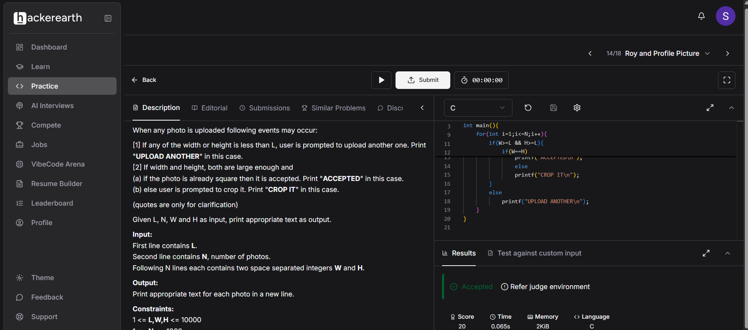
CODE:
#include <stdio.h>

int main(){
int N,L,W,H;
scanf("%d",&L);
scanf("%d",&N);

for(int i=1;i<=N;i++){
scanf("%d%d",&W,&H);
if(W>=L && H>=L){
if(W==H)
printf("ACCEPTED\n");
else
printf("CROP IT\n");
}
else
printf("UPLOAD ANOTHER\n");
}
}

LINK:
https://www.hackerearth.com/practice/basic-programming/input-output/basics-of-input-output/practice-problems/algorithm/roy-and-profile-picture/

