SUBMISSION SCREENSHOT:
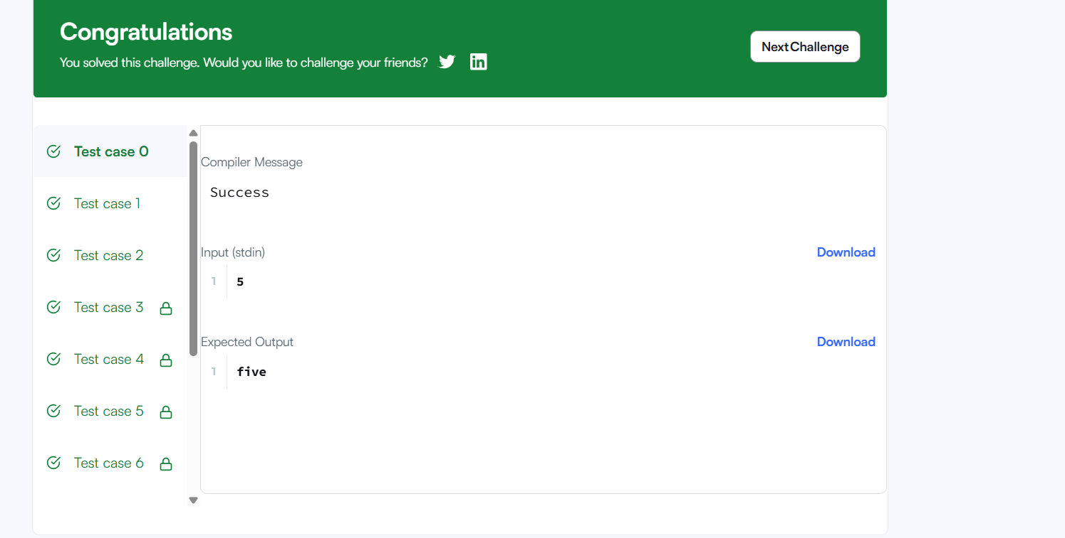
CODE:
if (n == 1) {
printf("one\n");
} else if (n == 2) {
printf("two\n");
} else if (n == 3) {
printf("three\n");
} else if (n == 4) {
printf("four\n");
} else if (n == 5) {
printf("five\n");
} else if (n == 6) {
printf("six\n");
} else if (n == 7) {
printf("seven\n");
} else if (n == 8) {
printf("eight\n");
} else if (n == 9) {
printf("nine\n");
} else {
printf("Greater than 9\n");
}
LINK:
https://www.hackerrank.com/challenges/conditional-statements-in-c/problem

