SUBMISSION SCREENSHOT:
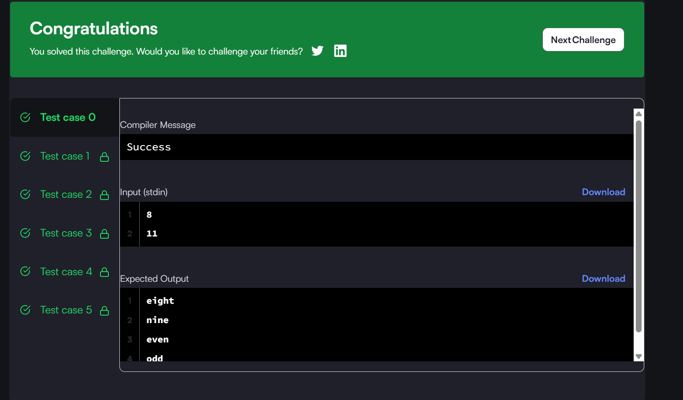
CODE:
#include <stdio.h>
int main()
{
int x, y;
scanf("%d\n%d", &x, &y);
for (int i = x; i <= y; i++) {
if (i == 1) printf("one\n");
else if (i == 2) printf("two\n");
else if (i == 3) printf("three\n");
else if (i == 4) printf("four\n");
else if (i == 5) printf("five\n");
else if (i == 6) printf("six\n");
else if (i == 7) printf("seven\n");
else if (i == 8) printf("eight\n");
else if (i == 9) printf("nine\n");
else if (i % 2 == 0) printf("even\n");
else printf("odd\n");
}

return 0;
}
LINK:
https://www.hackerrank.com/challenges/for-loop-in-c/problem

