SUBMISSION SCREENSHOT:
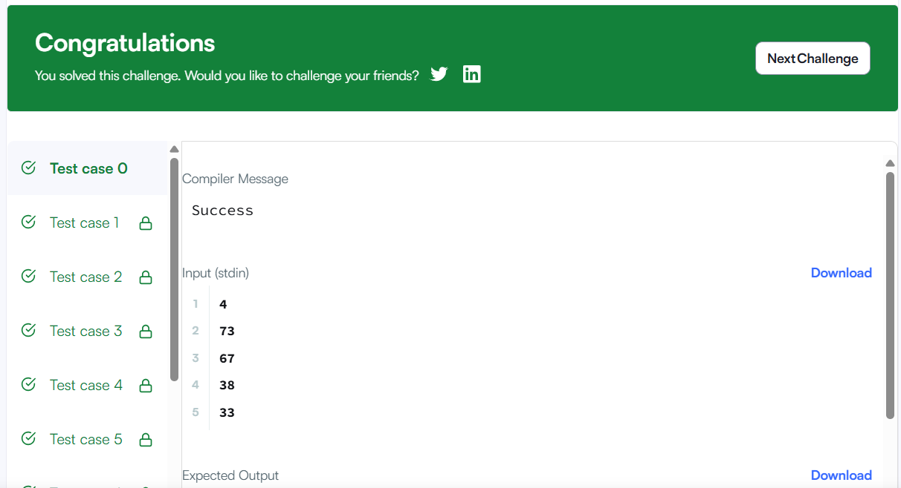
CODE:
*result_count = grades_count;
int *rounded_grades = malloc(grades_count * sizeof(int));

for (int i = 0; i < grades_count; i++) {
int current_grade = grades[i];

if (current_grade < 38) {
rounded_grades[i] = current_grade;
} else {
int next_multiple = ((current_grade / 5) + 1) * 5;
if (next_multiple - current_grade < 3) {
rounded_grades[i] = next_multiple;
} else {
rounded_grades[i] = current_grade;
}
}
}

return rounded_grades;
LINK:
https://www.hackerrank.com/challenges/grading/problem

