SUBMISSION SCREENSHOT:
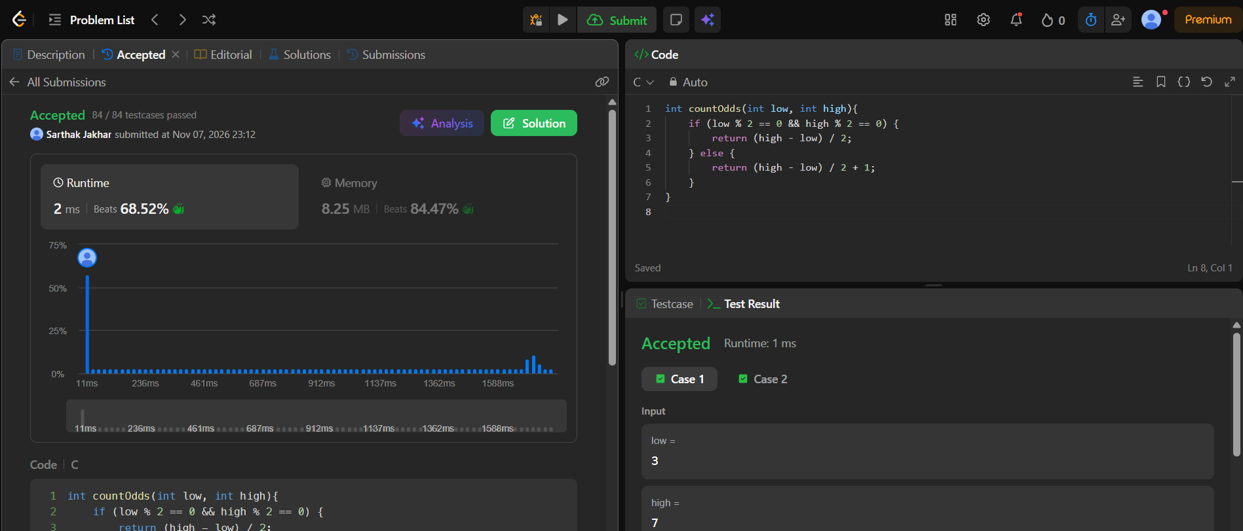
CODE:
int countOdds(int low, int high){
if (low % 2 == 0 && high % 2 == 0) {
return (high - low) / 2;
} else {
return (high - low) / 2 + 1;
}
}
LINK:
https://leetcode.com/problems/count-odd-numbers-in-an-interval-range/

