SUBMISSION SCREENSHOT:
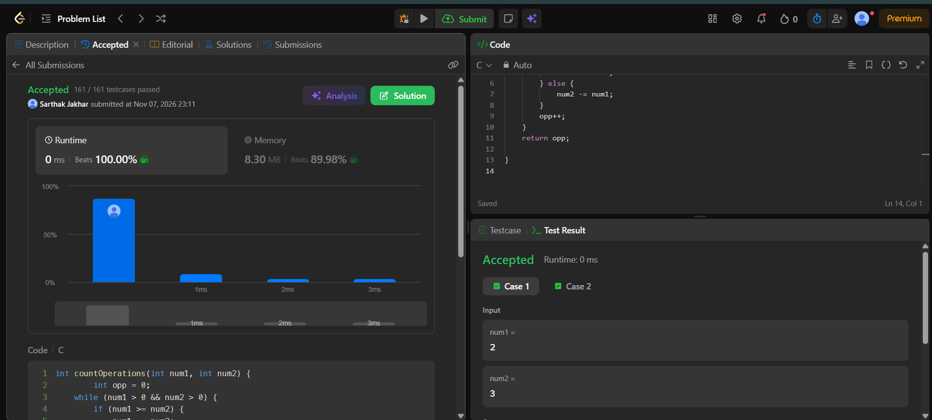
CODE:
int countOperations(int num1, int num2) {
int opp = 0;
while (num1 > 0 && num2 > 0) {
if (num1 >= num2) {
num1 -= num2;
} else {
num2 -= num1;
}
opp++;
}
return opp;

}
LINK:
https://leetcode.com/problems/count-operations-to-obtain-zero/submissions/2191222964/

