SUBMISSION SCREENSHOT:
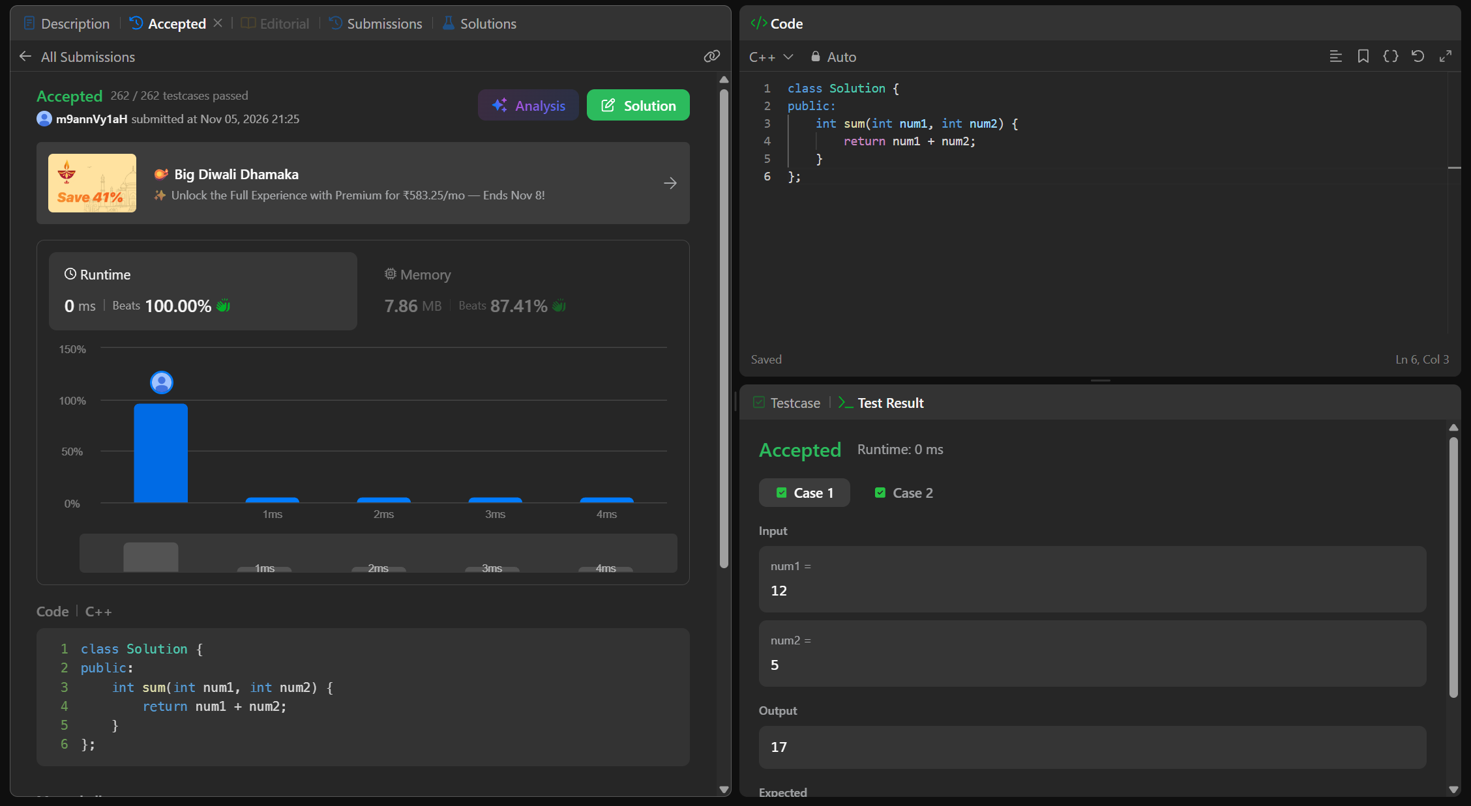
CODE:
class Solution {
public:
int sum(int num1, int num2) {
return num1 + num2;
}
};
LINK:
https://leetcode.com/problems/add-two-integers/submissions/2190175914/

