SUBMISSION SCREENSHOT:
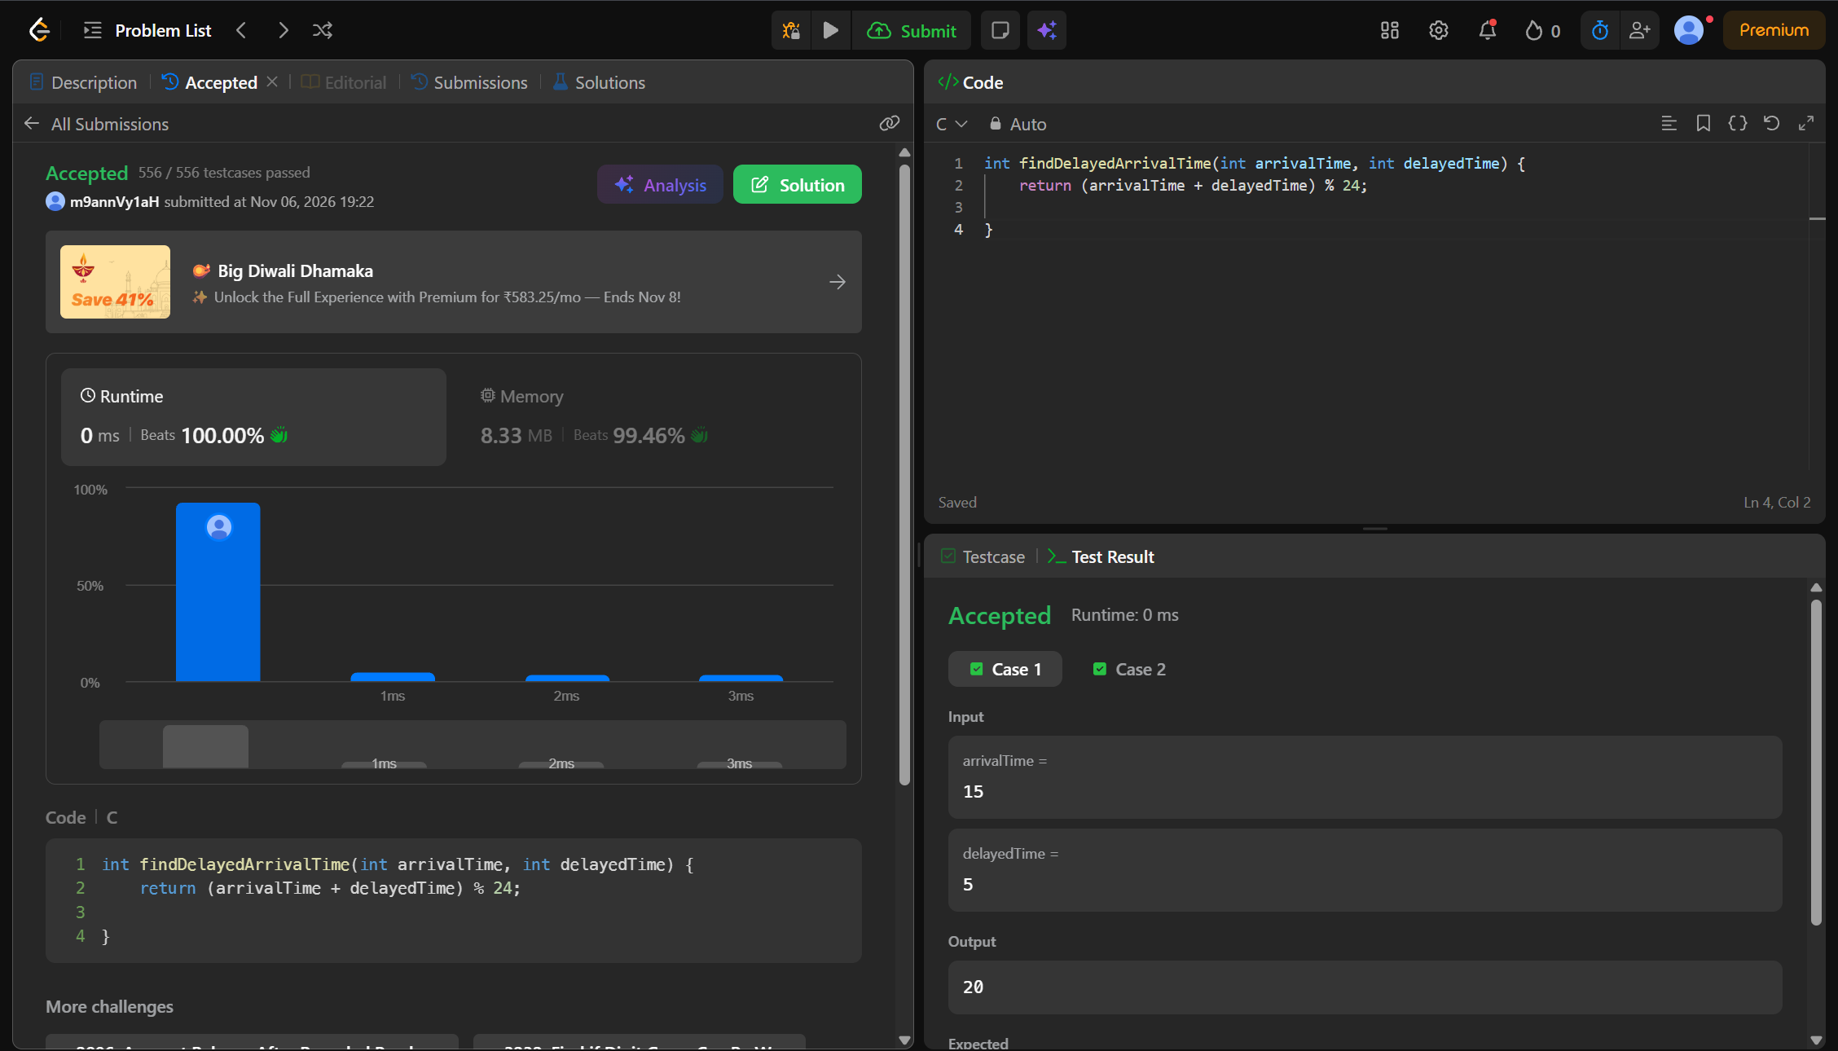
CODE:
int findDelayedArrivalTime(int arrivalTime, int delayedTime) {
return (arrivalTime + delayedTime) % 24;
}
LINK:
https://leetcode.com/problems/calculate-delayed-arrival-time/

