SUBMISSION SCREENSHOT:
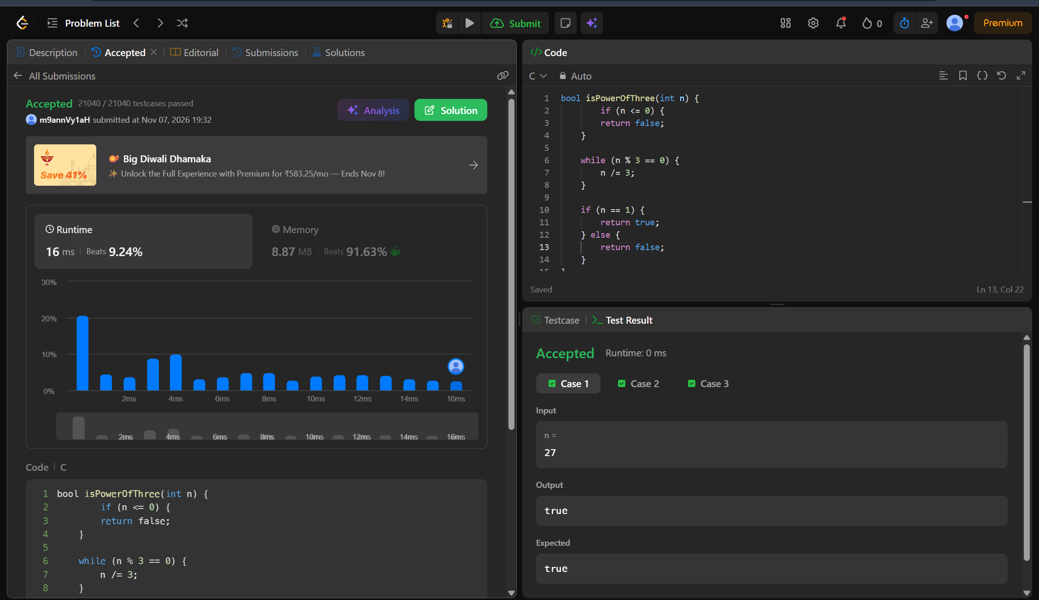
CODE:
bool isPowerOfThree(int n) {
if (n <= 0) {
return false;
}

while (n % 3 == 0) {
n /= 3;
}

if (n == 1) {
return true;
} else {
return false;
}
}
LINK:
https://leetcode.com/problems/power-of-three/

