SUBMISSION SCREENSHOT:
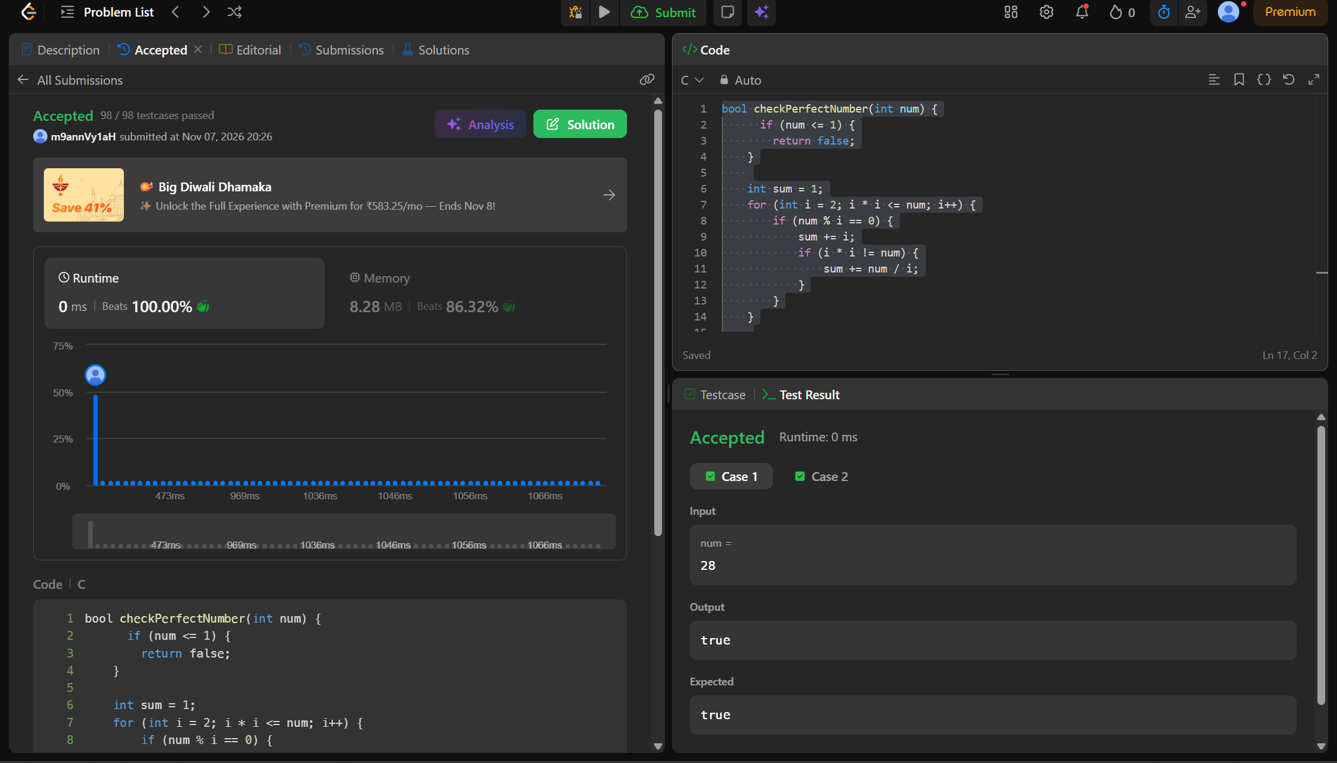
CODE:
bool checkPerfectNumber(int num) {
if (num <= 1) {
return false;
}

int sum = 1;
for (int i = 2; i * i <= num; i++) {
if (num % i == 0) {
sum += i;
if (i * i != num) {
sum += num / i;
}
}
}

return sum == num;
}
LINK:
https://leetcode.com/problems/perfect-number/

