SUBMISSION SCREENSHOT:
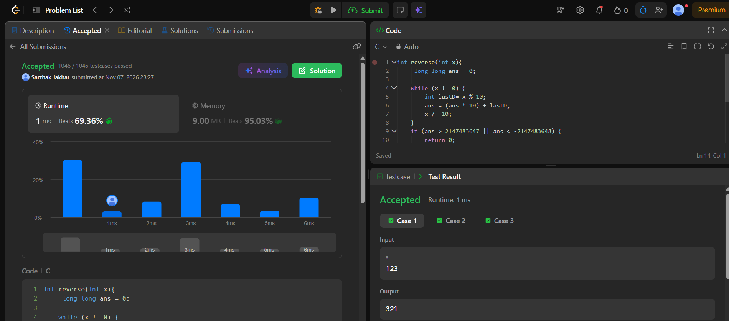
CODE:
int reverse(int x){
long long ans = 0;

while (x != 0) {
int lastD= x % 10;
ans = (ans * 10) + lastD;
x /= 10;
}
if (ans > 2147483647 || ans < -2147483648) {
return 0;
}
return ans;
}
LINK:
https://leetcode.com/problems/reverse-integer/

