SUBMISSION SCREENSHOT:
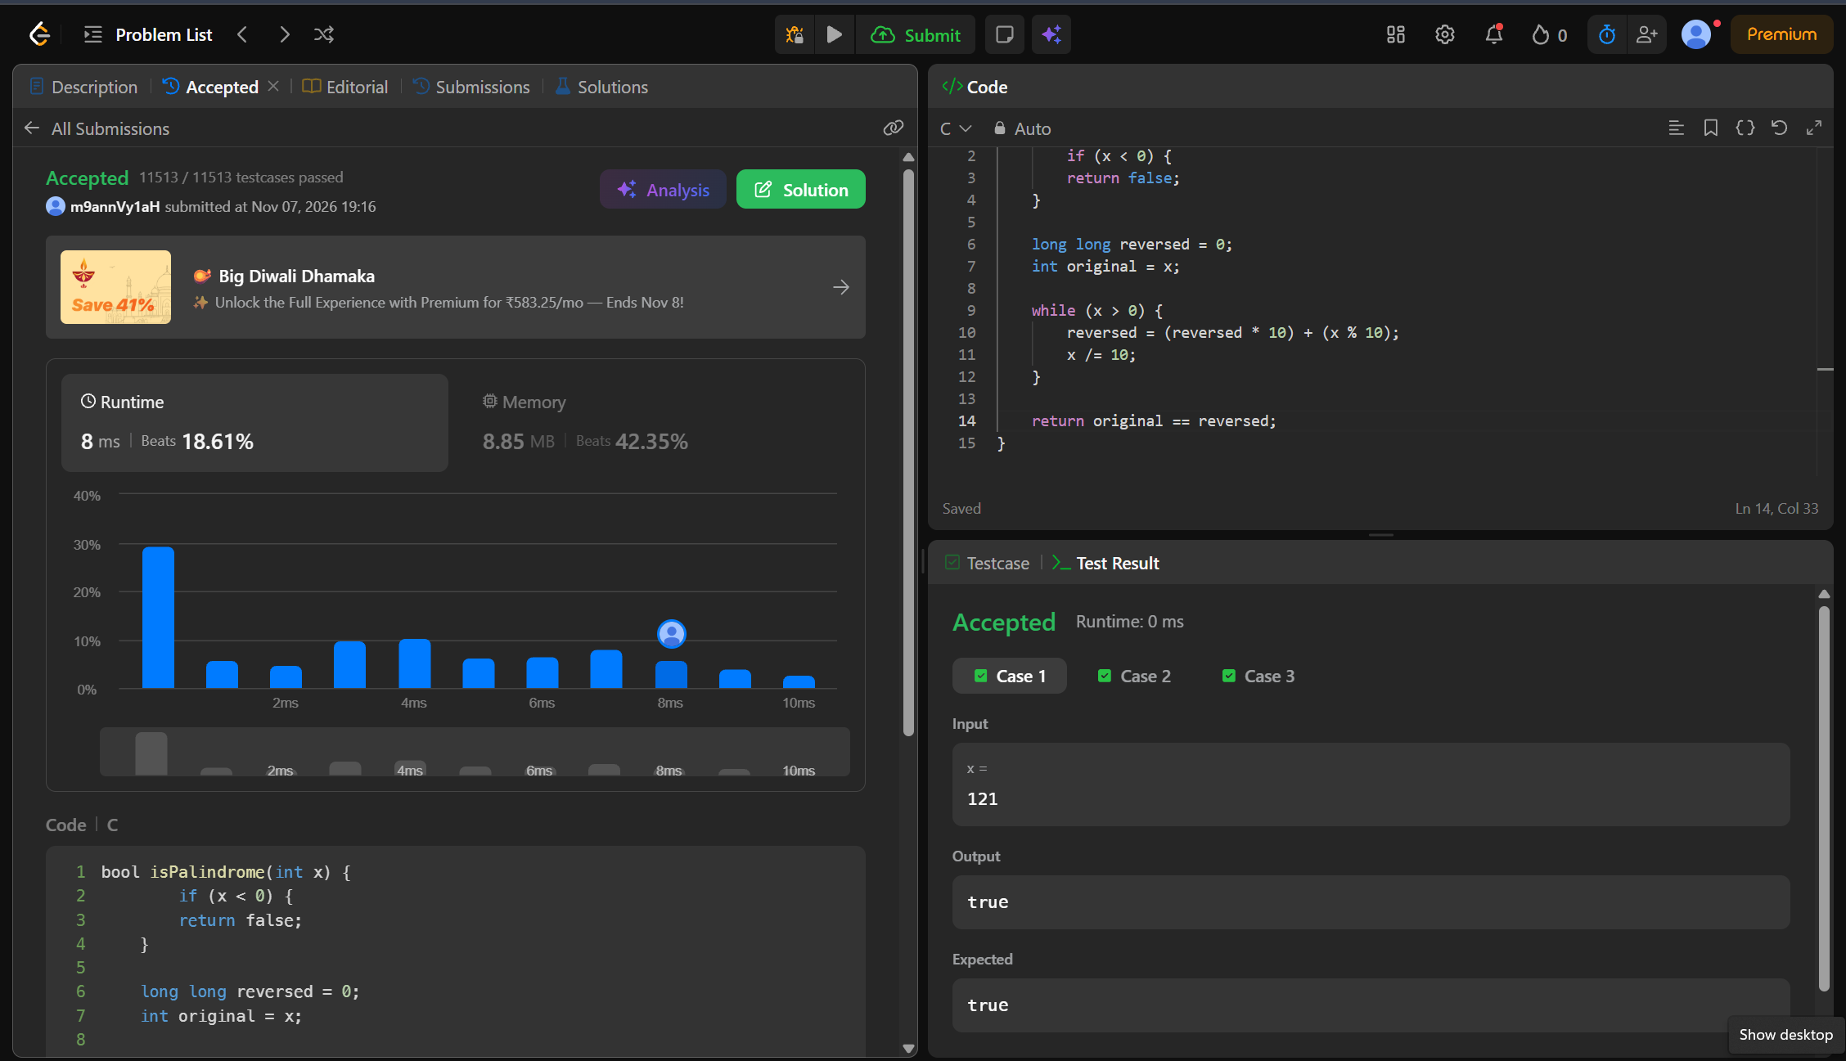
CODE:
bool isPalindrome(int x) {
if (x < 0) {
return false;
}
long long reversed = 0;
int original = x;

while (x > 0) {
reversed = (reversed * 10) + (x % 10);
x /= 10;
}
return original == reversed;
}
LINK:
https://leetcode.com/problems/palindrome-number/

