SUBMISSION SCREENSHOT:
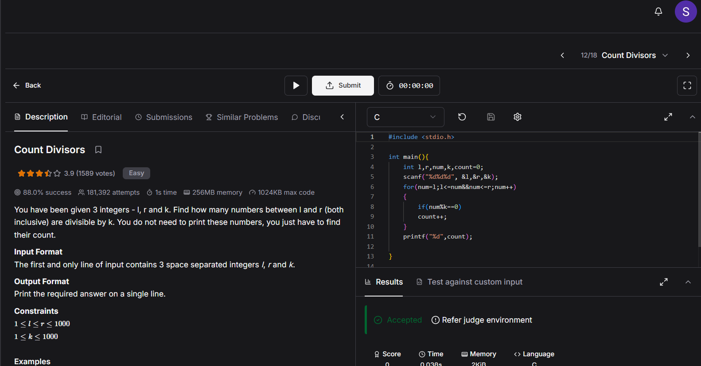
CODE:
#include <stdio.h>

int main(){
int l,r,num,k,count=0;
scanf("%d%d%d", &l,&r,&k);
for(num=l;l<=num&&num<=r;num++)
{
if(num%k==0)
count++;
}
printf("%d",count);

}

LINK:
https://www.hackerearth.com/practice/basic-programming/input-output/basics-of-input-output/practice-problems/algorithm/count-divisors/

