SUBMISSION SCREENSHOT:
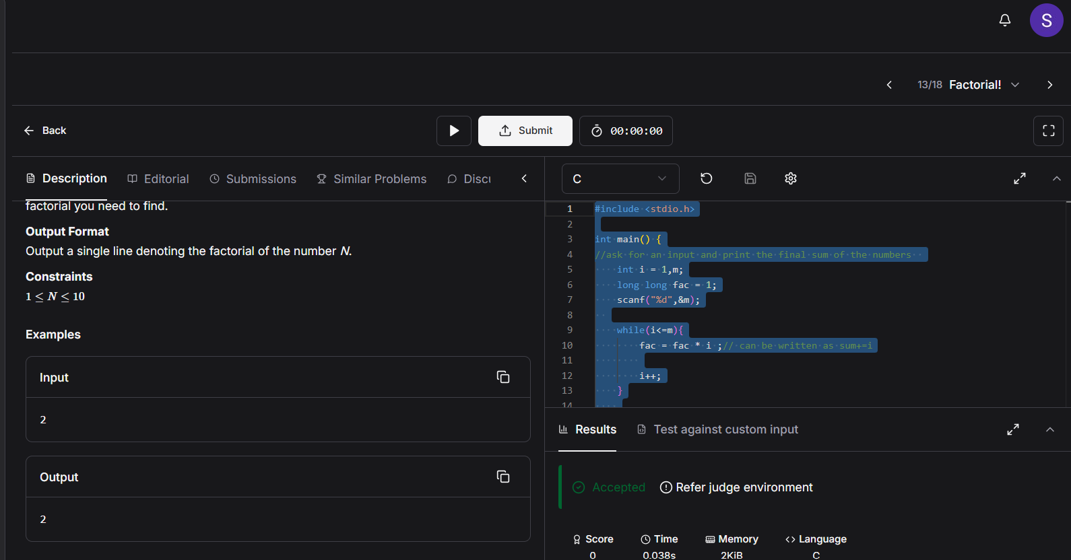
CODE:
#include <stdio.h>

int main() {
//ask for an input and print the final sum of the numbers
int i = 1,m;
long long fac = 1;
scanf("%d",&m);

while(i<=m){
fac = fac * i ;// can be written as sum+=i

i++;
}

printf("%d",fac);
return 0;
}
LINK:
https://www.hackerearth.com/practice/basic-programming/input-output/basics-of-input-output/practice-problems/algorithm/find-factorial/

