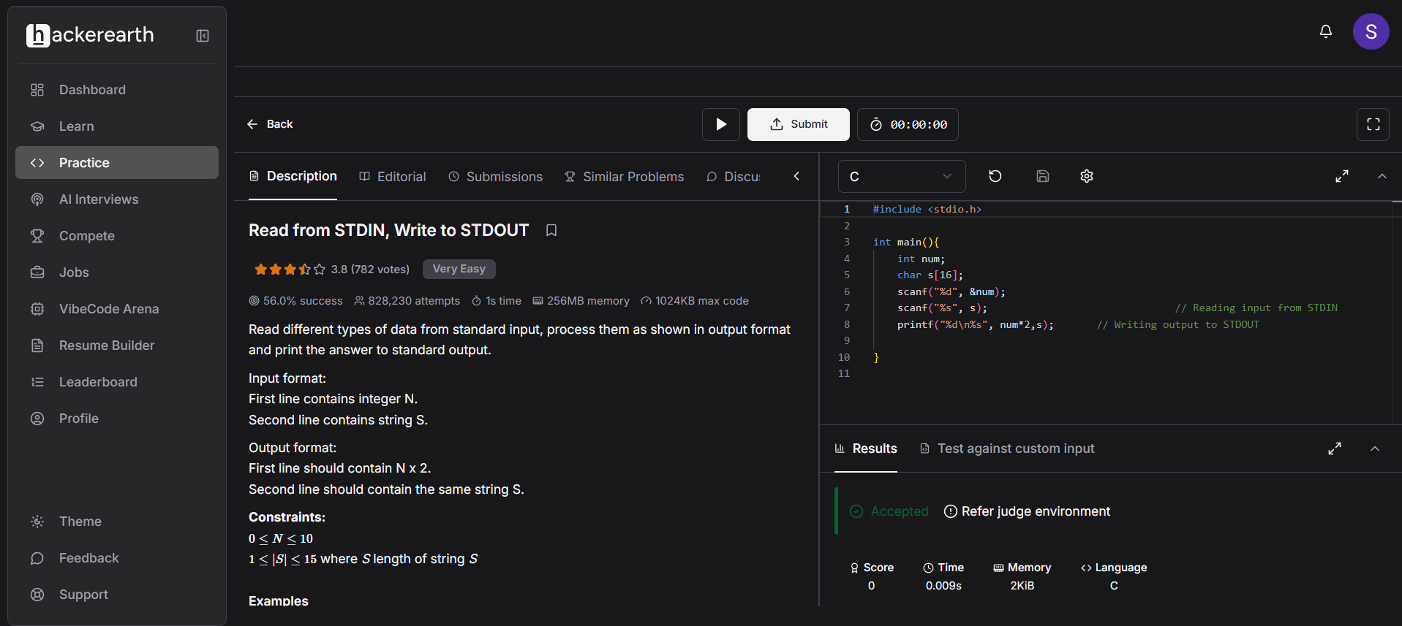

CODE:
#include <stdio.h>

int main(){
int num;
char s[16];
scanf("%d", &num);
scanf("%s", s); // Reading input from STDIN
printf("%d\n%s", num*2,s); // Writing output to STDOUT

}

LINK:
https://www.hackerearth.com/practice/basic-programming/input-output/basics-of-input-output/practice-problems/algorithm/io-exercise/

